**Information Security**

**Practical 11: IIT Virtual Cryptography Lab:**

**URL** [**https://cse29-iiith.vlabs.ac.in/Experiments.html**](https://cse29-iiith.vlabs.ac.in/Experiments.html)

**1. Message Authentication Code (CBC-MAC)**

**2. AES and Modes of Operation**

**3. Digital Signatures Scheme**

**Output:**

1. **Message Authentication Code (CBC-MAC)**

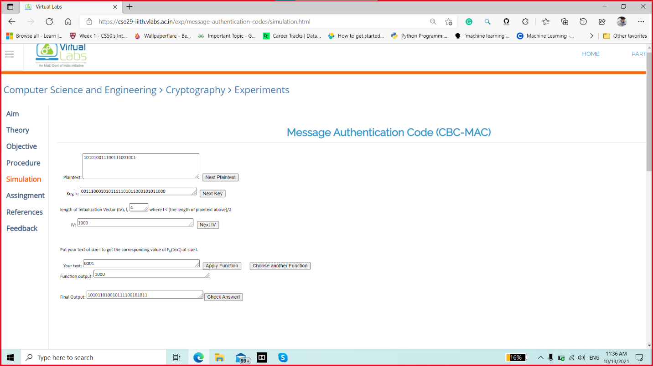

1. **AES and Modes of Operation [ Cipher Block Chaining]**

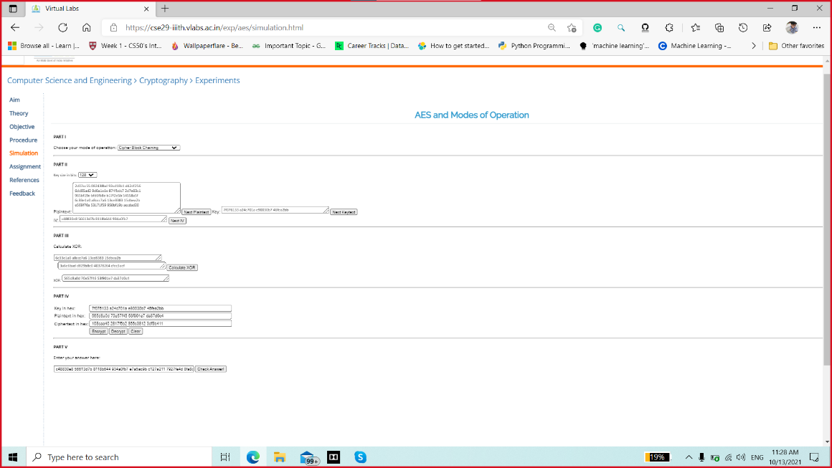

1. **AES and Modes of Operation [ Electronic Code Block]**

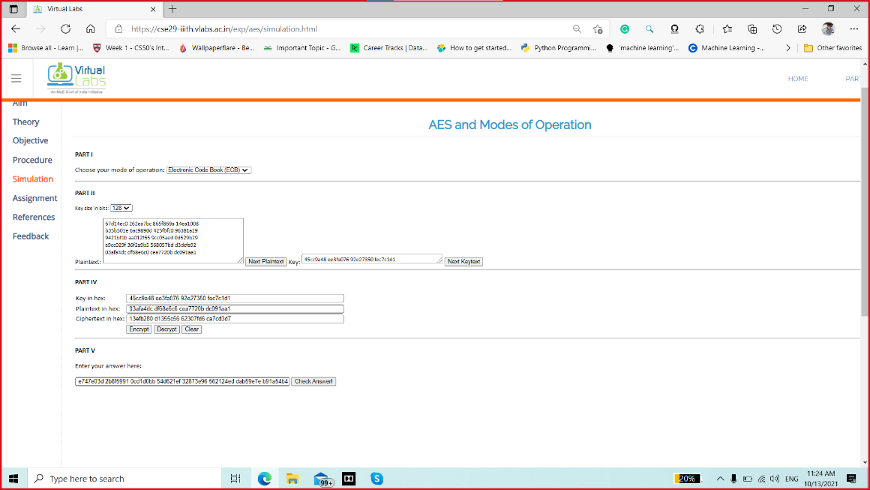

1. **AES and Modes of Operation [ Counter Mode]**

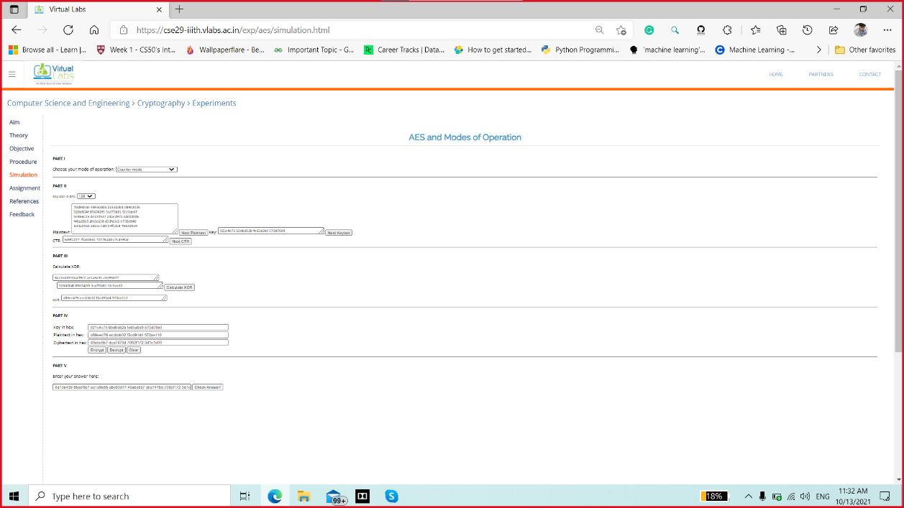

1. **AES and Modes of Operation [ Output FeedBack]**

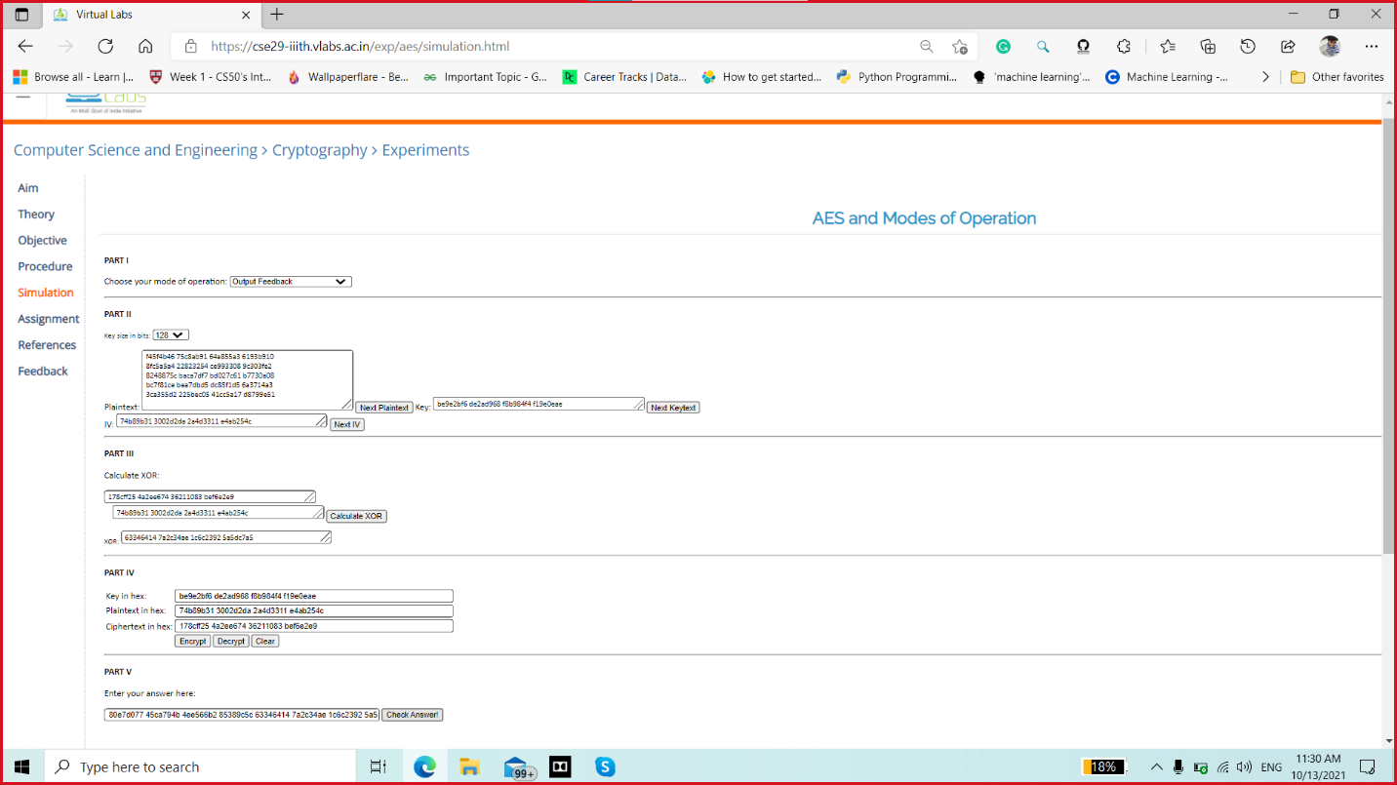

1. **Digital Signature Scheme**

