**Entertainment apps / Social media apps**

* **Abstraction:** It is about Watching videos online, Event, Chatting, posting photos on social sites, Music App and many more all those apps that are built to agitate the user’s mind are categorized as entertainment apps.

Such apps are highly engaging and with fun and interactive elements featured in these apps, the overall experience is too refreshing for the users.

* **Overview:** From last 1 and half years all the students and people are bored from online session and stay home for safe. So, there are we need part of Entertainment at home, where we can enjoy in playing games with family. Watching movies, listen music, Chat with Friends, posting photos & Watching Reels are part of enjoyment where Mobile Developer give functionality to can’t fill us alone at this time.

Where list all used application increasing day by day for Young as well old generation:

* **Social Media Apps: Movies Apps: Music Apps:**

Facebook Netflix Spotify

Instagram YouTube Ganna

Snapchat Amazon Prime Jio Savan

Tinder Hotstar

Twitter

WhatsApp

Signal

LinkedIn

Telegram

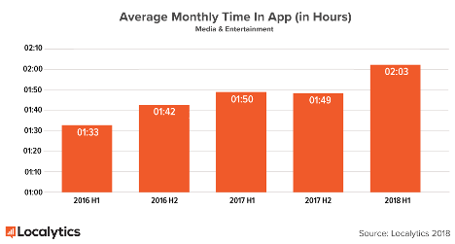

* **The Client:**

Young Generation as well as Old Generation

* **Services:**

Meet People online, Entertainment like Movie and Music and Web series

* 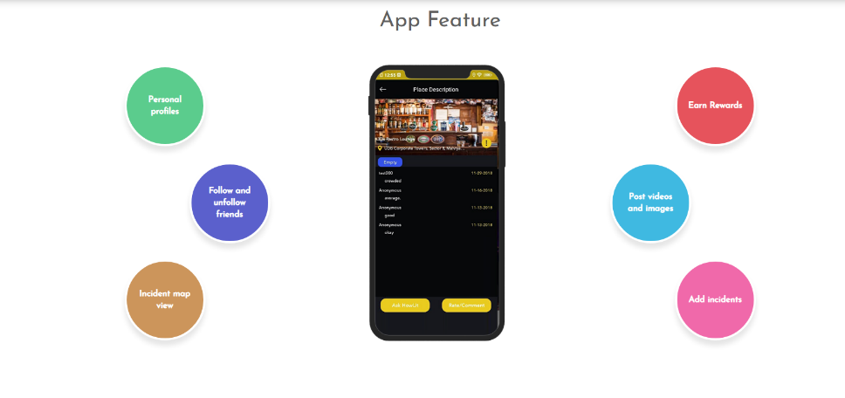**Feature Highlights:**

Easily talk and chat with friend,

View Reels and Photos,

Watching Movies with High-quality,

Listen Music anytime,

Easy Navigation,

Notification Alerts,

Mark favorites,

Content Customize

* **Points for create Entertainment App:**

Planning, Design& UI, Development, Release, Ongoing Support

* 55% of people who use entertainment apps use them while relaxing.

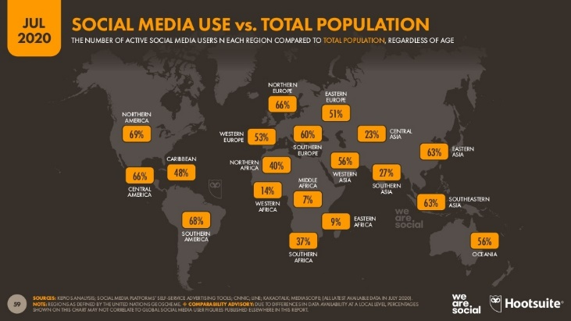

* **Conclusion:**

As of My point of view there is part of life together online and Entertainment is not only relaxing but it is Refreshment for start new things and motivate some time to us behind stage of scene.

* **Reference:**

[Entertainment app user statistics - Think with Google](https://www.thinkwithgoogle.com/consumer-insights/consumer-trends/mobile-app-user-demographics-relax-with-entertainment/)

[Top U.S. mobile entertainment apps by reach 2019 | Statista](https://www.statista.com/statistics/294586/smartphone-video-app-reach-us/)

[App Download and Usage Statistics (2020) - Business of Apps](https://www.businessofapps.com/data/app-statistics/#3.8)

[Case Study: Built a Entertainment Application Development | HowLit- Meet New People (devtechnosys.com)](https://devtechnosys.com/case-study/entertainment-application-howlit.php)

[Entertainment App Development Tips and Entertainment Industry Trends That Work (cleveroad.com)](https://www.cleveroad.com/blog/entertainment-app-development-tips-and-entertainment-industry-trends)

[Entertainment App Design and Development Case Study | Fox (bluewhaleapps.com)](https://bluewhaleapps.com/work/entertaiment-app-fox)

[Case Study - Voot Mobile App | Robosoft Technologies (robosoftin.com)](https://www.robosoftin.com/work/voot)

[Statistics & Tips for Entertainment Apps In-App Engagement | Storyly](https://storyly.io/statistics-tips-for-entertainment-apps-in-app-engagement/)