**Mobile Application Development**

* **Practical 1: Install Android**
* **Q 1) Write the steps for installing Android Studio in Windows.**

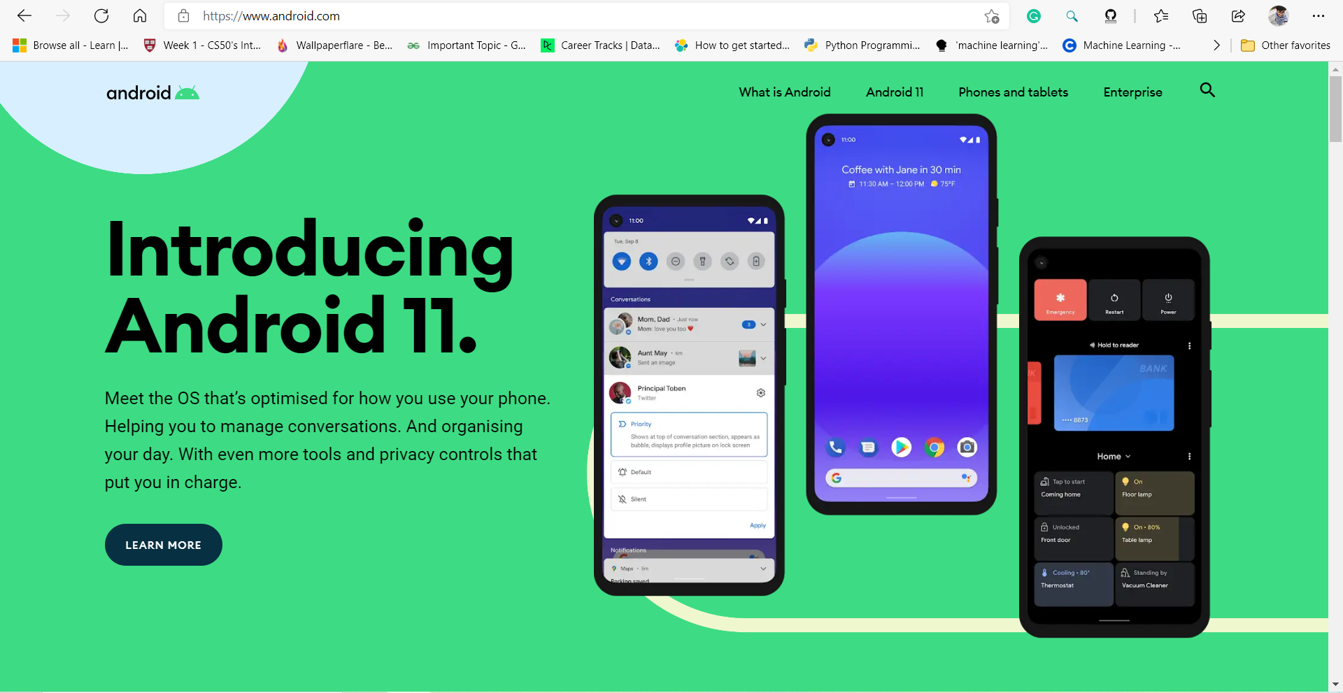

* **Step 1 -> Install Android Studio on Windows Steps.**
* [Download related android studio version](https://developer.android.com/studio/) from android studio official website.

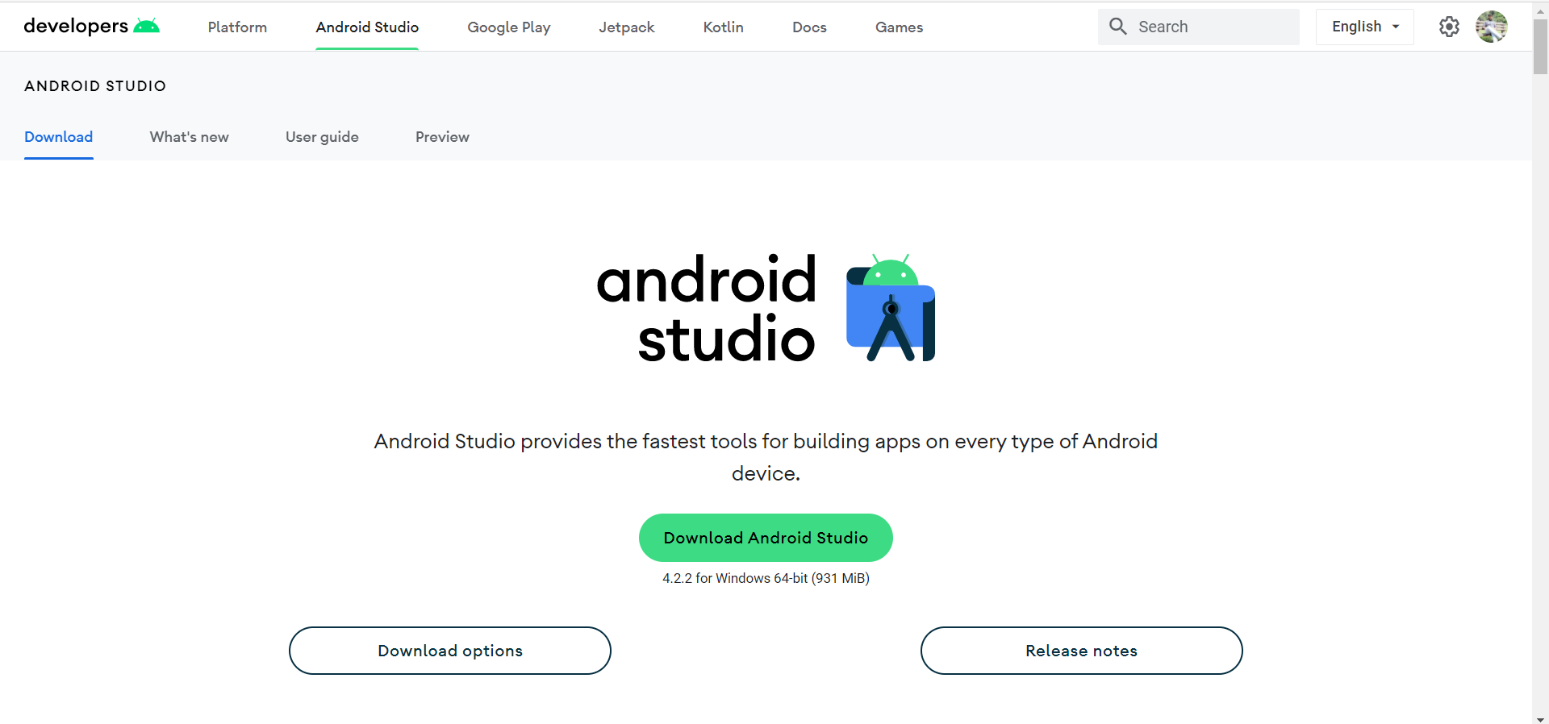

* Unzip the download zip file to a local directory for example **Download/android-studio-ide-181.5056338-windows.**
* Please note there is also another sub folder named **android-studio** in above folder. Now the android studio has been installed successfully.
* **Step 2 -> Start Android Studio on Windows.**

Start android studio on windows.

* Now click on application, and step by step install android.
* **Step 3 -> Specify Android SDK and JDK Path in Android Studio.**
* When the android studio is started, click **File —> New —> New Project** to create a new android project. If you want to change the default android sdk and jdk to other folders, you can follow below steps.

1. Click **File —> Other Settings —> Default Project Structure…** menu item in the android studio top menu bar.
2. Then you can change the android studio project sdk and jdk folder in the popup dialog window as below. If you are a beginner, you do not need to change them at all.

* **Step 4 -> Add Android SDK Command Tool in System PATH.**

Generally, you will use android studio to run android sdk command tool, but sometimes you may need to invoke those android sdk command in terminal, so please follow below steps to add android sdk command execute path in Linux PATH system environment variable value then you can invoke them in command line.

1. Get android SDK path from above picture in step 3.
2. Set android PATH variable value in Environment.

* **Step 5. Start ANDRIOD Studio**

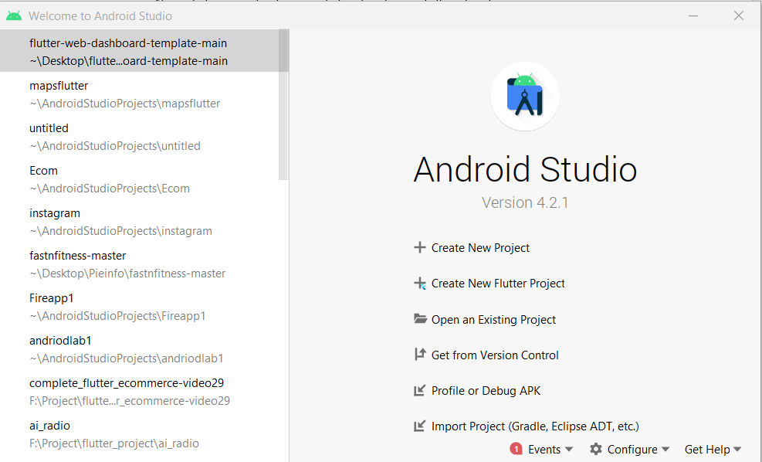

**Q 2 -> Write the steps for installing Android in Eclipse IDE**

* June of last year, Google announced "we are ending development and official support for the Android Developer Tools (ADT) in Eclipse at the end of the year.
* This specifically includes the Eclipse ADT plug-in and Android Ant build system." However, the company had been previously warning developers for quite some time that such a shift was in the works, noting back in 2014 -- with the release of Android Studio 1.0 -- that the ADT plug-in wasn't in active development any longer.