**Mobile Application Development**

* **Practical 2: Student Details Show in Android APP.**

**CODE:**

**Andriod_main.xml**

*<?***xml version="1.0" encoding="utf-8"***?>*<**androidx.constraintlayout.widget.ConstraintLayout xmlns:android="http://schemas.android.com/apk/res/android"  
 xmlns:app="http://schemas.android.com/apk/res-auto"  
 xmlns:tools="http://schemas.android.com/tools"  
 android:layout_width="match_parent"  
 android:layout_height="match_parent"  
 android:background="@drawable/images"  
 tools:context=".MainActivity"**>  
  
 <**EditText  
 android:id="@+id/name"  
 android:layout_width="wrap_content"  
 android:layout_height="wrap_content"  
 android:layout_marginStart="24dp"  
 android:layout_marginTop="13dp"  
 android:layout_marginEnd="187dp"  
 android:layout_marginBottom="26dp"  
 android:ems="10"  
 android:hint="Enter Name"  
 android:inputType="textPersonName"  
 app:layout_constraintBottom_toTopOf="@+id/n1"  
 app:layout_constraintEnd_toEndOf="parent"  
 app:layout_constraintHorizontal_bias="1.0"  
 app:layout_constraintStart_toStartOf="parent"  
 app:layout_constraintTop_toBottomOf="@+id/textView6"** />  
  
 <**EditText  
 android:id="@+id/n1"  
 android:layout_width="wrap_content"  
 android:layout_height="wrap_content"  
 android:layout_marginStart="24dp"  
 android:layout_marginTop="20dp"  
 android:layout_marginEnd="187dp"  
 android:layout_marginBottom="15dp"  
 android:ems="10"  
 android:hint="Mobile Number"  
 android:inputType="number"  
 app:layout_constraintBottom_toTopOf="@+id/n2"  
 app:layout_constraintEnd_toEndOf="parent"  
 app:layout_constraintHorizontal_bias="0.9"  
 app:layout_constraintStart_toStartOf="parent"  
 app:layout_constraintTop_toBottomOf="@+id/name"** />  
  
 <**EditText  
 android:id="@+id/n2"  
 android:layout_width="wrap_content"  
 android:layout_height="wrap_content"  
 android:layout_marginStart="24dp"  
 android:layout_marginTop="2dp"  
 android:layout_marginEnd="184dp"  
 android:layout_marginBottom="16dp"  
 android:ems="10"  
 android:hint="Enrollment Number"  
 android:inputType="number"  
 app:layout_constraintBottom_toTopOf="@+id/c1"  
 app:layout_constraintEnd_toEndOf="parent"  
 app:layout_constraintStart_toStartOf="parent"  
 app:layout_constraintTop_toBottomOf="@+id/n1"** />  
  
 <**EditText  
 android:id="@+id/c1"  
 android:layout_width="wrap_content"  
 android:layout_height="wrap_content"  
 android:layout_marginStart="24dp"  
 android:layout_marginTop="9dp"  
 android:layout_marginEnd="187dp"  
 android:layout_marginBottom="19dp"  
 android:ems="10"  
 android:hint="College"  
 android:inputType="textPersonName"  
 app:layout_constraintBottom_toTopOf="@+id/s1"  
 app:layout_constraintEnd_toEndOf="parent"  
 app:layout_constraintStart_toStartOf="parent"  
 app:layout_constraintTop_toBottomOf="@+id/n2"** />  
  
 <**EditText  
 android:id="@+id/s1"  
 android:layout_width="wrap_content"  
 android:layout_height="wrap_content"  
 android:layout_marginStart="24dp"  
 android:layout_marginTop="11dp"  
 android:layout_marginEnd="187dp"  
 android:layout_marginBottom="32dp"  
 android:ems="10"  
 android:hint="Sem"  
 android:inputType="textPersonName"  
 app:layout_constraintBottom_toTopOf="@+id/btn"  
 app:layout_constraintEnd_toEndOf="parent"  
 app:layout_constraintStart_toStartOf="parent"  
 app:layout_constraintTop_toBottomOf="@+id/c1"** />  
  
 <**TextView  
 android:id="@+id/textView6"  
 android:layout_width="162dp"  
 android:layout_height="40dp"  
 android:layout_marginStart="103dp"  
 android:layout_marginTop="16dp"  
 android:layout_marginEnd="146dp"  
 android:layout_marginBottom="13dp"  
 android:background="#FFEB3B"  
 android:text="Personal Details"  
 android:textSize="20sp"  
 app:layout_constraintBottom_toTopOf="@+id/name"  
 app:layout_constraintEnd_toEndOf="parent"  
 app:layout_constraintStart_toStartOf="parent"  
 app:layout_constraintTop_toTopOf="parent"** />  
  
 <**Button  
 android:id="@+id/btn"  
 android:layout_width="wrap_content"  
 android:layout_height="wrap_content"  
 android:layout_marginStart="116dp"  
 android:layout_marginTop="23dp"  
 android:layout_marginEnd="201dp"  
 android:layout_marginBottom="235dp"  
 android:background="#EF6D99"  
 android:backgroundTint="#D38C8C"  
 android:text="Button"  
 app:layout_constraintBottom_toBottomOf="parent"  
 app:layout_constraintEnd_toEndOf="parent"  
 app:layout_constraintHorizontal_bias="0.0"  
 app:layout_constraintStart_toStartOf="parent"  
 app:layout_constraintTop_toBottomOf="@+id/s1"** />  
  
 <**TextView  
 android:id="@+id/output"  
 android:layout_width="294dp"  
 android:layout_height="177dp"  
 android:layout_marginStart="31dp"  
 android:layout_marginTop="41dp"  
 android:layout_marginEnd="112dp"  
 android:layout_marginBottom="34dp"  
 app:layout_constraintBottom_toBottomOf="parent"  
 app:layout_constraintEnd_toEndOf="parent"  
 app:layout_constraintStart_toStartOf="parent"  
 app:layout_constraintTop_toBottomOf="@+id/btn"** />  
  
</**androidx.constraintlayout.widget.ConstraintLayout**>

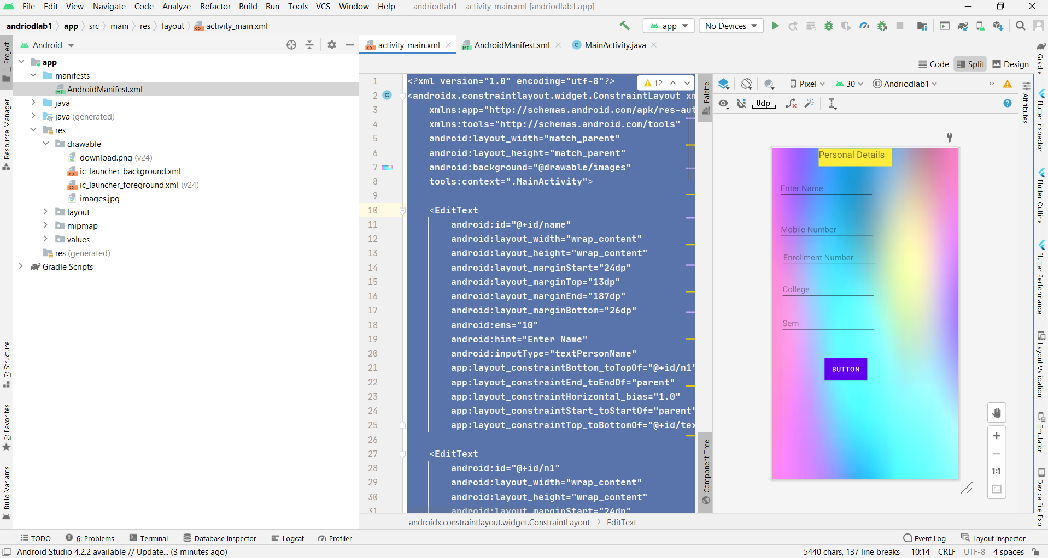

**AndroidManifest.xml**

*<?***xml version="1.0" encoding="utf-8"***?>*<**manifest xmlns:android="http://schemas.android.com/apk/res/android"  
 package="com.example.andriodlab1"**>  
  
 <**application  
 android:allowBackup="true"  
 android:icon="@mipmap/ic_launcher"  
 android:label="@string/app_name"  
 android:roundIcon="@drawable/download"  
 android:supportsRtl="true"  
 android:theme="@style/Theme.Andriodlab1"**>  
 <**activity android:name=".MainActivity"**>  
 <**intent-filter**>  
 <**action android:name="android.intent.action.MAIN"** />  
  
 <**category android:name="android.intent.category.LAUNCHER"** />  
 </**intent-filter**>  
 </**activity**>  
 </**application**>  
  
</**manifest**>

**MainActivity.java**

**package** com.example.andriodlab1;  
  
**import** androidx.appcompat.app.AppCompatActivity;  
  
**import** android.os.Bundle;  
**import** android.view.View;  
**import** android.widget.Button;  
**import** android.widget.EditText;  
**import** android.widget.TextView;  
  
**public class** MainActivity **extends** AppCompatActivity {  
  
 EditText **name**,**n1**,**n2**,**s1**,**c1**;  
 Button **btn**;  
 TextView **output**;  
 @Override  
 **protected void** onCreate(Bundle savedInstanceState) {  
 **super**.onCreate(savedInstanceState);  
 setContentView(R.layout.***activity_main***);  
  
 **name** = findViewById(R.id.***name***);  
 **n1** = findViewById(R.id.***n1***);  
 **n2** = findViewById(R.id.***n2***);  
 **s1** = findViewById(R.id.***s1***);  
 **c1** = findViewById(R.id.***c1***);  
 **btn** = findViewById(R.id.***btn***);  
 **output** = findViewById(R.id.***output***);  
  
 **btn**.setOnClickListener(**new** View.OnClickListener() {  
 @Override  
 **public void** onClick(View v) {  
 **output**.setText(**"Details are given below : \n"** + **name**.getText() + **"\n"** + **n1**.getText() + **"\n"** + **n2**.getText() + **"\n"**+ **s1**.getText() + **"\n"** + **c1**.getText() + **"\n"**);  
 }  
 });  
  
 }  
  
}

**Output:**

