**Mobile Application Development**

* **Practical 3: Input Text and Speak / View text**

**User login/ Password checkbox -> Show detials**

1. **Translator -> Text input and speak in German**

**CODE:**

**Andriod_main.xml**

*<?***xml version="1.0" encoding="utf-8"***?>*<**androidx.constraintlayout.widget.ConstraintLayout xmlns:android="http://schemas.android.com/apk/res/android"  
 xmlns:app="http://schemas.android.com/apk/res-auto"  
 xmlns:tools="http://schemas.android.com/tools"  
 android:layout_width="match_parent"  
 android:layout_height="match_parent"  
 tools:context=".MainActivity"**>  
  
  
 <**TextView  
 android:id="@+id/textView"  
 android:layout_width="260dp"  
 android:layout_height="47dp"  
 android:fontFamily="@font/aclonica"  
 android:text="Translator"  
 android:textColor="@color/teal_200"  
 android:textSize="24sp"  
 app:layout_constraintBottom_toBottomOf="parent"  
 app:layout_constraintEnd_toEndOf="parent"  
 app:layout_constraintHorizontal_bias="0.35"  
 app:layout_constraintStart_toStartOf="parent"  
 app:layout_constraintTop_toTopOf="parent"  
 app:layout_constraintVertical_bias="0.036"** />  
  
 <**EditText  
 android:id="@+id/text"  
 android:layout_width="296dp"  
 android:layout_height="47dp"  
 android:ems="10"  
 android:hint="Enter Text"  
 android:inputType="textPersonName"  
 app:layout_constraintBottom_toBottomOf="parent"  
 app:layout_constraintEnd_toEndOf="parent"  
 app:layout_constraintHorizontal_bias="0.495"  
 app:layout_constraintStart_toStartOf="parent"  
 app:layout_constraintTop_toBottomOf="@+id/textView"  
 app:layout_constraintVertical_bias="0.078"** />  
  
 <**Button  
 android:id="@+id/button"  
 android:layout_width="143dp"  
 android:layout_height="40dp"  
 android:backgroundTint="?attr/colorAccent"  
 android:text="Speak"  
 app:layout_constraintBottom_toBottomOf="parent"  
 app:layout_constraintEnd_toEndOf="parent"  
 app:layout_constraintHorizontal_bias="0.395"  
 app:layout_constraintStart_toStartOf="parent"  
 app:layout_constraintTop_toBottomOf="@+id/text"  
 app:layout_constraintVertical_bias="0.103"** />  
  
 <**TextView  
 android:id="@+id/answer"  
 android:layout_width="254dp"  
 android:layout_height="60dp"  
 app:layout_constraintBottom_toBottomOf="parent"  
 app:layout_constraintEnd_toEndOf="parent"  
 app:layout_constraintHorizontal_bias="0.363"  
 app:layout_constraintStart_toStartOf="parent"  
 app:layout_constraintTop_toBottomOf="@+id/button"  
 app:layout_constraintVertical_bias="0.134"** />  
  
</**androidx.constraintlayout.widget.ConstraintLayout**>

**Andriod_manifest.xml**

*<?***xml version="1.0" encoding="utf-8"***?>*<**manifest xmlns:android="http://schemas.android.com/apk/res/android"  
 package="com.example.andriodlab2"**>  
  
 <**uses-permission android:name="android.permission.INTERNET"**/>  
 <**application  
 android:allowBackup="true"  
 android:icon="@drawable/images"  
 android:label="@string/app_name"  
 android:roundIcon="@mipmap/ic_launcher_round"  
 android:supportsRtl="true"  
 android:theme="@style/Theme.Andriodlab2"** >  
 <**activity android:name=".MainActivity"**>  
 <**intent-filter**>  
 <**action android:name="android.intent.action.MAIN"** />  
  
 <**category android:name="android.intent.category.LAUNCHER"** />  
 </**intent-filter**>  
 </**activity**>  
 <**meta-data  
 android:name="preloaded_fonts"  
 android:resource="@array/preloaded_fonts"** />  
 </**application**>  
  
</**manifest**>

**MainActivity.java**

**package** com.example.andriodlab2;  
  
**import** android.os.Bundle;  
**import** android.speech.tts.TextToSpeech;  
**import** android.view.View;  
**import** android.widget.Button;  
**import** android.widget.EditText;  
**import** android.widget.TextView;  
**import** android.widget.Toast;  
  
**import** androidx.appcompat.app.AppCompatActivity;  
  
**import** java.util.Locale;  
  
  
**public class** MainActivity **extends** AppCompatActivity {  
  
 EditText Text;  
 Button btnText;  
 TextView answer;  
 TextToSpeech textToSpeech;  
  
 @Override  
 **protected void** onCreate(Bundle savedInstanceState) {  
 **super**.onCreate(savedInstanceState);  
 setContentView(R.layout.activity_main);  
  
  
 Text = findViewById(R.id.text);  
 btnText = findViewById(R.id.button);  
 answer = findViewById(R.id.answer);  
  
 textToSpeech = **new** TextToSpeech(getApplicationContext(), **new** TextToSpeech.OnInitListener() {  
 @Override  
 **public void** onInit(**int** i) {  
  
 **if**(i!=TextToSpeech.ERROR){  
  
 textToSpeech.setLanguage(Locale.GERMANY);  
 }  
 }  
 });  
  
 btnText.setOnClickListener(**new** View.OnClickListener() {  
 @Override  
 **public void** onClick(View view) {  
 Toast.makeText(getApplicationContext(),**"Speaking in German!"**,Toast.LENGTH_SHORT).show();  
  
 textToSpeech.speak(Text.getText().toString(),TextToSpeech.QUEUE_FLUSH,**null**);  
 answer.setText(**"Your Input : \n\n"**+Text.getText());  
 }  
 });  
  
 }  
}

**Output**

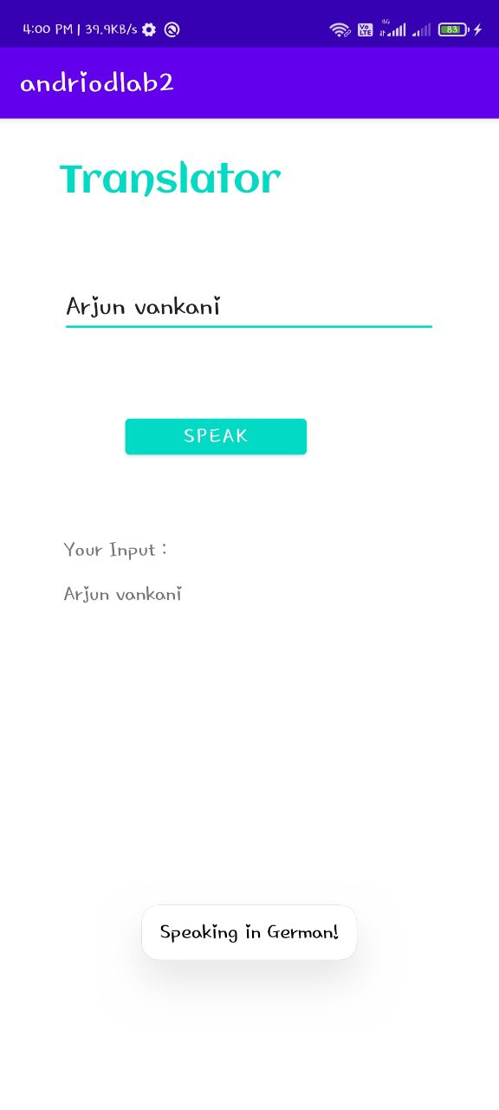 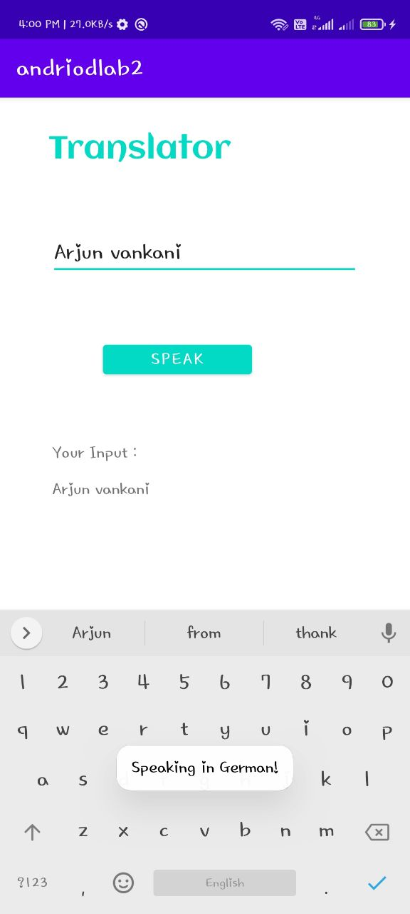

1. **User login/ Password checkbox -> Show details**

**CODE:**

**Andriod_main.xml**

*<?***xml version="1.0" encoding="utf-8"***?>*<**androidx.constraintlayout.widget.ConstraintLayout xmlns:android="http://schemas.android.com/apk/res/android"  
 xmlns:app="http://schemas.android.com/apk/res-auto"  
 xmlns:tools="http://schemas.android.com/tools"  
 android:layout_width="match_parent"  
 android:layout_height="match_parent"  
 tools:context=".MainActivity"**>  
  
 <**TextView  
 android:id="@+id/textView"  
 android:layout_width="109dp"  
 android:layout_height="48dp"  
 android:backgroundTint="@android:color/holo_blue_light"  
 android:fontFamily="@font/allura"  
 android:text="Login"  
 android:textColor="@android:color/holo_red_light"  
 android:textColorHighlight="@color/design_default_color_error"  
 android:textSize="34sp"  
 app:layout_constraintBottom_toBottomOf="parent"  
 app:layout_constraintEnd_toEndOf="parent"  
 app:layout_constraintHorizontal_bias="0.317"  
 app:layout_constraintStart_toStartOf="parent"  
 app:layout_constraintTop_toTopOf="parent"  
 app:layout_constraintVertical_bias="0.043"** />  
  
 <**EditText  
 android:id="@+id/user"  
 android:layout_width="wrap_content"  
 android:layout_height="wrap_content"  
 android:backgroundTint="@color/design_default_color_error"  
 android:ems="10"  
 android:fontFamily="@font/allura"  
 android:hint="Enter Name"  
 android:inputType="textPersonName"  
 app:layout_constraintBottom_toBottomOf="parent"  
 app:layout_constraintEnd_toEndOf="parent"  
 app:layout_constraintHorizontal_bias="0.298"  
 app:layout_constraintStart_toStartOf="parent"  
 app:layout_constraintTop_toBottomOf="@+id/textView"  
 app:layout_constraintVertical_bias="0.103"** />  
  
 <**EditText  
 android:id="@+id/pass"  
 android:layout_width="wrap_content"  
 android:layout_height="wrap_content"  
 android:backgroundTint="@color/design_default_color_error"  
 android:ems="10"  
 android:fontFamily="@font/allura"  
 android:hint="Password"  
 android:inputType="textPassword"  
 app:layout_constraintBottom_toBottomOf="parent"  
 app:layout_constraintEnd_toEndOf="parent"  
 app:layout_constraintHorizontal_bias="0.298"  
 app:layout_constraintStart_toStartOf="parent"  
 app:layout_constraintTop_toBottomOf="@+id/user"  
 app:layout_constraintVertical_bias="0.103"** />  
  
 <**CheckBox  
 android:id="@+id/checkBox"  
 android:layout_width="wrap_content"  
 android:layout_height="wrap_content"  
 android:fontFamily="@font/allura"  
 android:text="Show Password"  
 app:layout_constraintBottom_toBottomOf="parent"  
 app:layout_constraintEnd_toEndOf="parent"  
 app:layout_constraintHorizontal_bias="0.215"  
 app:layout_constraintStart_toStartOf="parent"  
 app:layout_constraintTop_toBottomOf="@+id/pass"  
 app:layout_constraintVertical_bias="0.092"** />  
  
 <**Button  
 android:id="@+id/button"  
 android:layout_width="wrap_content"  
 android:layout_height="wrap_content"  
 android:backgroundTint="?android:attr/colorActivatedHighlight"  
 android:fontFamily="@font/allura"  
 android:text="Show Details"  
 app:layout_constraintBottom_toBottomOf="parent"  
 app:layout_constraintEnd_toEndOf="parent"  
 app:layout_constraintHorizontal_bias="0.392"  
 app:layout_constraintStart_toStartOf="parent"  
 app:layout_constraintTop_toBottomOf="@+id/checkBox"  
 app:layout_constraintVertical_bias="0.158"** />  
  
 <**TextView  
 android:id="@+id/output"  
 android:layout_width="334dp"  
 android:layout_height="121dp"  
 android:fontFamily="@font/allura"  
 android:textSize="20sp"  
 app:layout_constraintBottom_toBottomOf="parent"  
 app:layout_constraintEnd_toEndOf="parent"  
 app:layout_constraintHorizontal_bias="0.413"  
 app:layout_constraintStart_toStartOf="parent"  
 app:layout_constraintTop_toBottomOf="@+id/button"  
 app:layout_constraintVertical_bias="0.458"** />  
  
</**androidx.constraintlayout.widget.ConstraintLayout**>

**AndriodManifest.xml**

*<?***xml version="1.0" encoding="utf-8"***?>*<**manifest xmlns:android="http://schemas.android.com/apk/res/android"  
 package="com.example.andriodlab21"**>  
  
 <**application  
 android:allowBackup="true"  
 android:icon="@drawable/download"  
 android:label="@string/app_name"  
 android:roundIcon="@mipmap/ic_launcher_round"  
 android:supportsRtl="true"  
 android:theme="@style/Theme.Andriodlab21"**>  
 <**activity android:name=".MainActivity"**>  
 <**intent-filter**>  
 <**action android:name="android.intent.action.MAIN"** />  
  
 <**category android:name="android.intent.category.LAUNCHER"** />  
 </**intent-filter**>  
 </**activity**>  
 <**meta-data  
 android:name="preloaded_fonts"  
 android:resource="@array/preloaded_fonts"** />  
 </**application**>  
  
</**manifest**>

**MainActivity.java**

**package** com.example.andriodlab21;  
  
**import** androidx.appcompat.app.AppCompatActivity;  
  
**import** android.content.Context;  
**import** android.os.Bundle;  
**import** android.text.InputType;  
**import** android.text.method.HideReturnsTransformationMethod;  
**import** android.text.method.PasswordTransformationMethod;  
**import** android.view.View;  
**import** android.view.inputmethod.InputMethodManager;  
**import** android.widget.Button;  
**import** android.widget.CheckBox;  
**import** android.widget.EditText;  
**import** android.widget.TextView;  
  
**public class** MainActivity **extends** AppCompatActivity {  
  
 EditText **user**,**pass**;  
 TextView **output**;  
 CheckBox **checkBox**;  
 Button **button**;  
 **private** String **Password**;  
  
 @Override  
 **protected void** onCreate(Bundle savedInstanceState) {  
 **super**.onCreate(savedInstanceState);  
 setContentView(R.layout.***activity_main***);  
  
 **user** = (EditText) findViewById(R.id.***user***);  
 **pass** = (EditText) findViewById(R.id.***pass***);  
 **output** = (TextView) findViewById(R.id.***output***);  
 **checkBox** = (CheckBox) findViewById(R.id.***checkBox***);  
 **button** = (Button) findViewById(R.id.***button***);  
  
 **checkBox**.setOnClickListener(**new** View.OnClickListener() {  
  
 @Override  
 **public void** onClick(View v) {  
 **if**(**checkBox**.isChecked()){  
 **pass**.setInputType(InputType.***TYPE_CLASS_TEXT***);  
  
 }**else**{  
 **pass**.setInputType(InputType.***TYPE_CLASS_TEXT***|InputType.***TYPE_TEXT_VARIATION_PASSWORD***);  
 }  
  
 }  
 });  
  
  
 **button**.setOnClickListener(**new** View.OnClickListener() {  
 @Override  
 **public void** onClick(View v) {  
 **output**.setText(**"User Name : \t "**+**user**.getText() + **"\n"** + **"Password : \t "** + **pass**.getText());  
 }  
 });  
 }  
}

**Output:**

