**Mobile Application Development**

* **Practical 5: Life Cycle Activity**

**CODE:**

**Andriod_main.xml**

*<?***xml version="1.0" encoding="utf-8"***?>*<**androidx.constraintlayout.widget.ConstraintLayout xmlns:android="http://schemas.android.com/apk/res/android"  
 xmlns:app="http://schemas.android.com/apk/res-auto"  
 xmlns:tools="http://schemas.android.com/tools"  
 android:layout_width="match_parent"  
 android:layout_height="match_parent"  
 tools:context=".MainActivity"**>  
  
 <**ImageView  
 android:layout_width="match_parent"  
 android:layout_height="match_parent"  
 android:src="@drawable/arjunnn"** >  
  
 </**ImageView**>  
  
</**androidx.constraintlayout.widget.ConstraintLayout**>

**MainActivity.java**

**package** com.example.andriodlab5;  
  
**import** androidx.appcompat.app.AppCompatActivity;  
  
**import** android.content.Context;  
**import** android.media.MediaPlayer;  
**import** android.os.Bundle;  
**import** android.text.Html;  
**import** android.util.Log;  
**import** android.widget.Toast;  
  
**public class** MainActivity **extends** AppCompatActivity {  
  
 **public static class** MusicManager **implements** MediaPlayer.OnPreparedListener {  
  
 **static** MediaPlayer *mPlayer*;  
 Context **context**;  
 **private int mySoundId**;  
  
 **public** MusicManager(Context ctx, **int** musicID) {  
 **context** = ctx;  
 **mySoundId** = musicID;  
 *mPlayer* = MediaPlayer.*create*(**context**, **mySoundId**);  
 *mPlayer*.setOnPreparedListener(**this**);  
 }  
  
 **public void** play() {  
 *mPlayer* = MediaPlayer.*create*(**context**, **mySoundId**);  
  
 }  
  
 **public void** stop() {  
 *mPlayer*.stop();  
 *mPlayer*.release();  
 }  
  
 @Override  
 **public void** onPrepared(MediaPlayer player) {  
 player.start();  
 *mPlayer*.setLooping(**true**);  
 *mPlayer*.setVolume(80, 80);  
  
 }  
  
 }  
 @Override  
 **protected void** onCreate(Bundle savedInstanceState) {  
 **super**.onCreate(savedInstanceState);  
 setContentView(R.layout.***activity_main***);  
 System.***out***.println(**"Arjun"**);  
 Log.*i*(**"Arjun"**,**"on Create Called"**);  
 Toast.*makeText*(getApplicationContext(),Html.*fromHtml*(**"<font color='yellow' ><b>"** + **"onCreate Called"** + **"</b></font>"**),  
 Toast.***LENGTH_LONG***).show();  
  
 }  
 **protected void** onStart() {  
 **super**.onStart();  
 Log.*i*(**"Arjun"**, **"on Start Called"**);  
 Toast.*makeText*(getApplicationContext(), Html.*fromHtml*(**"<font color='green' ><b>"** + **"on Start Called"** + **"</b></font>"**),  
 Toast.***LENGTH_LONG***).show();  
 MusicManager mm = **new** MusicManager(**this**, R.raw.***back***);  
 mm.play();  
 }  
 **protected void** onRestart() {  
  
 **super**.onRestart();  
 Log.*i*(**"Arjun"**, **"on Restart Called"**);  
 Toast.*makeText*(getApplicationContext(),Html.*fromHtml*(**"<font color='pink' ><b>"** + **"on retsart Called"** + **"</b></font>"**),  
 Toast.***LENGTH_LONG***).show();  
 MusicManager mm = **new** MusicManager(**this**, R.raw.***back2***);  
 mm.play();  
 }  
 **protected void** onResume() {  
  
 **super**.onResume();  
 Log.*i*(**"Arjun"**,**"On Resume Called"**);  
 Toast.*makeText*(getApplicationContext(), Html.*fromHtml*(**"<font color='black' ><b>"** + **"on Resume Called"** + **"</b></font>"**),  
 Toast.***LENGTH_LONG***).show();  
 MusicManager mm = **new** MusicManager(**this**, R.raw.***back3***);  
 mm.play();  
 }  
 **protected void** onPause() {  
  
 **super**.onPause();  
 Log.*i*(**"Arjun"**,**"On Pause Called"**);  
 Toast.*makeText*(getApplicationContext(), Html.*fromHtml*(**"<font color='purple' ><b>"** + **"on Pause Called"** + **"</b></font>"**),  
 Toast.***LENGTH_LONG***).show();  
 MusicManager mm = **new** MusicManager(**this**, R.raw.***back4***);  
 mm.play();  
 }  
  
 **protected void** onStop() {  
  
 **super**.onStop();  
 Log.*i*(**"Arjun"**,**"On Stop Called"**);  
 Toast.*makeText*(getApplicationContext(), Html.*fromHtml*(**"<font color='red' ><b>"** + **"on Stop Called"** + **"</b></font>"**),  
 Toast.***LENGTH_LONG***).show();  
 MusicManager mm = **new** MusicManager(**this**, R.raw.***back5***);  
 mm.play();  
 }  
 **protected void** onDestroy() {  
  
 **super**.onDestroy();  
 Log.*i*(**"Arjun"**,**"On Destroy Called"**);  
 System.***out***.println(**"Arjun"**);  
 Toast.*makeText*(getApplicationContext(),Html.*fromHtml*(**"<font color='red' ><b>"** + **"on Destroy Called"** + **"</b></font>"**),  
 Toast.***LENGTH_LONG***).show();  
 }  
  
}

**Output**

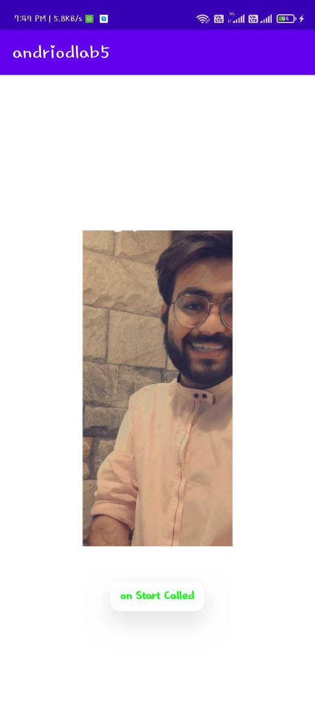

2021-08-13 19:40:12.782 8181-8181/com.example.all_activity_log I/System.out: Arjun

2021-08-13 19:40:12.782 8181-8181/com.example.all_activity_log I/Arjun: on Create Called

2021-08-13 19:40:12.807 8181-8181/com.example.all_activity_log I/Arjun: on Start Called

2021-08-13 19:40:13.444 8181-8181/com.example.all_activity_log I/Arjun: On Resume Called

2021-08-13 19:41:10.424 8181-8181/com.example.all_activity_log I/Arjun: On Pause Called

2021-08-13 19:41:11.490 8181-8181/com.example.all_activity_log I/Arjun: On Stop Called

2021-08-13 19:41:22.878 8181-8181/com.example.all_activity_log I/Arjun: on Restart Called

2021-08-13 19:41:22.981 8181-8181/com.example.all_activity_log I/Arjun: on Start Called

2021-08-13 19:41:23.035 8181-8181/com.example.all_activity_log I/Arjun: On Resume Called

2021-08-13 19:41:31.671 8181-8181/com.example.all_activity_log I/Arjun: On Pause Called

2021-08-13 19:41:32.205 8181-8181/com.example.all_activity_log I/Arjun: On Stop Called

2021-08-13 19:41:34.974 8181-8181/com.example.all_activity_log I/Arjun: On Destroy Called

2021-08-13 19:41:34.980 8181-8181/com.example.all_activity_log I/System.out: Arjun