**PRACTICAL: 1**

**AIM: Write a PROLOG program that list four address in a label form; each address should list a name, one-line address, city, state &ZIP code.**

**CODE:**

**Domains**

Name,Society,City,State,ZipCode = string

**Predicates**

getaddress(Name,Society,City,State,ZipCode)

**Clauses**

soc(bhumit,gayatrinagar).

soc(john,patelpark).

soc(peter,goghacircle).

city(bhumit,bhavnagar).

city(john,bhavnagar).

city(peter,surat).

state(bhumit,gujrat).

state(john,gujrat).

state(peter,gujrat).

zip(bhumit,364001).

zip(john,364001).

zip(peter,362002).

getaddress(Name,Soci,Mycity,Sta,Code):-

soc(Name,Soci),

city(Name,Mycity),

state(Name,Sta),

zip(Name,Code).

**OUTPUT**:

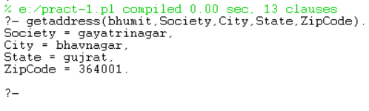

**PRACTICAL: 2**

**AIM: WAP to Create Database for Hobbies of Different Person.**

**CODE:**

**Domains**

person = symbol

hobby = symbol

**Predicates**

likes (person,hobby)

**Clauses**

likes(bhumit,cricket).

likes(shyam,volleyball).

likes(ram,basketball).

**OUTPUT:**

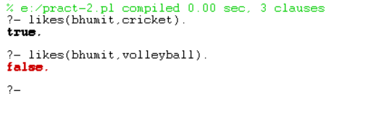

**PRACTICAL: 3**

**AIM: Write a Turbo PROLOG program for diagnosis the childhood diseases.**

**CODE:**

**Domains**

disease,indication,name = symbol

**Predicates**

hypothesis(name,disease)

symptom(name,indication)

**Clauses**

symptom(charlie,fever).

symptom(charlie,headache).

symptom(charlie,runnynose).

symptom(charlie,rash).

hypothesis(patient,measles):-

symptom(Patient,fever),

symptom(Patient,cough),

symptom(Patient,conjunctive),

symptom(Patient,runnynose),

symptom(Patient,rash).

hypothesis(Patient,germanmeasles):-

symptom(Patient,fever),

symptom(Patient,headache),

symptom(Patient,runnynose),

symptom(Patient,rash).

hypothesis(Patient,flu):-

symptom(Patient,fever),

symptom(Patient,headache),

symptom(Patient,bodyache),

symptom(Patient,chills),

symptom(Patient,sorethrought),

symptom(Patient,cough),

symptom(Patient,conjunctive),

symptom(Patient,conjunctive),

symptom(Patient,runnynose).

hypothesis(Patient,commoncold):-

symptom(Patient,headache),

symptom(Patient,runnynose),

symptom(Patient,snuzing),

symptom(Patient,chills),

symptom(Patient,sorethrought).

hypothesis(Patient,mumps):-

symptom(Patient,fever),

symptom(Patient,swallenglands).

hypothesis(Patient,chikenpox):-

symptom(Patient,fever),

symptom(Patient,rash),

symptom(Patient,bodyache).

hypothesis(Patient,whooping-cough):-

symptom(Patient,runnynose),

symptom(Patient,snuzing),

symptom(Patient,cough).

**OUTPUT**:

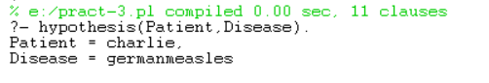

**PRACTICAL: 4**

**AIM: Write a Turbo PROLOG program for Family Relationship.**

**CODE:**

**Domains**

Person = symbol

**Predicates**

male(person)

female(person)

parent(person,person)

father(person,person)

mother(person,person)

sister(person,person)

brother(person,person)

son(person,person)

daughter(person,person)

aunt(person,person)

uncle(person,person)

child(person,person)

wife_of(person,person)

husband_of(person,person)

grand_father(person,person)

grand_mother(person,person)

cousin(person,person)

nephew(person,person)

**Clauses**

father("Motilal","Jawaharlal").

father("Motilal","Vijayalakshmi").

father("Motilal","Krishna").

father("Jawaharlal","Indira").

father("Ranjit","Tara").

father("Ranjit","Lekha").

father("Ranjit","Rita").

father("Feroz","Sanjay").

father("Feroz","Rajiv").

father("Sanjay","Varun").

father("Rajiv","Rahul").

father("Rajiv","Priyanka").

wife_of("Swaruprani","Motilal").

wife_of("Kamla","Jawaharlal").

wife_of("Vijayalakshmi","Ranjit").

wife_of("Indira","Feroz").

wife_of("Maneka","Sanjay").

wife_of("Sonia","Rajiv").

female("Krishna").

female("Priyanka").

female("Lekha").

female("Tara").

female("Rita").

female(X) :-

wife_of(X,_).

male("Varun").

male("Rahul").

male(X) :-

husband_of(X,_).

husband_of(X,Y) :-

wife_of(Y,X).

mother(X,Y):-

wife_of(X,Z),

father(Z,Y).

parent(X,Y):-

father(X,Y);

mother(X,Y).

child(X,Y):-

parent(Y,X).

son(X,Y):-

child(X,Y),

male(X).

daughter(X,Y):-

child(X,Y),

female(X).

brother(X,Y):-

father(Z,X),

father(Z,Y),

male(X),

not(X=Y).

sister(X,Y):-

father(Z,X),

father(Z,Y),

female(X),

not(X=Y).

uncle(X,Y):-

parent(Z,Y),

brother(X,Z);

parent(Z,Y),

sister(S,Z),

husband_of(X,S).

aunt(X,Y):-

sister(X,Z),

parent(Z,Y).

aunt(X,Y):-

wife_of(X,Z),

uncle(Z,Y).

ancestor(X,Y):-

parent(X,Y).

ancestor(X,Y):-

parent(Z,Y),

ancestor(X,Z).

grand_father(X,Y):-

parent(X,Z),

parent(Z,Y),

male(X).

grand_mother(X,Y):-

parent(X,Z),

parent(Z,Y),

female(X).

cousin(X,Y):-

parent(Z,X),

parent(W,Y),

brother(Z,W);

parent(Z,X);

parent(W,Y),

sister(Z,W).

nephew(X,Y):-

male(X),

uncle(Y,X);

male(X),

aunt(Y,X).

niece(X,Y):-

female(X),

uncle(Y,X);

female(X).

**OUTPUT:**

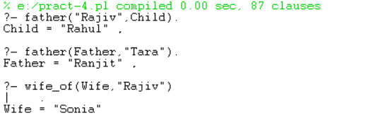

**PRACTICAL: 5**

**AIM: Write a prolog program to give an opportunity to user to re-enter the password three (03) times, on entering wrong password.**

**CODE:**

**Domains**

name, password = symbol

**Predicates**

getinput,

logon,

user(name,password)

**Clauses**

logon :- getinput,

write('You are logged on.'),nl.

logon :- repeat,

write('Sorry, you are not permitted.'),nl,

write('Try again.'),nl,

getinput,

write('You are now logged on.').

getinput :- write('please enter your name : '),

read(Name),nl,

write('please enter password : '),

read(Password),nl,

user(Name, Password).

user(bhumit,123).

**OUTPUT:**

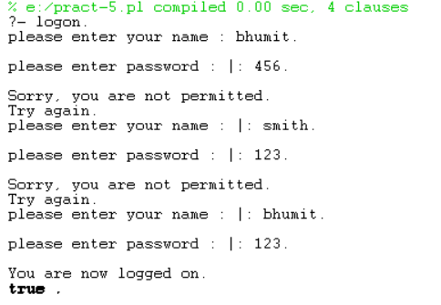

**PRACTICAL: 6**

**AIM: Write a Turbo PROLOG program to implement Tower of Hanoi problem.**

**CODE:**

**Domains**

POLE = symbol

**Predicates**

move(INTEGER, POLE, POLE, POLE)

**Clauses**

move(1,X,Y,_):-write('Move disk from '),write(X),write(' to '),write(Y),nl.

move(N,X,Y,Z):-N>1,M is N-1,

move(M,X,Z,Y),

move(1,X,Y,_),

move(M,Z,Y,X).

**OUTPUT:**

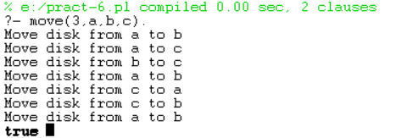

**PRACTICAL: 7**

**AIM: Write a Turbo PROLOG program to solve Water-Jug Problem.**

**CODE:**

**Domains**

**Predicates**

jug(INTRGER, INTRGER)

**Clauses**

jug(2, _).

jug(0,2):-

write('(0,2)'),nl,

write('(2,0)'),nl.

jug(4,0) :-

write('(4,0)'),nl,

jug(0,0).

jug(4,3) :-

write('(4,3)'),nl,

jug(0,0).

jug(3,0) :-

write('(3,0)'),nl,

jug(3,3).

jug(X,0) :-

write('('),write(X),write(',0'),nl,

jug(0,3).

jug(0,3) :-

write('(0,3)'),nl,

jug(3,0).

jug(0,X) :-

write('(0,'),write(X),write(')'),nl,

jug(0,0).

jug(3,3) :-

write('(3,3)'),nl,

jug(4,2).

jug(4,2) :-

write('(4,2)'),nl, write('2,0'), nl,

jug(2,0).

jug(X, Y) :-

X>4,fail,Y>3,fail.

**OUTPUT:**

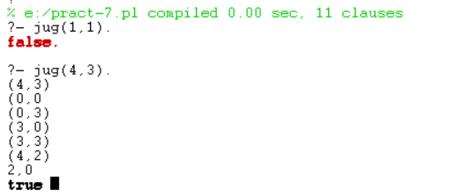

**PRACTICAL: 8**

**AIM: Implement Depth First Search and Breadth algorithm in choice of your language.**

1. **BFS:**

**CODE:**

**Domains**

**Predicates**

**Clauses**

s(a, b).

s(a, c).

s(b, g).

s(b, f).

s(c, r).

s(c, e).

goal(f).

solve( Start, Solution) :-

breadthfirst( [ [Start] ], Solution).

breadthfirst( [ [Node | Path] |_], [Node | Path] ) :-

goal( Node).

breadthfirst( [ [N | Path] | Paths], Solution) :-

bagof([M,N|Path],

( s( N, M), \+ member( M, [N | Path] ) ), NewPaths),

%conc( Paths, NewPaths, Pathsl), !,

append(Paths, NewPaths, Pathsl), !,

breadthfirst( Pathsl, Solution);

breadthfirst( Paths, Solution).

**OUTPUT:**



1. **DFS:**

**CODE:**

**Domains**

**Predicates**

**Clauses**

connected(1,7,1).

connected(1,8,1).

connected(1,3,1).

connected(7,4,1).

connected(7,20,1).

connected(7,17,1).

connected(8,6,1).

connected(3,9,1).

connected(3,12,1).

connected(9,19,1).

connected(4,42,1).

connected(20,28,1).

connected(17,10,1).

connected2(X,Y,D) :- connected(X,Y,D).

connected2(X,Y,D) :- connected(Y,X,D).

next_node(Current, Next, Path) :-

connected2(Current, Next, _),

not(member(Next, Path)).

depth_first(Goal, Goal, _, [Goal]).

depth_first(Start, Goal, Visited, [Start|Path]) :-

next_node(Start, Next_node, Visited),

write(Visited), nl,

depth_first(Next_node, Goal, [Next_node|Visited], Path).

**OUTPUT:**

