**PRACTICAL – 1**

**AIM: Write a program to simulate Fixed Time Division Multiplexing. Take 12 stations. Every station has time slice of 417 microseconds. Delay should be 10ms. Every time the station Gets turn, it shows message.**

**CODE:**

#include <stdio.h>

#include <conio.h>

void main()

{

int a[4],time=120;

int u1,u2,u3,u4,i;

clrscr();

printf("Enter Time of Each User : ");

for(i=0;i<4;i++)

{

printf("\na[%d] : ",i+1); scanf("%d",&a[i]);

}

u1=a[0]/10;

u2=a[1]/10;

u3=a[2]/10;

u4=a[3]/10;

while(time!=0)

{

if(u1>0)

{

printf("\nUser[1] Using Channel.");

time=time-10;

u1=u1-1;

}

if(u2>0)

{

printf("\nUser[2] Using Channel.");

time=time-10;

u2=u2-1;

}

if(u3>0)

{

printf("\nUser[3] Using Channel.");

time=time-10;

u3=u3-1;

}

if(u4>0)

{

printf("\nUser[4] Using Channel.");

time=time-10;

u4=u4-1;

}

getch();

}

**OUTPUT**:

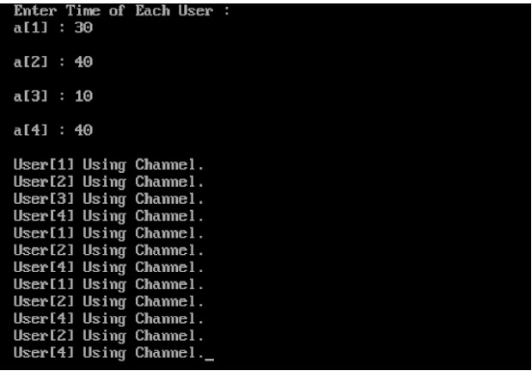

**PRACTICAL-2**

**AIM: Write a program that identifies the Bluetooth devices in the wireless range.**

* **Main Activity file**

**import android.app.Activity;**

**import android.bluetooth.BluetoothAdapter;**

**import android.bluetooth.BluetoothDevice;**

**import android.content.Intent;**

**import android.os.Bundle;**

**import android.view.View;**

**import android.widget.ArrayAdapter;**

**import android.widget.Button;**

**import android.widget.ListView;**

**import android.widget.Toast;**

**import java.util.ArrayList;**

**import java.util.Set;**

**public class MainActivity extends Activity {**

**Button b1,b2,b3,b4;**

**private BluetoothAdapter BA;**

**private Set<BluetoothDevice>pairedDevices;**

**ListView lv;**

**@Override**

**protected void onCreate(Bundle savedInstanceState) {**

**super.onCreate(savedInstanceState);**

**setContentView(R.layout.activity_main);**

**b1 = (Button) findViewById(R.id.button);**

**b2=(Button)findViewById(R.id.button2);**

**b3=(Button)findViewById(R.id.button3);**

**b4=(Button)findViewById(R.id.button4);**

**BA = BluetoothAdapter.getDefaultAdapter();**

**lv = (ListView)findViewById(R.id.listView);**

**}**

**public void on(View v){**

**if (!BA.isEnabled()) {**

**Intent turnOn = new Intent(BluetoothAdapter.ACTION_REQUEST_ENABLE);**

**startActivityForResult(turnOn, 0);**

**Toast.makeText(getApplicationContext(), "Turned on",Toast.LENGTH_LONG).show();**

**}**

**else {**

**Toast.makeText(getApplicationContext(), "Already on", Toast.LENGTH_LONG).show();**

**}**

**}**

**public void off(View v){**

**BA.disable();**

**Toast.makeText(getApplicationContext(), "Turned off" ,Toast.LENGTH_LONG).show();**

**}**

**public void visible(View v){**

**Intent getVisible = new Intent(BluetoothAdapter.ACTION_REQUEST_DISCOVERABLE);**

**startActivityForResult(getVisible, 0);**

**}**

**public void list(View v){**

**pairedDevices = BA.getBondedDevices();**

**ArrayList list = new ArrayList();**

**for(BluetoothDevice bt : pairedDevices) list.add(bt.getName());**

**Toast.makeText(getApplicationContext(), "Showing Paired Devices",Toast.LENGTH_SHORT).show();**

**final ArrayAdapter adapter = new ArrayAdapter(this,android.R.layout.simple_list_item_1, list);**

**lv.setAdapter(adapter);**

**}**

**}**

* **Layout file**

**<?xml version="1.0" encoding="utf-8"?>**

**<RelativeLayout**

**xmlns:android="http://schemas.android.com/apk/res/android"**

**xmlns:tools="http://schemas.android.com/tools"**

**android:layout_width="match_parent"**

**android:layout_height="match_parent"**

**android:paddingLeft="@dimen/activity_horizontal_margin"**

**android:paddingRight="@dimen/activity_horizontal_margin"**

**android:paddingTop="@dimen/activity_vertical_margin"**

**android:paddingBottom="@dimen/activity_vertical_margin"**

**tools:context=".MainActivity"**

**android:transitionGroup="true">**

**<TextView android:text="Bluetooth Example"**

**android:layout_width="wrap_content"**

**android:layout_height="wrap_content"**

**android:id="@+id/textview"**

**android:textSize="35dp"**

**android:layout_alignParentTop="true"**

**android:layout_centerHorizontal="true" />**

**<TextView**

**android:layout_width="wrap_content"**

**android:layout_height="wrap_content"**

**android:text="Daft Creation"**

**android:id="@+id/textView"**

**android:layout_below="@+id/textview"**

**android:layout_centerHorizontal="true"**

**android:textColor="#ff7aff24"**

**android:textSize="35dp" />**

**<ImageView**

**android:layout_width="wrap_content"**

**android:layout_height="wrap_content"**

**android:id="@+id/imageView"**

**android:src="@drawable/abc"**

**android:layout_below="@+id/textView"**

**android:layout_centerHorizontal="true"**

**android:theme="@style/Base.TextAppearance.AppCompat" />**

**<Button**

**android:layout_width="wrap_content"**

**android:layout_height="wrap_content"**

**android:text="Turn On"**

**android:id="@+id/button"**

**android:layout_below="@+id/imageView"**

**android:layout_toStartOf="@+id/imageView"**

**android:layout_toLeftOf="@+id/imageView"**

**android:clickable="true"**

**android:onClick="on" />**

**<Button**

**android:layout_width="wrap_content"**

**android:layout_height="wrap_content"**

**android:text="Get visible"**

**android:onClick="visible"**

**android:id="@+id/button2"**

**android:layout_alignBottom="@+id/button"**

**android:layout_centerHorizontal="true" />**

**<Button**

**android:layout_width="wrap_content"**

**android:layout_height="wrap_content"**

**android:text="List devices"**

**android:onClick="list"**

**android:id="@+id/button3"**

**android:layout_below="@+id/imageView"**

**android:layout_toRightOf="@+id/imageView"**

**android:layout_toEndOf="@+id/imageView" />**

**<Button**

**android:layout_width="wrap_content"**

**android:layout_height="wrap_content"**

**android:text="turn off"**

**android:onClick="off"**

**android:id="@+id/button4"**

**android:layout_below="@+id/button"**

**android:layout_alignParentLeft="true"**

**android:layout_alignParentStart="true" />**

**<ListView**

**android:layout_width="wrap_content"**

**android:layout_height="wrap_content"**

**android:id="@+id/listView"**

**android:layout_alignParentBottom="true"**

**android:layout_alignLeft="@+id/button"**

**android:layout_alignStart="@+id/button"**

**android:layout_below="@+id/textView2" />**

**<TextView**

**android:layout_width="wrap_content"**

**android:layout_height="wrap_content"**

**android:text="Paired devices:"**

**android:id="@+id/textView2"**

**android:textColor="#ff34ff06"**

**android:textSize="25dp"**

**android:layout_below="@+id/button4"**

**android:layout_alignLeft="@+id/listView"**

**android:layout_alignStart="@+id/listView" />**

**</RelativeLayout>**

* **Permission File**

**<?xml version="1.0" encoding="utf-8"?>**

**<manifest xmlns:android="http://schemas.android.com/apk/res/android"**

**package="com.example.codewithjava">**

**<uses-permission android:name="android.permission.BLUETOOTH" />**

**<uses-permission android:name="android.permission.BLUETOOTH_ADMIN" />**

**<application**

**android:allowBackup="true"**

**android:icon="@mipmap/ic_launcher"**

**android:label="@string/app_name"**

**android:roundIcon="@mipmap/ic_launcher_round"**

**android:supportsRtl="true"**

**android:theme="@style/AppTheme">**

**<activity android:name=".MainActivity">**

**<intent-filter>**

**<action android:name="android.intent.action.MAIN" />**

**<category android:name="android.intent.category.LAUNCHER" />**

**</intent-filter>**

**</activity>**

**<service android:name=".MyService" />**

**</application>**

**</manifest>**

**OUTPUT :**

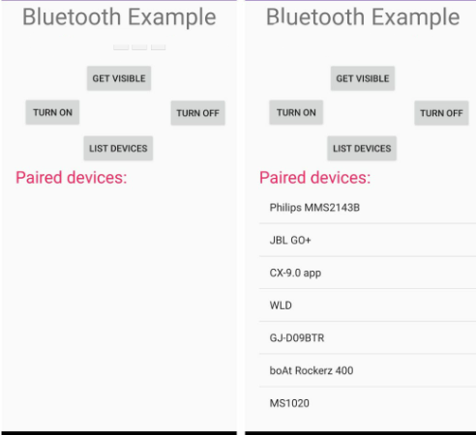

**PRACTICAL-3**

**AIM: Write a program that prints the signal strength of Wi-Fi connection of the given Computer.**

* **Displaying the Wlan/Wi-Fi drivers**

**Command: > netsh wlan show drivers**

**Output :**

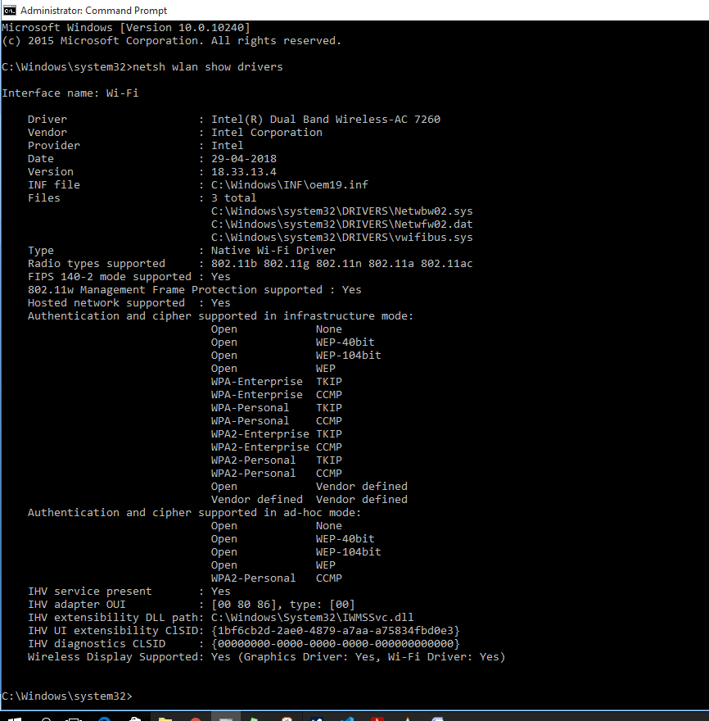

* **Displaying the Wlan/Wi-Fi Interfaces**

**Command: >netsh wlan show interfaces**

**Output:**

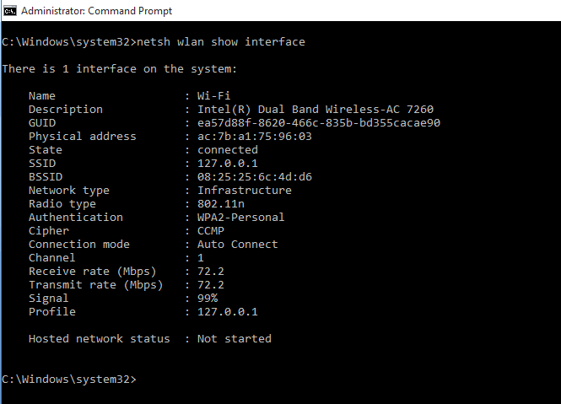

* **Displaying all Wi-Fi Profiles**

**Command: > netsh wlan show profiles**

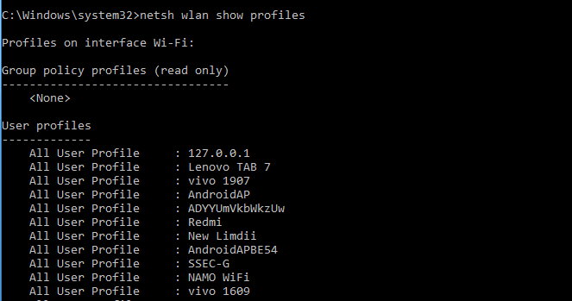**Output:**

* **Storing all profiles passwords and Key in to folder**

Command**: >** netsh wlan export profile key=clear folder=”folder_Path”

Output:

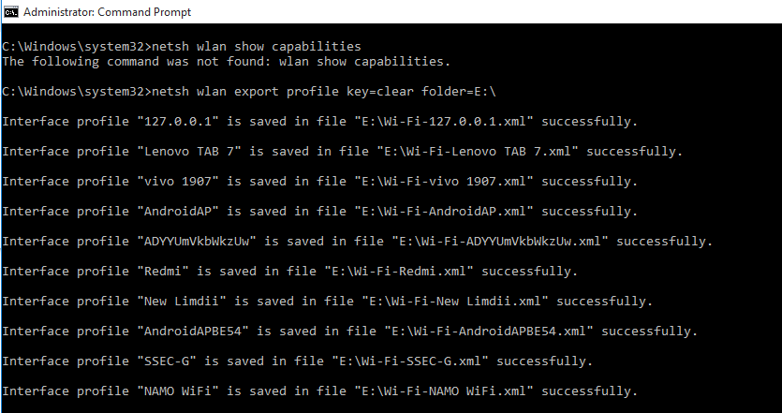

**PRACTICAL-4**

**AIM: Prepare a wireless ad hoc network and show its working.**

**Step 1:- Create an ad hoc Network**

* Open the Start Menu and type wireless into the Search box and select Manage wireless networks

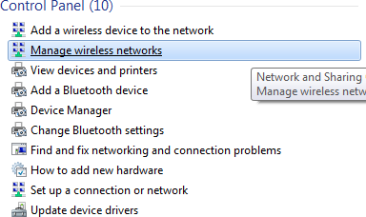

* 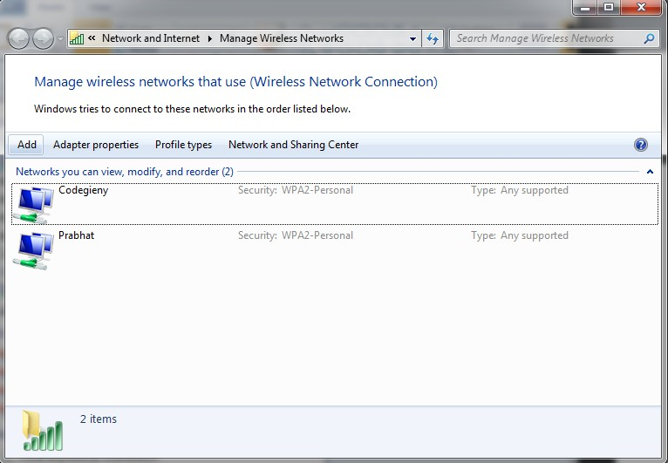Click the Add button to add a wireless network.
* Next click on Create an ad hoc network

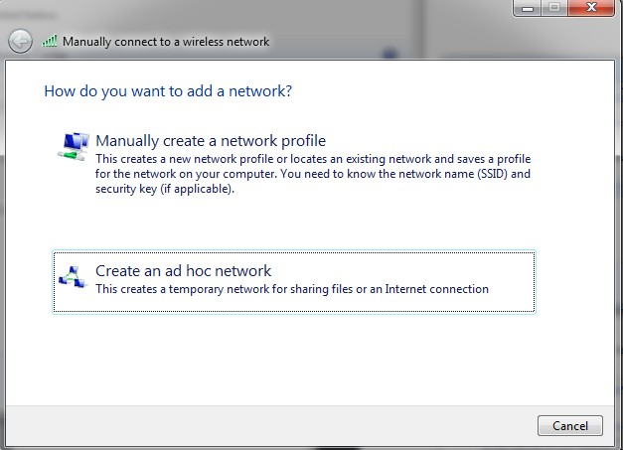

* You’ll get a message instructing you of what an adhoc-network is

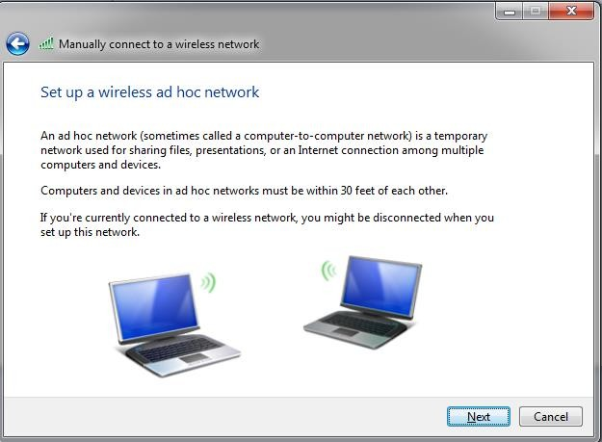

* Now give your network a name and choose security options…check Save this network if you plan to use it repeatedly so you don’t have to set one up each time. The security type will depend on what the wireless adapter is capable of. We found if you’re only using it quickly with different types of devices it’s easier to have no security. Of course if you are keeping it on for full-time use, you’ll definitely want to use security.

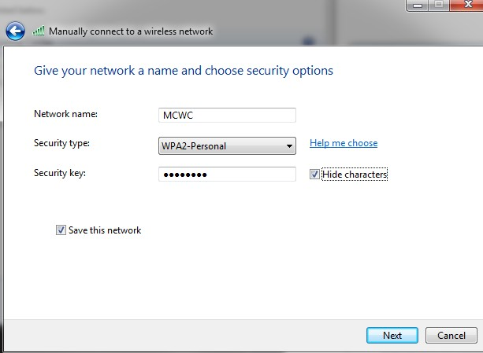

* 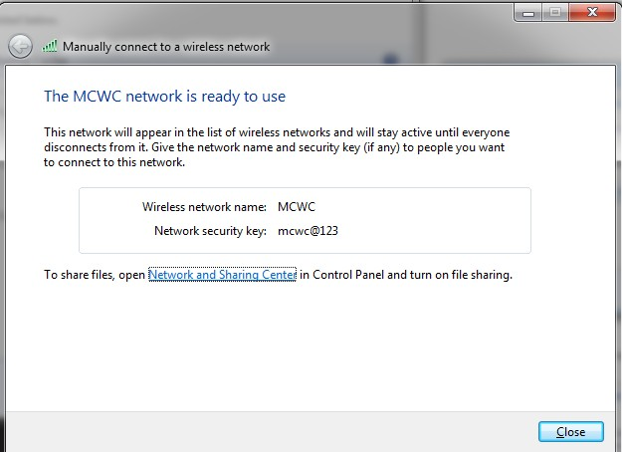The network was successfully created and is ready to use.
* Verify the network by clicking the wireless icon on the Taskbar…here you can see ours is waiting for users to connect.

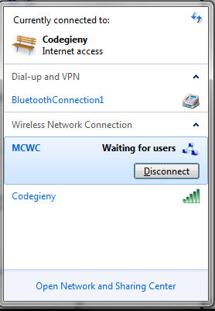

* On the Client computer, click on the wireless icon to see available networks and connect to the ad hoc network.
* 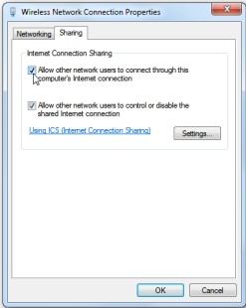At this point you’ll be able to share files between machines. To share an Internet connection with other devices, right-click on the Host’s wireless adapter icon. Go to Properties, click the Sharing tab, and select Allow other network users to connect through this computer’s Internet connection.
* In Settings you can select the network services the Client machine can access.

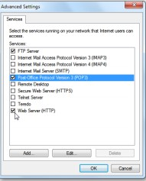

* Now you can share documents and the Internet connection between machines and devices. In this example we’re sharing between a Windows 7 desktop with a wireless card and a Netbook with Windows 7 Home Premium.

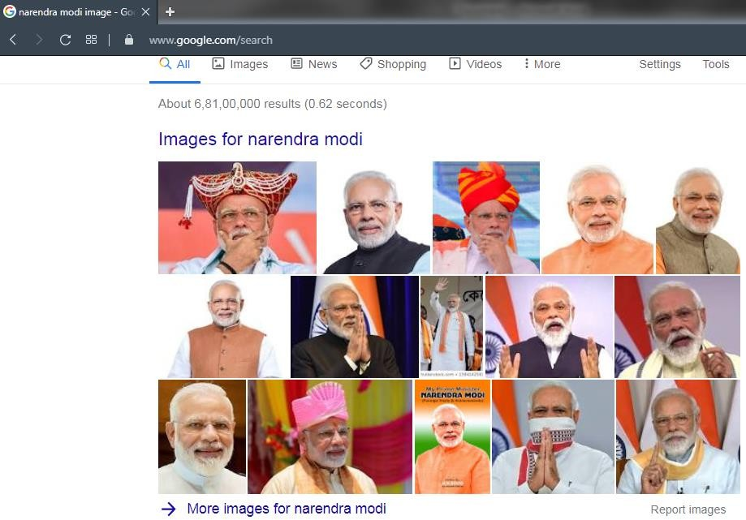

**PRACTICAL:5**

**AIM: Write a program to find a hamming distance of two strings.**

**CODE:**

#include<stdio.h>

#include<conio.h>

#include<string.h>

void main()

{

int i,len1,len2,count=0;

char one[200],two[200];

clrscr();

while(1){

printf("Enter 1st string:\n"); scanf("%s",&one);

printf("Enter 2nd string:\n"); scanf("%s",&two);

len1=strlen(one);

len2=strlen(two);

if(len1!=len2)

{

printf("\nLength of both strings must be same, enter again!\n");

}

else

{

for(i=0;i<len1;i++)

{

if(one[i]!=two[i])

{

count++;

}

}

break;

}

}

printf("\nHamming distance:\t%d",count);

getch();

}

**OUTPUT**:

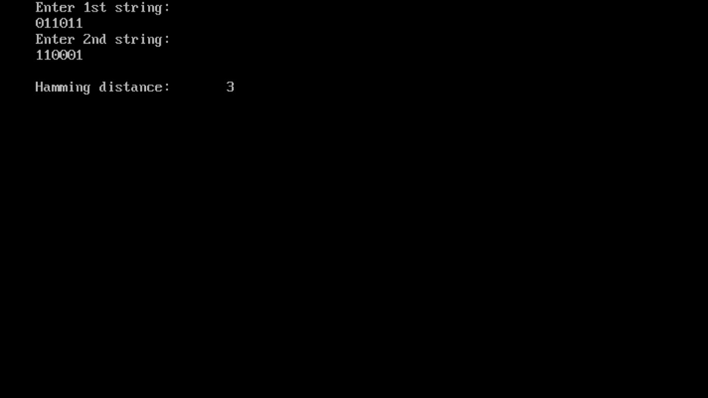

**PRACTICAL: 6**

**AIM: Write a program to perform infrared communication.**

**INTRODUCTION**:

* For data exchange, most of the new mobile phones and Pocket PCs possess an infrared (IRDA) port. So, why not use this infrared connection to communicate between these two devices?
* This simple Pocket PC 2002 application shows how to communicate with your mobile phone, it will read the manufacturer, the model identification and the Phone Book of your mobile phone to your Pocket PC.
* I have tried this Pocket PC application (running on my HP jornada 565) only with a Nokia 5210, my new Siemens S55 and a very old Siemens S25 mobile phone. So, I hope the application will also work with other mobile phones.

## How I can Speak with Mobile Phone?

* To speak with your mobile phone, you have to use some special commands, called AT commands. You have to send these commands via the IRDA port of your Pocket PC to the mobile phone and the mobile phone will respond to you. If the mobile phone supports the received AT command, it will send you a valid response, otherwise it will send you an error response.
* This command is to request the manufacturer identification of the mobile phone. For example, a Nokia 5210 will send you the following response:

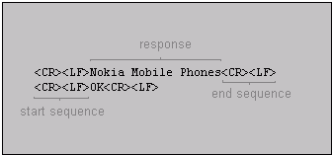

* If the mobile phone doesn't support the received AT command, it will send you an error response:

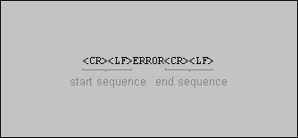

<CR> ... Carriage return

<LF> ... Line feed

* The application is a simple dialog based MFC application including some simple API calls.
* 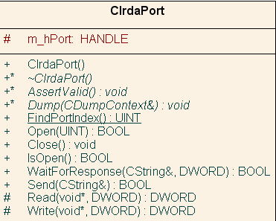For the infrared communication, I have written a simple class called CIrdaPort. The class supports some functions to open and close the IRDA port and some functions for the read and write operations.
* To open the IRDA port use the following function:
* BOOL CIrdaPort::Open(UINT uiPort);
* This function will open the IRDA port, the uiPort parameter defines the index of the IRDA port (1 for COM1, 2 for COM2, 3 for COM3). The return value TRUE indicates success, the value FALSE failure.
* You can use the following function to take a look in the registry for the index of the IRDA port:
* UINT CIrdaPort::FindPortIndex();
* If the function finds some index of the IRDA port in the registry this index will be returned, otherwise the return value is 0.
* If you want to write some characters to the IRDA port, you can use the following function:
* BOOL CIrdaPort::Send(const CString& strSend) const;
* This function will send the string strSend to the mobile phone. The return value FALSE indicates failure, the value TRUE success.
* To wait for a response, you can use the following function:
* BOOL CIrdaPort::WaitForResponse(CString& strResponse, DWORD dwTimeout) const;
* This function waits for a response strResponse of the mobile phone or returns with FALSE if the timeout dwTimeout occurred.
* If you are finished with all read and write operations, you have to close the port with the following function:
* void CIrdaPort::Close();
* This function will close the IRDA port.
* When you click on the "Read ..." button of the dialog, the application tries to connect to the mobile phone and read some information about the phone, like the manufacturer and the model identification (for example: Nokia Mobile Phones, Nokia 5210 or SIEMENS, S55). After that it tries to read all Phone Book entries of your mobile phone and display it in a list box on the dialog.
* **Don't forget to activate the infrared port of your mobile phone!**
* Before you can test the communication between your Pocket PC and your mobile phone, you have to activate the infrared (IRDA) port of your mobile phone. Most of the mobile phones have their own menu item to activate the infrared port. For example, for a Nokia mobile phone you have to choose Menu -> Infrared. After activating the infrared port, you will see the following symbol IR symbol at the top left corner on the display of your Nokia mobile phone and you will know that the infrared port is enabled.
* Some mobile phones, like the Nokia phones, disable the infrared port after some minutes if there is no data exchange on the infrared connection. So, before you start a communication take a look on your mobile phone and reactivate the infrared port if necessary. Look also that there is a straight connection between the infrared sensor of your Pocket PC and your mobile phone and that there is nothing between the two devices which can block the communication.
* **Bluetooth connection between Pocket PC and mobile phone**:
* Change the name of the communications port from COMx: to BTC1: and comment out the following line:
* VERIFY(SetupComm(m_hPort, 2048, 2048));
* It's also possible to increase the port speed up to 115200.
* The registry key that he found that holds the port's name is HKEY_LOCAL_MACHINE\ExtModems\BtDialupModem.

**PRACTICAL-7**

**AIM: Write a program for file sharing using Bluetooth.**

* + **MainActivity.java**

**package com.example.hp.bluetooth_file_transfer;**

**import android.support.v7.app.AppCompatActivity;**

**import android.os.Bundle;**

**import java.io.File;**

**import java.util.List;**

**import android.Manifest;**

**import android.app.Activity;**

**import android.bluetooth.BluetoothAdapter;**

**import android.content.ContentUris;**

**import android.content.Context;**

**import android.content.Intent;**

**import android.content.pm.PackageManager;**

**import android.content.pm.ResolveInfo;**

**import android.database.Cursor;**

**import android.net.Uri;**

**import android.os.Build;**

**import android.os.Bundle;**

**import android.os.Environment;**

**import android.provider.DocumentsContract;**

**import android.provider.MediaStore;**

**import android.support.v4.content.ContextCompat;**

**//import android.support.v7.app.ActionBarActivity;**

**import android.support.v7.app.AppCompatActivity;**

**import android.util.Log;**

**import android.view.View;**

**import android.widget.Button;**

**import android.widget.TextView;**

**import android.widget.Toast;**

**import com.example.hp.bluetooth_file_transfer.R;**

**public class MainActivity extends AppCompatActivity {**

**private static final int DISCOVER_DURATION = 300;**

**private static final int REQUEST_BLU = 1;**

**String path;**

**private static final String[] INITIAL_PERMS = {Manifest.permission.WRITE_EXTERNAL_STORAGE,**

**Manifest.permission.READ_EXTERNAL_STORAGE,**

**Manifest.permission.READ_CONTACTS,**

**Manifest.permission.WRITE_CONTACTS,**

**Manifest.permission.CAMERA,**

**Manifest.permission.ACCESS_FINE_LOCATION};**

**private static final int INITIAL_REQUEST = 1337;**

**private static final int REQUEST_WRITE_STORAGE = INITIAL_REQUEST + 4;**

**TextView textView_FileName;**

**@Override**

**protected void onCreate(Bundle savedInstanceState) {**

**super.onCreate(savedInstanceState);**

**setContentView(R.layout.activity_main);**

**textView_FileName = (TextView) findViewById(R.id.textView_FileName);**

**if (!canAccessLocation() || !canAccessCamera() || !canAccessWriteStorage() || !canAccessReadStorage() || !canAccessReadContacts() || !canAccessWriteContacts()) {**

**if (Build.VERSION.SDK_INT >= Build.VERSION_CODES.M) {**

**requestPermissions(INITIAL_PERMS, INITIAL_REQUEST);**

**}**

**}**

**}**

**@Override**

**public void onRequestPermissionsResult(int requestCode, String[] permissions, int[] grantResults) {**

**switch (requestCode) {**

**case REQUEST_WRITE_STORAGE:**

**if (canAccessWriteStorage()) {**

**//reload my activity with permission granted or use the features what required the permission**

**System.out.println("permission grantedddd");**

**} else {**

**Toast.makeText(this, "The app was not allowed to write to your storage. Hence, it cannot function properly. Please consider granting it this permission", Toast.LENGTH_LONG).show();**

**}**

**break;**

**}**

**}**

**public void sendViaBluetooth(View v) {**

**if (path == null) {**

**Toast.makeText(this, "Please select file first", Toast.LENGTH_SHORT).show();**

**return;**

**}**

**BluetoothAdapter btAdapter = BluetoothAdapter.getDefaultAdapter();**

**if (btAdapter == null) {**

**Toast.makeText(this, "Bluetooth is not supported on this device", Toast.LENGTH_LONG).show();**

**} else {**

**enableBluetooth();**

**}**

**}**

**public void getFile(View v) {**

**Intent mediaIntent = new Intent(Intent.ACTION_GET_CONTENT);**

**mediaIntent.setType("*/*"); //set mime type as per requirement**

**startActivityForResult(mediaIntent, 1001);**

**}**

**public void enableBluetooth() {**

**Intent discoveryIntent = new Intent(BluetoothAdapter.ACTION_REQUEST_DISCOVERABLE);**

**discoveryIntent.putExtra(BluetoothAdapter.EXTRA_DISCOVERABLE_DURATION, DISCOVER_DURATION);**

**startActivityForResult(discoveryIntent, REQUEST_BLU);**

**}**

**private boolean canAccessWriteStorage() {**

**return (hasPermission(Manifest.permission.WRITE_EXTERNAL_STORAGE));**

**}**

**private boolean canAccessReadStorage() {**

**return (hasPermission(Manifest.permission.READ_EXTERNAL_STORAGE));**

**}**

**private boolean canAccessReadContacts() {**

**return (hasPermission(Manifest.permission.READ_CONTACTS));**

**}**

**private boolean canAccessWriteContacts() {**

**return (hasPermission(Manifest.permission.WRITE_CONTACTS));**

**}**

**private boolean canAccessCamera() {**

**return (hasPermission(Manifest.permission.CAMERA));**

**}**

**private boolean canAccessLocation() {**

**return (hasPermission(Manifest.permission.ACCESS_FINE_LOCATION));**

**}**

**private boolean hasPermission(String perm) {**

**return (PackageManager.PERMISSION_GRANTED == ContextCompat.checkSelfPermission(this, perm));**

**}**

**public static String getPath(final Context context, final Uri uri) {**

**final boolean isKitKatOrAbove = Build.VERSION.SDK_INT >= Build.VERSION_CODES.KITKAT;**

**// DocumentProvider**

**if (isKitKatOrAbove && DocumentsContract.isDocumentUri(context, uri)) {**

**// ExternalStorageProvider**

**if (isExternalStorageDocument(uri)) {**

**final String docId = DocumentsContract.getDocumentId(uri);**

**final String[] split = docId.split(":");**

**final String type = split[0];**

**if ("primary".equalsIgnoreCase(type)) {**

**return Environment.getExternalStorageDirectory() + "/" + split[1];**

**}**

**// TODO handle non-primary volumes**

**}**

**// DownloadsProvider**

**else if (isDownloadsDocument(uri)) {**

**final String id = DocumentsContract.getDocumentId(uri);**

**final Uri contentUri = ContentUris.withAppendedId(**

**Uri.parse("content://downloads/public_downloads"), Long.valueOf(id));**

**return getDataColumn(context, contentUri, null, null);**

**}**

**// MediaProvider**

**else if (isMediaDocument(uri)) {**

**final String docId = DocumentsContract.getDocumentId(uri);**

**final String[] split = docId.split(":");**

**final String type = split[0];**

**Uri contentUri = null;**

**if ("image".equals(type)) {**

**contentUri = MediaStore.Images.Media.EXTERNAL_CONTENT_URI;**

**} else if ("video".equals(type)) {**

**contentUri = MediaStore.Video.Media.EXTERNAL_CONTENT_URI;**

**} else if ("audio".equals(type)) {**

**contentUri = MediaStore.Audio.Media.EXTERNAL_CONTENT_URI;**

**}**

**final String selection = "_id=?";**

**final String[] selectionArgs = new String[]{**

**split[1]**

**};**

**return getDataColumn(context, contentUri, selection, selectionArgs);**

**}**

**}**

**// MediaStore (and general)**

**else if ("content".equalsIgnoreCase(uri.getScheme())) {**

**return getDataColumn(context, uri, null, null);**

**}**

**// File**

**else if ("file".equalsIgnoreCase(uri.getScheme())) {**

**return uri.getPath();**

**}**

**return null;**

**}**

**public static String getDataColumn(Context context, Uri uri, String selection,**

**String[] selectionArgs) {**

**Cursor cursor = null;**

**final String column = "_data";**

**final String[] projection = {**

**column**

**};**

**try {**

**cursor = context.getContentResolver().query(uri, projection, selection, selectionArgs,**

**null);**

**if (cursor != null && cursor.moveToFirst()) {**

**final int column_index = cursor.getColumnIndexOrThrow(column);**

**return cursor.getString(column_index);**

**}**

**} finally {**

**if (cursor != null)**

**cursor.close();**

**}**

**return null;**

**}**

**public static boolean isExternalStorageDocument(Uri uri) {**

**return "com.android.externalstorage.documents".equals(uri.getAuthority());**

**}**

**public static boolean isDownloadsDocument(Uri uri) {**

**return "com.android.providers.downloads.documents".equals(uri.getAuthority());**

**}**

**public static boolean isMediaDocument(Uri uri) {**

**return "com.android.providers.media.documents".equals(uri.getAuthority());**

**}**

**}**

* + **Activity_main.xml**

**<?xml version="1.0" encoding="utf-8"?>**

**<android.support.constraint.ConstraintLayout xmlns:android="http://schemas.android.com/apk/res/android"**

**xmlns:app="http://schemas.android.com/apk/res-auto"**

**xmlns:tools="http://schemas.android.com/tools"**

**android:layout_width="match_parent"**

**android:layout_height="match_parent"**

**tools:context=".MainActivity">**

**<LinearLayout xmlns:android="http://schemas.android.com/apk/res/android"**

**android:id="@+id/linearLayout"**

**android:layout_width="match_parent"**

**android:layout_height="match_parent"**

**android:gravity="center_horizontal"**

**android:orientation="vertical"**

**app:layout_constraintBottom_toTopOf="parent"**

**app:layout_constraintEnd_toStartOf="parent"**

**app:layout_constraintHorizontal_bias="0.0"**

**app:layout_constraintStart_toStartOf="parent"**

**app:layout_constraintTop_toTopOf="parent"**

**app:layout_constraintVertical_bias="0.0">**

**<TextView**

**android:id="@+id/textView_FileName"**

**android:layout_width="wrap_content"**

**android:layout_height="wrap_content"**

**android:layout_marginTop="50dp"**

**android:text="@string/please_select_file"**

**android:textSize="18sp" />**

**<Button**

**android:id="@+id/button_GetFile"**

**android:layout_width="wrap_content"**

**android:layout_height="wrap_content"**

**android:onClick="getFile"**

**android:text="@string/get_file_from_device" />**

**<Button**

**android:id="@+id/button_SendFile"**

**android:layout_width="wrap_content"**

**android:layout_height="wrap_content"**

**android:onClick="sendViaBluetooth"**

**android:text="@string/send_via_bluetooth" />**

**</LinearLayout>**

**</android.support.constraint.ConstraintLayout>**

* + **AndroidManifest.xml**

**<?xml version="1.0" encoding="utf-8"?>**

**<manifest xmlns:android="http://schemas.android.com/apk/res/android"**

**package="com.example.hp.bluetooth_file_transfer">**

**<application**

**android:allowBackup="true"**

**android:icon="@mipmap/ic_launcher"**

**android:label="@string/app_name"**

**android:roundIcon="@mipmap/ic_launcher_round"**

**android:supportsRtl="true"**

**android:theme="@style/AppTheme">**

**<activity android:name=".MainActivity">**

**<intent-filter>**

**<action android:name="android.intent.action.MAIN" />**

**<category android:name="android.intent.category.LAUNCHER" />**

**</intent-filter>**

**</activity>**

**</application>**

**<uses-permission android:name="android.permission.BLUETOOTH_ADMIN" />**

**<uses-permission android:name="android.permission.BLUETOOTH" />**

**<uses-permission android:name="android.permission.WRITE_EXTERNAL_STORAGE" />**

**<uses-permission android:name="android.permission.READ_EXTERNAL_STORAGE" />**

**<uses-permission android:name="android.permission.INTERNET" />**

**</manifest>**

**OUTPUT:**

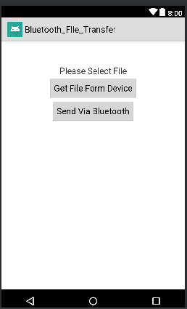

**PRACTICAL- 8**

**AIM : Develop an android app which displays “Hello, welcome to Android Lab” message.**

**CODE:**

**MainActivity.java:**

package com.example.admin.helloworld;

import android.support.v7.app.AppCompatActivity;

import android.os.Bundle;

public class MainActivity extends AppCompatActivity

{ @Override

protected void onCreate(Bundle savedInstanceState)

{ super.onCreate(savedInstanceState);

setContentView(R.layout.activity_main);

}

}

**activity_main.xml:**

<?xml version="1.0" encoding="utf-8"?>

<LinearLayout

xmlns:android="http://schemas.android.com/apk/res/android"

xmlns:app="http://schemas.android.com/apk/res-auto"

xmlns:tools="http://schemas.android.com/tools"

android:layout_width="match_parent"

android:layout_height="match_parent"

android:orientation="vertical"

android:gravity="center_vertical"

tools:context="com.example.admin.helloworld.MainActivity">

<TextView

android:layout_width="wrap_content"

android:layout_height="wrap_content"

android:text="Hello, welcome to Android Lab"

android:textSize="30sp"

android:layout_gravity="center"

app:layout_constraintBottom_toBottomOf="parent"

app:layout_constraintLeft_toLeftOf="parent"

app:layout_constraintRight_toRightOf="parent"

app:layout_constraintTop_toTopOf="parent" />

</LinearLayout>

**OUTPUT:**

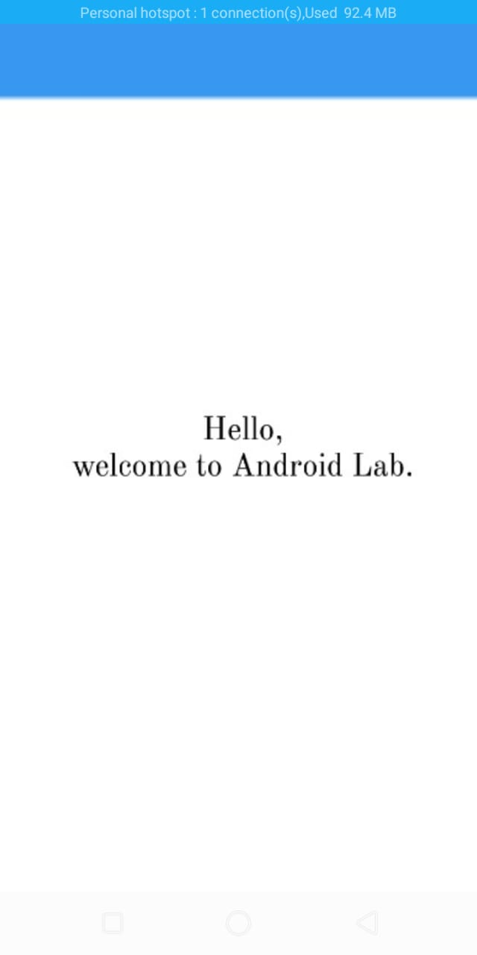

**PRACTICAL- 9**

**AIM**: **Develop an android app which displays a form to get following information from the user.**

**Username Password Email Address**

**Phone Number Country, State**

**Gender Interests Birth Date**

**Birth Time**

**Form should be followed by a Button with label “Submit”. When the user clicks the button, a message should be displayed to the user describing the information entered. Utilize suitable UI controls (i.e. widgets). [When user enters country in AutoCompleteTextView, list of**

**states should be displayed in Spinner automatically.]**

**CODE:**

**MainActivity.java:**

package com.believe.myform;

import android.content.Intent;

import android.support.v7.app.AppCompatActivity;

import android.os.Bundle;

import android.widget.TextView;

public class ViewData extends AppCompatActivity {

TextView musername;

TextView mpassword;

TextView memail;

TextView mphoneNumber;

TextView mcountry;

TextView mstate;

TextView mgender;

TextView minterests;

TextView mbirthDate;

TextView mbirthTime;

@Override

protected void onCreate(Bundle savedInstanceState) {

super.onCreate(savedInstanceState);

setContentView(R.layout.activity_view_data);

musername=(TextView)findViewById(R.id.tv_username);

mpassword=(TextView)findViewById(R.id.tv_password);

memail=(TextView)findViewById(R.id.tv_email);

mphoneNumber=(TextView)findViewById(R.id.tv_phone_number);

mcountry=(TextView)findViewById(R.id.tv_country);

mstate=(TextView)findViewById(R.id.tv_state);

mgender=(TextView)findViewById(R.id.tv_gender);

minterests=(TextView)findViewById(R.id.tv_interests);

mbirthDate=(TextView)findViewById(R.id.tv_birth_date);

mbirthTime=(TextView)findViewById(R.id.tv_birth_time);

Intent intent=getIntent();

Bundle data=intent.getExtras();

musername.setText(data.getString("username").toString());

mpassword.setText(data.getString("password").toString());

memail.setText(data.getString("email").toString());

mphoneNumber.setText(data.getString("phone").toString());

mcountry.setText(data.getString("country").toString());

mstate.setText(data.getString("state").toString());

mgender.setText(data.getString("gender").toString());

minterests.setText(data.getString("interests").toString());

mbirthDate.setText(data.getString("bdate").toString());

mbirthTime.setText(data.getString("btime").toString());

}

}

**Activity_main.xml:**

<?xml version="1.0" encoding="utf-8"?>

<ScrollView

xmlns:android="http://schemas.android.com/apk/res/android"

xmlns:app="http://schemas.android.com/apk/res-auto"

xmlns:tools="http://schemas.android.com/tools"

android:layout_width="match_parent"

android:layout_height="match_parent"

android:paddingTop="16dp"

android:paddingBottom="16dp"

android:paddingRight="8dp"

android:paddingLeft="8dp"

tools:context="com.believe.myform.MainActivity">

<LinearLayout

android:layout_width="match_parent"

android:layout_height="match_parent"

android:orientation="vertical">

<EditText

android:id="@+id/et_username" android:layout_width="match_parent"

android:layout_height="wrap_content"

android:hint="Username"

android:ems="10"

android:layout_marginBottom="8dp"

android:textSize="18dp"/>

<EditText

android:id="@+id/et_password"

android:layout_width="match_parent"

android:layout_height="wrap_content"

android:hint="Password"

android:ems="10"

android:inputType="textPassword"

android:layout_marginBottom="16dp"

android:textSize="18dp"/>

<EditText

android:id="@+id/et_email"

android:layout_width="match_parent"

android:layout_height="wrap_content"

android:hint="Email"

android:ems="10"

android:inputType="textEmailAddress"

android:layout_marginBottom="16dp"

android:textSize="18dp"/>

<EditText

android:id="@+id/et_phone_number"

android:layout_width="match_parent"

android:layout_height="wrap_content"

android:hint="Phone Number"

android:ems="10"

android:inputType="phone"

android:layout_marginBottom="16dp"

android:textSize="18dp"/>

<AutoCompleteTextView

android:id="@+id/actv_country"

android:layout_width="match_parent"

android:layout_height="wrap_content"

android:hint="Country"

android:textSize="18dp"

android:ems="10"

android:inputType="textAutoComplete"/>

<Spinner

android:id="@+id/sp_states"

android:layout_width="match_parent"

android:layout_height="wrap_content"

android:ems="10"

android:spinnerMode="dialog"

android:textSize="18dp"></Spinner>

<Spinner

android:id="@+id/sp_gender"

android:layout_width="match_parent"

android:layout_height="wrap_content"

android:ems="10"

android:spinnerMode="dialog"

android:textSize="18dp"></Spinner>

<EditText

android:id="@+id/et_interests"

android:layout_width="match_parent"

android:layout_height="wrap_content"

android:hint="Interests"

android:ems="10"

android:inputType="text"

android:layout_marginBottom="16dp"

android:textSize="18dp"/>

<TextView

android:id="@+id/tv_birth_date_label"

android:layout_width="wrap_content"

android:layout_height="wrap_content"

android:text="Select your Birth Date:"

android:layout_marginBottom="16dp"

android:textSize="18dp"/>

<Button

android:id="@+id/bt_birth_date"

android:layout_width="match_parent"

android:layout_height="wrap_content"

android:layout_marginBottom="16dp"

android:text="Select Date"

android:textSize="18dp" />

<TextView

android:id="@+id/tv_birth_time_label"

android:layout_width="wrap_content"

android:layout_height="wrap_content"

android:text="Select your Birth Time:"

android:layout_marginBottom="16dp"

android:textSize="18dp"/>

<Button

android:id="@+id/bt_birth_time"

android:layout_width="match_parent"

android:layout_height="wrap_content"

android:layout_marginBottom="16dp"

android:text="Select Date"

android:textSize="18dp" />

<Button

android:id="@+id/bt_submit"

style="@style/Widget.AppCompat.Button.Colored"

android:layout_width="wrap_content"

android:layout_height="wrap_content"

android:layout_gravity="center"

android:layout_marginBottom="16dp"

android:layout_marginTop="16dp"

android:text="Submit"

android:textSize="18dp" />

</LinearLayout>

</ScrollView>

ViewData.java

package com.believe.myform;

import android.content.Intent;

import android.support.v7.app.AppCompatActivity;

import android.os.Bundle;

import android.widget.TextView;

public class ViewData extends AppCompatActivity {

TextView musername;

TextView mpassword;

TextView memail;

TextView mphoneNumber;

TextView mcountry;

TextView mstate;

TextView mgender;

TextView minterests;

TextView mbirthDate;

TextView mbirthTime;

@Override

protected void onCreate(Bundle savedInstanceState) {

super.onCreate(savedInstanceState);

setContentView(R.layout.activity_view_data);

musername=(TextView)findViewById(R.id.tv_username);

mpassword=(TextView)findViewById(R.id.tv_password);

memail=(TextView)findViewById(R.id.tv_email);

mphoneNumber=(TextView)findViewById(R.id.tv_phone_number);

mcountry=(TextView)findViewById(R.id.tv_country);

mstate=(TextView)findViewById(R.id.tv_state);

mgender=(TextView)findViewById(R.id.tv_gender);

minterests=(TextView)findViewById(R.id.tv_interests);

mbirthDate=(TextView)findViewById(R.id.tv_birth_date);

mbirthTime=(TextView)findViewById(R.id.tv_birth_time);

Intent intent=getIntent();

Bundle data=intent.getExtras();

musername.setText(data.getString("username").toString());

mpassword.setText(data.getString("password").toString());

memail.setText(data.getString("email").toString());

mphoneNumber.setText(data.getString("phone").toString());

mcountry.setText(data.getString("country").toString());

mstate.setText(data.getString("state").toString());

mgender.setText(data.getString("gender").toString());

minterests.setText(data.getString("interests").toString());

mbirthDate.setText(data.getString("bdate").toString());

mbirthTime.setText(data.getString("btime").toString());

}

}

activity_view_data.xml

<?xml version="1.0" encoding="utf-8"?>

<ScrollView

xmlns:android="http://schemas.android.com/apk/res/android"

xmlns:app="http://schemas.android.com/apk/res-auto"

xmlns:tools="http://schemas.android.com/tools"

android:layout_width="match_parent"

android:layout_height="match_parent"

tools:context="com.believe.myform.ViewData">

<LinearLayout

android:layout_width="match_parent"

android:layout_height="match_parent"

android:layout_marginTop="16dp"

android:layout_marginBottom="16dp"

android:orientation="vertical"

android:gravity="center">

<TextView

android:layout_width="wrap_content"

android:layout_height="wrap_content"

android:text="Username"

android:layout_gravity="center"

android:textSize="18dp"/>

<TextView

android:id="@+id/tv_username"

android:layout_width="wrap_content"

android:layout_height="wrap_content"

android:text="Username"

android:textColor="@color/colorAccent"

android:layout_gravity="center"

android:layout_marginBottom="16dp"

android:textSize="18dp"/>

<TextView

android:layout_width="wrap_content"

android:layout_height="wrap_content"

android:text="Password"

android:layout_gravity="center"

android:textSize="18dp"/>

<TextView

android:id="@+id/tv_password"

android:layout_width="wrap_content"

android:layout_height="wrap_content"

android:text="Username"

android:textColor="@color/colorAccent"

android:layout_gravity="center"

android:layout_marginBottom="16dp"

android:textSize="18dp"/>

<TextView

android:layout_width="wrap_content"

android:layout_height="wrap_content"

android:text="Email"

android:layout_gravity="center"

android:textSize="18dp"/>

<TextView

android:id="@+id/tv_email"

android:layout_width="wrap_content"

android:layout_height="wrap_content"

android:text="Username"

android:textColor="@color/colorAccent"

android:layout_gravity="center"

android:layout_marginBottom="16dp"

android:textSize="18dp"/>

<TextView

android:layout_width="wrap_content"

android:layout_height="wrap_content"

android:text="Phone Number"

android:layout_gravity="center"

android:textSize="18dp"/>

<TextView

android:id="@+id/tv_phone_number"

android:layout_width="wrap_content"

android:layout_height="wrap_content"

android:text="Username"

android:textColor="@color/colorAccent"

android:layout_gravity="center"

android:layout_marginBottom="16dp"

android:textSize="18dp"/>

<TextView

android:layout_width="wrap_content"

android:layout_height="wrap_content"

android:text="Country"

android:layout_gravity="center"

android:textSize="18dp"/>

<TextView

android:id="@+id/tv_country"

android:layout_width="wrap_content"

android:layout_height="wrap_content"

android:text="Username"

android:textColor="@color/colorAccent"

android:layout_gravity="center"

android:layout_marginBottom="16dp"

android:textSize="18dp"/>

<TextView

android:layout_width="wrap_content"

android:layout_height="wrap_content"

android:text="State"

android:layout_gravity="center"

android:textSize="18dp"/>

<TextView

android:id="@+id/tv_state"

android:layout_width="wrap_content"

android:layout_height="wrap_content"

android:text="Username"

android:textColor="@color/colorAccent"

android:layout_gravity="center"

android:layout_marginBottom="16dp"

android:textSize="18dp"/>

<TextView

android:layout_width="wrap_content"

android:layout_height="wrap_content"

android:text="Gender"

android:layout_gravity="center"

android:textSize="18dp"/>

<TextView

android:id="@+id/tv_gender"

android:layout_width="wrap_content"

android:layout_height="wrap_content"

android:text="Username"

android:textColor="@color/colorAccent"

android:layout_gravity="center"

android:layout_marginBottom="16dp"

android:textSize="18dp"/>

<TextView

android:layout_width="wrap_content"

android:layout_height="wrap_content"

android:text="Interests"

android:layout_gravity="center"

android:textSize="18dp"/>

<TextView

android:id="@+id/tv_interests"

android:layout_width="wrap_content"

android:layout_height="wrap_content"

android:text="Username"

android:textColor="@color/colorAccent"

android:layout_gravity="center"

android:layout_marginBottom="16dp"

android:textSize="18dp"/>

<TextView

android:layout_width="wrap_content"

android:layout_height="wrap_content"

android:text="Birth Date"

android:layout_gravity="center"

android:textSize="18dp"/>

<TextView

android:id="@+id/tv_birth_date"

android:layout_width="wrap_content"

android:layout_height="wrap_content"

android:text="Username"

android:textColor="@color/colorAccent"

android:layout_gravity="center"

android:layout_marginBottom="16dp"

android:textSize="18dp"/>

<TextView

android:layout_width="wrap_content"

android:layout_height="wrap_content"

android:text="Birth Time"

android:layout_gravity="center"

android:textSize="18dp"/>

<TextView

android:id="@+id/tv_birth_time"

android:layout_width="wrap_content"

android:layout_height="wrap_content"

android:text="Username"

android:textColor="@color/colorAccent"

android:layout_gravity="center"

android:layout_marginBottom="16dp"

android:textSize="18dp"/>

</LinearLayout>

</ScrollView>

**OUTPUT:**

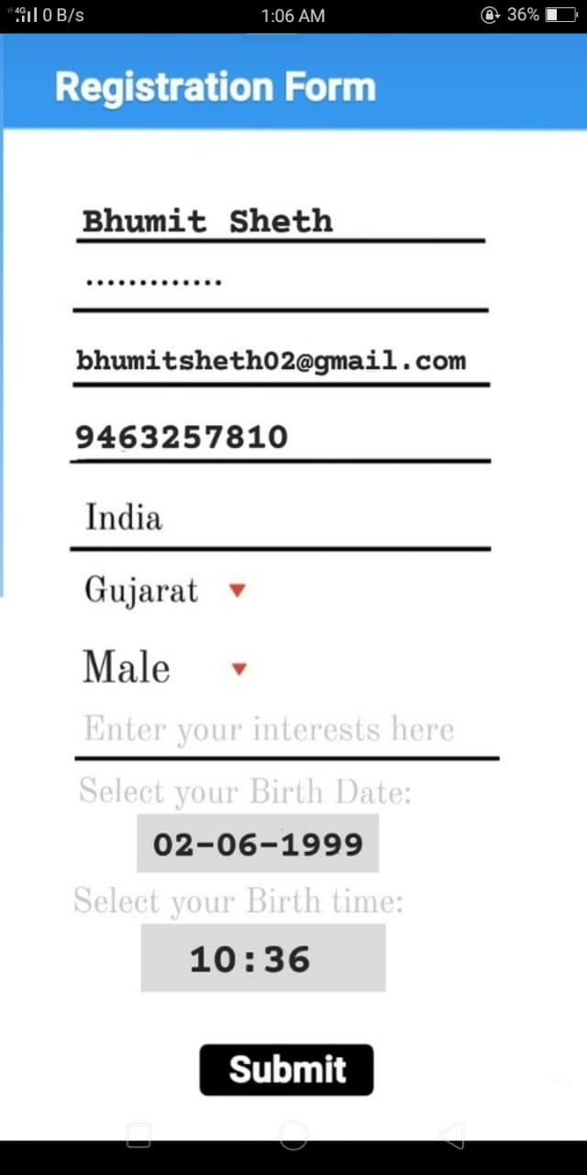

**PRACTICAL-10**

**AIM:** **Using Android, Create a login Activity. It asks “username” and “password” from user. If username and password are valid, it displays Welcome message using new activity.**

**CODE:**

**MainActivity.java**

package com.believe.loginmodule;

import android.content.Intent;

import android.os.Build;

import android.support.v7.app.AppCompatActivity;

import android.os.Bundle;

import android.view.View;

import android.view.Window;

import android.view.WindowManager;

import android.widget.Button;

import android.widget.EditText;

import android.widget.Toast;

public class MainActivity extends AppCompatActivity {

EditText musername;

EditText mpassword;

Button mlogin;

@Override

protected void onCreate(Bundle savedInstanceState) {

super.onCreate(savedInstanceState);

setContentView(R.layout.activity_main);

if (Build.VERSION.SDK_INT >= Build.VERSION_CODES.KITKAT) {

Window w = getWindow(); // in Activity's onCreate() for instance

w.setFlags(WindowManager.LayoutParams.FLAG_LAYOUT_NO_LIMITS, WindowManager.LayoutParams.FLAG_LAYOUT_NO_LIMITS);

}

musername=(EditText)findViewById(R.id.et_username);

mpassword=(EditText)findViewById(R.id.et_password);

mlogin=(Button)findViewById(R.id.bt_login);

musername.setOnFocusChangeListener(new View.OnFocusChangeListener() {

public void onFocusChange(View v, boolean hasFocus) {

if (hasFocus)

musername.setHint("");

else

musername.setHint("Username");

}

});

mpassword.setOnFocusChangeListener(new View.OnFocusChangeListener() {

public void onFocusChange(View v, boolean hasFocus) {

if (hasFocus)

mpassword.setHint("");

else

mpassword.setHint("Password");

}

});

mlogin.setOnClickListener(new View.OnClickListener() {

@Override

public void onClick(View view) {

if(!musername.getText().toString().equals("") && !mpassword.getText().toString().equals(""))

{

if(musername.getText().toString().equals("birju"))

{

if(mpassword.getText().toString().equals("1234"))

{

Intent intent=new Intent(MainActivity.this,WelcomeScreen.class);

intent.putExtra("user",musername.getText().toString());

startActivity(intent);

}

else

{

Toast.makeText(MainActivity.this,"Password is incorrect!",Toast.LENGTH_SHORT).show();

}

}

else

{

Toast.makeText(MainActivity.this,"Invaild username!",Toast.LENGTH_SHORT).show();

}

}

else

{

Toast.makeText(MainActivity.this,"Please fill both fields!",Toast.LENGTH_SHORT).show();

}

}

});

}

}

**activity_main.xml**

<?xml version="1.0" encoding="utf-8"?>

<RelativeLayout

xmlns:android="http://schemas.android.com/apk/res/android"

xmlns:app="http://schemas.android.com/apk/res-auto"

xmlns:tools="http://schemas.android.com/tools"

android:layout_width="match_parent"

android:orientation="vertical"

android:gravity="center"

android:background="@drawable/bg1"

android:layout_height="match_parent"

tools:context="com.believe.loginmodule.MainActivity">

<LinearLayout

android:layout_width="match_parent"

android:layout_height="wrap_content"

android:layout_gravity="center"

android:layout_marginTop="65dp"

android:background="@null"

android:gravity="center"

android:orientation="vertical"

app:layout_constraintBottom_toTopOf="@+id/button2"

app:layout_constraintLeft_toLeftOf="parent"

app:layout_constraintRight_toRightOf="parent"

app:layout_constraintTop_toTopOf="parent"

app:layout_constraintVertical_bias="0.278"

android:layout_alignParentTop="true"

android:layout_alignParentLeft="true"

android:layout_alignParentStart="true">

<ImageView

android:layout_width="wrap_content"

android:layout_height="wrap_content"

android:layout_marginBottom="24dp"

android:background="@drawable/ic_account" />

<LinearLayout

android:layout_width="match_parent"

android:layout_height="wrap_content"

android:layout_marginBottom="5dp"

android:layout_marginLeft="32dp"

android:layout_marginRight="32dp"

android:background="@drawable/shape"

android:orientation="vertical">

<EditText

android:id="@+id/et_username"

android:layout_width="match_parent"

android:layout_height="wrap_content"

android:layout_marginLeft="32dp"

android:layout_marginRight="32dp"

android:background="@android:color/transparent"

android:hint="Username"

android:inputType="text"

android:padding="8dp"

android:textAlignment="center"

android:textColor="#FFFFFF"

android:textColorHint="#FFFFFF"

android:textSize="18dp" />

</LinearLayout>

<LinearLayout

android:layout_width="match_parent"

android:layout_height="wrap_content"

android:layout_marginBottom="16dp"

android:layout_marginLeft="32dp"

android:layout_marginRight="32dp"

android:background="@drawable/shape"

android:orientation="vertical">

<EditText

android:id="@+id/et_password"

android:layout_width="match_parent"

android:layout_height="wrap_content"

android:layout_marginLeft="32dp"

android:layout_marginRight="32dp"

android:background="@android:color/transparent"

android:hint="Password"

android:inputType="textPassword"

android:padding="8dp"

android:textAlignment="center"

android:textColor="#FFFFFF"

android:textColorHint="#FFFFFF"

android:textSize="18dp" />

</LinearLayout>

</LinearLayout>

<Button

android:id="@+id/bt_login"

android:layout_width="match_parent"

android:layout_height="wrap_content"

android:layout_alignParentBottom="true"

android:background="#25FFFFFF"

android:text="Login"

android:textColor="#FFF"

app:layout_constraintBottom_toBottomOf="parent"

app:layout_constraintLeft_toLeftOf="parent"

app:layout_constraintRight_toRightOf="parent" />

</RelativeLayout>

**WelcomeScreen.java**

package com.believe.loginmodule;

import android.support.v7.app.AppCompatActivity;

import android.os.Bundle;

import android.widget.TextView;

public class WelcomeScreen extends AppCompatActivity {

TextView musername;

@Override

protected void onCreate(Bundle savedInstanceState) {

super.onCreate(savedInstanceState);

setContentView(R.layout.activity_welcome_screen);

musername=(TextView)findViewById(R.id.tv_user);

musername.setText(getIntent().getExtras().getString("user"));

}

}

**activity_welcome_screen.xml**

<?xml version="1.0" encoding="utf-8"?>

<LinearLayout

xmlns:android="http://schemas.android.com/apk/res/android"

xmlns:app="http://schemas.android.com/apk/res-auto"

xmlns:tools="http://schemas.android.com/tools"

android:layout_width="match_parent"

android:layout_height="match_parent"

android:orientation="vertical"

android:layout_gravity="center"

android:gravity="center"

tools:context="com.believe.loginmodule.WelcomeScreen">

<TextView

android:layout_width="wrap_content"

android:layout_height="wrap_content"

android:text="Welcome"

android:textSize="50sp"/>

<TextView

android:id="@+id/tv_user"

android:layout_width="wrap_content"

android:layout_height="wrap_content"

android:text="username"

android:layout_marginTop="16dp"

android:textColor="@color/colorAccent"

android:textSize="32sp"/>

<TextView

android:layout_width="wrap_content"

android:layout_height="wrap_content"

android:layout_marginTop="16dp"

android:text="You are successfully logged in!"

android:textSize="24sp"/>

</LinearLayout>

**OUTPUT**:

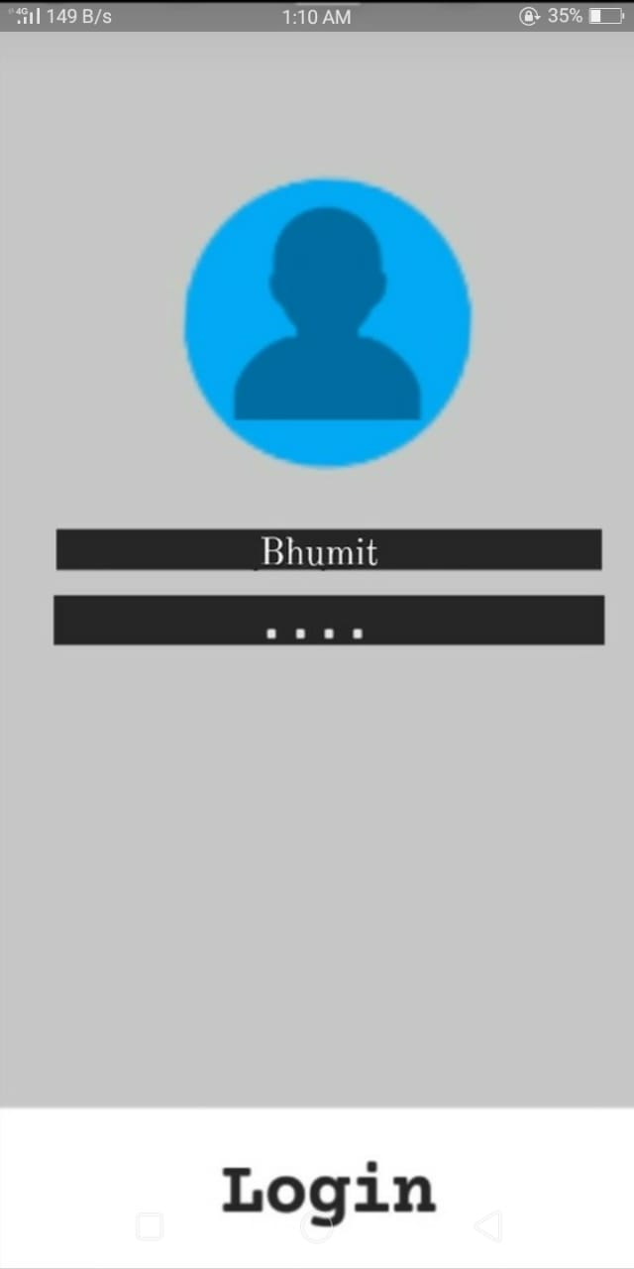

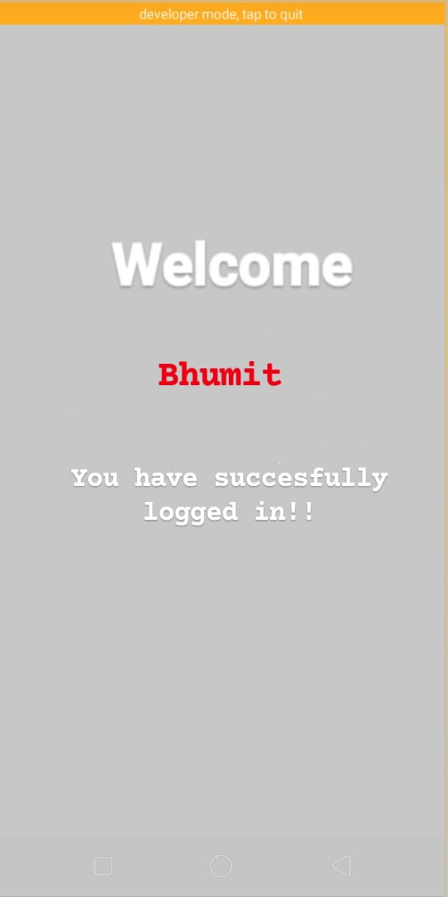

**PRACTICAL-11**

**AIM:** **Develop calculator Android Application.**

**CODE:**

**MainActivity.java**

package com.believe.calculator;

import android.os.Build;

import android.support.v7.app.AppCompatActivity;

import android.os.Bundle;

import android.view.View;

import android.view.Window;

import android.view.WindowManager;

import android.widget.Button;

import android.widget.TextView;

import java.text.DecimalFormat;

public class MainActivity extends AppCompatActivity {

Button mone;

Button mtwo;

Button mthree;

Button mfour;

Button mfive;

Button msix;

Button mseven;

Button meight;

Button mnine;

Button mzero;

Button mdot;

Button mplus;

Button mminus;

Button mmultiply;

Button mdevide;

Button mequal;

Button mallClear;

Button mclear;

Button mpercent;

Button msign;

TextView mdisplay;

TextView moperator;

DecimalFormat decimalFormat = new DecimalFormat("#.##########");

private double valueOne=Double.NaN;

private double valueTwo=0;

private static final char ADDITION = '+';

private static final char SUBTRACTION = '-';

private static final char MULTIPLICATION = '*';

private static final char DIVISION = '/';

private static final char PERCENT = '%';

private char CURRENT_ACTION;

@Override

protected void onCreate(Bundle savedInstanceState) {

super.onCreate(savedInstanceState);

setContentView(R.layout.activity_main);

mdisplay=(TextView)findViewById(R.id.tv_display);

moperator=(TextView)findViewById(R.id.tv_op);

mone=(Button)findViewById(R.id.bt_1);

mtwo=(Button)findViewById(R.id.bt_2);

mthree=(Button)findViewById(R.id.bt_3);

mfour=(Button)findViewById(R.id.bt_4);

mfive=(Button)findViewById(R.id.bt_5);

msix=(Button)findViewById(R.id.bt_6);

mseven=(Button)findViewById(R.id.bt_7);

meight=(Button)findViewById(R.id.bt_8);

mnine=(Button)findViewById(R.id.bt_9);

mzero=(Button)findViewById(R.id.bt_0);

mdot=(Button)findViewById(R.id.bt_dot);

mplus=(Button)findViewById(R.id.bt_plus);

mminus=(Button)findViewById(R.id.bt_minus);

mmultiply=(Button)findViewById(R.id.bt_multi);

mdevide=(Button)findViewById(R.id.bt_device);

mequal=(Button)findViewById(R.id.bt_equal);

mallClear=(Button)findViewById(R.id.bt_ac);

mclear=(Button)findViewById(R.id.bt_c);

mpercent=(Button)findViewById(R.id.bt_percent);

msign=(Button)findViewById(R.id.bt_sign);

mone.setOnClickListener(new View.OnClickListener() {

@Override

public void onClick(View view) {

String temp=mdisplay.getText().toString();

if(temp.length()<9)

mdisplay.setText(temp+"1");

}

});

mtwo.setOnClickListener(new View.OnClickListener() {

@Override

public void onClick(View view) {

String temp=mdisplay.getText().toString();

if(temp.length()<9)

mdisplay.setText(temp+"2");

}

});

mthree.setOnClickListener(new View.OnClickListener() {

@Override

public void onClick(View view) {

String temp=mdisplay.getText().toString();

if(temp.length()<9)

mdisplay.setText(temp+"3");

}

});

mfour.setOnClickListener(new View.OnClickListener() {

@Override

public void onClick(View view) {

String temp=mdisplay.getText().toString();

if(temp.length()<9)

mdisplay.setText(temp+"4");

}

});

mfive.setOnClickListener(new View.OnClickListener() {

@Override

public void onClick(View view) {

String temp=mdisplay.getText().toString();

if(temp.length()<9)

mdisplay.setText(temp+"5");

}

});

msix.setOnClickListener(new View.OnClickListener() {

@Override

public void onClick(View view) {

String temp=mdisplay.getText().toString();

if(temp.length()<9)

mdisplay.setText(temp+"6");

}

});

mseven.setOnClickListener(new View.OnClickListener() {

@Override

public void onClick(View view) {

String temp=mdisplay.getText().toString();

if(temp.length()<9)

mdisplay.setText(temp+"7");

}

});

meight.setOnClickListener(new View.OnClickListener() {

@Override

public void onClick(View view) {

String temp=mdisplay.getText().toString();

if(temp.length()<9)

mdisplay.setText(temp+"8");

}

});

mnine.setOnClickListener(new View.OnClickListener() {

@Override

public void onClick(View view) {

String temp=mdisplay.getText().toString();

if(temp.length()<9)

mdisplay.setText(temp+"9");

}

});

mzero.setOnClickListener(new View.OnClickListener() {

@Override

public void onClick(View view) {

String temp=mdisplay.getText().toString();

if(temp.length()<9 && !temp.equals("0"))

mdisplay.setText(temp+"0");

}

});

mdot.setOnClickListener(new View.OnClickListener() {

@Override

public void onClick(View view) {

String temp=mdisplay.getText().toString();

if(temp.length()<9)

mdisplay.setText(temp+".");

}

});

mallClear.setOnClickListener(new View.OnClickListener() {

@Override

public void onClick(View view) {

mdisplay.setText(null);

moperator.setText(null);

}

});

mclear.setOnClickListener(new View.OnClickListener() {

@Override

public void onClick(View view) {

String temp=mdisplay.getText().toString();

if(!temp.equals(""))

{

temp = temp.substring(0, temp.length() - 1);

mdisplay.setText(temp);

}

}

});

mplus.setOnClickListener(new View.OnClickListener() {

@Override

public void onClick(View view) {

String temp=moperator.getText().toString();

if(!temp.equals("") && mdisplay.getText().toString().equals("")) {

char c = temp.charAt(temp.length() - 1);

if (isOperator(c)) {

String t = temp.substring(0, temp.length() - 1);

t = t + "+";

moperator.setText(t);

}

}

else {

moperator.setText(moperator.getText().toString() + mdisplay.getText().toString() + "+");

}

computeCalculation();

CURRENT_ACTION = ADDITION;

mdisplay.setText(null);

}

});

mminus.setOnClickListener(new View.OnClickListener() {

@Override

public void onClick(View view) {

String temp=moperator.getText().toString();

if(!temp.equals("") && mdisplay.getText().toString().equals("")) { char c = temp.charAt(temp.length() - 1);

if (isOperator(c)) {

String t = temp.substring(0, temp.length() - 1);

t = t + "-";

moperator.setText(t);

}

}

else {

moperator.setText(moperator.getText().toString() + mdisplay.getText().toString() + "-");

}computeCalculation();

CURRENT_ACTION = SUBTRACTION;

mdisplay.setText(null);

}

});

mdevide.setOnClickListener(new View.OnClickListener() {

@Override

public void onClick(View view) {

String temp=moperator.getText().toString();

if(!temp.equals("") && mdisplay.getText().toString().equals("")) { char c = temp.charAt(temp.length() - 1);

if (isOperator(c)) {

String t = temp.substring(0, temp.length() - 1);

t = t + "/";

moperator.setText(t);

}

}

else {

moperator.setText(moperator.getText().toString() + mdisplay.getText().toString() + "/");

}computeCalculation();

CURRENT_ACTION = DIVISION;

mdisplay.setText(null);

}

});

mmultiply.setOnClickListener(new View.OnClickListener() {

@Override

public void onClick(View view) {

String temp=moperator.getText().toString();

if(!temp.equals("") && mdisplay.getText().toString().equals("")) { char c = temp.charAt(temp.length() - 1);

if (isOperator(c)) {

String t = temp.substring(0, temp.length() - 1);

t = t + "x";

moperator.setText(t);

}

}

else {

moperator.setText(moperator.getText().toString() + mdisplay.getText().toString() + "x");

}computeCalculation();

CURRENT_ACTION = MULTIPLICATION;

mdisplay.setText(null);

}

});

mpercent.setOnClickListener(new View.OnClickListener() {

@Override

public void onClick(View view) {

String temp=moperator.getText().toString();

if(!temp.equals("") && mdisplay.getText().toString().equals("")) { char c = temp.charAt(temp.length() - 1);

if (isOperator(c)) {

String t = temp.substring(0, temp.length() - 1);

t = t + "%";

moperator.setText(t);

}

}

else {

moperator.setText(moperator.getText().toString() + mdisplay.getText().toString() + "%");

}computeCalculation();

CURRENT_ACTION = PERCENT;

mdisplay.setText(null);

}

});

mequal.setOnClickListener(new View.OnClickListener() {

@Override

public void onClick(View view) {

computeCalculation();

mdisplay.setText(decimalFormat.format(valueOne));

moperator.setText(null);

valueOne = Double.NaN;

CURRENT_ACTION = '0';

}

});

msign.setOnClickListener(new View.OnClickListener() {

@Override

public void onClick(View view) {

String temp=mdisplay.getText().toString();

if(!temp.equals("") && !temp.equals("0") )

{

if(temp.charAt(0)=='-')

{

temp=temp.substring(1,temp.length());

}

else

{

temp="-"+temp;

}

mdisplay.setText(temp);

}

}

});

}

private void computeCalculation() {

if(!Double.isNaN(valueOne)) {

if(!mdisplay.getText().toString().equals(""))

valueTwo = Double.parseDouble(mdisplay.getText().toString());

else

if(CURRENT_ACTION == ADDITION || CURRENT_ACTION == SUBTRACTION)

valueTwo=0;

else if(CURRENT_ACTION == DIVISION || CURRENT_ACTION == MULTIPLICATION)

valueTwo=1;

mdisplay.setText(null);

if(CURRENT_ACTION == ADDITION)

valueOne = this.valueOne + valueTwo;

else if(CURRENT_ACTION == SUBTRACTION)

valueOne = this.valueOne - valueTwo;

else if(CURRENT_ACTION == MULTIPLICATION)

valueOne = this.valueOne * valueTwo;

else if(CURRENT_ACTION == DIVISION)

valueOne = this.valueOne / valueTwo;

else if(CURRENT_ACTION == PERCENT)

valueOne = this.valueOne % valueTwo;

}

else {

try {

valueOne = Double.parseDouble(mdisplay.getText().toString());

}

catch (Exception e){}

}

}

private boolean isOperator(char c)

{

if(c=='+' || c=='-' || c=='x' || c=='/' || c=='%')

return true;

return false;

}

}

**activity_main.xml**

<?xml version="1.0" encoding="utf-8"?>

<RelativeLayout

xmlns:android="http://schemas.android.com/apk/res/android"

android:layout_width="fill_parent"

android:layout_height="fill_parent"

android:minHeight="25px"

android:minWidth="25px"

android:background="#2c2c2c"

android:orientation="vertical">

<LinearLayout

android:layout_width="match_parent"

android:layout_height="match_parent"

android:orientation="vertical">

<TextView

android:id="@+id/tv_op"

android:layout_width="match_parent"

android:layout_height="wrap_content"

android:gravity="bottom"

android:paddingRight="10dp"

android:layout_marginTop="10dp"

android:paddingLeft="10dp"

android:textAlignment="textEnd"

android:textColor="#FFF"

android:textSize="30sp"

android:layout_weight="0.48" />

<TextView

android:id="@+id/tv_display"

android:layout_width="match_parent"

android:layout_height="wrap_content"

android:gravity="bottom"

android:paddingRight="10dp"

android:paddingLeft="10dp"

android:paddingBottom="20dp"

android:textAlignment="textEnd"

android:textColor="#FFF"

android:layout_below="@id/tv_op"

android:textSize="60sp"

android:layout_weight="0.48" />

<LinearLayout

android:layout_width="match_parent"

android:layout_height="wrap_content"

android:orientation="vertical"

android:layout_gravity="bottom"

android:background="#F44336"

>

<LinearLayout

android:id="@+id/superviserlinearLayout1"

android:layout_width="match_parent"

android:layout_height="wrap_content"

android:layout_centerHorizontal="true"

android:background="@null"

android:minHeight="25px"

android:minWidth="25px"

android:orientation="horizontal"

android:weightSum="4">

<Button

android:id="@+id/bt_ac"

android:layout_width="0dp"

android:layout_height="wrap_content"

android:layout_weight="1"

android:background="@color/button_color_highlighted"

android:padding="25dp"

android:text="AC"

android:textColor="@color/button_text_highlighted"

android:textSize="24sp" />

<Button

android:id="@+id/bt_c"

android:layout_width="0dp"

android:layout_height="wrap_content"

android:layout_weight="1"

android:background="@color/button_color_highlighted"

android:padding="25dp"

android:text="C"

android:textColor="@color/button_text_highlighted"

android:textSize="24sp" />

<Button

android:id="@+id/bt_device"

android:layout_width="0dp"

android:layout_height="wrap_content"

android:layout_weight="1"

android:background="@color/button_color_highlighted"

android:padding="25dp"

android:text="/"

android:textColor="@color/button_text_highlighted"

android:textSize="24sp" />

<Button

android:id="@+id/bt_multi"

android:layout_width="0dp"

android:layout_height="wrap_content"

android:layout_weight="1"

android:background="@color/button_color_highlighted"

android:fontFamily="sans-serif"

android:padding="25dp"

android:text="x"

android:textColor="@color/button_text_highlighted"

android:textSize="24sp"

android:typeface="monospace" />

</LinearLayout>

<LinearLayout

android:id="@+id/superviserlinearLayout2"

android:layout_width="match_parent"

android:layout_height="wrap_content"

android:layout_below="@id/superviserlinearLayout1"

android:layout_centerHorizontal="true"

android:minHeight="25px"

android:minWidth="25px"

android:orientation="horizontal"

android:weightSum="4">

<Button

android:id="@+id/bt_7"

android:layout_width="0dp"

android:layout_height="wrap_content"

android:layout_weight="1"

android:background="@color/button_color"

android:padding="25dp"

android:text="7"

android:textColor="@color/button_text"

android:textSize="24sp" />

<Button

android:id="@+id/bt_8"

android:layout_width="0dp"

android:layout_height="wrap_content"

android:layout_weight="1"

android:background="@color/button_color"

android:padding="25dp"

android:text="8"

android:textColor="@color/button_text"

android:textSize="24sp" />

<Button

android:id="@+id/bt_9"

android:layout_width="0dp"

android:layout_height="wrap_content"

android:layout_weight="1"

android:background="@color/button_color"

android:padding="25dp"

android:text="9"

android:textColor="@color/button_text"

android:textSize="24sp" />

<Button

android:id="@+id/bt_minus"

android:layout_width="0dp"

android:layout_height="wrap_content"

android:layout_weight="1"

android:background="@color/button_color_highlighted"

android:padding="25dp"

android:text="-"

android:textColor="@color/button_text_highlighted"

android:textSize="24sp" />

</LinearLayout>

<LinearLayout

android:id="@+id/superviserlinearLayout3"

android:layout_width="match_parent"

android:layout_height="wrap_content"

android:layout_below="@id/superviserlinearLayout2"

android:layout_centerHorizontal="true"

android:minHeight="25px"

android:minWidth="25px"

android:orientation="horizontal"

android:weightSum="4">

<Button

android:id="@+id/bt_4"

android:layout_width="0dp"

android:layout_height="wrap_content"

android:layout_weight="1"

android:background="@color/button_color"

android:padding="25dp"

android:text="4"

android:textColor="@color/button_text"

android:textSize="24sp" />

<Button

android:id="@+id/bt_5"

android:layout_width="0dp"

android:layout_height="wrap_content"

android:layout_weight="1"

android:background="@color/button_color"

android:padding="25dp"

android:text="5"

android:textColor="@color/button_text"

android:textSize="24sp" />

<Button

android:id="@+id/bt_6"

android:layout_width="0dp"

android:layout_height="wrap_content"

android:layout_weight="1"

android:background="@color/button_color"

android:padding="25dp"

android:text="6"

android:textColor="@color/button_text"

android:textSize="24sp" />

<Button

android:id="@+id/bt_plus"

android:layout_width="0dp"

android:layout_height="wrap_content"

android:layout_weight="1"

android:background="@color/button_color_highlighted"

android:padding="25dp"

android:text="+"

android:textColor="@color/button_text_highlighted"

android:textSize="24sp" />

</LinearLayout>

<LinearLayout

android:id="@+id/superviserlinearLayout4"

android:layout_width="match_parent"

android:layout_height="wrap_content"

android:layout_below="@id/superviserlinearLayout3"

android:layout_centerHorizontal="true"

android:minHeight="25px"

android:minWidth="25px"

android:orientation="horizontal"

android:weightSum="4">

<Button

android:id="@+id/bt_1"

android:layout_width="0dp"

android:layout_height="wrap_content"

android:layout_weight="1"

android:background="@color/button_color"

android:padding="25dp"

android:text="1"

android:textColor="@color/button_text"

android:textSize="24sp" />

<Button

android:id="@+id/bt_2"

android:layout_width="0dp"

android:layout_height="wrap_content"

android:layout_weight="1"

android:background="@color/button_color"

android:padding="25dp"

android:text="2"

android:textColor="@color/button_text"

android:textSize="24sp" />

<Button

android:id="@+id/bt_3"

android:layout_width="0dp"

android:layout_height="wrap_content"

android:layout_weight="1"

android:background="@color/button_color"

android:padding="25dp"

android:text="3"

android:textColor="@color/button_text"

android:textSize="24sp" />

<Button

android:id="@+id/bt_percent"

android:layout_width="0dp"

android:layout_height="wrap_content"

android:layout_weight="1"

android:background="@color/button_color_highlighted"

android:padding="25dp"

android:text="%"

android:textColor="@color/button_text_highlighted"

android:textSize="24sp" />

</LinearLayout>

<LinearLayout

android:id="@+id/superviserlinearLayout5"

android:layout_width="match_parent"

android:layout_height="wrap_content"

android:layout_below="@id/superviserlinearLayout4"

android:layout_centerHorizontal="true"

android:minHeight="25px"

android:minWidth="25px"

android:orientation="horizontal"

android:weightSum="4">

<Button

android:id="@+id/bt_sign"

android:layout_width="0dp"

android:layout_height="wrap_content"

android:layout_weight="1"

android:background="@color/button_color"

android:padding="25dp"

android:text="-/+"

android:textColor="@color/button_text_highlighted"

android:textSize="24sp" />

<Button

android:id="@+id/bt_0"

android:layout_width="0dp"

android:layout_height="wrap_content"

android:layout_weight="1"

android:background="@color/button_color"

android:padding="25dp"

android:text="0"

android:textColor="@color/button_text"

android:textSize="24sp" />

<Button

android:id="@+id/bt_dot"

android:layout_width="0dp"

android:layout_height="wrap_content"

android:layout_weight="1"

android:background="@color/button_color"

android:padding="25dp"

android:text="."

android:textColor="@color/button_text"

android:textSize="24sp" />

<Button

android:id="@+id/bt_equal"

android:layout_width="0dp"

android:layout_height="wrap_content"

android:layout_weight="1"

android:background="@color/button_color_highlighted"

android:padding="25dp"

android:text="="

android:textColor="#FFF"

android:textSize="24sp" />

</LinearLayout>

</LinearLayout>

</LinearLayout>

</RelativeLayout>

**OUTPUT**:

