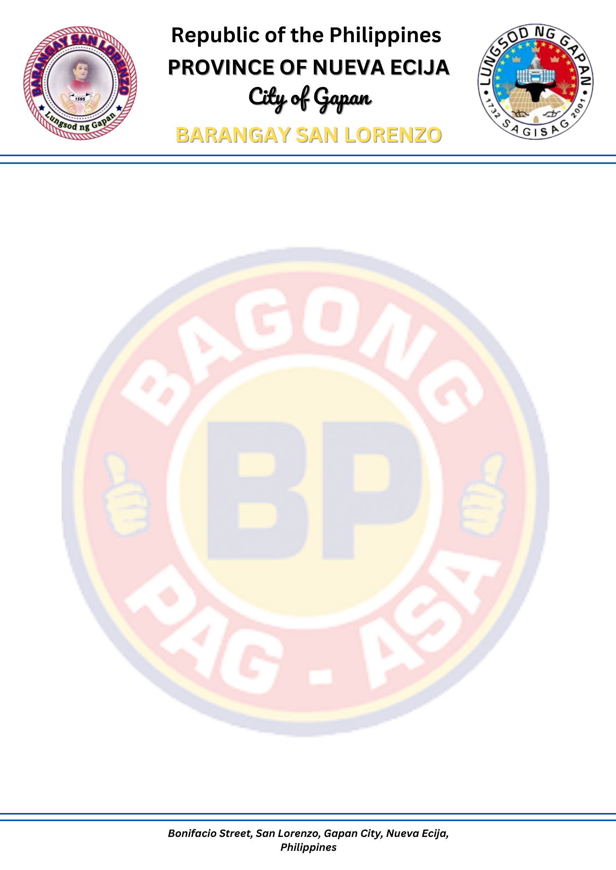
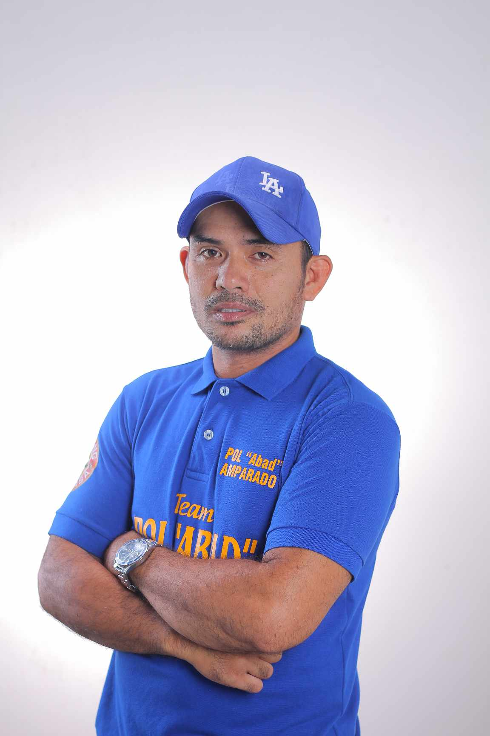

BRGY CERTIFICATION
(First Time Job Seeker Assistant Act. RA 11261)

This is to certify that Mr. /Mrs. /Ms. ${FULL_NAME} resident of ${ADDRESS}, for ${YEARS_QUALIFIED} year, is a qualified availee of RA 11261 or the First Time Job Seeker Act of 2019

I further certify that the holder/bearer was informed of his/her rights, including the duties
And responsibilities accorded by RA 11261 through the Oath of Undertaking he/she has signed and executed in the presence of our Barangay Officials/s.

Signed this ${DAY} day of ${MONTH_YEAR}, in the City of Gapan, province of Nueva Ecija.

Signed by:

___________________________

WITNESSED BY:

WILLIAM DS. TIRRADO PAUL MICHAEL A. AMPARADO
BARANGAY SECRETARY PUNONG BARANGAY

