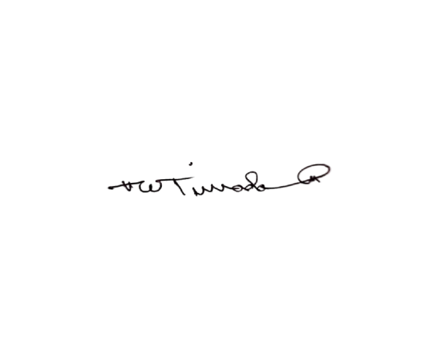

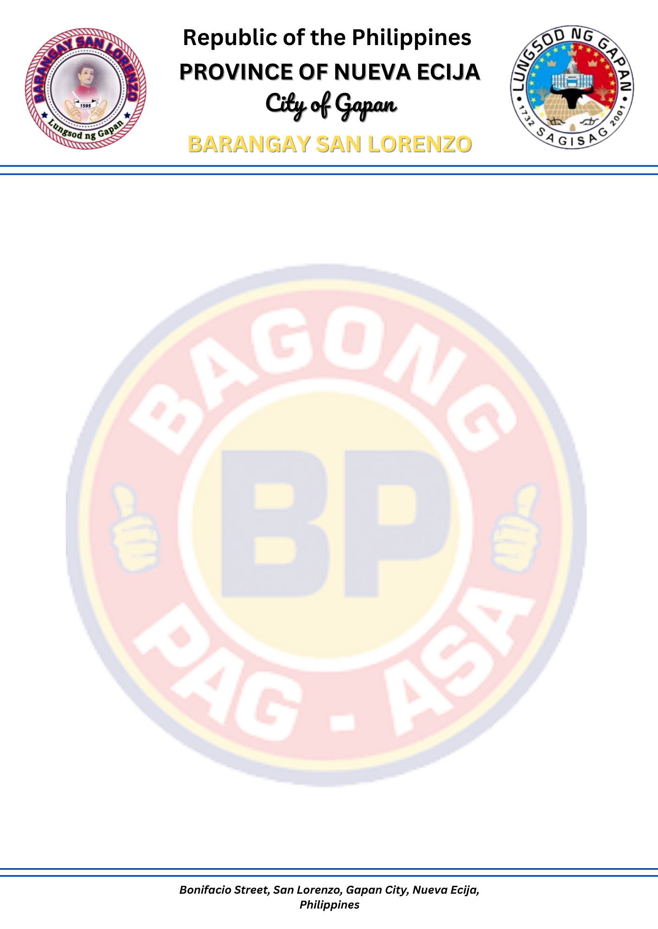
9
TO WHOM IT MAY CONCERN:
This is to certify that ${FULL_NAME}, ${AGE} years of age, resident of Barangay San Lorenzo, Gapan City, Nueva Ecija personally known to me, belongs to an indigent family in this barangay.
This certification is issued upon the request of the person named above for FINANCIAL ASSISTANCE purposes.
Issued on this 13th day of January 2025, here at Barangay Hall of San Lorenzo, Gapan City, Nueva Ecija.

Not valid without the Barangay seal.

CERTIFICATE OF INDIGENCY

JHHHHHHHHHHH

GG

Approved by:

PAUL MICHAEL A. AMPARADO
Punong Barangay
Certified by:

WILLIAM DS. TIRRADO
Barangay Secretary

