
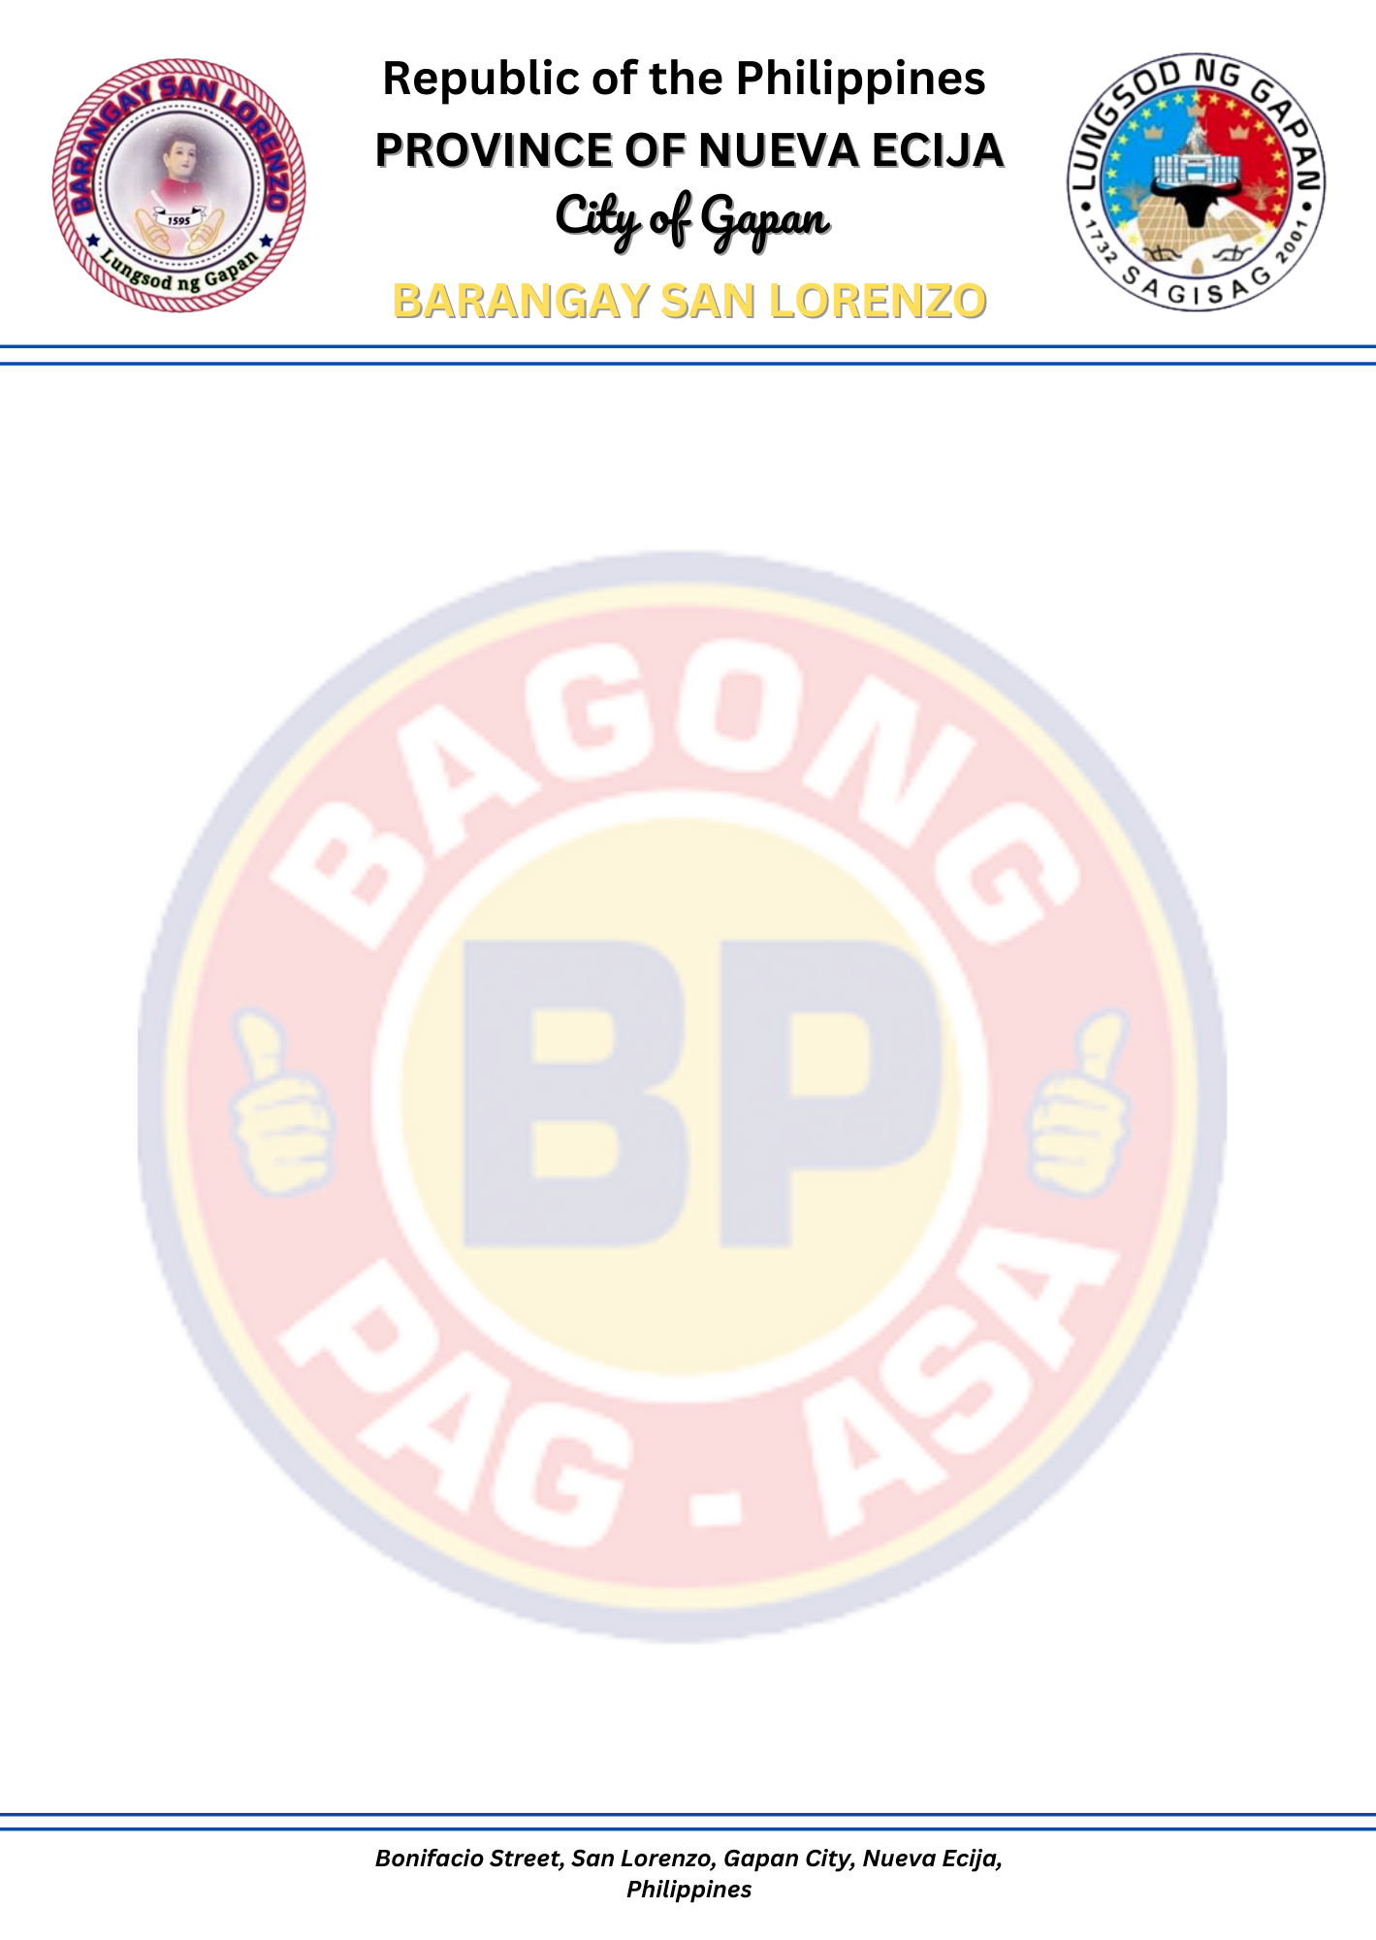
CERTIFICATE OF RESIDENCY

TO WHOM IT MAY CONCERN;
This is to certify that ${FULL_NAME}, ${AGE} years of age, Filipino Citizen, whose specimen signature appears below. Is a PERMANENT RESIDENT of this Barangay San Lorenzo, Gapan City, Nueva Ecija.
Based on records of this office, he/she has been residing at Tinio Street, San Lorenzo, Gapan City, Nueva Ecija.
This CERTIFICATION is being issued upon the request of the above-named person for whatever legal purpose it may serve.
Issued on this ${DAY} day of ${MONTH_YEAR}, here at Barangay Hall of San Lorenzo, Gapan City, Nueva Ecija.

${USER_SIGNATURE}
_________________________
Specimen signature

Hon. PAUL MICHAEL A. AMPARADO
Punong Barangay

Not valid without the Barangay seal.

