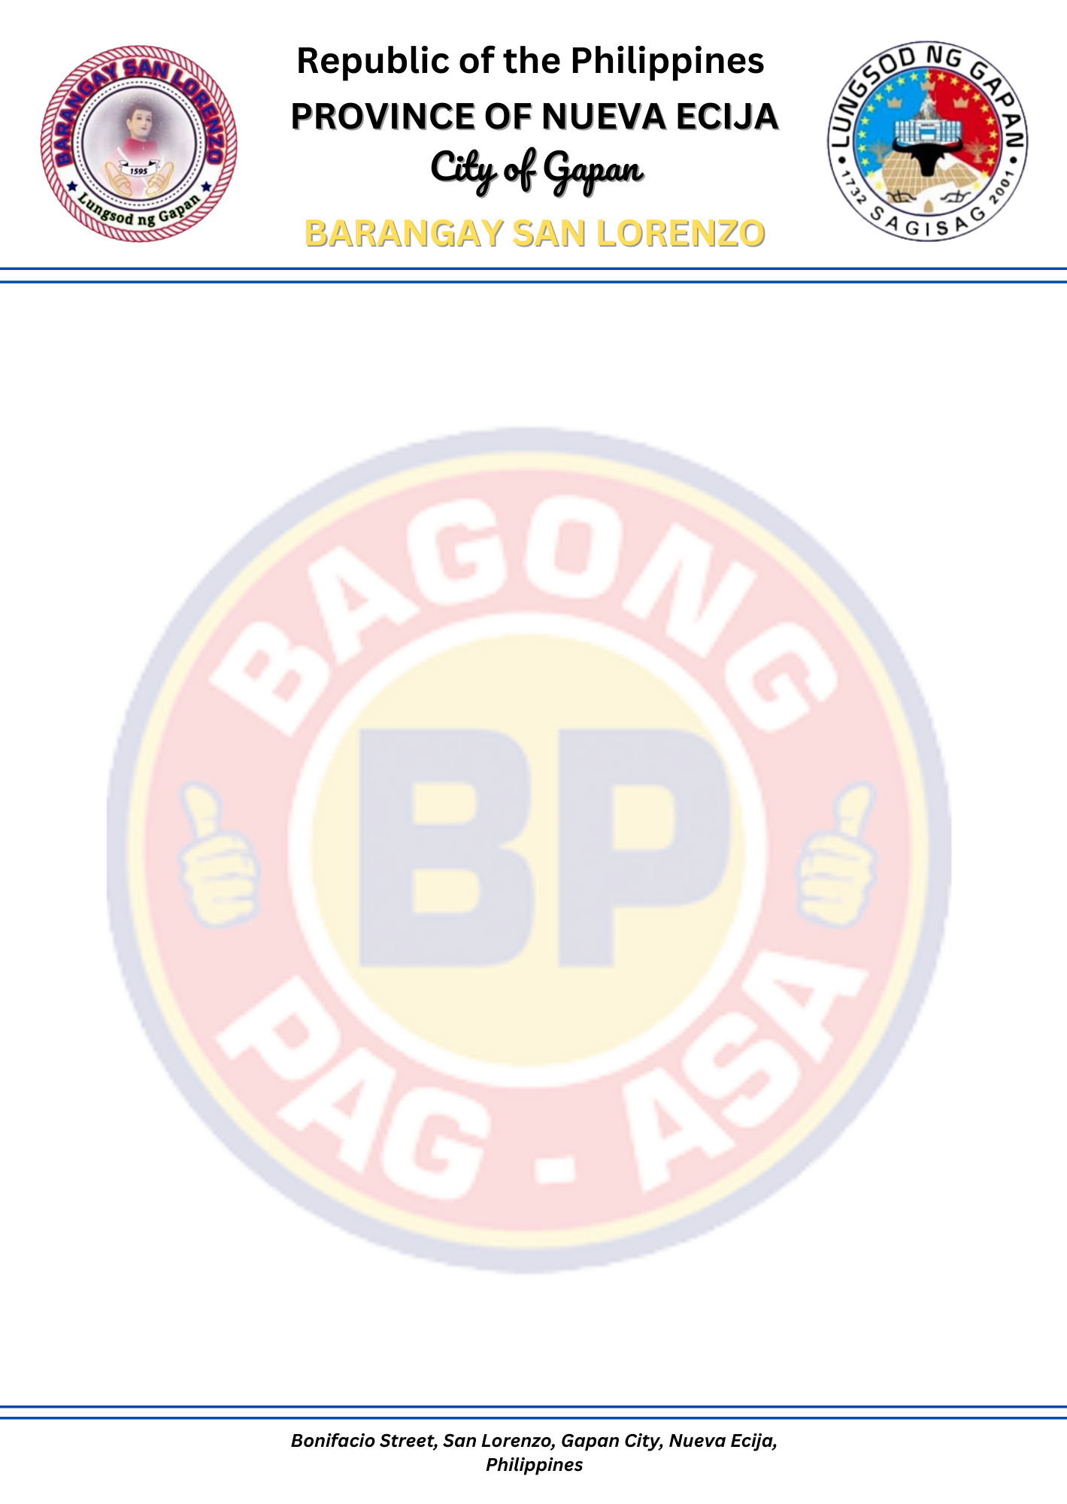

C E R T I F I C A T E

TO WHOM IT MAY CONCERN;

This is to certify that ${FULL_NAME}, ${AGE} years old and a , resident of Barangay San Lorenzo, Gapan City, Nueva Ecija, has been identified as a Person with Disability (PWD). The specific disability is ${DISABILITY_TYPE}.

This is issued upon the request of the person named above for whatever legal purpose it may serve as it is recognized that individuals with disabilities may be entitled to certain privileges and benefits as mandated by law.

Issued on this ${DAY} day of ${MONTH_YEAR}, at Barangay Hall of San Lorenzo, Gapan City, Nueva Ecija.

Certified by: Approved by:

WILLIAM DS. TIRRADO PAUL MICHAEL A. AMPARADO
Barangay Secretary Punong Barangay

Not valid without the Barangay seal.

Not valid without the Barangay Seal.

