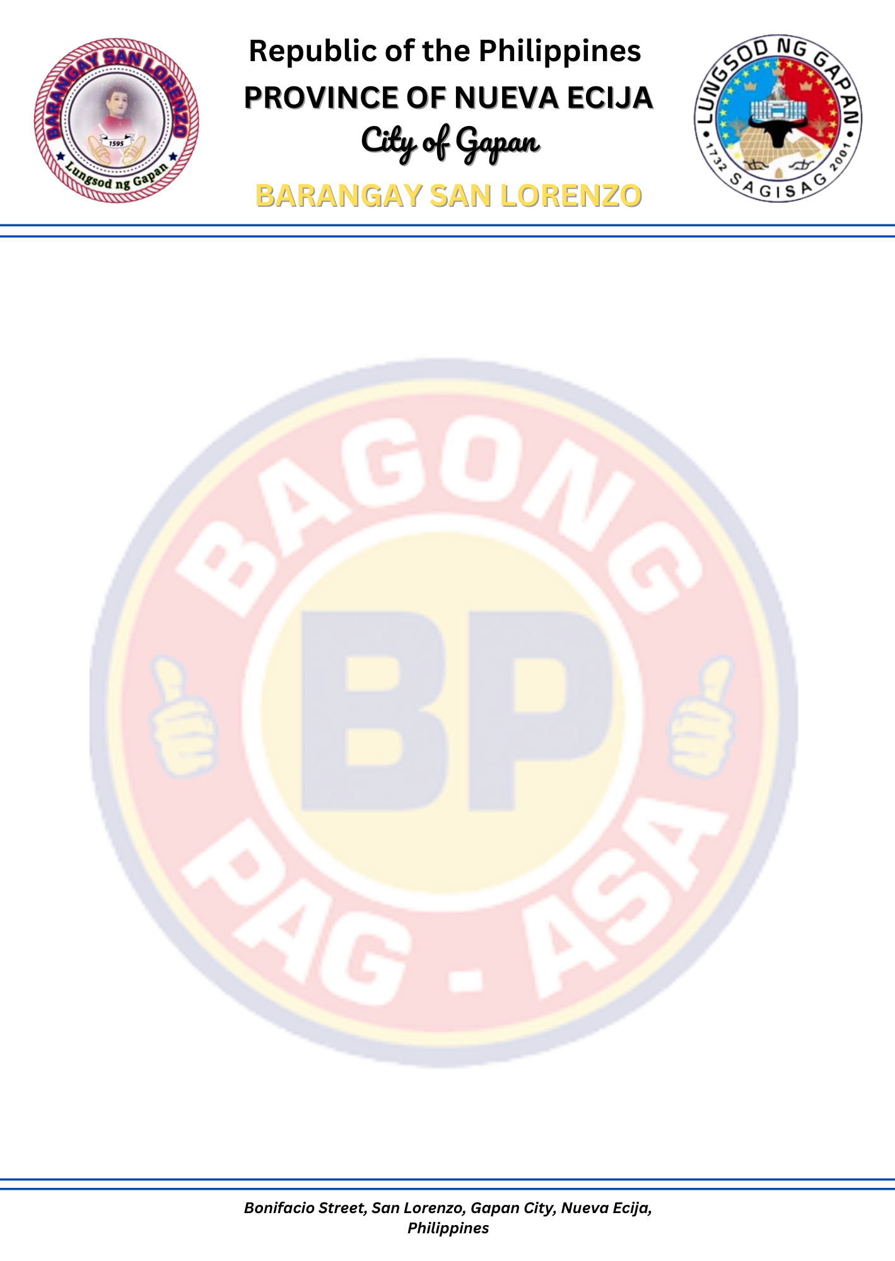

CERTIFICATE OF SOLO PARENT

This is to certify that ${FULL_NAME}, ${AGE} years of age, resident of Barangay San Lorenzo, Gapan City, Nueva Ecija personally known to me, belongs to an indigent family in this barangay.
This certification is issued upon the request of the person named above for ${PURPOSE} purposes.
Issued on this ${DAY} day of ${MONTH_YEAR} here at Barangay Hall of San Lorenzo, Gapan City, Nueva Ecija.

San Lorenzo, Gapan City, Nueva Ecija.
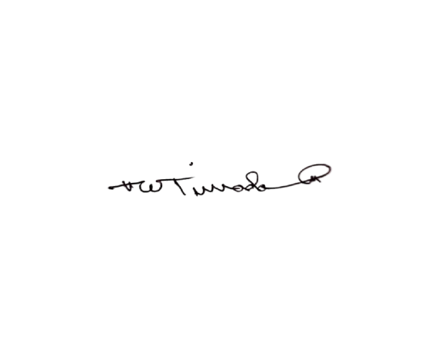

Certified by: Approved by:
WILLIAM DS. TIRRADO PAUL MICHAEL A. AMPARADO
Barangay Secretary Punong Barangay

Not valid without the Barangay seal.

