ULTRA MRF — ERPNext & VMS End-to-End Visual User Guide
Step-by-Step Operational Manual with Live Screen Walkthroughs for All Modules
ℹ️ OFFICIAL OPERATING MANUAL: This manual serves as the standard operational training and user guide for ULTRA MRF branch personnel, cashiers, technicians, warehouse custodians, and accountants. Every process flow is accompanied by actual production screenshots from ERPNext v16 and the Vehicle Management System.

Module 1: Vehicle Management Workspace & Live Analytics
The Vehicle Management Workspace is the primary command center in ERPNext Desk. When users navigate to /desk/vehicle-management, the system presents the live Vehicle Analytics & Performance Dashboard as the first view.

1.1 Workspace Top View: KPI Cards & Live Performance Charts
The top section displays real-time KPI counters (Registered Vehicles, Total Job Orders, POS Invoices, Lifetime Revenue) alongside 4 interactive charts (Job Orders by Company, POS Sales by Company, Customer Vehicles by Make, and Job Orders by Status).
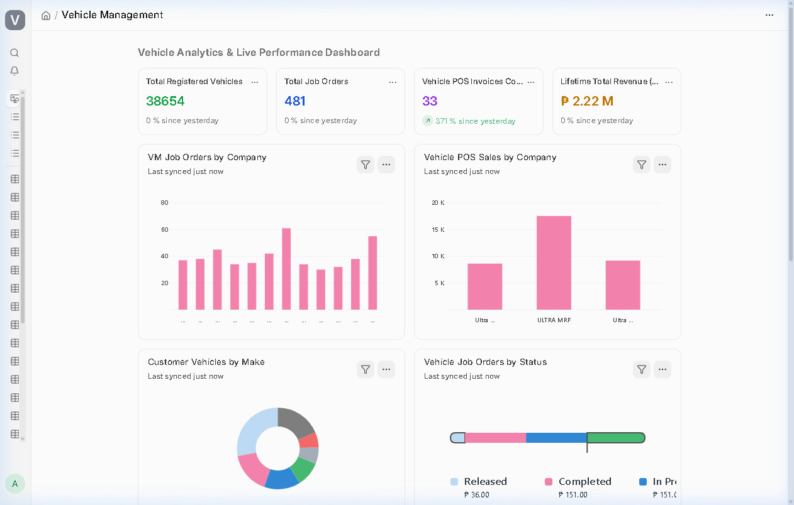
Figure: Vehicle Management Workspace — 1st View Dashboard, KPI Cards & Live Charts

1.2 Workspace Quick Shortcuts & Module Cards
Scrolling down reveals the Quick Shortcuts rail with live record count badges (e.g. 38,654 Vehicles, 481 Job Orders, 33 POS Invoices, 570 Bins) and 4 categorized module cards: Operations & Front Desk, Vehicle Masters & Registry, Reports & Analytics, and Inventory & Parts.
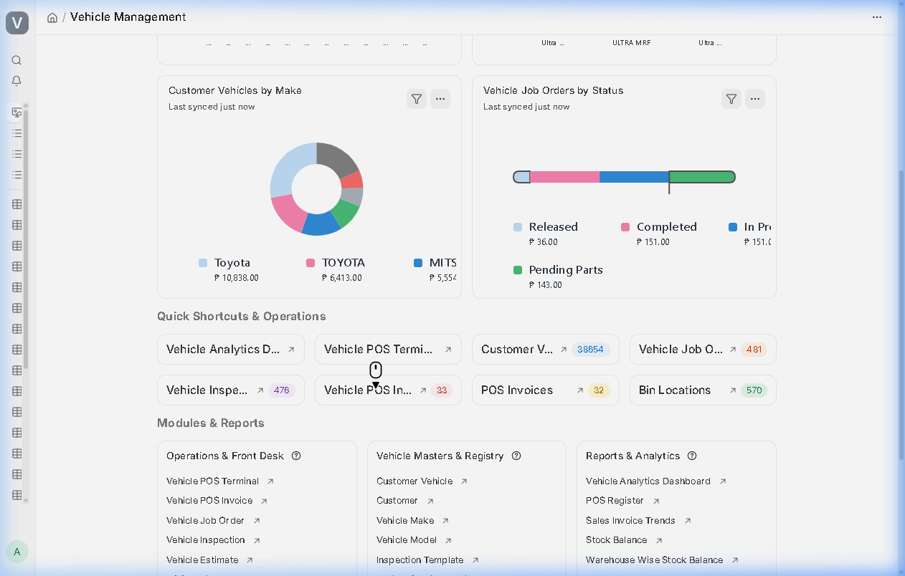
Figure: Vehicle Management Workspace — Quick Shortcuts & Organized Module Cards

1.3 Interactive Multi-Filter Vehicle Analytics Page
Clicking the 'Vehicle Analytics Dashboard' shortcut opens the dedicated multi-filter analytics engine at /desk/vehicle_analytics. Users can filter by branch and timespan to inspect labor vs. parts sales splits, top-selling tire models, and popular mechanic services.
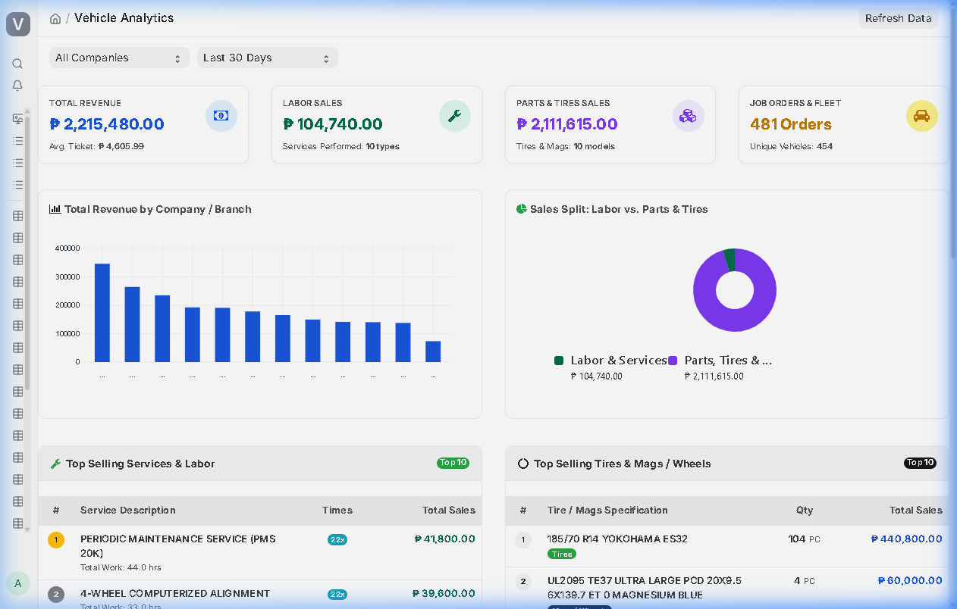
Figure: Dedicated Vehicle Analytics Page with Company Filter & Service Breakdown

Module 2: Touchscreen Vehicle POS Counter Operations
The Vehicle POS Terminal provides an ultra-fast checkout experience for retail tire sales, parts, and express bay services. It supports camera QR login, plate number lookups, real-time warehouse stock filtering, and dual-ledger ERPNext posting.

2.1 Cashier Sign-In via QR Badge or Credentials
Open http://38.247.138.224:10017/pos-terminal. Cashiers can log in by entering their username/password or by scanning their printed employee QR badge using the built-in camera scanner modal.
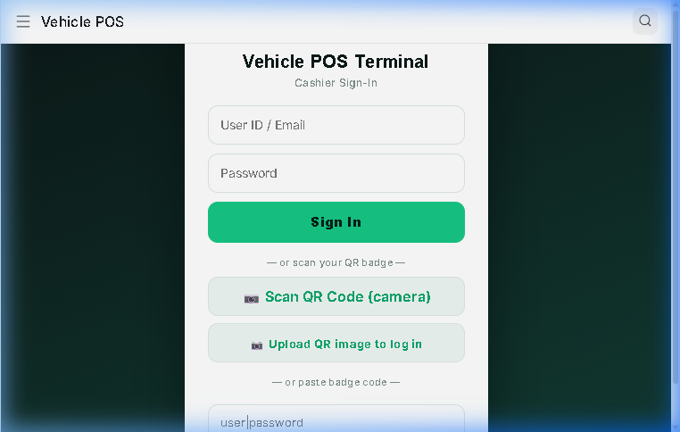
Figure: Web POS Terminal — Camera QR Badge Scanner Modal

2.2 POS Counter Interface & Real-Time In-Stock Filter
The main sales counter displays item categories (Tires, Wheels, Lubricants, Services). Toggling 'In Stock: ON' executes a direct SQL join against tabBin, instantly displaying only items physically on-hand in the active branch warehouse.
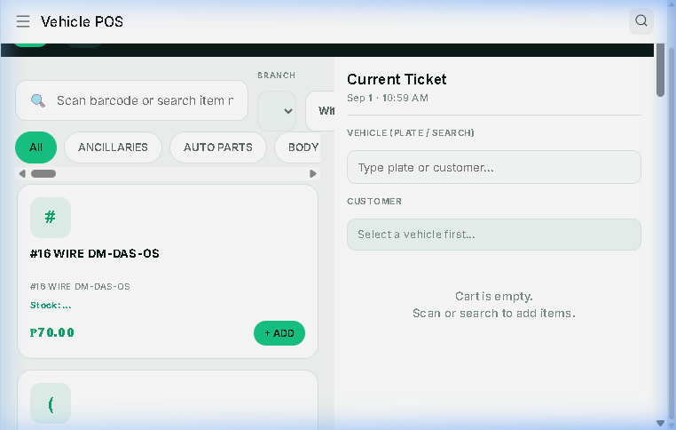
Figure: Web POS Terminal — Active Counter Screen with Categories and Plate Search
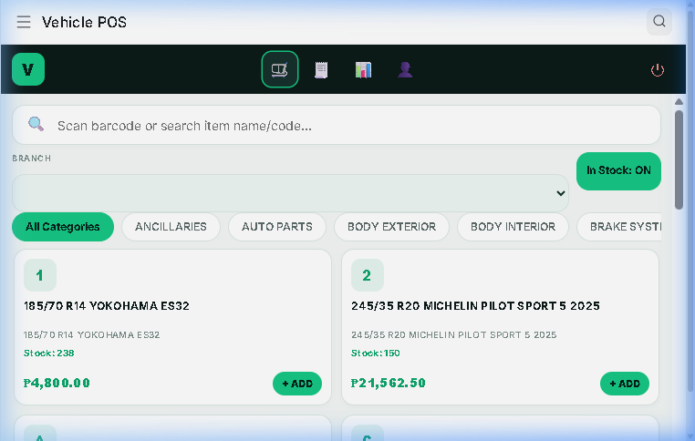
Figure: Desk Vehicle POS — Catalog with In-Stock: ON Enabled

2.3 Cashier Digital ID Badge Generation
Under the 'Cashier Profile' tab on the left navigation rail, cashiers can generate and download their official digital ID badge with scalable vector QR code, employee #, and branch designation.
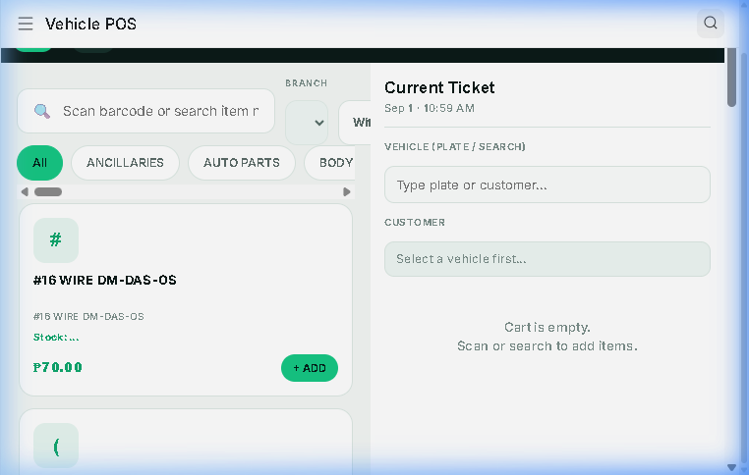
Figure: Web POS Terminal — Cashier Profile & Vector QR Badge Modal

2.4 Dual-Ledger Financial Posting (POS Invoice)
When a sale is completed, the system concurrently creates a Vehicle POS Invoice and auto-submits a standard ERPNext POS Invoice (ACC-PSINV-...). This immediately writes General Ledger entries and decrements warehouse stock.
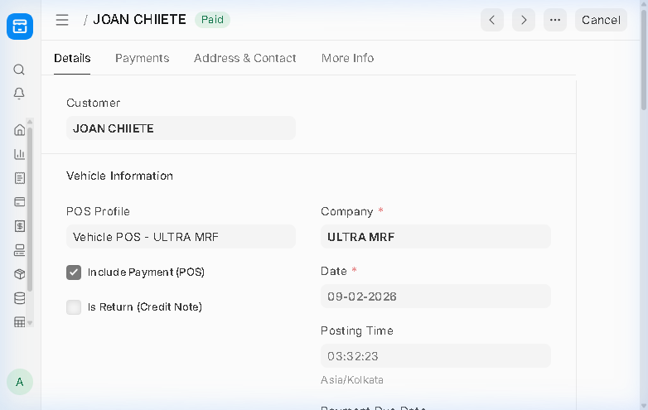
Figure: ERPNext Desk — Submitted POS Invoice (ACC-PSINV-2026-00032) with GL Impact

Module 3: Workshop Bay Operations & Job Order Lifecycle
Automotive workshop operations link vehicle intake, digital inspections, estimating, technician bay dispatch, and parts consumption.

3.1 Customer Vehicle Registry (38,654 Vehicles)
Navigate to /desk/customer-vehicle. Search or create customer vehicles. The system indexes plate numbers, makes, models, chassis/VIN, engine numbers, and customer linkages with automatic space normalization.
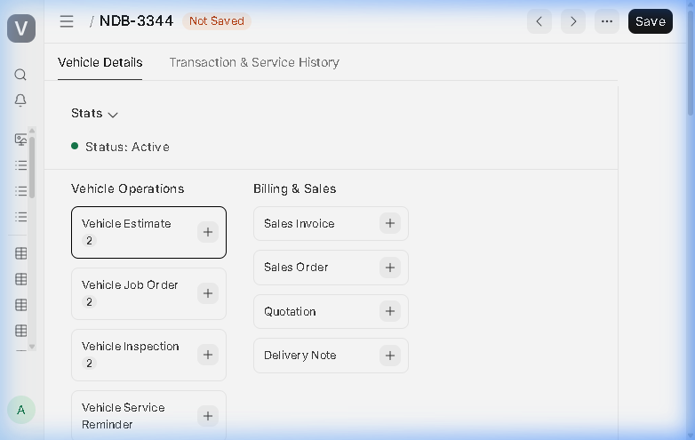
Figure: Customer Vehicle Form — NDB-3344 Master Record and Owner Details

3.2 Multi-Point Electronic Vehicle Inspection
Navigate to /desk/vehicle-inspection. Service advisors evaluate vehicle condition upon intake using customizable checklist templates (Tire Tread, Brake Pads, Battery Voltage, Fluid Levels) and attach intake photos.
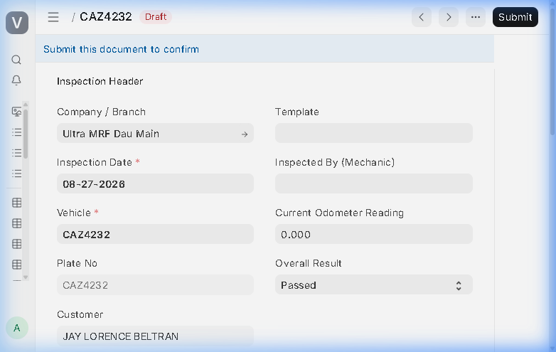
Figure: Vehicle Inspection Form — Electronic Multi-Point Inspection Checklist

3.3 Vehicle Job Order Bay Dispatch & Technician Allocation
Navigate to /desk/vehicle-job-order. Service advisors create job orders tracking labor lines (PMS, Alignment, Balancing) and parts lines (Tires, Oil, Filters). Track status progression: Draft -> In Progress -> Completed -> Released.
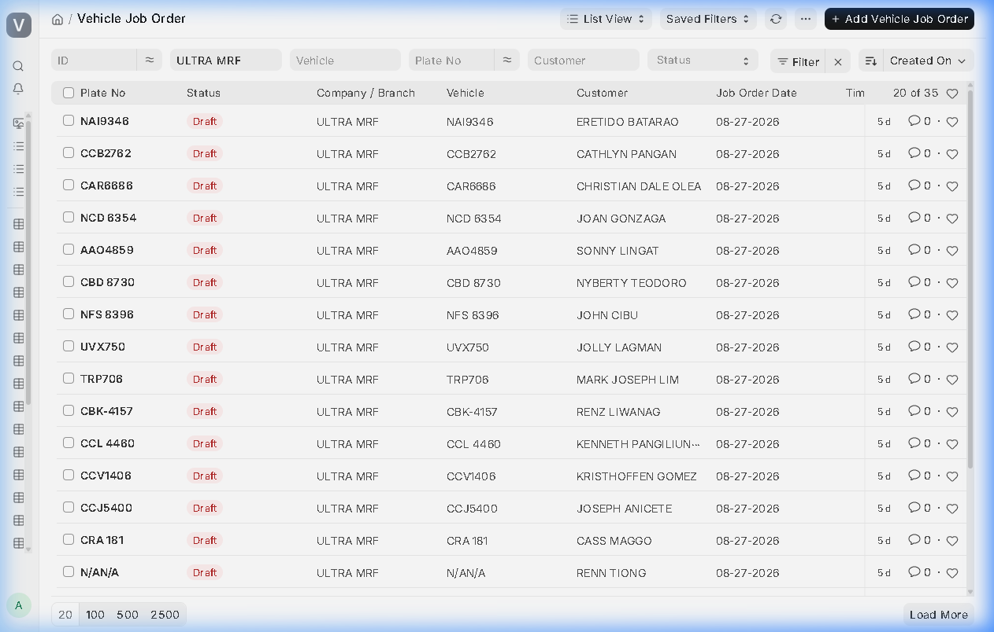
Figure: Vehicle Job Orders List in Desk — Bay Status & Operating Company Breakdown

Module 4: Inventory Management & Receiver Safety Handover
Warehouse controls manage 570 bin locations, inter-branch transfers, and mandatory receiver verification to eliminate unauthorized withdrawals.

4.1 Stock Entry (Material Issue) Safety Verification Check
When creating a Material Issue (/desk/stock-entry), the 'Receiver Verification & Handover Safety Check' box intercepts submission. Technicians must scan their employee QR badge, and a turnover photo proof must be captured.
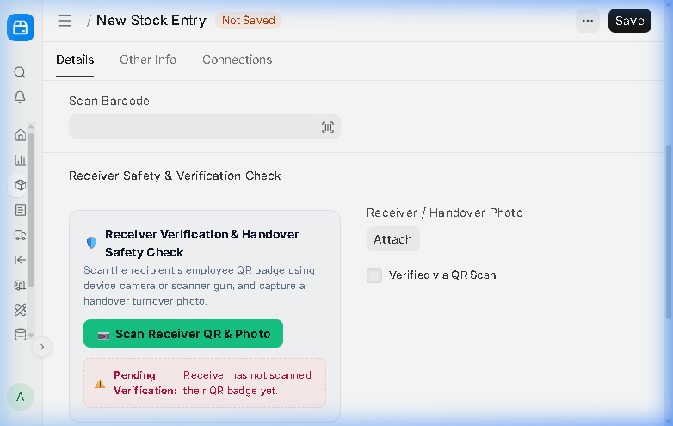
Figure: Stock Entry Material Issue — Receiver Verification & Handover Safety Check Box

4.2 Employee ID Badges with QR Code
Every employee has an official QR badge printable directly from their Employee record (/desk/employee) or via the POS Terminal. Scanning the QR code instantly verifies the employee's name, ID, and company.
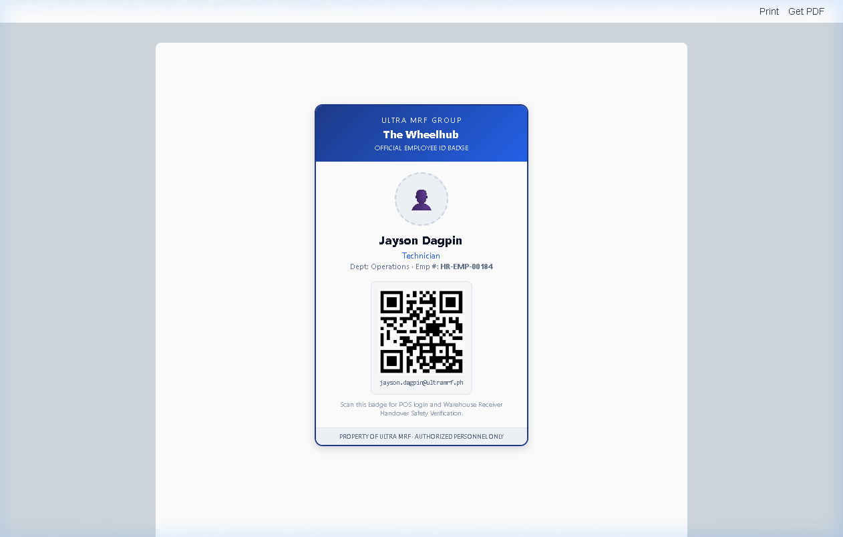
Figure: Official Employee ID Badge with QR Code — Ready to Print for Technicians

Module 5: Buying, Procurement & Executive Approvals
Governs tire and parts procurement contracts, vendor receipts, and multi-branch management approvals.

5.1 Purchase Orders & 3-Way Matching
Navigate to /desk/purchase-order. Issue commercial purchase orders to tire manufacturers and parts distributors. Compares quantities against Goods Receipts and Supplier Invoices.
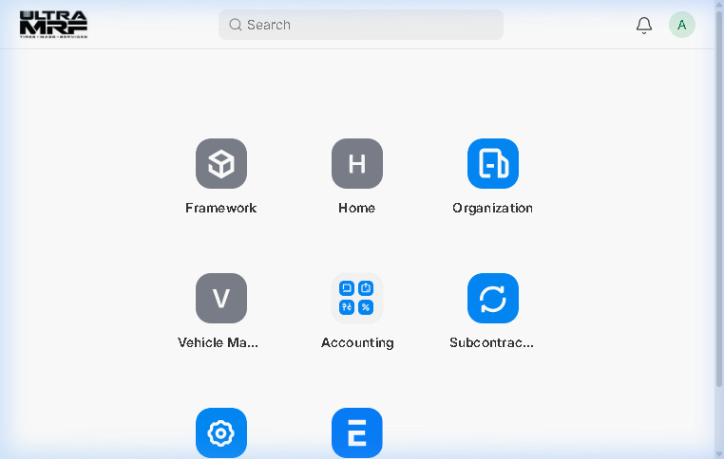
Figure: Purchase Order Form (PUR-ORD-2026-00010) — Supplier Procurement Details

5.2 Executive Dashboard Approvals Tab with Direct Desk Routing
Open /executive-dashboard and click the Approvals tab. Executives view live pending draft cards across 9 DocTypes. Clicking 'View all [DocType]s in Desk ->' opens the canonical desk list view pre-filtered to the operating company.
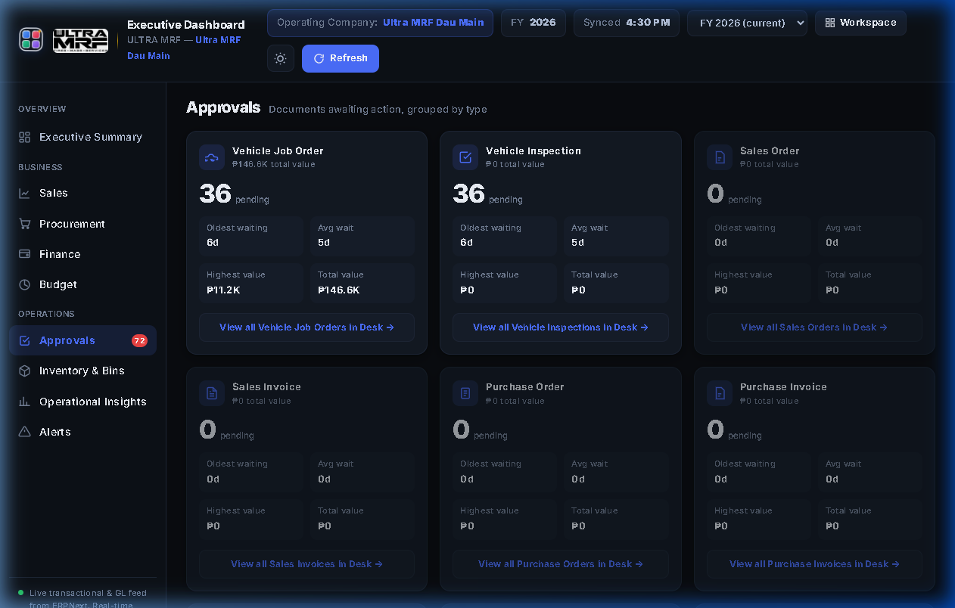
Figure: Executive Dashboard — Approvals Tab with Canonical Desk Routing

Module 6: Fixed Assets & Automated Depreciation Accounting
Capitalizes heavy automotive workshop machinery across all service centers with automated straight-line depreciation accounting under IAS 16.

6.1 Workshop Machinery Asset Master (10 Capitalized Machines)
Navigate to /desk/asset. Capitalized machinery includes 3D Wheel Aligners, Automatic Tire Changers, Dynamic Balancers, 2-Post Hydraulic Lifts, and AC Recovery Stations.
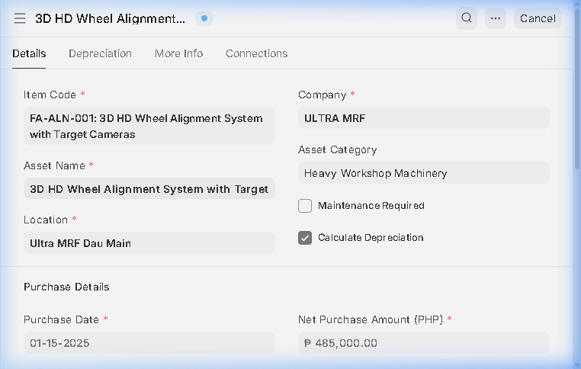
Figure: Fixed Asset Master Form — 3D HD Wheel Alignment System

6.2 Automated Monthly Straight-Line Depreciation Schedule
Under the Depreciation Schedule tab, ERPNext calculates exact monthly depreciation amounts and automatically generates monthly General Ledger journal entries crediting Accumulated Depreciation.
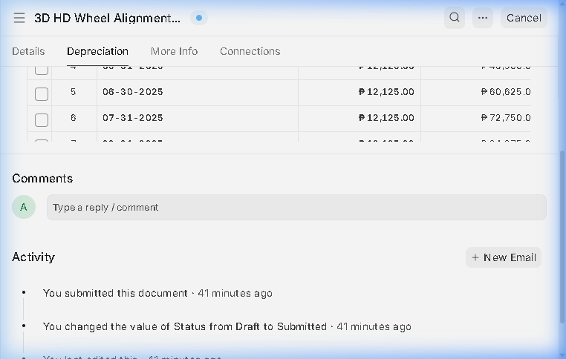
Figure: Fixed Asset Form — Straight-Line Monthly Depreciation Schedule Tab

