Fr. Conceicao Rodrigues College of Engineering, Bandra (W)
SE Electronics & Computer Science (SEM III-IV)
Mini Project-1A Proposal Form
AY -2022 - 23

Name of the student(s) with roll numbers
- RATAN SINGH [ ROLL NO.: - 9511]
- AARUSH WASNIK [ ROLL NO.: - 9517]
2. Title of the Mini Project:
“WEB SEARCH ENGINE- For Turf Booking”

- Mini Project Category:
Research | √ | Software | √
Application | √ | Hardware
Product |  | Software and Hardware

- Mini Project Area/ Problem Characteristics:
Analog Circuits |  | Software Tools | √
Digital Circuits |  | Mobile Application
Micro-Controller based circuits |  | DBMS/Data Structure Application | √
Basic Science/Engineering |  | Social/Environmental issues
Others (Please Specify)

Background
In this rapid developing world, the area available for outdoor activities has been reducing day-by-day or another option available for the people is to book a turf for limited period of time. Also, in public open ground there are more chances of getting restricted in the particular area or there might be disputes taking place among the people. So, now-a-days people prefer to play in turf rather than in open ground. But the problem faced by the user/people is that they don’t have enough resource or a single platform where they can browse and book the turf with best deal without doing any manual work for long period of time. So, we decided to develop a web search engine which will provide all the required services to the user.
The main characteristics of our platform is that it is not a website designed for the turf booking but it’s a web search engine which will be hosting all the best deal available on the that particular turf. It will sort all the turf with best deal within the selected price range with most of the amenities and services and also based on ratings given to the turf and their location.
5 A. Mini Project Abstract:
PURPOSE: - This study aims to design a web search engine to evaluate the best deal for the users while booking their turf along with another add-on’s.
DESIGN: - We will be using simple web development languages to build the web search engine which will perform reliability analysis to get the best deal with the help of measurable scales such as rating, amenities, price range, chatbot and much more.
ORIGINALITY: - This one of the first web engine that analyses the input resources and sort using algorithms and display the required output.

5 B. Project Objectives: -
- To determine the keyword and then used search algorithm mostly binary search and find the most accurate output.
- Using various filters (such as rating, amenities, price range) as keywords to find the most accurate search result.
- Using sorting algorithm with condition term frequency of filter keyword .

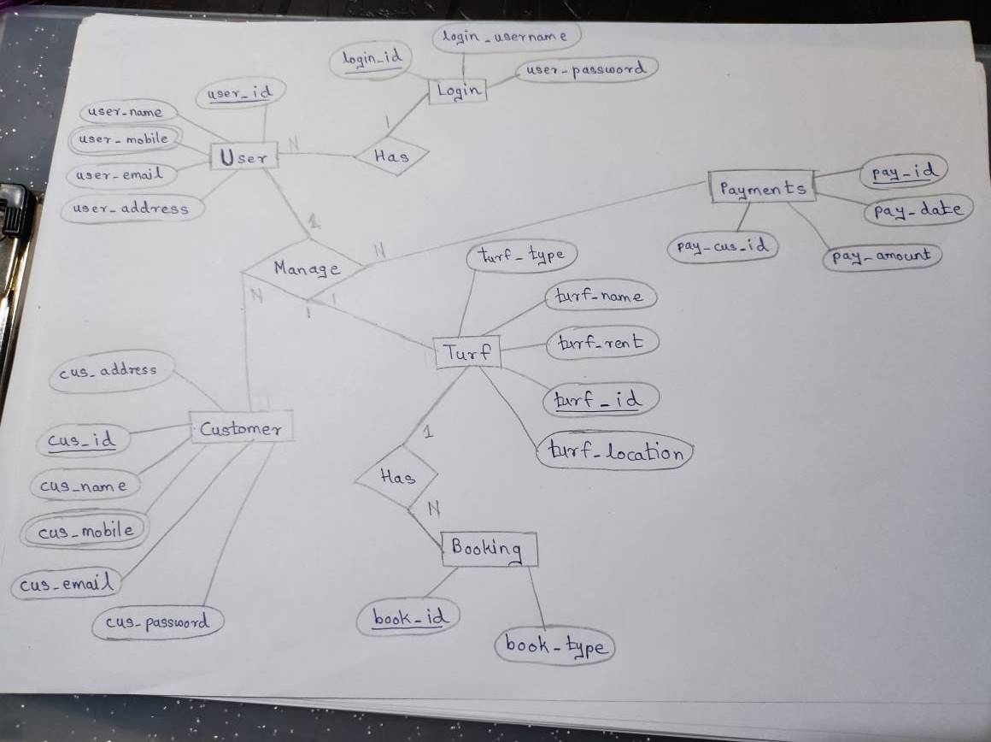
Technical Feasibility

System Requirements

7.1 Software Requirements
- Client-side Programming Language (JavaScript)
- External CSS-For separate CSS file
- HTML
- Embedded CSS- For elements within web page
- Top Level Domain- (.in)
- Image File formats- Portable Network Graphics (PNG)
- Python

- What is the Novelty / Innovation/ Social relevance in the proposed project?
A customized web search engine specifically for turf booking. The only search engine for turf booking.
Also, a chatbot will be present which will help to give suggestion to user.

References

Web Technologies used by Trivago.be (w3techs.com)

Google Scholar

