ArkCase Test Cases

Test Case: Change Profile picture

Steps:

1. Log into the application.
2. Click on the black drop-down arrow underneath the username at the top left screen.
3. Click on Profile.
4. Click on Change Picture, located underneath the user picture.
5. Select new picture and click Open.

Bugs founded:

* There are no restriction on image format, it can be uploaded image formats as: jpeg, gif, png etc.
* There is no restriction at all. All kind of files can be uploaded, such as : txt, xml, doc, msi, exe etc.

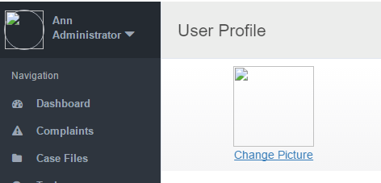

Test Case: Contact Information

Steps:

1. Log into the application.
2. Click on the black drop-down arrow underneath the username at the top left screen.
3. Click on Profile.
4. Click on the first text field under Contact information.
5. Edit the text and click the check mark to save changes.
6. Repeat these steps for each text field in Contact Information and Company Detail.

Bugs founded:

* There are no restriction in input fields and range, anything from keyboard can be entered.

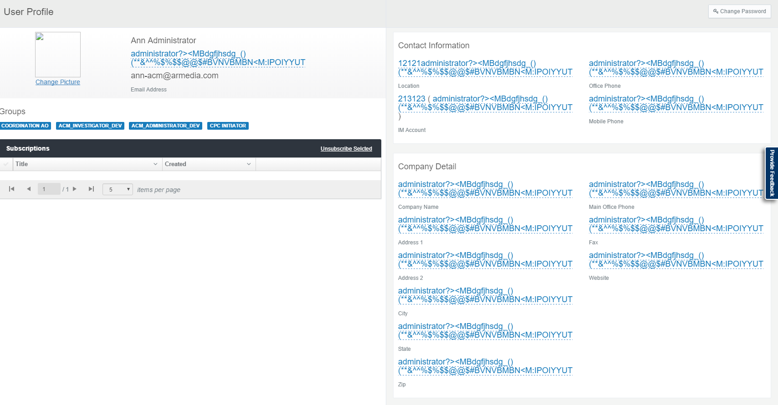

Test Case: Contact Information

Steps:

1. Log into the application.
2. Click on the black drop-down arrow underneath the username at the top left screen.
3. Click on My Profile.

Omissions found:

* Label is named “Unsubscribe Selcted”. It should be “Unsubscribe Selected”.

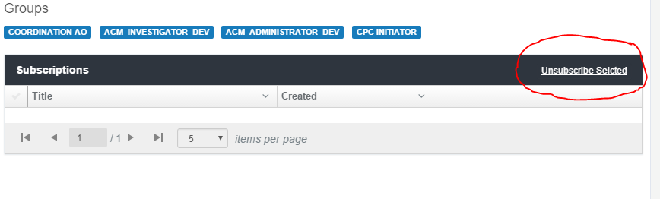

Test Case: Sidebar

Steps:

1. Log into the application.
2. Click on the arrow at the bottom-right side of sidebar to collapse the sidebar.

Omissions found:

* When is clicked on the black drop-down arrow underneath the username at the top left screen the drop down menu is half showed.

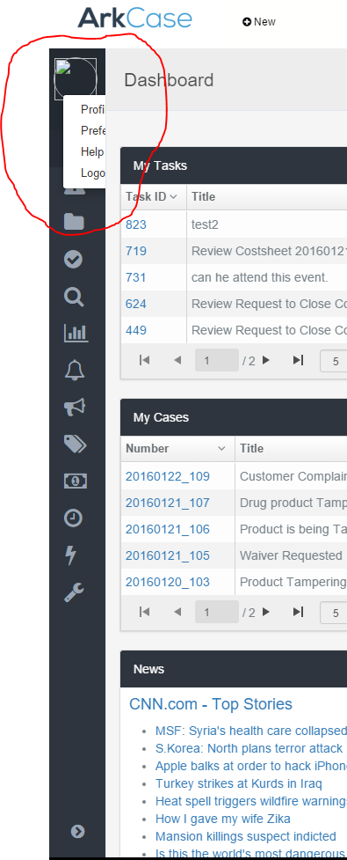

Test Case Dashboard Title:

Steps:

1. Log into the application.
2. Click the enable edit mode icon (pen and paper icon) in the right hand corner of the Dashboard.
3. Click on the edit widget configuration.
4. Set Title on the widget

Omissions found:

* There are no restriction for the title field

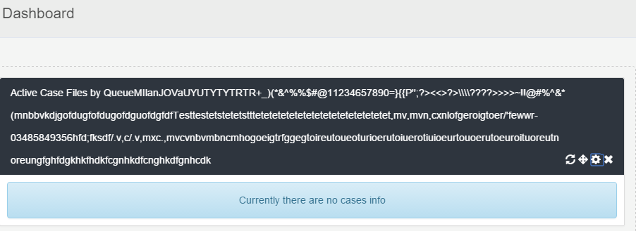

Test Case: New Task

Steps:

1. Log into the application.
2. Click on the new button at the top of the screen.
3. Click on Task.
4. Fill out all information on the form.

Bugs found:

* In Start Date filed, days before today on the calendar should be disabled.
* In the Due Date filed same issue.

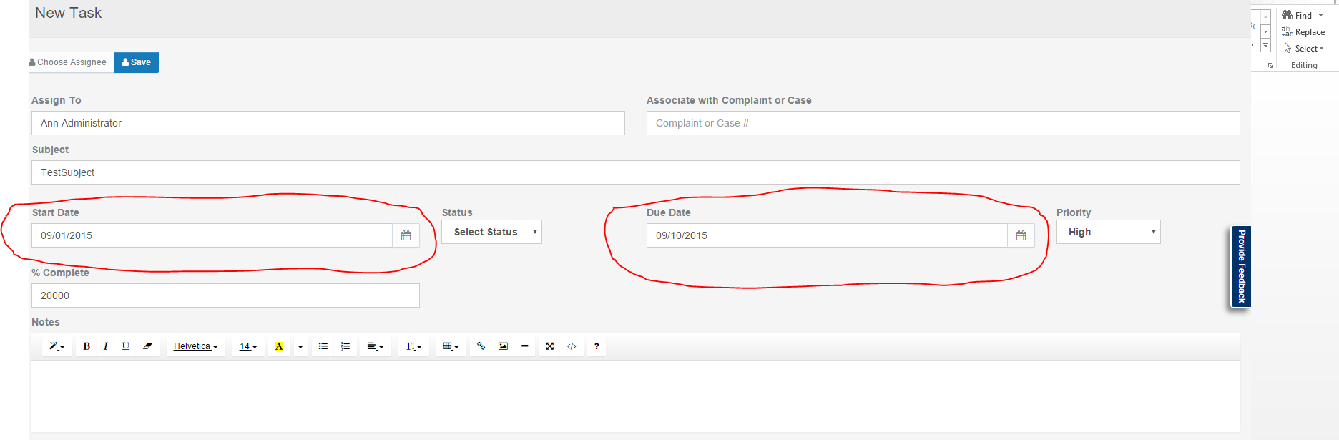

* In the “% Complete” field, there are no restriction. Number grater then 100 will pass.

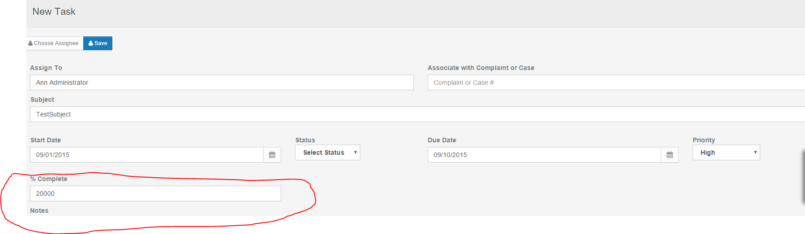

* In the Notes section, the insert Link functionality is not working

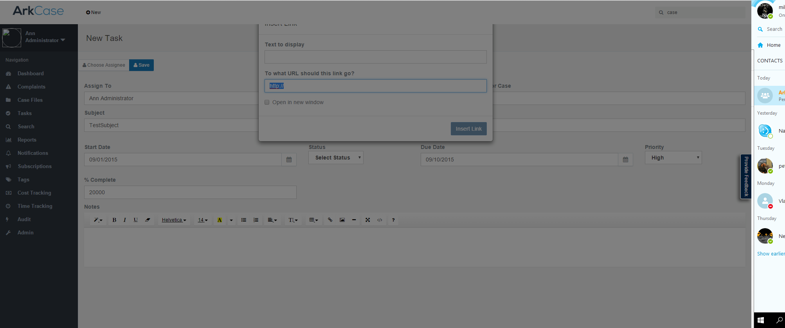

-In the Notes section, Insert picture functionality is not working.

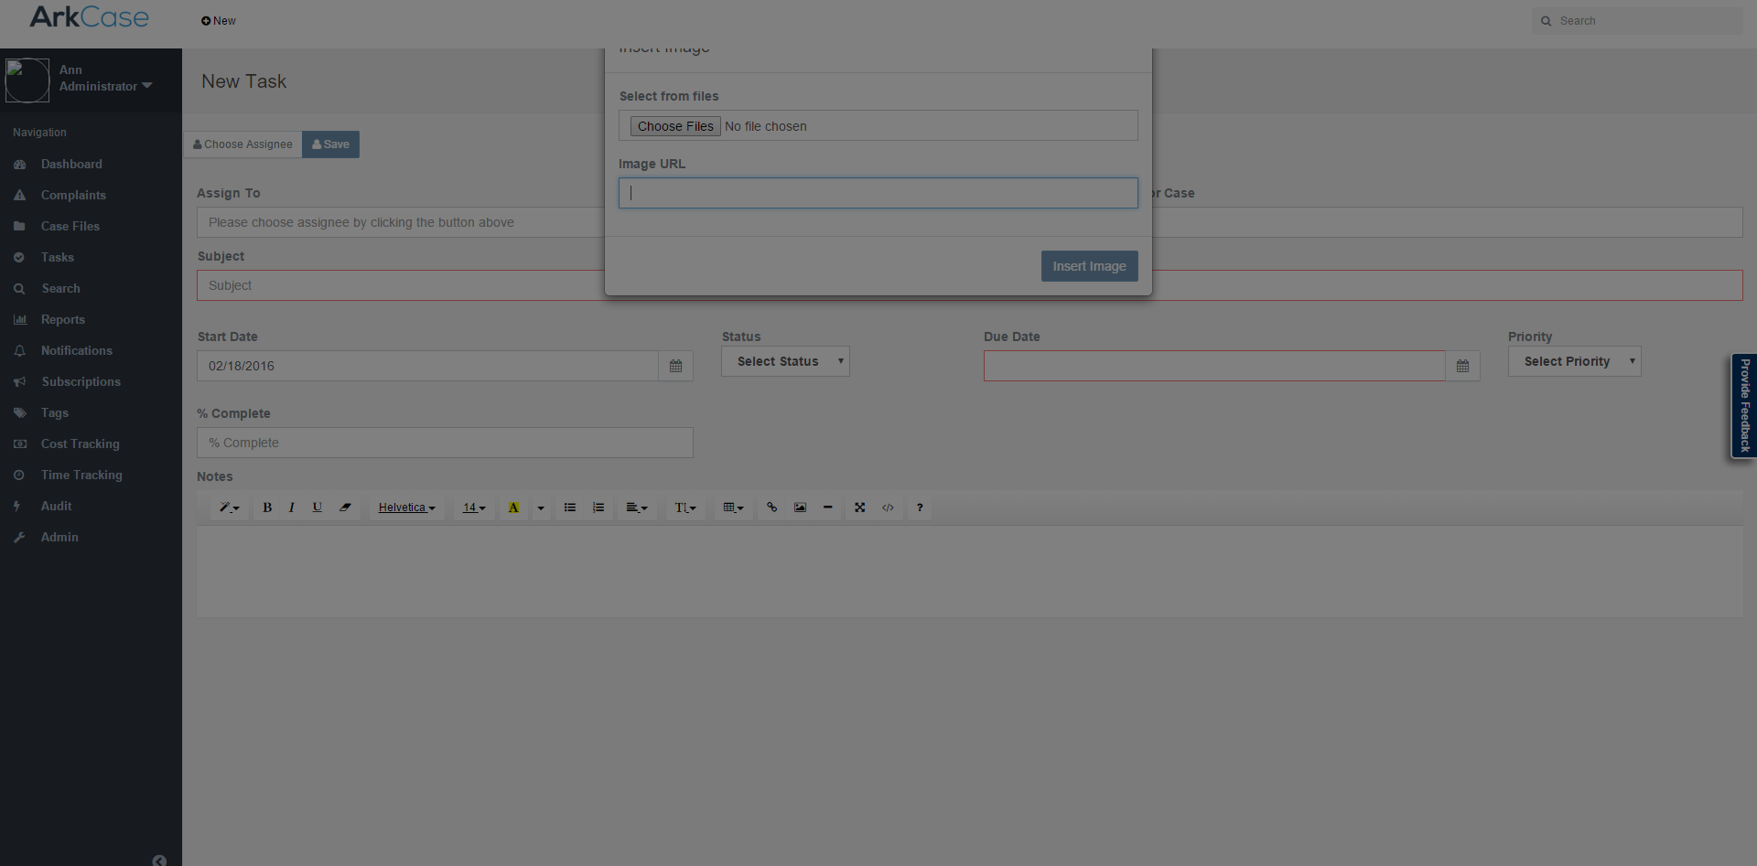

Test Case: Tasks-ADHOC

Steps:

1. Log into the application.
2. Click on Task in sidebar.
3. Click on Tasks title in the information ribbon.
4. Edit Assignee and click the check button.

Errors found:

* When you choose new assignee from dropdown menu and click the check button, name changes but only for 1 second and then returns to the first one.

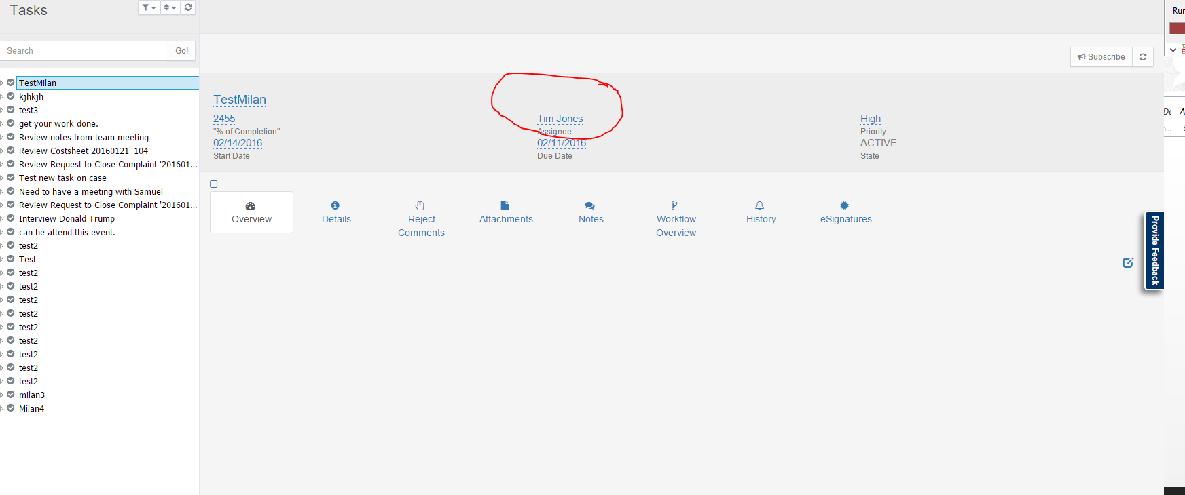

Test Case: Tasks-ADHOC (Add widget)

Steps:

1. Log into the application.
2. Click on Task in sidebar.
3. Click on Tasks title in the information ribbon.
4. Click on enable edit button.
5. Add new widget.

Bugs found:

* Titles of the widgets are wrong.

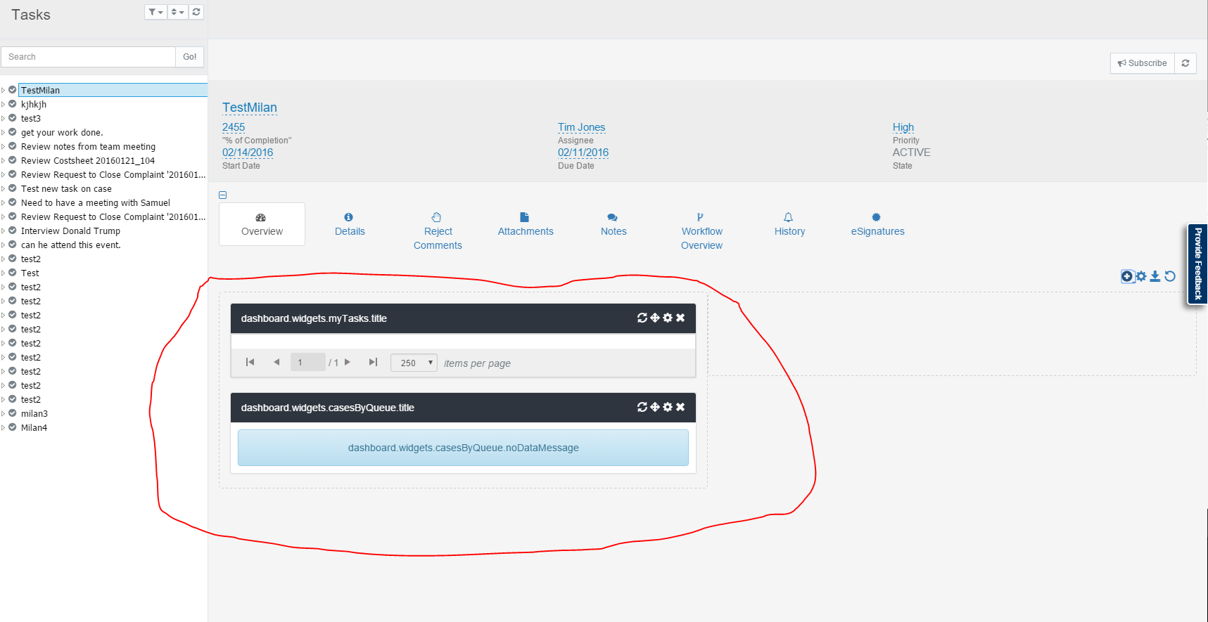

Test Case: Tasks-ADHOC (Add attachments)

Steps:

1. Log into the application.
2. Click on Task in sidebar.
3. Click on Show links .
4. Click on Attachments.
5. Right click on the Root section and add new document.

Bugs found:

* Al kind of files can be added as “New Document”

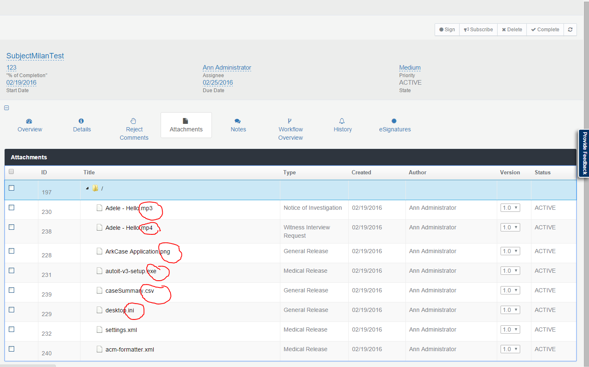

Test Case: Tasks-ADHOC (Add attachments)

Steps:

1. Log into the application.
2. Click on Task in sidebar.
3. Click on Show links.
4. Click on Attachments.
5. Right click on the Root section and add New Folder.
6. Create New Folder inside the folder created before.
7. Delete the first created folder (parent).

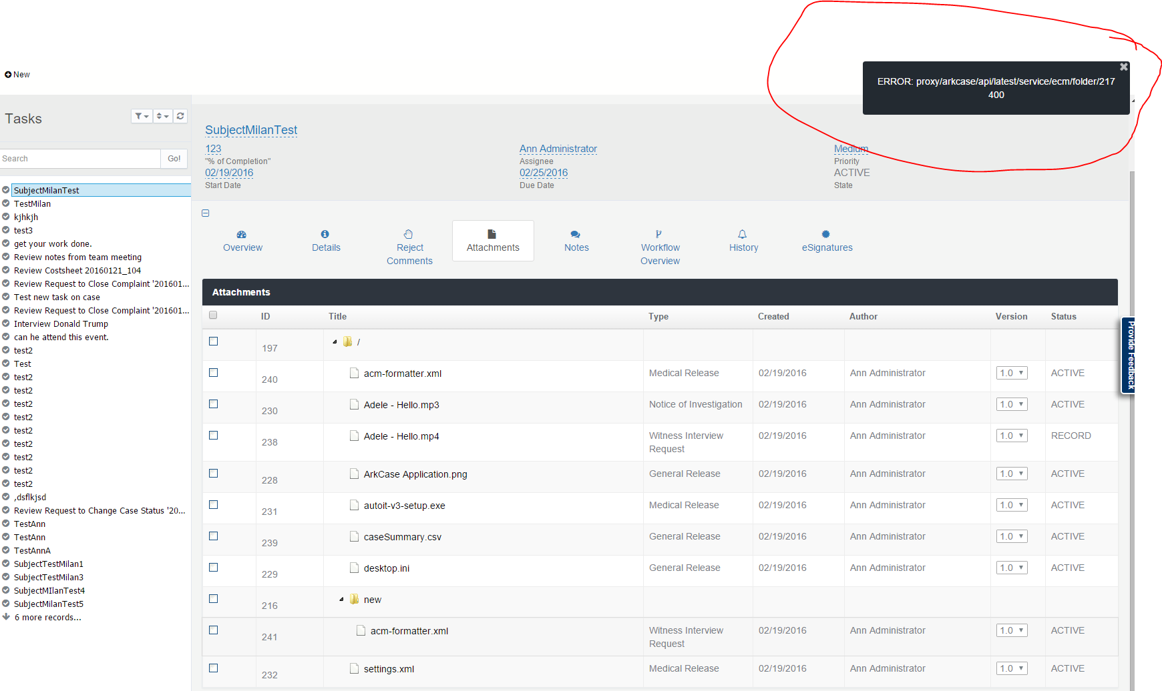

Bugs found:

* The folders cannot be deleted, although the folders are empty.

Test Case: Tasks-ADHOC (Reject Comments)

Steps:

1. Log into the application.
2. Click on Task in sidebar.
3. Click on Show links.
4. Click on Reject Comments.
5. Add new.

Bugs found:

* Cannot be created new rejected comment.

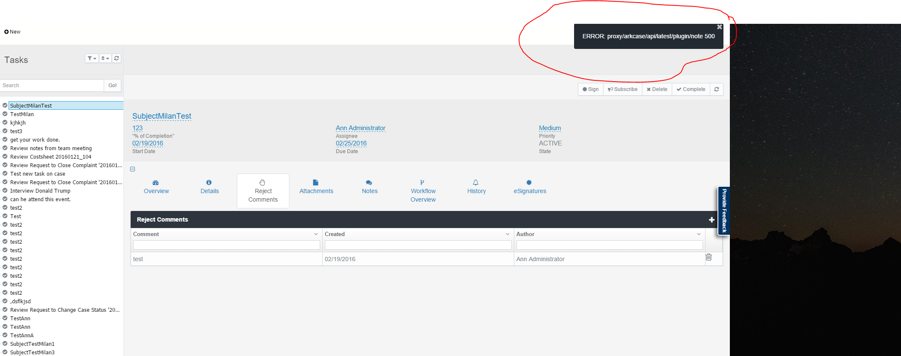

Test Case: Tasks-ADHOC (Closed Task)

Steps:

1. Log into the application.
2. Click on Task in sidebar.
3. Click on Active Task.
4. Click on Complete check button to close the Task.

Bugs found:

* All editable buttons are still enabled. When the values is changed in any of the fields this error is thrown.

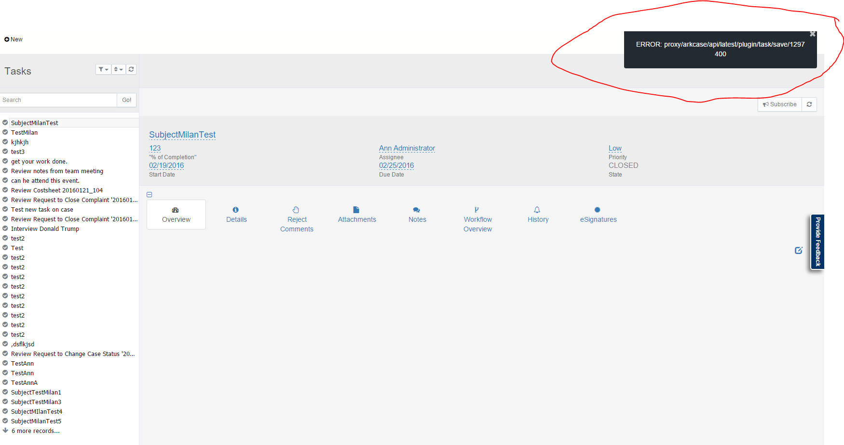

* Uploading files in Attachments is still enabled.
* Add new widgets.
* Task Details.
* New notes and etc.