**SYNOPSIS ON**

**“DataFlowX:Cloud Service”**

Submitted in

Partial Fulfillment of requirements for the Award of Degree of

Bachelor of Technology

*In*

Computer Science and Engineering

By

**(Project Id: 25_CS_AI_4A_09)**

**Ayush Verma (2101641520040)**

**Aakarshit Srivastava (2101641520001)**

**Bhaskar Banerjee (2101641520042)**

**Diksha Tiwari (2101641520049)**

**Ankita Singh (2101641520021)**

Under the supervision of

**Dr. Malti Nagle**

**(Assistant Professor)**



**Pranveer Singh Institute of Technology**.

Kanpur - Agra - Delhi National Highway - 19 Bhauti -Kanpur - 209305.

(Affiliated to Dr. A.P.J. Abdul Kalam Technical University)

1. **Introduction**

As the world becomes more digital, the amount of data created and collected constantly grows and accelerates. Analysis of this ever-growing data becomes a challenge with traditional analytical tools. Innovation is required to bridge the gap between generated data and data that can be analyzed effectively.

Big data tools and technologies offer opportunities to analyze data efficiently so you can better understand customer preferences, gain a competitive advantage in the marketplace, and grow your business. Data management architectures have evolved from the traditional data warehousing model to more complex architectures that address more requirements, such as real-time and batch processing, structured and unstructured data, high velocity transactions, and so on.

AWS provides a broad platform of managed services to help you build, secure, and seamlessly scale end-to-end big data applications quickly and with ease. Whether your applications require realtime streaming or batch data processing, AWS provides the infrastructure and tools to tackle your next big data project. There is no hardware to procure, no infrastructure to maintain and scale— only what you need to collect, store, process, and analyze big data. AWS has a system of analytical solutions specifically designed to handle this growing amount of data and provide insight into your business.

**1.2 AWS (Amazon Web Services)**

Amazon Web Services is a Cloud Platform which is subsidiary of Amazon founded by Jeff Bezos. AWS was established to solve many problems like provided flexibility in Operations, reduction in cost, increase in transparency, Enhanced risk management and improved Security etc., AWS was established in the year 2006 by launching Elastic Cloud EC2. This made the hosting and maintenance of websites in an easy, secured and at reduced costs. It reduced the Cost of establishing a private server for small Applications and made management of websites and other applications easier as it will be maintained by the AWS itself thereby reduces the risk and maintenance of the server. AWS also provides backup to the data hosted on the AWS platform.

**1.3 Amazon Athena**

Amazon Athena is an interactive query service that makes it easy to analyze data directly in Amazon Simple Storage Service (Amazon S3) using standard SQL. With a few actions in the AWS Management Console, you can point Athena at your data stored in Amazon S3 and begin using standard SQL to run ad-hoc queries and get results in seconds. Athena is serverless, so there is no infrastructure to set up or manage, and you pay only for the queries you run. Athena scales automatically—executing queries in parallel—so results are fast, even with large datasets and complex queries.

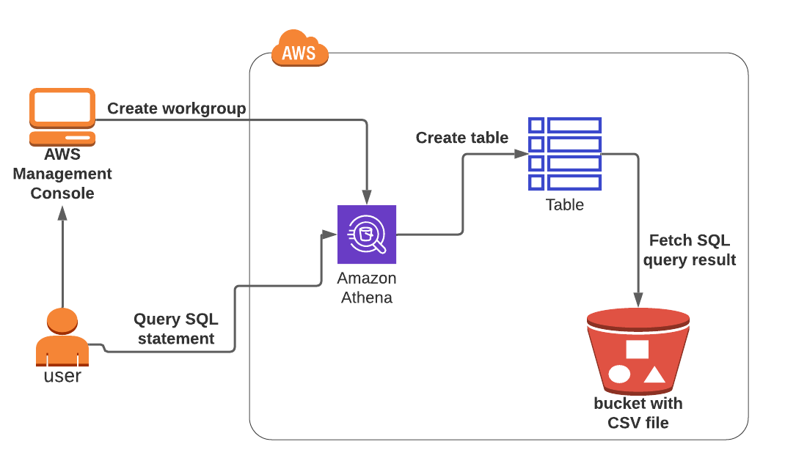

**Fig 1: Architecture of Athena**

**1.4 AWS Glue**

AWS Glue is a serverless data integration service that makes it easy to discover, prepare, and combine data for analytics, machine learning, and application development. AWS Glue provides all of the capabilities needed for data integration. It uses both visual and code-based interfaces to make data integration easier. Users can easily find and access data using the AWS Glue Data Catalog. Data engineers and ETL developers can visually create, run, and monitor ETL workflows with a few clicks in AWS Glue Studio. Data analysts and data scientists can use AWS Glue DataBrew to visually enrich, clean, and normalize data without writing code.

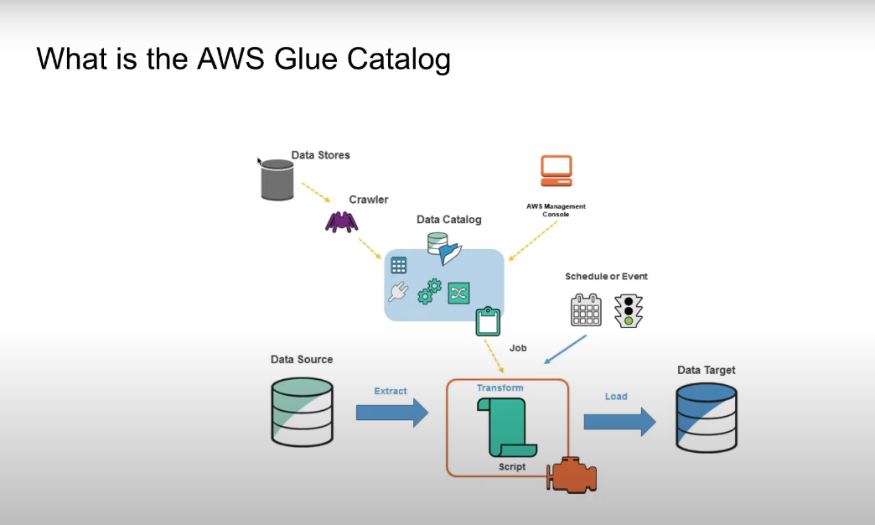

**Fig 2: Architecture of AWS Glue Catalog**

**1.5 AWS Lambda**

AWS Lambda enables you to run code without provisioning or managing servers. You pay only for the compute time you consume – there is no charge when your code is not running. With Lambda, you can run code for virtually any type of application or backend service – all with zero administration. Just upload your code and Lambda takes care of everything required to run and scale your code with high availability. You can set up your code to automatically trigger from other AWS services or call it directly from any web or mobile app.

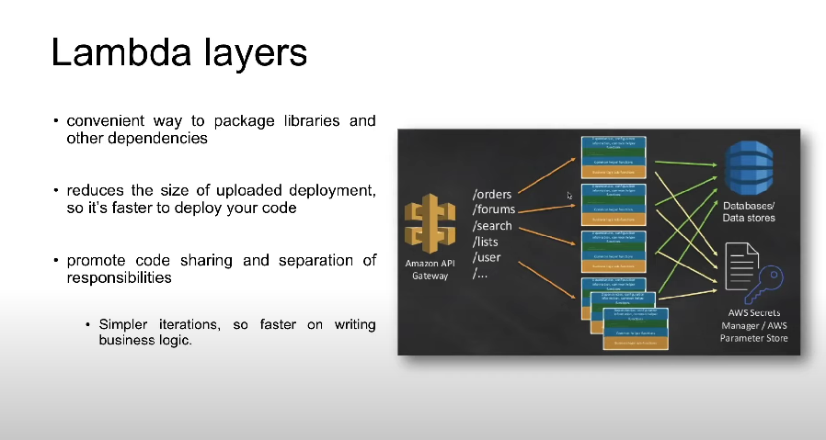

**Fig 3: Architecture of Lambda Layers**

**1.6 Amazon SageMaker**

**Amazon SageMaker** is a fully managed service for building, training, and deploying machine learning models. It provides a unified development environment, infrastructure management, governance tools, and advanced features like automated insights and scalability. SageMaker empowers data scientists and developers to work efficiently with ML models.

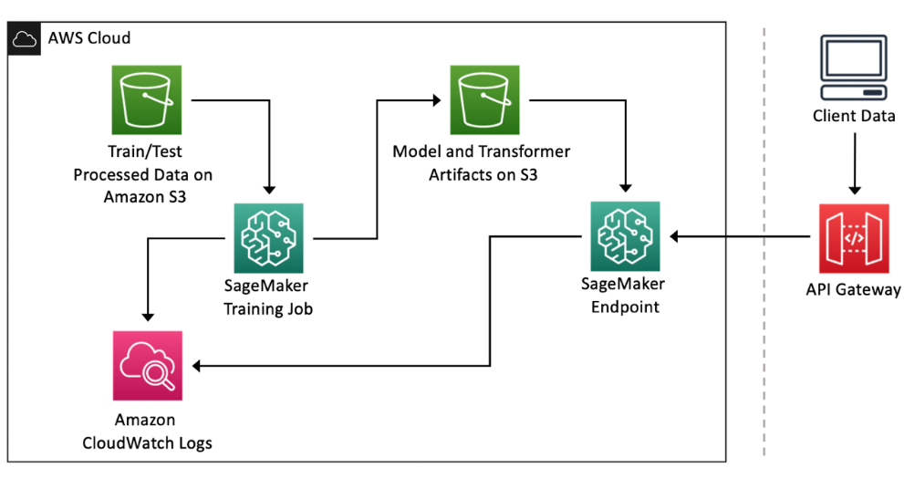

**Fig 4: Architecture of Amazon SageMaker**

**1.7 Amazon QuickSight**

Amazon QuickSight is a robust cloud-based business intelligence (BI) service that enables you to deliver clear insights to colleagues regardless of their location. Here are the key points:

* Data Integration and Variety:
  + QuickSight seamlessly connects to various data sources, including AWS data, third-party data, spreadsheets, and more.
  + It consolidates information into a single data dashboard.
* Key Features:
  + SPICE Engine: QuickSight’s in-memory engine ensures rapid data exploration and visualization.
  + Serverless and Cost-Effective: No server setup or management required.
  + Collaborative Analytics: Users can collaborate without installing applications.
  + Unified Data Analysis: Combine diverse data sources.
  + Dashboard Creation and Sharing: Publish interactive dashboards.
  + Fine-Grained Access Control: Share only relevant data.
* Advanced Features (Enterprise Edition):
  + Automated Insights: ML-powered insights.
  + Scalability: Easily scale from 10 to 10,000 users.

Why QuickSight?

* Unlock Insights: Explore data visually.
* Save Time and Money: Benefit from automated insights.
* Collaborate Effortlessly: Share secure dashboards.

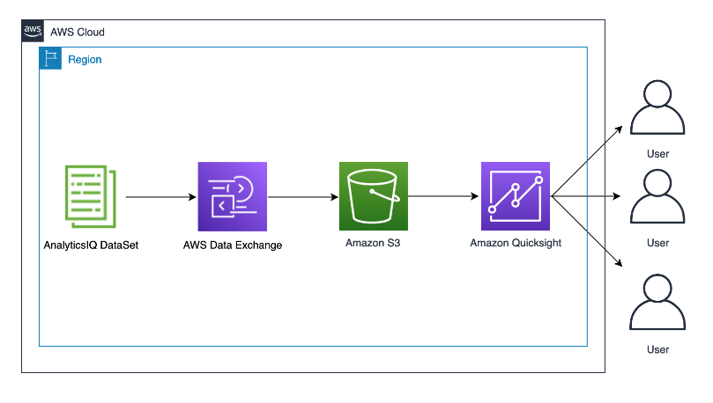

**Fig 5: Architecture of Amazon QuickSight**

1. **Project Objective**

DataFlowX is a robust and agile data analytics process designed to seamlessly manage the flow of data, extract valuable insights, and drive informed decision-making. At its core, DataFlowX is engineered to streamline the journey of raw data from its source to actionable insights, empowering organizations to harness the full potential of their data assets.

With DataFlowX, data flows through a series of orchestrated steps, including ingestion, transformation, analysis, and visualization, with precision and efficiency. Leveraging cutting-edge technologies and best-in-class AWS services, DataFlowX ensures that data is processed, refined, and analyzed in a secure and scalable environment.

DataFlowX embraces the principles of flexibility and adaptability, allowing organizations to tailor the analytics pipeline to suit their unique needs and objectives. Whether it's real-time data processing, batch analytics, or predictive modeling, DataFlowX provides the framework and tools to turn data into actionable insights.

Key Features of DataFlowX:

* Seamless Data Ingestion: Effortlessly collect data from various sources, including databases, APIs, and streaming platforms, and ingest it into the analytics pipeline.
* Transformative Data Processing: Utilize powerful ETL (Extract, Transform, Load) capabilities to cleanse, enrich, and transform raw data into a format suitable for analysis.
* Advanced Analytics: Leverage sophisticated analytical techniques to uncover patterns, trends, and correlations within the data, enabling data-driven decision-making.
* Interactive Visualization: Create immersive dashboards and visualizations using state-of-the-art tools, allowing stakeholders to explore and interpret insights intuitively.
* Scalable Infrastructure: Harness the scalability and reliability of AWS infrastructure to handle large volumes of data and accommodate evolving business needs.
* Security and Compliance: Implement robust security measures and adhere to regulatory compliance standards to safeguard sensitive data throughout the analytics process.

DataFlowX empowers organizations to unlock the full potential of their data assets, driving innovation, improving operational efficiency, and gaining a competitive edge in today's data-driven landscape. With DataFlowX, the journey from data to insights is not just a process—it's a transformational experience.

1. **Feasibility Study:**

**3.1 Technical Feasibility:**

* Service Integration: Determine if AWS services can seamlessly integrate and work together for data analytics tasks.
* Data Compatibility: Ensure data from various sources can be effectively ingested into AWS S3 and processed using the selected services.
* Scalability: Evaluate if the architecture can handle increasing data volumes and user demands by scaling resources efficiently.
* Performance: Assess if the solution meets performance requirements in terms of query response times, data processing speed, etc.
* Availability and Reliability: Verify if AWS services provide the necessary uptime, fault tolerance, and data durability for uninterrupted operation.
* Security: Ensure robust security measures are in place to protect data at rest, in transit, and during processing.
* Cost Optimization: Optimize resource usage and leverage cost-effective pricing models to minimize expenses while meeting performance needs.
* Technology Stack Compatibility: Confirm that the chosen technology stack aligns with AWS services and supports development and management tasks effectively.
* Data Governance: Implement policies and practices to ensure data quality, consistency, and compliance throughout the analytics lifecycle.
* Monitoring and Analytics: Set up monitoring tools to track performance metrics and troubleshoot issues proactively.

**3.2 Financial Feasibility:**

* Total Cost of Ownership (TCO): Estimate upfront and ongoing costs associated with deploying and maintaining the solution on AWS.
* Cost-Benefit Analysis: Compare projected benefits with estimated costs to determine if the investment is justified.
* ROI: Calculate the expected return on investment to assess the financial viability of the project.
* Payback Period: Determine how long it will take for the benefits to outweigh the initial investment.
* Risk Analysis: Identify and mitigate financial risks associated with the deployment of AWS services.
* Scalability and Flexibility: Evaluate the scalability of the solution and its ability to adapt to changing business needs without incurring significant additional costs.
* Opportunity Costs: Consider the potential gains from alternative investments or strategies.
* Budget Allocation: Allocate resources effectively across different components of the solution.
* Continuous Cost Optimization: Implement strategies to optimize costs throughout the project lifecycle.
  1. **Operational Feasibility:**
* Resource Availability Determine if the necessary human and technical resources are available or can be acquired to implement and maintain the solution effectively.
* Skills and Training: Assess if the existing workforce has the required skills to work with AWS services or if training needs to be provided.
* Change Management: Evaluate the organization's readiness for change and its ability to adapt to new processes and technologies.
* User Acceptance: Ensure that end-users understand and accept the benefits of the new solution and are willing to adopt it in their workflows.
* Support and Maintenance: Plan for ongoing support and maintenance activities to keep the solution operational and address any issues that may arise.
* Integration with Existing Systems: Determine how the new solution will integrate with existing systems and processes within the organization.

**3.4 Legal Feasibility:**

* Data Privacy and Compliance: Ensure that the solution complies with relevant data privacy regulations (e.g., GDPR, HIPAA) and industry-specific compliance standards.
* Data Ownership and Usage: Clarify ownership rights and usage permissions for the data being processed and analyzed within the AWS environment.
* Intellectual Property Rights: Address any concerns related to the ownership of intellectual property rights associated with the data analytics solution and its outputs.
* Contractual Obligations: Review contractual agreements with AWS and any third-party vendors to ensure compliance with legal requirements and obligations.
* Data Residency and Sovereignty: Consider legal requirements related to data residency and sovereignty, especially if the data is subject to jurisdiction-specific regulations.
* Liability and Risk Mitigation: Identify potential legal risks associated with the deployment of AWS services and implement measures to mitigate liability, such as indemnification clauses and insurance coverage.
* Ethical Considerations: Take into account ethical principles and guidelines when processing and analyzing data to ensure fairness, transparency, and accountability in decision-making processes.

**3.5 Schedule Feasibility:**

Schedule feasibility assesses whether the deployment of the data analytics solution within AWS can be accomplished within the allocated time frame. It involves defining project timelines, ensuring resource availability, identifying dependencies, managing risks, adopting suitable project management approaches, fostering communication, allocating time for testing and validation, planning for changes, incorporating contingency measures, and documenting project activities for effective handover. By addressing these aspects, the feasibility of adhering to the schedule can be evaluated and managed effectively.

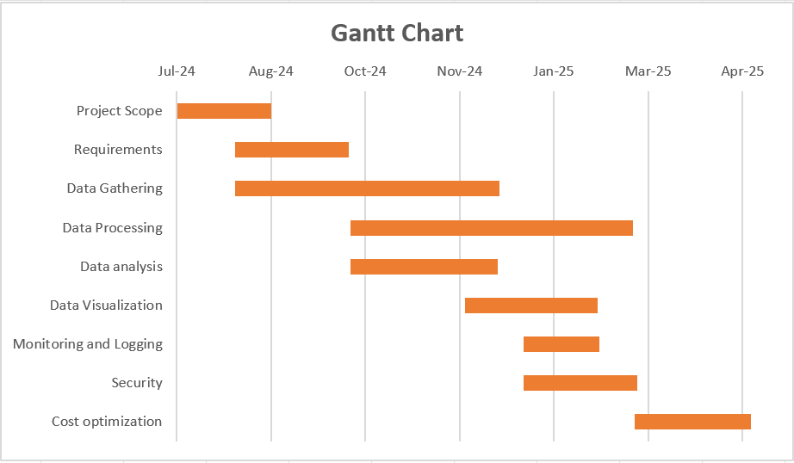

**Fig 6: Gantt Chart**

**4. Methodology/ Planning of work**

Setting up an AWS pipeline for cloud processing and database management involves several AWS services. Here's a basic outline of how you might structure such a pipeline:

**4.1 Data Ingestion:**

Amazon S3 (Simple Storage Service): Start by uploading your data to S3. It's highly durable, scalable, and secure. You can use various methods for uploading data, including AWS CLI, SDKs, or third-party tools.

**4.2 Data Processing:**

4.2.1 AWS Lambda: Use Lambda for serverless computing. You can trigger Lambda functions in response to events in S3, which can process the data.

4.2.2 Amazon EMR (Elastic MapReduce): If you have large-scale data processing needs (e.g., big data analytics), EMR can be used to run distributed frameworks such as Apache Hadoop or Apache Spark.

**4.3 Data Storage:**

4.3.1Amazon RDS (Relational Database Service): If your data is structured and relational, you can use RDS for databases like MySQL, PostgreSQL, or SQL Server.

4.3.2 Amazon DynamoDB: For NoSQL database requirements, DynamoDB provides a scalable, fully managed NoSQL database service.

**4.4 Data Warehousing (Optional):**

4.4.1 Amazon Redshift: If you need a data warehousing solution for analytics and reporting, Redshift can handle petabyte-scale data warehouses.

**4.5 Data Analysis and Visualization:**

4.5.1 Amazon Athena: Query data directly from S3 using standard SQL, without the need to load it into a database. It's useful for ad-hoc analysis.

4.5.2 Amazon QuickSight: For business intelligence and visualization needs, QuickSight can connect to various data sources including S3, Redshift, RDS, etc., and create interactive dashboards.

**4.6 Monitoring and Logging:**

4.6.1 Amazon CloudWatch: Monitor your AWS resources, including Lambda functions, EMR clusters, RDS instances, etc. Set up alarms for specific events.

4.6.2 AWS CloudTrail: Keep track of API activity in your AWS account for auditing and compliance purposes.

**4.7 Security:**

4.7.1 AWS IAM (Identity and Access Management): Control access to your AWS resources using IAM roles and policies.

4.7.2 Encryption: Use AWS Key Management Service (KMS) for encryption of data at rest and in transit.

**4.8 Orchestration and Automation:**

4.8.1 AWS Step Functions: Orchestrate multiple AWS services into serverless workflows. You can coordinate Lambda functions, EMR jobs, and other tasks.

4.8.2 AWS Glue: Build, automate, and monitor ETL (Extract, Transform, Load) workflows. Glue can automatically discover, catalog, and transform your data.

**4.9 Cost Optimization:**

4.9.1 AWS Cost Explorer: Analyse your AWS spending and identify cost-saving opportunities.

4.9.2 AWS Budgets: Set custom cost and usage budgets to track your AWS spending and receive alerts.

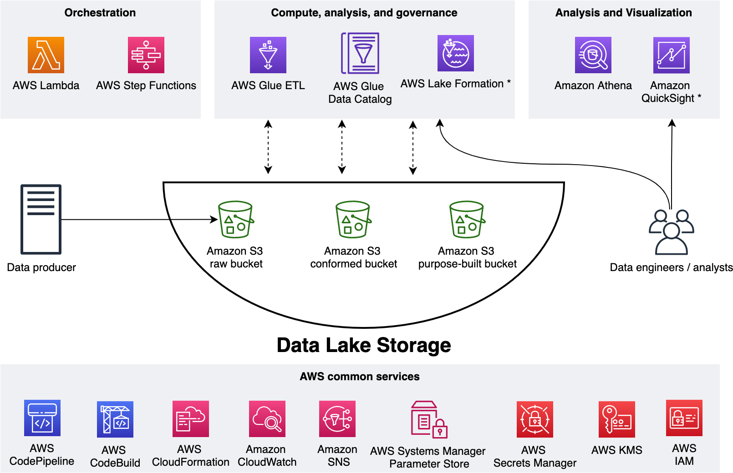

**Fig 7: Architecture of DataFlowX**

**5. Tools/Technology Used:**

* 1. **Minimum Hardware Requirements**

**5.1.1 Local Development Machine**:

5.1.1.1 Processor: Multi-core processor for running development tools and IDEs efficiently.

5.1.1.2 Memory (RAM): At least 8GB RAM for smooth operation of development environments and virtualization.

* + - 1. Storage: Solid-state drive (SSD) for fast read/write speeds, at least 256GB for storing project files and development environments.

**5.1.2 Networking**:

5.1.2.1 High-speed internet connection for accessing cloud services and resources.

* + - 1. Ethernet or Wi-Fi adapter for network connectivity.

**5.1.3 Testing Environment**:

5.1.3.1 Depending on the project's requirements, additional hardware may be needed for setting testing environments, such as virtualization servers or physical servers for testing deployments.

**5.1.4 Backup and Storage**:

5.1.4.1 External storage devices or network-attached storage (NAS) for backups and storing local project files.

**5.1.5 Security**:

5.1.5.1 Firewall/router for network security.

* + - 1. Antivirus software for endpoint protection.

**5.1.6 Miscellaneous**:

5.1.6.1 Monitor, keyboard, and mouse for local machine setup.

5.1.6.2 Power backup solutions (e.g., uninterruptible power supply or UPS) to prevent data loss during power outages.

* 1. **Minimum Software Requirements** 
     1. **Operating System**:

5.2.1.1 Depending on the preferences of the development and operations teams, the project may require an operating system such as Linux (e.g., Ubuntu, CentOS) or Windows Server.

* + 1. **Containerization and Orchestration**:

5.2.2.1 Docker Engine: Software for creating, managing, and running containers.

5.2.2.2 Kubernetes: Container orchestration platform for automating deployment, scaling, and management of containerized applications.

**5.2.3 Services**:

5.2.3.1 AWS ,AZURE ,Google Cloud platform and Machine Learning Algorithms using Multiple interfaces.

1. **References: [IEEE format]:**

* *Amazon Athena*: User Guide Copyright © 2018 Amazon Web Services, Inc. and/or its affiliates. All rights reserved.
* *Automation of Infrastructure Deployment using AWS* Dr. A.C. Santha Sheela, Ramya. G. Franklin, Associate Professor, [2] Assistant Professor, Department of Computer Science and Engineering, Sathyabama Institute of Science and Technology, Chennai, India. ISSN: 2094-0343 2326-9865
* *Big Data Analytics Options on AWS*: AWS Whitepaper Copyright © 2024 Amazon Web Services, Inc. and/or its affiliates. All rights reserved.
* *Lambada: Interactive Data Analytics on Cold Data using Serverless Cloud Infrastructure,* Ingo Müller (ingo.mueller@inf.ethz.ch), Renato Marroquín (marenato@inf.ethz.ch), Gustavo Alonso ([alonso@inf.ethz.ch](mailto:alonso@inf.ethz.ch)).
* *Building Media & Entertainment Predictive Analytics Solutions on AWS* First published December 2016 Updated March 30, 2021. © 2021 Amazon Web Services, Inc. or its affiliates. All rights reserved.
* *Lambda Architecture for Batch and Stream Processing* October 2018 © 2018, Amazon Web Services, Inc. or its affiliates. All rights reserved.
* *Data Warehousing on AWS*: AWS Whitepaper Copyright © 2024 Amazon Web Services, Inc. and/or its affiliates. All rights reserved.