**HeritageAI: Cultural Heritage Preservation and Restoration Using GenAI**

**Problem Statement**

Cultural heritage sites and artifacts are vital to the historical, artistic, and social fabric of civilizations. These invaluable assets, however, are at risk from natural disasters, environmental degradation, human conflicts, and the ravages of time. Traditional restoration methods can be slow, costly, and sometimes limited in their scope, leading to potential loss of cultural knowledge and historical context. The challenge is to develop innovative, scalable, and accessible solutions for restoring and preserving these treasures. Advanced AI technologies offer promising tools to accurately reconstruct and enhance damaged heritage sites and artifacts, helping ensure their survival for future generations.

Heritage AI is a conceptual web application designed to use advanced artificial intelligence technologies for the restoration and preservation of cultural heritage sites. The application allows users to upload images of damaged heritage sites or artifacts and generate restored images and 3D models. Users can also view these models in augmented reality (AR) and download them. The application will store all generated models and images in a database, with AR views including descriptive information about the heritage sites.

**Heritage AI** is a web application designed to restore and preserve cultural heritage sites and artifacts using artificial intelligence. Many historical sites and artifacts have been damaged over time due to various factors like natural disasters, human conflicts, environmental degradation, or aging. These cultural treasures are crucial for understanding our history and identity, but traditional restoration methods can be slow, expensive, and sometimes limited.

Heritage AI aims to make the restoration process more efficient and accessible. The application allows users to upload images of damaged sites or artifacts and uses advanced generative AI diffuser models, fine-tuned based on the strength of the damage, to generate restored images and 3D models. Users can view these models in augmented reality (AR), providing an immersive experience that helps them understand the historical context and significance of these sites and artifacts.

**Features to Build:**

* **Image Upload and Text Description**: Users can upload images of damaged heritage sites or artifacts.Users can provide descriptions to give more context about the uploaded images.
* **Restored Image Generation:** The application uses generative AI diffuser models to generate images showing how the sites or artifacts would look if restored. These models are fine-tuned based on the severity of the damage.
* **3D Model Generation:** From the restored images, the application creates 3D models, offering a more comprehensive view of the site or artifact.
* **360-Degree Video Integration:** Provide 360-degree videos of the restored sites or artifacts, allowing users to explore the restoration from multiple angles before moving to the AR view.
* **Augmented Reality (AR) View:** Users can view the 3D models in augmented reality, allowing them to place these models in their real-world environment through their device's camera. The AR view includes descriptive information about the site or artifact, providing educational context.
* **Download Options:** Users can download the restored images and 3D models in various formats for further use.

**Good-to-Have Features:**

* **Expanded Dataset:** Continuously improve the accuracy and variety of the restoration models by expanding the dataset used for training AI models.
* **Enhanced AR Features**: Develop more advanced AR features, such as interactive elements and guided tours, to provide a more engaging user experience.
* **Mobile Application**: Create a mobile version of the application for users who prefer to use the app on their smartphones or tablets.
* **User Contributions**: Allow users to contribute their own images and descriptions to the database, enriching the collection and providing more diverse restoration challenges.
* **Multilingual Support**: Implement support for multiple languages to make the application accessible to a global audience.
* **Partnerships:** Collaborate with museums, cultural institutions, and educational organizations to enhance the application's content and reach.

**Constraints:**

* **Data Quality:** The quality of the input images and descriptions can significantly impact the accuracy and quality of the restoration. Low-quality images may lead to less accurate restorations.
* **Computational Resources:** The generative AI diffuser models require substantial computational resources. Ensuring smooth operation may necessitate access to powerful servers or cloud services.
* **AR Compatibility:** The AR functionality requires devices with compatible hardware and software capabilities, which may limit accessibility for some users.

**Known Issues:**

* **Accuracy of Restorations:** The restored images and 3D models are generated based on AI predictions, which may not always be historically accurate or fully representative of the original state.
* **Privacy Concerns:** Handling user-uploaded images and data securely is crucial to protect user privacy and comply with data protection regulations.
* **Scalability:** As the application grows in terms of users and data, ensuring efficient data storage, processing, and retrieval can become challenging.
* **Hallucination in Generative AI Models:** Generative AI models sometimes generate details that weren't present in the original data, a phenomenon known as "hallucination." This issue requires further advanced fine-tuning to minimize inaccuracies and ensure restorations are as accurate as possible.

**HeritageAI seeks to combine technology with cultural preservation, offering an innovative way to experience and restore our shared history.**

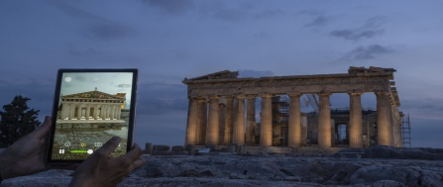

**Implementation Steps:**

* **Pre-trained Model Integration:**

**Restoration Model**: Integrate pre-trained generative AI diffuser models to generate restored images from damaged images or descriptions. Fine-tune these models based on the strength of the damage. Use pre-trained models to convert 2D restored images into 3D models.

* **Application Development:**

**Frontend Development:** Develop the user interface using Streamlit for a seamless and interactive user experience.

**Backend Development:** Implement the backend using Python to handle data processing and model inference.

* **Augmented Reality Integration:**

**AR Framework:** Integrate AR.js or WebXR to enable viewing 3D models in augmented reality.

Information Overlay: Implement a feature to display descriptive information about the heritage sites in AR.

* **Testing and Validation:** Conduct user testing to gather feedback and improve the application. Validate the accuracy and quality of the generated images and 3D models.

**Deployment:**

* **Hosting:** Deploy the application on a cloud platform (e.g., AWS, Google Cloud, Azure).
* **Maintenance:** Set up a maintenance plan to ensure the application remains up-to-date and functional.

**Benefits:**

* **Preservation of Cultural Heritage**: Aid in the restoration and preservation of cultural heritage sites and artifacts.
* **Educational Resource:** Provide an educational resource for learning about historical sites and their significance.
* **Accessibility:** Make heritage restoration accessible to a wider audience through an easy-to-use web application.
* **Innovation in Restoration:** Utilize cutting-edge AI technologies to innovate the field of cultural heritage restoration.

**Expected Application User Interface (UI):**

* **Homepage:** Introduction to Heritage AI and its purpose. Options for image upload, description input, or both.
* **Image and Description Input:** Drag-and-drop interface or file picker for uploading images, text box for descriptions, and combined input handling.
* **Restoration and 3D Model Generation:** Buttons to trigger the AI restoration process and create 3D models from the restored images.
* **Output Display:** View the generated restored image and interact with the 3D model viewer.
* **360-Degree Video Integration:** View 360-degree videos of the restored sites or artifacts.
* **Augmented Reality (AR) Integration**: Button to activate AR view, with descriptive information overlay in AR view.
* **Download :** Options to download the restored image, 3D model, and 360-degree video.

**Backend Functionality:**

* **User Input Handling:** Secure handling and pre-processing of image uploads and text descriptions.
* **AI Model Integration:** Integration of pre-trained generative AI diffuser models for restoration and 3D modeling.
* **AR Implementation:** Seamless integration of AR frameworks for displaying 3D models with descriptive overlays.
* **Security and Maintenance:** Implement security measures to protect user data and plan for regular updates.

**Technical Details (Planned):**

* Frontend: Streamlit
* Backend: Python
* Database: PostgreSQL/MySQL
* AI Models: Generative AI diffuser models
* 3D Modeling: Blender, Three.js
* Augmented Reality: AR.js, WebXR

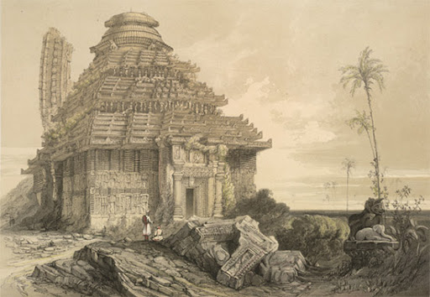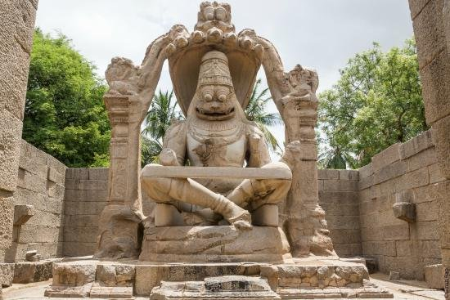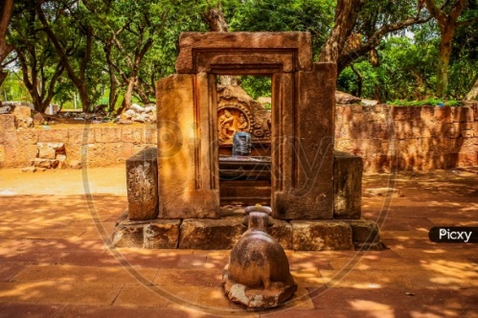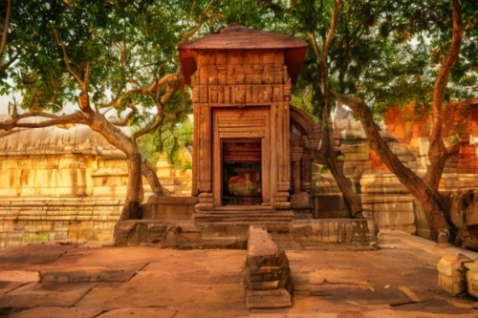

**Original Restored**