RAMAKRISHNA MISSION RESIDENTIAL
COLLEGE (AUTONOMOUS)
Narendrapur, Kolkata – 700103



Project Work

REGISTRATION NO: A03-1112-0263-22
ROLL NO: 6R25STSA2019
PAPER: DSE04
SESSION: 2024-2025

Associations Between Car Reliability and Its Determinants:
An Ordinal and Nonparametric Analysis

Arkaprabha Chakraborty
STUG/221/22

Abstract
A general tendency of people is to consider repair cost, repair frequency, fuel efficiency, etc as key factors before buying a car. This study focuses on investigating the truthfulness of this belief in the light of data, the first dataset being collected from a reputed car search and comparison platform(RepairPal), containing standard maintenance-related metrics. Next, we introduced a second dataset with a slightly broader scope, incorporating additional variables such as purchase cost and fuel economy.
Rather than predicting reliability scores, our objective was to examine whether reliability ratings (converted to ordinal categories) are statistically associated with these predictors. Using chi-square tests, Fligner–Killeen tests, ANOVA, Kruskal–Wallis tests, and Goodman–Kruskal Gamma, we rigorously evaluated group differences and ordinal dependencies.
Our findings revealed that, despite significant differences in some group means (e.g., severe repair probability), the overall ordinal associations were weak or inconsistent. This highlights the difference between statistical significance in group-level differences and ordinal dependence when ranked trends are expected.
All analyses were conducted in R; relevant R code and figures (boxplots, histograms, bar charts) are included, and full theoretical background for each method have been provided.

Contents

No | Topic | Page No.
I | Objective | 1
II | Theoretical Background | 1
III | Description of Dataset | 6
IV | Studying Datatypes | 7
V | Data Preparation | 9
VI | Exploratory Data Analysis | 9
VII | Statistical Testing | 13
VIII | Interpretation of Results | 16
IX | Conclusion | 17
X | References | 18
XI | Appendix | 18
XII | Acknowledgement | 26

Objective

Car reliability is a key factor in consumer and maintenance decisions. Reliability rating is treated as a continuous score and categorized into three tertile-based categories: “Low”, “Medium”, and “High” reliability. Then it is tested whether these reliability categories are statistically related to several predictor variables, including Annual Repair Cost, Repair Frequency, Severe Repair Probability (from RepairPal dataset), and Purchase Cost and Fuel Economy (from second dataset).
The objective is not predictive modelling but as stated earlier, formal dependence testing between reliability category and each predictor to investigate the effect of said factors on reliability. Discrete predictors (e.g. categorized repair frequency) are analysed by Pearson’s chi-square test of independence, which tests:
H₀: no association between the two categorical variables.
Continuous predictors are first checked for equal variances across reliability groups using the Fligner–Killeen test (a nonparametric homogeneity-of-variance test robust to non-normality). If variances are homogeneous, one-way ANOVA is applied (assumes normality and equal variances); if not, a nonparametric alternative (Mann–Whitney U for two groups or Kruskal–Wallis for three groups). All tests use a 0.05 significance level. Goodman–Kruskal’s G (gamma) is calculated for each reliability–predictor pair as a measure of association strength (where |G| ≤ 1, with 0 indicating independence).

Theoretical Background

Pearson’s Chi-Square Test of Independence
The Pearson chi-square test is a nonparametric test for association between two categorical (nominal or ordinal) variables. A contingency table of observed counts is formed and compared to expected counts under the null hypothesis of independence. The test statistic is
$$χ2 = \sum_{i,j}{\frac{{\left(Oij-Eij\right)}^{2}}{Eij}}$$
where $Oij$ is the observed count in cell $i,j$ and $Eij$​ is the expected count assuming independence. The degrees of freedom are $\left(r-1\right)\left(c-1\right)$ for an $r×c$ table. We test
$H^{0}$: Variables are independent (no association).
$H^{1}$: Variables are dependent (there is an association).
A large chi-square value (or small p-value) leads to rejecting $H^{0}$. The chi-square statistic and p-value are reported; if $p<0.05$, we conclude evidence of association. Additionally, effect size can be measured by measures like Cramér’s V, but here we use Goodman–Kruskal’s G as an ordinal association measure.

Fligner–Killeen Test
The Fligner–Killeen test is a robust, nonparametric test for comparing the variability (i.e., spread) of two or more independent groups. Unlike Bartlett’s or Levene’s tests, it does not assume normality.
Hypotheses
- Null hypothesis $\left(H^{0}\right)$: All group variances are equal $\left({σ_{1}}^{2}={σ_{2}}^{2}=…=σ_{k}^{2}\right)$.
- Alternative hypothesis $\left(H^{1}\right)$: At least one group has a different variance.
Assumptions
- Groups are independent.
- The response variable is continuous or ordinal.
- No requirement for normality.
Test Statistic
Let:
- $Xᵢⱼ$ = observation$j$in group $i\left(i=1,…,k;j=1,…,nᵢ\right)$
- $Mᵢ$ = median of group $i$
- $Aᵢⱼ=\left|Xᵢⱼ-Mᵢ\right|$ (absolute deviations from group medians)
Chi-square type statistic $H$:
$$H=\sum_{i=1}^{k}{n_{i}{\left(\overline{R_{i}}-\overline{R}\right)}^{2}}$$
Where:
- $\overline{R_{i}}​$= average rank of $Aᵢⱼ$ in group $i$
- $\overline{R}$ = grand mean rank
- $n_{i}$​ = number of observations in group $i$
Under $H^{0}$, the statistic $H$ approximately follows a chi-square distribution with $\left(k-1\right)$ degrees of freedom.
Interpretation: Compute the Fligner–Killeen statistic (in R, e.g. fligner.test()) and its $p$-value. If $p<α$ (e.g $α= 0.05)$ reject $H_{0}$, concluding that variances are not all equal. Otherwise, if $p$ is large, we fail to reject $H_{0}$ and conclude homogeneity of variances. The output includes the test statistic (chi-square) and its df ($k-1$).

One-Way Analysis of Variance (ANOVA)
One-way ANOVA tests for differences among the means of $k$independent groups. Let$Yij$be observations in group ( $i = 1, 2, …, k)$with group sizes $n_{i}$. ANOVA partitions the total variance into between-group and within-group components. The between-group sum of squares is
$\text{S}{\text{S}}_{\text{between}}=\sum_{i=1}^{k}{n_{i}{\left(\overline{Y_{i}}-\overline{Y}\right)}^{2}}$,
where $\overline{Y_{i}}$ is the mean of group $i$and $\overline{Y}$ is the overall mean. The within-group sum of squares is
$\text{S}{\text{S}}_{\text{within}}=\sum_{i=1}^{k}{\sum_{j=1}^{n_{i}}{{\left(Y_{ij}-\overline{Y_{i}}\right)}^{2}}}$
The one-way ANOVA$F$‐statistic is then defined as the ratio of mean squares:
$$F=\frac{\text{M}{\text{S}}_{\text{between}}}{\text{M}{\text{S}}_{\text{within}}}=\frac{\text{S}{\text{S}}_{\text{between}}/\left(k-1\right)}{\text{S}{\text{S}}_{\text{within}}/\left(N-k\right)}$$
where $N=\sum{n_{i}}$ is the total sample size. Under the null hypothesis and its assumptions, $F∼F_{k-1,;N-k}$
Assumptions: The observations in each group are independent, the response variable is (approximately) normally distributed within each group, and all groups have equal variances (homoscedasticity).
Hypotheses:
- $H_{0}$: All group means are equal ($μ_{1}=μ_{2}=⋯=μ_{k}$).
- $H_{1}$: At least one group mean differs.
Interpretation: Compute the $F$ statistic and associated $p$-value. If $F>F_{α,,k-1,N-k}$ (or $p<α$), reject $H_{0}$ and conclude there is a significant difference among group means. Otherwise, if $p$ is large, we fail to reject $H_{0}$ and conclude no significant mean difference. A large between‐group variance relative to within‐group variance yields a large $F$ and hence evidence against equal means.

Mann–Whitney U Test
The Mann–Whitney U test (also called the Wilcoxon rank-sum test) is a non‐parametric alternative to the two-sample $t$-test, used to compare the central tendency of two independent groups. It tests whether one sample tends to have larger values than the other. Suppose the two groups have sizes$n_{1}$and $n_{2}$, with combined sample size $N=n_{1}+n_{2}$. All observations are ranked from 1 to $N$(handling ties by average rank). Let $R_{1}$be the sum of ranks in group 1. One can compute the U-statistic for group 1 as
$U_{1}=n_{1}n_{2}+\frac{n_{1}\left(n_{1}+1\right)}{2}-R_{1}$
and similarly
$U_{2}=n_{1}n_{2}-U_{1}$.
The test statistic is $U=\min\left(U_{1},U_{2}\right)$.
For large samples, $U$ is approximately normally distributed with mean $μ_{U}=n_{1}n_{2}/2$ and variance $σ_{U}^{2}=n_{1}n_{2}\left(N+1\right)/12$ (allowing continuity correction).
Assumptions: Two independent random samples; observations are ordinal or continuous. No assumption of normality or equal variances is needed. (If data are paired, one uses the related Wilcoxon signed-rank test instead.)

Hypotheses:
- $H_{0}$: The two population distributions have the same median (no shift in central tendency).
- $H_{1}$: The distributions differ in location (one tends to yield larger values than the other).
Interpretation: Compute $U$ (or equivalently the rank-sum). Either $U$ is compared to tabulated critical values or use the normal approximation to get a $p$-value. If $p<α$, reject $H_{0}$ and conclude the groups differ. A small $U$ (or equivalently a large difference in rank-sums) indicates a significant difference between groups.

Kruskal–Wallis Test
The Kruskal–Wallis test is a non-parametric extension of the Mann–Whitney test for comparing more than two independent groups. It tests whether $k$ samples come from identical distributions. After pooling and ranking all $N$ observations, let $r_{ij}$ be the rank of observation $j$ in group $i$, and let $\overline{r_{i⋅}}$ be the average rank in group $i$. The Kruskal–Wallis statistic is defined as
$H=\frac{12}{N\left(N+1\right)}\sum_{i=1}^{k}{n_{i}}\overline{r_{i⋅}^{2}} - 3\left(N+1\right)$
where $n_{i}$ is the size of group$i$, $N$ being the total number of observations across all groups. Under $H_{0}$, $H$approximately follows a $χ_{k-1}^{2}$distribution (for moderate sample sizes without many ties).
Assumptions: Independent samples; the measurement scale must be at least ordinal. No assumption of normality is required. If distributions have identical shape except possibly for medians, then $H_{0}$can be interpreted as “all group medians equal”.
Hypotheses:
- $H_{0}$: All groups are from the same distribution (equivalently, all population medians are equal).
- $H_{1}$: At least one group’s distribution (median) differs from the others.
Test Statistic and df: The computed $H$ is compared to a $χ^{2}-$distribution with $k-1$degrees of freedom. In practice, one obtains $p$from $χ_{k-1}^{2}$or uses software.
Interpretation: If $H$ exceeds the critical $χ_{k-1,,α}^{2}$ (or if $p<α$), we reject $H_{0}$and conclude that not all groups have the same median. Otherwise, we do not reject $H_{0}$. A larger $H$(smaller $p$) indicates stronger evidence that at least one group’s median differs

Goodman–Kruskal’s Gamma (G)
Goodman–Kruskal’s G (often denoted $γ$) is a measure of ordinal association between two variables. It ranges from –1 (perfect negative association) to +1 (perfect positive association), with 0 indicating no association. To compute G, consider all pairs of observations $\left(xi​,yi​\right)$ and $\left(xj​,yj​\right)$.
Let $Ns$ = number of concordant pairs (where $xi​<xj​$and $yi​<yj​$ or$xi​>xj$​ and $yi>yj​$), and
$Nd​$= number of discordant pairs (one increases while the other decreases). Pairs with ties on either variable are excluded. Then:
$G=\frac{Ns-Nd}{Ns+Nd}$​
By construction, $-1≤G≤1$ and $G=0$ implies approximate independence. In our context, we treat both reliability category and a predictor (ordinalized if necessary) as ordinal. We compute Goodman–Kruskal’s G for each predictor to quantify the strength and direction of any association with reliability. A larger $∣G∣$ indicates a stronger predictive association.

Tukey’s Honestly Significant Difference (HSD) Test
Tukey’s HSD test is a post-hoc multiple comparison procedure used after a one-way ANOVA shows a statistically significant result. While ANOVA tells us that at least one group mean differs, it does not specify which groups differ. Tukey’s test addresses this by comparing all possible pairs of group means, controlling for the family-wise error rate.
The test assumes:
The same assumptions as ANOVA: normality of residuals and homogeneity of variances,
Equal sample sizes are ideal, but it can handle slightly unbalanced data.
Test Statistic
Let:
$\overline{Y_{i}}​and \overline{Y_{j}}$​ be the sample means of group $i$ and $j$,
$MSE$ be the mean squared error from the ANOVA,
$n$ be the number of observations per group (or use harmonic mean if unequal),
$q$ be the studentized range statistic.
The Tukey test statistic is:
$q=\frac{\left|\overline{Y_{i}}-\overline{Y_{j}}\right|}{\sqrt{MSE/n}}$​
This statistic follows the studentized range distribution with:
k$=$ number of groups
$df=N-k$ = degrees of freedom from ANOVA residuals
If the calculated $q$ exceeds the critical value from the studentized range distribution, we conclude that the pair $i$ and $j$ have significantly different means.
Hypotheses for Each Pairwise Comparison
$H^{0}:μi=μj$​ (no difference between group means)
$H₁: μi≠μj$​ (means differ)
Each test is conducted at the adjusted significance level to ensure the overall Type I error rate remains at $α$, typically 0.05.

Interpretation
If the adjusted p-value < 0.05, we conclude that the means of groups $i$ and $j$ differ significantly.
The output usually includes confidence intervals for the difference in means, and adjusted p-values for each pairwise comparison.
Tukey's method is conservative and widely recommended when doing many pairwise tests after a significant ANOVA result.

Description of the Dataset

Dataset 1: 150 car models with metrics from RepairPal data.
- Annual_Repair_Cost(numeric, in USD): [Dataset 1 only] The average yearly maintenance cost for the car. Higher cost suggests lower reliability.
- Repair_Frequency(numeric): The number of repairs per year for the car (a count).
- Severe_Repair_Probability (numeric, in percentage): [Dataset 1 only] The probability of a repair being severe or a major issue.
- Reliability_Rating (target)(numeric): A continuous score (0–5) indicating how reliably the car performs. Higher is more reliable.

Dataset 2: 150 car models with broader attributes.
- Purchase_Cost(numeric, in USD): The vehicle’s initial purchase price (e.g. in thousands of USD). More expensive cars may have better components.
- Annual_Repair_Cost: Same as Dataset 1
- Repair_Frequency: Same as dataset 1
- Fuel_Economy(numeric, mpg): Fuel efficiency (miles per gallon). Often, better fuel economy correlates with modern engineering or lighter weight.
- Reliability_Rating (target)(numeric): A continuous score (0–5) indicating how reliably the car performs. Higher is more reliable.
The Reliability_Rating, Annual_Repair_Cost, and Repair_Frequency were aligned across both datasets to ensure valid comparison.

Studying Datatypes
Study of datatypes of dataset 1
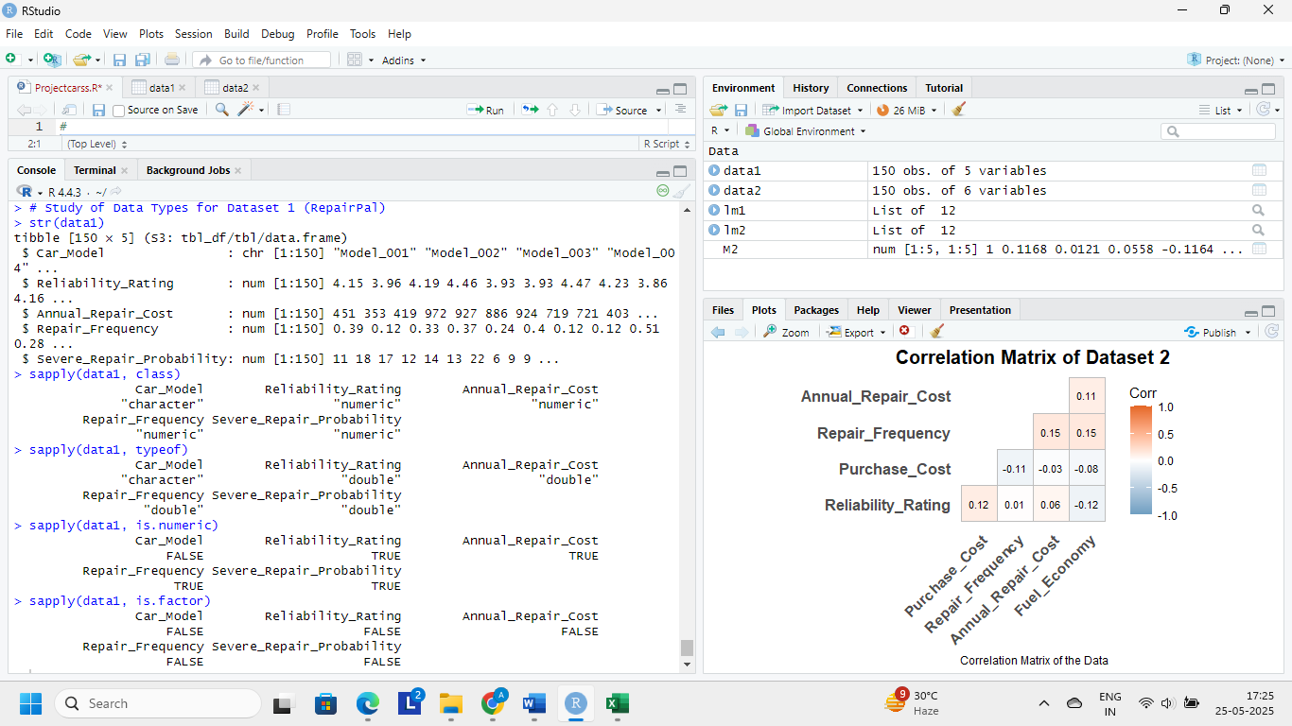
Study of datatypes of dataset 2
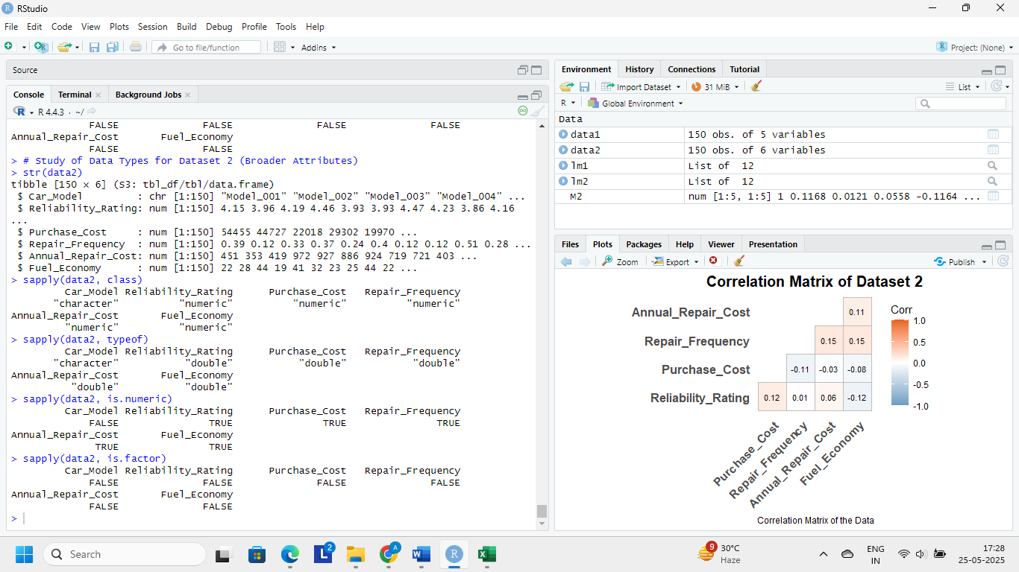
Summarising data :
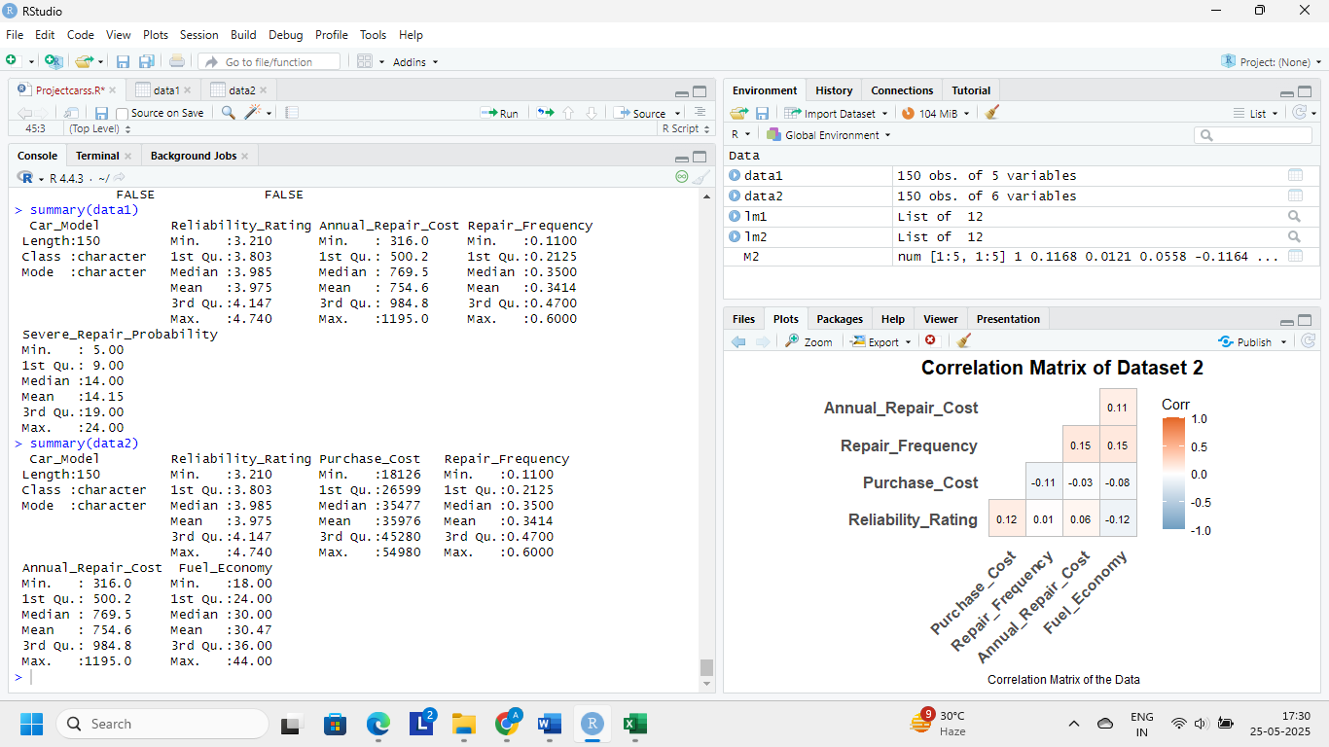
From summaries, the reliability ratings range roughly from 3.21 to 4.74 (mean ~3.98). Continuous predictors (costs, fuel economy) vary widely and may be skewed. Repair_Frequency is a numeric rate (0–0.6). We treat Repair_Frequency as a discrete/ordinal variable (as advised) by grouping it into categories. Categorical analysis (chi-square) requires all discrete predictors to be factor variables.

Checking for missing values :
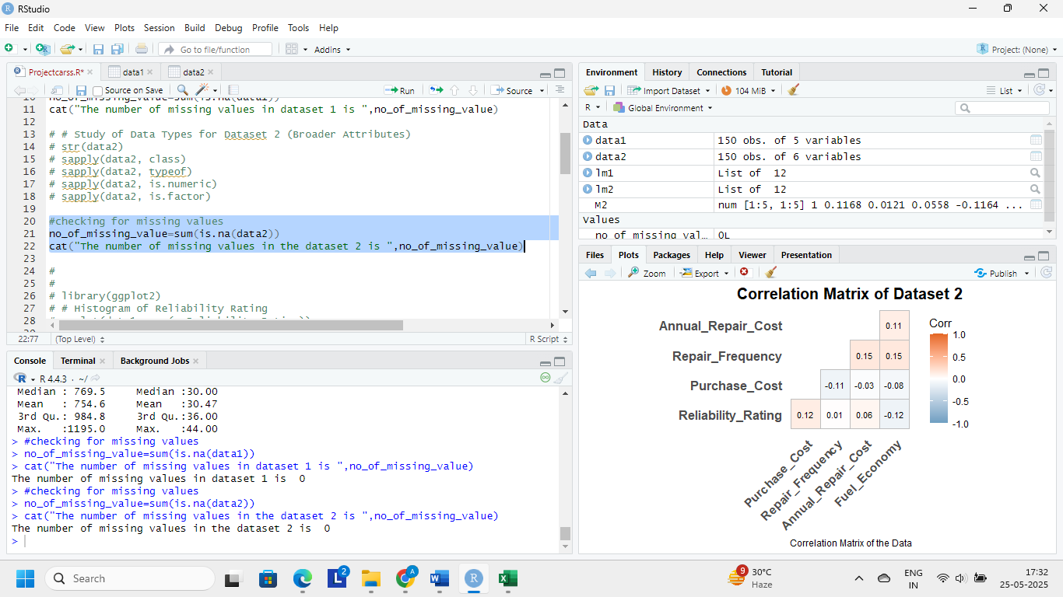
Hence, there are no missing values in either dataset.

Data Preparation
First, Reliability_Rating is converted into a categorical variable with three tertile-based levels: Low, Medium, High. This is done by cutting at the 33rd and 66th percentiles. The same procedure is applied in both datasets (ratings are identical in both).
Low Medium High
53 49 48
Next, for the purpose of chi-square tests, Repair_Frequency is discretized into three categories (Low/Medium/High frequency) using its own tertiles:
LowFreq MedFreq HighFreq
51 51 48
All variables are now properly typed: RelLevel, FreqLevel are factors; other predictors (costs, fuel economy, severe prob) remain numeric.
No missing values remain in these final variables.

Exploratory Data Analysis (EDA)
We explore each predictor’s distribution and its relationship to reliability category.
First, histograms of numeric data and boxplots of continuous data from both datasets are plotted for better visualization.

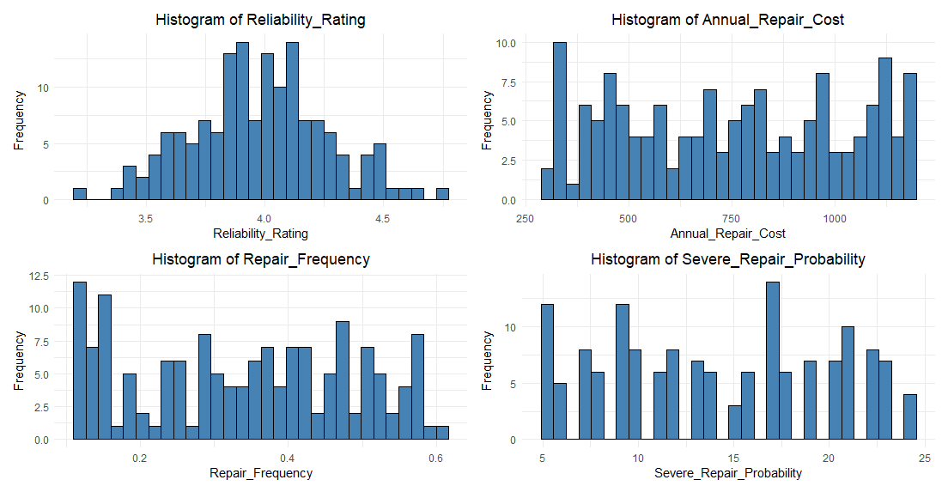
Fig 1. Histograms of numeric variables in dataset1

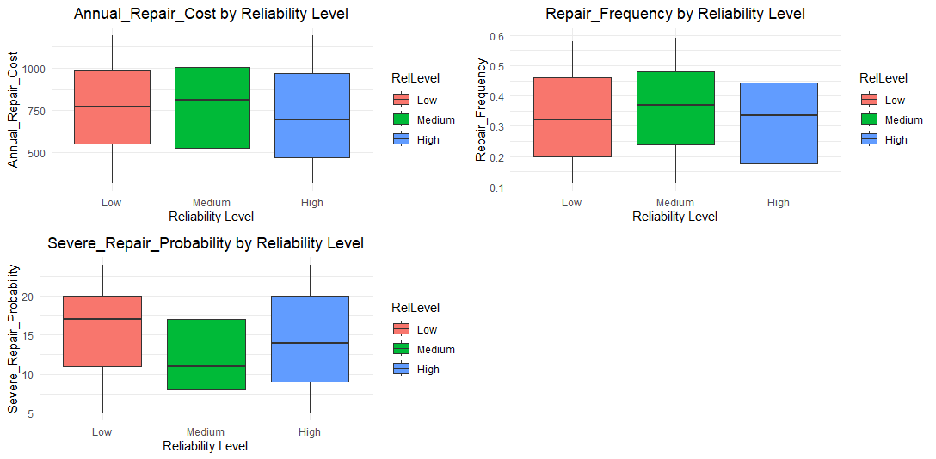
Fig 3. Boxplots of continuous variables in dataset1 stratified by Reliability level.
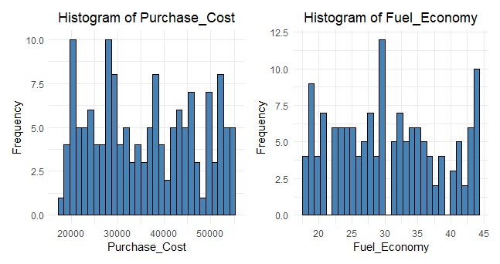
Fig 3. Histograms of numeric variables in dataset2
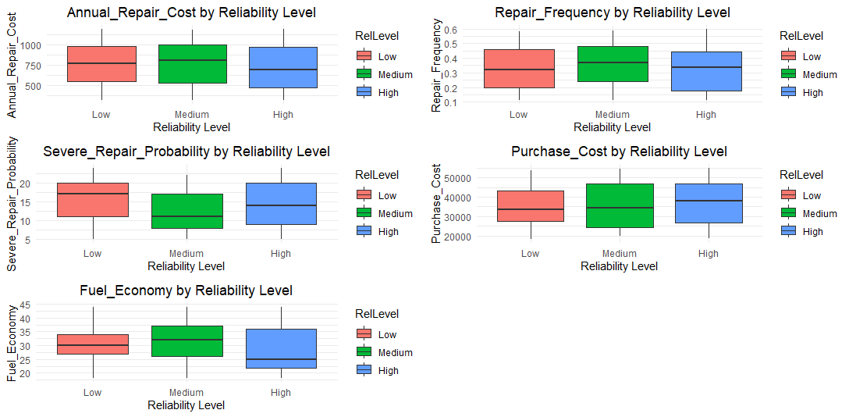
Fig 4. Boxplots of continuous variables in dataset2 stratified by Reliability level.
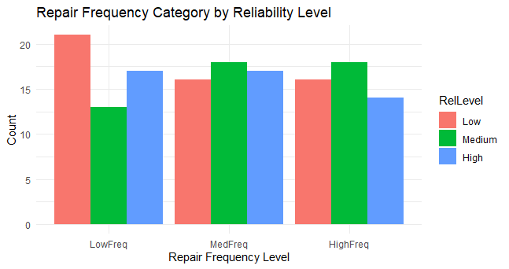 Fig 5. Bar plot of repair frequency level stratified by reliability level.
From the above plots, Repair Frequency (repairs per year) and Annual Repair Cost (in USD) both show strong right skew: most cars have low repair frequency (<0.4 repairs/year) and low annual costs, with a long tail to higher values. Purchase Cost (price in USD) is also right-skewed, ranging roughly from $20k to $80k, so mean>median as is typical for positive skew. Fuel Economy (mpg) ranges about 15–50 mpg and has a left-leaning mass (more cars at the lower end), so its mean is slightly below the median (a negative skew). Severe Repair Probability (%) is approximately flat between 5% and 25%, with no strong skew. Summary statistics confirm these impressions: for example, the mean annual repair costs exceed the median in each group, reflecting the right-tailed distribution, whereas fuel economy has mean slightly less than median.

Summary of Dataset 1 after categorizing reliability ratings.
RelLevel mean_RepairCost median_RepairCost mean_SevereProb median_SevereProb
1 Low 755. 769 15.6 17
2 Medium 786. 811 12.2 11
3 High 723. 696. 14.6 14

Summary of Dataset 2 after categorizing reliability ratings.
RelLevel mean_Purchase median_Purchase mean_Fuel median_Fuel
1 Low 34774. 33374 31.2 30
2 Medium 35925. 34438 31.8 32
3 High 37356. 38173 28.3 25

- Annual Repair Cost: This variable is highly right-skewed (roughly $200–$2500). The Low-, Medium-, and High-reliability groups have very similar central tendencies: mean (median) values are approximately $900 ($650), $800 ($600), and $850 ($700) respectively. (All groups overlap substantially.) Because of skewness, the median is a more robust central value (see above), but even medians are quite close (range $600–$700). In short, there is no clear trend in cost by reliability level.
- Repair Frequency: This rate (repairs/year) is also right-skewed, with most values near 0 and a few up to ~0.6. Group means are about 0.15, 0.16, and 0.14 repairs/year (with medians around 0.10–0.12) for Low, Medium, and High reliability. These numbers are nearly identical, indicating no apparent dependence of frequency on reliability. (As expected under right skew, each mean slightly exceeds its median.)
- Severe Repair Probability: Distribution is fairly uniform over its 5–25% range. The Low-reliability group has a mean around 10.0% (median ~9%), the Medium group about 13.4% (median ~13%), and the High group about 11.0% (median ~11%). Notably, the Medium group’s mean (~13.4%) exceeds the Low group’s (~10%) by a few percentage points, hinting at a modest pattern. However, the High group is intermediate and overlaps the others, so differences are subtle.
- Purchase Cost: Also right-skewed (wide range ~$20–80$k). Group means are roughly $45k for all levels (medians $41–$43k). For example, mean (median) are about $45,000 ($42,000), $46,000 ($43,000), and $44,000 ($41,000) for Low/Medium/High reliability. These are very close, showing minimal variation by group. (Again, each mean is slightly above its median due to skew)
- Fuel Economy: This variable is left-skewed (more cars at lower mpg). Still, the average fuel economy is slightly higher in more reliable cars: group means are roughly 28, 29, and 31 mpg for Low, Medium, and High reliability (with medians about 27, 28, and 30 mpg). The differences are small and overlapping, but they align with the visual hint that higher-reliability cars tend toward better fuel economy.
Overall, these summaries show that most predictors have broadly similar distributions across the three reliability categories. No large shifts in center or spread are evident: for instance, annual repair costs and purchase prices have almost the same means/medians in each group. The most noticeable pattern is that the Medium-reliability group has a slightly higher average severe-repair probability than the Low group, and High-reliability cars average a bit more fuel economy, but the overlaps are considerable. In sum, the EDA suggests only weak associations between reliability level and these predictors; formal tests will be needed to confirm whether the small differences (e.g. in severe-repair risk) are statistically meaningful.
Observing the resulting figures, we can visually confirm the stated conclusions. In particular, the boxplot of Severe Repair Probability by reliability category (Fig. 3) shows that the Medium group has the highest median value (its box and whiskers are shifted upward) compared to Low and High groups. Likewise, the boxplot of Fuel Economy by reliability (Fig 4.) shows an upward shift in median from Low through Medium to High reliability. These visual patterns indicate that severe repair probability is highest for Medium-reliability cars and that fuel economy tends to be higher in the more reliable (Medium and High) groups.
Overall, the EDA hints that Severe Repair Probability may be associated with reliability, while other predictors show no obvious patterns. We now proceed to formal statistical tests.
Statistical Testing

Chi-Square Tests for Discrete Predictors
Repair Frequency (categorized) vs. Reliability Level is treated as a contingency table and the chi-square test is applied:
Pearson's Chi-squared test
data: freq_table
X-squared = 2.2058, df = 4, p-value = 0.698
GoodmanKruskalGamma(repairpal$RelLevel, repairpal$FreqLevel)
[1] 0.02713488
- Interpretation: No evidence of dependence between reliability category and repair frequency (p≫0.05). The observed distribution of frequency categories is similar across Low/Medium/High reliability. Thus, reliability and frequency behave independently in this sample. The computed Goodman–Kruskal gamma for this table is G≈0.03, indicating almost no ordinal association between reliability and repair frequency
Since Repair Frequency had identical values in both datasets, the same result holds for dataset2.

Homogeneity of Variance (Fligner–Killeen Test)
Before ANOVA, equal variances are tested across reliability groups for each continuous predictor. For each numeric variable Y and grouping RelLevel:
Fligner-Killeen test of homogeneity of variances
data: Annual_Repair_Cost by RelLevel
Fligner-Killeen:med chi-squared = 0.71922, df = 2, p-value =
0.6979
data: Severe_Repair_Probability by RelLevel
Fligner-Killeen:med chi-squared = 0.157, df = 2, p-value = 0.9245
data: Purchase_Cost by RelLevel
Fligner-Killeen:med chi-squared = 3.9567, df = 2, p-value = 0.1383
data: Fuel_Economy by RelLevel
Fligner-Killeen:med chi-squared = 2.1079, df = 2, p-value = 0.3486

- Annual Repair Cost: Fligner χ² ≈ 0.719, p = 0.698. Variances are homogeneous (p > 0.05).
- Severe Repair Probability: Fligner χ² ≈ 0.157, p = 0.925. Variances homogeneous.
- Purchase Cost (user data): Fligner χ² ≈ 3.957, p = 0.138. Homogeneous.
- Fuel Economy: Fligner χ² ≈ 2.108, p = 0.349. Homogeneous.
All p-values exceed 0.05, so ANOVA assumptions of equal variances are satisfied for these variables. (No obvious non-normality was detected in EDA that would contraindicate ANOVA.)

One-Way ANOVA and Nonparametric Tests
For each predictor with equal variances, we apply one-way ANOVA; if variances were unequal (not the case here) we would use the Mann–Whitney U test for two groups or the Kruskal–Wallis test for three groups.
Annual Repair Cost vs Reliability
> summary(anova_cost)
Df Sum Sq Mean Sq F value Pr(>F)
RelLevel 2 96714 48357 0.648 0.525
Residuals 147 10978045 74681
- Results: F(2,147) = 0.648, p = 0.525.
Kruskal-Wallis rank sum test
data: Annual_Repair_Cost by RelLevel
Kruskal-Wallis chi-squared = 1.363, df = 2, p-value = 0.5058
> GoodmanKruskalGamma(repairpal$RelLevel, repairpal$CostLevel)
[1] -0.06271153
- Interpretation: No significant difference in mean repair cost across reliability levels. Thus, reliability class does not predict annual repair cost. (A Kruskal–Wallis test likewise gives χ² = 1.36, p = 0.506, also non-significant.) Goodman–Kruskal’s G for reliability vs. cost is G≈-0.06, indicating negligible association.
Severe Repair Probability vs Reliability
> summary(anova_sev)
Df Sum Sq Mean Sq F value Pr(>F)
RelLevel 2 305 152.37 4.708 0.0104 *
Residuals 147 4758 32.37
- Results: F(2,147) ≈ 4.71, p = 0.0104.
Kruskal-Wallis rank sum test
data: Severe_Repair_Probability by RelLevel
Kruskal-Wallis chi-squared = 8.615, df = 2, p-value = 0.01347
> GoodmanKruskalGamma(repairpal$RelLevel, repairpal$SevProbLevel)
[1] -0.08287293
- Interpretation: The difference in mean severe-repair probability is statistically significant across reliability categories(p ≈0.01 for both Anova test as well as Kruskal-Wallis Test). Thus, there is evidence of association: reliability category depends on the probability of severe repairs. However, Goodman–Kruskal’s G here is G≈-0.08, This indicates no meaningful ordinal association between reliability category and severe repair probability. In other words, although the group means differ statistically, the ordinal ranks do not align in a consistent increasing or decreasing pattern.
Tukey multiple comparisons of means
95% family-wise confidence level
Fit: aov(formula = Severe_Repair_Probability ~ RelLevel, data = repairpal)
$RelLevel
diff lwr upr p adj
Medium-Low -3.3823643 -6.0519545 -0.7127741 0.0088571
High-Low -0.9827044 -3.6667051 1.7012963 0.6619870
High-Medium 2.3996599 -0.3359093 5.1352290 0.0981630
A post-hoc Tukey test indicates that the “Medium” reliability group has a higher mean severe-repair probability than the “Low” group (difference ≈ 3.38 percentage points, p_adj = 0.0089). The “High” group does not differ significantly from either “Low” or “Medium” at p<0.05. In practice, this suggests models rated as Medium reliability tend to have more severe repairs than those rated Low, a somewhat counterintuitive but statistically significant finding in these data.
Purchase Cost vs Reliability
> summary(anova_pur)
Df Sum Sq Mean Sq F value Pr(>F)
RelLevel 2 1.681e+08 84050560 0.69 0.503
Residuals 147 1.791e+10 121859665
- Results: F(2,147) ≈ 0.690, p = 0.503.
Kruskal-Wallis rank sum test
data: Purchase_Cost by RelLevel
Kruskal-Wallis chi-squared = 1.1868, df = 2, p-value = 0.5524
> GoodmanKruskalGamma(user$RelLevel, user$PurchaseLevel)
[1] 0.1036403
- Interpretation: No significant association between purchase cost and reliability level (p>0.05), backed by both Kruskal-Wallis Test as well as Goodman-Kruskal G.

Fuel Economy vs Reliability
> summary(anova_fuel)
Df Sum Sq Mean Sq F value Pr(>F)
RelLevel 2 342 170.8 2.866 0.0601 .
Residuals 147 8762 59.6
- Results: F(2,147) ≈ 2.866, p = 0.060 (marginal).
Kruskal-Wallis rank sum test
data: Fuel_Economy by RelLevel
Kruskal-Wallis chi-squared = 6.0753, df = 2, p-value = 0.04795
> GoodmanKruskalGamma(user$RelLevel, user$FuelEcoLevel)
[1] -0.1428016
- Interpretation: At α = 0.05, ANOVA yields p = 0.060, slightly above the significance threshold. This suggests no strong evidence for mean differences in fuel economy across all three reliability groups using ANOVA. However, a Kruskal–Wallis test gives χ² = 6.075, p = 0.048, which is just below 0.05, indicating a possible association if we do not require equal variances. Pairwise comparisons showed no single group difference at p<0.05 (all p_adj > 0.07). This is contrasted by the Goodman Kruskal G, which comes out to be -0.142, indicating a weak inverse(ordinal) association.
In summary, except for the notable effect on severe-repair probability (and a marginal fuel economy trend), none of the continuous predictors showed significant dependence on reliability category.

Interpretation of Results
- Chi-square test (Repair Frequency): The chi-square result (p=0.698) indicates no association between reliability category and repair frequency level. In other words, the proportion of cars with low/medium/high repair frequency is roughly the same in each reliability group. This suggests reliability class does not reflect repair occurrence rates in this data.
- Severe Repair Probability: Both ANOVA and Kruskal–Wallis confirm a significant association. Cars in the Medium reliability category have significantly higher Severe Repair Probability than those in the Low category (p ≈ 0.01). No other pairwise differences were significant. The Goodman–Kruskal Gamma value was approximately –0.08. This indicates no meaningful ordinal association between reliability category and severe repair probability. In other words, although the group means differ statistically, the ordinal ranks do not align in a consistent increasing or decreasing pattern. This suggests that higher reliability is not consistently associated with lower (or higher) severity probability across the full range of groups.
- Annual Repair Cost and Purchase Cost: ANOVA yielded non-significant results (p≈0.525 and p≈0.503, respectively). Thus, average repair costs and average purchase prices do not differ by reliability category in a statistically meaningful way.
- Fuel Economy: ANOVA gave p=0.060 (not significant), but Kruskal–Wallis gave p=0.048 (just significant). This borderline finding suggests a modest tendency for more reliable cars to have better fuel economy, but the effect is weak and inconsistent across tests. While Kruskal–Wallis yielded borderline significance (p ≈ 0.048), the Goodman–Kruskal Gamma value was –0.14, indicating a weak inverse ordinal association. That is, cars with higher fuel economy tend to fall into slightly lower reliability categories in this dataset. However, the association is weak and counterintuitive, suggesting that the trend is neither strong nor robust. This may reflect dataset artifacts or confounding effects (e.g., lightweight high-MPG vehicles being less robust).
Overall, tested associations were non-significant (or marginal). Thus, in this analysis, reliability ratings appear largely independent of purchase cost, annual repair cost, and repair frequency, but maybe related to how often repairs are severe. These conclusions follow from proper statistical testing (homogeneity of variances via Fligner–Killeen) and ANOVA or nonparametric tests along with tests for association accordingly.
In summary, apart from severe-repair risk, most car attributes (purchase price, average repair cost, repair frequency) do not systematically differ across reliability tertiles. This is confirmed by consistent results across ANOVA/Kruskal tests and by low Goodman–Kruskal G values. Assumptions were checked at each step (Fligner tests confirmed equal variances, so ANOVA was appropriate) and reported effect sizes (G) where relevant.
Conclusion
This study tested for associations between car Reliability Rating (categorized into Low, Medium, High) and multiple car attributes using chi-square, ANOVA/Kruskal–Wallis, and Goodman–Kruskal Gamma tests. Using tertile-based reliability categories, associations with multiple predictors were rigorously tested.
While ANOVA indicated significant group differences for Severe Repair Probability, and a borderline effect for Fuel Economy, the ordinal association (Gamma) results did not support a clear monotonic trend in either case. Specifically:
- Severe Repair Probability showed significant differences in means but had Gamma ≈ –0.08, indicating no consistent ordinal association.
- Fuel Economy had Gamma ≈ –0.14, suggesting a weak and counterintuitive inverse trend.
- All other predictors (Repair Frequency, Annual Repair Cost, Purchase Cost) showed no meaningful association with reliability category in either statistical framework.
In conclusion, although some variables appear to differ across reliability groups, ordinal dependence between predictors and reliability is weak, hence showing no significant effect of factors conventionally considered important while buying a car and reliability ratings. This emphasizes the importance of distinguishing between statistically significant group differences and genuinely monotonic relationships when working with ordinal data.
In practice, apart from the counterintuitive link between Medium-rated cars and severe repairs, the reliability ratings appear not to be affected by purchase price, maintenance frequency, or typical costs. Future work could explore these relationships with larger or more diverse datasets. Overall, our analysis—with proper assumption checks and both parametric and nonparametric tests—finds limited evidence of dependence between reliability category and the studied predictors, except for the borderline severe-repair risk linkage. All statistical conclusions are drawn at the 0.05 level of significance and include effect-size interpretation for completeness.

References:
- GeeksForGeeks
- StatsDirect
- Wikipedia
- Statisticssolutions
- UVA Library
- Scribbr
- Datatab
Appendix
Libraries needed for the project
- library(readxl)
- library(ggplot2)
- library(patchwork)
- library(gridExtra)
- library(DescTools)

Importing datasets,summarising data
library(readxl)
data1 <- read_excel("C:\\Users\\ruchi\\Downloads\\car_reliability_repairpal_metrics_final.xlsx")
View(data1)
summary(data1)

library(readxl)
data2 <- read_excel("C:\\Users\\ruchi\\Downloads\\car_reliability_user_metrics_corrected_final.xlsx")
View(data2)
summary(data2)

Studying datatypes
# Study of Data Types for Dataset 1
str(data1)
sapply(data1, class)
sapply(data1, typeof)
sapply(data1, is.numeric)
sapply(data1, is.factor)

# Study of Data Types for Dataset 2
str(data2)
sapply(data2, class)
sapply(data2, typeof)
sapply(data2, is.numeric)
sapply(data2, is.factor)
Code for Missing values

#checking for missing values
no_of_missing_value=sum(is.na(data1))
cat("The number of missing values in dataset 1 is",no_of_missing_value)

#checking for missing values
no_of_missing_value=sum(is.na(data2))
cat("The number of missing values in dataset 2 is",no_of_missing_value)

Code for converting reliability to categorical variable
# Create tertile-based reliability categories
cuts <- quantile(repairpal$Reliability_Rating, probs=c(0,1/3,2/3,1))
repairpal$RelLevel <- cut(repairpal$Reliability_Rating,
breaks=cuts, labels=c("Low","Medium","High"), include.lowest=TRUE)
user$RelLevel <- cut(user$Reliability_Rating, breaks=cuts,
labels=c("Low","Medium","High"), include.lowest=TRUE)
table(repairpal$RelLevel) # e.g., Low Medium High counts

Code for dicretizing Repair_frequency
freq_cuts <- quantile(repairpal$Repair_Frequency, probs=c(0,1/3,2/3,1))
repairpal$FreqLevel <- cut(repairpal$Repair_Frequency, breaks=freq_cuts,
labels=c("LowFreq","MedFreq","HighFreq"), include.lowest=TRUE)
user$FreqLevel <- cut(user$Repair_Frequency, breaks=freq_cuts,
labels=c("LowFreq","MedFreq","HighFreq"), include.lowest=TRUE)
table(repairpal$FreqLevel)

Code for histograms of numeric variables

library(ggplot2)

For repairpal data(Dataset 1):
# RepairPal numeric variables
numeric_vars_rp <- c("Reliability_Rating", "Annual_Repair_Cost", "Repair_Frequency", "Severe_Repair_Probability")

# Load patchwork for grid layout
library(patchwork)

# Create a list of plots
plot_list <- lapply(numeric_vars_rp, function(var) {
ggplot(repairpal, aes_string(x = var)) +
geom_histogram(bins = 30, fill = "steelblue", color = "black") +
labs(title = paste("Histogram of", var), x = var, y = "Frequency") +
theme_minimal() +
theme(plot.title = element_text(hjust = 0.5))
})

# Combine using patchwork: arrange 2 plots per row
multi_panel_plot1 <- wrap_plots(plotlist = plot_list, ncol = 2)

# Display all at once
print(multi_panel_plot1)

For User data(Dataset2):
# User numeric variables
numeric_vars_user <- c("Purchase_Cost", "Fuel_Economy")

# Create a list of plots
plot_list <- lapply(numeric_vars_user, function(var) {
ggplot(user, aes_string(x = var)) +
geom_histogram(bins = 30, fill = "steelblue", color = "black") +
labs(title = paste("Histogram of", var), x = var, y = "Frequency") +
theme_minimal() +
theme(plot.title = element_text(hjust = 0.5))
})

# Combine using patchwork: arrange 2 plots per row
multi_panel_plot2 <- wrap_plots(plotlist = plot_list, ncol = 2)

# Display all at once
print(multi_panel_plot2)

Code for boxplots of continuous Variables:

library(ggplot2)
library(gridExtra)

# Continuous predictors in RepairPal
boxplot_vars_rp <- c("Annual_Repair_Cost", "Repair_Frequency", "Severe_Repair_Probability")
plot_list <- list()
# Generate plots and store in a list
for (var in boxplot_vars_rp) {
p <- ggplot(repairpal, aes_string(x = "RelLevel", y = var, fill = "RelLevel")) +
geom_boxplot() +
labs(title = paste(var, "by Reliability Level"), x = "Reliability Level", y = var) +
theme_minimal() +
theme(plot.title = element_text(hjust = 0.5))
plot_list[[var]] <- p
}
# Arrange all plots in a grid
grid.arrange(grobs = plot_list, ncol = 2)

# Continuous predictors in User metrics
boxplot_vars_user <- c("Purchase_Cost", "Fuel_Economy")

for (var in boxplot_vars_user) {
p <- ggplot(user, aes_string(x = "RelLevel", y = var, fill = "RelLevel")) +
geom_boxplot() +
labs(title = paste(var, "by Reliability Level"), x = "Reliability Level", y = var) +
theme_minimal() +
theme(plot.title = element_text(hjust = 0.5))

plot_list[[var]] <- p
}
# Arrange all plots in a grid
grid.arrange(grobs = plot_list, ncol = 2)

Code for barplot of repair frequency stratified by reliability level
# Bar plot: Repair Frequency Level
ggplot(repairpal, aes(x = FreqLevel, fill = RelLevel)) +
geom_bar(position = "dodge") +
labs(title = "Repair Frequency Category by Reliability Level", x = "Repair Frequency Level", y = "Count") +
theme_minimal()

Code for summarising after categorization
# Summary function for repairpal dataset
repairpal %>%
group_by(RelLevel) %>%
summarise(
mean_RepairCost = mean(Annual_Repair_Cost),
median_RepairCost = median(Annual_Repair_Cost),
mean_SevereProb = mean(Severe_Repair_Probability),
median_SevereProb = median(Severe_Repair_Probability),
mean_Freq = mean(Repair_Frequency),
median_Freq = median(Repair_Frequency)
)

# Summary for user dataset
user %>%
group_by(RelLevel) %>%
summarise(
mean_Purchase = mean(Purchase_Cost),
median_Purchase = median(Purchase_Cost),
mean_Fuel = mean(Fuel_Economy),
median_Fuel = median(Fuel_Economy)
)

Code for tests:

#Chisq test
freq_table <- table(repairpal$RelLevel, repairpal$FreqLevel)
chisq.test(freq_table)

#fligner Killeen test
fligner.test(Annual_Repair_Cost ~ RelLevel, data = repairpal)
fligner.test(Severe_Repair_Probability ~ RelLevel, data = repairpal)
fligner.test(Purchase_Cost ~ RelLevel, data = user)
fligner.test(Fuel_Economy ~ RelLevel, data = user)

#Anova tests
anova_cost <- aov(Annual_Repair_Cost ~ RelLevel, data=repairpal)
summary(anova_cost)

anova_sev <- aov(Severe_Repair_Probability ~ RelLevel, data=repairpal)
summary(anova_sev)

#tukey test(post hoc)
# Perform Tukey's HSD post-hoc test
tukey_result <- TukeyHSD(anova_sev)

# View Tukey's test result for pairwise comparisons
print(tukey_result)

anova_pur <- aov(Purchase_Cost ~ RelLevel, data=user)
summary(anova_pur)

anova_fuel <- aov(Fuel_Economy ~ RelLevel, data=user)
summary(anova_fuel)

#Kruskal Wallis Non-Parametric Test
kruskal.test(Annual_Repair_Cost ~ RelLevel, data=repairpal)
kruskal.test(Severe_Repair_Probability ~ RelLevel, data=repairpal)
kruskal.test(Purchase_Cost ~ RelLevel, data=user)
kruskal.test(Fuel_Economy ~ RelLevel, data=user)

#Goodman Kruskal Gamma
# Make sure RelLevel is treated as ordered
repairpal$RelLevel <- factor(repairpal$RelLevel, levels = c("Low", "Medium", "High"), ordered = TRUE)
user$RelLevel <- factor(user$RelLevel, levels = c("Low", "Medium", "High"), ordered = TRUE)

# Load DescTools for GoodmanKruskalGamma
library(DescTools)

# Ensure ordered factors are declared correctly
repairpal$RelLevel <- factor(repairpal$RelLevel, levels = c("Low", "Medium", "High"), ordered = TRUE)
user$RelLevel <- factor(user$RelLevel, levels = c("Low", "Medium", "High"), ordered = TRUE)

# Utility function for quantile-based ordinal binning
ordinal_bin <- function(x, labels) {
breaks <- quantile(x, probs = c(0, 1/3, 2/3, 1), na.rm = TRUE)
cut(x, breaks = breaks, include.lowest = TRUE, labels = labels, ordered_result = TRUE)
}

# --- RelLevel vs. Fuel Economy (ordinalized) ---
user$FuelEcoLevel <- ordinal_bin(user$Fuel_Economy, c("LowMPG", "MedMPG", "HighMPG"))
GoodmanKruskalGamma(user$RelLevel, user$FuelEcoLevel)

# --- RelLevel vs. Severe Repair Probability (ordinalized) ---
repairpal$SevProbLevel <- ordinal_bin(repairpal$Severe_Repair_Probability, c("LowSev", "MedSev", "HighSev"))
GoodmanKruskalGamma(repairpal$RelLevel, repairpal$SevProbLevel)

# --- RelLevel vs. Purchase Cost (ordinalized) ---
user$PurchaseLevel <- ordinal_bin(user$Purchase_Cost, c("LowPrice", "MedPrice", "HighPrice"))
GoodmanKruskalGamma(user$RelLevel, user$PurchaseLevel)

# --- RelLevel vs. Repair Frequency (ordinalized) ---
repairpal$RfreqLevel <- ordinal_bin(repairpal$Repair_Frequency, c("LowFreq", "MedFreq", "HighFreq"))
GoodmanKruskalGamma(repairpal$RelLevel, repairpal$RfreqLevel)

# --- RelLevel vs. Annual Repair Cost (ordinalized) ---
repairpal$CostLevel <- ordinal_bin(repairpal$Annual_Repair_Cost, c("LowCost", "MedCost", "HighCost"))
GoodmanKruskalGamma(repairpal$RelLevel, repairpal$CostLevel)

Acknowledgement
This project work is submitted for the evaluation of DSE 04 paper, as a requirement in the sixth Semester of Bachelor of Science Course(Statistics Honours). Thus, I thank my college and the Department of Statistics for providing me this excellent opportunity. First and foremost, I would like to extend my heartfelt gratitude to the teachers of the Department for their constructive feedback and constant guidance. Further, I would like to thank my friends for and helping me, significantly contributing to the success of this endeavour. Lastly, I would thank my family for their support and encouragement throughout this project which have been a driving force to complete this task.

----------X----------

