Student Name: Arka Singha Mahapatra
Student ID: 11905536
Email : arkasingha14@gmail.com
Github Link:
Problem
The Fibonacci sequence is the series of numbers 0, 1, 1, 2, 3, 5, 8, .... Formally, it can be expressed as: f ib0 = 0 f ib1 = 1 f ibn = f ibn−1 + f ibn−2 Write a multithreaded program that generates the Fibonacci sequence. This program should work as follows: On the command line, the user will enter the number of Fibonacci numbers that the program is to generate. The program will then create a separate thread that will generate the Fibonacci numbers, placing the sequence in data that can be shared by the threads (an array is probably the most convenient data structure). When the thread finishes execution, the parent thread will output the sequence generated by the child thread. Because the parent thread cannot begin outputting the Fibonacci sequence until the child thread finishes, the parent thread will have to wait for the child thread to finish
Algorithm :
The Fibonacci sequence is the series of numbers 0, 1, 1, 2, 3, 5, 8, .... Formally, it can be expressed as: f ib0 = 0 f ib1 = 1 f ibn = f ibn−1 + f ibn−2 Write a multithreaded program that generates the Fibonacci sequence. This program should work as follows: On the command line, the user will enter the number of Fibonacci numbers that the program is to generate. The program will then create a separate thread that will generate the Fibonacci numbers, placing the sequence in data that can be shared by the threads (an array is probably the most convenient data structure). When the thread finishes execution, the parent thread will output the sequence generated by the child thread. Because the parent thread cannot begin outputting the Fibonacci sequence until the child thread finishes, the parent thread will have to wait for the child thread to finish

Code:

#include<stdio.h>
#include<iostream>
using namepsace std;
int main(){
#include<iostream>
#include<pthread.h>
#include <unistd.h>
#include<stdlib.h>
#include<sys/wait.h>
using namespace std;
int size,first=0,second=1,third,n;
int a[1000];
void * cal(void * arg)
{
for(int i=0;i<n;i++)
{
first=a[i];
third=first+second;
first=second;
second=third;
}
}
int main(){ cout<<"enter number of elements"<<endl;
cin>>n;
pthread_t fd;
pthread_create(&fd,NULL,cal,NULL);
pthread_join(fd,NULL);
wait(1);
for(int i=0;i<n;i++)
{ //cout<<"in parent thread"<<endl;
cout<<a[i]<<" ";
}
}
//to be tested
}

Test Case for problem 1:
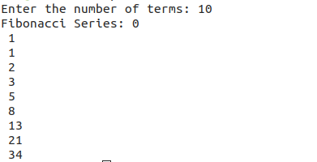
Output of Above Code

Problem : Consider a scenario of demand paged memory. Page table is held in registers. It takes 8 milliseconds to service a page fault if an empty page is available or the replaced page is not modified and 20 milliseconds if the replaced page is modified. Memory access time is 100 nanoseconds. Assume that the page to be replaced is modified 70 percent of the time. Generate a solution to find maximum acceptable page-fault rate for access time that is not more than 200 nanoseconds.
Algorithm :
We know how to find an effective access time (EAT) for a given page-fault rate (p).
Here, we have to find 'p' for given 'EAT' so we set up the following equation and solve for 'p':
(Note: 1 millisecond = 1,000,000 nanoseconds = 1e6 nanoseconds)
Time taken to service page Fault for empty page or unmodified page = 8ms.
Time taken to service page Fault for modified page = 20ms
Memory access time = 100ns
Effective Access time = 200ns
EAT = (1-p)*(100) + (p)*(100 + (1-.7)*(8msec) + (.7)*(20msec))
= 100 - 100p + 100p + (2.4e6)*p + (14e6)*p
= 100 + (16.4e6)*p
200 = 100 + (16.4e6)*p
p = 100/16.4e6 = 6.0975609756097560975609756097561e-6 ~ 6.01e-6
p-->page Fault Rate

Code:
#include <stdio.h>
#include <stdlib.h>
double page_fault_rate();
void userInput(void);
double service_page_fault_empty;
double service_page_fault_modified;
double mem_access_time;
double times_page_modified;
double effective_access_time;
double pageFaultRate;
double service_page_fault_empty_ns;
double service_page_fault_modified_ns;
double times_page_modified_per;
void main(){
int swtch;
do{
printf("Select the required option \n");
printf("1.Find the PageFault Rate\n");
printf("2.Exit");
scanf("%d",&swtch);
switch(swtch){
case 1:userInput();break;
case 2:exit(0);
}
printf("\n\n");
}while(swtch<3);
}
void userInput(){
printf("\nEnter service Page Fault [Empty|Page is not Modified][in milliseconds]");
scanf("%lf",&service_page_fault_empty);
printf("Enter Service Page Fault [Modified Page][in milliseconds]");
scanf("%lf",&service_page_fault_modified);
printf("Enter Memory Access Time[in nanoseconds]");
scanf("%lf",&mem_access_time);
printf("Enter Percentage of time the page to be replaced is modified[0-100]");
scanf("%lf",&times_page_modified);
printf("Enter Effective Access time[in nanoseconds]");
scanf("%lf",&effective_access_time);
service_page_fault_empty_ns = (service_page_fault_empty*1000000);
service_page_fault_modified_ns = (service_page_fault_modified*1000000);
times_page_modified_per = (times_page_modified/100);
printf("\nPage Fault rate calculated For:\n");
printf("Service Page Fault[Empty|Page Not Modified]=%lf \n",service_page_fault_empty_ns);
printf("Service Page Fault [Modified Page][in nanoseconds] %lf \n",service_page_fault_modified_ns);
printf("Memory Access Time[in nanoseconds]%lf\n",mem_access_time);
printf("Effective Access Time %lf\n",effective_access_time);
pageFaultRate = page_fault_rate(service_page_fault_empty_ns,service_page_fault_modified_ns,mem_access_time,times_page_modified_per,effective_access_time);
printf("\nMaximum Acceptable Page Fault rate = %.2e[exponential notation]",pageFaultRate);
}
double page_fault_rate(double servicePageFaultEmpty,double servicePageFaultMod,double memAccess,double timesPages,double effAccess){
double assume,serve;
double numErator,denOminator;
double pageFault;
assume = (1- timesPages)*servicePageFaultEmpty;
serve = timesPages*servicePageFaultMod;
numErator = effAccess - memAccess;
denOminator = (assume+serve);
pageFault = numErator/denOminator;
return pageFault;
}

Test Case for Problem 2:

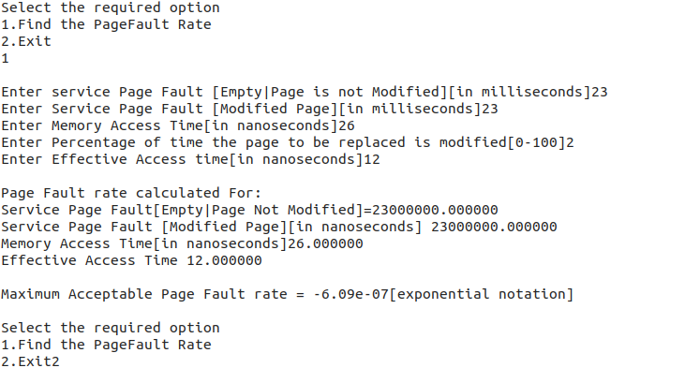
Output of Above C Program
