**Assignment- 3**

**Problem Statement:**

The objective of this laboratory exercise is to look at the details of the User Datagram Protocol (UDP). UDP is a transport layer protocol. It is used by many application protocols like DNS, DHCP, SNMP etc., where reliability is not a concern. To do this exercise you need to install the Wireshark tool, which is widely used to capture and examine a packet trace. Wireshark can be downloaded from [www.wireshark.org](http://www.wireshark.org).

**Step1: Capture a Trace**

1. Launch Wireshark
2. From Capture→Options select Loopback interface
3. Start a capture with a filter of “ip.addr==127.0.0.1 and udp.port==xxxx”, where xxxx is the port number used by the UDP server.
4. Run the UDP server program on a terminal.
5. Run multiple instances of the UDP client program on separate terminals and send requests to the sever.
6. Stop Wireshark capture

**Step2: Inspect the Trace**

Select different packets in the trace and browse the expanded UDP header and record the following fields:

* Source Port: the port from which the udp segment is sent.
* Destination Port: the port to which the udp segment is sent.
* Length: the length of the UDP segment.

**Capturing UDP packets in WireShark:**

UDP is an unreliable and connectionless protocol. There is no need for establishing any connection before data transfer. UDP packets contains a UPD header which contains the port number for both source and destination then there is a length field which is the size of header and payload in Bytes and then some more checksum information.

UDP is faster than TCP as there is no need for creating a connection. But it is unreliable.

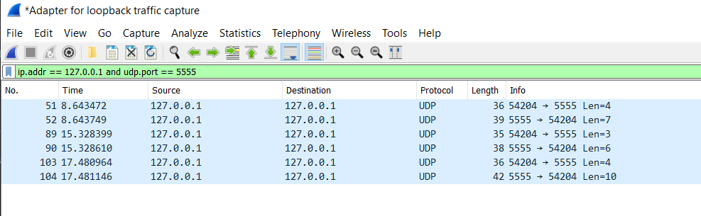

Considering the first frame sent –

The source port is : 54204 (Client in this case)

The destination port is : 5555 (Server in this case)

The length is : 27

The size of the payload is 4 Bytes.

