Dhaka [**Go** **Back]**

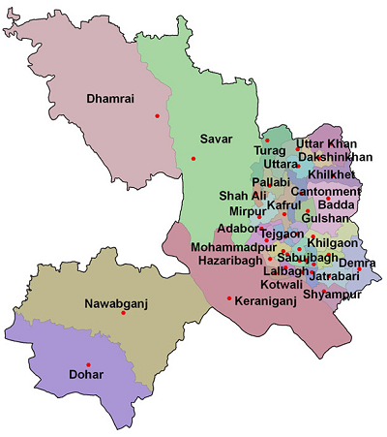

**Area:** 1463.60 Square Kilometres.

**Population:** 1,25,17,361.

**Geo Position:** 23˚22’30’’ to 24˚22’20’’ North latitudes and 89˚41’6’’ to 90˚59’23’’ east longitude.

**Number of Municipalties:** 3.

**Number of Upazillas (Sub-districts):** 5.

**Number of Villages :** 1,999.

**Number of Union:** 79.

**Establishing Year:** 1772.

**Tourist Spot:** National Memorial, Dhaka University, Dakeshari temple, Lalbag Fort, Ahsan Monjil, Aorangajeb Fort, National Museum, Sohrawardi Park, Botanical Garden, Central Sahid Minar, Satmosjid, The Parliament House, Curjon Hall, Bahadur Shah Park, Bangla Academy, Baitul Mokaram Mosque, Shatgambuj Mosque, Dhakeshari Temple, Armenian Church, Novo Theatre, Muktijuddha Museum etc..

**Others:** The densest district of the country. Dhaka city is known as the city of mosque.