Dhaka **Go Back**

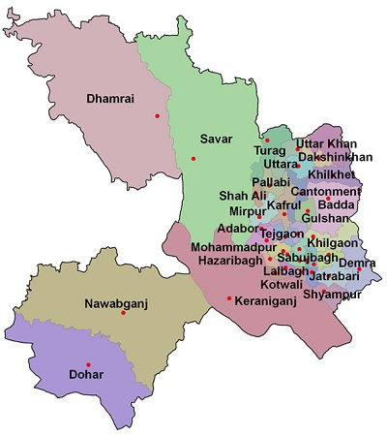

**Area:** 1463.60 Square Kilometres.

**Population:** 1,25,17,361.

**Geo Position:** 23˚22’30’’ to 24˚22’20’’ North latitudes and 89˚41’6’’ to 90˚59’23’’ east longitude.

**Number of Municipalties:** 3.

**Number of Upazillas (Sub-districts):** 5.

**Number of Villages :** 1,999.

**Number of Union:** 79.

**Establishing Year:** 1772.

**Tourist Spot:** National Memorial, Dhaka University, Dakeshari temple, Lalbag Fort, Ahsan Monjil, Aorangajeb Fort, Jinjira Palace, Baro Katara, Choto Katara, National Museum, Mirpur Zoo, Sohrawardi Park, Botanical Garden, Central Sahid Minar, Satmosjid, The Parliament House, Karjon Hall, Bahadur Shah Park, Bibi Morium Canon, Hosni Dalan, Bangla Academy, Martyred Graveyard of Mirpur, Baitul Mokaram Mosque, Shatgambuj Mosque, Dhakeshari Temple, Armenian Church, Novo Theatre, Muktijuddha Museum, Science and Technology Museum etc..

**Others:** The densest district of the country. Dhaka city is known as the city of mosque. Capital of the country.