Faridpur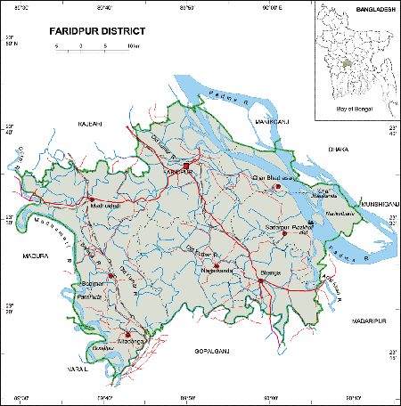 **Go Back**

**Area:** 2072.72 Square Kilometres.

**Population:** 17,42,720.

**Geo Position:** 23˚17’ to 23˚40’ North latitudes and 89˚17’ to 90˚11’ east longitude.

**Number of Municipalties:** 05.

**Number of Upazillas (Sub-districts):** 09.

**Number of Union:** 81.

**Number of Villages:** 1887.

**Establishing Year:** 1984.

**Tourist Spot:** Gorai Bridge, Atrashi, Chandrapara Darber Sharif, Mathurapur Temple, Shambikapur Field, Noder Chand Terminal, Modhukhali Sugar Mill, Residence of Pastoral Poet Jashim Uddin, Mazar of Dewan Sarker Shah, Mothurapur Daul, River Research Institute(RRI), Barisrashi Royal Palaace, Dighir Par Masjid, Bashudeb Temple, Monastery of Royal Palace, Dighir Par Mosque, Bashudeb Temple, Monastery of Jajabandhu Sundar, Atrashi Bishaw Jaker Monjil, Bishaw Jaker Monjil, Hazrat Shah Farid Mosque, gerda Shaheb Pera, Satayer Mosque, Patrail Mosque etc.