Gopalganj **Go Back**

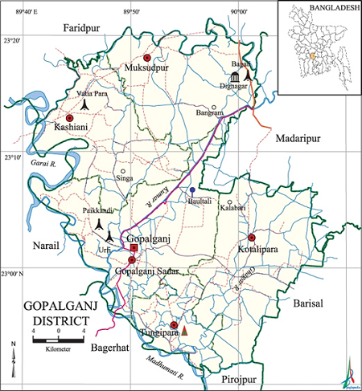

**Area:** 1489.92 Square Kilometres.

**Population:** 11,72,414.

**Geo Position:** 22˚51’ to 23˚50’ North latitudes and 89˚0’ to 90˚59’23’’ east longitude.

**Number of Municipalities:** 04.

**Number of Sub-districts:0**5.

**Number of Villages :** 905.

**Number of Union:** 68.

**Establishing Year:** 1984.

**Tourist Spot:** Graveyard of Bangabandhu Sheikh Mujibur Rahman, Kotali Fort, Orakandi Thakure Bari of Kashiani, Joy Bangla Pond of Gopalganj Sadar, Barni Baor of Gopalganj Sadar, Baganbari of Tungipara(Birds Sanctuary), The Parental Homestead of Poet Sukanta in Kotalipara, Kort Mosque, Chander Bill, Khaner Par Lake, Lal Saplar Bil of Kotalipara, Graveyard of Bangabandhu Sheikh Mujibur Rahman, Upalpur landlord House (Currently Tafsil Office), graveyard of St. Mathuranath, Home of Poet Sukanta Vattacharja, Bahutali Mosque, Uzanir Landlord Palace etc.

**Others:** The district holds some fresh memory of the father of the nation Bangabandhu Sheikh Mujibur Rahman.