Kishoreganj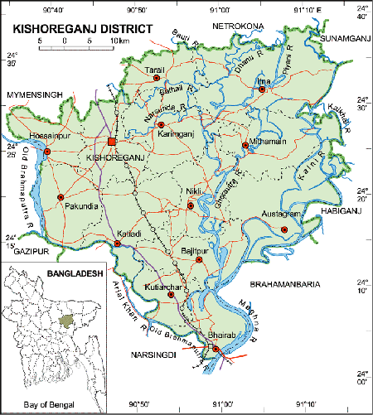 **Go Back**

**Area:** 2731.21 Square Kilometres.

**Population:** 29,11,907.

**Geo Position:** 24˚02’ to 24˚38’ North latitudes and 90˚02’ to 91˚13’ east longitude.

**Number of Municipalties:** 08.

**Number of Upazillas (Sub-districts):** 13.

**Number of Union:** 108.

**Number of Villages:** 1745.

**Establishing Year:** 1984.

**Tourist Spot:** Historical Sholakia Idhgah, Darbar Hall, Eagaro Shindhur Fort, Jangalbari Fort and Mosque of Isha Kha, Pagla Mosque, Pramanik Bhaban and Lake, Poet Chandraboty Shibmondir, Hazrat Nagor Royal Palace, Jinda bibir Mazar, Shah Mahmud Mosque and balakhana, Dilir Akhra, Pagla Mosque, Residence of Poet Sukumar Roy, Jaharul Islam Medical College, Ganda Sundari temple etc.