Madaripur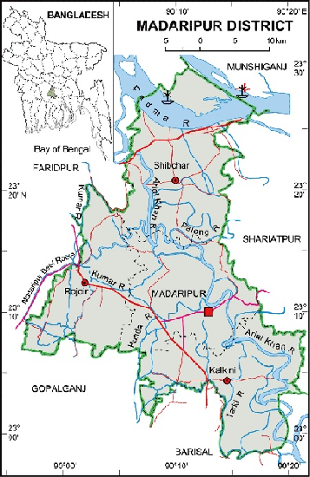 **Go Back**

**Area:** 1125.69 Square Kilometres.

**Population:** 11,65,952.

**Geo Position:** 23˚0’ to 23˚30’ North latitudes and 89˚56’ to 90˚21’ east longitude.

**Number of Municipalties:** 3.

**Number of Sub-districts:** 4.

**Number of Villages :** 1,062.

**Number of Union:** 59.

**Establishing Year:** 1984.

**Tourist Spot:** Graveyard of Khaza Yousuf Shah, Nilkuthi of Danlf, Home of Poet Kiron Chandra, Royal palace of Shishir Ganguly, Annaypurna Temple, Pronob Moth, Graveyard of Chittyapriya roy Chowdhury, porbot garden of Mustafapur, Shakuni Lake, Home of Land lord Premchand Roy and D.L. Roy Chowdhury, Noboratna temple, Dargah of Shah Madar, Bajitpur Pronabanda Temple, Kadambari Ganesh Pagol Temple, Khalia Rajaram Roy’s house, Arialkha River, the Madaripur Lake, Sakuni Lake, Jhaudi Giri, Shrine of Hazarat Shah Mader, Auliapur Indigo Kuthi etc.

**Others:** Madaripur is famous for date juice based raw sugar.