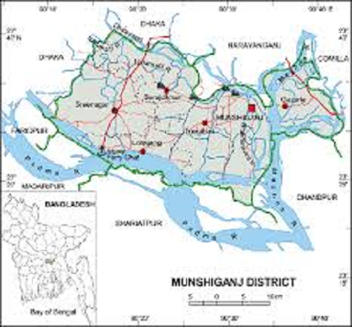 Munshiganj Go Back

**Area:** 954.96 Square Kilometers.

**Population:** 7,49,918.

**Geo Position:** 23˚29’ to 23˚45’ North latitudes and 90˚10’ to 90˚43’ east longitude.

**Number of Municipalities:** 67.

**Number of Upazillas (Sub-districts):** 2.

**Number of Union:** 603.

**Number of Villages:** 919.

**Establishing Year:** 1984.

**Tourist Spot:** Indrakpur Fort, Shamshiddhir Math, Panditer Vita, Home of Raja Bollal Sen, Birth Place of Atish Dipankar, Bhagyakul Rajbari,Residance of J C. Bosh, Pach Pirar Dargah, Rampal Lake, Hashara Dargha, Sholighor Math, Mohadev Mondir, Bhagyakul Rajbari, Padma Resort .

**Others:** Munshiganj is famous for potato production.