Narayanganj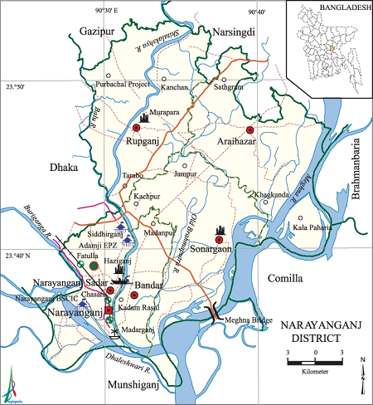 **Go Back**

**Area:** 683.14 Square Kilometers.

**Population:** 29,48,217.

**Geo Position:** 23˚34’ to 24˚15’ North latitudes and 90˚27’ to 90˚59’ east longitude.

**Number of Municipalties:** 05.

**Number of Upazillas (Sub-districts):** 05.

**Number of Union:** 39.

**Number of Villages:** 1374.

**Establishing Year:** 1984.

**Tourist Spot:** Sonargaon, Hazigonj Fort, Kadam Rasul Dargah, Graveyard of Sultan Gias Uddin Azam Shah, Pach Bibi Mazar, Langolbondha, Narayanganj Riverport, Dockyard, Marine Academy, Adamjee EPZ, Sonakanda Fort, Mary-Enderson Floating Restaurant, Rashel Park of Murapara, Jinda Park of Rupganj etc.

**Others:** Known as Dundee of East.