Narsingdi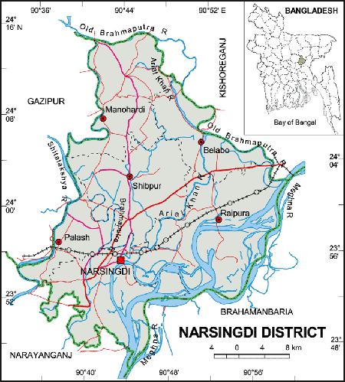 **Go Back**

**Area:** 1140.76 Square Kilometers.

**Population:** 22,24,944.

**Geo Position:** 23˚46’ to 24˚14’ North latitudes and 90˚35’ to 90˚60’ east longitude.

**Number of Municipalties:** 06.

**Number of Upazillas (Sub-districts):** 06.

**Number of Union:** 71.

**Number of Villages:** 1095.

**Establishing Year:** 1984.

**Tourist Spot:** Sonaimore Benodon Park, Wari Bateshwar, Dream-Holiday Park, Graveyard of Shaheed Asad (Hero of 1969), Sonaimuri Tek, Ashrfpur Mosque, Belab Bazar Mosque, Home of Vhai Girish Chandra Sen, Shah Irani Mazar, Ghorashal Fertilizer Factory, Asham Rajar Garh etc.

**Others:** Remarkable for the revolt occurred in 1969.