Rajbari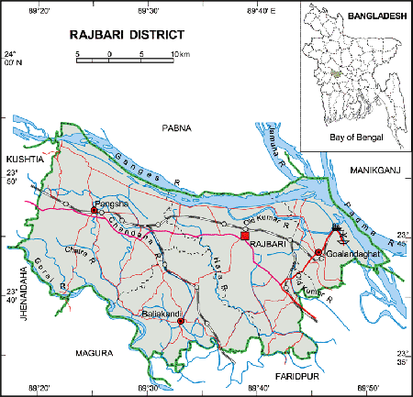 **Go Back**

**Area:** 1118.8 Square Kilometres.

**Population:** 10,15,519.

**Geo Position:** 23˚35’ to 23˚55’ North latitudes and 89˚09’ to 89˚55’ east longitude.

**Number of Municipalties:** 03.

**Number of Upazillas (Sub-districts):** 05.

**Number of Union:** 42.

**Number of Villages:** 1036.

**Establishing Year:** 1984.

**Tourist Spot:** Luxmi Kol Royal Palace, Baliakandi Royal Palace, Children Park, Graveyard of writer Mir Mosharrof Hossain, Memorial Center, Acrobatic Center, Rajbari Swimming Pole, Dauladia River Port, Rajbari Circuit House, Rajbari Uddyan Base, Jora Bangla temple, Sawdagor Mound, Shrine of Shah Palowan, Tomb of Saint Kamal Shah, Dauladia Ferry Ghat etc.

**Others:** Renowned as a historical place.