Tangail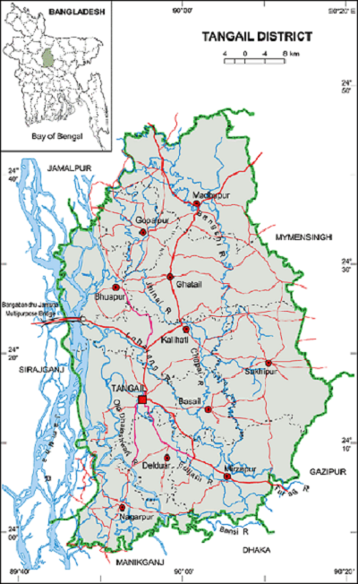 **Go Back.**

**Area:** 3414.35 Square Kilometres.

**Population:** 36,05,083.

**Geo Position:** 23˚59’ to 24˚48’ North latitudes and 89˚48’ to 90˚51’ east longitude.

**Number of Municipalties:** 10.

**Number of Upazillas (Sub-districts):** 12.

**Number of Union:** 110.

**Number of Villages:** 2516.

**Establishing Year:** 1969.

**Tourist Spot:** Madhupur National Park, Karatia Landlord Home, Mirjapur Cadet College, Dokhla Rest House, Jamuna Resort, Alegna Resort, Kumudiny Hospital, Vharatoshari Homes, Jamuna Multi-Purpose Bridge, Ghatail Sagordighi and Gupta Brindabon, Mawlana Bhashani Graveyard, Atia Jame Mosque, Atia Royal Palace, Dhonbari Royal Palace, Bangbandhu Multi-purpose Bridge, Hindu Paul Temple, Sagor Lake, Ishamoti Lake, Police Training Center, Modhupur temple etc.

**Others:** Largest district in Dhaka Division. Famous for sari.