**OPERATIONAL QUERY**

**# Retrieve all sessions attended by a specific member**

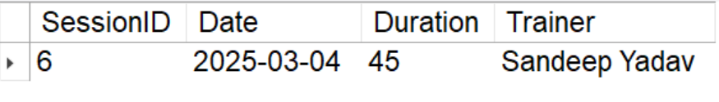

**# List all trainers and their specializations**

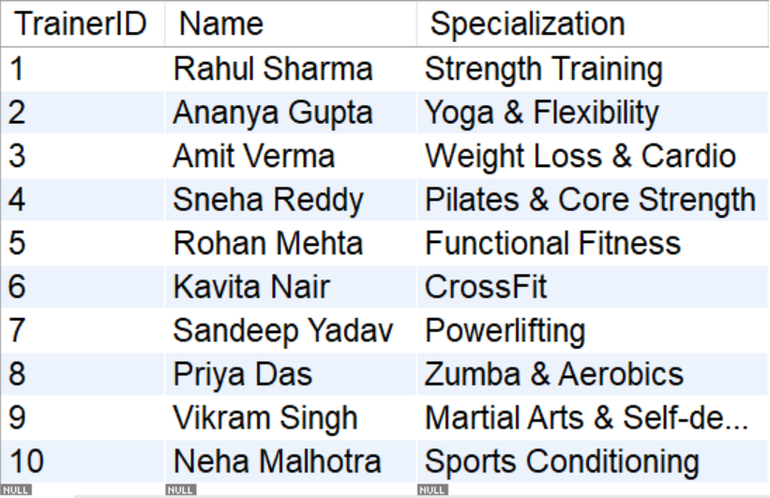

**# Find the number of sessions conducted by each trainer**

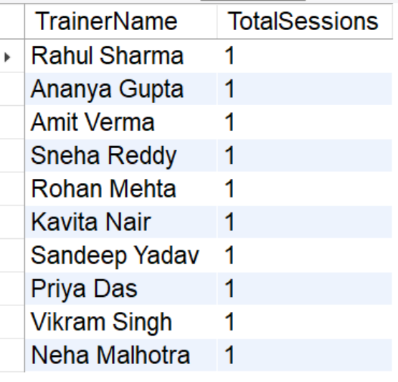

**# Update membership type for a specific member**



**# Calculate the total duration of workout sessions for a member**

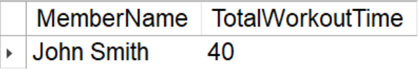

**# Identify the most frequently attended trainer**

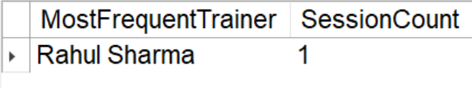

**# Retrieve members with expired memberships**

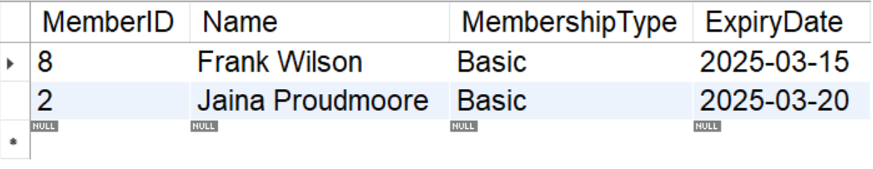

**# Fetch the busiest training days**

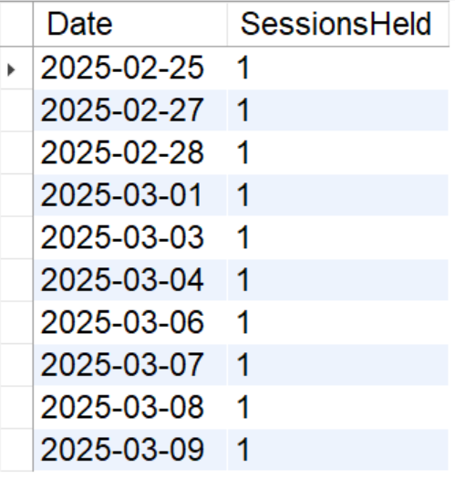

**STORED PROCEDURES**

# Get all sessions attended by a member

CALL GetSessionsByMember(2)

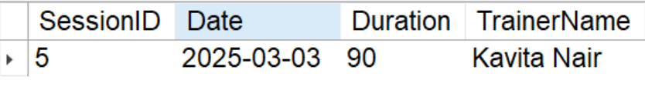

# Extend Membership by N Days

CALL ExtendMembership(1,31)

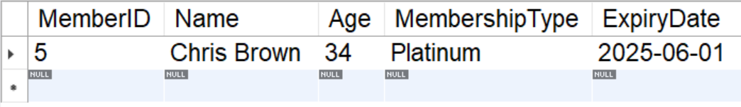

# Update a member’s membership type

CALL UpdateMembershipType(7,'Platinum')

OLD

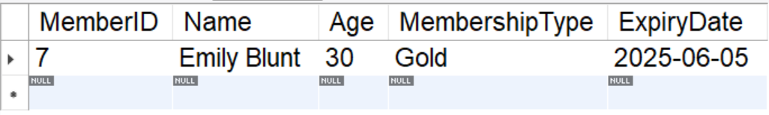

AFTER UPDATION

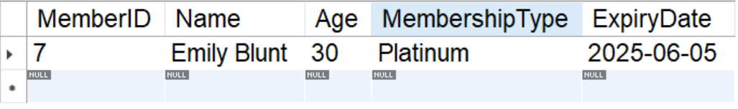

# Get total duration of sessions for a member

CALL GetTotalWorkoutDuration(6)

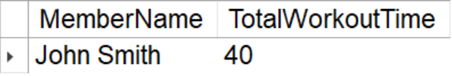

# Trainers with number of sessions

CALL TrainerSessionCount()

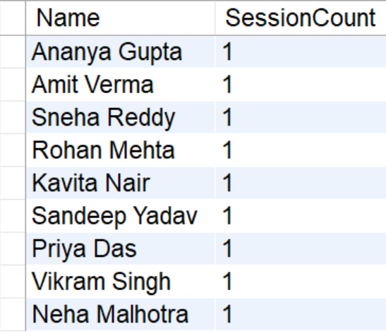

TRIGGERS

# logs changes to a member’s expiry date into the membership_audit table whenever the ExpiryDate is updated

trg_log_expiry_update

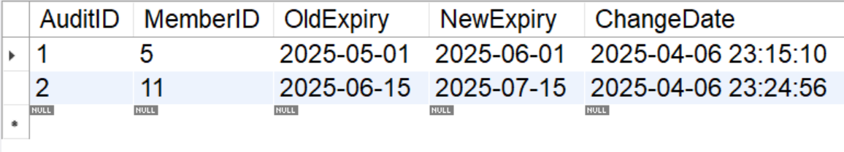

# Prevent Booking Sessions for Expired Members

trg_prevent_expired_sessions

