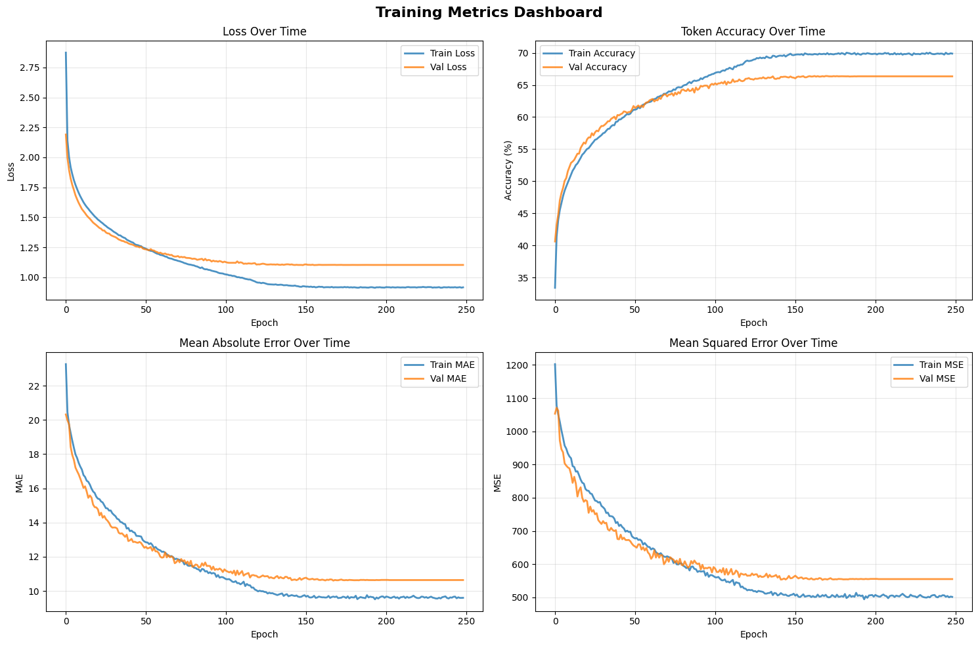

 Final Metrics Summary:

Final Train Loss: 0.9160

Final Val Loss: 1.1028

Final Train Accuracy: 69.88%

Final Val Accuracy: 66.34%

Final Train MAE: 9.6015

Final Val MAE: 10.6398

Final Train MSE: 501.3836

Final Val MSE: 555.0232

 Loading best model...

 Training Summary:

Early stopped: True

Total epochs: 249

Best validation loss: 1.1014

total data_2900

 Early stopping triggered! No improvement for 100 epochs.

 Training stopped early at epoch 309

 Best validation loss: 0.7845

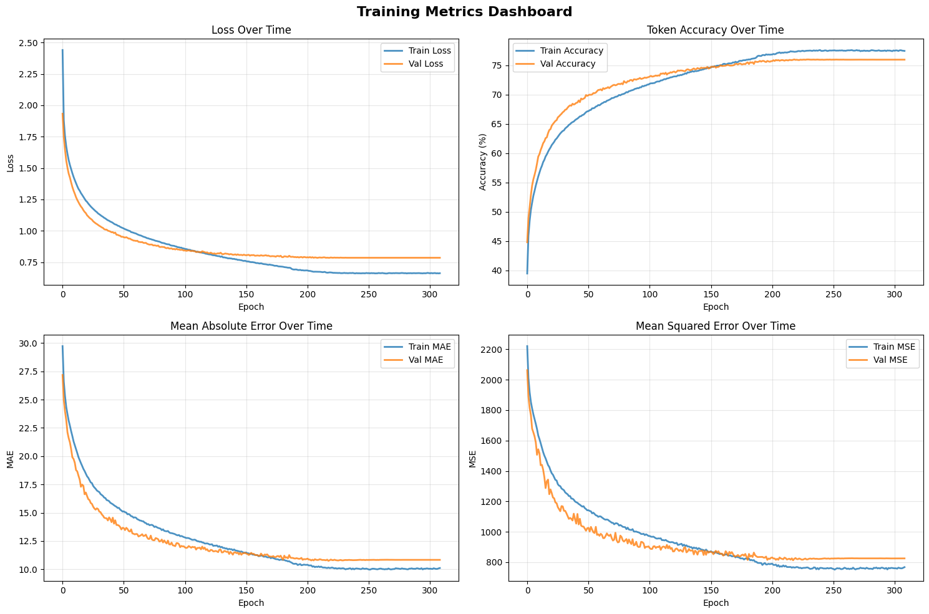

 Final Metrics Summary:

Final Train Loss: 0.6621

Final Val Loss: 0.7853

Final Train Accuracy: 77.48%

Final Val Accuracy: 75.98%

Final Train MAE: 10.1136

Final Val MAE: 10.8364

Final Train MSE: 767.4832

Final Val MSE: 825.0173

 Loading best model...

 Training Summary:

Early stopped: True

Total epochs: 309

Best validation loss: 0.7845

✅ Model training was stopped early to prevent overfitting

Number of data: 8476