

“SAMVED” HACKATHON 2026

- Problem Statement ID – PS-001
- Problem Statement Title - Smart Road Damage reporting & Rapid Response System For Solapur Municipal Corporation
- Theme - General

- Team ID- 302CCE5B

- Team Name - TRIUMVIRATE

2


Thermal Based Pothole Detection System

TRIUMVIRATE

IDEA/SOLUTION:

PROBLEM RESOLUTION:

- Early and Automatic Detection.
- Severity and Risk Assessment.
- Cause Identification.
- Improvement in road safety.
Implementation of a Thermal based pothole surveillance website for Solapur Municipal Corporation

- Thermal camera to detect and monitor the pothole.

- Embedded programming and censor control to measure and give the approximate pothole size and depth.

- AI and ML models predict the cause and the risk factor of the pothole and give the appropriate solution to solve the problem.
UNIQUENESS OF THE SOLUTION:
- Thermal identification of the potholes.
- Identification as well as giving approximate properties of potholes.
- Giving approximate causes of the potholes.
- Risk factor assessment.

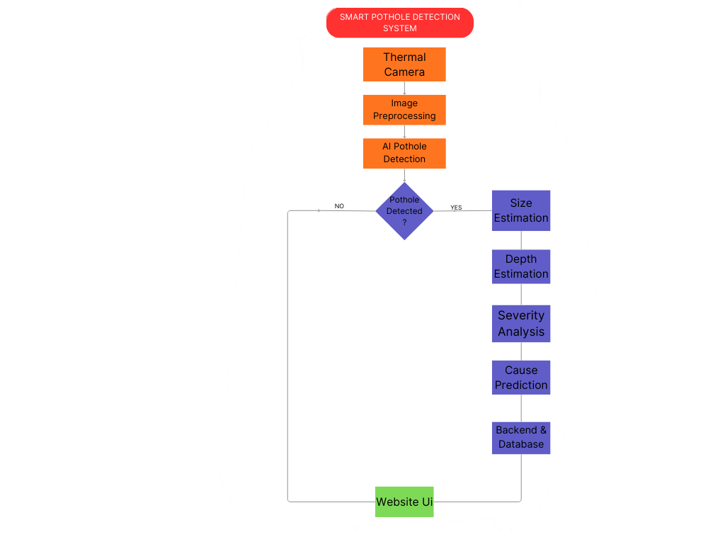
TECHNICAL APPROACH

TRIUMVIRATE

PROCESS FLOW ARCHITECTURE

Programming Languages :

Python , SQL , JavaScript , CSS , HTML.

Hardware :
Thermal Camera , sensors.

Framework:
Pytorch,FastAPI,IOT,React.js,SQLite.

3

FEASIBILITY AND VIABILITY

TRIUMVIRATE

FEASIBILITY:

Good connectivity , Cost Effective , Open to funding opportunities.

VIABILITY:

Can be used in areas with adverse weather conditions or at night.
POTENTIAL CHALLENGES AND RISKS:

- Infrastructure challenges include unreliable connectivity in rural areas , difficult hardware maintenance and power supply problems.
- Difficulty in obtaining information about potholes
in an unpaved road.
- Socio culture barriers including low digital literacy and limited cultural and language adaptation.

STRATEGIES TO OVERCOME CHALLENGES:
Removing technological and connectivity glitches ,and effective monitoring.

IMPACTS AND BENEFITS:

IMPACT AND BENEFITS

TRIUMVIRATE

  - Can be used for immediate identification of potholes.
  - Provides the approximate cause and risk factor of the potholes.
  - Minimizes the amounts of accidents caused by potholes.
  - User friendly interface .
  - Can be used in harsh environments like areas with heavy rain, fog etc.
  - Can be used in rural areas with different issues like power, signal etc.

RESEARCH AND REFERENCES

TRIUMVIRATE

- Article on Potholes :
https://pavementinteractive.org/reference-desk/pavement-management/pavement-distresses/potholes/

- Pothole detection using computer vision based techniques : https://pubs.aip.org/aip/acp/article-
abstract/3246/1/020007/3319232/Pothole-detection-using-computer-vision-based?redirectedFrom=fulltext

- Research on Road Pothole Recognition Based on Deep Convolutional Neural Networks : https://www.semanticscholar.org/paper/Research-on-Road-Pothole-Recognition-Based-on-Deep-Liu- Wang/cc1cd513bbf969e2bcdbf1acb27b91e89446744a#related-papers

- Evaluation of YOLOv8 and SSD Object Detection Models for Pothole Detection Systems : https://www.semanticscholar.org/paper/Evaluation-of-YOLOv8-and-SSD-Object-Detection-for-Sarange- Manmat/05328668171415d87c009e299315ec27a35b9c56

