The application for selection of student answers
Description
The application selects student answers from 2 tasks. We have similar application in the PHP (see Picture 1).
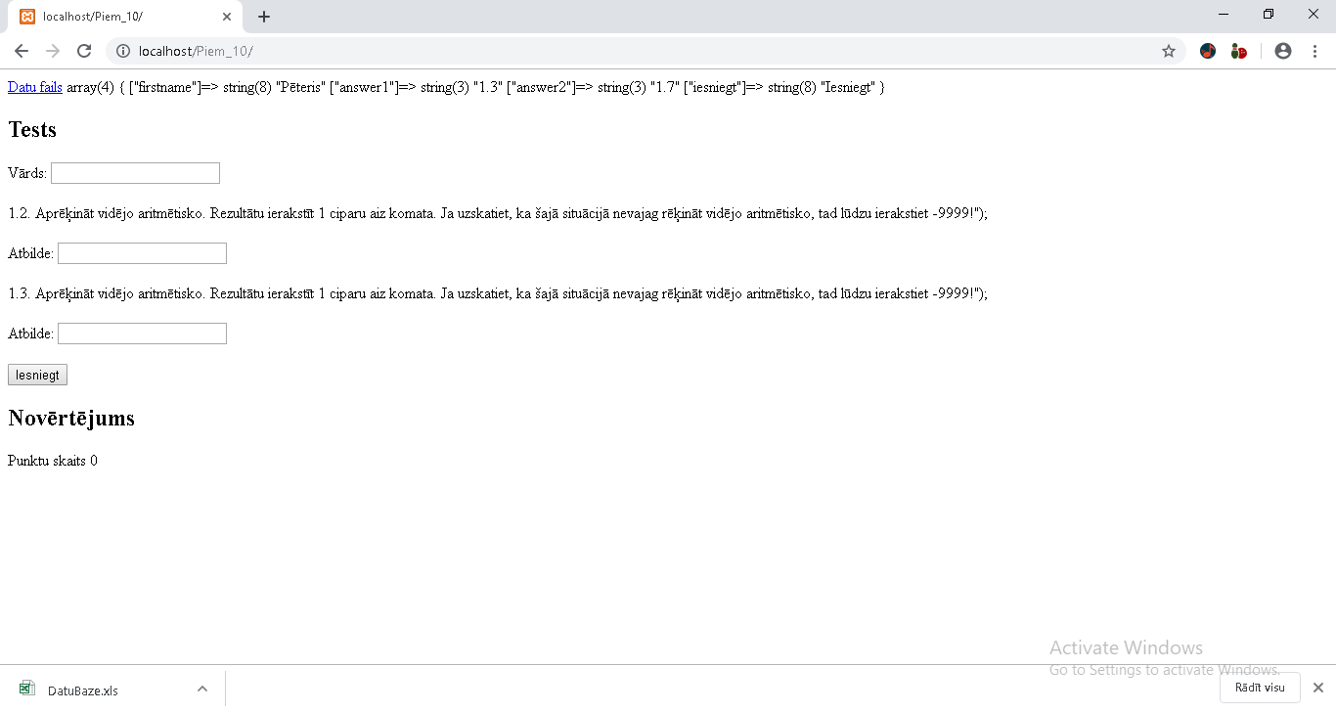
Picture 1. Example of PHP application
For application have 2 user level – student and teacher. A teacher may:
- upload file with the descriptions of task and data; the file can be any kind in free form;
- enter the name of test;
- enter comments of test;
- enter answers in free form.
The student may:
- enter the name of test;
- download test file;
- write comments of
- enter answers in free form.
The application gives evaluation of student skills – 0, 1 or 2 points.

The test examples of application

Example 1
The teacher given answers may be not dependent from file content. It is not recommended, but application will work.
http://192.168.8.144:8081/student
http://192.168.8.144:8081/Teacher
http://192.168.8.144:8081/Teacher2/addTest
Data values
15.32356
-12.5678998
Teacher
user
password
Enter nestrādā, Sign in strādā
New Test Upload
http://192.168.8.124:8080/Teacher/NewTest
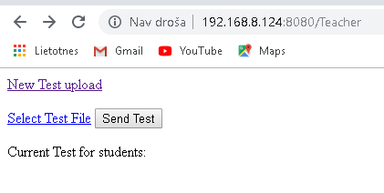
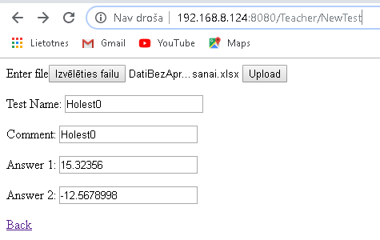
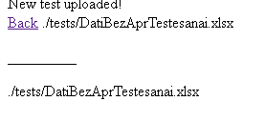
Student
http://192.168.8.144:8081/student

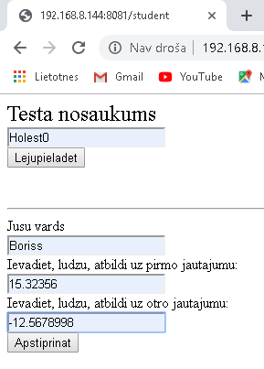
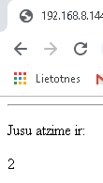
Other student Pēteris
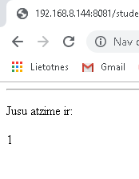
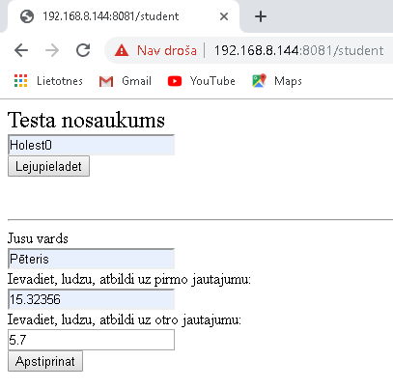
If Pēteris fill test again
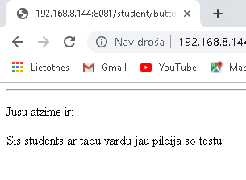

Other student Jānis
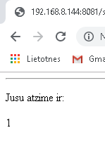
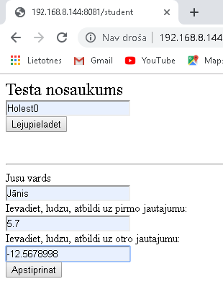
Other student Boriss
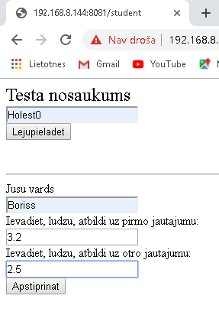
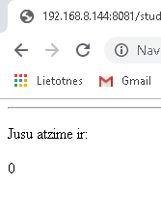

Example 2
Teacher
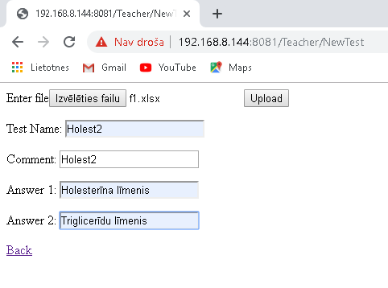
Student
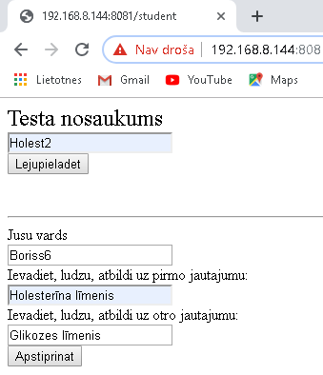
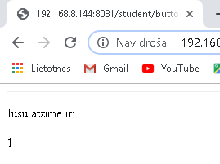
Case sensitive
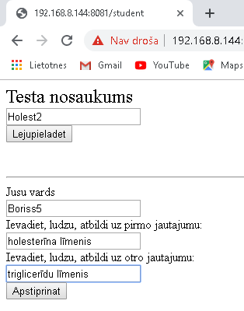
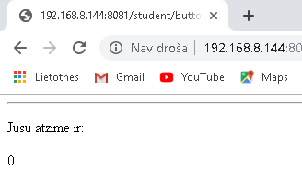

Example 3
Teacher adds one fail with same name Holest2
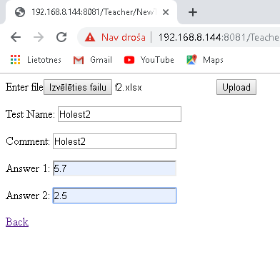
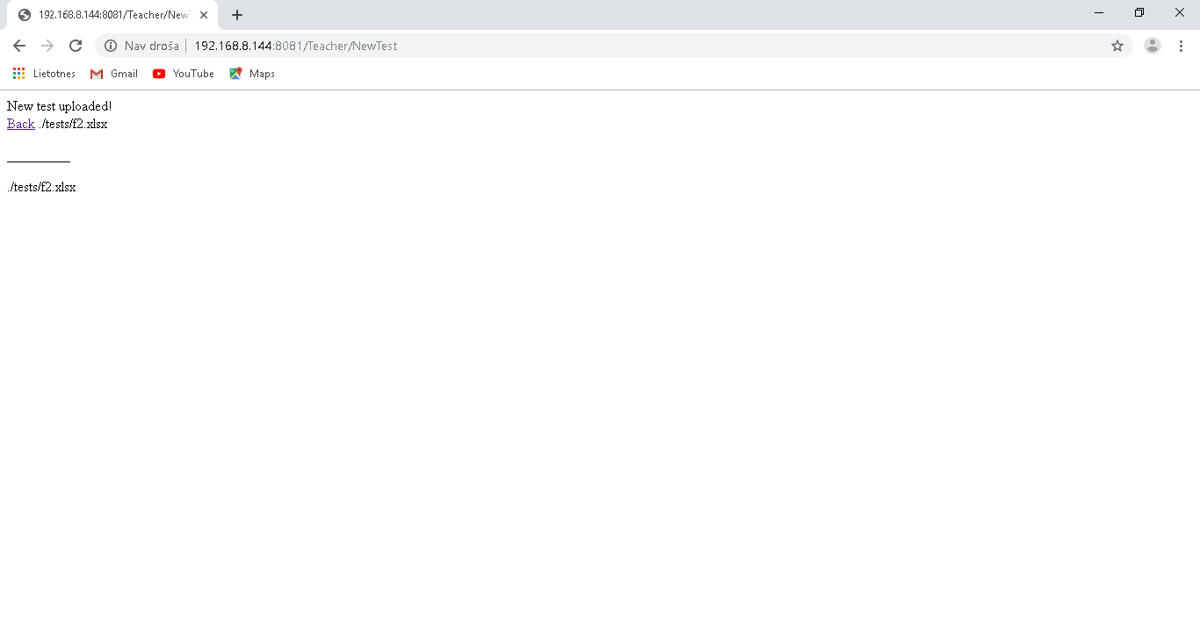
Mayn’t be same name with existing test and file
Necessary to click Lejupieladet for confirm posibility to one student to do some tests
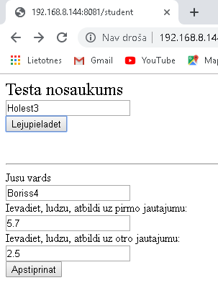
If student write any test first time then don’t necessary to click Lejupieladet!

Better always click Lejupieladet for any student!
