IN3046: Cloud Computing

Coursework - Specification of Application

Jack Negus

180053204

Arkadiusz Nowacki

220055077

01/11/2022

1. **Description of the Application:**

We are proposing to build a web-based application that stores, displays, and allows student records to be updated. The software will have a web-based GUI and will utilize AWS Elastic Beanstalk for deployment. Records will be stored in a DynamoDB database within the cloud and person will have an option to get a simple SMS notification that will confirm and let them know whether they have added a new attendance record. Before being able to store new information they will be authenticated by Amazon Cognito to get to the main form. The application will store the Name, Student ID number, modules, and attendance record of all students, and will allow users to check students' attendance across multiple modules. Users will be able to update students' attendance record as well as check attendance for all students enrolled in a module, as well as for all modules a single student is enrolled in.

1. **Typical Users:**

This application is aimed at lecturers/teachers who are interested in storing their student attendance records online. Once the records are stored online it essentially reduces the possibility of losing attendance records since local system failures will have no effect on stored information. Moreover, in case of any failure, the time taken to resolve it would not compare to the time taken to resolve the local issues, which perhaps could take hours or days. It is crucial since the purpose of this data is to be viewed/updated regularly otherwise the purpose of it is neglected and can lead to vast workflow/management issues. Lastly, the access to the records is achievable from anywhere.

1. **Implementation:**

Our implementation will be coded using Spring Boot in Java, and we will mostly utilize the software development kit provided by AWS to complete our application, which falls into the category of Software as a Service (SaaS). To make our application accessible, the GUI will utilize the java templating engine called Thymeleaf, which makes HTML correctly displayed in the browser. However, to get to the application itself, the user will have to be authenticated first by Amazon Cognito. When it comes to request handling and database queries, this will be taken care of by the java application, and due to the nature of the application, the records will be stored in a database called DynamoDB within AWS. In addition, AWS SNS will allow the user to get a textual notification message on their phone to confirm they have added a new record. In the end, the deployment of the application onto the cloud will be performed using AWS Elastic Beanstalk.

Figure 1: Graphical Representation of the Application Components

Browser

Amazon Cognito Authentication

DynamoDB

App Engine

DynamoDB

Figure 2: Database Schema for the Attendance Record

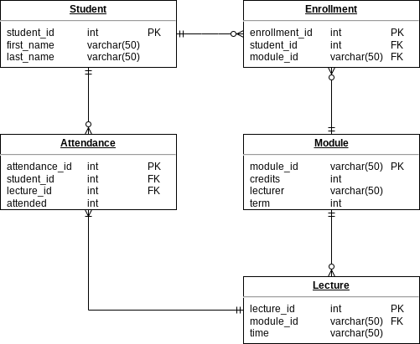

1. **Distribution of Work:**

Jack:

Arkadiusz: