**Earthquakes on Canadian Soil**

**Lab- 1 (The Plan)**

**Advanced Programming- OOP(COMP 6036)**

**Winter term, 2021**

**Submitted To: Submitted By:**

Clayton Greene Sarah Duplan

School of Design Biswash Lamsal

Fanshawe College Sarah Price

Bibhu Gautam

Date of Submission- 2021/01/27

# Introduction

The earth consists of many major and minor tectonic plates. These plates around the earth are constantly moving, but when there is movement along faults and plate boundaries, that is when earthquakes will happen. The specific data that will be presented in this project is from the country of Canada and includes categories including the dates ranging from the year 1985 to 2019, latitude, longitude, depth, magnitude, magnitude type and the place (province(s)) which were affected. The data that will be viewed and manipulated to fit “Team Ursula’s” Capstone project for the winter 2021 COMP 6036 term.

# Goal:

The goal of this project is to create a DDL, DML and stored procedures with SQL, which ultimately communicate between a C# Visual studios compiler, to be able to map out points and polygons, to view the data on a HTML google map.

# Vision Statement:

Team Ursula vision statement includes – “Project Ursula is for research students ranging from elementary school to university, who want to visualize and create data. The Ursula earthquake project is a computer program that will explore data of Canadian earthquakes, by using a C#/SQL application and turn it into a visual representation on google maps. Unlike textbooks or research papers, Ursula will produce and show a professional database on google maps to help students visualize where and how big the earthquakes in Canada can be, making each group member passionate about the research put into this project.”

# Product Roadmap:

Over the next 2 and a half months, Sarah P, Sarah D, Biswash and Bibhu will create a SQL/C# application like the WPF/airports project, which was done in COMP 6035 last semester. The main goal is to have the user view a google map that will show all earthquakes from a selected year as a location marker. Depending on what the user has inputted, the map will show the Latitude, Longitude, and the Town the earthquake was located on each side of the google map. On the other side of the map, a graph comparing earthquakes and its magnitude/Richter scale will be shown. One factor we would like to implement would be comparing magnitude of earthquakes in different latitudes for different years, to show if a certain location has been hit twice. The severity of those earthquakes could be compared on the Richter scale. The data will also produce an overlay of an active map compared to previous years to compare with Location markers/Heat markers. Each group member has decided on polygons to map the range of the earthquake and the towns which have been affected.

The Scrum Masters for each Sprints are given below:

Sprint 1: Sarah Price

Sprint 2: Bibhu Gautam

Sprint 3: Biswash Lamsal

Sprint 4: Sarah Duplan

Figure Grade Point System

## Build plan:

Ursula project is split up into four sprints.

## Sprint 1:

For the first sprint, members of Ursula, will create a database for earthquake data in Microsoft SQL server which includes a DML and a DDL and stored procedures. In the business logic layer, using C#, we will create a location object which takes the latitude and longitude data from the database layer to create the location marker. A data access class will also be made to read and retrieve earthquake data stored in the database layer. In the presentation layer, the user will be able to select a particular year to see all Earthquake location markers from that time frame on a google map. They will be able to select different location markers and the distance between the earthquakes and the corresponding data will appear. The user can select between one to two locations to see the data on each earthquake. The database layer, business logic layer and presentation layer will all communicate with each other so the user can select and visualize earthquake data.

Figure 2 Sprint 1

## Sprint 2:

In this sprint, members will be writing code to DELETE and ADD earthquakes to the data. This sprint will also include the option to create a polyline between two marked earthquakes to show the distance between the two. In the business logic layer, using C#, we will create a polyline object which uses the distance formula to calculate the distance between user selected locations. The polylines will appear only if the user selects the option on the side. All data from each earthquake will still appear on the side. There will be a button selection where the user can click "show polyline." There will be a clear, delete, and update selection implemented for the polylines as well.

Figure 3 Sprint 2

## Sprint 3:

Sprint three will entails, the user being able to see a marker and delete their selection or update the whole thing altogether to see a new earthquake dataset. The selected dataset will show to the screen with information provided as the location, magnitude, the depth, and the colour scheme of how high the earthquake was on the magnitude scale. The C# layer will communicate with database layer to read and create the polygon shape. This will help the user to visualize what surrounding areas would be most affected by the earthquakes. Just like the polyline option, there will be a delete, clear and update selection for the polygons. User can now pick polylines, polygons or both.

Figure 4 Sprint 3

## Sprint 4:

Sprint four will include, fixing up all bugs from the previous sprints, to make sure the program runs properly. A heatmap will also be created, to show the magnitude of the chosen earthquake as a color in two dimensions. The variation in color will depict the intensity of each dataset which was chosen, giving the researcher a visual cue about how the earthquake was on the magnitude scale, as well as the depth it caused.

Figure 5 Sprint 4

Attached in this report is an excel file that shows each individual sprint and the explanations.

# Product Backlog

The following diagram shows list of activities that team Ursula plans to deliver in the given dates. This is the initial product backlog of the project and it will regularly updated as we progress towards each sprints.

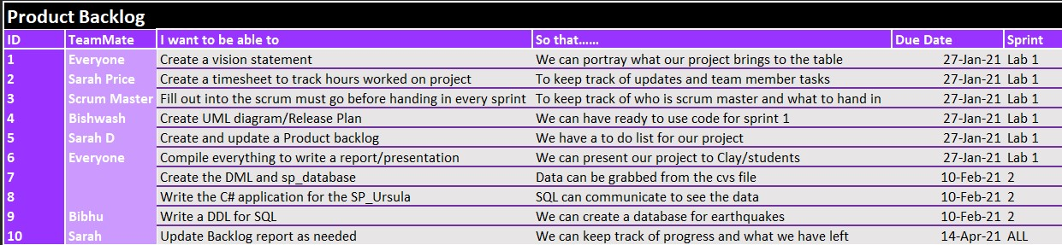

Figure 6 Product Backlog

# Unified Modelling Language (UML)

Labeled below is our UML. As shown by the photo, this process will help each member of Ursula decide the next goal/direction to go with this project. In each box, there is a ready to use model we can start off with to be able to design our code accordingly in each language code. Over the next 3 months, the UML will have more added to and will be constantly evolving and changing.

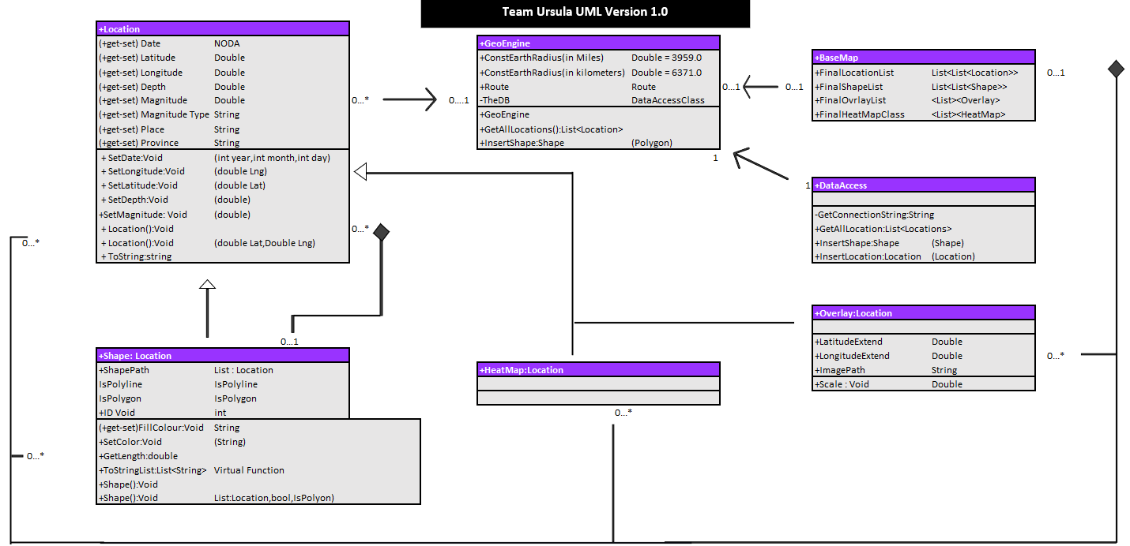

Figure 7 UML Diagram