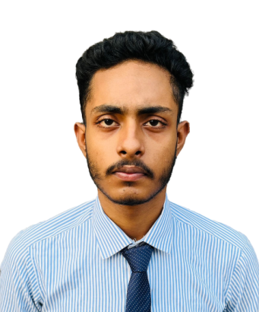

Rajarhat New Town,

West Bengal. PIN - 700136

[(+91) 9123813528](9123813528)

<soumyajitray2002@gmail.com>

Soumyajit Ray

[](http://www.linkedin.com/in/soumyajit-ray2002) **[-Soumyajit Ray](http://www.linkedin.com/in/soumyajit-ray2002)**

**CAREER OBJECTIVE**

Seeking an opportunity to work for an organization to have a platform to learn and earn and also explore new technologies and to improve my skills.

# Languages and Technologies

* Programming Languages - HTML5, CSS3 , JavaScript .
* Operating System - Windows,Linux Ubuntu.
* Library and Environments - React,NodeJS.
* Frameworks and tools - React Native, VS Code.

**EDUCATION**

**Kolkata, West Bengal Budge Budge Institute Of Technology 2020 - 2024**

* B.Tech. in Computer Science & Engineering . Overall SGPA-8
* Main coursework: Data Structures, Database Management Systems, Operating Systems, Software Engineering.

**Kolkata, West Bengal Naraindass Bangur Memorial Multipurpose School 2018 -2020**

Higher Secondary. Grade - 60%

**PROJECT**

* + Project Name : Portfolio Site
  + Duration : 1month .
  + Role : Student( Personal Project).
  + Project Details : React based project . Learning and practicing project with React.
  + Technology Used : HTML5, CSS3, ReactJS.
  + Tools : Visual Studio Code.

**Interests**

Problem solving, Playing Chess, Cycling, Bike riding ,Online games & Travelling.