Real-Time Healthcare Claims &
EHR Data Engineering Pipeline on AWS

End-to-End Pipeline: Lambda → S3 → Glue → Snowflake → Streamlit

Authors: Arukala Sai Vikas
Date: June 2026
Stack: AWS Lambda · AWS Glue · Amazon S3 · Snowflake · Streamlit

1. Project Overview
This project builds a real-time healthcare data engineering pipeline that:
- Generates synthetic CMS Claims (Medicare/Medicaid style) and FHIR R4 EHR data
- Ingests raw data into Amazon S3 via AWS Lambda functions
- Transforms and cleans the data using AWS Glue PySpark ETL jobs
- Loads clean Parquet data into Snowflake automatically via Snowpipe
- Provides an interactive Streamlit analytics dashboard for exploring the data
The pipeline is fully event-driven: a single API call triggers data generation, which cascades through S3 → Glue → Snowflake with no manual intervention.

2. Architecture
The pipeline follows a layered, event-driven architecture:
USER → API Gateway → Lambda: api-trigger
│
┌────────────────┴────────────────┐
▼ ▼
Lambda: cms-claims-generator Lambda: fhir-ehr-generator
│ │
▼ ▼
S3: healthcare-cms-claims-raw S3: healthcare-ehr-raw
│ │
▼ ▼
Glue: cms-claims-etl Glue: ehr-fhir-etl
│ │
▼ ▼
S3: cms-claims-clean S3: ehr-clean
│ │
└──────────────┬────────────────────┘
▼
Snowflake Snowpipe
│
Snowflake Tables
│
Streamlit Dashboard

3. Data Sources & Schema

3.1 CMS Claims Data (Synthetic DE-SynPUF)
The CMS DE-SynPUF (Synthetic Public Use File) schema mirrors real Medicare claims structure. Seven entity types are generated per batch:
Entity | Description | Key Fields
beneficiary_summary | Patient demographics + chronic conditions | DESYNPUF_ID, birth date, gender, race, 9 chronic flags
providers | Provider directory | PROVIDER_ID, NPI, specialty, state
inpatient_claims | Hospital stays | CLM_ID, admit/discharge dates, DRG code, payment
outpatient_claims | Outpatient visits | CLM_ID, service dates, HCPCS codes, payment
carrier_claims | Physician/carrier claims | CLM_ID, performing NPI, service date, payment
prescription_drug_events | Pharmacy fills | PDE_ID, drug code, generic/brand name, cost
diagnosis_codes | ICD-10 reference codes | ICD10 code + description

Medical coding standards used: ICD-10 (diagnoses), HCPCS (procedures), DRG (inpatient classification), NDC (drug codes).

3.2 FHIR R4 EHR Data (Synthetic Bundles)
FHIR (Fast Healthcare Interoperability Resources) R4 is the modern standard for healthcare data exchange. Each patient generates a Bundle containing 15 linked resources:
FHIR Resource | Description | Key Fields
Patient | Patient demographics | id, name, gender, birthDate, address, race, ethnicity
Practitioner | Healthcare provider | id, NPI, name, qualification/specialty
Encounter | Clinical visit | id, class (AMB/EMER/IMP), period, total cost
Condition | Diagnoses | id, ICD-10, SNOMED code, clinical status, chronic flag
Observation | Lab results & vitals | id, LOINC code, value, unit, reference range, abnormal flag
MedicationRequest | Prescriptions | id, RxNorm code, drug name, dosage, chronic flag
Procedure | Performed procedures | id, CPT code, SNOMED code, cost
AllergyIntolerance | Allergies | id, substance, reaction, severity
Immunization | Vaccines | id, CVX code, vaccine name, occurrence date

Medical coding standards used: ICD-10, SNOMED-CT, LOINC (lab tests), RxNorm (medications), CVX (vaccines), CPT (procedures).

4. AWS Infrastructure Setup
All AWS services were created manually via the AWS Console. Region used throughout: us-east-2 (Ohio).

4.1 IAM Roles
Role | Used By | Key Permissions
healthcare-lambda-role | All Lambda functions | S3 read/write, Lambda invoke, CloudWatch logs
healthcare-glue-role | Glue ETL jobs | S3 read/write (raw + clean buckets), CloudWatch logs
snowflake-s3-role | Snowflake integration | S3 GetObject, ListBucket on clean buckets

4.2 S3 Buckets
Bucket | Purpose
healthcare-cms-claims-raw | Raw CMS CSV files + Glue ETL scripts
healthcare-ehr-raw | Raw FHIR R4 JSON bundles
healthcare-cms-claims-clean | Cleaned CMS Parquet files (Snowpipe source)
healthcare-ehr-clean | Cleaned EHR Parquet files (Snowpipe source)

5. Data Ingestion — Lambda Functions
Three Lambda functions handle data generation and orchestration. All use Python 3.11 and the handler.handler entry point.

5.1 cms-claims-generator
Generates synthetic CMS Claims CSVs and uploads to S3 under date-partitioned prefixes.
- Trigger: Async invocation from api-trigger Lambda
- Output: 7 CSV files per invocation
- Key env vars: RAW_CMS_BUCKET, RECORDS_PER_BATCH (default 500)
S3 key pattern:
year=2026/month=06/day=15/beneficiary_summary_<uuid>.csv
year=2026/month=06/day=15/inpatient_claims_<uuid>.csv
year=2026/month=06/day=15/carrier_claims_<uuid>.csv

5.2 fhir-ehr-generator
Generates synthetic FHIR R4 Bundle JSON files and uploads to S3.
- Trigger: Async invocation from api-trigger Lambda
- Output: One JSON Bundle per patient under fhir/
- Key env vars: RAW_EHR_BUCKET, PATIENTS_PER_BATCH (default 200)
- Structure: Each file is a FHIR Bundle containing 15 linked resources for one patient

5.3 api-trigger
Entry point exposed via API Gateway. Asynchronously invokes both generators in parallel.
- Trigger: HTTP POST via API Gateway
- InvocationType=Event — fire and forget, both generators run in parallel
- Returns immediately with a batchId while generation continues in the background
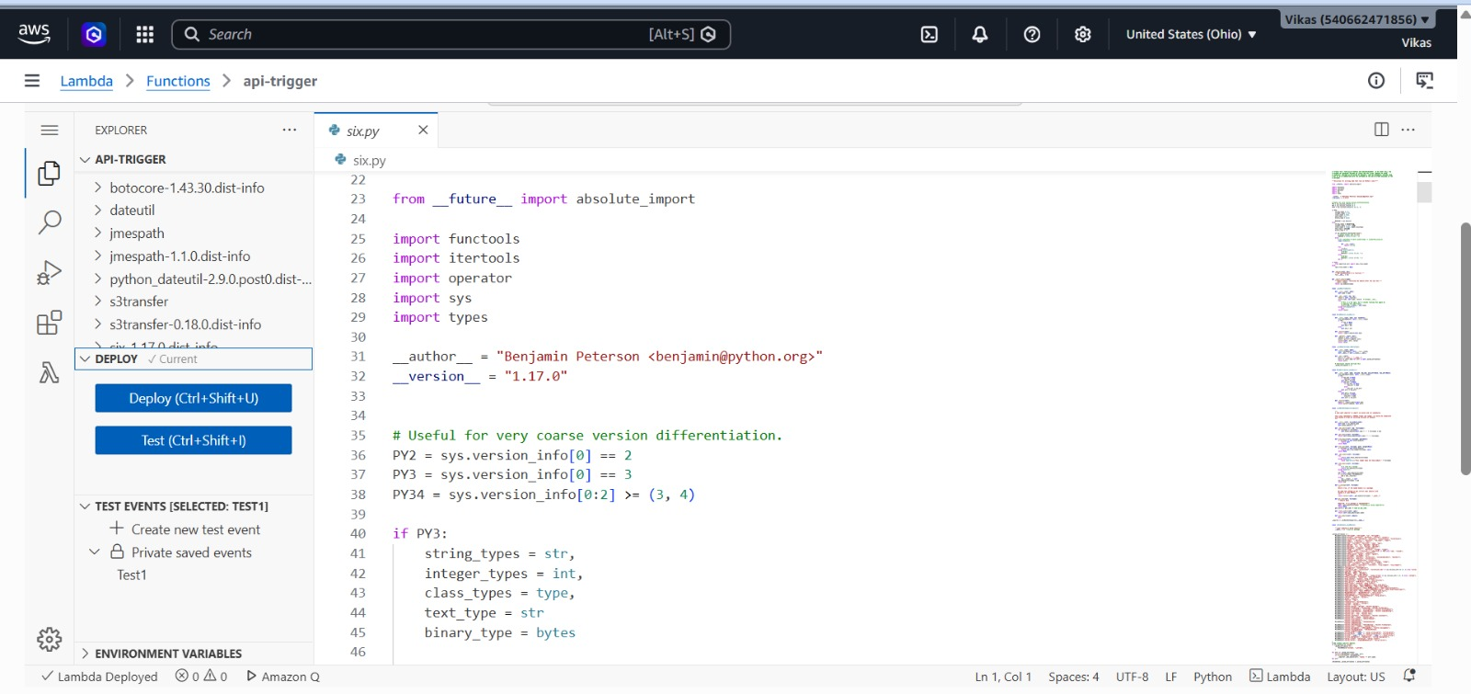
Figure 1 — Lambda Functions in AWS Console

6. API Gateway — Trigger Endpoint
An HTTP API (API Gateway v2) exposes a single POST endpoint that kicks off the entire pipeline.
Endpoint URL:
POST https://u0zg8lmc1c.execute-api.us-east-2.amazonaws.com/dev/trigger
Request body:
{
"records_per_batch": 500,
"patients_per_batch": 200
}
Response:
{
"message": "Data generation triggered successfully.",
"batchId": "2c8b7229-03c8-4748-b8c0-6eda01032cd0"
}
How to call it (PowerShell):
Invoke-RestMethod \
-Uri "https://u0zg8lmc1c.execute-api.us-east-2.amazonaws.com/dev/trigger" \
-Method POST \
-ContentType "application/json" \
-Body '{"records_per_batch": 500, "patients_per_batch": 200}'
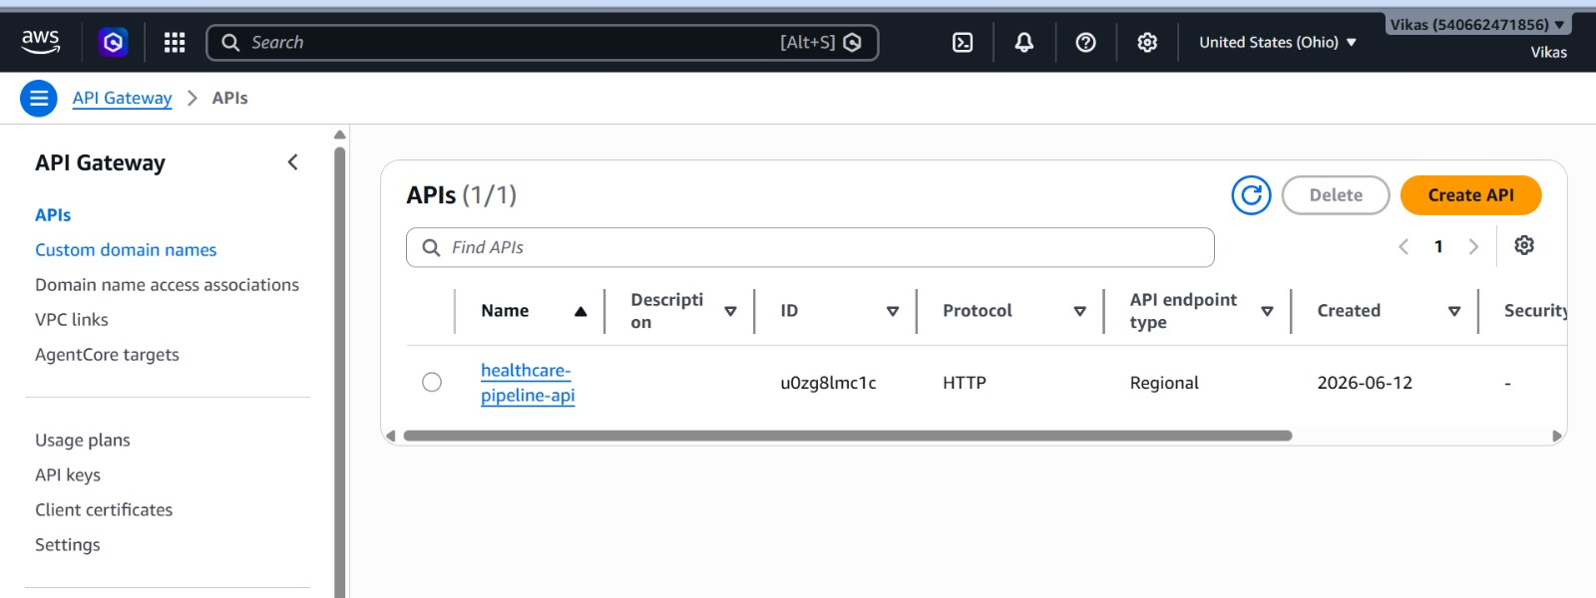
Figure 2 — API Gateway Configuration
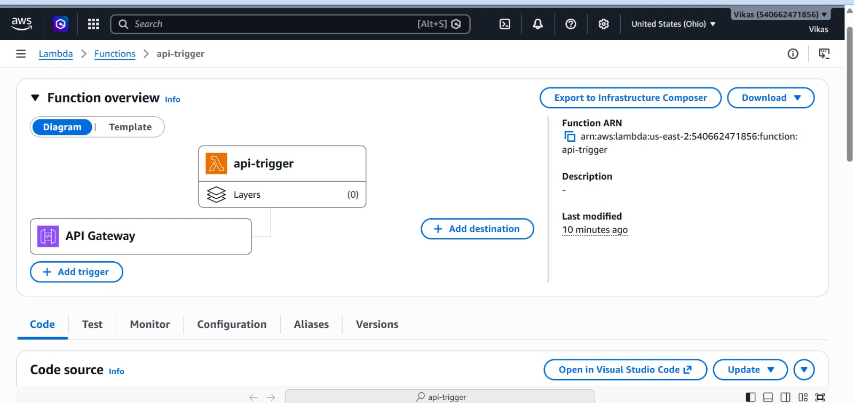
Figure 3 — API Gateway Architecture

7. Raw Data Storage — Amazon S3
Raw data lands in two S3 buckets with date-partitioned prefixes, allowing Glue to process data by date range.

7.1 CMS Raw Bucket Structure
healthcare-cms-claims-raw/
├── glue-scripts/
│ ├── cms_claims_etl.py
│ └── ehr_fhir_etl.py
└── year=2026/
└── month=06/
└── day=15/
├── beneficiary_summary_<uuid>.csv
├── providers_<uuid>.csv
├── inpatient_claims_<uuid>.csv
├── outpatient_claims_<uuid>.csv
├── carrier_claims_<uuid>.csv
├── prescription_drug_events_<uuid>.csv
└── diagnosis_codes_<uuid>.csv

7.2 EHR Raw Bucket Structure
healthcare-ehr-raw/
└── fhir/
├── patient_<uuid>.json
├── patient_<uuid>.json
└── ...
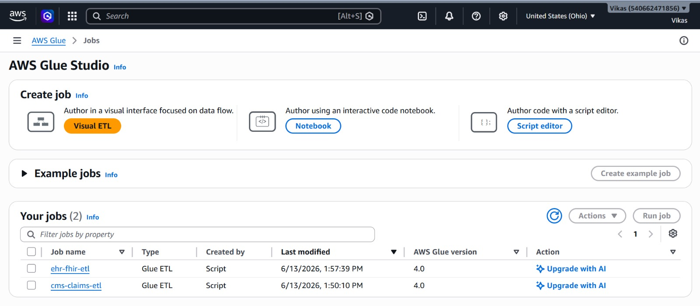
Figure 4 — S3 Buckets Overview
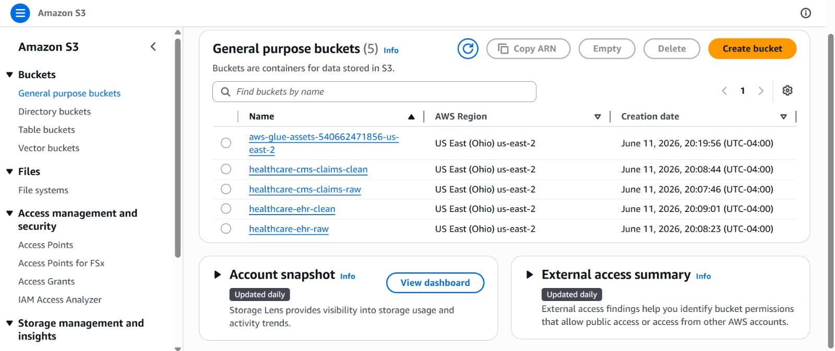
Figure 5 — S3 Raw Bucket Contents
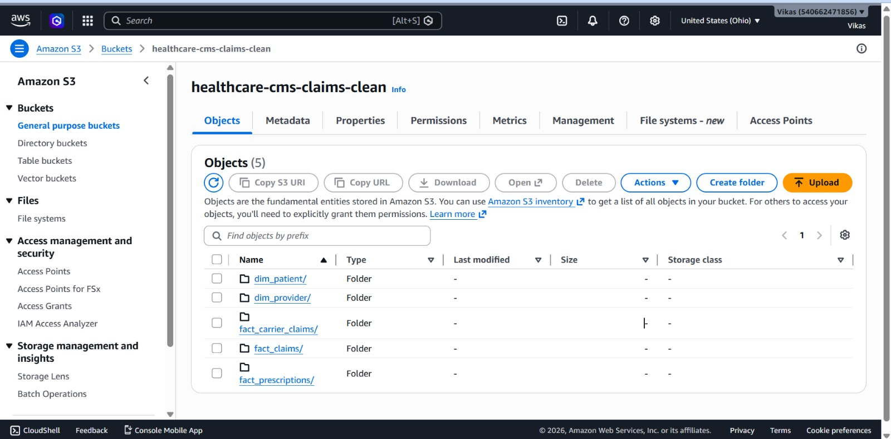
Figure 6 — S3 Date-Partitioned Folder Structure
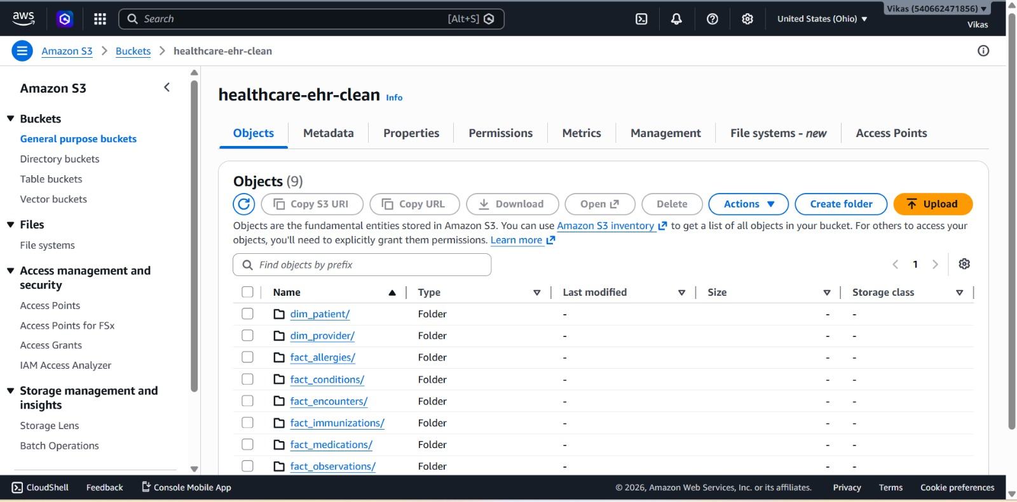
Figure 7 — S3 Entity File Names

8. ETL — AWS Glue
Two AWS Glue 4.0 PySpark ETL jobs transform raw data into analytics-ready Parquet format.

8.1 CMS Claims ETL (cms-claims-etl)
Script: src/glue/cms_claims_etl.py | Runtime: Glue 4.0, PySpark 3.3, Python 3.10
Job Parameters:
--RAW_CMS_BUCKET healthcare-cms-claims-raw
--CLEAN_CMS_BUCKET healthcare-cms-claims-clean
Nine transformation groups are applied in sequence:
Group | What It Does
1. Column rename | Maps raw CMS column names (e.g. DESYNPUF_ID) to clean names (patient_id)
2. Type casting | Converts date strings (yyyyMMdd) to DATE, amounts to DECIMAL(12,2)
3. Code decoding | Maps numeric gender/race codes to labels (1→Male, 1→White)
4. Null handling | Fills amount nulls with 0.0, flags missing birth dates, sets is_deceased
5. Deduplication | dropDuplicates on business keys (patient_id, claim_id, etc.)
6. Date derivation | Extracts year, quarter, month, week_of_year, date_key from date columns
7. Financial cleanup | Clips negative amounts to 0, rounds to 2dp, flags is_high_cost at 99th pct
8. Surrogate keys | SHA-256 hash of business key → patient_key, claim_key, etc.
9. Risk flags | Sums 9 chronic condition flags → risk_score, risk_tier (Low/Medium/High)

Output tables written as Parquet:
Parquet Prefix | Description | Sample Rows
dim_patient/ | Patient dimension | 3,000
dim_provider/ | Provider dimension | 300
fact_claims/ | Inpatient + outpatient claims | 6,000
fact_carrier_claims/ | Carrier/physician claims | 3,000
fact_prescriptions/ | Drug events | 3,000

8.2 EHR FHIR ETL (ehr-fhir-etl)
Script: src/glue/ehr_fhir_etl.py | Runtime: Glue 4.0, PySpark 3.3, Python 3.10
Job Parameters:
--RAW_EHR_BUCKET healthcare-ehr-raw
--CLEAN_EHR_BUCKET healthcare-ehr-clean
Key challenge — FHIR Schema Conflicts:
FHIR bundles contain mixed resource types in a single JSON array. Spark infers a merged schema, causing three type conflicts that were resolved:
- name field conflict: Organization.name is a plain string; Patient.name is an array of structs. Fixed using from_json() with an explicit schema after filtering by resourceType.
- valueMoney vs valueDecimal: The generator uses valueMoney:{value,currency} for costs. Fixed by changing to extension[0]['valueMoney']['value'].
- category field conflict: AllergyIntolerance.category is ['food'] (string array); Observation.category is [{coding:[...]}] (struct array). Fixed using get_json_object() instead of struct access.
Output tables:
Parquet Prefix | Description | Sample Rows
dim_patient/ | EHR patient dimension | 532
dim_provider/ | Practitioner dimension | ~50
fact_encounters/ | Clinical visits | 532
fact_conditions/ | Diagnoses | 0*
fact_observations/ | Lab results & vitals | 1,596
fact_medications/ | Medication requests | 1,064

* fact_conditions has 0 rows in this sample batch — varies by batch size.
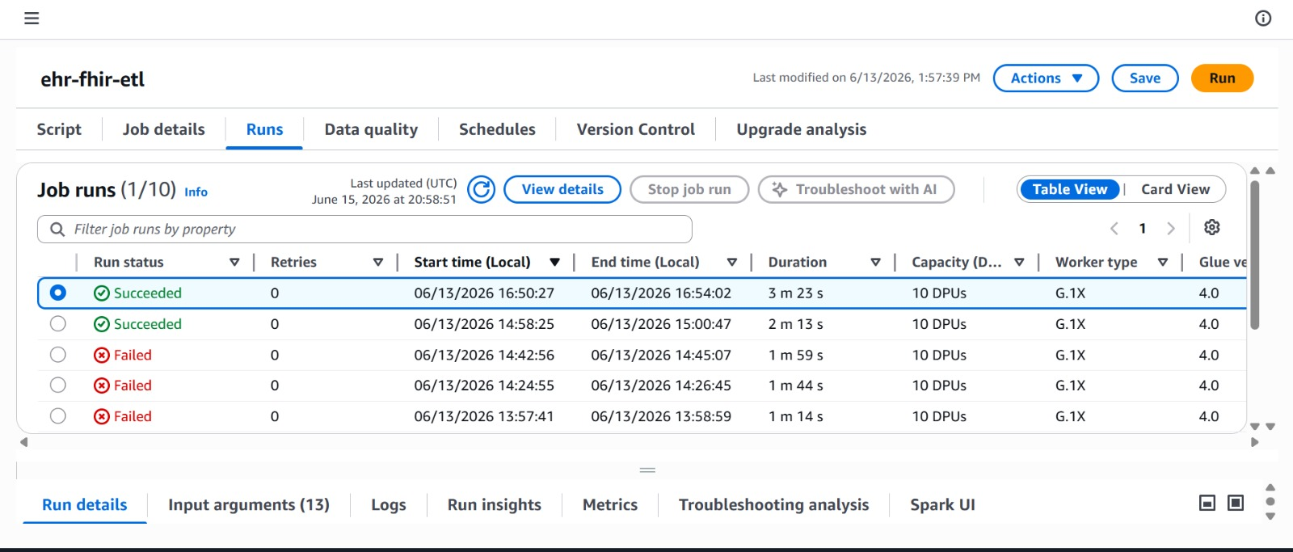
Figure 8 — AWS Glue Job Runs
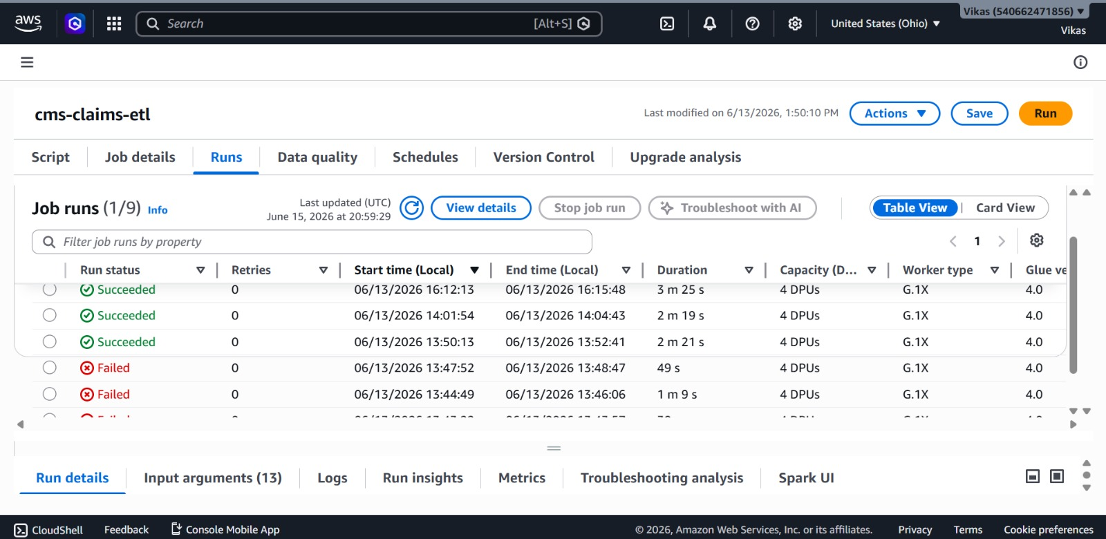
Figure 9 — CMS Glue Job Run History
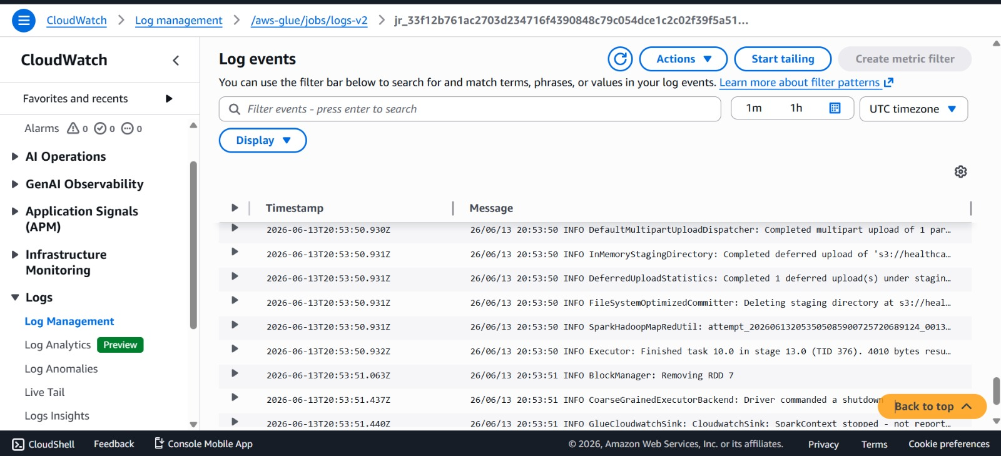
Figure 10 — Glue Job CloudWatch Logs

9. Clean Data Storage — S3 Clean Buckets
After Glue completes, cleaned Parquet files land in the clean S3 buckets. Snowpipe monitors these buckets and loads new files automatically.
Why Parquet?
- Columnar format — fast for analytical queries (reads only needed columns)
- Snappy compression — ~75% smaller than equivalent CSV
- Type-preserving — dates, decimals, and booleans stored correctly without parsing
- Native support in both Apache Spark and Snowflake

10. Snowflake — Data Warehouse

10.1 Account Details
Field | Value
Account Identifier | ABCIDUX-GP18792
Organization | ABCIDUX
Account Name | GP18792
Login Name | ARKALA
Warehouse | COMPUTE_WH (X-Small)
Database | healthcare
Schema | raw

10.2 Tables Loaded
CMS Tables:
Table | Source | Rows
dim_patient_cms | beneficiary_summary | 3,000
dim_provider_cms | providers | 300
fact_claims | inpatient + outpatient | 6,000
fact_carrier_claims | carrier_claims | 3,000
fact_prescriptions | prescription_drug_events | 3,000

EHR Tables:
Table | Source | Rows
dim_patient_ehr | FHIR Patient | 532
dim_provider_ehr | FHIR Practitioner | ~50
fact_encounters | FHIR Encounter | 532
fact_conditions | FHIR Condition | 0
fact_observations | FHIR Observation | 1,596
fact_medications | FHIR MedicationRequest | 1,064

10.3 Storage Integration
A Snowflake Storage Integration connects Snowflake to both clean S3 buckets using an IAM role trust relationship — no AWS credentials stored in Snowflake.
CREATE STORAGE INTEGRATION s3_healthcare
TYPE = EXTERNAL_STAGE
STORAGE_PROVIDER = 'S3'
ENABLED = TRUE
STORAGE_AWS_ROLE_ARN = 'arn:aws:iam::109676855909:role/snowflake-s3-role'
STORAGE_ALLOWED_LOCATIONS = (
's3://healthcare-cms-claims-clean/',
's3://healthcare-ehr-clean/'
);
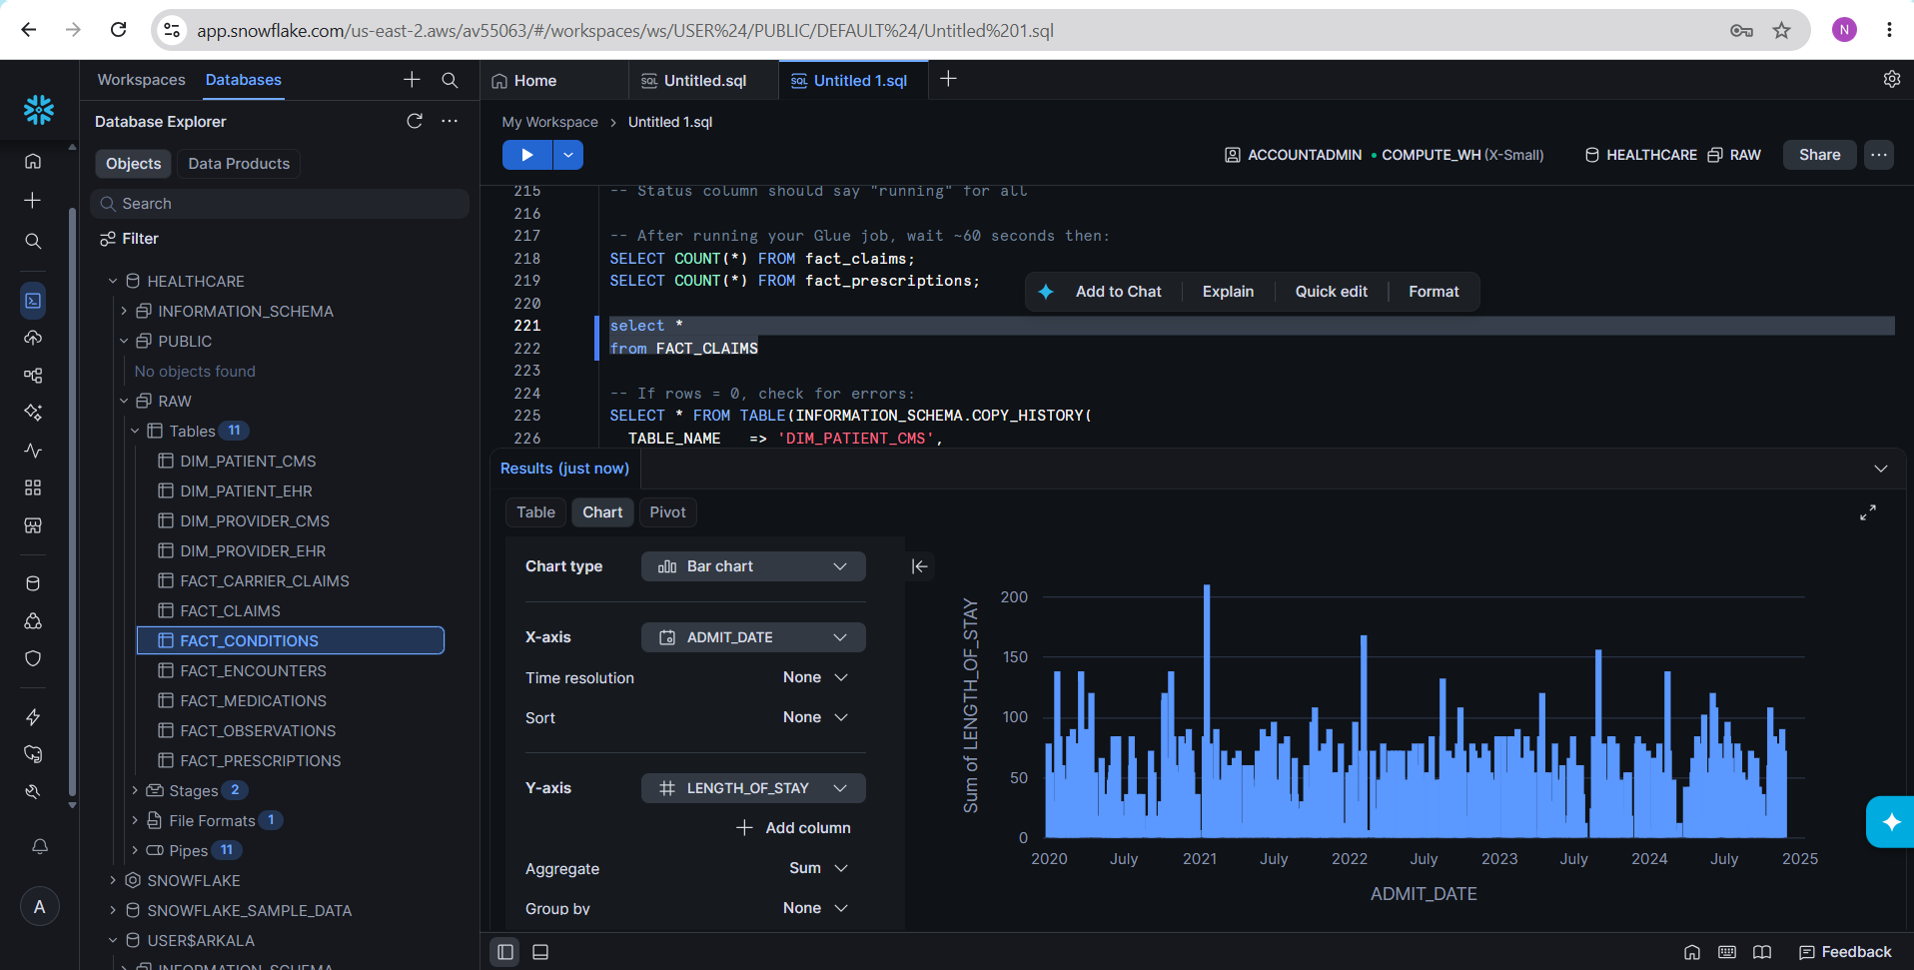
Figure 11 — Snowflake Tables and Data

11. Snowpipe — Auto-Ingest
Snowpipe automatically loads new Parquet files into Snowflake tables as soon as they appear in S3 — no manual COPY INTO required.

11.1 How It Works
Glue writes Parquet to S3 clean bucket
↓
S3 fires ObjectCreated event → SQS queue (owned by Snowflake)
↓ (~60 seconds latency)
Snowpipe reads SQS message, loads new files into target table
↓
Data available to query in Snowflake

11.2 Pipes Created
CMS Pipes (5):
Pipe Name | Source Prefix | Target Table
pipe_dim_patient_cms | cms_clean_stage/dim_patient/ | dim_patient_cms
pipe_dim_provider_cms | cms_clean_stage/dim_provider/ | dim_provider_cms
pipe_fact_claims | cms_clean_stage/fact_claims/ | fact_claims
pipe_fact_carrier | cms_clean_stage/fact_carrier_claims/ | fact_carrier_claims
pipe_fact_prescriptions | cms_clean_stage/fact_prescriptions/ | fact_prescriptions

EHR Pipes (6):
Pipe Name | Source Prefix | Target Table
pipe_dim_patient_ehr | ehr_clean_stage/dim_patient/ | dim_patient_ehr
pipe_dim_provider_ehr | ehr_clean_stage/dim_provider/ | dim_provider_ehr
pipe_fact_encounters | ehr_clean_stage/fact_encounters/ | fact_encounters
pipe_fact_conditions | ehr_clean_stage/fact_conditions/ | fact_conditions
pipe_fact_observations | ehr_clean_stage/fact_observations/ | fact_observations
pipe_fact_medications | ehr_clean_stage/fact_medications/ | fact_medications

11.3 S3 Event Notifications
Each clean S3 bucket has prefix-level ObjectCreated event notifications pointing to the Snowpipe SQS queue (ARN: arn:aws:sqs:us-east-2:109676855909:sf-snowpipe-...). All 11 pipes share the same SQS ARN — Snowflake routes events internally based on the stage path.
Verification:
SHOW PIPES;
SELECT * FROM TABLE(INFORMATION_SCHEMA.COPY_HISTORY(
TABLE_NAME => 'FACT_CLAIMS',
START_TIME => DATEADD(HOUR, -2, CURRENT_TIMESTAMP)
));

12. Streamlit Analytics Dashboard
An interactive Streamlit dashboard connects directly to Snowflake using the snowflake-connector-python library and renders live charts from query results.

12.1 Setup
cd streamlit_app
python -m venv venv
venv\Scripts\activate
pip install -r requirements.txt
streamlit run app.py
.env file (credentials — never committed to git):
SNOWFLAKE_ACCOUNT=ABCIDUX-GP18792
SNOWFLAKE_USER=Arkala
SNOWFLAKE_WAREHOUSE=COMPUTE_WH
SNOWFLAKE_DATABASE=healthcare
SNOWFLAKE_SCHEMA=raw

12.2 Dashboard Tabs
Overview Tab — KPIs + Patient Demographics:
- 9 KPI metric tiles (patients, claims, spend, encounters, etc.)
- Patient Risk Distribution — pie chart derived from risk_score (Low/Medium/High)
- Patient Age Group — bar chart with average risk score as color scale
- Gender × Race Breakdown — grouped bar chart
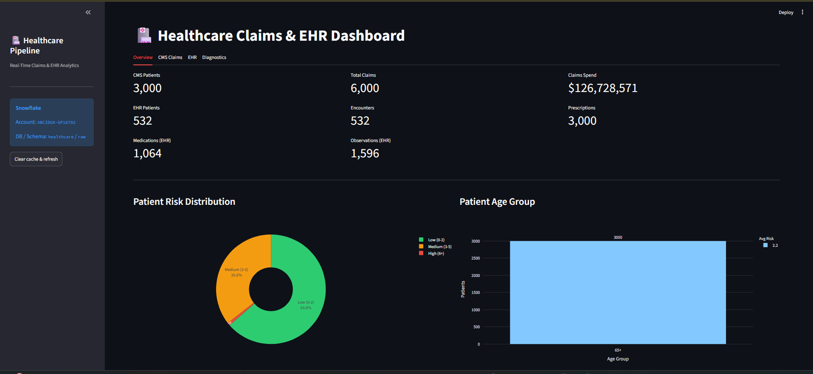
Figure 12 — Streamlit Overview Tab
CMS Claims Tab:
- Claims by Month — bar (count) + line (total payment) using YEAR/MONTH(admit_date)
- Payment Amount Buckets — claim count by payment range (< $500, $500–$2K, etc.)
- Top 10 Prescribed Drugs — horizontal bar colored by total cost
- High-Cost Patients Scatter — bubble chart: risk score vs total spend, sized by claim count
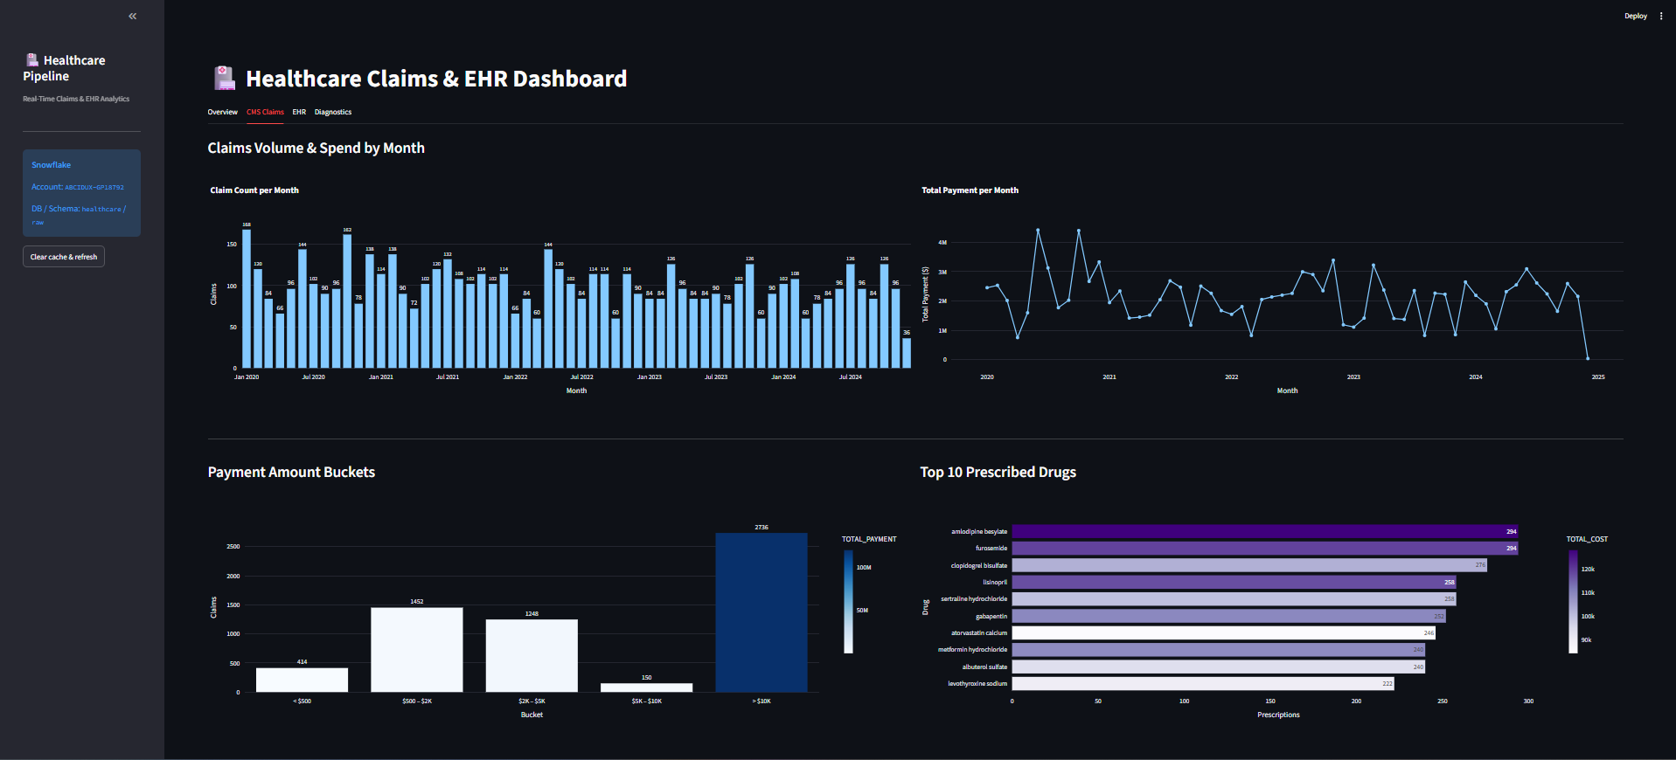
Figure 13 — CMS Claims Tab
EHR Tab:
- Encounter Class Breakdown — pie (AMB/EMER/IMP) + avg cost bar chart
- Encounters by Month — bar + line using YEAR/MONTH(period_start)
- Top 10 Medications — horizontal bar colored by chronic medication count
- Chronic vs Acute Medication Split — donut pie chart
- Lab Tests by Volume — colored by abnormal percentage
- Abnormal Rate by Lab Test — percentage horizontal bar
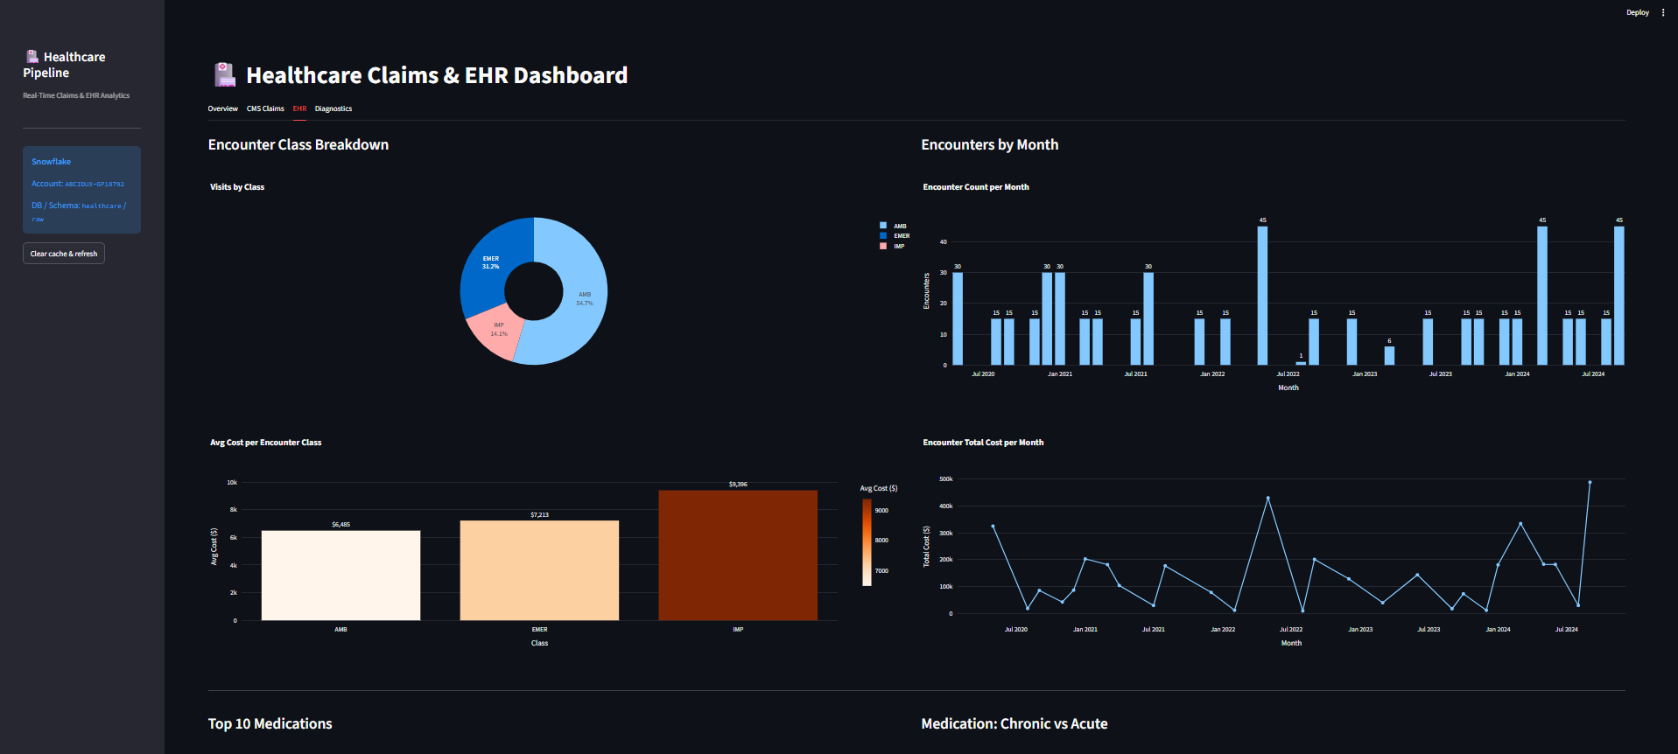
Figure 14 — EHR Tab (Encounters & Medications)
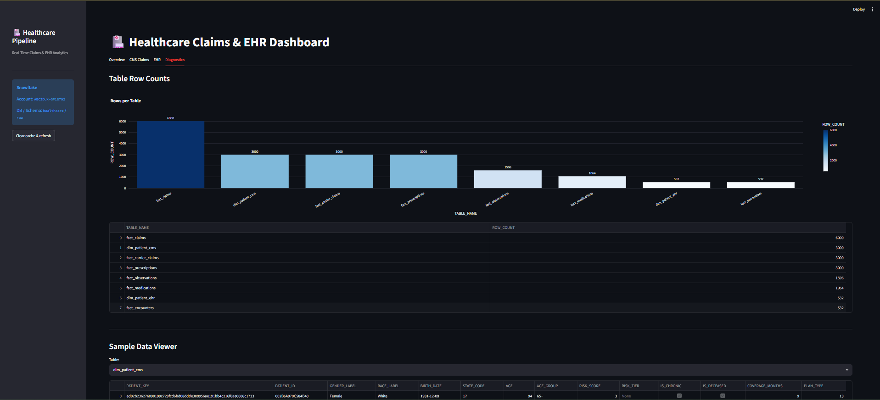
Figure 15 — EHR Tab (Lab Observations)
Diagnostics Tab:
- Row counts per table — bar chart showing how many rows Snowpipe has loaded
- Sample Data Viewer — dropdown to preview any table (5 rows)
- Null Detection — highlights columns with null values in the sample

12.3 Technical Note on Null Columns
Spark's partitionBy() writes partition column values into the S3 folder path (e.g., fact_claims/year=2026/) and removes them from the Parquet file schema. Snowpipe reads raw Parquet files without path inference, so those columns (year, claim_type, visit_year, etc.) arrive as NULL in Snowflake. The dashboard works around this by deriving year/month directly from admit_date and period_start using YEAR() and MONTH() SQL functions.

13. CI/CD — GitHub Actions
A GitHub Actions workflow (.github/workflows/deploy.yml) automatically deploys code on every push to main.

13.1 What It Deploys
Job 1 — deploy-lambdas (runs in parallel with Job 2):
- Packages and deploys all 3 Lambda functions with aws lambda update-function-code
- Creates the function automatically if it does not exist yet
Job 2 — deploy-glue:
- Uploads cms_claims_etl.py and ehr_fhir_etl.py to s3://healthcare-cms-claims-raw/glue-scripts/
- Updates the Glue job script location via aws glue update-job

13.2 Required Secrets & Variables
Type | Name | Value
Secret | AWS_ACCESS_KEY_ID | IAM user access key
Secret | AWS_SECRET_ACCESS_KEY | IAM user secret key
Secret | LAMBDA_ROLE_ARN | arn:aws:iam::109676855909:role/healthcare-lambda-role
Variable | CMS_RAW_BUCKET | healthcare-cms-claims-raw
Variable | EHR_RAW_BUCKET | healthcare-ehr-raw
Variable | CMS_LAMBDA_NAME | cms-claims-generator
Variable | FHIR_LAMBDA_NAME | fhir-ehr-generator
Variable | TRIGGER_LAMBDA_NAME | api-trigger
Variable | CMS_GLUE_JOB | cms-claims-etl
Variable | EHR_GLUE_JOB | ehr-fhir-etl

14. End-to-End Data Flow
Complete journey of a single API trigger call:
Step 1 — API Trigger: User calls POST /trigger → API Gateway routes to api-trigger Lambda → returns batchId immediately
Step 2 — Parallel Generation: api-trigger async invokes both generators in parallel:
• cms-claims-generator: generates 500 beneficiaries + 6 entity files → uploads 7 CSVs to healthcare-cms-claims-raw/year=.../
• fhir-ehr-generator: generates 200 FHIR Bundles → uploads JSON to healthcare-ehr-raw/fhir/
Step 3 — Glue ETL (CMS): cms-claims-etl reads all CSVs → applies 9 transformation groups → writes 5 Parquet tables to healthcare-cms-claims-clean/
Step 4 — Glue ETL (EHR): ehr-fhir-etl reads FHIR JSON bundles → explodes Bundle.entry[] → flattens 9 resource types → writes Parquet to healthcare-ehr-clean/
Step 5 — S3 Events: S3 fires ObjectCreated events on clean buckets → routed to Snowflake SQS queues (~60 sec latency)
Step 6 — Snowpipe Load: Snowpipe reads SQS messages → COPY INTO target tables using MATCH_BY_COLUMN_NAME=CASE_INSENSITIVE
Step 7 — Dashboard: Streamlit queries Snowflake → renders interactive charts for CMS Claims, EHR, and diagnostics

15. Project File Structure
Real-Time-Healthcare-Claims-EHR-Data-Engineering-Pipeline-on-AWS/
├── .github/
│ └── workflows/
│ └── deploy.yml ← CI/CD pipeline
├── src/
│ ├── lambdas/
│ │ ├── api_trigger/ ← Lambda 3: HTTP entry point
│ │ ├── cms_claims_generator/ ← Lambda 1: CMS data generator
│ │ └── fhir_generator/ ← Lambda 2: FHIR data generator
│ └── glue/
│ ├── cms_claims_etl.py ← PySpark CMS ETL (9 transform groups)
│ └── ehr_fhir_etl.py ← PySpark FHIR ETL (9 resource types)
├── streamlit_app/
│ ├── app.py ← Streamlit dashboard (4 tabs)
│ ├── queries.py ← All SQL queries
│ ├── requirements.txt
│ └── .env ← Snowflake credentials (gitignored)
├── snowflake/
│ ├── 01_setup.sql ← Database + schema
│ ├── 02_storage_integration.sql ← S3 integration + IAM trust
│ ├── 03_stages.sql ← File format + S3 stages
│ ├── 04_tables_cms.sql ← CMS table DDL
│ ├── 05_tables_ehr.sql ← EHR table DDL
│ ├── 06_pipes_cms.sql ← CMS Snowpipes
│ ├── 07_pipes_ehr.sql ← EHR Snowpipes
│ └── 08_analytics_queries.sql ← All dashboard queries
├── docs/
│ ├── pipeline_documentation.md ← Markdown version
│ └── Healthcare_Pipeline_Documentation.docx ← This document
└── images/
├── AWS/ ← AWS console screenshots
├── snowflake/ ← Snowflake screenshots
└── streamlit dashboard/ ← Dashboard screenshots

