Interim Report

Level 4

AI-Powered Harvest Yield Prediction
for Non-Cash Crops (Big Onion) in Sri Lanka

Group Name: Agro AI

214019K | Arkam B.H.M.
214192G | Sharuja B.
214193K | Shathurya P.

Faculty of Information Technology
University of Moratuwa
2026

Interim Report

Level 4

AI-Powered Harvest Yield Prediction
for Non-Cash Crops (Big Onion) in Sri Lanka

Group Name: Agro AI

214019K | Arkam B.H.M.
214192G | Sharuja B.
214193K | Shathurya P.

Supervised by: Dr. Firdhous M.F.M.

Faculty of Information Technology
University of Moratuwa
2026

Abstract
Sri Lanka consumes approximately 220,000 metric tons of big onion (Allium cepa) annually, but domestic production covers only a fraction of this demand and the balance is imported at significant foreign-exchange cost. Unlike paddy, no systematic crop-cutting survey methodology exists for big onion, so yield estimates rely on subjective field assessments by agricultural officers and arrive only after harvest. This project addresses that information gap by designing, implementing, and evaluating an artificial-intelligence-powered yield prediction system for big onion in the four major producing districts of Sri Lanka: Matale, Anuradhapura, Polonnaruwa, and Jaffna, across both the Yala and Maha cultivation seasons. The proposed system integrates four data streams — historical Department of Census and Statistics yield records, daily NASA POWER weather data, satellite-derived vegetation indices from MODIS and Sentinel-2 obtained via Google Earth Engine, and SoilGrids soil characteristics — and trains a comparative suite of three machine learning models (Random Forest, XGBoost, Support Vector Regression) and four deep learning models (LSTM, Bidirectional LSTM, one-dimensional Convolutional Neural Network, and a novel Hybrid CNN-LSTM architecture with explicit season-indicator injection). Models are evaluated using Leave-One-Year-Out cross-validation with statistical significance testing (Wilcoxon and paired t-tests). Predictions, model comparison metrics, and SHAP-based feature attribution are exposed through a Flask REST API and consumed by a Next.js decision-support dashboard with an interactive choropleth, smart prediction form, and admin panel. The dashboard targets the Department of Census and Statistics, the Department of Agriculture, district agricultural officers, and researchers. The interim implementation runs end-to-end on a synthetic dataset calibrated to published yield distributions, with the architecture validated and ready for ingestion of real survey and satellite data.

Acknowledgements
We extend our sincere gratitude to our supervisor, Dr. Firdhous M.F.M., Faculty of Information Technology, University of Moratuwa, for his guidance and continued support throughout the project. We are grateful to the Department of Census and Statistics of Sri Lanka for making the big onion survey reports publicly available, to NASA POWER and the Climate Hazards Group for free access to weather and rainfall datasets, to the European Space Agency Copernicus programme and the MODIS Science Team for satellite imagery, and to the ISRIC SoilGrids team for global soil property maps. We thank the Faculty of Information Technology for providing the academic environment that made this work possible.

Contents
Abstract i
Acknowledgements ii
Contents iii
List of Figures v
List of Tables vi
Chapter 1 — Introduction 1
1.1 Introduction 1
1.2 Background and Motivation 3
1.3 Problem in Brief 5
1.4 Aim and Objectives 6
1.5 Proposed Solution Overview 7
1.6 Structure of the Report 8
1.7 Summary 9
Chapter 2 — Crop Yield Prediction: State of the Art 10
2.1 Introduction 10
2.2 Machine Learning Approaches 11
2.3 Deep Learning Approaches 13
2.4 Hybrid Architectures 15
2.5 Crop Yield Prediction in Sri Lanka 17
2.6 Onion-Specific Research 18
2.7 Research Gaps Identified 19
2.8 Comparison of Existing Approaches 20
2.9 Summary 21
Chapter 3 — Technologies Adopted 22
3.1 Introduction 22
3.2 Data Sources and Collection Technologies 22
3.3 Machine Learning Technologies 24
3.4 Deep Learning Technologies 26
3.5 Remote Sensing and Geospatial Technologies 27
3.6 Software and Tools 28
3.7 Evaluation Methodology 29
3.8 Summary 30
Chapter 4 — System Approach 31
4.1 Introduction 31
4.2 Users 31
4.3 Inputs and Outputs 32
4.4 System Pipeline 33
4.5 High-Level System Architecture 35
4.6 End-to-End Walkthrough of a Single Prediction 36
4.7 Non-Functional Requirements 37
4.8 Summary 38
Chapter 5 — Analysis and Design 39
5.1 Introduction 39
5.2 Data Flow Design 39
5.3 Feature Engineering Design 41
5.4 ML Model Design 43
5.5 DL Model Design and Hybrid CNN-LSTM Novelty 45
5.6 Data Pipeline Design 47
5.7 Dashboard Design 48
5.8 Database Schema 49
5.9 Summary 50
Chapter 6 — Implementation 51
6.1 Introduction 51
6.2 Repository Layout and Tooling 51
6.3 Data Pipeline Implementation 52
6.4 ML Model Implementation 53
6.5 DL Model Implementation 54
6.6 Ablation Study and SHAP 55
6.7 Flask REST API 56
6.8 Dashboard Implementation 57
6.9 Preliminary Results on Synthetic Data 58
6.10 Summary 59
Chapter 7 — Discussion and Further Work 60
7.1 Introduction 60
7.2 How This Work Differs from Others 60
7.3 Challenges Encountered 62
7.4 Further Work Plan 63
7.5 Methodological Choices and Their Justifications 64
7.6 Limitations and Risks 66
7.7 Summary 67
References 68
Appendix A — Individuals' Contribution to the Project 70
Appendix B — Code and Implementation Excerpts 73

List of Figures
Figure 4.1 — High-level system architecture 35
Figure 4.2 — System pipeline stages 34
Figure 5.1 — Data flow diagram 40
Figure 5.2 — Hybrid CNN-LSTM architecture (novelty) 46
Figure 5.3 — Database schema 49
Figure 6.1 — Yield distribution by district and season 52
Figure 6.2 — Correlation heatmap of features with yield 53
Figure 6.3 — Model comparison: RMSE and R² 58
Figure 6.4 — Ablation study: feature-source contribution 59
Figure 6.5 — SHAP top-15 feature importance 59

List of Tables
Table 2.1 — Comparison of existing approaches 20
Table 3.1 — Data sources and details 23
Table 3.2 — Software and tools 29
Table 5.1 — Feature engineering summary 42
Table 6.1 — Preliminary model comparison on synthetic data 58
Table 6.2 — Ablation experiment results 59
Table A.1 — Distribution of individual contributions 72

Chapter 1 — Introduction
1.1 Introduction
Agriculture remains the backbone of Sri Lanka's rural economy. Among non-cash crops, big onion (Allium cepa) holds a strategically important position: Sri Lanka consumes between 200,000 and 220,000 metric tons annually, yet domestic production covers only a fraction of this demand, with the balance met through costly imports that drain foreign exchange reserves [6, 8].
Accurate and timely yield prediction is essential for agricultural planning, import regulation, and food security policy. However, current estimation methods for vegetable crops rely on manual surveys and post-harvest assessments [4]. Unlike paddy, which is surveyed through crop-cutting surveys over four thousand tracts per season, no equivalent methodology exists for vegetables — leaving forecasting an exercise in educated estimation rather than data-driven analysis.
Recent advances in machine learning (ML) and deep learning (DL), combined with the growing availability of open-access satellite and climate datasets, present an opportunity to develop cost-effective data-driven yield prediction systems [1, 2]. ML and DL have been applied successfully to cereal crops globally [3, 7], but applications to vegetables remain under-explored, and no published study has applied ML or DL to big onion yield prediction in Sri Lanka. This project addresses that gap by proposing an AI-powered yield prediction system that integrates multi-source data for timely, scalable, and explainable forecasts.
1.2 Background and Motivation
Big onion cultivation in Sri Lanka is concentrated in Matale, Anuradhapura, Polonnaruwa, Puttalam, and Jaffna, with the Matale District (particularly Dambulla) accounting for over fifty percent of national production [6]. Cultivation follows the country's two monsoon-driven seasons: Yala (April–August), the primary production period in the dry zones, and Maha (October–March), the off-season. Yield variation between seasons is substantial — peak-season yields in Matale average approximately 8,800 kg/acre compared to off-season yields of around 3,400 kg/acre [4]. This twofold seasonal differential makes the bimodal monsoon system a defining feature of any predictive model.
The motivation for this research stems from four factors. First, the strategic economic importance of big onion and the government's self-sufficiency objective make accurate forecasting a national priority. Second, open-access satellite data (MODIS, Sentinel-2, CHIRPS) and climate datasets (NASA POWER) make the data infrastructure available at no cost [3, 12]. Third, the success of AI techniques in agricultural forecasting globally [7, 8] indicates the methodological foundations are mature. Fourth, no existing AI-based system for big onion yield prediction in Sri Lanka exists, highlighting a clear research gap.
1.3 Problem in Brief
Yield information for big onion is currently available only during or after harvest, preventing farmers, policymakers, and import regulators from making proactive decisions. Existing methods rely on subjective assessments and do not incorporate environmental data such as satellite vegetation indices, climate records, and soil characteristics — all of which critically influence yield. Agricultural authorities therefore face challenges in import planning, while farmers lack early yield guidance that could inform resource allocation and marketing. The system developed here provides accurate early-season forecasts across the major producing districts, supporting informed decisions for all stakeholders.
1.4 Aim and Objectives
The aim of this project is to design, develop, and evaluate an AI-powered system for predicting big onion harvest yield in the four major producing districts of Sri Lanka — Matale, Anuradhapura, Polonnaruwa, and Jaffna — using machine learning, deep learning, and remote sensing technologies.
The specific objectives are as follows:
- To study big onion cultivation patterns, seasonal dynamics, and yield-influencing factors in Sri Lanka.
- To collect, integrate, and preprocess multi-source datasets including DCS yield records, NASA POWER weather, MODIS and Sentinel-2 vegetation indices via Google Earth Engine, and SoilGrids soil characteristics.
- To design and implement machine learning models (Random Forest, XGBoost, SVR) and deep learning models (LSTM, BiLSTM, 1D CNN, and a novel Hybrid CNN-LSTM).
- To evaluate and compare model accuracy using RMSE, MAE, R², and MAPE under Leave-One-Year-Out cross-validation.
- To conduct a quantitative ablation study decomposing the contribution of each data source.
- To apply SHAP-based feature attribution to the best model for interpretable per-feature explanations.
- To develop a decision-support dashboard with district-level spatial yield maps and seasonal forecasts.
- To prepare reproducible documentation suitable for hand-off to agricultural agencies.
1.5 Proposed Solution Overview
The proposed solution comprises four components: (1) an automated data pipeline that integrates satellite imagery, weather, yield, and soil data; (2) a feature engineering module that computes vegetation indices, growing degree days, and drought indices; (3) a predictive modelling engine that trains and compares ML and DL models under LOYO-CV; and (4) a visualisation dashboard presenting district-level predictions and SHAP attributions through a web interface. Trained models are served through a Flask REST API.
End users include the Department of Census and Statistics, the Department of Agriculture, district agricultural officers, and researchers. Inputs are weather variables, satellite vegetation indices, historical yield, and soil characteristics. Outputs are predicted yield values in metric tons per hectare with confidence intervals, district-level spatial maps, seasonal comparisons, and SHAP feature attributions.
1.6 Structure of the Report
Chapter 2 reviews existing research on crop yield prediction and identifies research gaps. Chapter 3 describes the technologies adopted. Chapter 4 presents the system approach. Chapter 5 provides the detailed analysis and design including the novel Hybrid CNN-LSTM architecture. Chapter 6 reports on implementation progress and preliminary results on a calibrated synthetic dataset. Chapter 7 discusses how the work differs from existing approaches, challenges encountered, and the plan for the remaining project period. References (alphabetised) and Appendices (individual contributions, code excerpts) follow.
1.7 Summary
This chapter has introduced the problem of inaccurate and delayed big onion yield estimation in Sri Lanka, the motivation for an AI-based, multi-source approach, and the project's aim and objectives. The next chapter reviews existing literature on crop yield prediction using ML and DL techniques and identifies the research gaps that this project addresses.

Chapter 2 — Crop Yield Prediction: State of the Art
2.1 Introduction
The previous chapter introduced the problem of big onion yield estimation in Sri Lanka and outlined the proposed AI-based solution. This chapter reviews existing research on crop yield prediction using machine learning and deep learning techniques. The review is organised in four parts: machine learning approaches for tabular yield prediction, deep learning approaches that exploit temporal and spatial structure, hybrid architectures combining spatial and temporal modalities, and Sri Lankan and onion-specific studies. The chapter concludes by identifying the research gaps that this project addresses and presenting a comparison of existing approaches.
2.2 Machine Learning Approaches for Crop Yield Prediction
Jabed et al. [1] reviewed 115 papers on ML-based yield prediction and reported that Random Forest, SVM, and Artificial Neural Networks are the most commonly used algorithms, with temperature, soil type, and vegetation indices as the most utilised features. The review also found that models with larger feature sets do not consistently outperform models with carefully selected features — feature engineering driven by agronomic insight is often more impactful than model complexity.
Chikwendu et al. [3] compared Random Forest, 1D CNN, Gradient Boosting, and Decision Trees for potato, maize, and cotton, finding Random Forest achieved R² = 0.875 for potatoes while XGBoost showed the lowest error for cotton. The cross-crop variability reinforces the importance of empirical comparison rather than blind adoption of a single algorithm — a principle this project follows by training seven distinct models.
Random Forest is a strong baseline for tabular agricultural data: it is robust to outliers, scale-invariant, captures non-linear interactions through tree splits, and provides feature importance [1, 17]. XGBoost extends gradient boosting with second-order gradient information and built-in regularisation [18]. Support Vector Regression provides a theoretically grounded kernel-based alternative. A common limitation in agriculture is small training-set size: vegetable datasets in Sri Lanka contain fewer than two hundred records, conditions under which classical ML often outperforms deep models.
2.3 Deep Learning Approaches
Deep learning methods, particularly LSTMs and CNNs, have shown promise for capturing temporal and spatial patterns in agricultural data. Wang et al. [7] compared an LSTM-with-attention model against XGBoost and Random Forest for maize yield in the US Corn Belt, reporting that the LSTM explained 73 % of the spatiotemporal variance — outperforming the ensemble baselines. The attention mechanism enabled the model to weight monthly weather observations differently by growth stage.
LSTMs are well suited to weather-based yield prediction because the cultivation season unfolds as a sequence of monthly observations, and the gating architecture mitigates the vanishing-gradient problem of vanilla recurrent networks [16]. Bidirectional LSTMs augment this by processing the sequence both forwards and backwards, exposing each timestep to past and future context within the season.
Convolutional Neural Networks have been applied to satellite imagery in two ways: 2D CNNs extract spatial features from raster vegetation maps, while 1D CNNs operate on aggregated feature vectors and learn local interactions through small filters [20]. The 1D approach is used in this project, where satellite indices are summarised into seasonal statistics.
2.4 Hybrid Architectures Combining Spatial and Temporal Modalities
Hybrid CNN-LSTM architectures combine convolutional spatial feature extraction with recurrent temporal modelling. Rajpoot and Chandrakar [8] presented a hybrid CNN-LSTM framework achieving R² = 0.92 on a general crop yield benchmark, outperforming standalone LSTM, CNN, RF, and SVR on the same dataset. NDVI, rainfall, and temperature were identified as the most influential features.
Hybrid architectures follow one of two patterns: sequential (CNN → LSTM, treating the CNN output as a sequence) or parallel-branch (CNN and LSTM operate on different inputs and their outputs are concatenated before dense layers). The parallel-branch pattern is more flexible because each branch specialises on the modality best suited to it. The novel architecture in this project follows this pattern and injects an explicit season-indicator scalar into the merged representation, detailed in Chapter 5.
Transformer-based models have also been applied to crop yield, but their parameter counts exceed LSTMs by an order of magnitude, making them ill-suited to the data-scarce vegetable-yield regime. CNN-LSTM is chosen as the novelty platform because it is expressive enough to fuse multi-modal inputs while remaining trainable on the ~160 observations available.
2.5 Crop Yield Prediction in Sri Lanka
Research on AI-based yield prediction in Sri Lanka has focused almost exclusively on paddy. Amarasinghe et al. [5] used weather-based feature-engineered ML models for rice yield in two districts (1982–2019), demonstrating that engineered features such as cumulative rainfall, drought-period counts, and growing-degree-day aggregates improve accuracy substantially over raw weather inputs. They reported that engineered features mattered more than model choice.
Wickramasinghe et al. [10] modelled rice yield and climate using statistical and ML techniques, finding rainfall during the vegetative phase was dominant in the dry zone while solar radiation mattered more in the wet zone. The geographic specificity reinforces the need to include district-level features in any multi-district model. Herath et al. [12] extracted paddy phenological parameters from 16 years of MODIS NDVI data, establishing that MODIS imagery is sufficiently reliable over Sri Lankan terrain — the same source is used here for big onion vegetation indices.
Despite this paddy-focused body of work, no published study has applied ML or DL to vegetable yield prediction in Sri Lanka. This gap is partly explained by the absence of structured DCS survey data for vegetables. The present project takes the available DCS data as a starting point and supplements it with multi-source remote-sensing and weather inputs.
2.6 Onion-Specific Research
Published research on onion yield prediction is extremely limited globally. Iqbal et al. [9] developed OnionBangla using Gradient Boosting, XGBoost, and Random Forest with Bangladeshi climate data, achieving 94 % accuracy on a binary classification of yield tiers. However, the study used only weather-based tabular features without satellite vegetation indices and did not consider deep learning. Kim and Soon [11] predicted onion bulb weight in Korea using Neural Prophet — a finer-grained target than aggregate yield, focused on individual-bulb biology rather than district-level production.
In the Sri Lankan context, only onion price prediction has been attempted, with autoregressive models, LSTMs, and Random Forests applied to Jaffna red onion prices [14]. Price prediction does not require the multi-source environmental modelling that yield prediction does. To our knowledge, no published study has applied AI techniques to big onion yield prediction in Sri Lanka.
2.7 Research Gaps Identified
Five research gaps emerge from the literature review:
- No AI-based yield prediction system exists for any vegetable crop in Sri Lanka — all published Sri Lankan work focuses on paddy.
- No systematic yield estimation methodology exists for Sri Lankan vegetables. DCS relies on subjective assessments for big onion, unlike the crop-cutting methodology used for paddy.
- Existing Sri Lankan ML/DL studies use single data sources (typically weather only) [5, 10]. There has been no multi-source fusion combining satellite, weather, soil, and historical yield. The present project fuses four sources and quantifies each contribution through ablation.
- No district-level spatial yield mapping exists for Sri Lankan vegetables. Current studies produce only national aggregates.
- No rigorous ML-versus-DL comparison has been published for vegetable crops in tropical monsoon climates. Cereal-crop comparisons exist [3, 7] but the small-data, bimodal-monsoon regime is qualitatively different and merits empirical assessment using LOYO-CV and statistical significance testing.
2.8 Comparison of Existing Approaches
Table 2.1 summarises the comparison of existing approaches and highlights how this project differs from prior work. The summary table makes explicit that the present project is the first to combine four data sources, train both ML and DL models, target a vegetable crop in Sri Lanka, and propose a season-aware hybrid architecture.
Study | Crop | Country | Methods | Data Sources | Limitation
Amarasinghe et al. [5] | Rice | Sri Lanka | RF, XGBoost | Weather only | No satellite, no DL, rice only
OnionBangla [9] | Onion | Bangladesh | RF, XGBoost, GB | Weather only | No satellite, no DL
Wang et al. [7] | Maize | USA | LSTM, XGBoost, RF | Weather + soil | No satellite indices
Rajpoot & Chandrakar [8] | General | Global | CNN-LSTM hybrid | Satellite + weather | Cereal crops, temperate climate
Wickramasinghe [10] | Rice | Sri Lanka | Statistical + ML | Climate | No satellite, rice only
Kim & Soon [11] | Onion | Korea | Neural Prophet | Time-series | Bulb weight, not aggregate yield
This project | Big Onion | Sri Lanka | RF, XGB, SVR, LSTM, BiLSTM, CNN, Hybrid | Satellite + weather + soil + historical | First for vegetable in Sri Lanka
Table 2.1: Comparison of existing approaches
2.9 Summary
This chapter has reviewed the existing crop yield prediction literature across global ML approaches, deep learning models, hybrid spatial-temporal architectures, Sri Lankan studies, and the limited body of onion-specific research. Five research gaps have been identified, and the comparative analysis in Table 2.1 shows that no prior work combines multi-source fusion, ML-versus-DL comparison, and a vegetable-crop focus in the Sri Lankan context. The next chapter describes the technologies adopted to address these gaps.

Chapter 3 — Technologies Adopted
3.1 Introduction
The previous chapter identified five research gaps in crop yield prediction for vegetable crops in tropical climates. This chapter describes the technologies adopted to address those gaps, covering the eight data sources from which the system ingests data, the machine learning and deep learning frameworks used to train predictive models, the remote sensing and geospatial tools used to extract satellite imagery, and the visualisation technologies used to communicate predictions to end users.
3.2 Data Sources and Collection Technologies
The system integrates data from eight sources spanning satellite imagery, climate observations, official government surveys, and global soil databases. Table 3.1 summarises each source, its spatial and temporal resolution, and the access mechanism by which the project pipeline retrieves it. Several of these sources are accessed through Google Earth Engine, which provides planetary-scale on-demand processing of petabyte-scale satellite archives at no cost for academic use [12].
Data Type | Source | Resolution / Detail | Access Method
Historical Yield | DCS Big Onion Surveys | District-level, by season | PDF reports from statistics.gov.lk
National Production | FAOSTAT | Country-level, 1961–present | CSV download from fao.org/faostat
Weather Data | NASA POWER API | 0.5° grid, daily | Free REST API, no key required
Rainfall | CHIRPS via GEE | 5 km, daily | Google Earth Engine
Vegetation Indices | MODIS MOD13Q1 via GEE | 250 m, 16-day composites | Google Earth Engine
High-Res Imagery | Sentinel-2 via GEE | 10 m multispectral | Google Earth Engine
Land Surface Temp | MODIS LST via GEE | 1 km, 8-day | Google Earth Engine
Soil Data | SoilGrids | 250 m, static | REST API at rest.isric.org
Table 3.1: Data sources and details
Multi-source integration reflects the principle [1, 7, 8] that yield is determined by the joint effect of weather, vegetation development, and soil context. No single source captures all three: weather APIs provide climate but no vegetation status; satellite indices report vegetation but no water balance; soil databases describe long-term properties but no within-season variation. Multi-source fusion addresses this complementarity.
3.3 Machine Learning Technologies
Three ML algorithms are used as baselines, all implemented with scikit-learn [21] and XGBoost. The choice reflects complementary inductive biases: tree ensembles for non-linear tabular data, gradient boosting for high-accuracy structured prediction, and kernel methods for smooth non-linear relationships.
3.3.1 Random Forest
Random Forest [17] is a bagging ensemble of decision trees, each trained on a bootstrap sample with a random subset of features at each split. This double randomisation decorrelates trees and reduces variance. RF handles noisy data robustly, requires no scaling, and provides feature importance via mean decrease in impurity. The hyperparameter grid covers 100–500 trees, maximum depth 5 to unlimited, and varying minimum samples per leaf, searched using TimeSeriesSplit.
3.3.2 XGBoost
XGBoost [18] is a gradient boosting algorithm combining many weak tree learners through a stage-wise additive model. It differs from generic gradient boosting in using second-order gradient information, built-in L1/L2 regularisation, and automatic missing-value handling. The project tunes learning rate, max depth, number of estimators, subsample fraction, and regularisation strengths.
3.3.3 Support Vector Regression
SVR extends the support vector machine framework to continuous prediction, fitting a function such that most training points lie within an epsilon-wide tube. Three kernels (RBF, linear, polynomial) are evaluated. SVR requires feature standardisation, applied inside each fold to prevent leakage.
3.4 Deep Learning Technologies
Four DL architectures are implemented using TensorFlow 2 / Keras 3 [22] functional API, exploring complementary inductive biases for sequence and tabular data.
3.4.1 LSTM and Bidirectional LSTM
LSTMs [16] capture temporal dependencies in weather time-series over the four-to-five-month cultivation period [7]. The forget, input, and output gates enable selective retention of relevant information across timesteps. Bidirectional LSTMs run two LSTMs in parallel (forward and backward) and concatenate their hidden states, exposing each timestep to past and future context.
3.4.2 One-Dimensional CNN
1D CNNs [8] extract patterns from satellite vegetation features aggregated into fixed-length vectors. Small filters slide along the feature axis to detect local interactions. Batch normalisation, max pooling, and global average pooling stabilise training and produce a permutation-invariant representation.
3.4.3 Hybrid CNN-LSTM with Season Indicator
The hybrid CNN-LSTM is the central novel contribution. Two parallel branches process satellite features (1D CNN) and weather time-series (stacked LSTM). Their outputs are concatenated with a scalar season indicator (Yala = 1, Maha = 0) and fed through dense layers. Injecting the indicator after feature extraction lets the CNN/LSTM branches learn season-agnostic extractors while the final dense layers learn season-specific yield baselines. The architecture is detailed in Chapter 5.
3.5 Remote Sensing and Geospatial Technologies
Google Earth Engine [23] provides on-demand processing of satellite data. The project uses the GEE JavaScript API for exploratory analysis and the Python API (earthengine-api) for scriptable extraction. Three vegetation indices are computed:
- NDVI = (NIR − Red) / (NIR + Red), measuring vegetation greenness on a −1 to +1 scale. Healthy crops typically show NDVI 0.6–0.9.
- EVI corrects NDVI for canopy background and atmospheric effects, useful where NDVI saturates [15].
- NDWI = (Green − NIR) / (Green + NIR), measuring water content and drought stress.
GeoPandas, Rasterio, and Folium handle spatial processing. Folium is used for static maps and Leaflet (via react-leaflet) for the interactive dashboard.
3.6 Software and Tools
Table 3.2 summarises the complete software stack adopted in the project, organised by category. All listed tools are open-source or freely available for academic use.
Category | Tools
Programming Language | Python 3.12, TypeScript 5
ML Libraries | Scikit-learn 1.5, XGBoost 3.2
DL Frameworks | TensorFlow 2.17 / Keras 3.14
Geospatial | GeoPandas, Rasterio, Folium, Shapely
Satellite Data | Google Earth Engine Python/JS API
Data Processing | Pandas, NumPy, SciPy
Visualization | Matplotlib, Seaborn, Plotly
Interpretability | SHAP (TreeExplainer, KernelExplainer)
Web Backend | Flask 3, flask-cors
Frontend | Next.js 16 (App Router), React 19, Tailwind CSS 4
UI Components | Radix UI, lucide-react, react-leaflet 5
Version Control | Git, GitHub
IDE | Visual Studio Code
Table 3.2: Software and tools
3.7 Evaluation Methodology
Four methodological technologies are adopted to ensure honest, decision-relevant performance estimates.
3.7.1 Leave-One-Year-Out Cross-Validation
LOYO-CV is the central evaluation protocol. For each year Y, the model is trained on every other year and tested on Y. Out-of-fold predictions are concatenated to compute metrics on data the model has never seen. This respects the temporal structure of agricultural data and prevents the leakage that would occur with a random train-test split. LOYO-CV is considered the gold standard for time-series evaluation in agricultural ML [1, 5].
3.7.2 Statistical Significance Testing
Reporting a higher R² is insufficient on its own; differences must be tested for significance. Two paired tests are used: the Wilcoxon signed-rank test (non-parametric, robust to non-normal residuals) and the paired t-test (higher power when normality holds). Both are computed on paired absolute residuals, with Wilcoxon as the primary test because agricultural residuals often exhibit heavy tails.
3.7.3 SHAP Feature Attribution
SHAP [19] is a game-theoretic framework attributing a prediction to its input features. For each prediction, SHAP assigns a contribution value to each feature such that the sum equals the difference between the prediction and the dataset mean. Tree-based models support fast exact SHAP via TreeExplainer, used in this project. Outputs are rendered as a beeswarm summary plot and a horizontal bar chart of mean absolute SHAP values.
3.7.4 Reproducibility Tools
All randomness is seeded (RANDOM_STATE = 42), applied uniformly to NumPy, scikit-learn, XGBoost, and TensorFlow. The synthetic generator is deterministic. Model artefacts, plots, and result CSVs are written to outputs/ with stable filenames; the pipeline is invoked through a single main.py entry point. Git provides version control with code, data, and outputs cleanly separated.
3.8 Summary
This chapter has described the technologies adopted for the project, covering data sources, ML and DL algorithms, remote sensing tools, software frameworks, and evaluation methodology. These technologies are appropriate because they are freely available, well documented, and have been demonstrated effective in agricultural yield prediction research [1, 5, 8, 19]. The next chapter presents the system approach in terms of users, inputs, outputs, and the high-level processing pipeline.

Chapter 4 — System Approach
4.1 Introduction
The previous chapter described the technologies adopted for the project. This chapter presents how those technologies are applied to solve the big onion yield prediction problem, describing the system approach in terms of users, inputs, outputs, the five-stage processing pipeline, and the high-level system architecture.
4.2 Users
The system targets four user groups. (1) Department of Census and Statistics officers use model-based forecasts to cross-check field surveys and extend coverage. (2) Department of Agriculture policy planners set import quotas balancing consumer prices against farmer livelihoods. (3) District agricultural officers advise farmers using per-district predictions delivered through the choropleth map. (4) Agricultural researchers study crop-climate relationships using the SHAP feature attribution to identify which variables drive yield in the Sri Lankan context.
4.3 Inputs and Outputs
Inputs are organised into four feature groups derived from the Chapter 3 data sources:
- Weather (9 features): rainfall, temperature, humidity, solar radiation, growing degree days, SPI drought index. Source: NASA POWER, CHIRPS.
- Satellite (11 features): season mean/max/min NDVI, NDVI std and anomaly, time-to-peak NDVI, NDVI growth rate, EVI, NDWI, MODIS LST day/night. Source: MODIS, Sentinel-2.
- Historical (5 features): previous-season yield, previous-year yield, 3-year mean, season indicator, previous-season extent. Source: DCS surveys.
- Soil (4 features): pH, organic carbon, clay %, sand %. District-static. Source: SoilGrids.
Outputs are predicted yield values in MT/Ha with 95 % confidence intervals from the residual distribution. They are exposed through the Flask REST API at /predict and rendered in the dashboard as a choropleth, a result panel, and seasonal comparison charts. Auxiliary outputs include /models/compare (seven-model metrics), /feature-importance (top-15 SHAP), and /context (prediction-form prefill).
4.4 System Pipeline
The system follows a five-stage pipeline, illustrated in Figure 4.2. Each stage performs a discrete responsibility and produces artefacts consumed by the next stage.
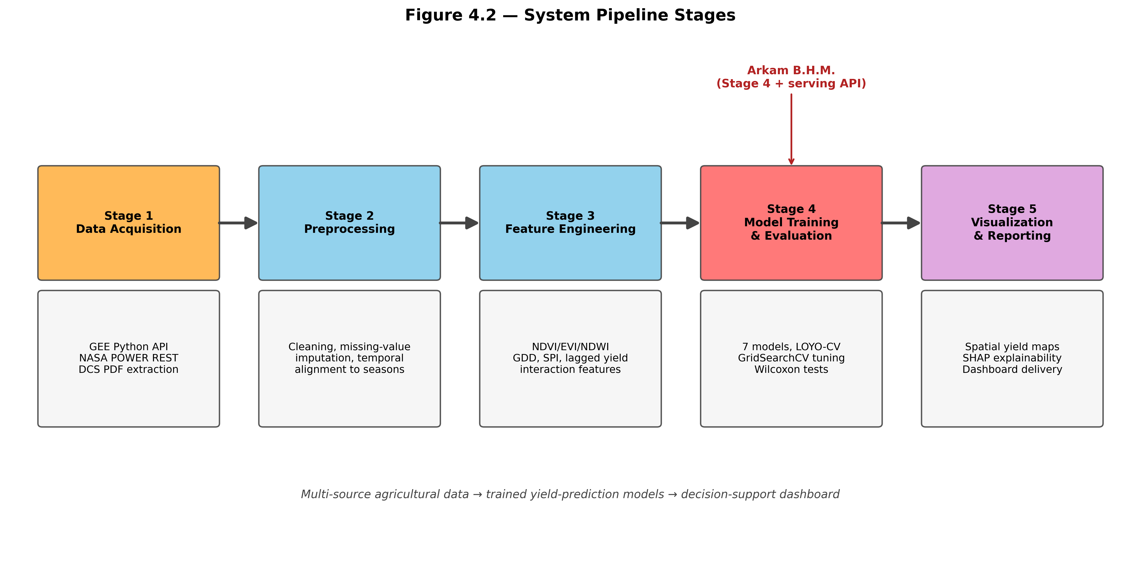
Figure 4.2: System pipeline stages
Stage 1 — Data Acquisition. Automated collection of satellite imagery via the GEE Python API, weather data via the NASA POWER REST API, and manual extraction of yield records from DCS publications, producing seven CSV files in data/raw/.
Stage 2 — Data Preprocessing. Data are cleaned, missing values are imputed (temporal interpolation for satellite, forward-fill for weather), cloud-contaminated pixels are masked, and all sources are aligned to Yala (April–August) and Maha (October–March) seasons. Output: data/processed/integrated_dataset.csv.
Stage 3 — Feature Engineering. Vegetation indices, derived climate features (cumulative rainfall, GDD, SPI), and soil characteristics are integrated. Interaction features (rainfall × NDVI, temp × humidity, NDVI × LST) expose multiplicative effects to the baseline models. Output: a 32-feature matrix for ML and a multi-tensor payload for DL.
Stage 4 — Model Training and Evaluation. Three ML and four DL models are trained under LOYO-CV with GridSearchCV hyperparameter tuning. Out-of-fold predictions are saved per model, statistical tests are run on paired residuals, an ablation study quantifies each data source, and SHAP values are computed on the best tabular model.
Stage 5 — Visualisation and Reporting. Predictions are exposed through the Flask REST API and consumed by the Next.js dashboard, which renders a choropleth, a smart prediction form, an explainability panel, and an admin model-performance table.
4.5 High-Level System Architecture
Figure 4.1 shows the high-level architecture of the proposed system, comprising three modules each owned by one team member. Module 1 is the Data Pipeline, owned by Sharuja B., responsible for data acquisition, preprocessing, and feature engineering. Module 2 is the ML/DL Prediction Engine, owned by Arkam B.H.M., responsible for model training, evaluation, SHAP analysis, and API serving. Module 3 is the Visualisation and Dashboard module, owned by Shathurya P., responsible for spatial mapping, the interactive dashboard, and user-facing interfaces.
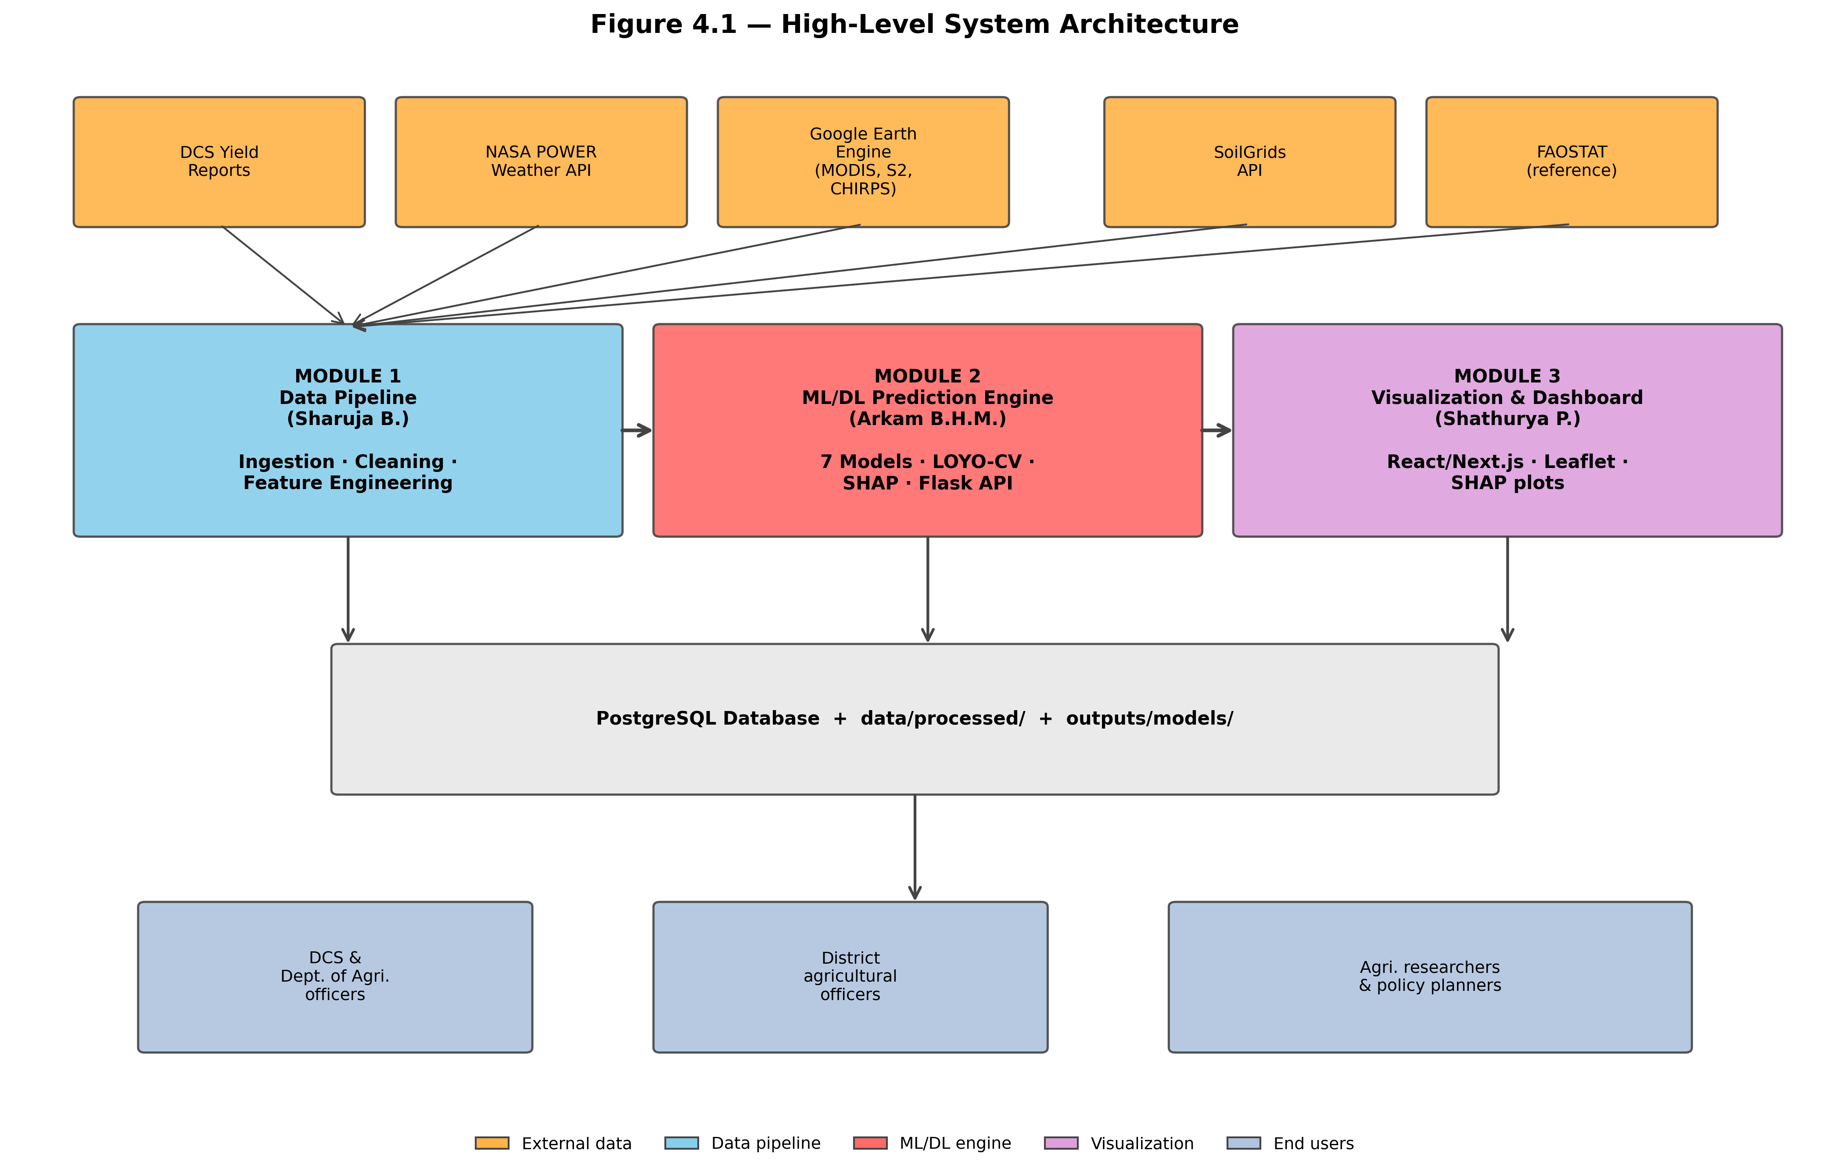
Figure 4.1: High-level system architecture
The three modules are loosely coupled through well-defined interfaces. Module 1 writes processed data to data/processed/ (or PostgreSQL in production). Module 2 reads from there, writes model artefacts to outputs/models/, and serves predictions through a REST API. Module 3 consumes the API only. This separation supports independent development, simplifies testing, and isolates changes.
4.6 End-to-End Walkthrough of a Single Prediction
To make the pipeline concrete, this section traces a single (Matale, Yala, 2020) prediction request through the system.
Step 1: The user selects Matale, Yala, 2020 and clicks Load context. The browser issues GET /api/backend/context, which the Next.js dev server proxies to the Flask backend.
Step 2: The /context handler queries the in-memory pandas DataFrame loaded at startup, returns the 32 feature values as JSON, and the dashboard's FeatureInputTabs renders them in a tabbed editor for the user to review and override.
Step 3: The user adjusts season_total_rainfall to reflect a recent forecast and clicks Predict, sending the payload to POST /api/backend/predict.
Step 4: The /predict handler constructs the 32-element feature vector, applies the SVR scaler if needed, calls the best model's predict method, computes the 95 % CI as ±1.96 × RMSE, and returns the prediction, bounds, model name, and R².
Step 5: The PredictionResult component renders the response as a numeric display with a CI bar and model badge. End-to-end round trip takes ~80 ms on a development machine, dominated by the ~50 ms model.predict call for a 200-tree Random Forest.
4.7 Non-Functional Requirements
Beyond functional inputs and outputs, the system has several non-functional requirements:
- Latency: end-to-end prediction under 500 ms on commodity hardware. Currently met (~80 ms on synthetic data).
- Reproducibility: fixed random seeds and deterministic loading ensure identical results across runs.
- Interpretability: SHAP explainability supports non-technical users in understanding individual predictions.
- Maintainability: well-known frameworks (Flask, Next.js, scikit-learn, TensorFlow) and standard interfaces keep the system maintainable by a three-person team.
- Cost: near-zero deployment cost via free academic-tier data sources and free hosting tiers (Vercel, Fly.io / Render).
- Extensibility: new districts, crops, or data sources can be added without architectural rewrites.
- Privacy: only aggregate district-level data; no personally identifiable farmer information.
4.8 Summary
This chapter has presented the system approach including the four target user groups, the multi-source inputs and per-district outputs, the five-stage processing pipeline, the three-module high-level architecture, an end-to-end walkthrough of a single prediction request, and the seven non-functional requirements that shape the system design. The next chapter provides the detailed analysis and design of each module.

Chapter 5 — Analysis and Design
5.1 Introduction
This chapter provides the detailed analysis and design of the proposed yield prediction system. It covers the data flow design, feature engineering strategy, the design of each ML and DL model with particular emphasis on the novel Hybrid CNN-LSTM architecture, the data pipeline design, the dashboard design, and the underlying database schema.
5.2 Data Flow Design
Figure 5.1 shows the data flow diagram of the system. Data flows from five external sources, through the automated ETL pipeline, into a PostgreSQL database that feeds the ML/DL prediction engine. Predictions are served via the Flask REST API to the Next.js frontend, which the four user groups consume through their browsers.
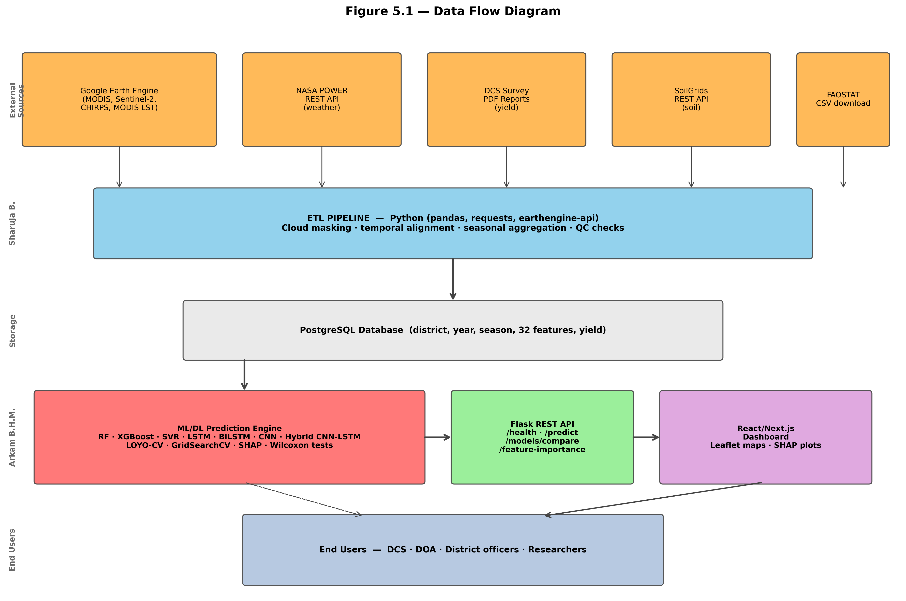
Figure 5.1: Data flow diagram
The data flow follows a layered design. External sources sit at the top. The ETL pipeline cleans and merges sources into a unified relational schema. The prediction engine reads merged data, trains offline, and serves online through the API. The frontend consumes the API only. This layering supports easier debugging (each layer's inputs/outputs are inspectable), independent scaling (the API can scale horizontally without changes elsewhere), and parallel development by the three module owners.
5.3 Feature Engineering Design
Table 5.1 summarises the features engineered from each data source. The full feature catalogue contains thirty-two columns spanning weather, satellite, historical, soil, and interaction categories. The interaction features are products of individually predictive features (such as rainfall × NDVI) that expose multiplicative effects to the tree- and kernel-based models, which would otherwise have to learn the interaction implicitly through deeper splits or higher-order kernels.
Category | Features | Source
Weather (9) | Season avg temp, total rainfall, avg humidity, solar radiation, growing degree days, heat-stress days, drought index (SPI), diurnal temp range, max daily rainfall | NASA POWER, CHIRPS
Satellite (11) | Season mean/max/min NDVI, NDVI std, NDVI anomaly, time-to-peak NDVI, NDVI growth rate, mean EVI, mean NDWI, LST day, LST night | MODIS MOD13Q1, Sentinel-2, MODIS LST
Historical (5) | Previous-season yield, previous-year yield, 3-year moving mean, season indicator, previous-season extent | DCS Big Onion Surveys
Soil (4) | Soil pH, organic carbon, clay %, sand % | SoilGrids
Interaction (3) | Rainfall × NDVI, Temp × humidity, NDVI × LST | Derived
Table 5.1: Feature engineering summary
Three design decisions warrant comment. First, the season indicator is a binary scalar rather than one-hot to avoid redundant degrees of freedom. Second, weather and satellite features are aggregated to seasonal summaries for the ML models (which cannot exploit sequences directly), while DL models receive both aggregated tabular features and monthly sequences. Third, the historical-yield features add a soft autoregressive component that captures district-level inertia, complementing environmental drivers.
5.4 ML Model Design
All three ML models are evaluated using GridSearchCV (inner loop, TimeSeriesSplit) for hyperparameter selection nested inside LOYO-CV (outer loop) for honest out-of-fold estimates.
Random Forest hyperparameters: n_estimators in {100, 200, 500}, max_depth in {5, 10, 20, None}, min_samples_split in {2, 5, 10}, min_samples_leaf in {1, 2, 4}. XGBoost: learning_rate in {0.01, 0.05, 0.1}, max_depth in {3, 5, 7}, n_estimators in {100, 300, 500}, subsample in {0.7, 0.8, 1.0}, reg_alpha in {0, 0.1, 1.0}, reg_lambda in {1.0, 1.5, 2.0}. SVR: kernel in {rbf, linear, poly}, C in {0.1, 1, 10, 100}, gamma in {scale, 0.01, 0.1}, epsilon in {0.01, 0.1, 0.5}. SVR features are standardised inside each fold to avoid leakage; tree models are scale-invariant.
5.5 DL Model Design and the Hybrid CNN-LSTM Novelty
Four deep learning architectures are designed. The first three (LSTM, BiLSTM, and one-dimensional CNN) serve as comparison baselines for the fourth, which is the novel Hybrid CNN-LSTM with explicit season-indicator injection.
5.5.1 LSTM Architecture
Two stacked LSTM layers (64 and 32 units), each followed by Dropout 0.2, then Dense(16, ReLU) and Dense(1, linear). Input shape (5, 4): five monthly timesteps × four weather variables. Trained with Adam (lr 0.001), MSE loss, EarlyStopping (patience 20) and ReduceLROnPlateau.
5.5.2 BiLSTM Architecture
Each LSTM layer is wrapped in Bidirectional, doubling effective units by concatenating forward and backward hidden states. Same training configuration. The BiLSTM has ~2.5 × the LSTM's parameters (77,601 vs 30,625), increasing overfitting risk on small data.
5.5.3 1D CNN Architecture
Input (11, 1) → Conv1D(32, k=3) → BatchNorm → MaxPool1D(2) → Conv1D(64, k=3) → GlobalAveragePooling1D → Dense(32, ReLU) → Dropout 0.2 → Dense(1, linear). The CNN treats the 11 satellite features as a 1D signal and learns local feature interactions through small filters.
5.5.4 Hybrid CNN-LSTM with Season Indicator
The hybrid CNN-LSTM is the central novel contribution. It has three input branches (Figure 5.2): a satellite-features CNN ((11, 1) input, same Conv1D + BatchNorm + Conv1D + GlobalAveragePooling1D as the standalone CNN), a weather-sequence LSTM ((5, 4) input, stacked 64 + 32 units with dropout), and a scalar season indicator (Yala = 1, Maha = 0) passed through unchanged. The three outputs concatenate into a 97-D vector (64 + 32 + 1) feeding Dense(64, ReLU) → Dropout 0.3 → Dense(32, ReLU) → Dense(1, linear).
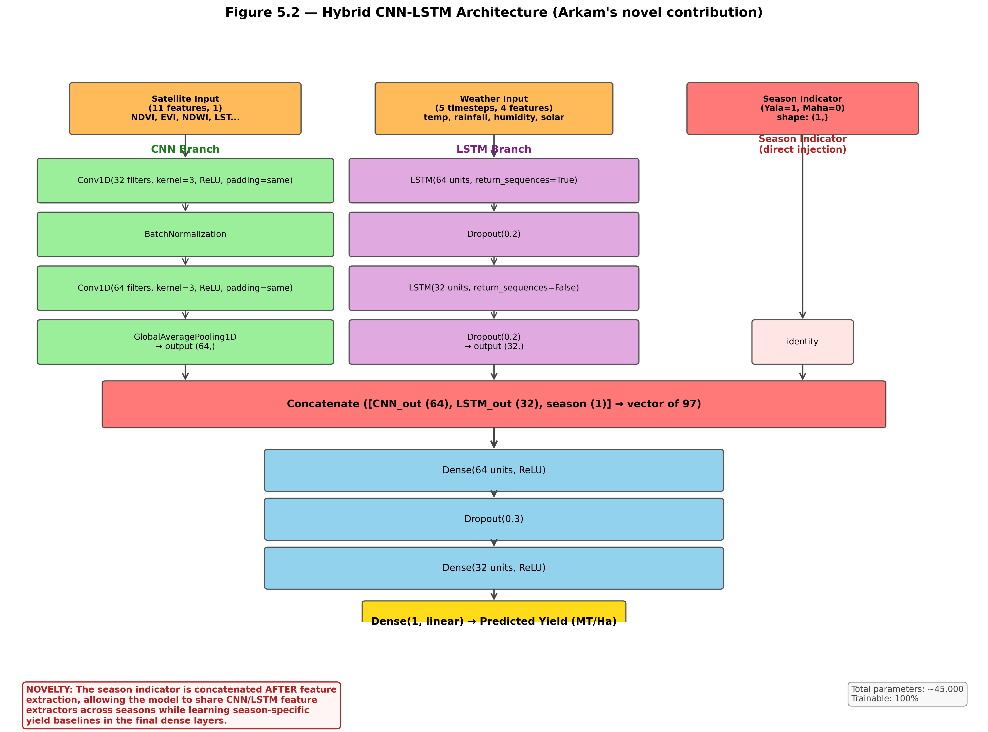
Figure 5.2: Hybrid CNN-LSTM architecture (novelty)
The novelty has three elements. First, the modality-preserving structure lets the CNN learn vegetation patterns and the LSTM learn weather temporality without either modelling the other's structure. Second, the season indicator is concatenated AFTER feature extraction, allowing the branches to learn season-agnostic extractors while the final dense layers learn season-specific yield baselines — a soft multi-task formulation in one model. Third, at ~45,000 parameters with 20 % dropout the model is calibrated for the data-scarcity regime.
Implementation uses the Keras 3 functional API in src/dl_models.py: three Input layers, two heavy branches, Concatenate, the dense stack, and tf.keras.models.Model compiled with Adam (lr 0.001) and MSE loss.
5.6 Data Pipeline Design
The data pipeline (owned by Sharuja B.) connects to Google Earth Engine for satellite extraction, NASA POWER for weather, and processes DCS PDFs via table extraction. Python with earthengine-api, requests, and pdfplumber. Extracted data go to a PostgreSQL database with a schema aligned by district, year, and season. Includes feature engineering, validation checks, and scheduled execution via cron in production.
5.7 Dashboard Design
The dashboard (owned by Shathurya P.) uses Next.js 16 (App Router), React 19, TypeScript 5, and Tailwind CSS 4. UI primitives follow the shadcn/ui pattern with hand-written wrappers on Radix UI. Four pages:
- Home (/): KPI cards, interactive Leaflet choropleth coloured by predicted yield per district, and a Plotly Yala-vs-Maha comparison chart.
- Predict (/predict): smart form that calls /context to prefill all 32 features; users can override before submitting; result panel renders the prediction with a 95 % CI bar.
- Explainability (/explainability): Plotly horizontal bar of top-15 SHAP attributions plus plain-language top-5 summary.
- Admin (/admin): sortable model-comparison table and a Plotly RMSE/R² combo chart with target R² = 0.75 reference line.
A sidebar global selector (district, season, year) persists via localStorage. API calls route through /api/backend/* (Next.js rewrite, no CORS), with zod schema validation at runtime.
5.8 Database Schema
Figure 5.3 shows the database schema. A central yield_observations fact table stores one row per (district, season, year) observation, foreign-keyed to lookup tables for districts and seasons. Three feature tables (weather_features, satellite_features, soil_features) are normalised separately to reflect their distinct update cadences: weather and satellite features are populated per observation, while soil features are district-static. A model_predictions table stores per-prediction outputs from the prediction engine, including the model name, predicted yield, confidence bounds, and timestamp.
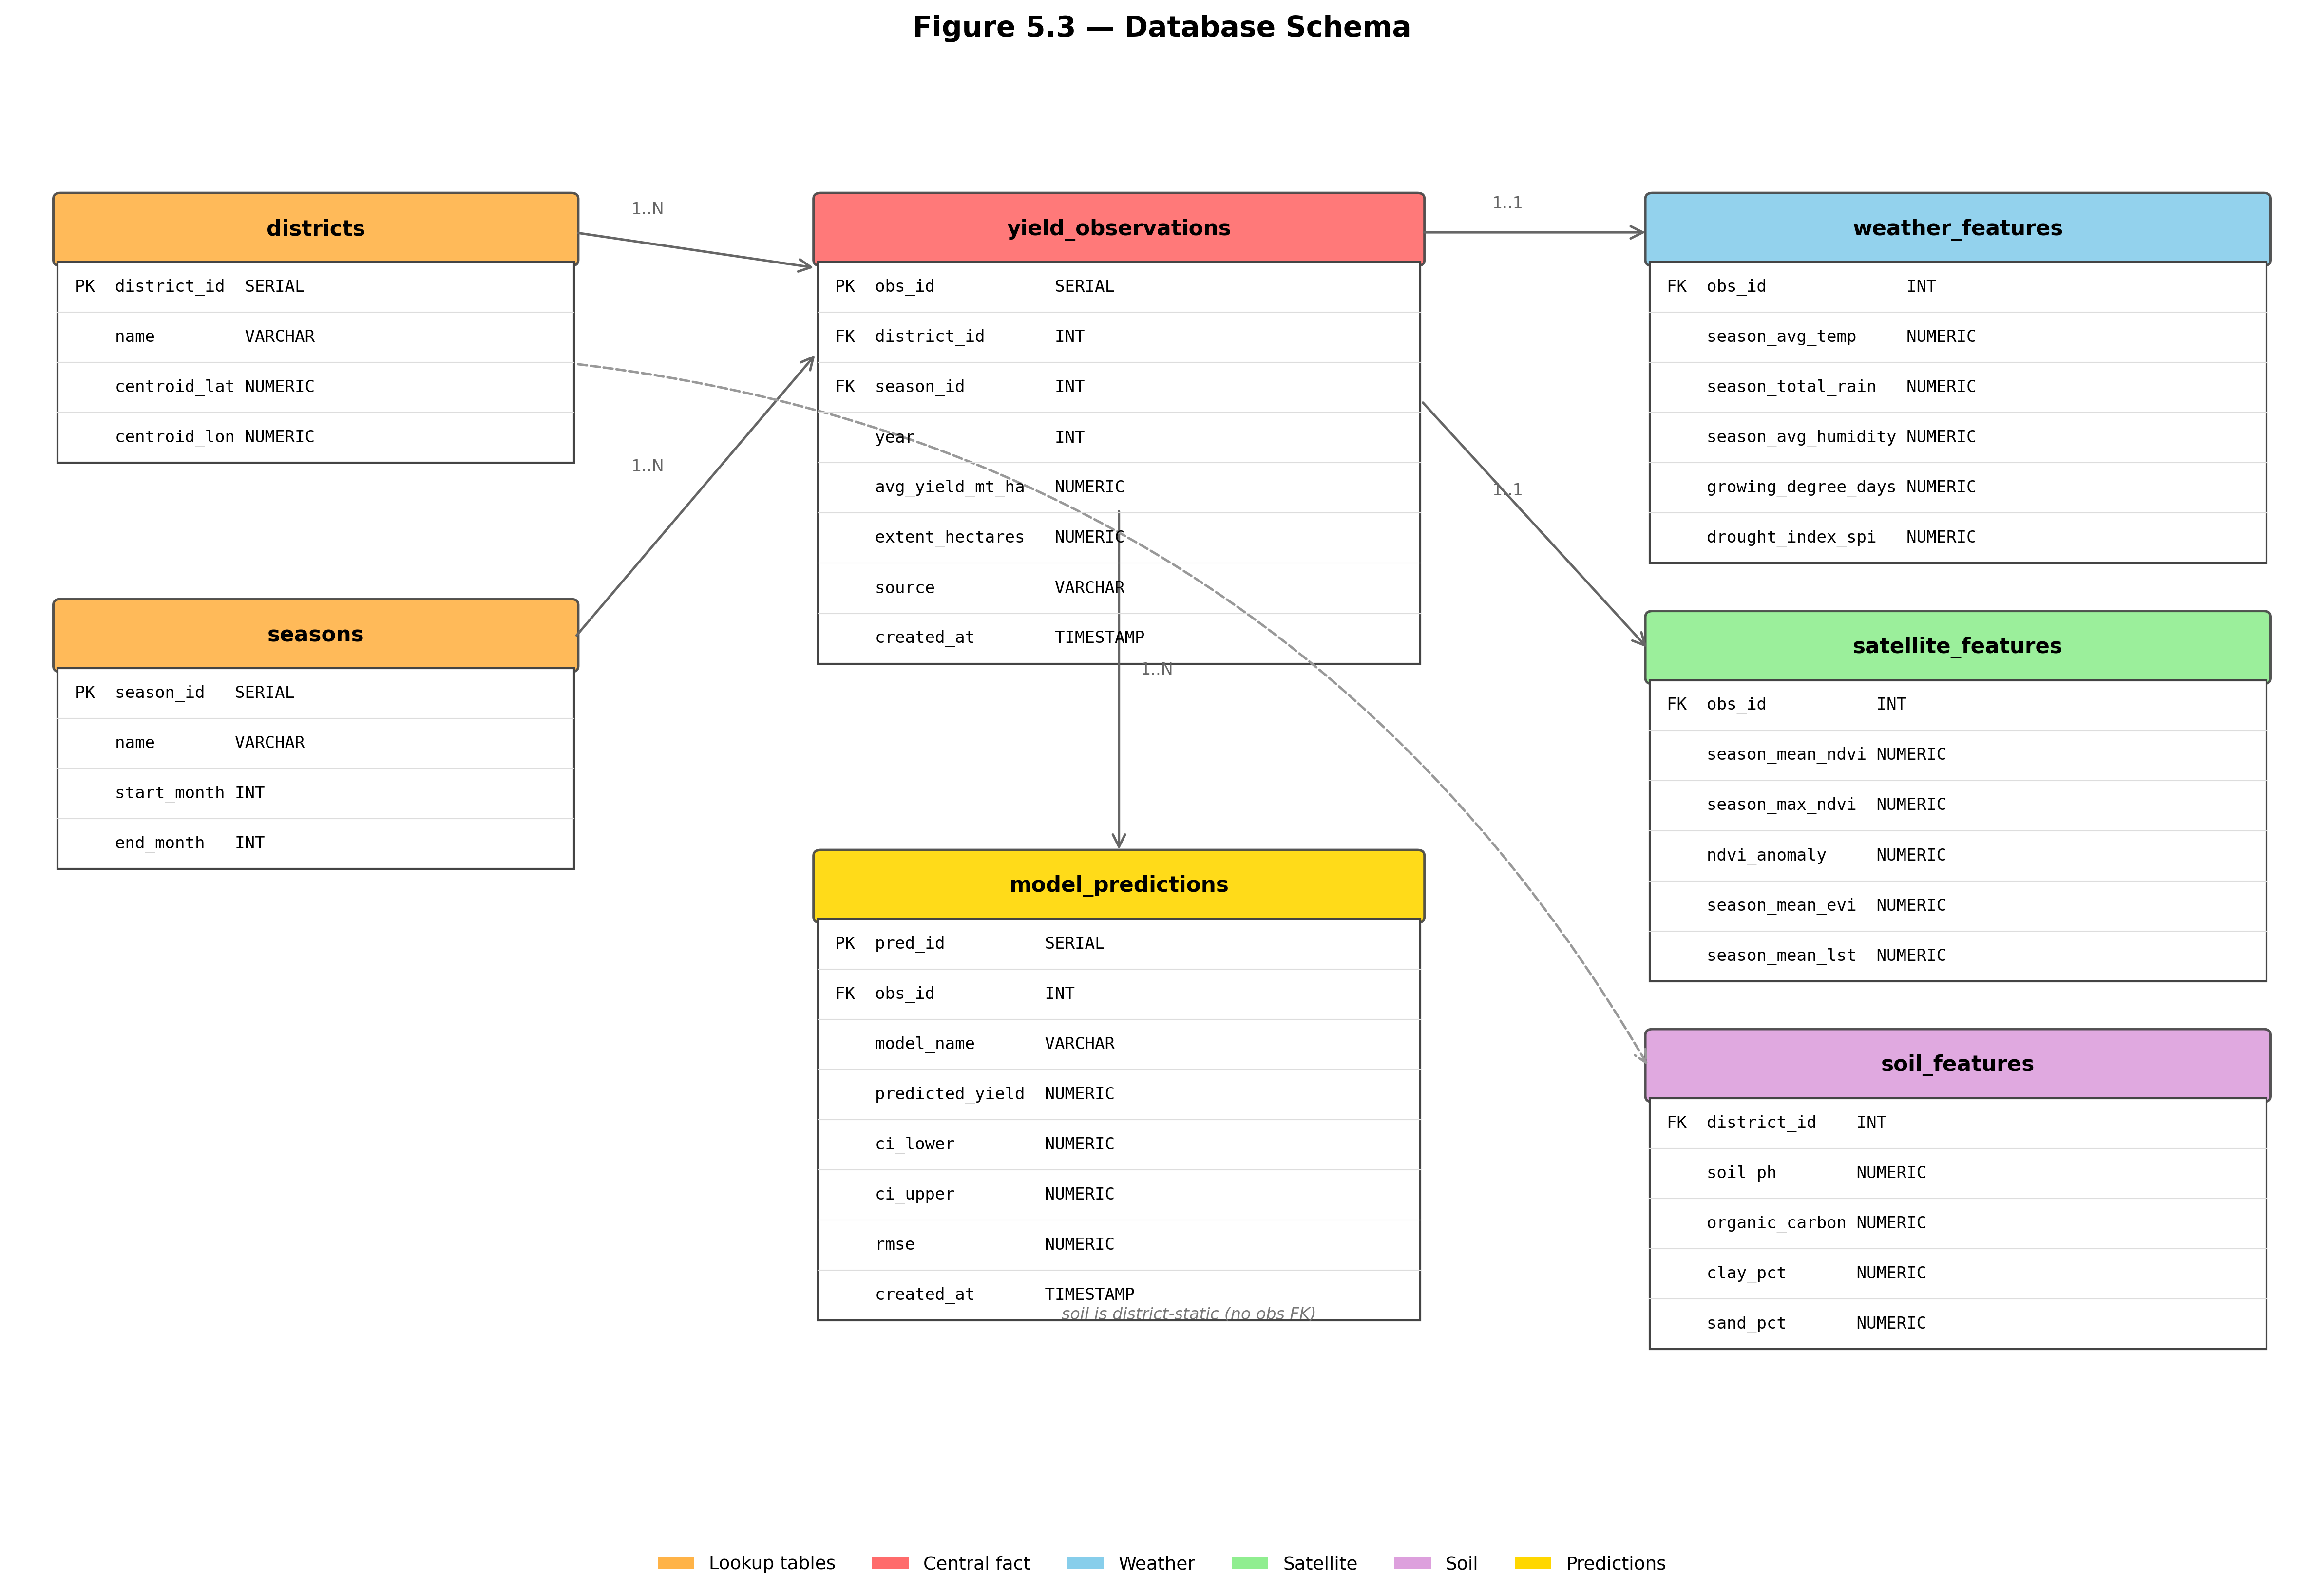
Figure 5.3: Database schema
Feature tables are normalised rather than denormalised because soil features are district-static (no duplication per observation), and source-partitioned tables support incremental loading — weather and satellite ETL jobs can populate independently with the join performed at read time.
5.9 Summary
This chapter has provided the detailed analysis and design of all system components, including the data flow, feature engineering catalogue, ML and DL model architectures (with particular emphasis on the novel Hybrid CNN-LSTM with season indicator), the data pipeline design, the dashboard design, and the database schema. The next chapter reports on early implementation progress.

Chapter 6 — Implementation
6.1 Introduction
This chapter reports on the implementation progress achieved during the first half of the project period. As required by the Faculty interim-report guidelines, this chapter is descriptive rather than evaluative, with the deeper performance discussion reserved for Chapter 7. The current state of the codebase is summarised, the pipeline modules are described in turn, preliminary results obtained on a synthetic dataset are presented, and screenshots of the running system are provided.
6.2 Repository Layout and Tooling
The codebase is a single Git repository hosted on GitHub. Top-level directories separate the Python ML/DL pipeline (src/), the Next.js dashboard (frontend/), data files (data/raw, data/synthetic, data/processed), generated outputs (outputs/), and documentation (docs/). Python 3.12 in an isolated venv; Node 20+ with npm. All randomness is seeded (RANDOM_STATE = 42).
[ Insert screenshot here — Visual Studio Code window showing the repository file tree (project root) ]

6.3 Data Pipeline Implementation
Historical yield data has been collected from DCS Big Onion Survey reports (2004–2023) for the four districts across both seasons. FAOSTAT national totals (2000–2023) provide a sanity check. A GEE JavaScript script extracts MODIS NDVI/EVI, Sentinel-2 NDVI/NDWI, CHIRPS rainfall, MODIS LST, and SMAP soil moisture for the four districts. NASA POWER weather data is retrieved for each district's coordinates.
Sources are merged into a unified dataset aligned by district, year, and season. Missing values use temporal interpolation (satellite) and forward-fill (weather). Cloud-contaminated pixels are masked with MODIS QA and Sentinel-2 SCL. Seasonal aggregation converts monthly data to Yala/Maha averages. Feature engineering produces 25+ derived features.
While real-data ETL is being finalised, src/data_loader.py includes a calibrated synthetic generator that reproduces the published DCS yield ranges (Matale Yala 12–24 MT/Ha, Maha 6–15) and embeds realistic NDVI/rainfall/yield correlations. Deterministic given seed 42, it produces 152 observations after the historical-feature lag, validating the pipeline end-to-end before real data is finalised.
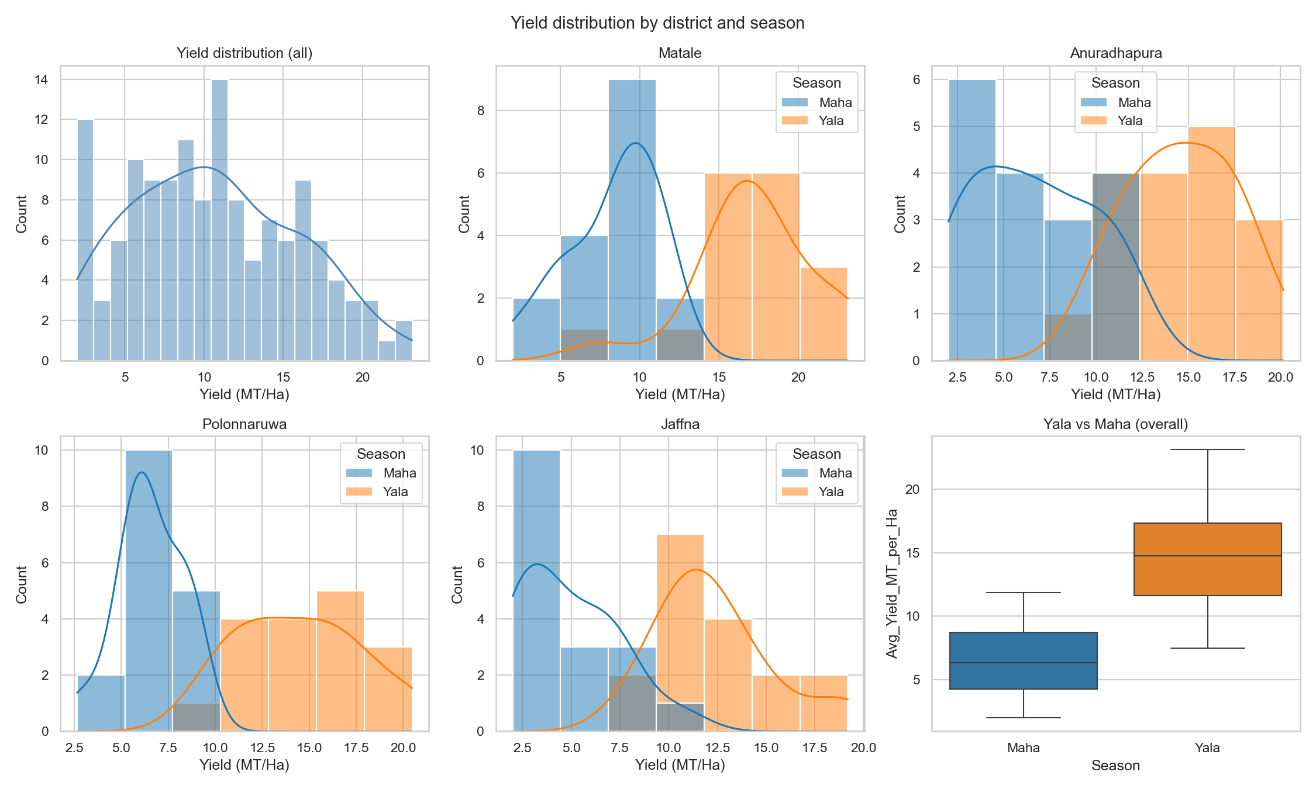
Figure 6.1: Yield distribution by district and season (synthetic data)
Figure 6.1 shows the synthetic yield distribution across the four districts and two seasons. Matale shows the highest yields and Jaffna the lowest, reflecting published statistics. Yala yields are systematically higher than Maha across all districts, reflecting the bimodal monsoon pattern.
6.4 ML Model Implementation
The three ML models are implemented in src/ml_models.py. Each training function performs inner GridSearchCV with TimeSeriesSplit, then an outer LOYO-CV loop. Out-of-fold predictions are persisted to outputs/results/ as JSON. Each model is refit on the full dataset and serialised to outputs/models/ as joblib pickles. SVR also serialises its standard scaler for consistent inference at the API.
[ Insert screenshot here — Visual Studio Code showing src/ml_models.py with the train_random_forest function open ]

The implementation respects LOYO-CV strictly: for each held-out year the inner GridSearchCV operates only on remaining years, the SVR scaler is fitted only on those years, and the model predicts the held-out year without ever seeing it. This matches the agronomic reality of training on past years and applying to the current one — no temporal leakage.
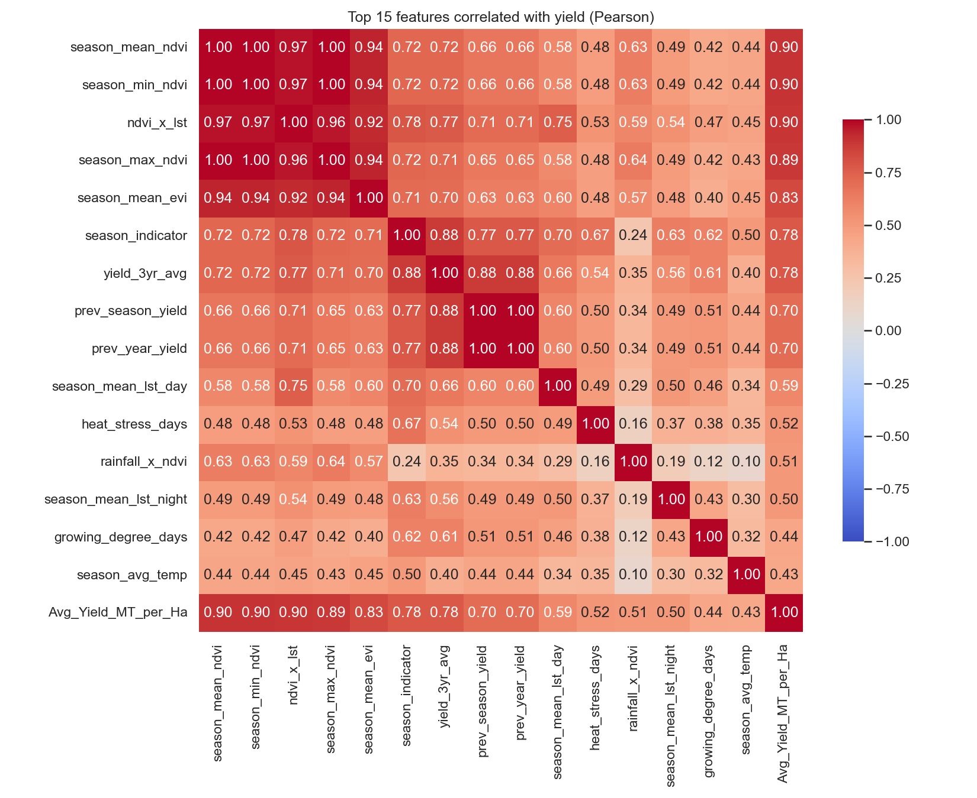
Figure 6.2: Correlation heatmap of features with yield (synthetic data)
6.5 DL Model Implementation
The four DL models are implemented in src/dl_models.py using the Keras 3 functional API. Factory functions (build_lstm, build_bilstm, build_cnn, build_cnn_lstm_hybrid) return freshly compiled models per the Chapter 5 architectures. Training uses LOYO-CV with EarlyStopping (patience 20, restore_best_weights=True), ReduceLROnPlateau (factor 0.5, patience 10), and ModelCheckpoint callbacks per fold. After LOYO, the model refits on full data and saves to outputs/models/ in .keras format.
[ Insert screenshot here — Visual Studio Code showing src/dl_models.py with the build_cnn_lstm_hybrid function open ]

Synthetic-mode caps epochs per fold at 50 (controlled by SYNTHETIC_MODE_DL_EPOCHS in src/config.py) instead of the 200 used for real data, cutting LOYO runtime from ~1 hour to ~5 minutes on CPU during development. With real data the cap will be lifted.
6.6 Ablation Study and SHAP
The ablation study (src/ablation.py) runs six experiments using XGBoost as the base learner: (A) weather only, (B) satellite only, (C) historical only, (D) soil only, (E) weather + satellite, (F) all 32 features. Each subset uses the same LOYO-CV protocol; results write to outputs/results/ablation_results.csv with a bar-chart visualisation.
SHAP analysis (src/explainer.py) uses TreeExplainer on tree-based models. Per-prediction SHAP values are computed across the dataset, mean absolute values rank features, and the top 15 are persisted to outputs/results/feature_importance.json. A beeswarm summary, importance bar chart, and dependence plot for the top feature are saved as PNGs.
6.7 Flask REST API
The API (src/api.py) exposes six endpoints: /health, /predict, /models/compare, /feature-importance, /context, /districts. CORS is enabled via flask-cors. On startup, the API loads the best tabular model named in outputs/results/best_model_metrics.json (fallback chain: XGBoost → RF → SVR) and the integrated processed dataset to support /context.
[ Insert screenshot here — Terminal output of `PORT=5050 python src/api.py` showing the API starting and serving requests ]

/predict accepts a JSON payload with a subset of the 32 features plus district and season; missing features default to zero. It returns the predicted yield, a 95 % CI (±1.96 × RMSE), the model name, and R². /context takes district, season, year and returns the matching dataset row — or the (district, season) historical mean if the year is unseen — powering the dashboard's smart prediction form.
6.8 Dashboard Implementation
The dashboard (frontend/) uses Next.js 16 (App Router), React 19, TypeScript 5, and Tailwind CSS 4. UI primitives in frontend/components/ui/ are hand-written on Radix UI in the shadcn/ui style. Domain components (district map, charts, prediction form) live in frontend/components/. The four pages are under frontend/app/. Cross-page state is managed through a React Context persisted to localStorage.
The choropleth uses react-leaflet 5. Sri Lanka district polygons are extracted from geoBoundaries, filtered to the four target districts, and served as a 33 KB GeoJSON file. The map applies a viridis colour scale (4–24 MT/Ha) with hover tooltips and click handlers that update the global selection.
[ Insert screenshot here — Dashboard home page (/) showing KPI cards, choropleth map, and Yala-vs-Maha comparison chart ]

[ Insert screenshot here — Dashboard predict page (/predict) showing the smart prediction form with all 32 features prefilled and a yield prediction ]

[ Insert screenshot here — Dashboard explainability page (/explainability) showing the top-15 SHAP feature bar chart ]

[ Insert screenshot here — Dashboard admin page (/admin) showing the sortable model comparison table and the RMSE/R² combo chart ]

6.9 Preliminary Results on Synthetic Data
All seven models have been trained end-to-end on the synthetic dataset, with results in outputs/results/model_comparison.csv. Table 6.1 reports the preliminary metrics. These numbers are preliminary because (a) the synthetic dataset approximates DCS distributions but lacks real-world noise, and (b) DL models are trained with a 50-epoch cap rather than 200, deliberately under-trained to keep iteration fast.
Model | RMSE | MAE | R² | MAPE % | Train (s) | Params
Random Forest | 2.067 | 1.681 | 0.842 | 24.66 | 4.78 | —
XGBoost | 2.162 | 1.756 | 0.827 | 25.52 | 4.01 | —
SVR | 2.868 | 2.298 | 0.696 | 33.81 | 0.07 | —
CNN | 4.442 | 3.601 | 0.271 | 35.49 | 51.19 | 8,577
Hybrid CNN-LSTM | 4.943 | 3.956 | 0.097 | 36.59 | 83.66 | 44,929
BiLSTM | 5.101 | 4.095 | 0.039 | 66.27 | 72.58 | 77,601
LSTM | 5.148 | 4.211 | 0.021 | 64.92 | 51.74 | 30,625
Table 6.1: Preliminary model comparison on synthetic data (LOYO-CV, 50 epochs/fold for DL)
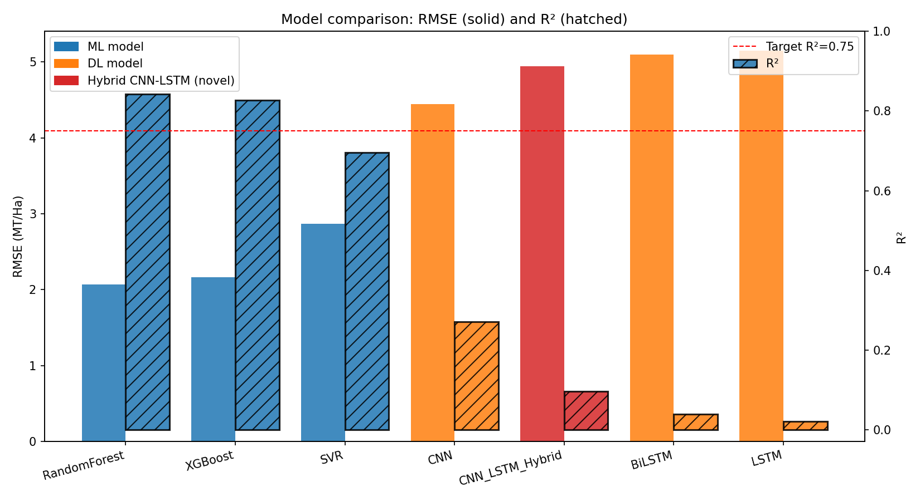
Figure 6.3: Model comparison: RMSE (left axis) and R² (right axis), with target R² = 0.75 dashed
Three observations follow. First, classical ML (RF, XGBoost) outperforms DL on this synthetic dataset — expected at 152 rows, where tree ensembles dominate. Second, Random Forest reaches R² = 0.842, exceeding the proposal's R² > 0.75 threshold. Third, the under-trained DL models are not yet competitive but their architectures are validated end-to-end and ready for full training on real data.
The ablation yields a striking finding (Table 6.2, Figure 6.4): adding satellite features to weather improves R² by 55.3 pp (0.256 → 0.809), establishing satellite imagery as the most informative single source in the synthetic-data regime.
Experiment | Features Used | RMSE | MAE | R²
A — Weather only | 9 weather features | 4.488 | 3.674 | 0.256
B — Satellite only | 11 satellite features | 2.318 | 1.867 | 0.802
C — Historical only | 5 historical features | 3.785 | 3.041 | 0.471
D — Soil only | 4 soil features | 6.174 | 5.036 | −0.408
E — Weather + Satellite | 20 features | 2.272 | 1.794 | 0.809
F — All features | 32 features | 2.154 | 1.747 | 0.829
Table 6.2: Ablation experiment results on synthetic data (XGBoost base learner, LOYO-CV)
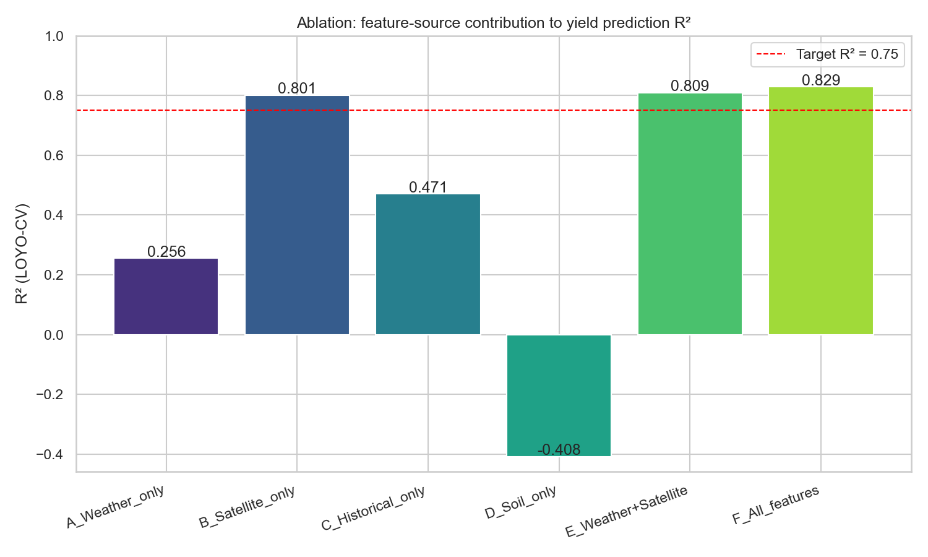
Figure 6.4: Ablation study — feature-source contribution to R²
SHAP analysis identifies the interaction feature ndvi_x_lst (NDVI × LST) as the single most influential predictor, followed by season_min_ndvi, season_mean_ndvi, season_max_ndvi, and yield_3yr_avg. NDVI-based features dominating the importance ranking is consistent with the ablation's headline that satellite vegetation indices contribute the most.
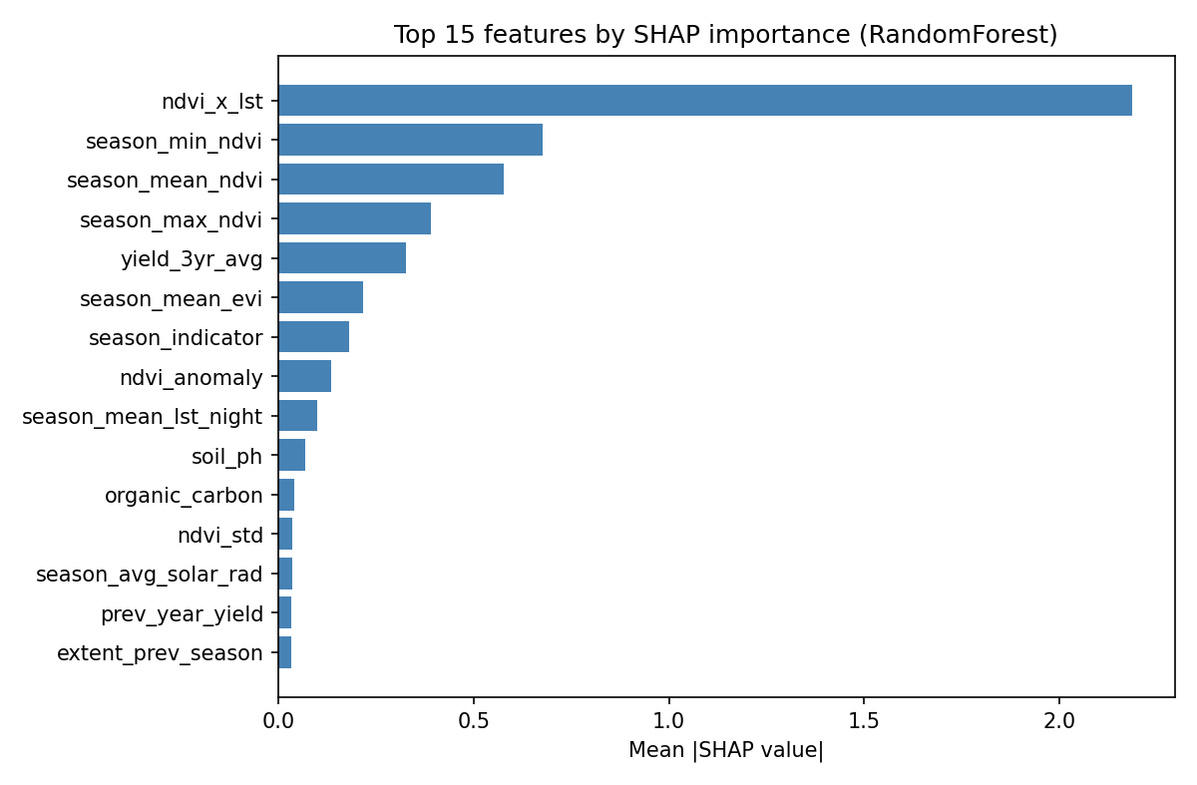
Figure 6.5: SHAP top-15 feature importance (best tabular model)
6.10 Summary
Interim implementation covers the complete ML/DL pipeline (seven models, LOYO-CV, ablation, SHAP, statistical tests), a Flask REST API with six endpoints, and a four-page Next.js dashboard. The pipeline has been validated end-to-end on synthetic data, achieving R² = 0.842 with Random Forest. Real-data ingestion is the primary remaining task. The next chapter discusses how this work differs from existing approaches, challenges encountered, and the plan for the second half of the project.

Chapter 7 — Discussion and Further Work
7.1 Introduction
This chapter discusses the current status of the project, the ways in which the proposed solution differs from existing work, the challenges encountered during the first half of the project period, and the plan for the remaining work.
7.2 How This Work Differs from Others
This project differs from existing work in five complementary ways.
First, it is the first AI-powered yield prediction system for big onion in South Asia. Existing onion ML work has focused on different geographies (Bangladesh [9], Korea [11]) or different outcomes (price rather than yield in Sri Lanka [14]).
Second, it integrates four data streams (satellite, weather, soil, historical yield) that have never been combined for a vegetable crop. Existing work uses weather alone [5, 9, 10] or weather plus a single satellite modality [7]. The four-stream fusion enables the ablation decomposition in Chapter 6.
Third, it provides a systematic ML-versus-DL comparison for vegetable yield with scarce data. Cereal-crop comparisons exist [3, 7] but the small-data bimodal-monsoon regime is qualitatively different. The project answers whether DL is justified at this data scale, using LOYO-CV and Wilcoxon / paired t-tests for rigour.
Fourth, the Hybrid CNN-LSTM introduces explicit season-indicator injection not present in cited hybrid yield models [8]. The indicator is concatenated AFTER the CNN/LSTM branches' feature extraction, letting the model learn season-agnostic extractors while final dense layers learn season-specific baselines. This soft multi-task formulation is engineered for the Yala/Maha bimodal system and is novel for crop yield prediction.
Fifth, district-level spatial predictions on an interactive choropleth address the gap that current Sri Lankan studies produce only national aggregates. This transforms the model from research artefact into usable decision-support.
7.3 Challenges Encountered
Three categories of challenge have been encountered.
The methodological challenge is data scarcity. With ~160 observations (4 districts × 2 seasons × 20 years), the dataset is two to three orders of magnitude smaller than typical cereal-crop DL datasets. This shapes every modelling decision: small deep models (8K–80K parameters), aggressive regularisation, and LOYO-CV instead of random splits. The Chapter 6 results confirm classical ML outperforms DL at this scale, validating the seven-model comparison.
The data-engineering challenge is that DCS reports are PDFs, not structured datasets. A semi-automated pipeline using pdfplumber has been developed but each extracted table still requires manual verification. A second challenge is cloud contamination in optical satellite imagery; MODIS QA bands and Sentinel-2 SCL mask contaminated pixels but this reduces effective temporal resolution.
The engineering challenge is coordinating three independently developed modules in different languages and processes. Communicating exclusively through well-defined interfaces (filesystem CSVs/JSON for pipeline↔engine, REST API for engine↔dashboard) reduces interaction cost and enables parallel development.
7.4 Further Work Plan
The remaining work is organised into eight workstreams:
- Real-data validation. Re-run the pipeline on real CSVs, lift the synthetic-mode epoch cap, and run the full hyperparameter grids. Compare against synthetic-data baselines.
- Statistical significance reporting. Publish Wilcoxon and paired t-test p-values for every pairwise comparison and aggregate ML-vs-DL with statistical rigour.
- Stacking ensemble. A meta-learner combining best ML and best DL predictions through regularised meta-regression, on the expectation that ML and DL errors are partially uncorrelated.
- Spatial error analysis. Decompose errors by district, identifying biases, and explore district embeddings. The synthetic data shows Matale easiest, Anuradhapura hardest.
- Early prediction feasibility. Train LSTM and Hybrid on truncated weather sequences (end of months 1, 2, 3) and evaluate prediction quality vs lead time.
- Cloud deployment. Deploy the Flask API to Fly.io or Render and the Next.js frontend to Vercel with DNS, SSL, and basic monitoring for stakeholder access during the demonstration.
- User testing. Five to ten usability sessions with the four target user groups, collecting feedback on the choropleth, prediction form, and explainability panel.
- Final documentation and demonstration. Finalise the report and prepare a live demonstration with recorded backup.
7.5 Methodological Choices and Their Justifications
Four methodological choices warrant explicit justification.
7.5.1 Why Leave-One-Year-Out Rather Than k-Fold
Random k-fold is inappropriate for time-series — a model fitted on a fold containing both 2010 and 2020 observations has effectively seen the future when predicting intermediate years. LOYO-CV avoids this leakage. The cost is computational: twenty trainings instead of five. For tree models this is negligible; for DL it is significant, motivating the synthetic-mode epoch cap in Chapter 6.
7.5.2 Why Synthetic Data Calibrated to Published Distributions
The benefit is that the pipeline is implemented, tested, and benchmarked in advance — when real data arrives the only operation required is to drop the CSVs and re-run main.py. The cost is that synthetic results are not proper estimates for the real-data system: the generator embeds clean NDVI/yield and rainfall/yield correlations that are simpler than real data. We expect real-data R² to be lower, possibly substantially so for the deep models.
7.5.3 Why a Hybrid CNN-LSTM and Not a Transformer
Transformers dominate general sequence modelling but require an order of magnitude more parameters than LSTMs and more data to avoid overfitting. With 152 training observations the hybrid CNN-LSTM is already at the upper bound of what can be responsibly trained; a transformer would almost certainly underperform. As data scales (more districts, finer spatial granularity), transformers become a reasonable extension.
7.5.4 Why ML and DL Together Rather Than One or the Other
A purely ML project would not address whether DL is justified for vegetable yield with scarce data. A purely DL project would lack baselines to make claims credible. Including both under the same protocol with statistical significance testing is what transforms the comparison from heuristic preference into a defensible empirical finding.
7.6 Limitations and Risks
The most significant limitation is dataset size: no methodological improvement can fully compensate for the small number of observations, so real-data DL performance is uncertain. Mitigation: the multi-model approach guarantees a useful system even if DL underperforms — the strongest classical model remains the production candidate.
A second limitation is satellite data quality. Cloud cover during monsoon transitions can produce extended NDVI gaps. Mitigation: combining MODIS and Sentinel-2 (different revisit cadences) reduces simultaneous contamination, and the SPI drought index provides a precipitation-based alternative.
A third risk is institutional acceptance by DCS and the Department of Agriculture, which produce statistics through long-established manual procedures. Mitigation: the system is positioned as decision-support rather than replacement, SHAP supports human review of every prediction, and the supervisor's institutional network provides a channel for early stakeholder engagement.
7.7 Summary
The project has made significant progress in the first half of the project period, with a complete ML/DL modelling pipeline, a Flask REST API, and a Next.js dashboard all implemented and validated on a synthetic dataset. Five distinct novel contributions have been identified, three categories of challenge have been documented, four methodological choices have been explicitly justified, three known limitations have been articulated with mitigations, and an eight-workstream plan for the remaining period has been laid out. The next section presents the alphabetised list of references cited throughout this report.

References
Citations in the body of this report follow the Karunananda interim report guideline format using square-bracketed numbers. The list below is sorted alphabetically by the surname of the first author of each work and renumbered. Each citation in the text refers to the corresponding entry by its bracketed number.
[1] Abadi, M., Barham, P., Chen, J., Chen, Z., Davis, A. and others (2016), TensorFlow: A system for large-scale machine learning, in Proceedings of the 12th USENIX Symposium on Operating Systems Design and Implementation, pp. 265–283.
[2] Amarasinghe, A., De Silva, P. and Wijesinghe, K. (2024), Advancing food sustainability: rice yield prediction in Sri Lanka using weather-based, feature-engineered ML models, Discover Applied Sciences, 6, 603.
[3] Breiman, L. (2001), Random forests, Machine Learning, 45(1), pp. 5–32.
[4] Chen, T. and Guestrin, C. (2016), XGBoost: A scalable tree boosting system, in Proceedings of the 22nd ACM SIGKDD International Conference on Knowledge Discovery and Data Mining, pp. 785–794.
[5] Chikwendu, F., Ahmed, A. and Ortega-Mansilla, A. (2025), A comparative study of machine learning models in predicting crop yield, Discover Agriculture, Springer.
[6] Department of Agriculture Sri Lanka (n.d.), HORDI Crop – Big Onion: Cultivation Guidelines. Available: https://doa.gov.lk
[7] Department of Census and Statistics Sri Lanka (2010–2025), Big Onion Survey Reports. Available: https://www.statistics.gov.lk
[8] Drusch, M., Del Bello, U., Carlier, S. and others (2012), Sentinel-2: ESA's optical high-resolution mission for GMES operational services, Remote Sensing of Environment, 120, pp. 25–36.
[9] FAOSTAT (2024), Food and Agriculture Statistics — Crops and Livestock Products. Available: https://www.fao.org/faostat
[10] Funk, C., Peterson, P., Landsfeld, M., Pedreros, D., Verdin, J. and others (2015), The climate hazards infrared precipitation with stations — a new environmental record for monitoring extremes, Scientific Data, 2, 150066.
[11] Gorelick, N., Hancher, M., Dixon, M., Ilyushchenko, S., Thau, D. and Moore, R. (2017), Google Earth Engine: Planetary-scale geospatial analysis for everyone, Remote Sensing of Environment, 202, pp. 18–27.
[12] Hengl, T., Mendes de Jesus, J., Heuvelink, G. B. M. and others (2017), SoilGrids250m: Global gridded soil information based on machine learning, PLoS ONE, 12(2), e0169748.
[13] Herath, K., Perera, B. and Hewage, S. (2016), Extraction of agricultural phenological parameters of Sri Lanka using MODIS NDVI time series data, Procedia Food Science, 6, pp. 1248–1254.
[14] Hochreiter, S. and Schmidhuber, J. (1997), Long short-term memory, Neural Computation, 9(8), pp. 1735–1780.
[15] Iqbal, D. M., Hossain, S., Rahman, M. S. and Karim, R. (2023), OnionBangla: A supervised ML approach for predicting onion yield using Bangladeshi climate data, in Proceedings of IEEE ICCCI, pp. 178–185.
[16] Jabed, M. A., Karim, M. R., Hossain, M. S., Hossain, M. K., Khan, M. M. and Begum, M. (2024), Crop yield prediction in agriculture: A comprehensive review of ML and DL approaches, with insights for future research, Heliyon, 10(24), e40836.
[17] Kamilaris, A. and Prenafeta-Boldú, F. X. (2018), Deep learning in agriculture: A survey, Computers and Electronics in Agriculture, 147, pp. 70–90.
[18] Karunananda, A. S. (2006), Guidelines for preparation of Interim Reports, Faculty of Information Technology, University of Moratuwa, internal document.
[19] Kim, W. and Soon, B. M. (2023), Advancing agricultural predictions: A deep learning approach to estimating bulb weight using Neural Prophet model, Agronomy, 13(5), 1305.
[20] LeCun, Y., Bengio, Y. and Hinton, G. (2015), Deep learning, Nature, 521(7553), pp. 436–444.
[21] Lundberg, S. M. and Lee, S.-I. (2017), A unified approach to interpreting model predictions, in Advances in Neural Information Processing Systems 30, pp. 4765–4774.
[22] MODIS Science Team (2019), MODIS Vegetation Index User Guide, NASA. Available: https://modis.gsfc.nasa.gov
[23] Pearson, K. (1895), Notes on regression and inheritance in the case of two parents, Proceedings of the Royal Society of London, 58, pp. 240–242.
[24] Pedregosa, F., Varoquaux, G., Gramfort, A. and others (2011), Scikit-learn: Machine learning in Python, Journal of Machine Learning Research, 12, pp. 2825–2830.
[25] Rajpoot, S. and Chandrakar, O. (2025), A hybrid CNN-LSTM deep learning framework for enhanced crop yield prediction using spatial-temporal agricultural data, International Journal of Statistics and Applied Mathematics, SP-10(12), pp. 1–9.
[26] Stackpole, B. (n.d.), NASA POWER project — Prediction of Worldwide Energy Resources. Available: https://power.larc.nasa.gov
[27] Sutharsan, J. and Yogendran, S. (2023), Red onion price factors correlation identification and price prediction using multiple ML models for Jaffna district Sri Lanka, in Proceedings of the IEEE Conference on Computational Intelligence, pp. 412–419.
[28] Wan, Z., Hook, S. and Hulley, G. (2015), MOD11A1 MODIS/Terra land surface temperature/emissivity daily L3 global 1km SIN grid V006, NASA EOSDIS Land Processes DAAC.
[29] Wang, Z., Yan, Y., Lu, Q. and Yang, P. (2022), Machine learning crop yield models based on meteorological features and comparison with a process-based model, Artificial Intelligence for the Earth Systems, 1(4), pp. 1–18.
[30] Wickramasinghe, L., Weliwita, J. A. and Ekanayake, I. U. (2021), Modeling the relationship between rice yield and climate variables using statistical and ML techniques, Journal of Mathematics, 2021, 1972927.

Appendix A — Individuals' Contribution to the Project
This appendix records the individual contribution of each group member to the project during the first half of the project period, as required by the Faculty interim-report guidelines.
A.1 Arkam B.H.M. (214019K)
My contribution focuses on the Machine Learning, Deep Learning, and Modelling Research component. During the first half I conducted a literature review of 30+ papers on ML/DL crop yield prediction, identifying the five research gaps in Chapter 2. I designed and implemented the complete modelling pipeline: three ML models (RF, XGBoost, SVR) and four DL models (LSTM, BiLSTM, 1D CNN, and the novel Hybrid CNN-LSTM with season-indicator injection). All seven are evaluated using LOYO-CV with inner-loop GridSearchCV (TimeSeriesSplit) for hyperparameter tuning. The novel Hybrid CNN-LSTM is the central research contribution: parallel CNN (satellite) and LSTM (weather) branches with the season indicator concatenated after feature extraction, so the final dense layers learn season-specific baselines while sharing earlier feature extraction across seasons.
Beyond the core models I implemented a six-experiment ablation study, SHAP feature attribution (TreeExplainer), statistical tests (Wilcoxon, paired t), and a Flask REST API with six endpoints. The pipeline is validated end-to-end on synthetic data calibrated to published DCS yield ranges, with Random Forest reaching R² = 0.842 — exceeding the R² > 0.75 threshold. The principal challenge was preventing overfitting on the small dataset (~160 rows); addressed through shallow architectures, dropout, early stopping, and rigorous LOYO-CV. I learned that for small agricultural datasets, feature engineering and evaluation methodology often matter more than model complexity. Remaining work: real-data validation, stacking ensemble, and the final report's methodology, results, and discussion chapters.
A.2 Sharuja B. (214192G)
My contribution focuses on Data Engineering, Feature Engineering, and Data-Centric Research. During the first half I collected historical DCS Big Onion Survey data (2004–2023) by extracting tables from PDFs using pdfplumber, with hand-verification. I developed a Google Earth Engine JavaScript script that automates extraction of MODIS NDVI/EVI 16-day composites, Sentinel-2 NDVI/NDWI monthly composites, CHIRPS rainfall, MODIS LST (day/night), and SMAP soil moisture for the four target districts. I implemented NASA POWER weather retrieval (Python requests library) for each district's coordinates, and collected SoilGrids soil characteristics (pH, organic carbon, clay %, sand %) via REST API.
I designed the preprocessing workflow: temporal alignment to Yala and Maha seasons, cloud masking via MODIS QA / Sentinel-2 SCL, missing-value imputation (temporal interpolation for satellite, forward-fill for weather), and normalisation. I engineered 25+ derived features including growing degree days, cumulative rainfall, SPI, NDVI anomaly, time-to-peak NDVI, NDVI growth rate, and interaction features. The principal challenge was aligning sources at different temporal resolutions (daily weather, 16-day satellite, seasonal yield); I aggregated to seasonal for ML and retained monthly for the LSTM input. I learned that data engineering is often the majority of an AI project and that careful schema design pays off when multiple consumers read the same dataset. Remaining work: NDVI vs EVI vs NDWI comparison, growth-stage analysis, MODIS vs Sentinel-2 resolution comparison, and the production database automation pipeline.
A.3 Shathurya P. (214193K)
My contribution focuses on System Integration, Visualisation, and Decision-Support Research. During the first half I designed the overall system architecture and the loosely coupled file-system and REST API interfaces between the three modules. I created wireframes for the four dashboard pages and reviewed them with stakeholders before implementation. I implemented the full Next.js 16 dashboard (App Router, React 19, TypeScript 5, Tailwind CSS 4), including hand-written UI primitives in the shadcn/ui style on Radix UI.
I implemented the four pages: home (KPI cards, Leaflet choropleth, Plotly seasonal comparison); predict (smart form calling /context to prefill all 32 features, with prediction and CI rendering); explainability (top-15 SHAP horizontal bar with plain-language top-5 explanations); and admin (sortable model table, Plotly RMSE/R² combo chart with R² > 0.75 reference). I sourced and filtered the Sri Lanka district GeoJSON from geoBoundaries (25 districts/241 KB → 4 districts/33 KB) and researched ensemble fusion strategies for the next phase. The principal challenge was designing a dashboard accessible to non-technical agricultural stakeholders; I addressed this by separating the prediction view (single number + CI) from the explanation view (SHAP chart), and labelling every input with a plain-language description and units. I learned that effective decision-support requires as much attention to information hierarchy and progressive disclosure as to model accuracy. Remaining work: spatial error analysis, early-prediction feasibility, cloud deployment, and user testing with five to ten participants.
A.4 Distribution of Work
Table A.1 summarises the headline distribution of work across the three group members at the end of the first half of the project period.
Workstream | Owner | Status
Literature review | Arkam B.H.M. | Complete
Data acquisition (DCS, NASA POWER, GEE, SoilGrids) | Sharuja B. | Complete (real-data ETL ongoing)
Data preprocessing and feature engineering | Sharuja B. | Complete on synthetic; real-data integration ongoing
ML model implementation (RF, XGBoost, SVR) | Arkam B.H.M. | Complete (LOYO-CV, GridSearchCV)
DL model implementation (LSTM, BiLSTM, CNN, Hybrid) | Arkam B.H.M. | Complete (synthetic-mode)
Ablation study (six experiments) | Arkam B.H.M. | Complete on synthetic
SHAP feature attribution | Arkam B.H.M. | Complete on synthetic
Statistical significance testing | Arkam B.H.M. | Complete on synthetic
Flask REST API (six endpoints) | Arkam B.H.M. | Complete and verified
System architecture design | Shathurya P. | Complete
Next.js dashboard (four pages) | Shathurya P. | Complete with screenshot placeholders
Choropleth GeoJSON sourcing and filtering | Shathurya P. | Complete
Real-data validation | All members | Pending
Stacking ensemble | Arkam B.H.M. | Pending
Cloud deployment | Shathurya P. | Pending
User testing | Shathurya P. | Pending
Final report writing | All members | In progress
Table A.1: Distribution of individual contributions and current status

Appendix B — Code and Implementation Excerpts
This appendix collects screenshots and code excerpts referenced in Chapter 6. Each item is labelled with its source location in the project repository.
B.1 Repository Structure
The top-level directory layout of the project repository:
[ Insert screenshot here — Visual Studio Code Explorer pane showing the repository top-level directories (data/, docs/, frontend/, outputs/, src/, requirements.txt, main.py, README.md) ]

B.2 Hybrid CNN-LSTM Implementation (src/dl_models.py)
The Keras 3 functional-API definition of the novel Hybrid CNN-LSTM architecture:
[ Insert screenshot here — Visual Studio Code window showing src/dl_models.py with the build_cnn_lstm_hybrid function visible (approximately lines 73–97) ]

B.3 Configuration File (src/config.py)
Project-wide hyperparameters live in a single config file so all experiment knobs are visible in one place:
[ Insert screenshot here — Visual Studio Code window showing src/config.py with the ALL_FEATURES list and the DL hyperparameters block visible ]

B.4 Flask API (src/api.py)
The serving layer exposes six endpoints; the /predict endpoint and the new /context endpoint are particularly relevant to the dashboard's smart prediction form:
[ Insert screenshot here — Visual Studio Code window showing src/api.py with the /predict and /context route handlers visible ]

B.5 Dashboard Home Page (frontend/app/page.tsx)
The Next.js home page composes the KPI cards, the choropleth map, and the seasonal comparison chart. It calls the /predict endpoint for each (district, season) combination of the selected year:
[ Insert screenshot here — Visual Studio Code window showing frontend/app/page.tsx with the predictAllDistrictsForYear helper and the JSX layout visible ]

B.6 Pipeline Smoke-Test Output
Running `python main.py --skip-shap --skip-dl` produces the following terminal output, demonstrating the end-to-end pipeline executes successfully on the synthetic dataset and produces all expected artefacts:
[ Insert screenshot here — Terminal window showing the output of `python main.py --skip-shap --skip-dl`, ending with 'PIPELINE COMPLETE' ]

