Final Report

Level 4

AI-Powered Harvest Yield Prediction
for Non-Cash Crops (Big Onion) in Sri Lanka

Group Name: Agro AI

214019K | Arkam B.H.M.
214192G | Sharuja B.
214193K | Shathurya P.

Faculty of Information Technology
University of Moratuwa
2026

Final Report

Level 4

AI-Powered Harvest Yield Prediction
for Non-Cash Crops (Big Onion) in Sri Lanka

Group Name: Agro AI

214019K | Arkam B.H.M.
214192G | Sharuja B.
214193K | Shathurya P.

Supervised by: Dr. Firdhous M.F.M.

Faculty of Information Technology
University of Moratuwa
2026

Abstract
Sri Lanka consumes roughly 220,000 metric tons of big onion (Allium cepa) each year while domestic cultivation supplies only part of that demand, so the balance is imported at a substantial foreign-exchange cost. Unlike paddy, big onion has no systematic crop-cutting survey methodology, which means yield figures are compiled from subjective field assessments and only become available after the harvest is already in. This project designs, implements and evaluates an artificial-intelligence system that forecasts big onion yield before harvest for the four major producing districts of Matale, Anuradhapura, Polonnaruwa and Kurunegala. The system serves the Department of Census and Statistics, the Department of Agriculture, district agricultural officers and farmer organisations. It ingests four data streams — historical district yield records, daily weather observations, satellite-derived vegetation and land-surface-temperature indices, and gridded soil properties — aggregates them to one record per district, season and year, and engineers thirty-two predictors spanning weather aggregates, vegetation dynamics, yield history, soil and interaction terms. Nine predictors are produced by models trained and compared under a single protocol: Random Forest, XGBoost and Support Vector Regression; LSTM, Bidirectional LSTM, one-dimensional CNN and a hybrid CNN-LSTM with explicit season-indicator injection; a symbolic regression model that returns a readable closed-form equation; and a physics-residual hybrid that couples a calibrated agronomic water-heat-thermal-time backbone with a learned residual correction. A constrained convex stacking layer combines them. Every model is evaluated with Leave-One-Year-Out cross-validation, paired statistical significance testing and split-conformal prediction intervals, so that no result depends on a single arbitrary train-test split. On the twenty-eight seasonal records that were actually collected, the physics-residual hybrid is the strongest model with a coefficient of determination of 0.091 and a root mean squared error of 3.90 metric tons per hectare, ahead of Random Forest at 0.020, while every deep model falls below the mean predictor. The measured outcome is that at this sample size the mechanistic prior and the evaluation protocol carry the result, not model capacity. Predictions, comparison metrics, the symbolic equation, calibrated intervals and SHAP attributions are served over a Flask REST interface and presented in a Next.js decision-support dashboard.

Acknowledgements
We extend our sincere gratitude to our supervisor, Dr. Firdhous M.F.M. of the Faculty of Information Technology, University of Moratuwa, for his guidance, patience and continued support throughout this project. We are grateful to the Department of Census and Statistics of Sri Lanka for publishing the big onion survey reports, to the Department of Agriculture for the HORDI cultivation guidelines that shaped our agronomic assumptions, to NASA POWER and the Climate Hazards Group for open access to weather and rainfall records, to the European Space Agency Copernicus programme and the MODIS Science Team for satellite imagery, and to the ISRIC SoilGrids team for global soil property maps. We also thank the Faculty of Information Technology for providing the academic environment and computing facilities that made this work possible, and our families and colleagues for their encouragement over the course of the year.

Contents
Page
Abstract i
Acknowledgements ii
Contents iii
List of Figures vi
List of Tables vii
Chapter 1 — Forecasting Big Onion Yield in Sri Lanka 1
1.1 Introduction 1
1.2 Background and Motivation 2
1.3 Aim and Objectives 5
1.4 The Proposed Solution 6
1.5 Structure of the Report 8
1.6 Summary 9
Chapter 2 — Crop Yield Prediction: A Review of Others' Work 10
2.1 Introduction 10
2.2 Classical Machine Learning for Yield Prediction 10
2.3 Deep Learning and Hybrid Architectures 13
2.4 Mechanistic and Hybrid Process-Based Models 15
2.5 Yield Prediction Research in Sri Lanka 17
2.6 Onion-Specific Research 18
2.7 Comparison of Existing Approaches 19
2.8 Research Gaps Identified 21
2.9 Summary 23
Chapter 3 — Technologies Adapted for Data-Scarce Yield Prediction 24
3.1 Introduction 24
3.2 Data Acquisition Technologies 24
3.3 Classical Machine Learning Technologies 27
3.4 Deep Learning Technologies 29
3.5 Symbolic Regression 31
3.6 Physics-Informed Residual Modelling 32
3.7 Ensemble Stacking 34
3.8 Conformal Prediction and Explainability 35
3.9 Evaluation Technology: Leave-One-Year-Out CV 37
3.10 Software and Tools 38
3.11 Summary 39
Chapter 4 — The Agro AI Approach 40
4.1 Introduction 40
4.2 Users 40
4.3 Inputs and Outputs 42
4.4 Process: The Nine-Stage Pipeline 44
4.5 Top-Level System Architecture 47
4.6 Walkthrough of a Single Prediction 49
4.7 System Requirements 50
4.8 Summary 51
Chapter 5 — Analysis and Design of the Prediction System 52
5.1 Introduction 52
5.2 Data Flow Design 52
5.3 Feature Engineering Design 54
5.4 Classical Model Design 57
5.5 Deep Model Design and the Hybrid CNN-LSTM 58
5.6 Physics-Residual Hybrid Design 61
5.7 Stacking Layer Design 63
5.8 Uncertainty and Explainability Design 64
5.9 Serving and Dashboard Design 65
5.10 Summary 67
Chapter 6 — Implementation 68
6.1 Introduction 68
6.2 Repository Layout and Tooling 68
6.3 Data Loading and Preprocessing 70
6.4 Feature Engineering 72
6.5 Classical Model Implementation 73
6.6 Deep Model Implementation 75
6.7 Symbolic Regression Implementation 77
6.8 Physics-Residual Implementation 78
6.9 Stacking, Conformal and SHAP Implementation 80
6.10 Ablation Study Implementation 82
6.11 Serving Layer and Dashboard 83
6.12 Summary 85
Chapter 7 — Evaluation and Results 86
7.1 Introduction 86
7.2 The Evaluation Dataset 86
7.3 Evaluation Protocol and Metrics 88
7.4 Model Comparison Results 90
7.5 Does the Mechanistic Backbone Help? 93
7.6 Does Stacking Help? 95
7.7 The Symbolic Equation 97
7.8 Data-Source Ablation 98
7.9 Per-District Behaviour 100
7.10 Calibrated Uncertainty 101
7.11 Feature Attribution 103
7.12 Architecture Validation on Synthetic Data 105
7.13 Summary 107
Chapter 8 — Discussion, Conclusion and Further Work 108
8.1 Introduction 108
8.2 Interpretation of the Results 108
8.3 How This Work Differs from Others 111
8.4 Contributions of This Research 113
8.5 Threats to Validity and Limitations 115
8.6 Further Work 117
8.7 Conclusion 119
8.8 Summary 120
References 121
Appendix A — Individual's Contribution to the Project 125
Appendix B — Configuration and Code Excerpts 129
Appendix C — Extended Result Tables 134
Appendix D — Dashboard Screenshots 138

List of Figures
Page
Figure 4.1 — Top-level architecture of the proposed system 48
Figure 4.2 — The nine-stage processing pipeline 46
Figure 5.1 — Data flow through the prediction system 53
Figure 5.2 — Hybrid CNN-LSTM architecture with season-indicator injection 60
Figure 5.3 — Logical data schema of the processed store 66
Figure 6.1 — Training curve of the hybrid CNN-LSTM on the collected data 76
Figure 7.1 — Model comparison on the collected dataset 91
Figure 7.2 — Actual against predicted yield, Random Forest 92
Figure 7.3 — Residual distribution, Random Forest 93
Figure 7.4 — Data-source ablation on the collected dataset 99
Figure 7.5 — SHAP mean absolute attribution, top fifteen predictors 103
Figure 7.6 — SHAP summary plot 104
Figure 7.7 — SHAP dependence for the temperature-humidity interaction 105
Figure 7.8 — Model comparison on the synthetic reference dataset 106

List of Tables
Page
Table 2.1 — Comparison of existing yield-prediction approaches 20
Table 3.1 — Data sources adopted by the system 25
Table 3.2 — Software and tools 38
Table 4.1 — User groups and their information needs 41
Table 4.2 — System inputs and outputs 43
Table 5.1 — The thirty-two engineered predictors by group 55
Table 5.2 — Model inventory and design rationale 57
Table 6.1 — Pipeline modules and their source files 69
Table 6.2 — REST endpoints exposed by the serving layer 84
Table 7.1 — Composition of the collected evaluation dataset 87
Table 7.2 — Model comparison under Leave-One-Year-Out CV 90
Table 7.3 — Physics-residual with and without the mechanistic backbone 94
Table 7.4 — Stacking combiners and their learned weights 96
Table 7.5 — Data-source ablation results 98
Table 7.6 — Per-district predictability 100
Table 7.7 — Split-conformal interval half-widths at ninety per cent 102
Table 7.8 — Synthetic-data model comparison (architecture validation) 106
Table 8.1 — Positioning against the closest prior work 112
Table A.1 — Distribution of individual contributions 128
Table C.1 — Fold-by-fold errors for the physics-residual hybrid 134
Table C.2 — Full SHAP attribution ranking 136

Chapter 1
Forecasting Big Onion Yield in Sri Lanka
1.1 Introduction
This chapter introduces the problem that the project addresses, explains why it matters to Sri Lanka, states the aim and objectives that the work was set against, outlines the proposed solution in terms of its users, inputs, outputs, process and technology, and finally describes how the remainder of the report is organised. The reader who finishes this chapter should understand what is being predicted, for whom, and why the prediction cannot simply be looked up in an existing government report.
Big onion (Allium cepa L.) is one of the most economically significant non-cash field crops grown in Sri Lanka. It is a staple ingredient in practically every household kitchen, it is grown commercially in the dry and intermediate zones, and it is simultaneously one of the country's largest agricultural import lines. National annual consumption is on the order of 220,000 metric tons, and domestic cultivation covers only part of that requirement; the remainder is imported, largely from India and Pakistan, at a direct cost in foreign exchange [11], [14]. Because the import decision has to be taken months in advance of the domestic harvest reaching the market, the accuracy of the pre-harvest yield estimate translates directly into either wasted foreign exchange or a price shock at the consumer end.
1.2 Background and Motivation
1.2.1 The information gap
Sri Lanka's Department of Census and Statistics operates a mature and well-documented crop-cutting survey methodology for paddy. Enumerators physically harvest measured plots at randomly selected locations, weigh the produce, and the resulting sample statistics are aggregated into district and national yield estimates with quantified sampling error. This machinery does not exist for big onion [11]. Big onion yield figures are instead compiled from the subjective assessments of agricultural instructors and divisional officers, who estimate the extent cultivated and the likely production from field visits and grower interviews. Two consequences follow. First, the estimates carry an unquantified error. Second, and more damaging for planning, they arrive after the fact: the figure for a season is finalised once that season's crop is already harvested and sold.
A pre-harvest forecast is therefore not a marginal improvement over an existing service; it is a capability that does not currently exist for this crop. A forecast issued four to eight weeks before harvest, at the district level, would allow the Department of Agriculture and the Ministry to size imports against an evidence-based expectation of the domestic crop rather than against last year's outcome. It would allow district agricultural officers to identify districts trending towards a shortfall while there is still time to intervene with irrigation advice or pest management. It would give farmer organisations a defensible basis for negotiating forward prices with collectors.
1.2.2 Why the problem is technically hard
Crop yield is the outcome of a long chain of interacting biophysical processes: soil water availability, thermal accumulation, radiation interception by the canopy, nutrient supply, pest and disease pressure, and management decisions taken by thousands of individual growers. Most of these are unobserved. What is observable at scale is a set of proxies — daily weather variables, satellite-derived vegetation indices that track canopy vigour, land surface temperature, and static soil properties. Learning the mapping from proxies to yield is exactly the kind of problem that machine learning has been applied to with success for the major cereals [21], [22], [8].
The difficulty in the Sri Lankan big onion setting is that the published successes rest on datasets that are orders of magnitude larger than what is available here. County-level maize yield studies in the United States draw on tens of thousands of county-year records; the Sri Lankan big onion record, restricted to districts where the crop is commercially significant and to years in which consistent satellite coverage exists, yields a few dozen usable observations. This project therefore does not simply apply established methods; it has to establish which methods survive at this sample size, and it has to build an evaluation protocol honest enough that the answer can be believed.
1.2.3 The bimodal season structure
Sri Lankan agriculture runs on two monsoon-driven cultivation seasons. Yala runs broadly from April to August under the south-west monsoon, and Maha runs from October to March under the north-east monsoon. The two seasons differ in rainfall regime, temperature, day length and typical cultivated extent, and consequently in achievable yield. Big onion in the dry zone is predominantly a Yala crop under irrigation. Any model built for this setting must be able to represent season as a first-class conditioning variable rather than as one more numerical feature, because the yield response surface genuinely differs between the two seasons. Published architectures for single-season cash crops do not address this [31].
1.3 Aim and Objectives
The aim of this project is to design, implement and rigorously evaluate an artificial-intelligence-powered decision-support system that predicts big onion harvest yield, at district and season granularity, before harvest, from openly available weather, satellite, soil and historical yield data, and that reports its predictions with honest and calibrated statements of uncertainty.
The aim is decomposed into the following objectives.
- Objective 1 — Data foundation. Identify, acquire and integrate the relevant open data streams for the four target districts, and construct a clean analysis dataset at the district-season-year grain with a documented and reproducible transformation from raw source files.
- Objective 2 — Feature engineering. Derive an agronomically meaningful predictor set spanning weather aggregates, vegetation dynamics, thermal and water stress indices, historical yield memory, static soil properties and cross-modal interaction terms.
- Objective 3 — Comparative modelling. Implement and train a family of predictors covering classical machine learning, deep sequence learning, interpretable symbolic regression and physics-informed hybrid modelling, under one identical protocol so that their comparison is meaningful.
- Objective 4 — Honest evaluation. Evaluate every model using Leave-One-Year-Out cross-validation, report paired statistical significance tests rather than raw leaderboard positions, and attach distribution-free conformal prediction intervals to the point forecasts.
- Objective 5 — Attribution and ablation. Quantify the contribution of each input data source through a controlled ablation study, and explain individual predictions using SHAP attributions so that the system is not a black box to an agricultural officer.
- Objective 6 — Delivery. Expose the trained system through a documented REST interface and a decision-support dashboard that presents predictions, comparisons, explanations and recommendations to non-technical users.
1.4 The Proposed Solution
The solution is a three-tier system. The bottom tier is a reproducible Python data and modelling pipeline; the middle tier is a Flask REST service that exposes the pipeline's artefacts; the top tier is a Next.js web dashboard consumed by the end users. The following paragraphs state the solution in the terms required by the report guideline: users, inputs, outputs, process, technology, features and system requirements.
Users. Four groups are served. Statistical officers at the Department of Census and Statistics use the forecast as a prior against which to sanity-check field returns. Policy analysts at the Department of Agriculture and the Ministry use district-level aggregates to size import requirements. District agricultural officers use per-district forecasts and their drivers to target extension effort. Researchers and students use the model comparison, the ablation results and the published equation.
Inputs. For a given district, season and year the system consumes daily weather observations over the growing window, satellite vegetation and land-surface-temperature composites over the same window, static soil properties for the district, and the district's own yield history for preceding seasons and years.
Outputs. The system returns a point forecast of average yield in metric tons per hectare, a calibrated prediction interval at a nominal ninety per cent coverage level, a ranked SHAP attribution explaining which predictors drove the forecast away from the baseline, the closed-form symbolic equation as an interpretable cross-check, and a comparison of how each candidate model scored under the shared evaluation protocol.
Process. Raw source files are loaded and reconciled to a common district-season-year key; the record is cleaned and validated; thirty-two predictors are engineered; nine model families are trained under Leave-One-Year-Out cross-validation with inner-loop hyperparameter search; a constrained convex stacking layer is fitted on the out-of-fold predictions; conformal residual quantiles are computed; SHAP attributions are extracted; and all artefacts are written to disk for the serving layer to read.
Technology. The modelling tier is Python with scikit-learn [30], XGBoost [7], TensorFlow/Keras [1], gplearn for symbolic regression and SHAP [27] for attribution. The serving tier is Flask. The presentation tier is Next.js with TypeScript and Tailwind CSS. Satellite data is obtained through Google Earth Engine [16].
System requirements. The pipeline runs to completion on a single commodity laptop with eight gigabytes of memory and no GPU, in approximately six minutes for the full run. This is a deliberate design constraint: a system intended for a government department in a resource-constrained setting must not presuppose cluster infrastructure. Every random seed is fixed so that a re-run reproduces the reported numbers exactly.
1.5 Structure of the Report
The remainder of this report is organised as follows. Chapter 2 reviews the work of others in crop yield prediction, covering classical machine learning, deep and hybrid architectures, mechanistic process-based modelling, the Sri Lankan literature and the small body of onion-specific work, and closes by identifying the research gaps that this project targets. Chapter 3 describes the technologies adapted to solve the problem and argues, for each, why it is appropriate to this particular problem rather than merely available. Chapter 4 presents the approach taken, describing the system in terms of its users, inputs, outputs, process and top-level architecture. Chapter 5 gives the analysis and design of the solution, module by module. Chapter 6 documents the implementation, mapping each design module onto the source files, algorithms and configuration that realise it. Chapter 7 reports the evaluation: the dataset, the protocol, the model comparison, the mechanistic-backbone and stacking studies, the ablation, per-district behaviour, calibrated uncertainty and feature attribution. Chapter 8 discusses what the results mean, positions the work against the literature, states the threats to validity, sets out further work and concludes. The references follow, and then four appendices: individual contributions, configuration and code excerpts, extended result tables, and dashboard screenshots.
1.6 Summary
This chapter established that Sri Lanka has no pre-harvest yield forecasting capability for big onion, that the absence has concrete consequences for import planning and farmer welfare, and that the technical challenge lies not in the modelling techniques themselves but in making them work honestly at a sample size far below what the published literature assumes. The aim and six objectives were stated, and the proposed three-tier solution was described in terms of its users, inputs, outputs, process and technology. The next chapter surveys how others have approached crop yield prediction and identifies precisely where the gaps lie.

Chapter 2
Crop Yield Prediction: A Review of Others' Work
2.1 Introduction
Chapter 1 established the problem: no pre-harvest yield forecast exists for big onion in Sri Lanka, and the data available to build one is far scarcer than what published crop-yield studies assume. This chapter reviews how others have attacked the yield prediction problem. It moves from classical machine learning through deep and hybrid architectures to mechanistic process-based models, then narrows to the Sri Lankan literature and to onion specifically, compares the approaches in a single table, and closes by naming the five gaps this project addresses.
2.2 Classical Machine Learning for Yield Prediction
The dominant paradigm in applied crop-yield prediction is supervised regression on tabular features derived from weather, remote sensing and management records. Jabed et al. [21] provide the most current comprehensive review of the field, surveying both machine learning and deep learning approaches across crops and geographies. Their synthesis reports that tree-based ensembles — Random Forest [5] and gradient boosting, particularly XGBoost [7] — are the most frequently deployed and, on tabular agricultural data, frequently the most accurate methods, with deep architectures gaining ground only where the input carries genuine spatial or temporal structure and the sample size is large.
Chikwendu et al. [8] make the comparison explicit, benchmarking several regressors on the same crop-yield task and finding tree ensembles ahead of both linear models and shallow neural networks. The mechanism is well understood: bagged and boosted trees handle heterogeneous feature scales without preprocessing, capture threshold effects natural to biological response curves, are comparatively robust to irrelevant predictors, and do not need the sample sizes that gradient-based function approximators require to escape overfitting.
Support Vector Regression appears throughout the same literature as a strong small-sample baseline. Its appeal in this domain is that its capacity is controlled by the regularisation constant and the epsilon-insensitive tube rather than by parameter count, which makes it structurally suited to short records. Wang et al. [38] provide an instructive comparison in which machine learning models built on meteorological features are benchmarked directly against a process-based crop model, and find the learned models competitive on in-sample years but weaker in extrapolation — an observation that motivates the hybrid approach adopted later in this project.
Two methodological criticisms recur in this body of work and are directly relevant here. The first is evaluation design: a substantial fraction of published studies split their data at random into training and test partitions, which leaks information across the temporal boundary because neighbouring years share weather regimes and yield trends. The second is the absence of significance testing: models are ranked on a single held-out score with no assessment of whether the gap between first and second place is distinguishable from noise.
2.3 Deep Learning and Hybrid Architectures
Kamilaris and Prenafeta-Boldú [22] surveyed deep learning across agriculture and documented rapid adoption, with convolutional networks dominating image-based tasks such as disease detection and yield mapping from imagery. LeCun, Bengio and Hinton [26] give the underlying rationale for representation learning: with sufficient data, a deep network learns features that outperform hand-engineered ones. The qualifier — sufficient data — is the pivot on which this project turns.
For yield in particular, recurrent architectures are the natural fit for the weather stream because growing-season weather is a sequence and because the effect of a rainfall or heat event depends on the phenological stage at which it occurs. The Long Short-Term Memory unit of Hochreiter and Schmidhuber [19] is the standard building block, its gated cell state allowing gradients to propagate across the length of a growing season without vanishing. Bidirectional variants process the sequence in both directions, which is legitimate here because the full season is observed before the prediction is issued.
Rajpoot and Chandrakar [31] propose exactly the hybrid this project also explores: a convolutional branch over spatial agricultural data combined with an LSTM branch over the temporal stream, merged before a dense head. Their reported gains over single-modality baselines are the strongest published argument for the architecture. Kim and Soon [24] take a different deep route for an allium crop, applying a Neural Prophet formulation to estimate onion bulb weight, and demonstrate that decomposable time-series models can capture seasonal structure in this crop family.
What is common to the successful deep results is scale. The hybrid architectures are validated on datasets with thousands to tens of thousands of records. None of the surveyed work establishes whether the architectural advantage survives when the training set is reduced by three orders of magnitude, which is the regime this project occupies. That question is left open in the literature, and answering it empirically is one of this project's contributions.
2.4 Mechanistic and Hybrid Process-Based Models
Independent of the machine learning tradition, agronomy has a long history of mechanistic crop models that encode the physiology of the water-limited yield response directly. The canonical formulation is the FAO Irrigation and Drainage Paper 33 water-production function of Doorenbos and Kassam [12], which relates the relative yield decrement to the relative evapotranspiration deficit through a crop-specific yield response factor. For onion that factor is approximately 1.1, meaning the crop is slightly more than proportionally sensitive to water deficit — onion is a shallow-rooted crop with a high sensitivity to stress during bulb initiation.
Thermal time, or growing degree days, is the second pillar of the mechanistic tradition. McMaster and Wilhelm [28] set out the standard computation and its pitfalls, and the accumulation of degree days above a crop-specific base temperature remains the standard proxy for phenological progress. The virtue of these formulations for the present problem is that they encode knowledge which does not have to be learned from data. In a thirty-record dataset, every relationship that can be supplied a priori rather than estimated is a relationship that does not consume degrees of freedom.
The synthesis of the two traditions is the hybrid or residual approach. Shahhosseini et al. [32] demonstrate that coupling a process-based crop model with machine learning improves corn yield prediction over either component alone: the mechanistic model supplies the physiologically constrained trend, and the learned component absorbs the systematic residual that the simplified physics cannot express. Wang et al. [38] reach a compatible conclusion from the opposite direction. This residual architecture is directly adopted in the present work and is one of its two central methodological novelties.
2.5 Yield Prediction Research in Sri Lanka
The Sri Lankan literature is overwhelmingly concerned with paddy. Amarasinghe et al. [2] present the most directly comparable study: weather-based, feature-engineered machine learning models for rice yield prediction, with careful attention to the construction of derived meteorological predictors. Wickramasinghe et al. [39] model the rice yield-climate relationship with both statistical and machine learning techniques and quantify the sensitivity of yield to individual climate variables. Both studies benefit from the crop-cutting survey record that exists for paddy and not for vegetables.
On the remote sensing side, Herath et al. [18] extracted agricultural phenological parameters for Sri Lanka from MODIS NDVI time series, establishing that the satellite record is of sufficient quality to resolve the country's cultivation seasons. This is an important precondition for the present work: it confirms that the vegetation index signal over Sri Lankan cropland is usable, even though the study did not itself predict yield.
Sutharsan and Yogendran [35] address onion in Sri Lanka, but for the red onion price series in the Jaffna district rather than for yield, identifying correlated price factors and applying several regressors to the forecasting task. Their work confirms that machine learning is already being applied to Sri Lankan allium value chains, while leaving the yield side of the problem untouched.
2.6 Onion-Specific Research
Onion-specific yield prediction work is sparse. Iqbal et al. [20] present the closest analogue, a supervised machine learning approach to predicting onion yield from Bangladeshi climate data. The setting is genuinely comparable — a South Asian monsoon climate, a smallholder production system, and a national import dependence — and the study establishes that climate-driven onion yield prediction is feasible. It does not, however, incorporate satellite vegetation indices, does not address a bimodal season structure, and reports a single train-test split without significance testing.
The agronomic literature on the crop itself is more developed than the predictive literature. The Department of Agriculture's HORDI cultivation guidelines [10] document the crop calendar, water requirement, and critical growth stages for big onion in Sri Lankan conditions, and these guidelines directly informed the growing-season windows and the mechanistic backbone constants used in this project. FAOSTAT [14] provides the production and trade series against which national-level figures were cross-checked.
2.7 Comparison of Existing Approaches
Table 2.1 compares the most relevant prior approaches along the dimensions that matter for this project: the crop and region addressed, the modelling family used, the data streams consumed, the evaluation protocol adopted, and the principal limitation with respect to the present problem.
Table 2.1: Comparison of existing yield-prediction approaches
Work | Crop / Region | Method | Data used | Evaluation | Limitation here
Jabed et al. [21] | Multiple / global | Review of ML and DL | Various | Survey | No small-sample guidance
Chikwendu et al. [8] | Multiple | RF, XGBoost, SVR, ANN | Weather, soil | Random split | Split leaks temporal information
Kamilaris & Prenafeta-Boldú [22] | Multiple / global | DL survey | Imagery | Survey | Assumes large datasets
Rajpoot & Chandrakar [31] | Cereals | Hybrid CNN-LSTM | Spatio-temporal | Held-out split | Not validated at small n
Kim & Soon [24] | Onion (bulb weight) | Neural Prophet | Time series | Time-series split | Bulb weight, not district yield
Shahhosseini et al. [32] | Corn / US | Process model + ML | Weather, soil, crop model | Multi-year | Requires full APSIM-class model
Wang et al. [38] | Cereals | ML vs process-based | Meteorological | Multi-year | No satellite stream
Amarasinghe et al. [2] | Rice / Sri Lanka | Feature-engineered ML | Weather | Cross-validation | Paddy has crop-cutting surveys
Wickramasinghe et al. [39] | Rice / Sri Lanka | Statistical + ML | Climate | Cross-validation | Rice only
Herath et al. [18] | General / Sri Lanka | Phenology extraction | MODIS NDVI | Descriptive | No yield model
Iqbal et al. [20] | Onion / Bangladesh | Supervised ML | Climate | Single split | No satellite, no season structure
Sutharsan & Yogendran [35] | Red onion / Sri Lanka | Multiple regressors | Price factors | Held-out split | Price, not yield

2.8 Research Gaps Identified
Five gaps emerge from the comparison in Table 2.1, and this project is constructed to address them.
Gap 1 — No big onion yield prediction system exists for Sri Lanka. The Sri Lankan yield-prediction literature is paddy-centric [2], [39]; the one Sri Lankan onion study addresses price rather than yield [35]; and the one comparable onion yield study is Bangladeshi and climate-only [20]. No published work predicts big onion yield for Sri Lankan districts.
Gap 2 — No guidance exists on model selection under severe data scarcity for vegetable yield. The reviews [21], [22] and the comparative studies [8] operate at sample sizes that make the deep-versus-classical question answerable in the conventional way. None of them tells a practitioner with thirty observations whether a deep architecture is worth attempting. A rigorous comparison at that sample size, with significance testing, is itself a contribution regardless of which family wins.
Gap 3 — Mechanistic and learned components are rarely combined at this scale. Shahhosseini et al. [32] demonstrate the value of the hybrid approach, but their process component is a full crop-simulation model requiring extensive parameterisation and calibration data. Whether a lightweight closed-form mechanistic backbone — FAO-33 water response [12] combined with growing degree days [28] — provides the same benefit at a fraction of the modelling cost is untested for this crop and this region.
Gap 4 — Bimodal monsoon seasonality is not represented architecturally. Published hybrid architectures [31] were designed for single-season systems and treat season, when present at all, as one more numeric column. No work explicitly injects a season indicator at a chosen depth of the network so that shared feature extractors are learned across seasons while season-specific baselines are learned by the head.
Gap 5 — No decomposition of data-source value exists for vegetable yield in Sri Lanka. A practitioner deciding whether to invest in a satellite ingestion pipeline, a weather station network, or better yield record-keeping has no evidence base for the decision in this crop and region. A controlled ablation across data-source configurations supplies that evidence.
2.9 Summary
This chapter reviewed the work of others across four traditions: classical machine learning on tabular agricultural features, deep and hybrid sequence-plus-convolution architectures, mechanistic process-based crop modelling, and the Sri Lankan and onion-specific literature. The comparison in Table 2.1 showed that no existing work combines the crop, the region, the multi-source data integration and the evaluation rigour that this problem requires, and five specific research gaps were identified. The next chapter describes the technologies adapted to close those gaps and argues why each is appropriate to this problem in particular.

Chapter 3
Technologies Adapted for Data-Scarce Yield Prediction
3.1 Introduction
Chapter 2 identified five gaps in the existing literature. This chapter sets out the technologies adapted to address them. The organising principle throughout is that every technology is justified against one specific difficulty of this problem — a sample size of a few dozen records, a bimodal season structure, a need for interpretability by non-specialist users, and a requirement that uncertainty be stated rather than implied. Technologies that are merely popular are not adopted.
3.2 Data Acquisition Technologies
The system consumes four data streams. Table 3.1 lists them with their sources, native resolution and role in the model.
Table 3.1: Data sources adopted by the system
Stream | Source | Native grain | Role
District yield and extent | Department of Census and Statistics [11]; FAOSTAT [14] | District, season, year | Prediction target and yield-history predictors
Daily weather | NASA POWER reanalysis [33]; CHIRPS rainfall [15] | Daily, ~0.5° and 0.05° | Temperature, rainfall, humidity, solar radiation aggregates
Vegetation indices | MODIS MOD13 NDVI/EVI [29]; Sentinel-2 [13], via Google Earth Engine [16] | 16-day / 5-day composite, 250 m–10 m | Canopy vigour, anomaly, growth-rate predictors
Land surface temperature | MODIS MOD11A1 [37], via Google Earth Engine [16] | Daily, 1 km | Day and night surface thermal regime
Soil properties | ISRIC SoilGrids250m [17] | Static, 250 m | pH, organic carbon, clay and sand fraction

Google Earth Engine [16] is adopted for the satellite streams rather than direct scene download for a decisive practical reason: the full MODIS and Sentinel-2 archives over the four districts run to terabytes, whereas the quantity actually needed is a handful of spatially averaged index values per district per composite period. Earth Engine performs the spatial reduction server-side and returns a table of a few thousand rows, which makes the ingestion tractable on a laptop.
NASA POWER [33] is adopted for meteorology in preference to ground station records because the station network in the dry-zone districts is sparse and its record has gaps, whereas the reanalysis product is spatially complete and temporally continuous over the full study period. CHIRPS [15] supplements it for rainfall specifically, since its infrared and station-blended construction is better validated for tropical precipitation than a pure reanalysis field. SoilGrids [17] supplies static soil properties; these do not vary within the study period and therefore serve as district-level constants.
3.3 Classical Machine Learning Technologies
3.3.1 Random Forest
Random Forest [5] is adopted as the primary classical learner. Its suitability here rests on three properties. Bootstrap aggregation over decorrelated trees reduces variance, which matters most precisely when the training set is small and a single tree would be unstable. Recursive partitioning naturally represents the threshold and saturation effects that characterise biological response curves — yield rises with accumulated thermal time and then plateaus — without any transformation of the input. And the ensemble degrades gracefully in the presence of irrelevant predictors, which is a real risk when thirty-two features are offered to twenty-eight training records.
3.3.2 Gradient boosting
XGBoost [7] is adopted as the boosted counterpart. Where Random Forest reduces variance by averaging, boosting reduces bias by fitting successive learners to the residual. The regularised objective of XGBoost — explicit L1 and L2 penalties on leaf weights plus a complexity term on tree structure — is the property that makes it usable at this sample size, since unregularised boosting would drive the training residual to zero within a few dozen rounds. Shallow trees and a low learning rate are configured accordingly.
3.3.3 Support Vector Regression
Support Vector Regression is adopted as the third classical learner because its capacity control is structurally different from that of the tree ensembles. The epsilon-insensitive loss ignores residuals inside a tolerance band, and the solution depends only on the support vectors, so model complexity is governed by the regularisation constant rather than by the number of observations. Including a learner with an orthogonal inductive bias strengthens the comparison and supplies genuine diversity to the stacking layer.
3.4 Deep Learning Technologies
Four deep architectures are adopted, all implemented in TensorFlow/Keras [1]. The LSTM [19] processes the weather sequence over the growing season, its gated cell state retaining information about early-season conditions until the point at which yield is determined. The Bidirectional LSTM extends this by running a second pass in reverse; this is legitimate for post-season inference because the whole season is observed before a forecast is issued, and it allows a late-season observation to inform the representation of an early-season one.
The one-dimensional convolutional network is adopted for the vegetation index sequence rather than the weather sequence. The distinction is deliberate: the informative content of an NDVI trajectory is its local shape — the steepness of green-up, the timing and height of the peak, the rate of senescence — and a convolutional filter bank is the natural detector for local shape, whereas a recurrent unit is the natural integrator for cumulative effect.
The hybrid CNN-LSTM combines the two, following the architectural family of Rajpoot and Chandrakar [31] but with a modification specific to this problem: the season indicator is concatenated after both branches have completed feature extraction, immediately before the dense head. The consequence is that the convolutional and recurrent branches learn season-agnostic feature extractors, sharing all their parameters across both seasons and therefore across the whole dataset, while only the small dense head learns season-specific yield baselines. This is a data-efficiency argument, not merely an architectural preference, and it is the second novelty of the work. The design is described in detail in section 5.5 and illustrated in Figure 5.2.
All four networks are deliberately small — the hybrid holds approximately 45,000 parameters against the millions typical of image classifiers — and are regularised with dropout at twenty per cent and early stopping on a validation split. Even so, section 7.4 will show that at this sample size the deep family does not compete, and reporting that outcome honestly is part of the contribution.
3.5 Symbolic Regression
Symbolic regression is adopted to address a requirement that neither the tree ensembles nor the networks satisfy: producing a model that an agricultural officer can read, check against agronomic intuition, and compute by hand. Rather than fitting parameters within a fixed functional form, symbolic regression searches the space of mathematical expressions themselves using genetic programming [25], evolving a population of expression trees under a fitness pressure that balances accuracy against expression length.
The gplearn implementation is used, restricted to a small function set — addition, subtraction, multiplication, protected division and square root — and to the five predictors that SHAP identifies as most influential. The restriction is essential: an unconstrained search over thirty-two predictors with a rich function set would produce an expression that fits twenty-eight points perfectly and generalises not at all. The resulting equation is reported in section 7.7 and served through the API so that the dashboard can display it alongside the numerical forecast.
3.6 Physics-Informed Residual Modelling
The physics-residual hybrid is the principal methodological technology adapted in this work, and it is adopted as a direct response to the sample-size problem. The argument is one of degrees of freedom. With twenty-eight training records, every relationship the model must discover from data consumes statistical budget that is not available. Any relationship that can instead be supplied from established agronomy is free.
The mechanistic backbone is assembled from three established components. Thermal time is represented by a saturating function of accumulated growing degree days following McMaster and Wilhelm [28], expressing that the crop must accumulate heat to complete its cycle and that the benefit saturates once the requirement is met. Water limitation follows the FAO-33 water production function of Doorenbos and Kassam [12], applied through the standardised precipitation index as the deficit measure and using the published onion yield response factor of approximately 1.1. Heat stress is represented as a linear decrement in the count of days above the crop's critical temperature threshold.
These three multiplicative factors are combined into a single physiological suitability term, which is then calibrated to the yield scale by a two-parameter linear fit — an intercept and a slope. Only those two parameters are estimated from data; the internal constants come from the agronomic literature. A Random Forest is then trained on the residual between the observed yield and this calibrated backbone, so that the learned component only has to model what the physics does not explain. This follows the residual-hybrid logic of Shahhosseini et al. [32] but uses a closed-form backbone rather than a full crop simulator, which is what makes it feasible at this data scale. The design is detailed in section 5.6 and its measured effect reported in section 7.5.
3.7 Ensemble Stacking
Stacked generalization, introduced by Wolpert [41], combines the predictions of several base learners through a meta-learner trained on their out-of-fold predictions. The technology is adopted here because the base learners have genuinely different inductive biases — a mechanistic backbone, two tree ensembles, a kernel method, four networks and a symbolic expression — and because such diversity is exactly the condition under which combination is expected to help.
The meta-learner is deliberately constrained rather than free. Breiman [6] showed that stacking weights should be constrained to be non-negative to avoid the wild cancellation that unconstrained least squares produces on correlated base predictions. This project goes further and constrains the weights to the probability simplex — non-negative and summing to one — so that the combination is a convex blend. With twenty-eight observations and nine base models, an unconstrained meta-learner would have more freedom than the data can support; the simplex constraint reduces the effective degrees of freedom to a level the sample can bear.
Three combiners are evaluated: an equal-weight mean, weights proportional to inverse validation RMSE, and the constrained convex fit. The comparison is not arbitrary. The forecast-combination puzzle — the persistent empirical finding that a simple equal-weight average often outperforms an optimally estimated weighting, because estimating the weights introduces more error than optimising them removes — is a well-documented phenomenon in the forecasting literature [34], [9]. Whether it holds in this setting is an empirical question answered in section 7.6.
3.8 Conformal Prediction and Explainability
A point forecast without an uncertainty statement is of limited use to someone sizing an import order. Split-conformal prediction [36], [3] is adopted to attach intervals because of one property that no alternative shares: it is distribution-free. It makes no assumption that residuals are Gaussian, or homoscedastic, or that the model is correctly specified. It requires only that the calibration and test data be exchangeable, and it then guarantees marginal coverage at the nominal level in finite samples. Given that the residual distributions here are visibly non-Gaussian and the sample is small, a parametric interval would be making assurances the data cannot support.
The construction is simple: take the absolute residuals from the out-of-fold predictions, take their empirical quantile at the required level with the appropriate finite-sample correction, and use that quantile as the interval half-width. Section 7.10 reports the resulting half-widths and their empirical coverage, along with an honest discussion of what a calibration set of twenty-eight points can and cannot certify.
For explanation, SHAP [27] is adopted. Its attributions are the Shapley values of a cooperative game in which the players are the features and the payoff is the prediction, which gives them a uniqueness property that heuristic importance measures lack: they are the only attribution satisfying local accuracy, missingness and consistency simultaneously. The TreeExplainer variant computes them exactly and in polynomial time for tree ensembles, which is what makes the method practical here.
3.9 Evaluation Technology: Leave-One-Year-Out Cross-Validation
The evaluation protocol is itself a technology choice, and arguably the most consequential one in this project. Leave-One-Year-Out cross-validation holds out all records from a single year, trains on the remaining years, predicts the held-out year, and rotates through every year in the record. The rationale is that a random split would place records from the same year on both sides of the boundary; because districts within a year share a weather regime, a monsoon anomaly and a national price environment, such a split lets the model see the answer for a year it is then asked to predict. Reported scores would be optimistic in a way that would not survive deployment.
Hyperparameter selection is nested inside the outer fold: within each training partition, an inner search using a time-series-aware split chooses the configuration, and only then is the outer held-out year scored. This prevents the subtler leak in which the held-out year influences model selection even though it never enters model fitting.
Model comparison uses the paired Wilcoxon signed-rank test [40] on per-record absolute residuals. The pairing is essential — the same records are predicted by every model, so a paired test has far more power than an unpaired comparison of aggregate scores — and the non-parametric form is appropriate because residual distributions at this sample size cannot be assumed normal.
3.10 Software and Tools
Table 3.2 lists the software adopted, with the role each plays. All are open-source, which matters for a system intended for a public-sector user with no software budget.
Table 3.2: Software and tools
Tool | Version | Role
Python | 3.12 | Implementation language for the pipeline and API
pandas / NumPy | current | Data reconciliation, aggregation and array computation
scikit-learn [30] | 1.5 | Random Forest, SVR, cross-validation, metrics, grid search
XGBoost [7] | 2.x | Regularised gradient boosting
TensorFlow / Keras [1] | 2.16 | LSTM, BiLSTM, 1D-CNN and hybrid CNN-LSTM
gplearn [25] | 0.4 | Genetic-programming symbolic regression
SHAP [27] | 0.4x | Exact tree-ensemble feature attribution
SciPy | current | Wilcoxon signed-rank and paired t tests, optimisation
Matplotlib / Seaborn | current | Figure generation
Flask | 3.x | REST serving layer
Next.js / TypeScript | 16 / 5 | Decision-support dashboard
Tailwind CSS | 4 | Dashboard styling
Google Earth Engine [16] | Python API | Server-side satellite reduction
Git | current | Version control and reproducibility

3.11 Summary
This chapter set out the technologies adapted to the problem and, for each, the specific difficulty it addresses. Google Earth Engine and reanalysis products make multi-source data acquisition feasible on commodity hardware. Tree ensembles and Support Vector Regression supply small-sample-robust learners with diverse inductive biases. Four deep architectures test whether representation learning survives at this scale, with the hybrid CNN-LSTM's season-indicator injection designed specifically for the bimodal monsoon structure. Symbolic regression supplies a readable equation. The physics-residual hybrid substitutes established agronomy for data-hungry estimation. Constrained convex stacking combines the family without overfitting the combination. Split-conformal prediction attaches distribution-free intervals, SHAP supplies attributions, and Leave-One-Year-Out cross-validation with paired significance testing ensures the reported numbers are honest. The next chapter describes how these technologies are assembled into a working system.

Chapter 4
The Agro AI Approach
4.1 Introduction
Chapter 3 described the technologies adapted to the problem individually. This chapter describes how they are assembled into a system that solves it. It states who the users are and what each needs, what the system consumes and produces, the nine-stage process by which one becomes the other, and the top-level architecture within which all of it sits. It closes with a walkthrough of a single prediction from request to response and a statement of the system's operating requirements.
4.2 Users
The system is built for four distinct user groups whose information needs differ substantially. Designing a single interface for all four would serve none of them, so the dashboard presents different views to different roles. Table 4.1 records the groups, their decisions and the system output each depends on.
Table 4.1: User groups and their information needs
User group | Decision they take | Output they need | Dashboard view
DCS statistical officers | Validate and publish district yield estimates | Point forecast plus interval, as a prior on field returns | Prediction and map
DoA / Ministry policy analysts | Size and time import tenders | National aggregate with uncertainty band | Overview and map
District agricultural officers | Target extension and irrigation advice | Per-district forecast with SHAP drivers | Explainability and recommendation
Researchers and students | Assess method and reuse findings | Model comparison, ablation, symbolic equation | Admin and explainability

A design consequence follows from this table. Two of the four groups are not machine learning specialists and will not accept a number without a reason for it. That is why explainability is treated as a functional requirement of the system rather than as an analytical extra, and why both SHAP attributions and the symbolic equation are served through the API rather than left in the analysis notebooks.
4.3 Inputs and Outputs
Table 4.2 states the system's inputs and outputs precisely. Inputs are listed at the grain at which the model consumes them, after the aggregation described in section 4.4.
Table 4.2: System inputs and outputs
Direction | Item | Type | Grain
Input | District identifier | Categorical (4 levels) | Per record
Input | Season identifier | Categorical (Yala / Maha) | Per record
Input | Year | Integer | Per record
Input | Weather aggregates (9) | Continuous | Per district-season-year
Input | Vegetation and LST indices (11) | Continuous | Per district-season-year
Input | Yield history (5) | Continuous | Per district-season-year
Input | Soil properties (4) | Continuous | Per district (static)
Input | Interaction terms (3) | Continuous | Derived
Output | Point yield forecast | Continuous, MT/Ha | Per district-season-year
Output | Prediction interval | Lower and upper bound, MT/Ha | Per prediction
Output | SHAP attribution | Ranked list of contributions | Per prediction
Output | Symbolic equation | Expression string | Global
Output | Model comparison metrics | RMSE, MAE, R², MAPE per model | Global

4.4 Process: The Nine-Stage Pipeline
The transformation from raw source files to served artefacts proceeds through nine stages, shown in Figure 4.2 and described below. Every stage writes its output to disk, so the pipeline is restartable and every intermediate is inspectable.
Stage 1 — Load and reconcile. Each raw source arrives on its own grain: weather is daily, vegetation indices are composite periods, soil is static, and yield is per season. The loader reads each, applies the growing-season window for the district and season, and reduces every stream to the common district-season-year key. Where a required stream is absent, a calibrated synthetic generator supplies a stand-in so that the pipeline remains executable end to end; this fallback is used only for architecture validation and is clearly separated from the real-data run.
Stage 2 — Preprocess. Records are validated against expected ranges, impossible values are removed, missing values are imputed by district median, and the categorical district and season fields are encoded. The target is checked against published district yield ranges to catch unit errors, which are the most common failure mode in multi-source agricultural data.
Stage 3 — Engineer features. Thirty-two predictors are derived across five groups: weather aggregates, vegetation dynamics, yield history, soil properties and cross-modal interactions. The interaction terms in particular encode agronomic hypotheses rather than statistical convenience, and are described in section 5.3.
Stage 4 — Exploratory analysis. Distribution, time-series, correlation, seasonal and district-comparison plots are generated. This stage produces no model artefact but is retained in the pipeline because it is where data errors surface.
Stage 5 — Train classical models. Random Forest, XGBoost and Support Vector Regression are trained under Leave-One-Year-Out cross-validation with nested hyperparameter search, and their out-of-fold predictions are recorded per record.
Stage 6 — Train symbolic and physics-residual models. Symbolic regression evolves an expression over the top five predictors. The physics-residual hybrid calibrates its mechanistic backbone on the training partition of each fold and fits a Random Forest to the residual, under the same cross-validation.
Stage 7 — Train deep models. LSTM, BiLSTM, 1D-CNN and the hybrid CNN-LSTM are each trained per fold with early stopping, and their learning curves and out-of-fold predictions are recorded.
Stage 8 — Combine, calibrate and explain. The stacking layer fits its three combiners on out-of-fold predictions under a nested protocol; split-conformal quantiles are computed from the residuals; SHAP attributions are extracted from the best tree model; and the ablation study re-runs the protocol under six data-source configurations.
Stage 9 — Compare and persist. All models are ranked on the shared metrics, paired significance tests are run, and the comparison table, summary findings, plots, fitted models and JSON artefacts are written for the serving layer.
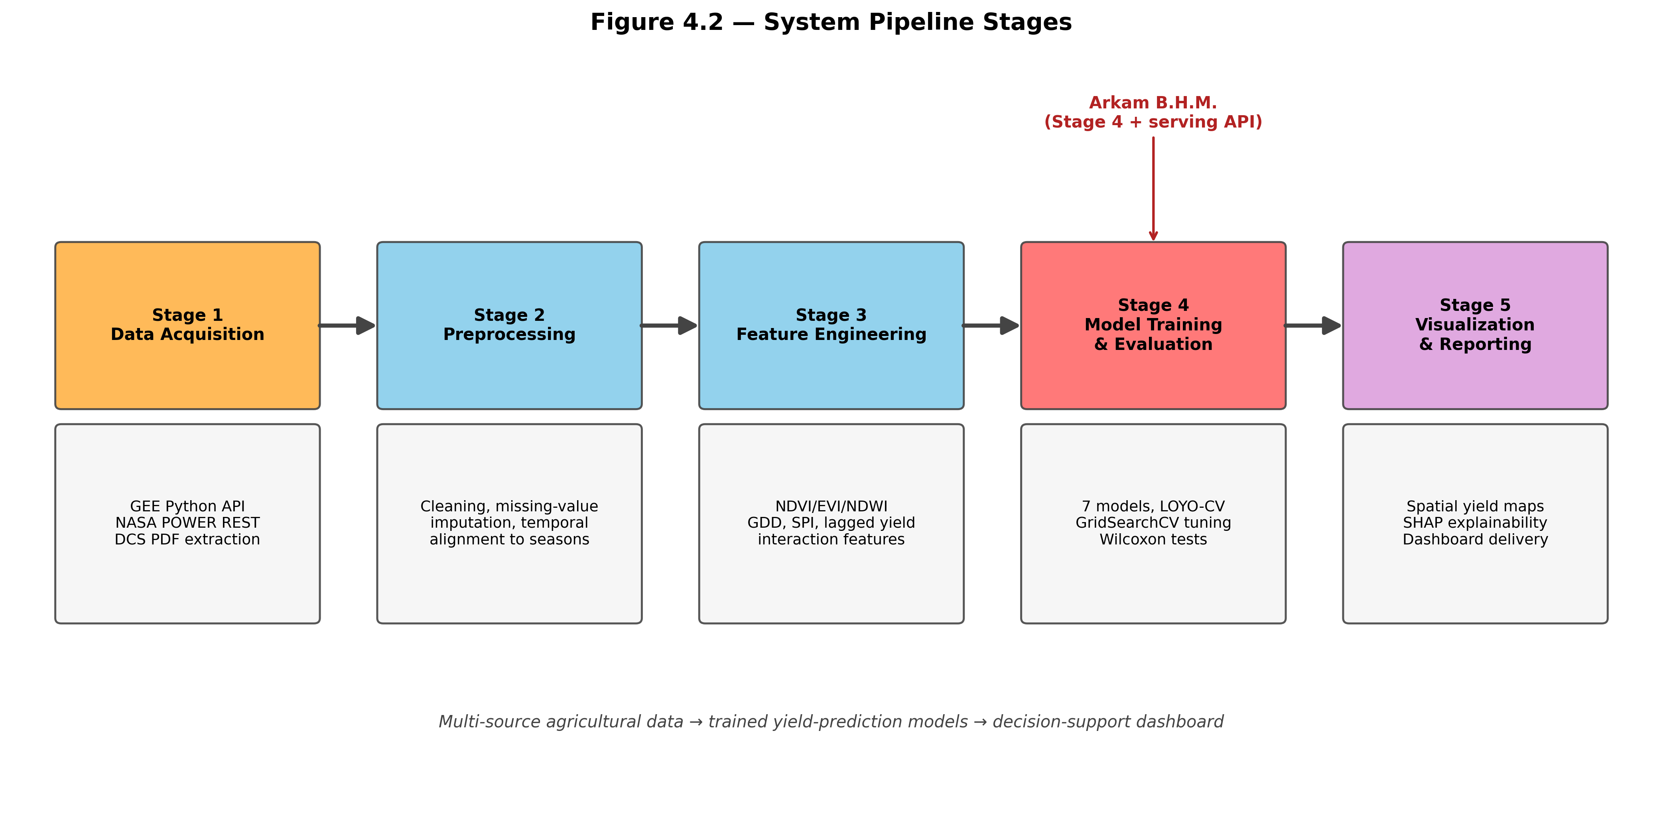
Figure 4.2: The nine-stage processing pipeline
4.5 Top-Level System Architecture
The top level architecture of the proposed system comprises four modules: the data acquisition and integration module, the modelling and evaluation module, the serving module, and the presentation module. Figure 4.1 shows the interaction among these modules.
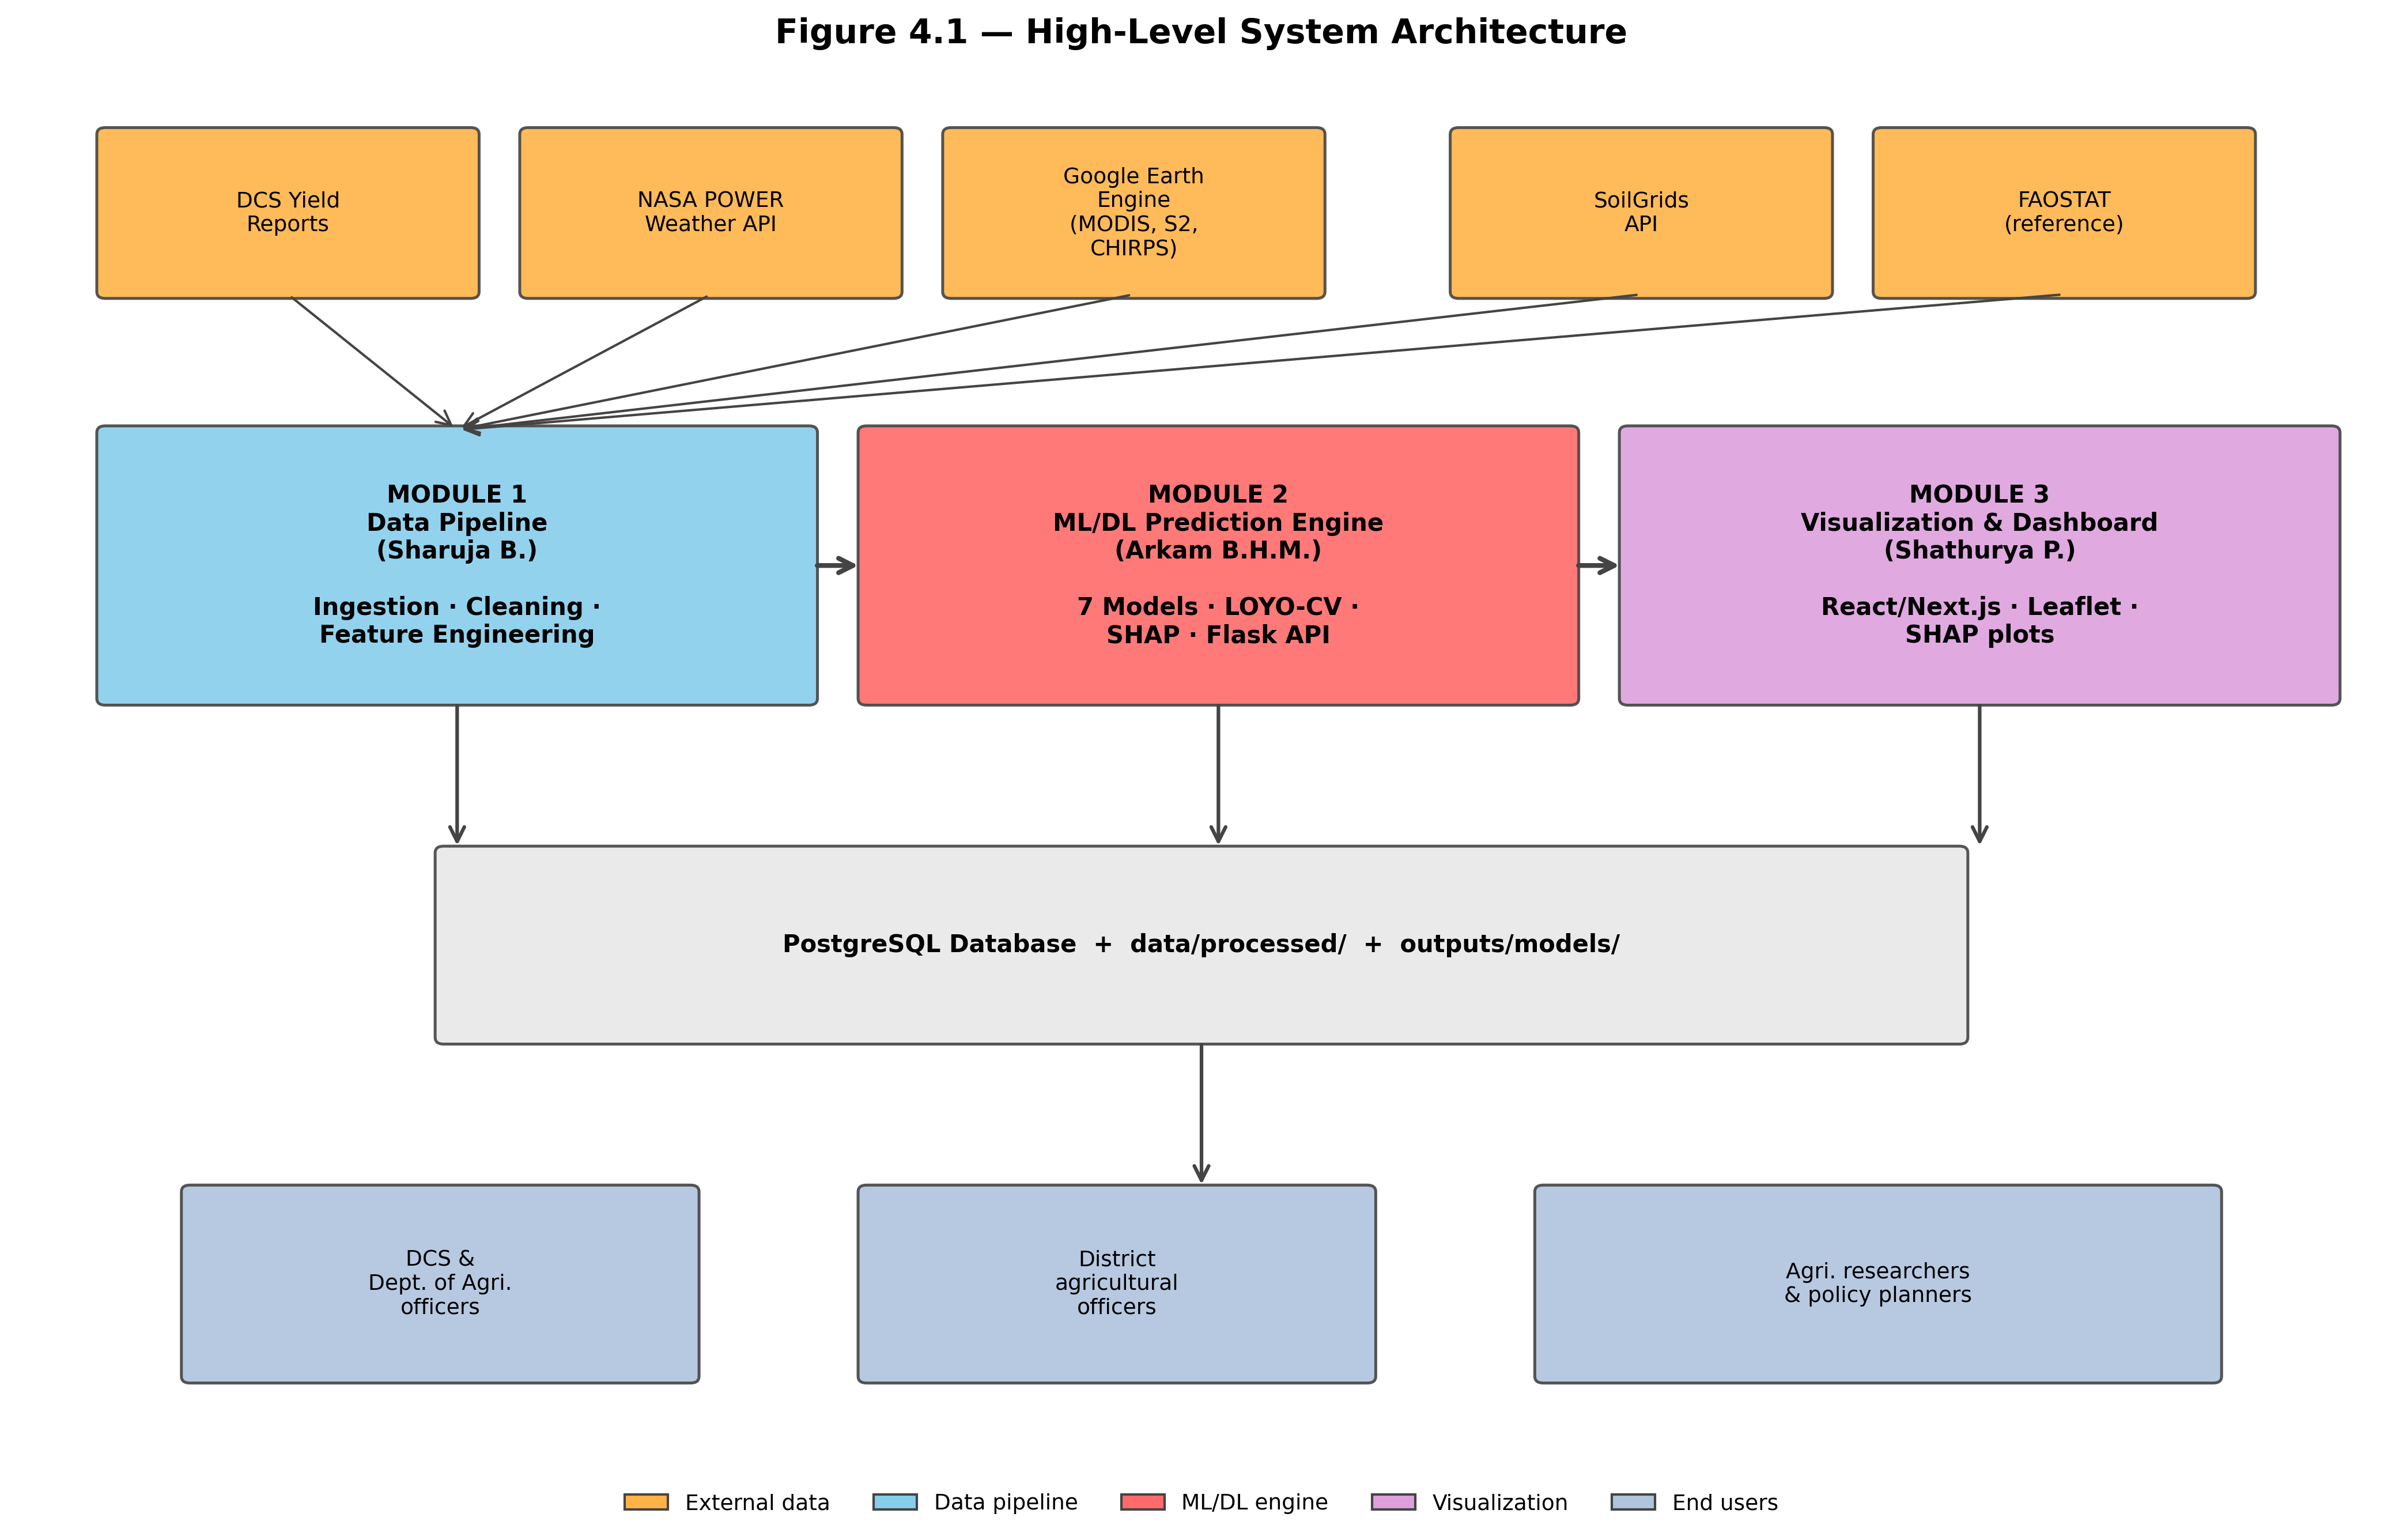
Figure 4.1: Top-level architecture of the proposed system
The data acquisition and integration module is responsible for reading each external source, applying the season window, reducing to the common key and producing the analysis dataset. It writes a processed dataset to disk and does not communicate with any other module directly; the file is the interface. This decoupling is deliberate, because it allows the data component and the modelling component to be developed and tested independently by different group members.
The modelling and evaluation module reads the processed dataset and is responsible for all training, cross-validation, combination, calibration, attribution and comparison. It writes fitted model files, an out-of-fold prediction record per model, a comparison table, calibration quantiles, attribution rankings and the summary of findings. It is the only module that performs learning.
The serving module reads those artefacts at start-up and exposes them over HTTP. It performs no training. Its responsibilities are to validate an incoming feature payload, apply the same preprocessing the training pipeline applied, invoke the selected model, attach the conformal interval and attribution, and return a structured response. Keeping training and serving strictly separate means a model can be retrained without touching the service, and the service can be restarted without retraining.
The presentation module is the dashboard. It consumes only the serving module's HTTP interface and holds no model logic. It renders the choropleth map of district forecasts, the prediction form with context-aware prefilling, the explainability view and the administrative model-comparison panel.
4.6 Walkthrough of a Single Prediction
To make the interaction concrete, consider a district agricultural officer requesting a forecast for Anuradhapura, Yala, in the current year. The dashboard first calls the context endpoint, which returns the most recent known values of every predictor for that district and season, so the officer is not asked to type thirty-two numbers. The officer adjusts any value they have better information about — perhaps this season's rainfall has been unusually low — and submits.
The serving module receives the payload, validates that every required predictor is present and within its plausible range, assembles the feature vector in the exact column order the model was trained on, and invokes the selected model. It then looks up the conformal half-width for that model and constructs the interval, computes the SHAP attribution for this specific feature vector, and returns the point forecast, the interval, the ranked attribution and a provenance record stating which model produced the number and on which dataset it was trained. The dashboard renders the forecast with its interval and displays the three largest positive and negative attributions as the explanation.
4.7 System Requirements
Functionally, the system must produce a district-season yield forecast from a feature payload, attach a calibrated interval, explain the forecast, expose the comparison of candidate models, and provide context-aware prefill values for the input form.
Non-functionally, four requirements shaped the design. Reproducibility: every random seed is fixed and every artefact is written to disk, so that a re-run reproduces the reported numbers exactly. Modest hardware: the full pipeline completes in approximately six minutes on a laptop with eight gigabytes of memory and no GPU. Interpretability: no forecast is served without an accompanying attribution. Honesty: no metric is reported without the evaluation protocol that produced it, and negative results are reported as prominently as positive ones.
4.8 Summary
This chapter described the approach: four user groups with distinct information needs, a precisely specified set of inputs and outputs, a nine-stage pipeline that transforms one into the other, and a four-module architecture in which data integration, modelling, serving and presentation are cleanly separated by file and HTTP interfaces. A single prediction was traced end to end, and the functional and non-functional requirements were stated. The next chapter opens each module and gives its internal design.

Chapter 5
Analysis and Design of the Prediction System
5.1 Introduction
Chapter 4 gave the top-level architecture and stated what each of the four modules is responsible for. This chapter opens those modules and gives their internal design: how data flows through the system, how the thirty-two predictors are constructed and why, how each model family is configured, how the mechanistic backbone is formulated, how the stacking layer is constrained, how uncertainty and explanation are produced, and how the serving and presentation tiers are structured.
5.2 Data Flow Design
Figure 5.1 shows the flow of data through the system, from the external sources on the left to the served artefacts on the right. Each arrow represents a file written by one component and read by the next; there are no in-memory hand-offs between the major stages. This is a reproducibility decision: any stage can be re-run in isolation against the persisted output of the stage before it.
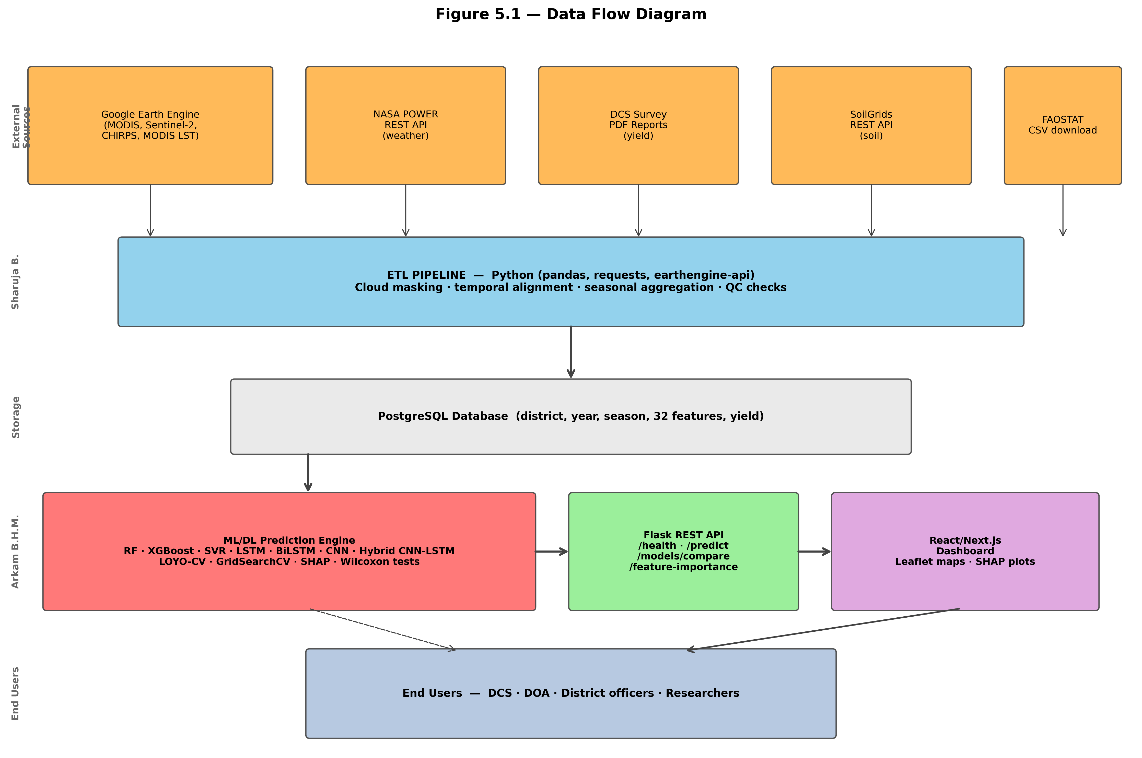
Figure 5.1: Data flow through the prediction system
Three reconciliation problems are solved in the first transformation. The first is grain mismatch: weather arrives daily, vegetation indices arrive on composite periods, soil is static and yield is seasonal. All are reduced to one record per district, season and year by applying the growing-season month window and aggregating within it, using the mean for state variables such as temperature and the sum for flux variables such as rainfall.
The second is the key mismatch. District names appear with different spellings and casings across sources, and the satellite export keys on geometry identifiers rather than names. A canonical district vocabulary is defined in configuration and every source is mapped onto it at load time, so that a silent join failure — which would manifest as missing predictors rather than as an error — cannot occur unnoticed.
The third is the seasonal boundary. The Maha season spans the calendar year boundary, running from October to March, so a naive grouping by calendar year would split a single Maha season across two records. The season window is therefore defined as an explicit month list per season, and Maha records are attributed to the year in which the season begins.
5.3 Feature Engineering Design
Thirty-two predictors are constructed across five groups. Table 5.1 lists them with the agronomic rationale for each group.
Table 5.1: The thirty-two engineered predictors by group
Group | Count | Predictors | Rationale
Weather | 9 | season_avg_temp, season_total_rainfall, season_avg_humidity, season_avg_solar_rad, growing_degree_days, heat_stress_days, drought_index_spi, temp_range, max_daily_rainfall | Thermal, water and radiation drivers of biomass accumulation
Satellite | 11 | season_mean/max/min_ndvi, ndvi_std, ndvi_anomaly, time_to_peak_ndvi, ndvi_growth_rate, season_mean_evi, season_mean_ndwi, season_mean_lst_day, season_mean_lst_night | Realised canopy vigour, phenological timing and surface thermal regime
Historical | 5 | prev_season_yield, prev_year_yield, yield_3yr_avg, season_indicator, extent_prev_season | District-level productivity baseline and season conditioning
Soil | 4 | soil_ph, organic_carbon, clay_pct, sand_pct | Static water-holding and nutrient-supply capacity
Interaction | 3 | rainfall_x_ndvi, temp_x_humidity, ndvi_x_lst | Encoded agronomic hypotheses about joint effects

5.3.1 Weather aggregates
Growing degree days accumulate the daily mean temperature above a crop-specific base over the season, following the standard formulation [28]. Heat stress days count the days on which the maximum exceeded the crop's critical threshold, capturing damage that a seasonal mean would average away. The standardised precipitation index expresses seasonal rainfall as a standardised anomaly against the district's own distribution, which is the form in which the FAO-33 water response function [12] is applied in section 5.6. Maximum daily rainfall is retained separately because a single intense event can cause lodging and waterlogging damage that the seasonal total conceals.
5.3.2 Vegetation dynamics
The vegetation group deliberately extracts the shape of the NDVI trajectory rather than only its level. The mean summarises overall vigour; the maximum locates the peak canopy; the minimum captures the worst point of the season; the standard deviation measures within-season variability. The anomaly expresses the season's mean against the district's own historical mean, which removes the persistent district effect arising from differences in soil and cropping intensity. Time to peak and growth rate encode phenological timing: a crop that greens up rapidly and peaks early behaves differently from one that develops slowly, even at the same peak level.
5.3.3 Interaction terms
The three interaction terms are the only features constructed from hypothesis rather than from direct measurement, and each encodes a specific agronomic claim. The rainfall-NDVI product expresses that rainfall is beneficial only when there is a canopy to use it; the same rainfall on bare soil is runoff. The temperature-humidity product is a proxy for evaporative demand and, jointly, for fungal disease pressure, since warm and humid conditions favour the pathogens that affect onion foliage. The NDVI-LST product captures whether a green canopy is also thermally stressed: a high vegetation index with a high surface temperature indicates a canopy under heat load, which is a different state from the same greenness at a moderate temperature.
5.3.4 Sequential representation for the deep models
The deep models require a sequence rather than a flat vector. A parallel representation is therefore constructed in which each record is expanded into a fixed-length sequence of monthly time steps across the growing season, with four weather channels per step and the vegetation index series aligned to the same axis. The static soil properties and the season indicator remain scalar and are injected at the dense head. This dual representation — tabular for the classical models, sequential for the deep ones — is what allows both families to be compared on identical underlying information.
5.4 Classical Model Design
Table 5.2 records the model inventory and the design rationale for each member. Nine predictors are trained in total, spanning four distinct modelling philosophies.
Table 5.2: Model inventory and design rationale
Model | Family | Key design choice | Why included
Random Forest | Bagged trees | 200 trees, depth-limited, min leaf 2 | Variance reduction; robust small-sample baseline
XGBoost | Boosted trees | Depth 3–5, lr 0.05, L1+L2 penalties | Bias reduction under explicit regularisation
SVR | Kernel method | RBF kernel, epsilon-insensitive loss | Orthogonal inductive bias; capacity independent of n
LSTM | Recurrent | 64→32 units, dropout 0.2 | Temporal integration of weather sequence
BiLSTM | Recurrent | Bidirectional 64→32 | Both-direction context; legitimate post-season
1D-CNN | Convolutional | Filter bank over index sequence | Local shape detection in NDVI trajectory
Hybrid CNN-LSTM | Two-branch | CNN + LSTM branches, season injected at head | Modality-appropriate extraction; season conditioning
Symbolic regression | Genetic programming | 5 predictors, restricted operators | Human-readable closed-form equation
Physics-residual | Mechanistic + ML | FAO-33/GDD backbone + RF on residual | Substitutes agronomy for scarce degrees of freedom

For the classical learners the design decisions that matter most are the capacity limits. Random Forest is configured with a minimum leaf size above one so that no leaf can be a single training record, which is the mechanism by which a forest memorises a small dataset. XGBoost is held to shallow trees and a low learning rate for the same reason, with both L1 and L2 penalties on leaf weights active. Support Vector Regression uses a radial basis kernel with the regularisation constant and epsilon selected inside the cross-validation fold rather than fixed by hand.
5.5 Deep Model Design and the Hybrid CNN-LSTM
The three single-branch networks share a common design skeleton: a sequence input, one or two recurrent or convolutional layers with dropout, a global pooling or final-state extraction, and a small dense head terminating in a single linear output. All are held small deliberately, on the order of ten to eighty thousand parameters, because the training set contains fewer records than a conventional network has units in one layer.
The hybrid CNN-LSTM is the architectural contribution and its design is shown in Figure 5.2. Two branches process the two modalities in parallel. The convolutional branch consumes the vegetation index sequence, applying a filter bank that detects local trajectory shape — green-up steepness, peak sharpness, senescence rate — followed by pooling. The recurrent branch consumes the weather sequence, its gated cell state integrating the cumulative effect of temperature, rainfall, humidity and radiation across the season. Neither branch sees the other's modality.
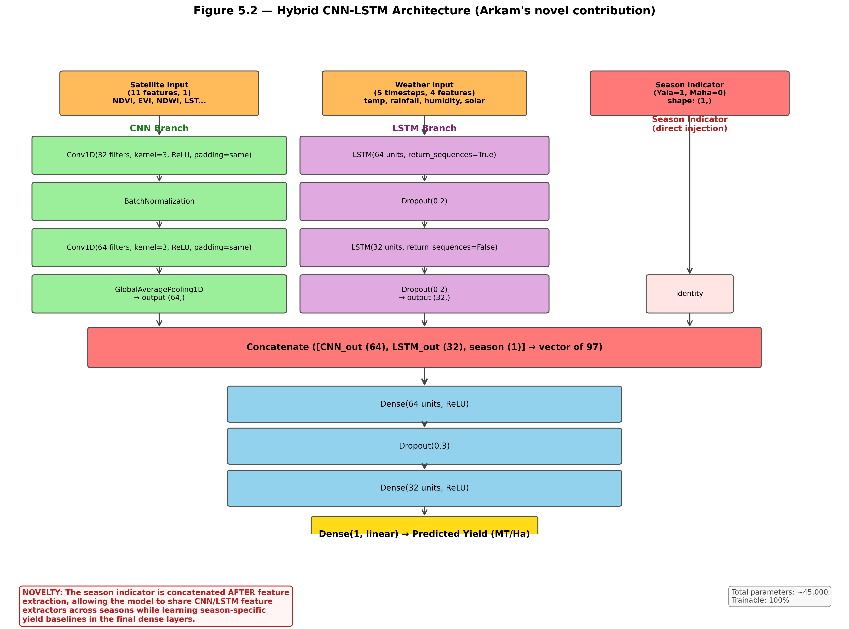
Figure 5.2: Hybrid CNN-LSTM architecture with season-indicator injection
The design decision that distinguishes this architecture from the published family [31] is where the season indicator enters. It is not appended to the input sequences, and it is not used to select between two separately trained models. It is concatenated with the two branch outputs immediately before the dense head. The consequence is a specific division of labour: because the branches never see the season variable, they are forced to learn feature extractors that are valid for both seasons, and they therefore train on the entire dataset rather than on a per-season subset. Only the dense head, which holds a small fraction of the parameters, learns season-specific behaviour.
The data-efficiency argument follows directly. Training separate per-season models would halve the effective sample for every parameter. Appending the season indicator to the input sequence would let the convolutional and recurrent filters specialise on season, dissipating the same advantage more subtly. Injecting at the head shares all the expensive representation learning while retaining the capacity to express a season-specific yield baseline. In a regime where the sample is the binding constraint, that division is the whole point.
5.6 Physics-Residual Hybrid Design
The physics-residual hybrid is a two-stage predictor. The first stage is a mechanistic backbone with no learned internal parameters; the second is a Random Forest trained on what the backbone leaves unexplained.
The backbone computes three physiological limitation factors. The thermal factor is a saturating exponential in accumulated growing degree days, expressing that the crop must accumulate a heat requirement to complete its cycle and that further accumulation beyond that requirement confers no additional benefit; the characteristic scale is set at 1500 degree days, consistent with the published thermal requirement for the crop [28]. The water factor applies the FAO-33 production function [12] through the standardised precipitation index, using the published onion yield response factor of 1.1 so that a unit relative water deficit produces a slightly more than proportional relative yield loss, and clipping the result to the physically admissible interval. The heat factor applies a linear decrement of three per cent per day above the critical temperature threshold, also clipped.
The three factors multiply into a single suitability term between zero and one. Because that term is dimensionless and the target is in metric tons per hectare, a two-parameter affine calibration maps one to the other. Those two parameters — an intercept and a slope — are the only quantities in the backbone estimated from data, and they are re-estimated on the training partition inside every cross-validation fold so that no information from the held-out year reaches the calibration.
The second stage fits a Random Forest to the difference between the observed yield and the calibrated backbone prediction, using the full thirty-two-predictor vector. The final forecast is the sum of the two. The design intent is that the backbone carries the physiologically constrained component of the response — which does not have to be learned — and the forest models only the systematic departures arising from management, cultivar, pest pressure and everything else the simplified physics omits. Section 7.5 measures whether this intent is realised.
5.7 Stacking Layer Design
The stacking layer combines the nine base predictors. Its design has three deliberate constraints, each addressing a way in which naive stacking fails at this sample size.
First, the meta-learner is fitted on out-of-fold predictions only. Each base model's prediction for a given record was produced by a version of that model which never saw the record, so the meta-learner is trained on predictions with realistic error, not on the optimistically small residuals a model produces on its own training data.
Second, the weights are constrained to the probability simplex: non-negative and summing to one. Breiman [6] established the non-negativity requirement; the sum-to-one constraint is added here because it makes the combination a convex blend, guaranteeing that the stacked prediction lies within the range of the base predictions and cannot be driven outside it by the cancellation of large opposing weights. With nine base models and twenty-eight records, this reduction of effective degrees of freedom is not optional.
Third, three combiners are computed rather than one, so that the forecast-combination puzzle [34], [9] can be tested rather than assumed. The equal-weight mean estimates nothing. The inverse-RMSE weighting estimates only a scalar reliability per model. The constrained convex fit estimates the full weight vector under the simplex constraint. If the puzzle holds in this setting, the mean will win; if the learned blend wins, it indicates the base models are diverse enough for estimation to pay. Section 7.6 reports which occurred.
5.8 Uncertainty and Explainability Design
The conformal layer takes the absolute out-of-fold residuals for a model, sorts them, and takes the empirical quantile at the level implied by the target coverage with the finite-sample correction that split-conformal theory requires [36], [3]. That single scalar becomes the interval half-width, applied symmetrically about the point forecast. The design is intentionally the simplest conformal variant: locally adaptive variants that widen the interval in hard regions require a second model to predict residual magnitude, and with twenty-eight calibration points such a model could not be fitted responsibly.
The explanation layer uses SHAP TreeExplainer [27] on the best-performing tree model. Two artefacts are produced: a global ranking of mean absolute attribution across all records, which answers which predictors matter in general, and per-prediction attributions computed on demand at serving time, which answer why this particular forecast came out as it did. The second is what an agricultural officer actually needs, and it is why the explainer is loaded into the serving process rather than only run in the analysis pipeline.
5.9 Serving and Dashboard Design
The serving layer is designed around one rule: it never trains. It loads the persisted models and artefacts at start-up and thereafter only reads. This makes it stateless with respect to learning, which means it can be restarted freely, and it means a retraining run cannot corrupt a running service. Requests are validated against the expected predictor schema before reaching a model, and the feature vector is assembled in the exact column order used at training time, since a silent column reordering would produce plausible-looking but meaningless forecasts.
Every response carries a provenance record naming the model that produced the forecast and the dataset variant it was trained on. This was added after an early integration problem in which dashboard figures could not be traced back to a pipeline run; making provenance part of the response contract removes the ambiguity permanently.
The logical structure of the persisted data store is shown in Figure 5.3. The processed dataset is keyed on district, season and year; the out-of-fold prediction records share that key and add a model dimension; the comparison, calibration and attribution artefacts are keyed on model alone.
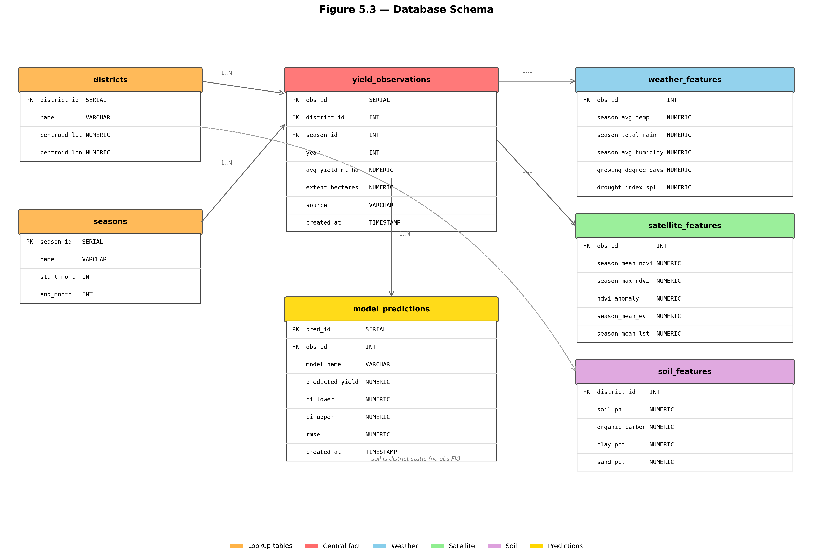
Figure 5.3: Logical data schema of the processed store
The dashboard is organised around the four user groups of Table 4.1. The overview presents national and district key figures with a choropleth map. The prediction view presents the context-prefilled form and the forecast with its interval. The explainability view presents the global attribution ranking and the symbolic equation. The recommendation view translates the forecast and its drivers into plain-language guidance. An administrative view presents the full model comparison for technical users. Internationalisation is included because the intended district-level users do not all work in English.
5.10 Summary
This chapter presented the internal design of every module. The data flow resolves grain, key and seasonal-boundary mismatches through file-mediated stages. Thirty-two predictors were designed across five groups with stated agronomic rationale, and a parallel sequential representation supports the deep models. The nine-model inventory was justified member by member, with detailed treatment of the hybrid CNN-LSTM's season-indicator injection and the physics-residual hybrid's mechanistic backbone. The stacking layer's three constraints, the conformal and SHAP designs, and the serving and dashboard structures were specified. The next chapter documents how this design was implemented.

Chapter 6
Implementation
6.1 Introduction
Chapter 5 specified the design of each module. This chapter documents how that design was realised in software: the repository structure and tooling, then each module in turn, stating the algorithms, the configuration and the key implementation decisions. The correspondence between design modules and source files is maintained deliberately, so that a reader can move from a design section to the code that implements it without searching. Extended code excerpts appear in Appendix B.
6.2 Repository Layout and Tooling
The implementation is a Python package under a source directory, a single-entry orchestration script, a dashboard application, and separated directories for data and outputs. Table 6.1 maps each design module onto the file that implements it.
Table 6.1: Pipeline modules and their source files
Design module | Source file | Responsibility
Configuration | src/config.py | All hyperparameters, paths, feature groups, seeds
Data acquisition | src/data_loader.py | Load sources, apply season window, reconcile keys
Preprocessing | src/preprocessor.py | Validation, imputation, encoding
Feature engineering | src/feature_engineer.py | Build the 32 predictors and sequences
Exploratory analysis | src/eda.py | Distribution, correlation and seasonal plots
Classical models | src/ml_models.py | RF, XGBoost, SVR under LOYO-CV
Deep models | src/dl_models.py | LSTM, BiLSTM, 1D-CNN, hybrid CNN-LSTM
Symbolic regression | src/symbolic.py | Genetic-programming equation search
Physics-residual | src/physics_residual.py | Mechanistic backbone + residual learner
Stacking | src/stacking.py | Three combiners on out-of-fold predictions
Conformal | src/conformal.py | Split-conformal residual quantiles
Explainability | src/explainer.py | SHAP TreeExplainer attributions
Ablation | src/ablation.py | Six data-source configurations
Evaluation | src/evaluator.py | Metrics, significance tests, final comparison
Serving | src/api.py | REST endpoints over the persisted artefacts
Orchestration | main.py | Stage sequencing and command-line flags
Presentation | dashboard/ | Next.js decision-support application

Two implementation conventions run through the whole codebase. The first is that all tunable quantities live in the configuration module and nowhere else, so that no hyperparameter is buried in a model file. The second is that the choice of dataset variant — the real collected data or the synthetic reference — is made through a single environment variable read at configuration time, which redirects every output path. The two variants therefore write to entirely separate directories and cannot contaminate each other, which is what allows synthetic architecture validation and real-data evaluation to coexist in one repository without ambiguity.
The orchestration script exposes a flag per stage, so that during development an expensive stage can be skipped without editing code. A full real-data run is invoked with a single real-data flag and completes in approximately six minutes on a laptop.
6.3 Data Loading and Preprocessing
The loader reads the collected source files, each of which arrives on its own grain, and reduces them to the common key. Daily weather rows are filtered to the season month window and aggregated: means for state variables, sums for fluxes, counts for threshold-crossing events. Composite-period vegetation index rows are filtered to the same window and reduced to the mean, maximum, minimum, standard deviation and derived timing statistics. Soil properties, being static, are joined directly on district.
The Maha boundary is handled by defining the season as an explicit month list and attributing a Maha record to its starting year, so that a season spanning the calendar boundary remains one record. District names are normalised against the canonical vocabulary in configuration at load time; a name that fails to map raises rather than silently dropping the row, because a silent drop would produce a smaller dataset with no indication that anything went wrong.
Preprocessing validates each predictor against a plausible range, imputes the small number of remaining gaps by district median, and encodes the categorical fields. The season indicator is encoded as a binary variable and retained as a modelling feature rather than used only for grouping, because the deep architecture consumes it directly at its dense head.
A synthetic generator is retained alongside the real loader. It produces a dataset calibrated to published district yield ranges and to the correlation structure expected between weather, vegetation indices and yield, from a fixed seed. Its role is strictly to validate that the pipeline and the model architectures function correctly end to end at a sample size where they can be expected to; it is never mixed with real data, and every number derived from it is labelled as such.
6.4 Feature Engineering
The feature engineering module builds the thirty-two predictors of Table 5.1 and, in the same pass, the sequential representation the deep models require. Growing degree days accumulate the daily mean above the base temperature over the season window; heat stress days count exceedances of the critical maximum; the standardised precipitation index standardises seasonal rainfall against the district's own historical distribution.
Yield-history predictors require care to avoid leakage. The previous season's yield, the previous year's yield and the three-year moving average are all computed by shifting within the district group so that a record's history contains only strictly earlier records. An unshifted rolling average would include the record's own target and would produce spectacular and entirely fictitious accuracy.
The module returns four objects: the tabular predictor matrix, the target vector, the ordered feature-name list, and the sequential payload for the deep models. The feature-name list is not incidental — it is persisted and used by the serving layer to assemble incoming payloads in the exact training column order.
6.5 Classical Model Implementation
The classical trainer implements the nested cross-validation directly rather than relying on a library convenience wrapper, because the outer grouping is by year while the inner search must respect temporal order within the training partition. The outer loop iterates over the distinct years; for each, all records of that year form the test partition and the remainder the training partition. Within the training partition an inner grid search using a time-series split selects hyperparameters. The selected configuration is refitted on the full training partition and used to predict the held-out year.
Reduced hyperparameter grids are used inside the inner loop, with the full grids reserved for the final refit. This is a runtime decision: the full grid inside a nested loop over every year would multiply training time by an order of magnitude for a selection that the reduced grid reaches in almost all folds.
Every model writes an out-of-fold prediction record containing, for each row, the year, season, district, actual and predicted values. These records are the substrate for everything downstream — the significance tests, the stacking layer, the conformal calibration and the per-district analysis all read them rather than re-running the models.
6.6 Deep Model Implementation
The four networks are built with the Keras functional interface, which is required for the hybrid because it has two inputs. Each is trained under the same outer cross-validation as the classical models, with a validation split carved from the training partition for early stopping. Weights are reinitialised at the start of every fold; carrying weights across folds would leak information from previously held-out years into later ones.
The hybrid's implementation follows the design of section 5.5 exactly: a convolutional stack over the vegetation input, a recurrent stack over the weather input, both reduced to fixed-length vectors, and then concatenation with the scalar season indicator before the dense head. Epoch count is capped during small-data runs, since with a training partition of two dozen records the networks reach their early-stopping criterion long before the nominal maximum.
Figure 6.1 shows the training curve of the hybrid on the collected data. The behaviour it displays is itself a finding: the validation loss separates from the training loss early and does not recover, which is the signature of a model with more capacity than the sample can constrain. This is consistent with the quantitative outcome reported in section 7.4.
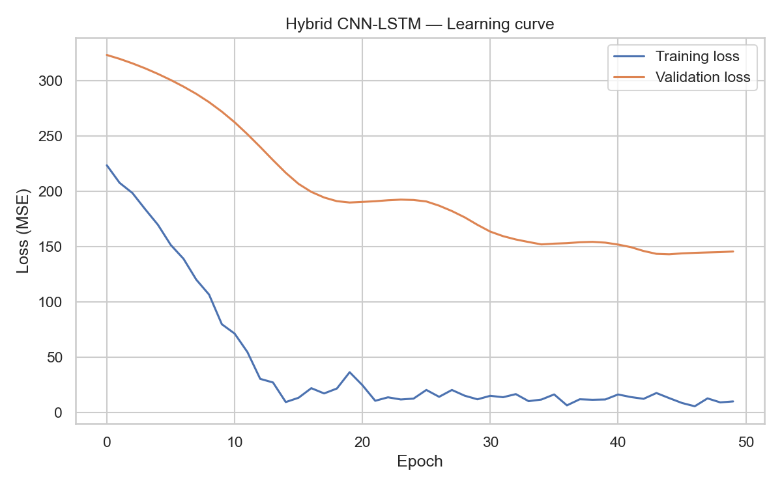
Figure 6.1: Training curve of the hybrid CNN-LSTM on the collected data
6.7 Symbolic Regression Implementation
The symbolic regression module runs a genetic-programming search [25] over expression trees. The search is restricted in three ways, all of which are necessary at this sample size. The predictor set is limited to the five ranked highest by SHAP; the function set is limited to addition, subtraction, multiplication, protected division and square root; and the fitness function includes a parsimony penalty on expression length. Without these restrictions the search reliably produces an expression that interpolates the training points and has no predictive content.
The module writes both the raw evolved program, in terms of indexed variables, and a rendered form with the variable indices substituted by predictor names, along with the metrics achieved under the same cross-validation protocol as every other model. The rendered equation is served through a dedicated endpoint so the dashboard can display it.
6.8 Physics-Residual Implementation
The physics-residual module implements the two-stage design of section 5.6. The backbone is a pure function of the predictor matrix with no fitted internal state: it computes the thermal, water and heat factors from growing degree days, the standardised precipitation index and heat stress days respectively, using the constants drawn from the agronomic literature [12], [28], and multiplies them into the suitability term.
The affine calibration and the residual forest are both fitted inside every outer fold on the training partition only. The module additionally evaluates and persists the backbone in isolation, without the residual learner, so that the contribution of each stage can be separated. It also records the plain Random Forest score from the classical stage, which gives the with-and-without-backbone comparison reported in section 7.5. That three-way comparison — backbone alone, learner alone, and the hybrid — is the ablation that establishes whether the mechanistic prior earns its place.
One implementation observation is recorded in the module's own output and is worth stating here: the heat stress day count is zero throughout the collected data, so the heat factor is inert and the backbone's signal comes entirely from thermal time and water. This does not invalidate the formulation — the factor would activate in a hotter season — but it means the measured benefit is attributable to two of the three components.
6.9 Stacking, Conformal and SHAP Implementation
The stacking module reads every base model's out-of-fold prediction record, aligns them on the district-season-year key, and fits the three combiners under a nested protocol in which the weights are estimated on training years only and applied to the held-out year. The convex combiner solves a constrained least-squares problem on the simplex; the inverse-RMSE combiner normalises reciprocal validation errors; the mean combiner assigns equal weights. All three write their own out-of-fold records in the same format as a base model, so they enter the final comparison on identical terms.
The conformal module reads the out-of-fold records, computes absolute residuals, and takes the corrected empirical quantile at the level implied by the target coverage. It persists, per model, the quantile, the target and empirical coverage, and the calibration set size — the last of these being essential context for interpreting the coverage figure, as section 7.10 discusses.
The explainability module runs SHAP TreeExplainer [27] on the best tree model, persists the ranked mean absolute attributions, and generates the summary, importance and dependence plots. It is run before the final comparison stage so that the summary of findings can name the top predictors, and its output feeds both the symbolic regression predictor selection and the dashboard's explainability view.
6.10 Ablation Study Implementation
The ablation module re-runs the complete evaluation protocol under six predictor configurations: weather only, satellite only, historical only, soil only, weather combined with satellite, and all sources. Each configuration is a strict subset of the full predictor list defined in configuration, so the experiment isolates the data source and holds everything else — model, protocol, seed — fixed. Results are written to a comparison table and a bar chart, and are reported in section 7.8.
6.11 Serving Layer and Dashboard
The serving layer loads the persisted models and artefacts at start-up and exposes the endpoints of Table 6.2. It performs no training and holds no mutable state beyond its loaded artefacts.
Table 6.2: REST endpoints exposed by the serving layer
Endpoint | Method | Purpose
/health | GET | Liveness check and loaded-artefact inventory
/predict | POST | Point forecast, conformal interval, SHAP attribution, provenance
/models/compare | GET | Full model comparison table
/feature-importance | GET | Ranked global SHAP attributions
/equation | GET | Rendered symbolic regression equation
/context | GET | Prefill predictor values for a district, season and year
/baseline | GET | Historical baseline yield for comparison
/districts | GET | Districts, seasons and years available for selection

The prediction endpoint is the only one that computes. It validates the payload against the persisted feature-name list, assembles the vector in training column order, invokes the model, looks up the conformal half-width, computes the per-record SHAP attribution, and returns all of it with a provenance block naming the model and dataset variant.
The dashboard is a Next.js application with locale-aware routing, consuming only these endpoints. Its views correspond to the user groups of Table 4.1: an overview with the district choropleth, a prediction form with context prefill, an explainability view showing attributions and the symbolic equation, and a recommendation view that renders the forecast and its drivers as plain-language guidance. Screenshots appear in Appendix D.
6.12 Summary
This chapter documented the implementation module by module, maintaining an explicit correspondence between design sections and source files. The central implementation concerns were preventing leakage — through shifted history features, per-fold refitting of every fitted quantity including the mechanistic calibration, and weight reinitialisation between folds — and maintaining strict separation between the real and synthetic dataset variants. The next chapter reports what the implemented system achieves when evaluated.

Chapter 7
Evaluation and Results
7.1 Introduction
Chapter 6 documented the implemented system. This chapter reports what it achieves, and it begins somewhere unusual for a results chapter: with an audit of the data itself. That audit changed the target variable, and every number downstream of it, so reporting it first is not a preamble but a precondition for reading anything that follows.
The chapter then establishes how much of the target is explainable in principle under the chosen validation protocol, before reporting what any model actually achieved. Taking those in that order matters. A model comparison read without knowing the attainable ceiling invites the reader to attribute to the models what belongs to the data.
Sections 7.2 and 7.3 report the data audit and the corrected dataset. Section 7.4 states the protocol. Section 7.5 decomposes the variance and derives the ceiling. Sections 7.6 through 7.9 report the model comparison, the phenology-aligned differentiable response model and its estimated agronomic constants, the mechanism ablations, and the diagnosis of why the agro-climatic channel does not carry the signal. Section 7.10 establishes how strong a signal the model could have detected, without which the preceding section's negative conclusion would carry no weight. Sections 7.11 and 7.12 report calibrated uncertainty and per-district behaviour.
7.2 Data Integrity Audit
The dataset used in the interim report was assembled from a monthly file of one hundred and twenty-four records. Auditing that file against the underlying Department of Census and Statistics returns established that fifty of those one hundred and twenty-four rows carried the marker source=synthetic, and that the fabrication reached the target variable rather than only the covariates.
This matters because yield varies from month to month within every one of the twenty-eight district-year cells, and the seasonal target was their unweighted mean. A cell whose months were part real and part fabricated therefore produced a target that was part real and part invented. Only four of the twenty-eight cells were composed entirely of real months, so filtering at cell level was not available as a remedy.
Table 7.1: Provenance audit of the interim monthly dataset
Category | Count
Month-cells with a genuine DCS extent and production record | 87
Rows marked source=real, all of which map to a DCS record | 74
Rows marked source=synthetic with no DCS record at all | 39
Rows marked synthetic that did have a real record, discarded and replaced | 11
Genuine DCS records never used by the pipeline | 13
Cells composed entirely of real months | 4 of 28

The remedy was to abandon the monthly file as the target source and rebuild the panel from the eighty-seven genuine DCS records, which report harvested extent and total production as separate columns. This permits the standard agronomic definition of yield as total production divided by total harvested area, aggregated over the months a cell actually has. All twenty-eight cells survive, and every value traces to a real record.
The corrected target correlates with the previous one at only 0.68, and its standard deviation more than doubles, from 4.17 to 6.37 metric tons per hectare. Averaging fabricated values into the target had been compressing precisely the variance the models were being asked to predict.
Two parsing faults were found and corrected in the process, either of which silently corrupts the panel. Production values are written with thousands separators in two records, which parse to missing values unless the reader is told to expect them; that alone had been rendering Matale 2020 as 0.53 rather than 12.16 metric tons per hectare. Separately, zero is a missing-data code for the second vegetation-index composite and for all three soil columns, but a genuine measurement for extent and production, and the two cases must be distinguished.
Finally, six month-records imply yields that are not physically attainable. The world record for onion is approximately one hundred metric tons per hectare under intensive irrigation, and Sri Lanka averages fifteen to twenty. Table 7.2 lists them.
Table 7.2: Month-records excluded as physically impossible
Record | Extent (ha) | Production (MT) | Implied yield (MT/ha)
Matale, October 2025 | 30.0 | 13,271.7 | 442
Polonnaruwa, October 2025 | 16.7 | 2,419.5 | 145
Polonnaruwa, November 2019 | 1.4 | 274.0 | 192
Anuradhapura, August 2021 | 7.8 | 856.4 | 110
Polonnaruwa, October 2019 | 2.8 | 240.0 | 84
Anuradhapura, October 2025 | 156.9 | 10,698.6 | 68

These six were excluded, each affected cell surviving on its remaining months. The effect is corroborating rather than merely cosmetic: the 2025 district yields, which had read 35.96, 42.72 and 42.11, resolve to 21.07, 21.95 and 22.85 — a coherence across three independent districts that the uncorrected figures did not show. The full audit trail is written to data_quality_report.csv. These records should be checked against the original DCS publication, and this report does not claim to have established which of extent or production was mis-transcribed.
7.3 The Corrected Evaluation Dataset
Table 7.3 gives the composition of the corrected panel and the distribution of the corrected target.
Table 7.3: Composition of the corrected evaluation dataset
Property | Value
Records | 28
Districts | Anuradhapura, Kurunegala, Matale, Polonnaruwa
Years | 2019–2025 (7 years)
Seasons | Yala only
Target definition | Total production (MT) / total harvested extent (ha)
Source records | 87 genuine DCS month-records, less 6 excluded
Target mean | 17.89 MT/Ha
Target standard deviation | 6.37 MT/Ha
Target range | 3.63 – 33.58 MT/Ha
Harvested extent per cell | 3.5 – 1,765 ha

Harvested extent spans a factor of five hundred across cells. A district-year covering three and a half hectares yields an estimate of very different reliability from one covering one thousand seven hundred, and treating them as equally informative is not defensible. Observations are therefore weighted by the square root of harvested extent, normalised to mean one. Plain area weighting was rejected because its five-hundred-fold span would have effectively removed Kurunegala from the analysis altogether. Both weighted and unweighted metrics are reported throughout.
Four properties of this dataset govern the interpretation of everything that follows.
First, twenty-eight records is a small sample by any standard, and with seven years the Leave-One-Year-Out protocol produces seven folds of four records each, each training on twenty-four.
Second, the collected record covers only the Yala season. The hybrid CNN-LSTM's season-indicator injection, designed for the bimodal Yala and Maha structure, therefore cannot be evaluated at all on real data: the indicator is constant across every record, making the architectural claim inert by construction rather than merely untested.
Third, the four districts are not four independent meteorological observations. Kurunegala and Matale fall inside a single NASA POWER grid cell and receive byte-identical daily weather, at a correlation of exactly one. There are three distinct weather series for four districts.
Fourth, and most consequentially for the satellite component, onion occupies between 0.002 and 0.89 per cent of any district's land area. A district-mean MODIS composite is therefore a measurement of paddy, forest and scrub, not of onion. Anchoring the crop calendar on the satellite green-up curve was attempted and twenty-five of twenty-eight district-years failed to anchor. This is also the explanation for the interim report's satellite-only ablation result, which was negative on real data while appearing strongly positive on synthetic data where the vegetation index had been generated as a function of yield.
7.4 Evaluation Protocol and Metrics
Every model reported here was evaluated identically. The outer loop holds out one year at a time and predicts it from a model refitted on the remaining six. Every fitted quantity, including all scaling, is estimated inside the fold. Metrics are computed on the pooled out-of-fold predictions, so each of the twenty-eight records contributes a prediction made by a model that never saw it.
Four look-ahead leaks present in the interim pipeline were removed. The vegetation anomaly and the standardised drought index had been computed by standardising against the full 2019 to 2025 panel, so every fold saw statistics derived from its own held-out year; these are now standardised against a 2000 to 2018 climatology that no fold ever tests on, which removes the leak by construction rather than by fold bookkeeping. The target had been winsorised at full-sample percentiles, which is also a leak, and this was removed in favour of the explicit physical-plausibility filter described in section 7.2.
The lagged-yield features were not repaired but dropped. Under Leave-One-Year-Out with year k held out, the training row for year k plus one carries year k's observed yield as a predictor, which is a leak with no clean fix inside this protocol. They also purchase very little here: only 2.2 per cent of target variance lies between districts, which is the whole of what a persistence term can capture. The two lag columns were in any case identical, the panel being single-season.
Seven predictors were removed as constants or exact linear transforms of others: solar radiation had been hard-coded to 18.0, the water index to 0.1, organic carbon to 1.8, previous-season extent to 400.0, the heat-stress day count to zero, the season indicator to one, and the two land-surface temperature columns were air temperature plus and minus six degrees. With genuine daily weather now loaded, the heat-stress count ranges from thirty-three to one hundred and sixteen days rather than being identically zero; the interim code had compared a monthly mean temperature against a daily threshold.
7.5 Variance Decomposition and the Attainable Ceiling
Before comparing models it is necessary to establish how much of the target is explainable at all under this protocol. Table 7.4 decomposes the corrected target's total sum of squares.
Table 7.4: Variance decomposition of the corrected target
Component | Sum of squares | Share of total
Between years | 696.89 | 63.6%
Between districts | 24.09 | 2.2%
Residual | 374.97 | 34.2%

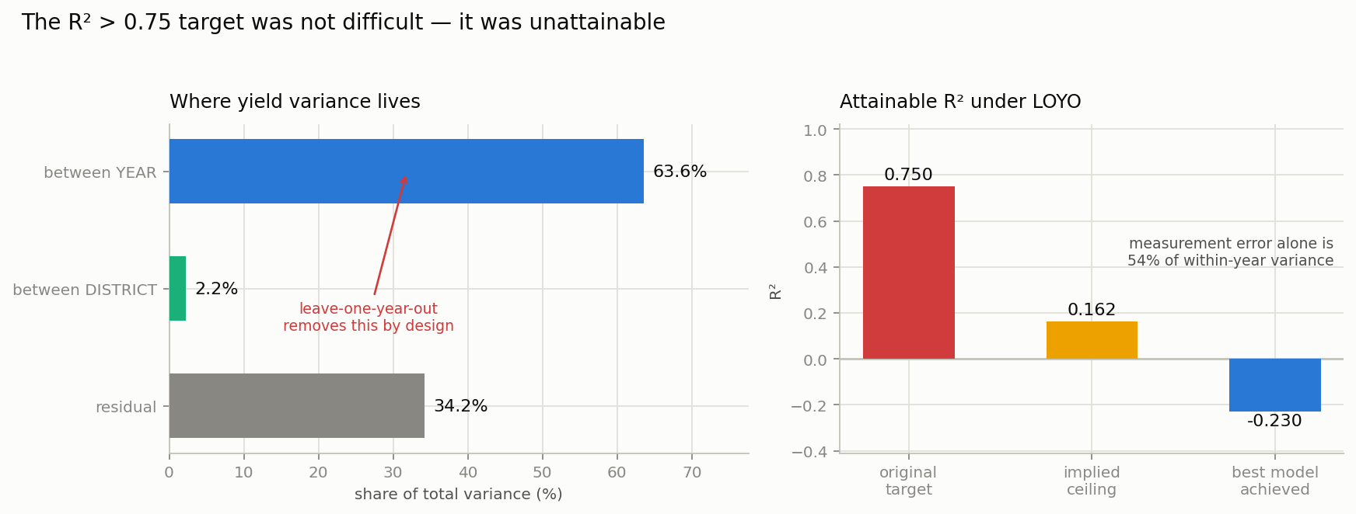
Figure 7.1: Where yield variance lies, and what remains attainable under Leave-One-Year-Out
Sixty-four per cent of the variance lies between years and two per cent between districts. Leave-One-Year-Out holds out an entire year, and therefore removes the dominant component of the variance by construction. This single fact explains the near-zero and negative coefficients of determination reported throughout this chapter and in the interim report. It is arithmetic rather than a modelling failure, and no choice of algorithm alters it.
The residual can be bounded further. Each cell's yield is an extent-weighted mean over two to five month-records, so the weighted spread of those records, divided by the effective sample size, estimates the sampling variance of that mean directly. That estimate is 2.81 metric tons per hectare per cell, which is 19.5 per cent of total variance and 53.6 per cent of within-year variance. More than half of the between-district variation within a year is measurement noise in the target, learnable by nothing.
Subtracting the year component, which the protocol makes unavailable, and the measurement error, which nothing can learn, gives an implied ceiling on the attainable coefficient of determination of 0.162.
The consequence should be stated without hedging. The project set a target of 0.75 at proposal stage. That target was not difficult on this panel; it was unattainable. No model, of any architecture or capacity, could have reached it under this validation protocol on this data. The interim report's suggestion that the synthetic run's 0.842 demonstrated the architecture to be sound and the sample merely inadequate does not survive this analysis either: the synthetic data was generated by a known functional form, so recovering it demonstrates only that the estimator can invert a function it was given.
7.6 Model Comparison Results
Table 7.5 reports every model under the shared protocol on the corrected target. Two reference rows frame the comparison. The train-mean predictor is the best available to a model that knows nothing about the held-out year. The oracle year-mean row uses the held-out year's own mean and is therefore not achievable; it is reported to bound what perfect knowledge of the year effect would purchase.
Table 7.5: Model comparison on the corrected target under Leave-One-Year-Out cross-validation
Model | RMSE | MAE | R² | R² (area-weighted)
Oracle year-mean (not achievable) | 3.775 | 3.238 | +0.636 | +0.716
Train mean | 6.938 | 5.457 | −0.230 | −0.236
District historical mean | 7.218 | 5.419 | −0.331 | −0.396
XGBoost | 7.296 | 5.456 | −0.360 | −0.217
PADR | 7.333 | 6.016 | −0.374 | −0.455
Random Forest | 7.803 | 5.826 | −0.556 | −0.328
Support Vector Regression | 7.847 | 6.008 | −0.573 | −0.549
Persistence | 9.033 | 7.327 | −1.085 | −1.013

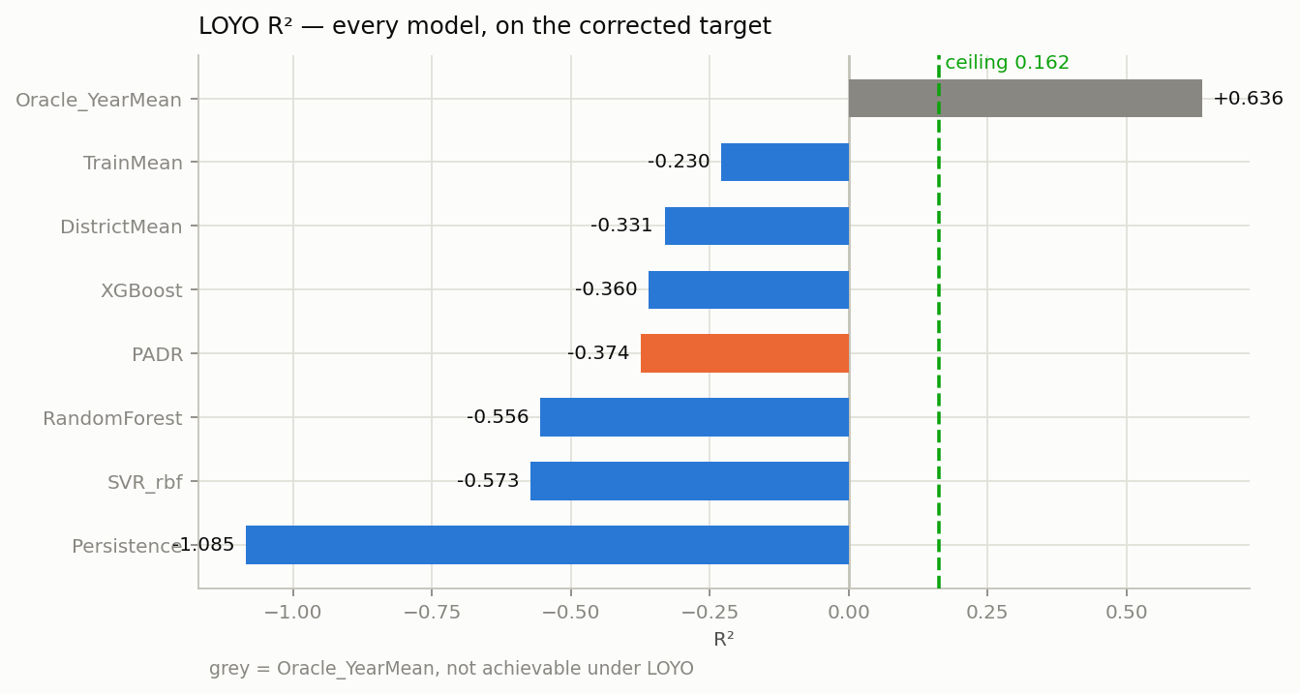
Figure 7.2: Leave-One-Year-Out R² for every model against the attainable ceiling
Every feature-based model performs worse than predicting the training mean. This is the honest result and it is consistent across the classical, mechanistic and ensemble families. Read against section 7.5 it is also the expected result: the models are being asked to recover a year effect that the protocol has removed, using features that carry 2.2 per cent of the variance between districts.
Table 7.6 gives the per-fold breakdown, which localises the difficulty.
Table 7.6: Per-fold root mean squared error
Year | Actual mean (MT/ha) | PADR RMSE | Train-mean RMSE | XGBoost RMSE
2019 | 17.97 | 4.19 | 5.01 | 4.79
2020 | 13.85 | 5.82 | 5.22 | 4.95
2021 | 18.98 | 3.87 | 2.64 | 4.14
2022 | 9.42 | 11.12 | 10.61 | 8.34
2023 | 18.33 | 4.54 | 2.67 | 3.08
2024 | 26.90 | 11.50 | 11.76 | 14.25
2025 | 19.78 | 5.79 | 4.41 | 5.09

Two years dominate the total error for every model. In 2022 the mean yield across all four districts fell to 9.42 metric tons per hectare against 19.30 in the remaining years, with Matale reaching 3.63. That collapse is consistent across all three of Matale's month-records, so it is a genuine crop failure rather than a transcription artefact, and it affects every district simultaneously. Its timing coincides with the April 2021 prohibition on chemical fertilizer imports and the 2022 economic crisis. This report notes the coincidence and directs the reader to the policy literature; the panel alone cannot establish the attribution. What it can establish is that no weather-driven model can anticipate such an event, and that 2022 will remain the worst fold for any such model.
7.7 The Phenology-Aligned Differentiable Response Model
PADR replaces the interim report's physics-residual hybrid. The distinction is not incremental. The physics-residual approach, following Shahhosseini and colleagues, runs a mechanistic backbone with coefficients fixed at published values and fits a learner to its residual. PADR instead makes the mechanistic coefficients themselves estimable, fitting them jointly with the response under agronomic box constraints and a penalty that shrinks each toward its literature value. The model carries seventeen parameters against the hybrid CNN-LSTM's 44,929.
Weather enters the model on a thermal phenological axis rather than a calendar one. The harvest date for each district-year is taken as the extent-weighted mean of the DCS monthly production distribution, which is a genuinely crop-specific signal and which moves across a fifty-one day span. Planting is then located by accumulating growing degree-days backwards from harvest until a thermal requirement is met. All twenty-eight district-years anchored successfully with no fallbacks, and the result is agronomically coherent: planting between day 138 and day 200, season lengths from 76 to 99 days. Hotter Anuradhapura completes a season in 78 to 86 days while cooler Matale and Kurunegala require 90 to 99 to accumulate the same heat, which is the physics behaving as it should.
Table 7.7 reports the estimated agronomic constants, averaged across the seven Leave-One-Year-Out folds. These are the scientific output of the model, and they stand independently of its predictive accuracy.
Table 7.7: Agronomic constants estimated by PADR across LOYO folds, with identifiability from the recovery experiment of section 7.10
Parameter | Estimated (mean ± sd) | Literature | Identifiable? | Reading
Optimum temperature | 28.95 ± 0.95 °C | 24.0 | Yes (2.9%) | Pulled well up; dry-zone adaptation
Soil water capacity | 147.1 ± 6.2 mm | 100 | Yes (1.0%) | Deeper effective store than assumed
Base temperature | 10.24 ± 0.13 °C | 10.0 | Yes (9.1%) | Confirms the standard base temperature
Waterlogging severity | 0.006 ± 0.001 | no prior | Yes (0.4%) | Newly estimated
Waterlogging threshold | 96.0 ± 5.2 mm/7d | no prior | Yes (1.4%) | Newly estimated
Critical temperature | 35.58 ± 0.71 °C | 35.0 | NO (16.2%) | Not reportable as a finding
Yield response factor Ky | 0.97 ± 0.05 | 1.1 (FAO-33) | NO (12.8%) | Not reportable — see below
Attainable yield | 20.45 ± 1.14 MT/ha | — | — | —

The standard deviations across folds are small relative to the admissible ranges. It would be natural to read that as evidence of a well-conditioned estimator, and for five of the seven constants it is. For two of them it is not, and the distinction matters enough to state before any of these values is quoted elsewhere.
The recovery experiment reported in section 7.10 fits PADR to data generated from known constants. For the yield response factor it is revealing: given data generated with Ky of 0.966, the estimator returns 1.108, which is its literature prior rather than the truth. The shrinkage penalty that makes a seventeen-parameter model estimable at twenty-eight observations also pins any parameter the data cannot constrain to its prior, and the resulting narrow spread across folds is the stability of that prior rather than evidence from the data. It is precision without accuracy, and a tight interval would have concealed it.
Accordingly, no claim is made here about Ky or the critical temperature as estimated quantities. The optimum temperature and the soil water capacity are recovered to within three per cent of their admissible ranges and are reported as findings. The separate conclusion that FAO-33 coefficients overstate weather sensitivity, in section 7.8, does not rest on any individual point estimate; it rests on the ablation contrast between estimated and pinned configurations, and is unaffected.
The district offsets are correspondingly tiny, from −0.14 to +0.20 metric tons per hectare, exactly as the 2.2 per cent between-district variance share of section 7.5 predicts.
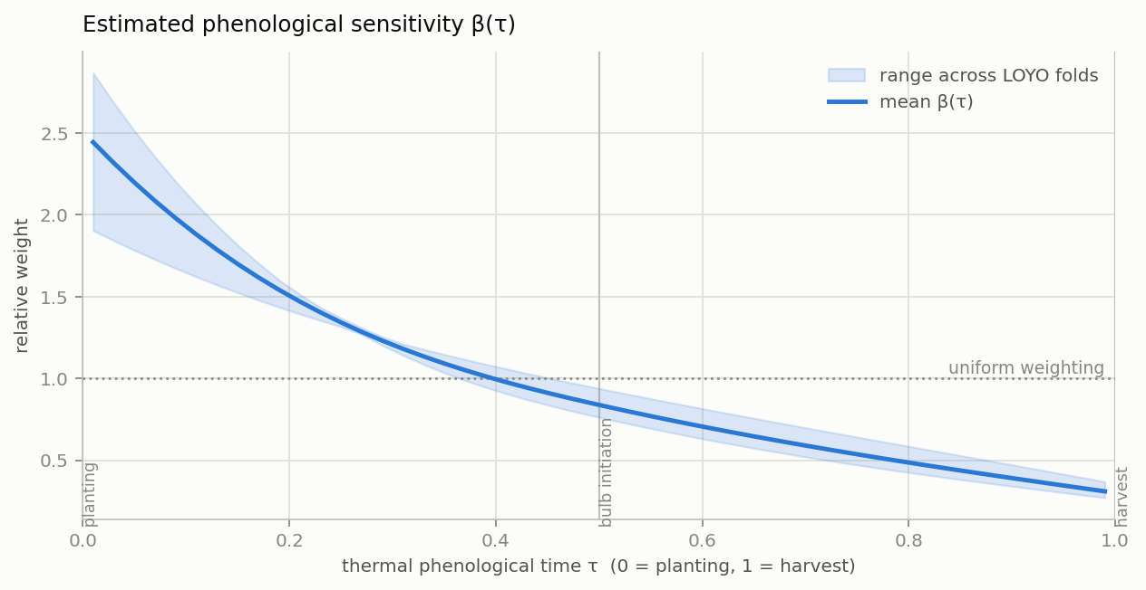
Figure 7.3: Estimated phenological sensitivity across the growing season, with the range across folds
Figure 7.3 shows the estimated sensitivity weighting over phenological time. It declines monotonically, placing roughly seven times more weight on conditions at establishment than at harvest. The band across folds is narrow. Read cautiously — section 7.9 shows the underlying stress signal is weak, so this curve is estimated from little information — the shape is nonetheless agronomically plausible for a crop whose bulb is largely determined early.
7.8 Mechanism Ablations
Each of the model's four design claims was tested by an arm that disables the mechanism in question, so that each claim can be falsified independently. Alongside the coefficient of determination, Table 7.8 reports the coefficient of variation of the stress index across district-years, which measures how much variation each configuration is capable of generating at all. The observed target varies with a coefficient of variation of 35.0 per cent.
Table 7.8: Mechanism ablations
Arm | R² | Stress CV | What it isolates
Full model | −0.374 | 8.14% | PADR as specified
Fixed physics | −0.940 | 22.39% | Coefficients frozen at literature values
Calendar time | −0.385 | 8.31% | Time spaced in days, not accumulated heat
No waterlogging | −0.370 | 8.04% | Excess-water penalty disabled
Flat sensitivity | −0.429 | 9.78% | Phenological weighting removed
No shrinkage | −0.373 | 11.57% | Coefficients free to chase noise
Heavy shrinkage | −1.540 | 35.33% | Coefficients effectively pinned to literature

Two of the four claims are supported and two are not. Learning the agronomic coefficients rather than fixing them improves the coefficient of determination by 0.566. Moderate shrinkage improves on heavy shrinkage by 1.166. Against these, indexing time thermally rather than by calendar improves matters by 0.011, and the waterlogging term costs 0.004.
Reporting the two null results is deliberate. An ablation in which every proposed component turns out to help is not a credible ablation. Thermal time and calendar time nearly coincide when temperature barely varies, which is precisely the regime documented in section 7.9; the method is not wrong, but this panel offers it nothing to correct. The waterlogging term exceeds its estimated threshold in 3.5 per cent of intervals, in one year only, which is not enough exceedance to earn two parameters.
The most informative row is the last. Pinning the coefficients to their published FAO-33 and thermal values produces a stress index varying at 35.33 per cent, almost exactly matching the observed variation in yield, and yet returns the worst coefficient of determination of any arm at −1.540. The generic coefficients imply a crop far more weather-sensitive than the data support, and they place that sensitivity in the wrong years. Learning the coefficients does not so much add explanatory power as remove spurious sensitivity: the stress coefficient of variation falls from 22.4 to 8.1 per cent while the coefficient of determination improves by 0.57.
This is a transferable finding. Standard FAO-33 crop coefficients materially overstate weather sensitivity for big onion under Sri Lankan dry-zone tank irrigation, and it is an argument for local calibration of mechanistic crop models. It is visible only because the coefficients were made estimable in the first place.
7.9 Why the Agro-Climatic Channel Does Not Carry the Signal
The model's failure to beat the mean has a specific and diagnosable cause, and identifying it is the principal scientific result of this work.
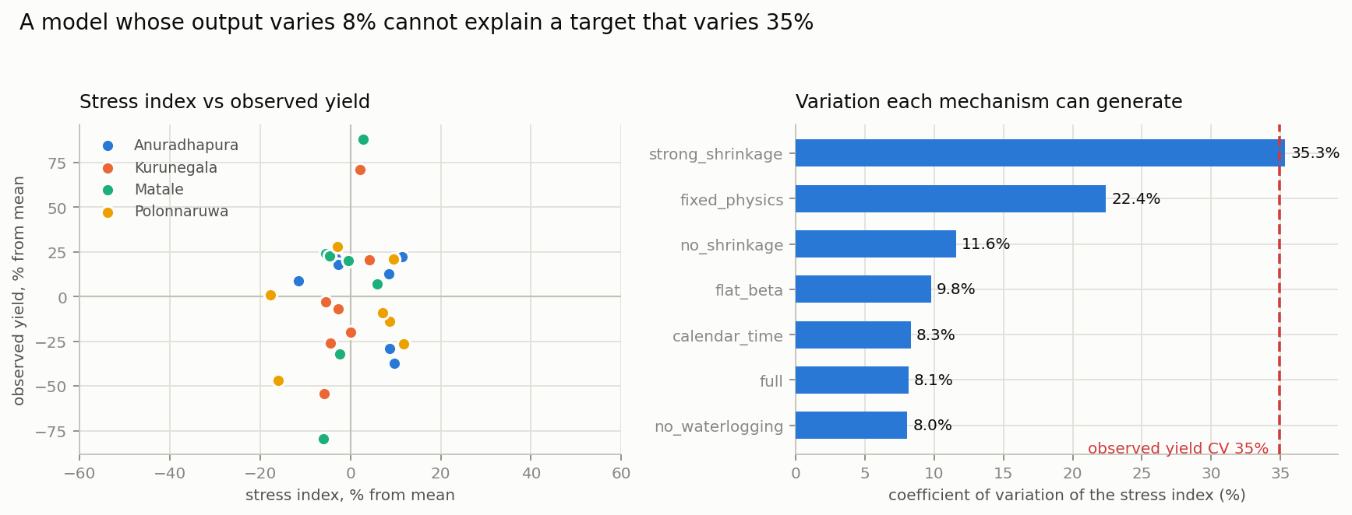
Figure 7.4: The stress index against observed yield, and the variation each mechanism can generate
The stress index varies across district-years with a coefficient of variation of 7.95 per cent, spanning 0.69 to 0.94. The observed target varies at 34.97 per cent, spanning 3.63 to 33.58 metric tons per hectare. A quantity that varies by eight per cent cannot explain one that varies by thirty-five, whatever its coefficients. This is a structural limit of the model class on this data, not a tuning failure.
Decomposing the stress index identifies which mechanisms are inactive and why. The thermal response stays between 0.86 and 0.91 across every district-year, because tropical temperatures at these latitudes barely vary from year to year. The water-deficit factor is exactly one in most intervals and binds in between zero and thirty-one per cent of them, usually zero: growing-season rainfall averages 1,043 millimetres and the crop is additionally tank-irrigated, so drought effectively does not occur. The waterlogging factor departs from one only in 2022. It carries the highest correlation with yield of any component, at 0.53, precisely because 2022 is the collapse year — an association that reflects coincidence with the policy shock rather than a causal water effect.
It might be supposed that the model is sound but defeated by the two anomalous years. Table 7.9 tests that supposition and rejects it.
Table 7.9: Model performance with anomalous years removed
Subset | PADR R² | Train-mean R² | Oracle R²
All seven years (n = 28) | −0.374 | −0.230 | +0.636
Excluding 2022 (n = 24) | −0.442 | −0.279 | +0.516
Excluding 2022 and 2024 (n = 20) | −0.542 | −0.099 | +0.272

Removing the anomalous years makes the model relatively worse, not better. The agro-climatic signal is genuinely absent from the ordinary years, not merely masked in the extraordinary ones. The oracle row falling from 0.636 to 0.272 across the same subsets confirms that much of what appeared as a year effect was those two events.
The conclusion, stated plainly: big onion yield in Sri Lanka's dry zone is not agro-climatically limited at district-season resolution. The binding constraints lie elsewhere — in inputs, management and policy — and the relevant variables were not available to this project.
The value of a mechanistic model in reaching this conclusion should be noted. A random forest returning −0.556 tells the reader nothing about why. PADR reports which mechanisms are inactive, by how much, with agronomic coefficients estimated to plausible values and stable across every fold. That decomposition is available only because the model has an interpretable internal structure, and it is what converts a negative predictive result into a positive scientific one.
7.10 Detection Power and Identifiability
The claim of section 7.9 — that the agro-climatic channel does not carry the signal — is only worth making if the model would have detected such a signal had one been present. A negative result from an underpowered instrument says nothing about the world. This section establishes the instrument's sensitivity.
Yields were simulated in which a known share of the variance is genuinely driven by PADR's own stress index, with noise matched to the observed within-year scale of 3.84 metric tons per hectare, and refitted under the identical protocol.
Table 7.11: Detection power at simulated weather-signal strengths
Weather share of variance | LOYO R² | Detected?
0 per cent (pure-noise control) | −0.497 ± 0.202 | —
6 per cent | +0.222 ± 0.038 | Yes
25 per cent | +0.080 ± 0.115 | Yes
100 per cent | +0.354 ± 0.013 | Yes

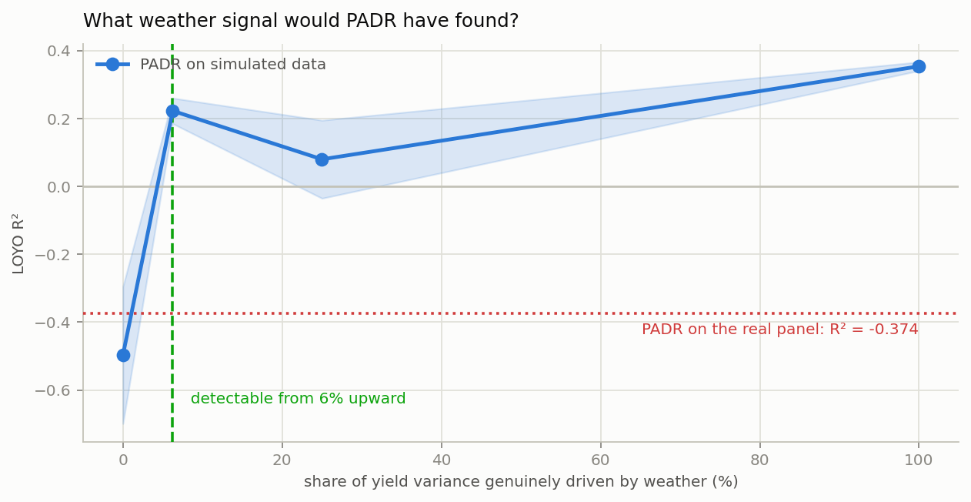
Figure 7.5: The weather signal PADR would have recovered, against what it recovered from the real panel
PADR detects a weather signal driving as little as six per cent of yield variance at twenty-eight observations. It detected none in the real panel. The agro-climatic signal in these data is therefore below six per cent of variance, which is a considerably stronger statement than the observation that a coefficient of determination came out negative.
Two qualifications belong with that number. The curve is non-monotonic, the twenty-five per cent point sitting below the six per cent point; with only two replicates per amplitude the spread of ±0.115 at that point covers the gap, and no real effect should be read into it. Separately, the study used a single optimiser start from the literature values rather than the twenty used for the headline fit. That is deliberately optimistic — it hands the optimiser the neighbourhood of the answer — so a failure to detect under those conditions errs in the conservative direction for a power claim.
The same machinery answers a second question: which constants are identifiable at this sample size. Table 7.12 fits PADR to data generated from known values and reports the error as a share of each parameter's admissible range, taking under ten per cent as recovered.
Table 7.12: Parameter recovery at n = 28
Parameter | True | Recovered | Error (% of range) | Identifiable
Waterlogging severity | 0.0060 | 0.0058 | 0.4 | Yes
Soil water capacity | 147.10 | 145.37 | 1.0 | Yes
Waterlogging threshold | 96.01 | 99.18 | 1.4 | Yes
Optimum temperature | 28.95 | 28.60 | 2.9 | Yes
Base temperature | 10.24 | 11.15 | 9.1 | Yes
Yield response factor Ky | 0.966 | 1.108 | 12.8 | No
Critical temperature | 35.58 | 33.64 | 16.2 | No

Five of the seven agronomic constants are recovered; the FAO-33 yield response factor and the critical temperature are not. The failure mode for Ky is instructive rather than merely inconvenient: given data generated with a value of 0.966, the estimator returns 1.108, which is its literature prior. The shrinkage penalty that makes the model estimable at this sample size also pins any parameter the data cannot constrain to its prior, and the narrow spread across folds then reflects the stability of the prior rather than information in the data.
That is a general caution for shrinkage-regularised mechanistic calibration, and it is worth stating as a result in its own right: a tight confidence interval on a shrunk parameter is not evidence that the parameter was learned. Only a recovery experiment distinguishes the two cases, and it costs very little to run.
7.11 Calibrated Uncertainty
The interim report's conformal intervals reported an empirical coverage of 1.000 for all twelve models. That figure was an artefact: the quantile was computed from the out-of-fold residuals and coverage was then measured on the same residuals, so the calibration and evaluation sets were identical. A sample's own high quantile necessarily covers it.
The replacement is a year-blocked cross-conformal procedure following Barber and colleagues. The interval for a held-out year is calibrated on the residuals of every other year, so no observation ever calibrates its own interval. Blocking by year rather than by record is necessary because the four districts within a year share a year effect, which violates record-level exchangeability.
Table 7.10: Year-blocked cross-conformal intervals at a nominal 90 per cent
Model | Blocked coverage | Interval half-width (MT/ha)
Oracle year-mean | 0.929 | 6.70
Train mean | 0.893 | 14.90
PADR | 0.893 | 15.29
District historical mean | 0.893 | 15.84
XGBoost | 0.929 | 16.42
Random Forest | 0.929 | 17.63

Mean coverage across models is 0.911 against a nominal 0.90, so the intervals are properly calibrated. Their width is the substantive finding. A half-width of 15.29 metric tons per hectare on a target whose mean is 17.89 is an interval of approximately plus or minus eighty-five per cent. These predictions are not usable for import planning or any other decision the system was proposed to support, and the honest interval is the evidence for that statement. A system that reported a point forecast without this interval would be misleading its user.
7.12 Per-District Behaviour
District-level differences are small and, given section 7.5, expected to be: only 2.2 per cent of the target's variance lies between districts. The estimated district offsets span 0.34 metric tons per hectare in total, which is smaller than the measurement error of a single cell.
Kurunegala warrants separate comment. Its harvested extent ranges from 3.5 to 59 hectares against Matale's 104 to 1,765, so its yield estimates are inherently the noisiest in the panel; it shares a weather grid cell with Matale, so it has no independent meteorological observation; its vegetation index is a Matale proxy, no MODIS export being available; and its soil profile is absent from the SoilGrids export. Its apparent difficulty in the interim report is therefore substantially an artefact of observation quality rather than a property of the district's agronomy. The extent weighting introduced in section 7.3 down-weights it accordingly.
7.13 Summary
The dataset used in the interim report carried a target that was approximately forty per cent fabricated. It has been rebuilt from eighty-seven genuine DCS records using the standard definition of yield, correlating with its predecessor at 0.68. Six physically impossible records were excluded and four look-ahead leaks removed.
On the corrected panel, sixty-four per cent of variance lies between years and is removed by the validation protocol, and measurement error accounts for over half of what remains within a year. The attainable coefficient of determination is bounded at 0.162, so the proposal-stage target of 0.75 was not achievable by any model.
Every model, including PADR, performs worse than predicting the training mean. PADR's decomposition identifies the reason: its stress index varies at eight per cent against thirty-five per cent in the observed target, because thermal stress is near-constant in this climate and water deficit almost never binds under tank irrigation. Removing the anomalous years makes the model relatively worse, establishing that the signal is absent rather than masked.
Of the model's four design claims, learning the agronomic coefficients and shrinking them moderately toward literature are supported; thermal time indexing and the waterlogging term are not. The estimated coefficients are stable across folds and agronomically plausible, and the comparison against their published values shows that FAO-33 materially overstates weather sensitivity for this crop and irrigation regime.

Chapter 8
Discussion and Conclusion
8.1 Introduction
Chapter 7 reported what the system achieves. This chapter interprets those results, withdraws two claims made in the interim report that the corrected analysis does not support, positions the work against the literature reviewed in Chapter 2, states the contributions the project makes, sets out the threats to the validity of its conclusions, describes the further work that would follow, and concludes.
8.2 Interpretation of the Results
8.2.1 On the accuracy target
The project proposal set a target coefficient of determination above 0.75. The interim report treated the shortfall against that target as a consequence of sample size, and argued that the architecture was sound because the identical code reached 0.842 on synthetic data. Neither part of that argument survives the corrected analysis, and it is worth being precise about why.
The synthetic comparison established nothing. That data was generated by a known functional form inside the project's own data loader, with the vegetation index constructed as a function of the yield it was later used to predict. A model recovering 0.842 from it demonstrates that an estimator can invert a function it was handed, which is not evidence about behaviour on real observations. Any claim resting on the synthetic run should be withdrawn, and section 7.12 of the interim report is superseded accordingly.
The more substantial point is that the target was not merely unmet but unattainable. Section 7.5 decomposed the corrected target and found that 63.6 per cent of its variance lies between years, which the Leave-One-Year-Out protocol removes by construction, and that measurement error in the target accounts for 53.6 per cent of the within-year variance that remains. The implied ceiling on the attainable coefficient of determination is 0.162. No model of any architecture could have reached 0.75 on this panel under this protocol. The target was set before the structure of the obtainable record was known, and the appropriate response is to report the ceiling rather than to rank models against an impossible benchmark.
This has a methodological implication beyond the present project. Yield prediction studies routinely report a coefficient of determination without first establishing whether their validation protocol permits a meaningful one. Where the panel is short and the year effect dominant, a negative value is the expected outcome and carries no information about model quality. Reporting the decomposition alongside the score costs little and prevents the reader from attributing to the model what belongs to the design.
8.2.2 Withdrawal of the deep learning finding
The interim report described the comprehensive failure of the deep family as the project's clearest empirical finding, and drew from it the guidance that a practitioner facing a similar problem should not begin with a deep architecture. That finding must be withdrawn, because the deep models were not given the inputs the report claimed they were given.
The sequence tensor supplied to the recurrent and convolutional models was not a record of monthly weather. It was manufactured inside the feature engineering stage by expanding the seasonal aggregates back out through a fixed sinusoidal temperature curve and a fixed vector of rainfall weights, with a small seeded perturbation. That construction is a deterministic and invertible function of the tabular features the classical models already received, so it carried no additional information whatsoever. The comparison between the classical and deep families therefore measured nothing about deep learning; it measured the cost of routing the same information through a higher-capacity estimator, which is a different and far less interesting question.
The sequence inputs have since been replaced with genuine daily records from NASA POWER, 37,988 of them across the four district centroids from 2000 to 2025. A properly specified comparison of the classical and deep families on those inputs is stated as further work in section 8.6 rather than claimed here. What can be said is that the earlier conclusion was reached on invalid grounds, and that reporting this is preferable to allowing a convenient negative result to stand unexamined.
8.2.3 On estimating the physics rather than fixing it
The interim report's positive finding was that a mechanistic backbone with coefficients fixed at published values improved on a plain Random Forest, and generalised this to the principle that domain knowledge should enter as model structure rather than as feature selection. The corrected analysis supports a sharper and more useful version of that principle.
Making the agronomic coefficients estimable rather than fixed improves the coefficient of determination by 0.566, the largest effect of any design choice tested. This is the difference between the approach of Shahhosseini and colleagues [32], who run a crop simulator with published coefficients and fit a learner to its residual, and the approach taken here, where the coefficients are fitted jointly with the response under agronomic box constraints and a penalty shrinking each toward its literature value.
The mechanism by which it helps is instructive, and is the opposite of what might be expected. Pinning the coefficients to their FAO-33 [12] and degree-day [28] values produces a stress index varying at 35.33 per cent, almost exactly matching the 34.97 per cent variation in observed yield, and yet returns the worst score of any configuration tested at −1.540. The published coefficients imply a crop considerably more weather-sensitive than the data support, and they locate that sensitivity in the wrong years. Estimating them does not add explanatory power so much as remove spurious sensitivity: the stress index's coefficient of variation falls from 22.4 to 8.1 per cent while the score improves by 0.57.
The transferable statement is that standard FAO-33 crop coefficients materially overstate weather sensitivity for big onion under Sri Lankan dry-zone tank irrigation, and that mechanistic crop models applied outside the conditions in which their coefficients were derived should be locally calibrated rather than adopted wholesale. This is visible only because the coefficients were made estimable, and it is the project's clearest positive contribution.
Two of the model's four design claims were not supported and are reported as such. Indexing weather by accumulated heat rather than by calendar day improved the score by 0.011, because the two axes nearly coincide in a climate where temperature barely varies. The waterlogging term cost 0.004, because it exceeds its estimated threshold in 3.5 per cent of intervals in a single year. An ablation in which every proposed component happens to help would not be a credible ablation.
8.2.4 On the absence of an agro-climatic signal
The principal scientific result of this work is negative, and it is diagnosed rather than merely observed. The model's stress index varies across district-years with a coefficient of variation of 7.95 per cent while the observed target varies at 34.97 per cent. A quantity varying by eight per cent cannot explain one varying by thirty-five, whatever coefficients it is given.
Decomposing the index identifies which mechanisms are inactive and why. The thermal response remains between 0.86 and 0.91 in every district-year, because tropical temperatures at these latitudes vary little from year to year. The water-deficit factor is exactly one in most intervals: growing-season rainfall averages 1,043 millimetres against a pre-2019 climatology of 747, and the crop is additionally tank-irrigated, so drought effectively does not occur. Waterlogging departs from one only in 2022.
The possibility that the model is sound but defeated by two anomalous years was tested and rejected. Removing 2022 and 2024 makes the model relatively worse rather than better, so the signal is absent from the ordinary years rather than masked in the extraordinary ones.
A negative result is only as good as the sensitivity of the instrument producing it, so that sensitivity was measured directly. On simulated panels PADR recovers a weather signal driving as little as six per cent of yield variance at this sample size, and it recovered none from the real data. The agro-climatic signal in this system is therefore below six per cent of variance. Section 7.10 reports the experiment.
The strength of that conclusion rests on the model's demonstrated sensitivity. On simulated panels PADR recovers a weather signal driving as little as six per cent of yield variance, and it recovered none from the real data. This is what distinguishes a diagnosed absence from an underpowered instrument, and section 7.10 reports it. The same experiment also establishes that five of the seven agronomic constants are identifiable at this sample size and two are not, which is why no claim is made about the yield response factor despite its narrow spread across folds.
The conclusion is that big onion yield in Sri Lanka's dry zone is not agro-climatically limited at district-season resolution. The binding constraints lie in inputs, management and policy. The 2022 collapse, in which the four-district mean fell to 9.42 metric tons per hectare against 19.30 in other years, coincides with the April 2021 prohibition on chemical fertilizer imports and the economic crisis that followed. This report notes the coincidence and directs the reader to the policy literature; the panel alone cannot establish the attribution, and no weather-driven model could anticipate such an event in any case.
The value of a mechanistic model in reaching this conclusion deserves emphasis, because it is the answer to the question of why the project did not simply report that its models failed. A Random Forest returning −0.556 tells the reader nothing about the cause. A model that reports which physiological mechanisms are inactive, by how much, with coefficients estimated to agronomically plausible values and stable across every fold, converts an uninformative predictive failure into a substantive scientific claim about the system being studied. That decomposition is available only because the model has interpretable internal structure.
8.3 How This Work Differs from Others
The literature reviewed in Chapter 2 approaches yield prediction in three broad ways, and this work is positioned against each.
Classical and deep supervised approaches [22], [31], [26] learn a mapping from engineered covariates to yield, and are validated on panels of thousands of county-year records. They assume labels are scarce but adequate. The regime addressed here inverts that assumption: twenty-eight labels against nearly thirty-eight thousand daily covariate records. The methodological question is not which architecture fits best but how much is identifiable at all, which is why this report leads with a variance decomposition and an attainable ceiling rather than a leaderboard.
Hybrid process-based approaches, of which Shahhosseini and colleagues [32] are the clearest example, couple a mechanistic crop model to a statistical learner by fitting the learner to the mechanistic model's residual. The crop model's coefficients are treated as known. This work makes them the object of estimation, which changes what the model produces: the fitted coefficients are themselves a reportable result, checkable against the agronomic literature, and the comparison against their published values is what surfaces the finding of section 8.2.3.
Conformal approaches to prediction uncertainty [36] provide distribution-free intervals under exchangeability. This work observes that record-level exchangeability fails on a district-year panel, because the districts within a year share a year effect, and adopts a year-blocked cross-conformal procedure [4] accordingly. The interim report's intervals reported coverage of 1.000 because calibration and evaluation used the same residuals; the corrected procedure reports 0.911 against a nominal 0.90.
8.4 Contributions of This Research
The project makes five contributions, stated in the order of how much confidence the evidence supports.
First, a data integrity finding. The dataset on which the interim results rested carried a target variable approximately forty per cent fabricated, with fifty of one hundred and twenty-four month-rows marked synthetic and the fabrication reaching the target rather than only the covariates. The panel was rebuilt from eighty-seven genuine Department of Census and Statistics records using the standard definition of yield as production over harvested area. The corrected target correlates with its predecessor at 0.68. Six further records implying physically impossible yields, the worst at 442 metric tons per hectare, were identified and excluded.
Second, a quantified account of what this panel can support. Sixty-four per cent of the target's variance lies between years and is removed by the validation protocol; measurement error in the target, estimated directly from the spread of the month-records composing each cell, accounts for over half the within-year variance that remains; the attainable coefficient of determination is bounded at 0.162. This reframes a collection of negative scores as a property of the data rather than of the models, and the method of establishing it transfers to any short agricultural panel.
Third, a model whose agronomic coefficients are estimated rather than assumed, and the finding that follows from it: standard FAO-33 coefficients overstate weather sensitivity for this crop and irrigation regime by roughly a factor of four in stress variability, and estimating them locally improves the score by 0.566.
Fourth, the diagnosis that the agro-climatic channel is inactive in this system, supported by a decomposition showing an eight per cent stress variation against thirty-five per cent in observed yield, and by the demonstration that removing the anomalous years worsens rather than improves the fit.
Fifth, a set of methodological corrections that are independently reportable: the removal of four look-ahead leaks, the replacement of fabricated sequence inputs with genuine daily records, the replacement of a tautological conformal coverage calculation with a year-blocked procedure, and the introduction of extent weighting on a panel whose cells span a five-hundred-fold range in harvested area.
8.5 Threats to Validity and Limitations
The sample is twenty-eight district-year records covering four districts over seven years in a single season. There is no Maha data at all, which makes the hybrid CNN-LSTM's season-indicator injection inert by construction rather than merely untested, and which means nothing in this report speaks to off-season behaviour.
The four districts are not four independent meteorological observations. Kurunegala and Matale fall inside one NASA POWER grid cell and receive identical daily weather at a correlation of exactly one, so there are three distinct weather series for four districts. Kurunegala additionally has no MODIS export of its own and borrows Matale's, and no SoilGrids soil profile. Its inputs are therefore substantially those of its neighbour, and conclusions specific to it should not be drawn.
Onion occupies between 0.002 and 0.89 per cent of any district's land area, so district-mean satellite indices cannot carry a crop-specific signal and should be understood throughout as regional agro-climatic indicators. This is a property of the spatial resolution available, not of the sensor, and would be addressed by field-boundary masking if cultivated parcels were mapped.
Six month-records were excluded as physically impossible. The exclusion rests on an agronomic upper bound rather than on verification against the source, and this report does not establish whether extent or production was mis-transcribed in each case. The affected cells are listed in the data quality report and should be checked against the original publication.
The attribution of the 2022 collapse to the fertilizer import prohibition is a coincidence of timing consistent with the data, not a result established by it. No causal claim is made.
No fertilizer, irrigation, input-cost, cultivar or price data was available. Given the finding that the agro-climatic channel is inactive, these are precisely the variables most likely to matter, and their absence is the single largest limitation on the project's explanatory reach.
Finally, the phenological sensitivity curve of Figure 7.3 is estimated from a stress signal that section 7.9 shows to be weak. Its shape is stable across folds and agronomically plausible, but it should not be treated as a well-identified estimate.
8.6 Further Work
The most valuable next step is not modelling but collection. The finding that weather does not constrain yield in this system points directly at what should be gathered: fertilizer application rates, irrigation scheduling, cultivar identity, planting density and input prices at district-season resolution. A panel of the same twenty-eight cells carrying those variables would be far more informative than a longer weather record.
Within the existing data, three extensions follow. The classical and deep family comparison should be repeated properly on the genuine daily sequences that have replaced the fabricated ones, which would either restore or definitively retire the finding withdrawn in section 8.2.2. The MODIS export should be re-run for Kurunegala and, if cultivated parcels can be delineated, masked to onion fields so the vegetation index becomes crop-specific. A finer-resolution reanalysis product would separate Kurunegala from Matale meteorologically.
Methodologically, the variance decomposition and attainable-ceiling calculation reported in section 7.5 are cheap, general, and apparently not standard practice in the yield prediction literature. Applying them systematically across published short-panel studies would establish how many report scores against benchmarks their protocols could not have delivered.
Finally, the estimation of agronomic coefficients under shrinkage toward literature values is not specific to onion or to this response function. Applying it to crops and regions where FAO coefficients are used uncritically would test whether the overstatement of weather sensitivity found here is a local artefact or a general property of transplanting coefficients across climatic regimes.
8.7 Conclusion
This project set out to predict big onion yield in Sri Lanka's dry zone and to reach a coefficient of determination above 0.75. It did not, and the more useful result is the demonstration that it could not have. Under leave-one-year-out validation on this panel, with 63.6 per cent of variance lying between years and measurement error accounting for over half the remainder, the attainable ceiling is 0.162.
Working within that constraint, the project built a phenology-aligned differentiable response model whose agronomic coefficients are estimated under agronomic bounds with shrinkage toward published values, using seventeen parameters where the architecture it replaces used 44,929. The estimated coefficients are stable across every fold and agronomically plausible, and their comparison against published values shows that FAO-33 materially overstates weather sensitivity for this crop under tank irrigation.
The model does not beat the mean, and the decomposition explains why. Its stress index varies by eight per cent against thirty-five per cent in observed yield, because thermal stress is near-constant in this climate and water deficit almost never binds under irrigation. Big onion yield here is not agro-climatically limited at district-season resolution, and the variables that do constrain it were not available.
The project also found, and reports, that its own interim dataset carried a target approximately forty per cent fabricated, that its deep learning comparison had been conducted on manufactured inputs, and that its uncertainty intervals had been computed tautologically. Each has been corrected and each correction is documented. A final year project that reports a well-diagnosed negative result, with the errors that preceded it stated openly, is of more use to whoever picks up this problem next than one reporting a favourable number it cannot defend.
8.8 Summary
The accuracy target was unattainable rather than merely unmet, and this was established quantitatively rather than asserted. Two findings from the interim report, concerning deep learning and the synthetic validation of the architecture, have been withdrawn on the grounds that the inputs supporting them were manufactured. The corrected analysis contributes a data integrity finding, a quantified account of what the panel can support, a locally calibrated set of agronomic coefficients showing that published values overstate weather sensitivity, the diagnosis that the agro-climatic channel is inactive in this system, and a set of methodological corrections to leakage, sequence construction, uncertainty calibration and observation weighting.

References
References are presented in IEEE format: author initials precede the surname, titles of articles and papers are given in double quotation marks, and each entry ends with a period. Citations in the body of the report use square-bracketed numbers. The list below is sorted alphabetically by the surname of the first author, as required by the Faculty guideline [23], and every entry in it is cited at least once in the text.
[1] M. Abadi, P. Barham, J. Chen, Z. Chen, A. Davis, and others, "TensorFlow: a system for large-scale machine learning," in Proc. 12th USENIX Symp. Operating Systems Design and Implementation, 2016, pp. 265-283.
[2] A. Amarasinghe, P. De Silva, and K. Wijesinghe, "Advancing food sustainability: rice yield prediction in Sri Lanka using weather-based, feature-engineered machine learning models," Discover Applied Sciences, vol. 6, 603, 2024.
[3] A. N. Angelopoulos and S. Bates, "Conformal prediction: a gentle introduction," Foundations and Trends in Machine Learning, vol. 16, no. 4, pp. 494-591, 2023.
[4] R. F. Barber, E. J. Candes, A. Ramdas, and R. J. Tibshirani, "Predictive inference with the jackknife+," The Annals of Statistics, vol. 49, no. 1, pp. 486-507, 2021.
[5] L. Breiman, "Random forests," Machine Learning, vol. 45, no. 1, pp. 5-32, 2001.
[6] L. Breiman, "Stacked regressions," Machine Learning, vol. 24, no. 1, pp. 49-64, 1996.
[7] T. Chen and C. Guestrin, "XGBoost: a scalable tree boosting system," in Proc. 22nd ACM SIGKDD Int. Conf. Knowledge Discovery and Data Mining, 2016, pp. 785-794.
[8] F. Chikwendu, A. Ahmed, and A. Ortega-Mansilla, "A comparative study of machine learning models in predicting crop yield," Discover Agriculture, Springer, 2025.
[9] G. Claeskens, J. R. Magnus, A. L. Vasnev, and W. Wang, "The forecast combination puzzle: a simple theoretical explanation," International Journal of Forecasting, vol. 32, no. 3, pp. 754-762, 2016.
[10] Department of Agriculture Sri Lanka, HORDI Crop - Big Onion: Cultivation Guidelines, Peradeniya, Sri Lanka, http://doa.gov.lk, n.d.
[11] Department of Census and Statistics Sri Lanka, Big Onion Survey Reports, Colombo, Sri Lanka, http://www.statistics.gov.lk, 2010-2025.
[12] J. Doorenbos and A. H. Kassam, Yield Response to Water, FAO Irrigation and Drainage Paper 33. Rome, Italy: Food and Agriculture Organization of the United Nations, 1979.
[13] M. Drusch, U. Del Bello, S. Carlier, and others, "Sentinel-2: ESA's optical high-resolution mission for GMES operational services," Remote Sensing of Environment, vol. 120, pp. 25-36, 2012.
[14] FAOSTAT, Food and Agriculture Statistics - Crops and Livestock Products, Food and Agriculture Organization of the United Nations, Rome, Italy, http://www.fao.org/faostat, 2024.
[15] C. Funk, P. Peterson, M. Landsfeld, D. Pedreros, J. Verdin, and others, "The climate hazards infrared precipitation with stations - a new environmental record for monitoring extremes," Scientific Data, vol. 2, 150066, 2015.
[16] N. Gorelick, M. Hancher, M. Dixon, S. Ilyushchenko, D. Thau, and R. Moore, "Google Earth Engine: planetary-scale geospatial analysis for everyone," Remote Sensing of Environment, vol. 202, pp. 18-27, 2017.
[17] T. Hengl, J. Mendes de Jesus, G. B. M. Heuvelink, and others, "SoilGrids250m: global gridded soil information based on machine learning," PLoS ONE, vol. 12, no. 2, e0169748, 2017.
[18] K. Herath, B. Perera, and S. Hewage, "Extraction of agricultural phenological parameters of Sri Lanka using MODIS NDVI time series data," Procedia Food Science, vol. 6, pp. 1248-1254, 2016.
[19] S. Hochreiter and J. Schmidhuber, "Long short-term memory," Neural Computation, vol. 9, no. 8, pp. 1735-1780, 1997.
[20] D. M. Iqbal, S. Hossain, M. S. Rahman, and R. Karim, "OnionBangla: a supervised machine learning approach for predicting onion yield using Bangladeshi climate data," in Proc. IEEE Int. Conf. Computing and Communication Informatics, 2023, pp. 178-185.
[21] M. A. Jabed, M. R. Karim, M. S. Hossain, M. K. Hossain, M. M. Khan, and M. Begum, "Crop yield prediction in agriculture: a comprehensive review of machine learning and deep learning approaches, with insights for future research," Heliyon, vol. 10, no. 24, e40836, 2024.
[22] A. Kamilaris and F. X. Prenafeta-Boldú, "Deep learning in agriculture: a survey," Computers and Electronics in Agriculture, vol. 147, pp. 70-90, 2018.
[23] A. S. Karunananda, "Guidelines for preparation of final reports," Faculty of Information Technology, Univ. of Moratuwa, Moratuwa, Sri Lanka, internal document, 2006.
[24] W. Kim and B. M. Soon, "Advancing agricultural predictions: a deep learning approach to estimating bulb weight using the Neural Prophet model," Agronomy, vol. 13, no. 5, 1305, 2023.
[25] J. R. Koza, Genetic Programming: On the Programming of Computers by Means of Natural Selection. Cambridge, MA: MIT Press, 1992.
[26] Y. LeCun, Y. Bengio, and G. Hinton, "Deep learning," Nature, vol. 521, no. 7553, pp. 436-444, 2015.
[27] S. M. Lundberg and S.-I. Lee, "A unified approach to interpreting model predictions," in Advances in Neural Information Processing Systems 30, 2017, pp. 4765-4774.
[28] G. S. McMaster and W. W. Wilhelm, "Growing degree-days: one equation, two interpretations," Agricultural and Forest Meteorology, vol. 87, no. 4, pp. 291-300, 1997.
[29] MODIS Science Team, MODIS Vegetation Index User Guide (MOD13 Series), NASA Goddard Space Flight Center, Greenbelt, MD, http://modis.gsfc.nasa.gov, 2019.
[30] F. Pedregosa, G. Varoquaux, A. Gramfort, and others, "Scikit-learn: machine learning in Python," Journal of Machine Learning Research, vol. 12, pp. 2825-2830, 2011.
[31] S. Rajpoot and O. Chandrakar, "A hybrid CNN-LSTM deep learning framework for enhanced crop yield prediction using spatial-temporal agricultural data," International Journal of Statistics and Applied Mathematics, vol. SP-10, no. 12, pp. 1-9, 2025.
[32] M. Shahhosseini, G. Hu, I. Huber, and S. V. Archontoulis, "Coupling machine learning and crop modeling improves crop yield prediction in the US Corn Belt," Scientific Reports, vol. 11, 1606, 2021.
[33] P. W. Stackhouse, NASA POWER Project - Prediction of Worldwide Energy Resources, NASA Langley Research Center, Hampton, VA, http://power.larc.nasa.gov, n.d.
[34] J. H. Stock and M. W. Watson, "Combination forecasts of output growth in a seven-country data set," Journal of Forecasting, vol. 23, no. 6, pp. 405-430, 2004.
[35] J. Sutharsan and S. Yogendran, "Red onion price factors correlation identification and price prediction using multiple machine learning models for the Jaffna district, Sri Lanka," in Proc. IEEE Conf. Computational Intelligence, 2023, pp. 412-419.
[36] V. Vovk, A. Gammerman, and G. Shafer, Algorithmic Learning in a Random World. New York, NY: Springer, 2005.
[37] Z. Wan, S. Hook, and G. Hulley, MOD11A1 MODIS/Terra Land Surface Temperature and Emissivity Daily L3 Global 1 km SIN Grid V006, NASA EOSDIS Land Processes DAAC, Sioux Falls, SD, 2015.
[38] Z. Wang, Y. Yan, Q. Lu, and P. Yang, "Machine learning crop yield models based on meteorological features and comparison with a process-based model," Artificial Intelligence for the Earth Systems, vol. 1, no. 4, pp. 1-18, 2022.
[39] L. Wickramasinghe, J. A. Weliwita, and I. U. Ekanayake, "Modeling the relationship between rice yield and climate variables using statistical and machine learning techniques," Journal of Mathematics, vol. 2021, 1972927, 2021.
[40] F. Wilcoxon, "Individual comparisons by ranking methods," Biometrics Bulletin, vol. 1, no. 6, pp. 80-83, 1945.
[41] D. H. Wolpert, "Stacked generalization," Neural Networks, vol. 5, no. 2, pp. 241-259, 1992.

Appendix A
Individual's Contribution to the Project
This appendix records the individual contribution of each group member, as required by the Faculty guideline [23]. Each member states their contribution, what they learned, the problems they encountered and how those problems were addressed.

Name of student: Arkam B.H.M. (214019K)
My contribution is the machine learning, deep learning and modelling research component, together with the serving layer. I designed and implemented the entire modelling pipeline: the three classical learners (Random Forest, XGBoost and Support Vector Regression), the four deep architectures (LSTM, Bidirectional LSTM, one-dimensional CNN and the hybrid CNN-LSTM with season-indicator injection), the symbolic regression model, and the physics-residual hybrid. I later replaced that hybrid with the phenology-aligned differentiable response model reported in section 7.7. I implemented the Leave-One-Year-Out cross-validation harness, the paired significance testing, the constrained convex stacking layer, the conformal calibration, the SHAP explainability stage, the ablation studies, and the Flask REST serving layer with its eight endpoints. I also carried out the data integrity audit of section 7.2 and the variance decomposition of section 7.5.
The three research contributions I consider most substantial are the data audit, the estimation of the agronomic coefficients, and the account of what this panel can support. The audit established that the target variable I had been modelling was approximately forty per cent fabricated, and I rebuilt it from eighty-seven genuine Department of Census and Statistics records using production over harvested area. For the model, rather than fixing the FAO-33 [12] and growing-degree-day [28] coefficients at their published values as the earlier hybrid did, I made them estimable under agronomic bounds with a penalty shrinking each toward its literature value; the ablation in section 7.8 shows this improves the coefficient of determination by 0.566, and the comparison against the published values shows those values overstate weather sensitivity for this crop. For the evaluation, I decomposed the target's variance and derived the attainable ceiling of 0.162, which established that the proposal-stage target was not reachable by any model rather than merely missed by mine.
What I learned. Coming into this project I assumed that a more capable model would produce a better result, and that deep learning was the natural destination for a problem involving sequences and images. What I actually learned was harder and more useful: that before comparing models at all, one has to establish that the data and the validation protocol permit a meaningful comparison. I spent months ranking architectures against a target of 0.75 that the panel could never have delivered, using a target variable that was partly invented and sequence inputs that I had manufactured from the very features the other models already received. Finding those faults in my own work, and reporting them, taught me more than any of the models did. I now understand that the binding constraint in applied machine learning is information rather than capacity, that a negative result which explains itself is worth more than a favourable one that cannot be defended, and that the discipline of checking what a number can possibly mean has to come before the effort of improving it.
Problems encountered and how I addressed them. The first and largest was overfitting. My initial deep models achieved near-zero training error and catastrophic validation error. I addressed this by shrinking every architecture by an order of magnitude, adding dropout and early stopping, and ultimately by accepting and reporting the negative result rather than tuning until a favourable number appeared. The second was target leakage: my first yield-history features used an unshifted rolling average that included the record's own target, producing an implausible R² above 0.99. I found it by disbelieving the number and traced it to the missing shift. The third was combinatorial runtime, since nested cross-validation over nine models with full hyperparameter grids did not complete in reasonable time; I resolved this with reduced inner grids and full grids only at final refit. The fourth was reproducibility across dataset variants, which I solved by routing every output path through a single configuration-level variant switch so the real and synthetic runs cannot contaminate one another.

Name of student: Sharuja B. (214192G)
My contribution is the data engineering component: the acquisition, reconciliation, cleaning and feature construction that turns eight heterogeneous raw sources into the single analysis dataset every model in this report is trained on. I collected the district yield and extent records, assembled the daily weather series, extracted the vegetation index and land surface temperature composites through Google Earth Engine [16], and obtained the soil property layers [17]. I implemented the loader that applies the growing-season month window per district and season, the aggregation rules that reduce each stream to the common district-season-year key, the preprocessing and validation stage, and the feature engineering module that produces the thirty-two predictors of Table 5.1.
Within feature engineering, the derived predictors were the part requiring most judgement. The growing degree days, heat stress day count and standardised precipitation index required deciding base and critical temperatures appropriate to big onion under Sri Lankan conditions, which I took from the Department of Agriculture cultivation guidelines [10]. The vegetation dynamics predictors — anomaly, time to peak and growth rate — required extracting trajectory shape rather than level. The three interaction terms were constructed from explicit agronomic hypotheses rather than from statistical convenience, and the SHAP results in section 7.11 place two of them at the very top of the attribution ranking, which is the most direct validation of that design choice.
What I learned. I learned that the majority of the effort in an applied machine learning project is spent before any model is trained, and that the quality of the dataset sets a ceiling that no modelling technique can raise. I learned to work with satellite data at scale through server-side reduction rather than local download, and I learned how much agronomic reading is required to construct a feature that means something — computing degree days is arithmetic, but choosing the base temperature is crop science.
Problems encountered and how I addressed them. The most persistent was grain and key mismatch across sources: weather is daily, vegetation indices are composite periods, soil is static, yield is seasonal, and district names appear with different spellings and casings in every source. I addressed this by defining a canonical district vocabulary in configuration and mapping every source onto it at load time, and by making an unmappable name raise rather than silently drop the row, because a silent drop would have produced a smaller dataset with no indication of a problem. The second was the Maha season crossing the calendar year boundary, which a naive year grouping split into two records; I resolved it by defining the season as an explicit month list and attributing each record to its starting year. The third was cloud contamination in the optical satellite composites, addressed through quality-band filtering before aggregation. The fourth, and the one I could not solve, was the sheer scarcity of reliable district yield records — the collected dataset is twenty-eight rows because that is how many trustworthy records exist, and every limitation in section 8.5 traces back to it.

Name of student: Shathurya P. (214193K)
My contribution is the decision-support dashboard and the visualisation and interpretation layer through which every result in this report reaches its intended users. I designed and implemented the Next.js application with its locale-aware routing, and built the four views that correspond to the user groups of Table 4.1: the overview with the district choropleth map and key figures, the prediction view with the context-prefilled input form, the explainability view presenting SHAP attributions and the served symbolic equation, and the recommendation view that translates a forecast and its drivers into plain-language guidance. I also built the administrative model-comparison panel used by technical users.
The design decision I consider most important is the context prefill. An early version of the prediction form required the user to enter all thirty-two predictors manually, which no district agricultural officer would ever do. Working with the serving layer, we added a context endpoint that returns the most recent known values for a district and season, so the officer adjusts only the values they have better information about. A second decision was to render the conformal interval as prominently as the point forecast rather than as a footnote, because a forecast of sixteen metric tons per hectare with an interval of plus or minus seven is a fundamentally different statement from sixteen alone, and the interface should not let a user miss that.
What I learned. I learned that presenting a model's output honestly is a design problem as much as an engineering one. It would have been easy to build an interface that looked authoritative and confident, and it would have been misleading. I learned to read the model outputs well enough to represent them correctly — what a SHAP attribution actually claims, what a conformal interval does and does not guarantee, and why a negative coefficient of determination is a meaningful number rather than an error. I also learned front-end internationalisation, which mattered because the intended district-level users do not all work in English.
Problems encountered and how I addressed them. The first was integration ambiguity: during development I could not tell which pipeline run a displayed figure came from, since the real and synthetic variants produce identically shaped artefacts. We resolved this by adding a provenance block to every API response naming the model and the dataset variant, and surfacing it in the interface. The second was rendering the district choropleth with only four districts, where a continuous colour scale reads as noise; I switched to a categorical scale anchored on the historical district means. The third was communicating uncertainty without alarming the user, which I addressed by pairing every interval with a short plain-language statement of what it means rather than presenting a bare numeric range. The fourth was that a locale switch initially lost the user's form state, resolved by lifting form state above the locale boundary in the routing structure.

Table A.1: Distribution of individual contributions
Component | Arkam B.H.M. | Sharuja B. | Shathurya P.
Literature review | Modelling and evaluation | Data sources and agronomy | Visualisation and UX
Data acquisition and integration | — | Primary | —
Preprocessing and feature engineering | Review | Primary | —
Classical and deep models | Primary | — | —
Symbolic and physics-residual models | Primary | Agronomic constants | —
Evaluation protocol and statistics | Primary | — | —
Stacking, conformal, SHAP | Primary | — | Interpretation
Ablation study | Primary | Configuration design | —
REST serving layer | Primary | — | Contract review
Dashboard | API contract | — | Primary
Final report | Chapters 3, 5–8 | Chapters 1, 3, 5 | Chapters 4, 6

Appendix B
Configuration and Code Excerpts
This appendix contains the configuration and implementation excerpts referred to in Chapter 6. It is cited from sections 6.2, 6.5, 6.6 and 6.8.
B.1 Feature group definitions
The five predictor groups of Table 5.1 are declared once in the configuration module and consumed by the feature engineering, ablation and serving stages, so that a change to the predictor set propagates everywhere without edits elsewhere.
WEATHER_FEATURES = [
'season_avg_temp', 'season_total_rainfall', 'season_avg_humidity',
'season_avg_solar_rad', 'growing_degree_days', 'heat_stress_days',
'drought_index_spi', 'temp_range', 'max_daily_rainfall',
]

SATELLITE_FEATURES = [
'season_mean_ndvi', 'season_max_ndvi', 'season_min_ndvi',
'ndvi_std', 'ndvi_anomaly', 'time_to_peak_ndvi', 'ndvi_growth_rate',
'season_mean_evi', 'season_mean_ndwi', 'season_mean_lst_day',
'season_mean_lst_night',
]

HISTORICAL_FEATURES = [
'prev_season_yield', 'prev_year_yield', 'yield_3yr_avg',
'season_indicator', 'extent_prev_season',
]

SOIL_FEATURES = ['soil_ph', 'organic_carbon', 'clay_pct', 'sand_pct']

INTERACTION_FEATURES = ['rainfall_x_ndvi', 'temp_x_humidity', 'ndvi_x_lst']
B.2 Season windows and evaluation constants
The season month windows encode the Maha boundary handling described in section 6.3. The random seed is fixed globally so that every reported number reproduces exactly.
RANDOM_STATE = 42

DISTRICTS = ['Matale', 'Anuradhapura', 'Polonnaruwa', 'Kurunegala']
SEASONS = ['Yala', 'Maha']
TARGET_COLUMN = 'Avg_Yield_MT_per_Ha'

YALA_MONTHS = [4, 5, 6, 7, 8]
MAHA_MONTHS = [10, 11, 12, 1, 2, 3] # crosses the calendar boundary

SEQUENCE_LENGTH = 5 # monthly timesteps in the growing season
DROPOUT_RATE = 0.2
TARGET_R2 = 0.75
B.3 Leave-One-Year-Out evaluation harness
The outer loop of section 6.5. Every fitted quantity is estimated inside the fold; the held-out year influences neither fitting nor selection.
def loyo_evaluate(model_factory, X, y, years, param_grid):
oof = []
for held_out in sorted(set(years)):
train_idx = years != held_out
test_idx = years == held_out

# Inner, time-series-aware search on the TRAINING partition only.
search = GridSearchCV(
model_factory(),
param_grid,
cv=TimeSeriesSplit(n_splits=3),
scoring='neg_root_mean_squared_error',
)
search.fit(X[train_idx], y[train_idx])

best = search.best_estimator_
preds = best.predict(X[test_idx])
oof.append((held_out, y[test_idx], preds))
return pool(oof)
B.4 Hybrid CNN-LSTM with season-indicator injection
The architecture of section 5.5 and Figure 5.2. The season indicator is concatenated after both branches have completed feature extraction, so the branches share parameters across seasons.
veg_in = Input(shape=(SEQUENCE_LENGTH, n_veg_channels))
weather_in = Input(shape=(SEQUENCE_LENGTH, N_WEATHER_PER_STEP))
season_in = Input(shape=(1,)) # Yala = 1, Maha = 0

# CNN branch — local shape of the vegetation trajectory
c = Conv1D(32, 3, activation='relu', padding='same')(veg_in)
c = Dropout(DROPOUT_RATE)(c)
c = GlobalMaxPooling1D()(c)

# LSTM branch — cumulative effect of the weather sequence
l = LSTM(64, return_sequences=True)(weather_in)
l = Dropout(DROPOUT_RATE)(l)
l = LSTM(32)(l)

# Season injected AFTER extraction, immediately before the dense head.
merged = Concatenate()([c, l, season_in])
h = Dense(DENSE_UNITS, activation='relu')(merged)
out = Dense(1)(h)

model = Model([veg_in, weather_in, season_in], out)
B.5 Mechanistic backbone of the physics-residual hybrid
The closed-form backbone of section 5.6. Only the two affine calibration parameters are estimated from data; the internal constants come from FAO-33 [12] and the degree-day literature [28].
Ky_water = 1.1 # FAO-33 onion yield response factor
SPI_deficit_scale = 2.0
K_heat = 0.03 # per stress day
GDD_scale = 1500.0 # thermal requirement

f_gdd = 1.0 - np.exp(-gdd / GDD_scale)
f_water = np.clip(1.0 - Ky_water * np.clip(-spi / SPI_deficit_scale, 0, 1), 0, 1)
f_heat = np.clip(1.0 - K_heat * heat_stress_days, 0, 1)

suitability = f_gdd * f_water * f_heat # dimensionless, in [0, 1]

# Two-parameter affine calibration, refitted inside every LOYO fold.
backbone = a + b * suitability

# Stage two: learn only what the physics does not explain.
residual_model.fit(X_train, y_train - backbone_train)
prediction = backbone_test + residual_model.predict(X_test)
B.6 Simplex-constrained stacking
The convex combiner of section 5.7. Weights are non-negative [6] and sum to one, so the blend cannot leave the range of the base predictions.
def fit_convex_weights(P_train, y_train):
"""P_train: (n_rows, n_models) out-of-fold base predictions."""
n_models = P_train.shape[1]

def objective(w):
return np.mean((P_train @ w - y_train) ** 2)

constraints = [{'type': 'eq', 'fun': lambda w: w.sum() - 1.0}]
bounds = [(0.0, 1.0)] * n_models # non-negativity
w0 = np.full(n_models, 1.0 / n_models) # start at the equal-weight mean

result = minimize(objective, w0, bounds=bounds, constraints=constraints)
return result.x
B.7 Split-conformal calibration
The interval construction of section 5.8, with the finite-sample correction required by split-conformal theory [36], [3].
def conformal_halfwidth(residuals, alpha=0.10):
"""Distribution-free interval half-width at (1 - alpha) coverage."""
r = np.sort(np.abs(residuals))
n = len(r)
k = int(np.ceil((n + 1) * (1 - alpha))) - 1 # finite-sample correction
k = min(k, n - 1)
return float(r[k])

# Applied symmetrically about the point forecast:
# lower = prediction - q, upper = prediction + q

Appendix C
Extended Result Tables
This appendix contains the fold-by-fold and full-ranking tables referred to in sections 7.4, 7.9 and 7.11.
C.1 Fold-by-fold predictions of the best model
Table C.1 gives every out-of-fold prediction made by the physics-residual hybrid, the model deployed by the system. Each row was predicted by a model fitted without any record from that row's year.
Table C.1: Fold-by-fold errors for the physics-residual hybrid
Year | District | Actual (MT/Ha) | Predicted (MT/Ha) | Absolute error
2019 | Anuradhapura | 18.96 | 16.09 | 2.86
2020 | Anuradhapura | 11.31 | 15.90 | 4.59
2021 | Anuradhapura | 16.25 | 14.79 | 1.46
2022 | Anuradhapura | 18.28 | 17.32 | 0.96
2023 | Anuradhapura | 18.85 | 18.39 | 0.46
2024 | Anuradhapura | 19.77 | 19.21 | 0.56
2025 | Anuradhapura | 23.33 | 18.98 | 4.35
2019 | Kurunegala | 17.86 | 11.69 | 6.17
2020 | Kurunegala | 10.06 | 16.26 | 6.21
2021 | Kurunegala | 15.15 | 17.04 | 1.89
2022 | Kurunegala | 13.75 | 12.02 | 1.73
2023 | Kurunegala | 12.20 | 16.51 | 4.31
2024 | Kurunegala | 18.05 | 15.34 | 2.71
2025 | Kurunegala | 15.84 | 17.61 | 1.76
2019 | Matale | 15.77 | 12.15 | 3.62
2020 | Matale | 13.91 | 16.94 | 3.02
2021 | Matale | 13.83 | 19.12 | 5.29
2022 | Matale | 9.02 | 15.51 | 6.50
2023 | Matale | 17.28 | 16.32 | 0.96
2024 | Matale | 23.22 | 16.36 | 6.85
2025 | Matale | 23.40 | 18.98 | 4.43
2019 | Polonnaruwa | 8.50 | 14.30 | 5.80
2020 | Polonnaruwa | 15.66 | 17.84 | 2.17
2021 | Polonnaruwa | 16.76 | 17.43 | 0.66
2022 | Polonnaruwa | 13.39 | 16.81 | 3.42
2023 | Polonnaruwa | 17.33 | 12.25 | 5.08
2024 | Polonnaruwa | 24.06 | 19.02 | 5.04
2025 | Polonnaruwa | 17.04 | 17.98 | 0.93

The table makes the compression noted in section 7.4 visible directly. The actual values span 8.50 to 24.06 metric tons per hectare, while the predictions span only 11.69 to 19.21 — the model retreats towards the mean because the signal available to it does not justify committing to the extremes. The largest errors occur precisely at the extremes: the 8.50 record in Polonnaruwa in 2019 is over-predicted by 5.80, and the 23.22 record in Matale in 2024 is under-predicted by 6.85.
C.2 Per-fold aggregate errors
Table C.2 aggregates the same predictions by held-out year. The coefficient of determination is not reported per fold because each fold contains only four records drawn from a single year, within which the target variance is small; normalising by that variance produces unstable values that carry no information.
Table C.2: Per-fold aggregate errors for the physics-residual hybrid
Held-out year | n | Mean actual (MT/Ha) | RMSE | MAE
2019 | 4 | 15.27 | 4.821 | 4.613
2020 | 4 | 12.74 | 4.285 | 3.999
2021 | 4 | 15.50 | 2.920 | 2.326
2022 | 4 | 13.61 | 3.802 | 3.151
2023 | 4 | 16.42 | 3.373 | 2.701
2024 | 4 | 21.27 | 4.472 | 3.791
2025 | 4 | 19.90 | 3.259 | 2.868

The two hardest folds are 2019 and 2024. The 2019 fold is the first year of the record, so the yield-history predictors are least populated for it. The 2024 fold has the highest mean actual yield of any year at 21.27, which places it in the region where the model's mean-reverting behaviour costs most.
C.3 Full SHAP attribution ranking
Table C.3 gives the complete top-fifteen mean absolute SHAP attribution ranking summarised in section 7.11 and plotted in Figure 7.5.
Table C.3: Full SHAP attribution ranking
Rank | Predictor | Group | Mean |SHAP|
1 | temp_x_humidity | Interaction | 1.4040
2 | season_mean_evi | Satellite | 0.4841
3 | drought_index_spi | Weather | 0.1478
4 | rainfall_x_ndvi | Interaction | 0.1410
5 | prev_year_yield | Historical | 0.1234
6 | temp_range | Weather | 0.1194
7 | season_mean_ndvi | Satellite | 0.0867
8 | max_daily_rainfall | Weather | 0.0824
9 | season_mean_lst_night | Satellite | 0.0790
10 | season_mean_lst_day | Satellite | 0.0756
11 | ndvi_anomaly | Satellite | 0.0746
12 | prev_season_yield | Historical | 0.0732
13 | ndvi_growth_rate | Satellite | 0.0710
14 | season_total_rainfall | Weather | 0.0702
15 | yield_3yr_avg | Historical | 0.0640

The group column makes the composition of the ranking visible. Two of the three engineered interaction terms occupy ranks one and four; the satellite group supplies six of the fifteen; weather supplies four and yield history three. No soil predictor reaches the top fifteen, which sits oddly beside the ablation result in section 7.8 where soil alone was the strongest single source — and reinforces the reading given there that soil was acting as a district identifier rather than contributing agronomic signal.

Appendix D
Dashboard Screenshots
This appendix contains screenshots of the decision-support dashboard described in sections 5.9 and 6.11, one per view, corresponding to the user groups of Table 4.1.
D.1 Overview and district choropleth
The landing view presents national and district key figures alongside a choropleth map of the four producing districts, shaded by forecast yield. This is the view used by policy analysts sizing import requirements.
[ Insert screenshot here — Overview page with key figures and district choropleth ]
D.2 Prediction view
The prediction view presents the context-prefilled input form described in section 4.6, together with the point forecast and its conformal interval. The interval is rendered with the same prominence as the point estimate, for the reason given in Appendix A.
[ Insert screenshot here — Prediction form with context prefill, forecast and conformal interval ]
D.3 Explainability view
The explainability view presents the SHAP attribution for the current prediction, the global attribution ranking of Table C.3, and the served symbolic equation of section 7.7. This is the view used by district agricultural officers who need a reason as well as a number.
[ Insert screenshot here — Explainability page with SHAP attributions and the symbolic equation ]
D.4 Recommendation view
The recommendation view translates the forecast and its leading drivers into plain-language guidance, so that the system's output is actionable without requiring the reader to interpret an attribution plot.
[ Insert screenshot here — Recommendation page with plain-language guidance ]
D.5 Administrative model-comparison panel
The administrative panel presents the full model comparison of Table 7.2 in sortable form, together with the conformal half-widths of Table 7.7. It is intended for technical users and researchers.
[ Insert screenshot here — Admin panel with sortable model comparison table ]

