SUPPLEMENTAL LEGISLATIVE REVIEW

Vendor Record Custody
and FOIA Routing
  - Sherwood Request CITY-2026-130
Supplement to the July 22, 2026 Legislative Review Packet
Ark. Code Ann. §§ 12-12-1801 through 12-12-1808
Review status | Documentary statement established; legal effect unresolved
Source record | CITY-2026-130 City Attorney Emails—Redacted
Source dates | July 21–22 and July 31, 2026
Reviewed | August 4, 2026
Handling | Public reference; redacted source

Facts First. Questions Second. Conclusions Last.
Prepared by the Arkansas Accountability Project — ARAP
Evidence-based and non-accusatory. This addendum is not legal advice and is not intended to allege misconduct by any person, public body, or technology provider.

Executive Summary
The newly reviewed record contains a July 22, 2026 email from Arkansas Municipal League counsel stating:
“[M]y advice to cities who are entering Flock contracts is to ensure that the agreement makes clear that Flock is the custodian of the records and that FOIA requests for records captured by Flock cameras will be diverted to Flock by the city.”
Neutral assessment. The statement documents advice to structure future contracts so that Flock is identified as records custodian and city-directed requests are sent to Flock. It does not, by itself, prove concealment, destruction, an unlawful denial, or that Sherwood adopted the suggested language. It does create a concrete legislative question: whether a contract may assign or label custody in a way that changes a public agency’s FOIA duties when the agency retains practical access to, use of, or contractual authority over the records.
RECORD  An express recommendation to designate Flock as custodian and divert city FOIA requests. | LIMIT  No proof in this record that Sherwood changed its contract or denied a request on that basis. | LEGISLATIVE QUESTION  Should custody turn on contractual wording, functional administrative control, or both?

Why This Belongs in the Legislative Record
- The current ALPR Act restricts disclosure of captured plate data, while the Arkansas FOIA separately defines the records custodian and establishes response duties.
- Modern ALPR systems are commonly vendor-hosted, making the difference between storage, administrative control, access, retrieval, preservation, and legal custody operationally important.
- The email presents the issue as a prospective contract-design choice, not merely a response to one request.
- The record gives the General Assembly a specific factual basis for asking whether statutory clarification is needed.

Review Standard
This addendum distinguishes: (1) the text of the produced email; (2) statutory language; (3) a published Attorney General discussion of private-entity custody; (4) reasonable but unresolved questions; and (5) possible legislative clarifications. No conclusion is stated without identifying its source and limitations.

Documentary Record
Source. City of Sherwood, “CITY-2026-130 City Attorney Emails—Redacted,” six-page PDF produced in redacted form. The chain reflects communications among Sherwood’s city attorney, Arkansas Municipal League counsel, and municipal attorneys from other Arkansas cities.

Chronology Reflected in the Production
Date | Record actor | What the record reflects
July 21 | Steve Cobb | Asked Municipal League counsel to identify someone with experience handling Flock-camera FOIA requests.
July 21 | Municipal attorneys | A multijurisdictional discussion was initiated; one participant asked whether the request concerned images or general data.
July 22, 9:44 a.m. | Amy Fields | Referenced Ark. Code Ann. § 12-12-1808 and its restrictions on disclosure of captured plate data.
July 22, 9:54 a.m. | Caleb Alexander-McKinzie | Recommended that cities entering Flock contracts designate Flock as custodian and divert captured-record requests to Flock.
July 31 | Steve Cobb | Forwarded the email chains internally; the records were later produced in redacted form under CITY-2026-130.

What the Record Establishes
- Sherwood’s city attorney sought outside municipal-law guidance about Flock-camera FOIA requests.
- The discussion distinguished captured plate data from more general data.
- Municipal League counsel expressly recommended a future-contract term identifying Flock as custodian and routing requests away from the city to Flock.
- The email uses the word “diverted,” which makes request routing—not only confidentiality—the subject of the advice.

What the Record Does Not Establish
- That the advice was adopted by Sherwood or incorporated into an existing or later agreement.
- That Flock agreed to accept Arkansas FOIA duties or is legally the proper custodian under any particular contract.
- That Sherwood denied, delayed, concealed, destroyed, or failed to preserve a record because of this advice.
- Whether the advice concerned Sherwood’s existing contract, a contemplated renewal, a future procurement, or only cities generally.
- A definitive legal interpretation of the relationship among the FOIA, § 12-12-1808, and vendor-hosted ALPR records.
Editorial conclusion: The appropriate description is that the email documents proposed contractual routing of requests. The available record does not establish intentional concealment or an actual denial based on that proposal.

Arkansas Statutory and Legal Framework
The following provisions frame the question but do not resolve the facts of any unreviewed contract. Citations link to official Arkansas enactments or an official published opinion.
Ark. Code Ann. § 25-19-103 — “Custodian”
The FOIA defines the custodian of a public record as the person having administrative control of that record. It excludes a person who holds public records solely for storage, safekeeping, or data processing for others. The statutory text therefore directs attention to administrative control, not only possession or a contractual label.
Act 505 of 2025, § 1

Ark. Code Ann. § 25-19-105(a)(3) — Written response duties
A custodian receiving a written request must respond within the statutory period. The response must say when no responsive records exist, identify applicable exemptions, or—if the custodian lacks administrative control—identify the appropriate custodian when known or readily ascertainable.
Act 879 of 2023, §§ 1–2

Ark. Code Ann. § 12-12-1808 — Captured plate data
The ALPR Act limits disclosure of captured plate data to specified circumstances, including disclosure to the registered owner, with that owner’s written consent, or when permitted by the referenced federal driver-privacy law. This provision addresses whether particular captured data may be disclosed; the email raises the separate procedural question of who must receive, evaluate, and answer a request.
Act 1491 of 2013, § 12-12-1808

Arkansas Attorney General Opinion 2023-101
The opinion cites Nabholz Construction Corp. v. Contractors for Public Protection Association for the proposition that FOIA obligations cannot be avoided by a simple hand-off of documents to an entity not covered by the Act. The opinion also explains that public functions delegated to private entities may require a fact-intensive functional-equivalent analysis.
Op. 2023-101, pp. 2–4

Analytical Boundary
The email and authorities support a question, not a final legal conclusion. Whether a city or Flock has administrative control depends on facts not established by the email alone, including contract terms; each party’s ability to search, view, export, preserve, delete, and audit records; who decides disclosure; and whether the vendor holds records solely for storage or data processing.

Questions for Legislative Review
1 | Custodian definition — When a governmental agency can search, view, export, preserve, or direct the disposition of vendor-hosted ALPR records, should the agency remain a custodian for FOIA purposes regardless of contractual wording?

2 | Contractual designation — May a public entity designate a vendor as the exclusive custodian, or should the vendor instead be treated as an agent or service provider for the public custodian?

3 | Request intake — Should a resident be permitted to submit a request to the public agency that operates the ALPR program, with the agency responsible for obtaining responsive records from its vendor?

4 | Response deadline — If an agency refers or transmits a request to a vendor, when does the statutory response period begin, and which entity must issue the written response required by § 25-19-105(a)(3)?

5 | Disclosure decision — Who applies § 12-12-1808, identifies any exemption or statutory restriction, performs required redaction, and provides the reason for withholding?

6 | Contract transparency — Should ALPR contracts be required to disclose custody, retrieval, preservation, export, audit, deletion, subcontractor, and FOIA-assistance terms before approval?

7 | Enforcement — What remedy should apply if a vendor does not timely retrieve records or if agency and vendor each direct the requester to the other?

8 | Privacy and accountability — How can Arkansas protect identifiable vehicle-location data while ensuring that contracts, policies, audit logs, aggregate statistics, and nonexempt governance records remain publicly reviewable?

Possible Legislative Clarifications
- Define administrative control for vendor-hosted public records using functional factors, including access, retrieval authority, preservation authority, deletion authority, disclosure authority, and audit access.
- Require the governmental operator to accept FOIA requests and remain responsible for a compliant written response, even when a vendor performs retrieval or processing.
- Require ALPR contracts to obligate vendors to search, export, preserve, and return responsive records within timeframes that permit the agency to meet Arkansas law.
- Prohibit contract terms that disclaim or frustrate public-record obligations applicable to the governmental customer.
- Clarify that § 12-12-1808 protects restricted captured plate data without converting nonexempt program-administration records into secret records. Privacy is not secrecy.
- Require a written record of referrals, retrieval requests, disclosure decisions, cited exemptions, response dates, and any vendor delay or refusal.
Policy note: These are options for legislative study, not findings that current law was violated or recommendations that any single formulation be adopted without stakeholder and legal review.

Evidence-Index Update
This addendum preserves the July 22 packet’s attachment sequence A–H. It adds new evidence within the Sherwood evidence group and assigns the addendum the next available analytical-work-product identifier.
ID | Record | Handling | Use / limitation
H-066 | CITY-2026-130 City Attorney Emails—Redacted (six-page PDF) | Public / redacted | Primary agency-produced correspondence. Establishes the wording and context of the July 21–22 exchange; does not establish adoption or legal effect.
H-066-A | Public-reference image excerpt from H-066, July 22 email | Public / redacted | Derived display copy. Use only with H-066; it is not a substitute for the complete production.
H-078 | Supplemental Legislative Review: Vendor Record Custody and FOIA Routing | Public | ARAP analytical work product. Separates record facts, legal authorities, unresolved questions, and policy options.

Integrity Record
Original filename: CITY-2026-130 City Attorney Emails-Redacted.pdf
SHA-256: 2dbab73e042b08f5252adf5cde777fbc202dc628ab3685e8bdbbd189587e9677
Source scope: Six pages; redacted; email-chain dates July 21–22 and forwarding dates July 31, 2026.
Verification status: Content and chronology verified against the produced PDF; contract adoption and legal effect unresolved.

Official Authorities
1. Arkansas Act 505 of 2025. Amending Ark. Code Ann. § 25-19-103; custodian means the person with administrative control and excludes storage-, safekeeping-, or data-processing-only holders. Official source
2. Arkansas Act 879 of 2023. Amending Ark. Code Ann. § 25-19-105(a)(3); written response and appropriate-custodian identification requirements. Official source
3. Arkansas Act 1491 of 2013. Enacting the Automatic License Plate Reader System Act, including Ark. Code Ann. § 12-12-1808. Official source
4. Arkansas Attorney General Opinion 2023-101 (Aug. 26, 2024). Discussing private entities, functional equivalence, and the Arkansas Supreme Court’s warning against circumvention by a simple hand-off of records. Official source
Legal-research note: The official enactments are cited for the quoted statutory language. Legislative counsel should confirm the current codified text, later amendments, and application to any specific contract before relying on this addendum as a legal interpretation.

Public-Reference Evidence Excerpt
ARAP Evidence H-066-A, derived from H-066. July 22, 2026 email excerpt as produced in redacted form under CITY-2026-130. The complete six-page production should be retained as the controlling source record.
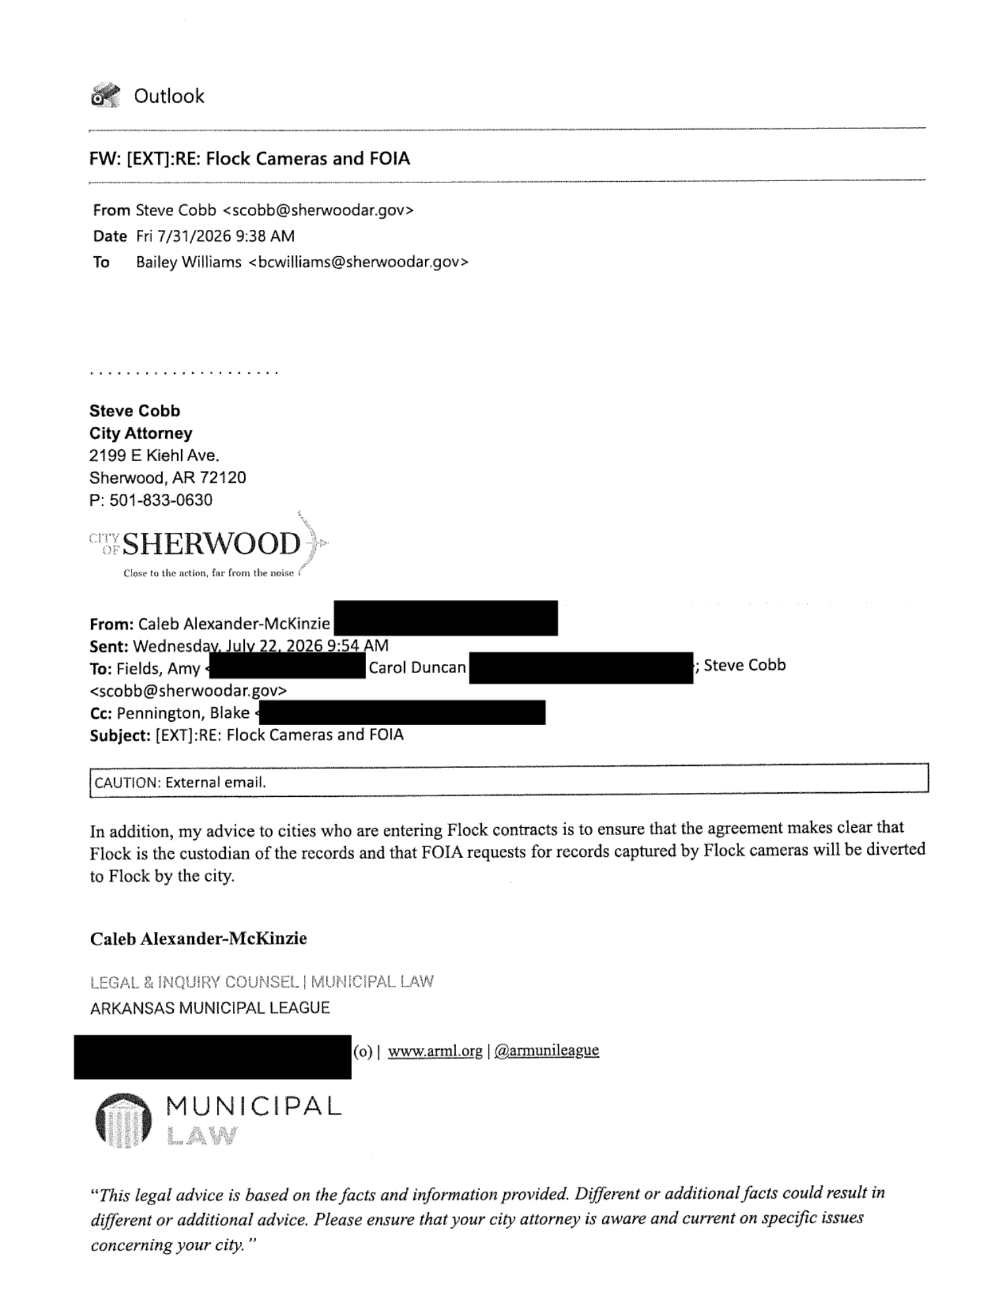
Figure 1. Redacted July 22, 2026 email in CITY-2026-130.

