**GIS Data Import Documentation for Federal Communication Commission Antenna Structure Registration to ArcGIS 10.2**

The Federal Communications Commission (FCC) maintains a national database of Antenna Structure Registrations (ASR) representing locations for telecommunication towers. Antenna registration is required by law for structures that exceed 200 feet in height. The ASR data is updated on a weekly basis. The telecommunication industry began registering structures less than 200 feet in height because the ASR information has become the defacto national repository for these assets. Although the data will not contain all structures, it does represent the single largest collection in the U.S. The compressed file contained within this package provides instructions and programming that will allow a user to readily import the ASR data into an ArcGIS format for immediate use.

**FCC_SCRIPT COMPRESSED FILE CONTENTS**

**FCC_ASR_TOWER.gdb** – This is an ESRI file geodatabase containing an empty file structure for storing the imported ASR data. This geodatabase includes the GIS metadata that is necessary to understand and utilize the information contained in the columns of the ASR data.

**FCC_TOWER_10_2.py** - This is the python program to use for importing the ASR data into ArcGIS Version 10.2

**README.pdf** – This is the README document for the package.

**PROCESSING INSTRUCTIONS**

1. Extract the FCC_SCRIPT.zip to a directory navigable via ArcCatalog.

2. In ArcCatalog navigate to the extracted directory and open the FCC_ASR_TOWER script that is embedded in the toolbox located in the FCC_ASR_TOWER.gdb

3. To run the script it must be sourced appropriately. Navigate in ArcMap or ArcCatalog to where you extracted the zip file. Find the toolbox and expand it to see FCC_ASR_TOWER script, right click on the script. Select properties at the bottom. From there select the Source tab and navigate to where you extracted all the data, source the script appropriately.

4.The Script has 3 parameters:

a. represents the FCC_ASR_TOWER.gdb included in the zip file

b. represents the folder where the ASR Tower data will be downloaded and processed

c. represents the two character State abbreviation appropriate for the state you would like to extract

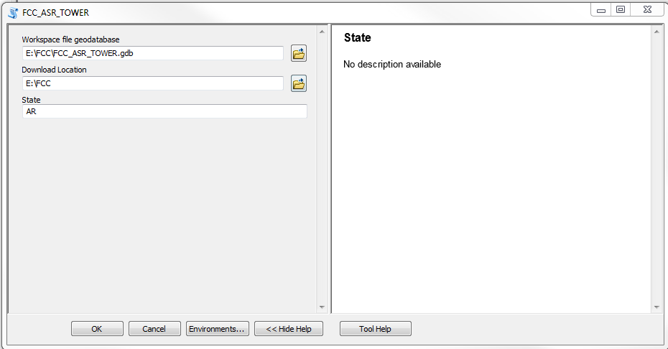

5. Once the parameters are appropriately populated press Ok and the script should complete successfully.

The script will download the Antenna Structure Registration [Registrations](http://wireless.fcc.gov/uls/data/complete/r_tower.zip) database located at http://wireless.fcc.gov/uls/data/complete/r_tower.zip. The database consists of a total of seven (7)table files, but this script only process the CO, RA, and EN table files.

a. CO -This data file contains the coordinate lists the latitude and Longitude for each tower

b. RA -This data file contains the registration which maintains contact information for each registrant as well structure details excluding location such as tower Height, type, etc..

c. EN -This data file contains the entity data which equates to the organization and contact information that is submitted to FCC during the registration.

The Script will unzip, rename , and execute a character replace on the aforementioned files. It will then import the files into the geodatabase and create a composite table from all three files. Geometry is formatted and generated with the Convert Coordinate Notation geoprocessing tool. The script will then export the following feature classes to the FCC_ASR_TOWER.gdb

**FCC_ASR_ALL** = This feature class was created by the Convert Coordinate Notation process that derives the X, Y location for all records in the database.

**FCC_ASR_STATE** = This feature class is a subset of FCC_ASR_ALL to include only the records that pertain to the State of interest.

The last process of the script will be to delete all intermediary data to include the downloaded zip and the original unzipped directory.