Table of contents

Model Checking

Introduction to Model Checking
Model checking is a formal verification technique for systems, proposed in 1981 by Clarke, Emerson, and Sifakis. It allows automatically verifying whether a system (modeled by a finite-state automaton) satisfies a property specified in temporal logic.

The Model Checking Problem
Given a finite automaton $A$ (possibly with labels) and a temporal logic formula $F$, the problem is to:
- Determine if $A⊨F$, i.e., if all traces of $A$ are included in the traces of $F$: $Traces\left(A\right)⊆Traces\left(F\right)$.
- If not, provide a counterexample: an execution of $A$ that does not satisfy $F$.
The difficulty of the problem (decidability, complexity) depends on the expressiveness of $A$ and $F$. In this course, we focus on:
- $A$: a finite automaton with only actions (simple labels) on transitions, and nothing on states.
- $F$: a linear temporal logic (LTL) formula.

Infinite Words and ω-Regular Languages

ω-Words
Reactive systems do not stop, so their executions are infinite. Similarly, the properties to verify concern infinite behaviors. An infinite trace (or word) of actions is called an ω-word.
Example: The infinite word consisting of the infinite repetition of “ab” is written ${\left(ab\right)}^{ω}$.
Compare with ${\left(ab\right)}^{*}$ which represents finite words with an arbitrary (finite) number of repetitions of “ab”. The symbol $ω$ indicates an infinite repetition.

ω-Regular Expressions
By extending regular expressions with the operator $ω$, we define ω-regular expressions.
Examples: Over the alphabet $\{a,b\}$:
- ${\left(a+b\right)}^{*}.a^{ω}$ represents infinite words with a finite number of $b$.
- ${\left(a^{*}b\right)}^{ω}$ represents infinite words with an infinite number of $b$.
Caution: $a^{ω}b^{ω}$ does not make sense (we cannot finish reading the infinite $a$ to move to $b$) and is therefore forbidden.

ω-Regular Languages
Just as regular languages can be represented by regular expressions or finite automata, ω-regular languages are exactly those that can be expressed by:
- ω-regular expressions (with operators $+,⋅,*,ω$),
- Büchi automata.
Definition: A language $L$ is ω-regular if it can be written in one of the following forms (and their combinations):
- $L=A^{ω}$ where $A$ is a regular language and $ϵ∉A$,
- $L=A⋅B$ where $A$ is regular and $B$ is ω-regular,
- $L=A∪B$ where $A$ and $B$ are ω-regular.
Closure properties: If we have automata (finite or Büchi) for $A$ and $B$, we can construct a Büchi automaton for $A^{ω}$, $A⋅B$, $A+B$, $A∩B$. However, complementation $\overline{A}$ is more complex (exponential size).
Important remark: Unlike finite automata, a nondeterministic Büchi automaton cannot always be determinized. For example, ${\left(a+b\right)}^{*}a^{ω}$ cannot be recognized by a deterministic Büchi automaton.

Emptiness Problem for ω-Regular Languages
The problem of deciding whether an ω-regular language $L$ is empty is decidable. Given a Büchi automaton $A$ such that $L\left(A\right)=L$, we have:
$L≠∅$ if and only if $A$ contains an ω-word. Since the number of final states is finite, every accepted ω-word is ultimately periodic.
Thus, $L≠∅$ iff $A$ contains a strongly connected component (SCC) reachable from the initial state and containing a final state.

Büchi Automata

Formal Definition
A Büchi automaton is a tuple $A=\left(S,S_{0},L,T,F\right)$ where:
- $S$: finite set of states,
- $S_{0}⊆S$: initial states,
- $L$: alphabet (labels),
- $T⊆S×L×S$: transition relation,
- $F⊆S$: final states (or acceptance states).

Acceptance Semantics
An ω-word $w=a_{0}a_{1}a_{2}…$ is accepted by $A$ if there exists an infinite execution $s_{0}s_{1}s_{2}…$ such that:
- $s_{0}∈S_{0}$,
- for all $i≥0$, $\left(s_{i},a_{i},s_{i+1}\right)∈T$,
- and a final state $f∈F$ appears infinitely often in the execution.
The language recognized by $A$, denoted $L\left(A\right)$, is the set of accepted ω-words.
Remark: This acceptance condition (visiting a final state infinitely often) is characteristic of Büchi automata.
Here is an example of a Büchi automaton illustrating the ω-regular language ${\left(a+b\right)}^{*}a^{ω}$ (infinite words containing a finite number of $b$), integrated directly into your course.

Example
The Büchi automaton below recognizes the ω-regular language $L={\left(a+b\right)}^{*}a^{ω}$, i.e., the set of infinite words over $\{a,b\}$ that, after some finite prefix, contain only the symbol $a$.

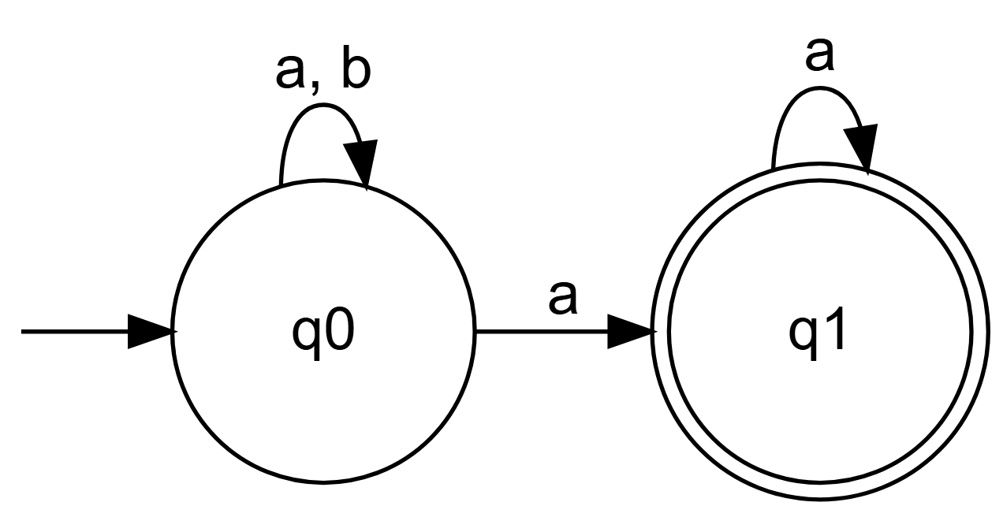

Operation of the automaton:
- From the initial state $q_{0}$, the automaton can read any finite sequence (possibly empty) of $a$ and $b$ while staying in $q_{0}$ (transition on $a,b$).
- At any time, upon reading an $a$, it can choose to go to the final state $q_{1}$.
- Once in $q_{1}$, it can only read $a$ (loop on $a$) to stay there.
- For an infinite word to be accepted, there must exist an execution that visits $q_{1}$ infinitely often. The only way to do this is to go to $q_{1}$ at some point and then read only $a$ indefinitely. Therefore, any accepted word must end with an infinity of $a$, which exactly corresponds to the definition of the language ${\left(a+b\right)}^{*}a^{ω}$.
This example also illustrates the nondeterminism of some Büchi automata: upon reading an $a$ in $q_{0}$, the automaton can choose between staying in $q_{0}$ or going to $q_{1}$. This nondeterminism is essential to recognize this language with a Büchi automaton.

Linear Temporal Logic (LTL)
Introduced by Pnueli in 1977, LTL allows expressing properties about the infinite behaviors of systems.

Syntax
The syntax of LTL is defined by the following grammar:
$$ϕ::=a∣¬ϕ∣ϕ_{1}∨ϕ_{2}∣○ϕ∣ϕ_{1} U ϕ_{2}$$
where $a$ is a propositional variable (an action or atomic property).

Semantics
An LTL formula $ϕ$ interprets an ω-word $σ={\left(σ_{i}\right)}_{i≥0}$ (where each $σ_{i}$ is a set of propositions true at instant $i$). The satisfaction relation $σ⊨ϕ$ is defined inductively:
- $σ⊨a$ iff $a∈σ_{0}$ (the proposition $a$ is true at the first instant).
- $σ⊨¬ϕ$ iff $σ⊭ϕ$.
- $σ⊨ϕ_{1}∨ϕ_{2}$ iff $σ⊨ϕ_{1}$ or $σ⊨ϕ_{2}$.
- $σ⊨○ϕ$ iff $σ′={\left(σ_{i}\right)}_{i≥1}⊨ϕ$ (the formula $ϕ$ is true at the next instant).
- $σ⊨ϕ_{1} U ϕ_{2}$ iff there exists $j≥0$ such that:
  - $σ^{\left(j\right)}={\left(σ_{i}\right)}_{i≥j}⊨ϕ_{2}$,
  - and for all $k$ with $0≤k<j$, we have $σ^{\left(k\right)}={\left(σ_{i}\right)}_{i≥k}⊨ϕ_{1}$.
Intuitively, $ϕ_{1} U ϕ_{2}$ means that $ϕ_{1}$ remains true until $ϕ_{2}$ becomes true (and $ϕ_{2}$ eventually becomes true).

Derived Operators
From the basic operators, we define:
- Eventually: $◊ϕ≡\text{True} U ϕ$. The formula $ϕ$ becomes true after a finite time.
- Always: $▫ϕ≡¬◊¬ϕ$. The formula $ϕ$ is true at every instant.
Some useful equivalences:
- $▫\left(a∨b\right)≠▫a∨▫b$
- $◊\left(a∨b\right)≡◊a∨◊b$
- $▫\left(a∧b\right)≡▫a∧▫b$
- $◊\left(a∧b\right)≠◊a∧◊b$ (since $a$ and $b$ can occur at different instants).

LTL and Büchi Automata
A fundamental result: every LTL formula can be translated into a Büchi automaton that accepts exactly the ω-words satisfying the formula. Algorithms exist for this construction.

Büchi Automata for Basic LTL Operators
To better understand the semantics of LTL operators, here are Büchi automata that recognize exactly the ω-words satisfying each formula.
1. Next Operator: $○a$
The formula $○a$ requires that $a$ be true at the instant following the current instant.

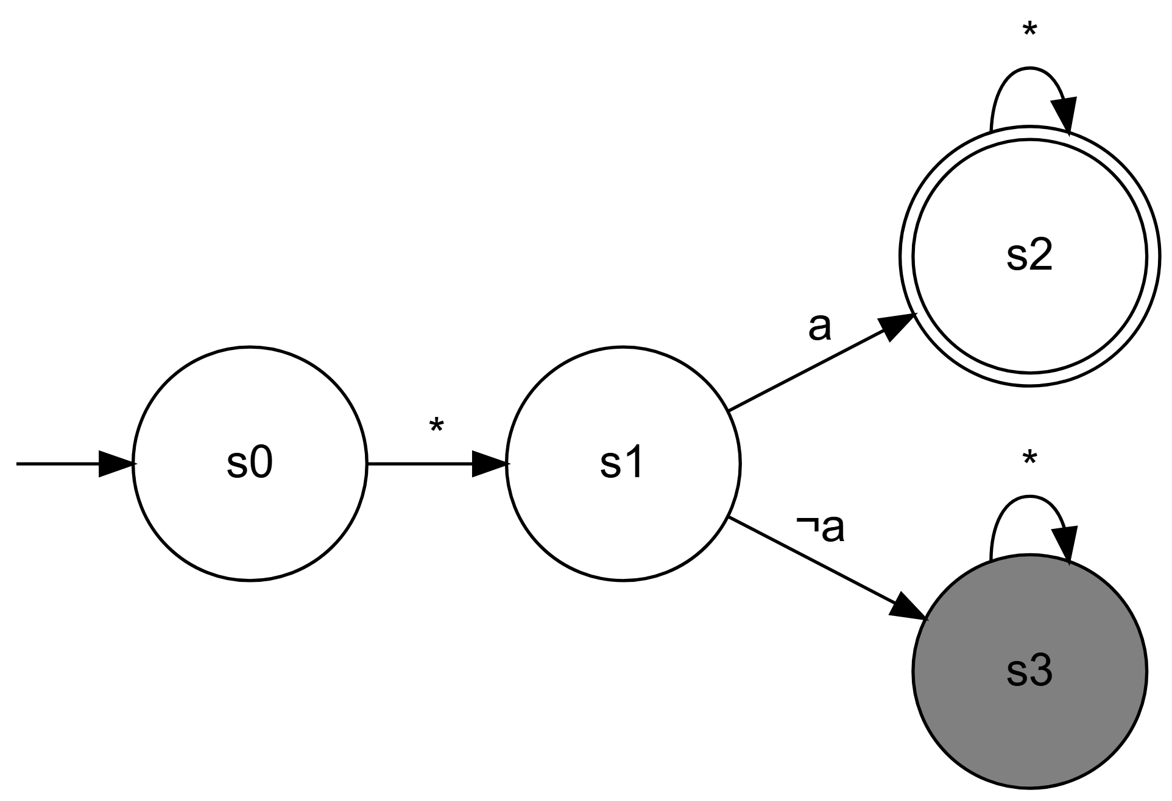

Operation: The automaton immediately moves from the initial state $s_{0}$ to $s_{1}$ (representing the next instant). If $a$ is true in this next state ($s_{1}$), it goes to the final state $s_{2}$ and the word is accepted. If $a$ is false, it enters the sink state $s_{3}$ and is not accepted.
2. Until Operator: $a U b$
The formula $a U b$ requires that $a$ remain true until $b$ becomes true (and $b$ must eventually become true).

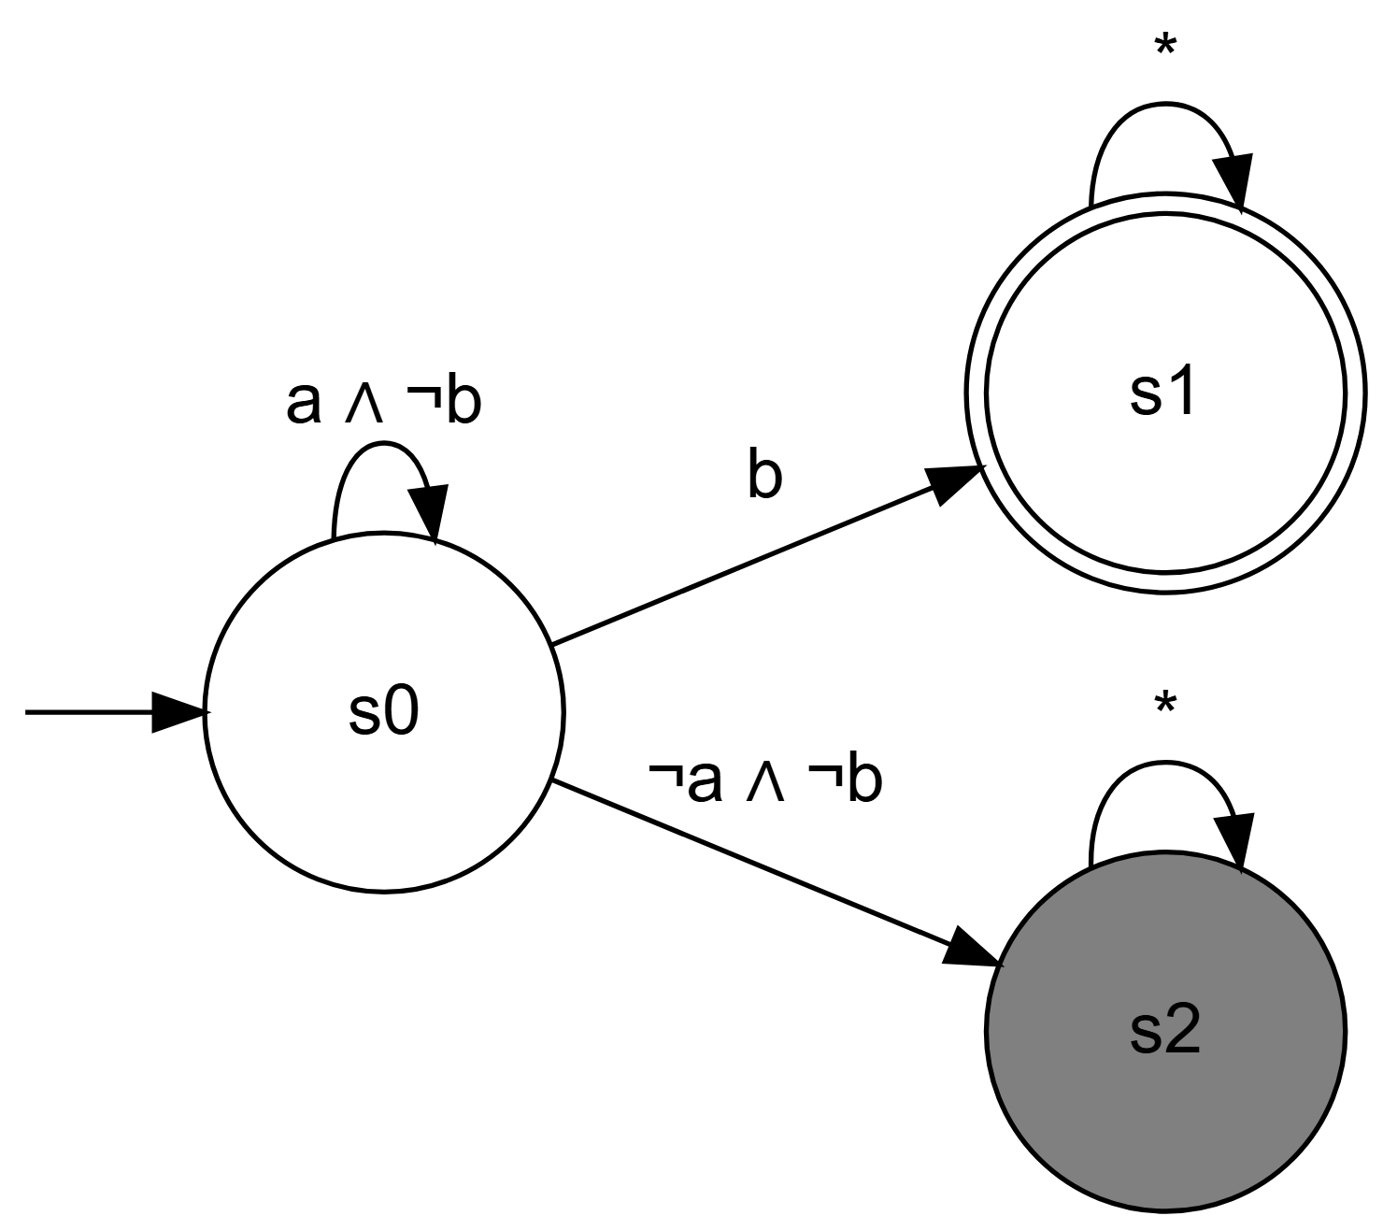

Operation: As long as $a∧¬b$ is true, the automaton remains in the initial state $s_{0}$. As soon as $b$ becomes true, it moves to the final state $s_{1}$ (and stays there) and the word is accepted. If $¬a∧¬b$ becomes true, it enters the sink state $s_{2}$ and the word is not accepted.
3. Eventually Operator: $◊a$
The formula $◊a$ requires that $a$ become true at some future moment.

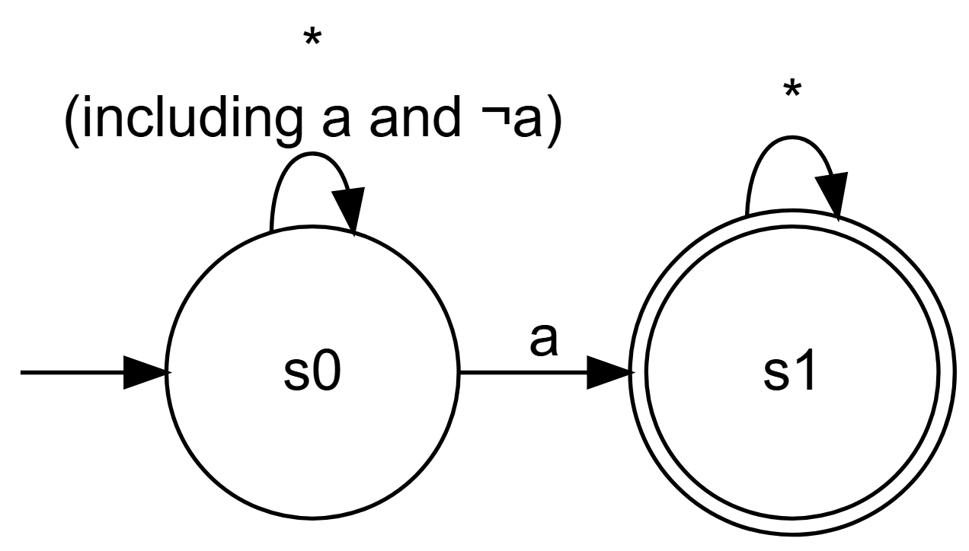

Operation: The automaton remains in the initial state $s_{0}$. At some point, when $a$ becomes true (not excluding that other $a$ may have occurred), it moves to the final state $s_{1}$ and stays there, accepting the word. If $a$ is never true, it remains indefinitely in $s_{0}$ and the word is not accepted (because $s_{0}$ is not final).
4. Always Operator: $▫a$
The formula $▫a$ requires that $a$ be true at every instant.

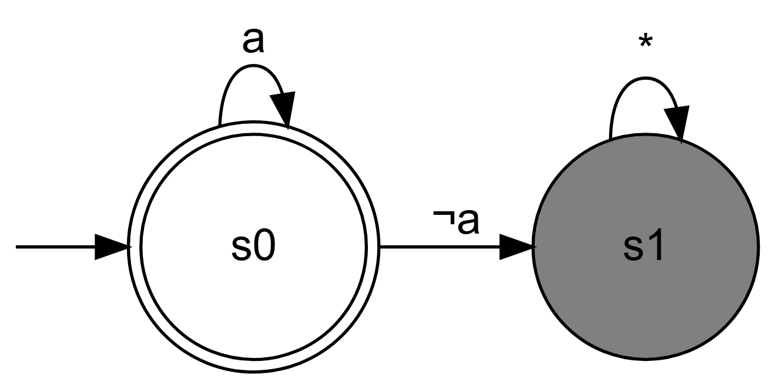

Operation: The automaton starts in the final state $s_{0}$. As long as $a$ is true, it remains in $s_{0}$. As soon as $a$ becomes false, it enters the sink state $s_{1}$ and the word is not accepted. To be accepted, $a$ must therefore be true at every instant.
These automata illustrate how the semantics of each operator translates into acceptance conditions on infinite executions. They form the basis for the systematic construction of automata for more complex LTL formulas.

Application to Model Checking

General Method
To verify that a system $A$ (modeled by a Büchi automaton) satisfies a property $F$ (expressed in LTL), we follow these steps:
- Model the system with a Büchi automaton $A$.
- Express the desired property as an LTL formula $F$.
- Construct a Büchi automaton for the negation of $F$, denoted $¬F$.
- Compute the synchronous product of automata $A$ and $¬F$, which accepts the language $L\left(A\right)∩L\left(¬F\right)$.
- Check if $L\left(A\right)∩L\left(¬F\right)$ is empty.

Interpretation of Results
- If $L\left(A\right)∩L\left(¬F\right)=∅$, then $L\left(A\right)⊆L\left(F\right)$, which means that $A⊨F$ (the system satisfies the property).
- Otherwise, any ω-word in $L\left(A\right)∩L\left(¬F\right)$ is a counterexample: an execution of system $A$ that violates property $F$.

Emptiness Check
To check if $L\left(A\right)∩L\left(¬F\right)$ is empty, we use the algorithm based on strongly connected components (SCC):
- Construct the graph of the product automaton.
- Look for an SCC that is:
  - Reachable from an initial state,
  - Contains at least one final state.
- If such an SCC exists, then the language is non-empty (there is a counterexample). Otherwise, it is empty.

Simplified Example: An Elevator
Consider an elevator system modeled by an automaton $A$. A safety property could be: “if the elevator starts, then immediately after, it will remain moving until it stops”. In LTL, this is expressed:
$$F=▫\left(\text{start}⇒○\left(\text{move} U \text{stop}\right)\right)$$
The negation is:
$$¬F=◊\left(\text{start}∧○\left(¬\left(\text{move} U \text{stop}\right)\right)\right)$$

Step 1: System Modeling
Here is automaton $A$ representing the simplified behavior of an elevator:

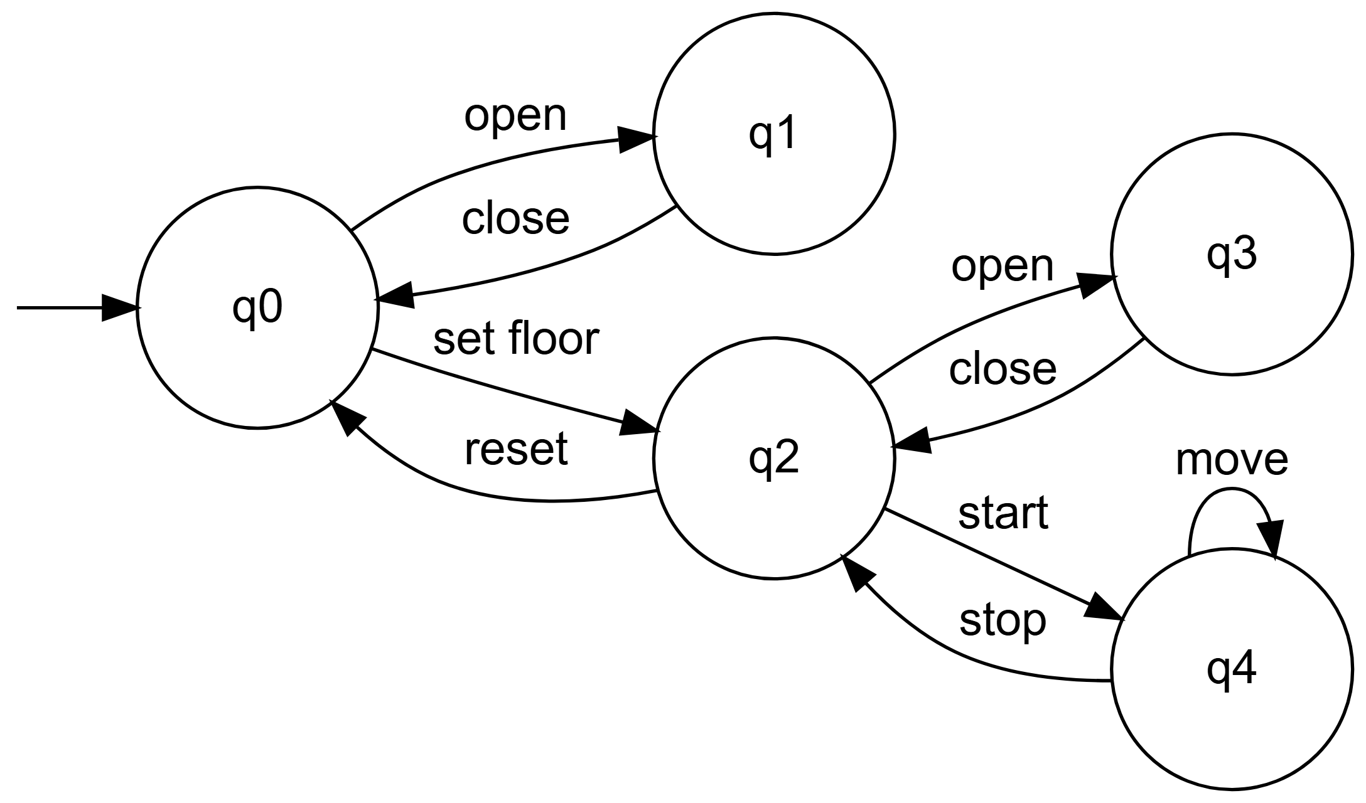

State Descriptions:
- $q_{0}$: Rest state (doors closed, no floor selected)
- $q_{1}$: Doors open
- $q_{2}$: Floor selected (waiting)
- $q_{3}$: Doors open after floor selection
- $q_{4}$: Elevator in motion

Step 2: Construction of Büchi Automata for $F$ and $¬F$
1. Büchi Automaton for $F=▫\left(\text{start}⇒○\left(\text{move} U \text{stop}\right)\right)$
This automaton accepts executions where each occurrence of start is followed by a state where move remains true until stop becomes true.

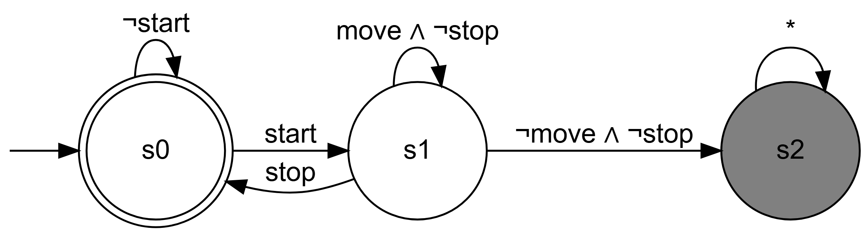

Operation:
- $s_{0}$ (final state): No current obligation
- $s_{1}$: A start just occurred, we must now verify $\text{move} U \text{stop}$
- Acceptance condition: Visit $s_{0}$ infinitely often
- An execution is accepted only if each obligation $\text{move} U \text{stop}$ is eventually satisfied (by a stop)
2. Büchi Automaton for $¬F=◊\left(\text{start}∧○\left(¬\left(\text{move} U \text{stop}\right)\right)\right)$
This automaton accepts executions where at some moment, a start occurs and immediately after, $\text{move} U \text{stop}$ is false.

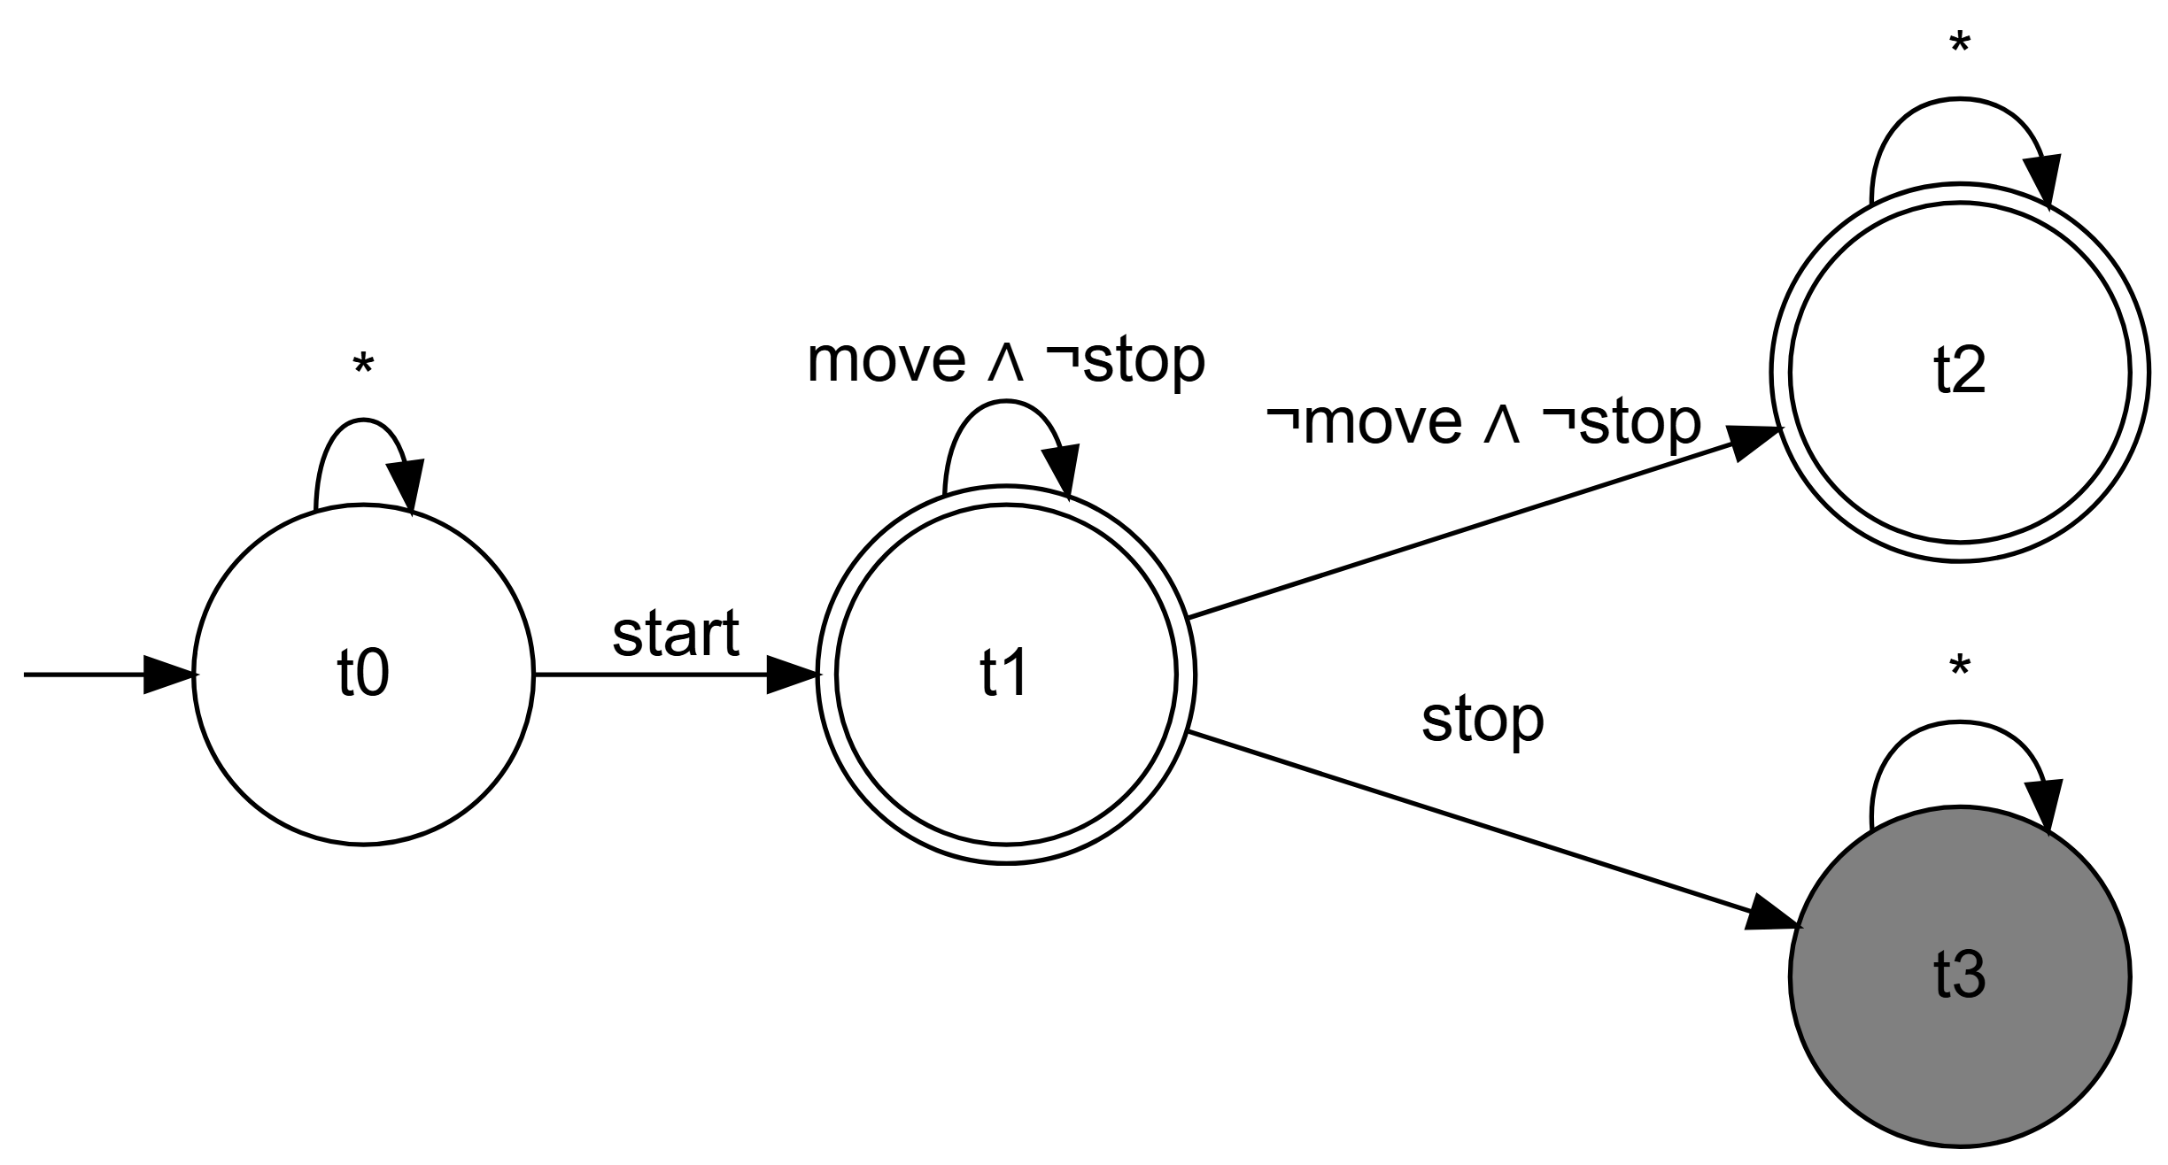

Operation:
- $t_{0}$: We have not yet seen the problematic start
- $t_{1}$: We just saw start, we move to the next instant
- $t_{2}$ (final state): We verify $¬\left(\text{move} U \text{stop}\right)$; here as long as we have move ∧ ¬stop, we stay in $t_{2}$
- $t_{3}$ (final state): We have ¬move ∧ ¬stop, which immediately violates $\text{move} U \text{stop}$
- Acceptance condition: Visit $t_{2}$ or $t_{3}$ infinitely often
- An execution is accepted if it remains indefinitely in $t_{2}$ (with move ∧ ¬stop) or in $t_{3}$

Step 3: Synchronous Product $A×¬F$
The product combines the states of $A$ and $¬F$. Let’s analyze possible executions:
Problematic Execution:
- $q_{0}\overset{\text{set floor}}{→}q_{2}$
- $q_{2}\overset{\text{start}}{→}q_{4}$
- $q_{4}\overset{\text{move}}{→}q_{4}\overset{\text{move}}{→}q_{4}\overset{\text{move}}{→}…$
This execution corresponds to the word: set floor, start, move, move, move, ...
In the Product:
- After start, we go to $t_{2}$ in $¬F$
- In $t_{2}$, as long as we read move ∧ ¬stop, we stay in $t_{2}$
- Since the elevator can remain indefinitely in $q_{4}$ with move, we have an SCC $\left(q_{4},t_{2}\right)$ with the move loop
This SCC $\left(q_{4},t_{2}\right)$ is:
- Reachable from the initial state
- Contains a final state ($t_{2}$ is final)

Step 3: Synchronous Product $A×¬F$ (Detailed)
The synchronous product combines the states of $A$ and $¬F$. A state of the product is a pair $\left(q_{i},t_{j}\right)$ where $q_{i}$ is a system state and $t_{j}$ a state of the property-violating automaton.

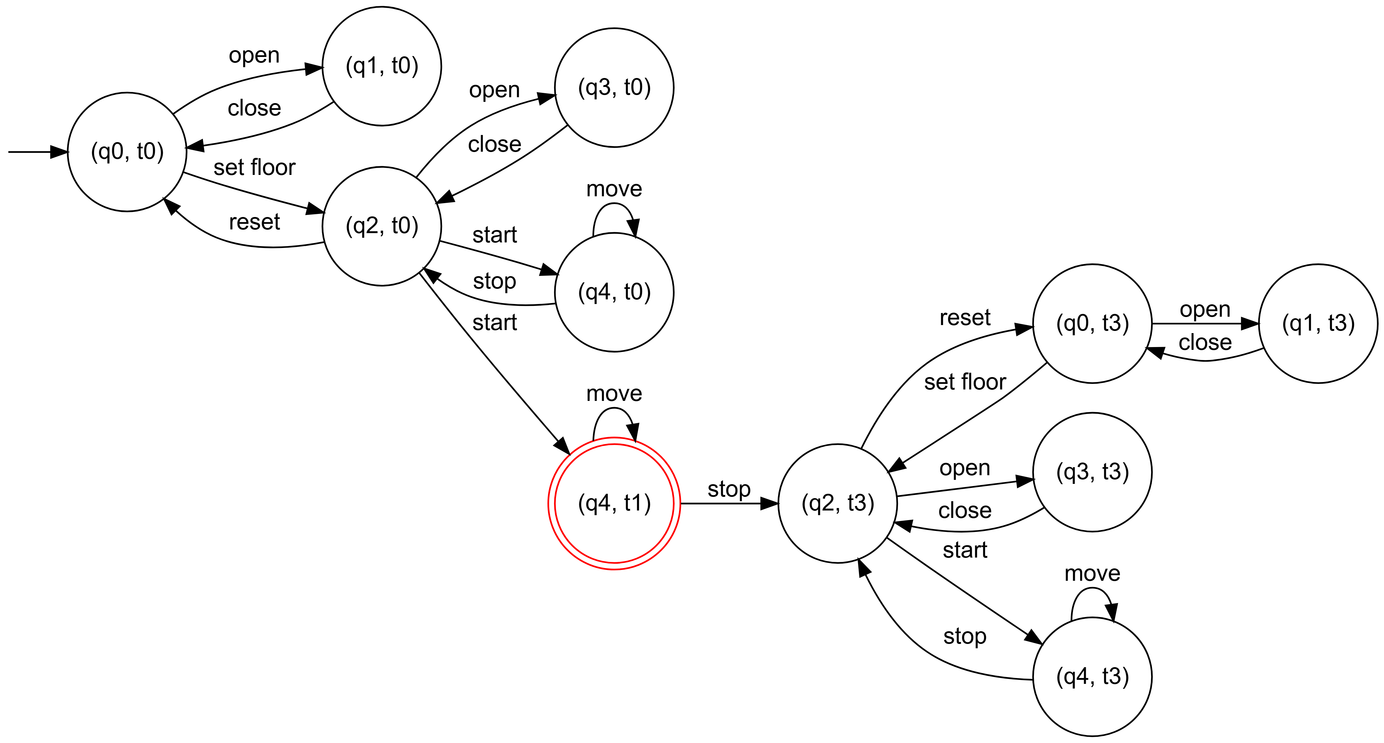

Product Analysis:
- Final States: Only $\left(q_{4},t_{1}\right)$ is final (represented by a red double circle), because $t_{1}$ is a final state in $¬F$.
- Problematic Strongly Connected Component (SCC):
  - The state $\left(q_{4},t_{1}\right)$ forms an SCC with the transition $\left(q_{4},t_{1}\right)\overset{move}{→}\left(q_{4},t_{1}\right)$
  - This SCC is reachable from the initial state via: $\left(q_{0},t_{0}\right)\overset{\text{set floor}}{→}\left(q_{2},t_{0}\right)\overset{\text{start}}{→}\left(q_{4},t_{1}\right)$
  - This SCC contains a final state ($t_{1}$ is final)

Step 4: Emptiness Check
Since there exists an SCC $\left(q_{4},t_{1}\right)$ that:
- Is reachable from an initial state
- Contains at least one final state
Then $L\left(A\right)∩L\left(¬F\right)≠∅$.

Step 5: Counterexample
Since the language is not empty, we can extract a counterexample. The following execution is accepted by the product:
- $\left(q_{0},t_{0}\right)\overset{\text{set floor}}{→}\left(q_{2},t_{0}\right)$
- $\left(q_{2},t_{0}\right)\overset{\text{start}}{→}\left(q_{4},t_{1}\right)$
- $\left(q_{4},t_{1}\right)\overset{\text{move}}{→}\left(q_{4},t_{1}\right)\overset{\text{move}}{→}\left(q_{4},t_{1}\right)\overset{\text{move}}{→}…$
This execution corresponds to the infinite word: set floor, start, move, move, move, ...
Interpretation:
- The system $A$ does not satisfy property $F$
- Reason: the elevator can start and continue moving indefinitely without ever executing the stop action
- To correct this, we would need to modify the system to guarantee that after a start, the elevator always eventually executes stop (for example by adding a timer or monitoring)
This example illustrates how LTL model checking can detect design flaws in systems.

Summary and Perspectives
Model checking is an automatic and complete method (under the assumptions of a finite system) for verifying temporal properties. The key points are:
- Modeling the system and properties with Büchi automata and LTL logic.
- Reducing the verification problem to an emptiness problem of intersection of ω-regular languages.
- Using graph algorithms (SCC) to decide emptiness.
However, complexity can be high (notably due to constructing the automaton for the negation of the LTL formula). Optimization techniques and industrial tools (like SPIN, NuSMV) are developed to apply model checking to real-size systems.

