Table of contents

Serie 1

Part 1: Resolution Methods

Methods for Tautologies and Validity

1. Complete Truth Table
Exhaustive method that evaluates all possible variable combinations to determine if a formula is always true.

2. Transformation by Rewriting
Systematic use of logical laws to simplify or transform formulas until an obvious form is obtained.

3. Counterexample Search
To prove that a formula is not a tautology, search for a variable assignment that makes the formula false.

4. Conjunctive Normal Form (CNF)
Transformation of a formula into a conjunction of disjunctions of literals, allowing easy validity checking.

5. Case Analysis
Systematic examination of all possible scenarios for a variable or subformula.

Methods for First-Order Logic

6. Identification of Predicates and Constants
Precise definition of predicates, functions, and constants needed to model a natural language statement.

7. Guided Translation by Logical Structure
Use of logical connectives ($∀$, $∃$, $⇒$, $∧$, $∨$, $¬$) to reflect the structure of the statement.

8. Quantifier Management
Correct placement of quantifiers to capture variable scope.

9. Modeling Uniqueness Constraints
Use of quantifier combinations and equality to express uniqueness.

Methods for Satisfaction Problems

10. Propositional Formalization
Transformation of a concrete problem into propositional variables and logical constraints.

11. Satisfiability by Systematic Reasoning
Examination of constraints and search for consistent assignments by eliminating impossible cases.

Review of Fundamental Logical Laws

Implication Laws
- Implication elimination: $p⇒q≡¬p∨q$
- Contrapositive: $p⇒q≡¬q⇒¬p$
- Negation of implication: $¬\left(p⇒q\right)≡p∧¬q$

De Morgan’s Laws
- $¬\left(p∧q\right)≡¬p∨¬q$
- $¬\left(p∨q\right)≡¬p∧¬q$

Distributive Laws
- $p∨\left(q∧r\right)≡\left(p∨q\right)∧\left(p∨r\right)$
- $p∧\left(q∨r\right)≡\left(p∧q\right)∨\left(p∧r\right)$

Associativity and Commutativity Laws
- $\left(p∧q\right)∧r≡p∧\left(q∧r\right)$
- $\left(p∨q\right)∨r≡p∨\left(q∨r\right)$
- $p∧q≡q∧p$
- $p∨q≡q∨p$

Identity and Complement Laws
- $p∨\text{False}≡p$
- $p∧\text{True}≡p$
- $p∨¬p≡\text{True}$
- $p∧¬p≡\text{False}$

Part 2: Illustrative Examples

Example 1: Transformation by Rewriting (Modus Ponens)
Formula: $\left(p∧\left(p⇒q\right)\right)⇒q$
Application of methods:
- Use of implication elimination
- Application of De Morgan’s laws
- Use of distributivity
- Simplification by complement laws
Demonstration:
$$\begin{matrix} & \left(p∧\left(p⇒q\right)\right)⇒q \\ ≡ & ¬\left(p∧\left(p⇒q\right)\right)∨q \text{(elimination of }⇒) \\ ≡ & ¬\left(p∧\left(¬p∨q\right)\right)∨q \text{(elimination of }⇒) \\ ≡ & \left(¬p∨¬\left(¬p∨q\right)\right)∨q \text{(De Morgan)} \\ ≡ & \left(¬p∨\left(p∧¬q\right)\right)∨q \text{(De Morgan)} \\ ≡ & \left(\left(¬p∨p\right)∧\left(¬p∨¬q\right)\right)∨q \text{(distributivity)} \\ ≡ & \left(\text{True}∧\left(¬p∨¬q\right)\right)∨q \text{(complement)} \\ ≡ & \left(¬p∨¬q\right)∨q \\ ≡ & ¬p∨\left(¬q∨q\right) \\ ≡ & ¬p∨\text{True} \\ ≡ & \text{True}\end{matrix}$$

Example 2: Counterexample Search
Formula: $\left(q∨r⇒p∧¬s\right)∧\left(s∨p⇒\left(¬r⇒q\right)\right)⇒¬\left(s∨r\right)$
Application of methods:
- Analysis of implication structure
- Search for assignment making premise true and conclusion false
- Consistency verification
Demonstration:
- For the conclusion to be false: $¬\left(s∨r\right)$ must be false, so $s∨r$ must be true. Choice: $s=\text{False}$, $r=\text{True}$
- For the premise to be true:
  - First part: $q∨r⇒p∧¬s$ With $r=\text{True}$, $q∨r$ is true. For the implication to be true, $p∧¬s$ must be true. With $s=\text{False}$, $¬s$ is true, so $p$ must be true.
  - Second part: $s∨p⇒\left(¬r⇒q\right)$ With $p=\text{True}$, $s∨p$ is true. $¬r$ is false (since $r$ is true), so $¬r⇒q$ is true (false premise).
- Found assignment: $p=\text{True}$, $q$ arbitrary, $r=\text{True}$, $s=\text{False}$ This assignment makes the premise true and the conclusion false, so the formula is not a tautology.

Example 3: Formalization in First-Order Logic
Statement: “Every person who works in computer science has written at least one program”
Application of methods:
- Identification of predicates: $\text{CS}\left(x\right)$, $\text{P}\left(y\right)$, $W\left(x,y\right)$
- Analysis of structure: “for all x, if CS(x) then there exists y such that…”
- Guided translation by logical structure
Formalization:
$$∀x \left(\text{CS}\left(x\right)⇒∃y \left(\text{P}\left(y\right)∧W\left(x,y\right)\right)\right)$$

Example 4: Modeling Uniqueness Constraints
Statement: “Each program was written by a unique person who works in computer science”
Application of methods:
- Expression of existence: $∃y$
- Expression of uniqueness: $∀z \left(\left(\text{CS}\left(z\right)∧W\left(z,x\right)\right)⇒z=y\right)$
- Combination with conjunction
Formalization:
$$∀x \left(\text{P}\left(x\right)⇒∃y \left(\text{CS}\left(y\right)∧W\left(y,x\right)∧∀z \left(\left(\text{CS}\left(z\right)∧W\left(z,x\right)\right)⇒z=y\right)\right)\right)$$

Example 5: Systematic Reasoning (Box Problem)
Problem: Find which box contains the treasure with contradictory statements
Application of methods:
- Propositional formalization:
  - Variables $T_{i}$: treasure in box i
  - Variables $B_{i}$: statement on box i is true
- Constraint translation:
  - $B_{1}⇔¬T_{1}$
  - $B_{2}⇔¬T_{2}$
  - $B_{3}⇔T_{1}$
  - Exactly one $B_{i}$ true
  - Exactly one $T_{i}$ true
- Case analysis:
  - Case 1: $T_{1}$ true → contradiction with $B_{2}$
  - Case 2: $T_{3}$ true → contradiction with uniqueness of $B_{i}$
  - Case 3: $T_{2}$ true → all constraints satisfied
Conclusion: The treasure is in $B_{2}$.

Example 6: Conjunctive Normal Form
Formula: $\left(¬q⇒¬p\right)⇒\left(\left(¬q⇒p\right)⇒q\right)$
Application of methods:
- Transformation to CNF
- Observation that each clause contains a literal and its negation
- Validity conclusion
Demonstration (excerpt):
After transformations, we obtain a CNF where each clause is of the form $\left(p∨q∨¬q\right)$ or similar, therefore always true.

Methods Diagram

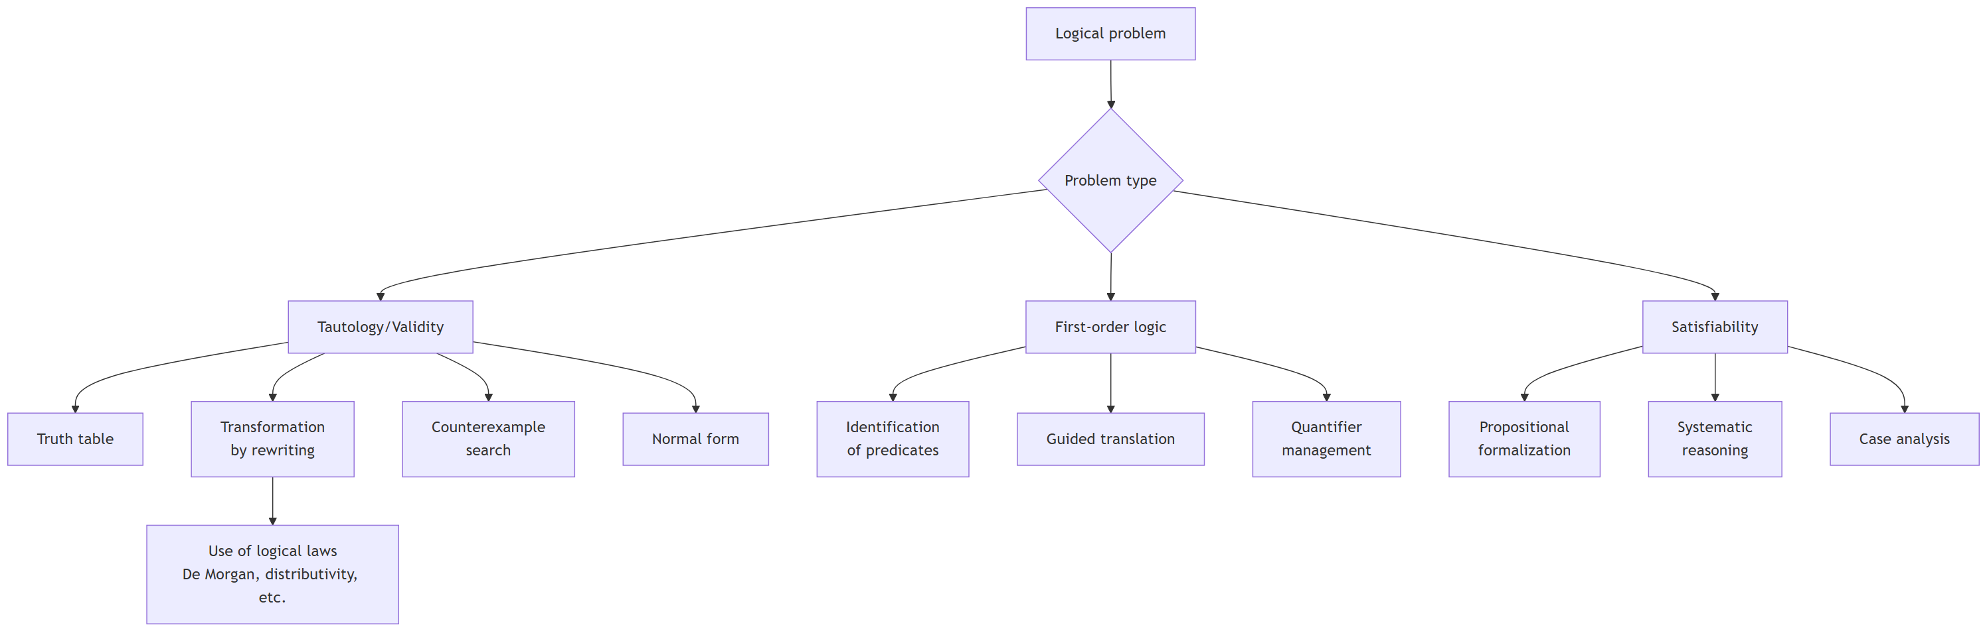

Synthesis
The presented methods cover the main aspects of problem solving in propositional and first-order logic. Mastering these methods, combined with a good knowledge of fundamental logical laws, allows addressing a wide variety of problems in software modeling and verification.
Key points:
- Always start by understanding the logical structure of the problem
- Choose the method adapted to the problem type (validation, modeling, satisfaction)
- Systematically apply logical laws in transformations
- Verify the consistency of found solutions
- Clearly document each step of the reasoning

