Table of contents

Series 9: Abstract Interpretation I

Methods

Construction of CFG (Control Flow Graph)
- Inductive method: Define a recursive function CFG(P, ip, rp) that constructs the control flow graph for a program P, with an entry point ip and a return point rp.
- Construction rules:
  - Assignment: CFG(x:=e, ip, rp) adds a transition labeled x:=e from ip to rp.
  - Sequence: CFG(e1; e2, ip, rp) creates an intermediate point e1 and recursively calls CFG(e1, ip, e1) and CFG(e2, e1, rp).
  - Conditional: CFG(if c then e1 else e2, ip, rp) creates two new points e1 and e2, adds transitions from ip to e1 (label c) and from ip to e2 (label ¬c), then recursively calls CFG(e1, e1, rp) and CFG(e2, e2, rp).
  - Loop: CFG(while c do e1 done, ip, rp) creates a point e1, adds a transition from ip to e1 (label c) and one from ip to rp (label ¬c), then calls CFG(e1, e1, ip).

Collecting Semantics
- System of equations: Associate with each control point s a variable V(s) representing the set of possible memory states at that point.
- Equations: Deduce equations from the CFG structure, using union operations and filtering by conditions.
- Entry point: Introduce an initial state st to model parameter initialization.

Iterative Resolution of the Equation System
- Iteration to fixed point: Initialize V(s0) with the initial state, then recursively apply equations until stabilization (or divergence).
- Termination analysis: Observe value evolution to conclude about program behavior (termination, infinite loop, error).

Abstraction by Intervals
- Abstract domain: Replace concrete sets of values with intervals (e.g., [2, 6] for {2,3,4,5,6}).
- Abstract operations: Adapt operations (assignment, union, intersection) to work on intervals.
- Goal: Simplify analysis by losing precision, but guaranteeing termination and capturing general properties.

Abstraction by Signs
- Abstract domain: Represent sets of values by their sign: ≤0, ≥0, <0, >0, =0, ≠0, ⊥ (no value), ⊤ (all values).
- Abstract operations: Define operations on signs (e.g., addition, subtraction, comparison).
- Goal: Even coarser but faster analysis, to infer simple properties about variables.

Reminder
- CFG: Graphical representation of program control flow. Nodes are control points, arcs are transitions labeled by conditions or assignments.
- Collecting semantics: Semantics that associates with each control point the set of all possible memory states during execution.
- Fixed point: In abstract interpretation, we look for a fixed point of the equation system (a state where V(s) no longer changes after an iteration). The iterative algorithm converges to this fixed point (under certain conditions).
- Abstraction: Function that maps a concrete set (e.g., {2,3,4}) to an element of an abstract domain (e.g., interval [2,4] or sign >0). It must be safe (over-approximative).
- Abstract operations: Must over-approximate concrete operations. For example, interval addition [a,b] + [c,d] = [a+c, b+d].

Illustrative Examples

Example 1: CFG Construction for sillyprogram
Context: Program sillyprogram(a,b) = while (a > 0) do if a mod 2 = 0 then a := a/b else b := b-1; a := a+1 endif done. We want to construct its CFG.
Application: Apply inductive rules.
- Loop while: CFG(while (a>0) do ... done, ip, rp)
  - Creates a new point e1 for the loop body.
  - Adds a transition from ip to e1 labeled a>0.
  - Adds a transition from ip to rp labeled ¬(a>0) (i.e., a<=0).
  - Recursive call: CFG(body, e1, ip) where body is the if ... endif instruction.
- Conditional if: CFG(if a mod 2 = 0 then a:=a/b else b:=b-1; a:=a+1, e1, ip)
  - Creates two points e2 (for then) and e3 (for else).
  - Adds a transition from e1 to e2 labeled a mod 2 = 0.
  - Adds a transition from e1 to e3 labeled ¬(a mod 2 = 0).
  - Recursive calls:
    - CFG(a:=a/b, e2, ip)
    - CFG(b:=b-1; a:=a+1, e3, ip)
- Sequence: CFG(b:=b-1; a:=a+1, e3, ip)
  - Creates an intermediate point e4.
  - Recursive calls:
    - CFG(b:=b-1, e3, e4)
    - CFG(a:=a+1, e4, ip)
The resulting CFG has control points st (initial), s0 (loop start), s1 (loop exit), s2 (if start), s3 (then branch), s4 (else branch), s5 (after b:=b-1). Transitions are labeled as described.

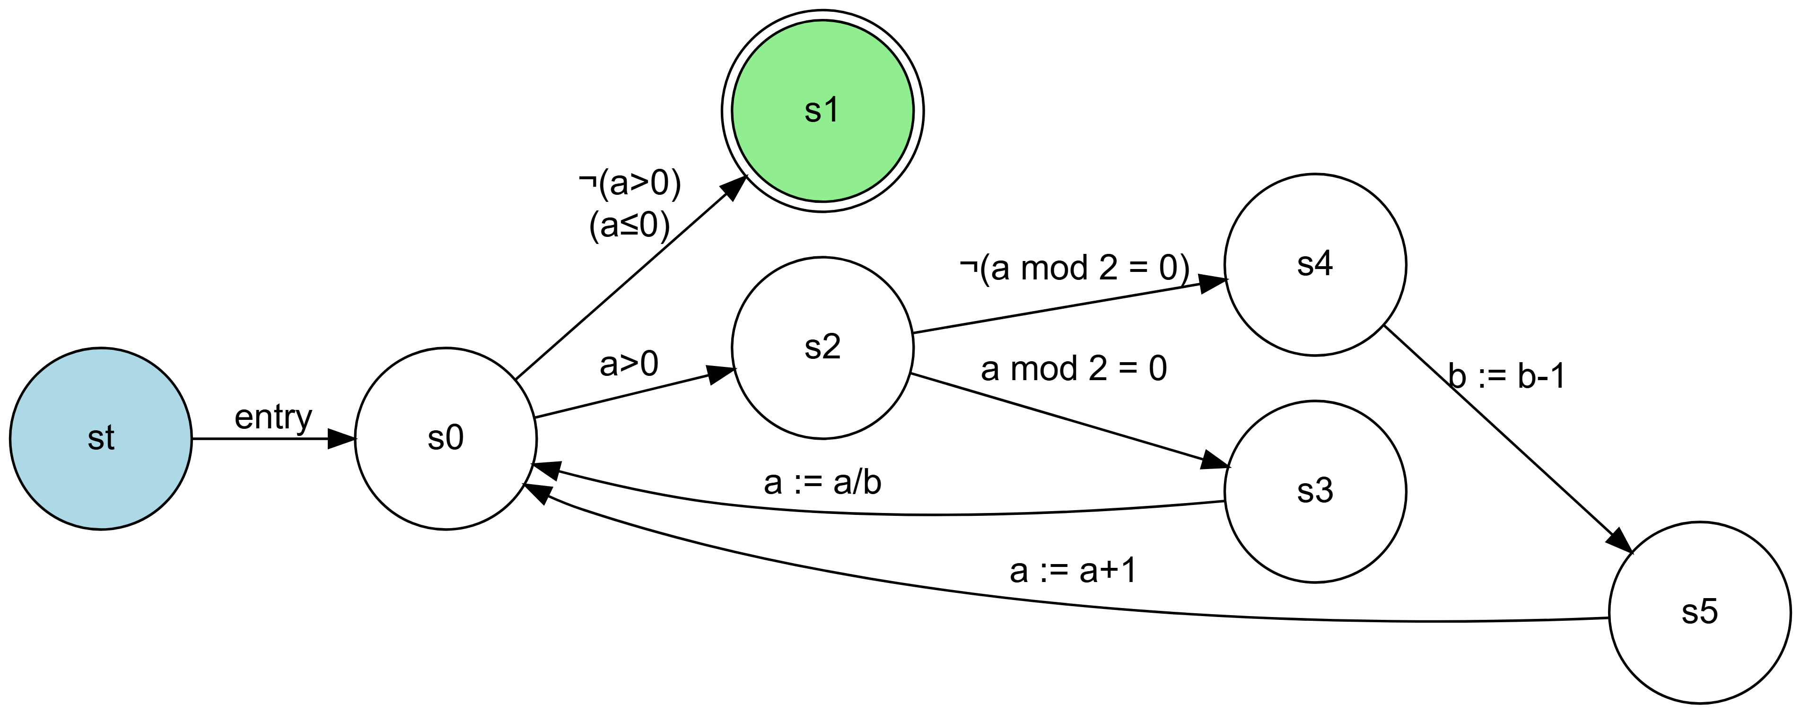

Example 2: Collecting Semantics for sillyprogram
Context: We have the CFG of sillyprogram. We want to write the collecting semantics equation system.
Application: Define V(s) for each control point s.
$$\begin{matrix}V\left(st\right) & =⊤ \text{(unspecified initial state)} \\ V\left(s0\right) & =V\left(st\right)\left[a:=a_{0},b:=b_{0}\right]∪V\left(s3\right)\left[a:=a/b\right]∪V\left(s5\right)\left[a:=a+1\right] \\ V\left(s1\right) & =V\left(s0\right)∩\left[a≤0\right] \\ V\left(s2\right) & =V\left(s0\right)∩\left[a>0\right] \\ V\left(s3\right) & =V\left(s2\right)∩\left[a mod 2=0\right] \\ V\left(s4\right) & =V\left(s2\right)∩\left[a mod 2≠0\right] \\ V\left(s5\right) & =V\left(s4\right)\left[b:=b−1\right]\end{matrix}$$
Here, [cond] denotes the set of states satisfying condition cond. The operation V(s)[x:=expr] means “take all states from V(s), evaluate expr in each state, and assign the resulting value to x”.

Example 3: Concrete Resolution for a=5, b=3
Context: Solve the equation system for initial values a=5, b=3.
Application: Iterate manually.
- Initialization: V(s0) = {a:{5}, b:{3}}
- First iteration (loop):
  - Via s2 (since a>0): V(s2) = {a:{5}, b:{3}}
  - Via s4 (since a mod 2 ≠ 0): V(s4) = {a:{5}, b:{3}}
  - Via s5: V(s5) = {a:{5}, b:{2}}
  - Return to s0: V(s0) = {a:{5}, b:{3}} ∪ ∅ ∪ {a:{6}, b:{2}} = {a:{5,6}, b:{2,3}}
- Second iteration: Recompute with the new V(s0). We get V(s0) = {a:{2,3,5,6}, b:{1,2,3}}.
- Third iteration: V(s0) = {a:{0,1,2,3,5,6}, b:{0,1,2,3}}.
- Fourth iteration: V(s0) = {a:{0,1,2,3,5,6}, b:{-1,0,1,2,3}}.
- Fifth iteration: Sets continue to expand (appearance of negative values). We conclude that the loop does not terminate and values diverge.

Example 4: Abstraction by Intervals
Context: Take the same system, but abstract value sets with intervals.
Application: Re-express equations with intervals.
- Initialization: V(s0) = {a:[5,5], b:[3,3]}
- First iteration:
  - V(s2) = {a:[5,5], b:[3,3]}
  - V(s4) = {a:[5,5], b:[3,3]}
  - V(s5) = {a:[5,5], b:[2,2]}
  - V(s0) = {a:[5,5], b:[3,3]} ∪ ∅ ∪ {a:[6,6], b:[2,2]} = {a:[5,6], b:[2,3]}
- Second iteration: We get V(s0) = {a:[2,6], b:[1,3]}.
- Third iteration: V(s0) = {a:[0,6], b:[0,3]}.
- Fourth iteration: V(s0) = {a:[0,6], b:[-1,3]}.
- Fifth iteration: V(s0) = {a:[-6,6], b:[-2,3]} (approximating appeared negative values). The interval for a expands toward negatives, and we can conjecture it will become (-∞, +∞) after enough iterations.

Example 5: Abstraction by Signs
Context: Now use sign abstraction.
Application: Translate values to signs.
- Initialization: V(s0) = {a:>0, b:>0} (since 5>0, 3>0)
- First iteration:
  - V(s2) = {a:>0, b:>0}
  - V(s4) = {a:>0, b:>0}
  - V(s5) = {a:>0, b:≥0} (since b-1 can be 2>0, but we over-approximate by ≥0)
  - Return to s0: Union of signs: {a:>0, b:>0} ∪ ∅ ∪ {a:>0, b:≥0} = {a:>0, b:⊤} (since >0 ∪ ≥0 = ⊤ for b)
- Second iteration: With b:⊤, abstract calculations will yield very broad signs. Quickly, we get V(s0) = {a:⊤, b:⊤}, meaning any value is possible for a and b. This indicates that sign analysis is too coarse for this program, but it allows concluding that the program may not terminate (since we cannot guarantee that a becomes ≤0).

Synthesis
Abstract interpretation is a static analysis technique that approximates program behavior without concretely executing it. First construct a CFG, then define a collecting semantics equation system. Iterative resolution of this system may not terminate on complex programs. To guarantee termination, we use abstract domains (intervals, signs) that simplify data and allow computing a fixed point in a finite number of steps. However, abstraction causes loss of precision: we can obtain safe results but sometimes too broad.

