Table of contents

Series 10: Abstract Interpretation II/III

Methods

Analysis of Order Structures
- Verification of lattice properties: Determine if a given poset is a lattice, a complete lattice, or a semi-complete lattice by checking the existence of infimum and supremum for any pair (lattice) and for any subset (complete).
- Construction of order on abstract domains: Define an order that captures the notion of “precision” between abstract elements (e.g., inclusion for intervals).
- Cartesian product of lattices: Show that the product of two complete lattices, equipped with the product order, is itself a complete lattice.

Analysis of Functions on Lattices
- Monotonicity and Scott-continuity: Prove that a function is monotonic and/or Scott-continuous. Scott-continuity guarantees preservation of suprema of increasing chains.
- Composition of continuous functions: Show that the composition of two Scott-continuous functions is Scott-continuous.
- Fixed-point calculation: Apply Kleene’s theorem to compute the least fixed point (lfp) of a continuous function, often via iteration starting from $⟂$.
- Comparison of fixed points: If $f\left(x\right)≤g\left(x\right)$ for all $x$, then $\text{lfp}\left(f\right)≤\text{lfp}\left(g\right)$.

Galois Connections
- Definition of functions $α$ (abstraction) and $γ$ (concretization) between a concrete domain and an abstract domain.
- Proof of fundamental properties: Verify that $\left(α,γ\right)$ indeed form a Galois connection, i.e., $α\left(X\right)⊆i⇔X⊆γ\left(i\right)$.
- Derived properties: Show that $α$ and $γ$ are monotonic, that $x≤γ\left(α\left(x\right)\right)$, and that $α\left(γ\left(y\right)\right)≤y$.

Abstract Interpretation of Programs
- Construction of the equation system: From a CFG (Control Flow Graph), write the fixed-point equations for each program point.
- Iterative resolution: Apply Kleene iteration on an abstract domain (e.g., sign lattice, interval lattice) until convergence.
- Condition handling: Define the “filtering” operator ($∩\left[condition\right]$) to refine information at a guard (e.g., $x≥y$ in the interval domain).

Reminder
- Complete lattice: Every subset has an infimum and a supremum.
- Scott-continuity: $f\left(\sup_{i}u_{i}\right)=\sup_{i}f\left(u_{i}\right)$ for any increasing chain $\left(u_{i}\right)$.
- Kleene’s theorem: In a complete lattice, a Scott-continuous function has a least fixed point given by $\sup_{n≥0}f^{n}\left(⟂\right)$.
- Galois connection: Pair $\left(α:C→A,γ:A→C\right)$ satisfying $∀X∈C,∀i∈A,α\left(X\right)⊆i⇔X⊆γ\left(i\right)$.
- Product order: $\left(a,b\right)≤\left(c,d\right)⇔a≤c∧b≤d$. Infimum and supremum are computed componentwise.

Illustrative Examples

Example 1: Verification that a poset is a complete lattice
Context: The exercise asks whether $\left(N,≤\right)$ is a (complete) lattice.
Application:
- It is a lattice because for any pair $\{a,b\}$, $inf\left(a,b\right)=min\left(a,b\right)$ and $sup\left(a,b\right)=max\left(a,b\right)$ exist in $N$.
- It is not complete because the subset $X=N$ has no supremum in $N$ ($sup\left(N\right)=+∞∉N$).
- It is a semi-complete lattice because every subset $A⊆N$ has an infimum (its minimum).
- However, $\left(N∪\{∞\},≤\right)$ is a complete lattice.

Example 2: Definition of an order and inf/sup calculation on the interval domain
Context: For the set of intervals $I$, define an order representing loss of precision.
Application:
- Define the order by reverse inclusion of value sets: $\left(a,c\right)≤\left(b,d\right)⇔\left[b,d\right]⊇\left[a,c\right]⇔\left(b≤a∧c≤d\right)$.
- The infimum corresponds to the intersection of value sets:
$$inf\left(\left(a,c\right),\left(b,d\right)\right)=\left(max\left(a,b\right),min\left(c,d\right)\right)$$
- (which gives the smallest interval contained in both).
- The supremum corresponds to the union (the smallest over-approximation):
$$sup\left(\left(a,c\right),\left(b,d\right)\right)=\left(min\left(a,b\right),max\left(c,d\right)\right)$$
- Prove that $\left(I,≤\right)$ is a complete lattice using this correspondence with set inclusion.

Example 3: Proof that a Scott-continuous function is monotonic
Context: Let $f:E→F$ be Scott-continuous, with $E,F$ complete lattices.
Application: Let $x,y∈E$ such that $x≤y$.
- Construct the increasing chain $\left(u_{i}\right)$: $u_{0}=x$, and $u_{i}=y$ for all $i≥1$.
- By construction, $\sup_{i}u_{i}=y$.
- By Scott-continuity: $f\left(y\right)=f\left(\sup_{i}u_{i}\right)=\sup_{i}f\left(u_{i}\right)$.
- In particular, $f\left(u_{0}\right)=f\left(x\right)≤\sup_{i}f\left(u_{i}\right)=f\left(y\right)$.
- Therefore $f\left(x\right)≤f\left(y\right)$, which proves monotonicity.

Example 4: Construction of a Galois Connection between $P\left(Z\right)$ and $I$
Context: Define $α$ and $γ$ between the power set of $Z$ (concrete) and the interval lattice $I$ (abstract).
Application:
- Abstraction function $α$:
$$α:P\left(Z\right)→I, α\left(X\right)=\left[infX,supX\right]$$
- (with $inf∅=+∞$, $sup∅=−∞$ by convention).
- Concretization function $γ$:
$$γ:I→P\left(Z\right), γ\left(\left[a,b\right]\right)=\{z∈Z∣a≤z≤b\}$$
- Proof of the connection: Must show $∀X⊆Z,∀i∈I$:
$$α\left(X\right)⊆Ii⇔X⊆γ\left(i\right)$$
  - ($⇒$) If $\left[infX,supX\right]⊆i$, then every $x∈X$ satisfies $x∈γ\left(i\right)$.
  - ($⇐$) If $X⊆γ\left(i\right)$, then $infX≥a$ and $supX≤b$, so $\left[infX,supX\right]⊆\left[a,b\right]=i$.

Example 5: Program Analysis with the Interval Lattice
Context: Analyze the following program with the interval domain:
y := 3; x := 4;
while (x >= y) do x := x - 4; done;
Application:
- CFG and equations:
  - Entry: $v_{0}=\left(x:⊤,y:⊤\right)$
  - $v_{1}=\left(x:\left[4,4\right],y:\left[3,3\right]\right)$ after assignments.
  - Loop (point $v_{2}$): $v_{2}=v_{1}⊔F\left(v_{2}\right)$, where $F$ is the transfer function of the body.
  - Loop body: $F\left(\left(x,y\right)\right)=\left(x−4,y\right)∩\left[x≥y\right]$.
- Kleene iteration:
  - $v_{2}^{\left(0\right)}=⟂=\left(x:⊥,y:⊥\right)$
  - $v_{2}^{\left(1\right)}=v_{1}⊔F\left(⟂\right)=\left(x:\left[4,4\right],y:\left[3,3\right]\right)$
  - Compute $F\left(v_{2}^{\left(1\right)}\right)$: $\left(x:\left[4,4\right]−4,y:\left[3,3\right]\right)=\left(x:\left[0,0\right],y:\left[3,3\right]\right)$. The condition $x≥y$ becomes $\left[0,0\right]≥\left[3,3\right]$ which is false, so the result is $⊥$.
  - $v_{2}^{\left(2\right)}=v_{1}⊔⊥=v_{2}^{\left(1\right)}$. Fixed point reached.
- Result: At loop exit, $x=\left[4,4\right]$ and $y=\left[3,3\right]$. The loop does not execute.

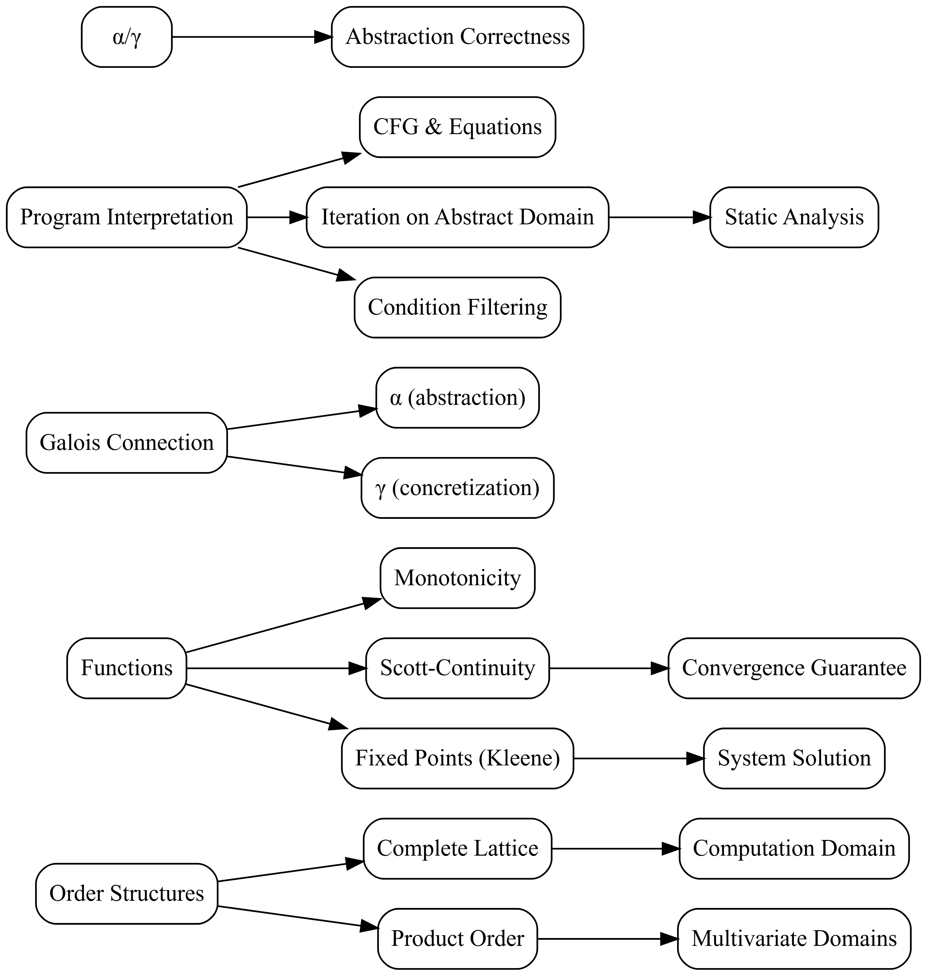

Synthesis
This series highlights the mathematical foundations of abstract interpretation: complete lattices serve as computation domains, Scott-continuity ensures iteration convergence, and Galois connections guarantee abstraction correctness.
The core method combines modeling a program by a fixed-point equation system and its iterative resolution on an abstract domain (signs, intervals).
These techniques allow automatically inferring properties about programs (variable bounds, signs) without executing them.

