Table of contents

Series 11: Model Checking with Büchi Automata and LTL

Methods

Construction of Büchi Automata (BA) from ω-Regular Expressions
- Objective: Represent an infinite word language (ω-language) described by an ω-regular expression as a Büchi automaton.
- Method: Apply basic constructions for concatenation, union, Kleene star, and omega-power ($⋅^{ω}$) operators, then combine them.

Operations on Büchi Automata
- Concatenation of a Finite Automaton (FA) and a BA:
  - Keep states of both automata $A$ (FA) and $B$ (BA).
  - The initial state is that of $A$.
  - The accepting (final) states are those of $B$.
  - Keep all existing transitions.
  - For each transition in $A$ going to one of its final states, add a similarly labeled transition from the origin to the initial state of $B$.
- Omega-power of a Finite Automaton ($A^{ω}$):
  - Keep states of the finite automaton $A$.
  - The initial state is that of $A$.
  - The accepting states are those reachable from themselves via a cycle (i.e., part of an accessible strongly connected component).
  - All transitions are kept. The resulting automaton accepts infinite executions that visit at least one accepting state infinitely often.

Translation between Properties, ω-Regular Expressions, LTL, and Büchi Automata
- Objective: Express a property described in natural language in different equivalent formal forms.
- Process:
  - Understand the property’s semantics (accepted vs rejected infinite words).
  - Propose an ω-regular expression that captures this semantics.
  - Construct a BA that recognizes this expression.
  - (If possible) Provide an equivalent LTL formula.

Satisfiability and Validity Verification for LTL Formulas
- Satisfiability: Does there exist at least one infinite word (an execution) that satisfies the formula $ϕ$? Method: Propose a concrete counterexample $w$ such that $w⊨ϕ$.
- Validity: Is the formula $ϕ$ true for all infinite words? Method: Prove validity by semantic reasoning, or show it is not valid by exhibiting a counterexample $w$ such that $w⊭ϕ$.

Model Checking by Synchronous Product
- Objective: Verify whether all behaviors (infinite words) of a system $A$ satisfy a property $ϕ$ ($A⊨ϕ$).
- Method:
  - Negation: Construct the Büchi automaton $B_{¬ϕ}$ for the negation of the property.
  - Synchronous Product: Construct the product automaton $A×B_{¬ϕ}$ that recognizes the intersection of languages $L\left(A\right)∩L\left(¬ϕ\right)$.
  - SCC Analysis: Look in the product graph for a Strongly Connected Component (SCC) that is accessible from the initial state and contains at least one accepting state of $B_{¬ϕ}$.
    - If such an SCC exists: $L\left(A\right)∩L\left(¬ϕ\right)≠∅$, so $A⊭ϕ$. A counterexample is a word in this SCC.
    - If no such SCC exists: $L\left(A\right)∩L\left(¬ϕ\right)=∅$, so $A⊨ϕ$.

Manipulation of Extended LTL Connectives
- Weak Until ($pWq$): “$p$ remains true until $q$ becomes true, without guarantee that $q$ arrives”. Formally: $σ⊨pWq⇔\left(σ⊨pUq\right)∨\left(σ⊨▫p\right)$.
- Infinitely Often ($F^{∞}p$): “$p$ is true infinitely often”. Formally: $σ⊨F^{∞}p⇔∀i≥0,∃j≥i,σ^{j}⊨p$. Can be expressed in standard LTL as $▫⋄p$.

Reminder
- Büchi Automaton: Automaton on infinite words where a word is accepted if there exists an execution that visits an accepting (final) state infinitely often.
- ω-Regular Expression: Generalizes regular expressions to infinite languages. Basic operators are concatenation, union, Kleene star $*$ (finite repetition), and the omega operator $ω$ (infinite repetition).
- LTL Semantics: An LTL formula is interpreted over an infinite word $σ=σ_{0}σ_{1}σ_{2}...$.
  - $σ⊨∘ϕ⇔σ^{1}⊨ϕ$
  - $σ⊨▫ϕ⇔∀i≥0,σ^{i}⊨ϕ$
  - $σ⊨⋄ϕ⇔∃i≥0,σ^{i}⊨ϕ$
  - $σ⊨ϕUψ⇔∃i≥0$ such that $σ^{i}⊨ψ$ and $∀0≤j<i,σ^{j}⊨ϕ$
- Synchronous Product: Given $A=\left(Q_{A},Σ,δ_{A},q_{0A},F_{A}\right)$ and $B=\left(Q_{B},Σ,δ_{B},q_{0B},F_{B}\right)$, the product $A×B$ has states $Q_{A}×Q_{B}$, initial state $\left(q_{0A},q_{0B}\right)$, and a transition $\left(\left(s,t\right),a,\left(s′,t′\right)\right)$ if $\left(s,a,s′\right)∈δ_{A}$ and $\left(t,a,t′\right)∈δ_{B}$. Accepting states depend on the automaton type.

Illustrative Examples

Example 1: Translation of a Property into BA and ω-Regular Expression
Context: Express the property “a response is eventually provided on each request”.
Application:
- Semantics: After each occurrence of req, there must eventually be an occurrence of res. A word like (req any* res)^ω is accepted. A word like req (any)^ω (a request never served) is rejected.
- ω-Regular Expression:
$${\left({\left(\text{req}∪\text{res}∪\text{any}\right)}^{*}⋅\text{res}\right)}^{ω} ∪ {\left({\left(\text{req}∪\text{res}∪\text{any}\right)}^{*}⋅\text{req}⋅{\left(\text{any}\right)}^{*}⋅\text{res}\right)}^{ω}$$
- A simpler equivalent expression would be ${\left({\left(¬\text{req}\right)}^{*}⋅\text{req}⋅{\left(¬\text{res}\right)}^{*}⋅\text{res}\right)}^{ω}$
- Construction of the BA: The automaton has two main states:
  - $q_{0}$: “Waiting for a request or nothing special”.
  - $q_{1}$: “A request has been issued and we await the response”.
  - Transition from $q_{0}$ to $q_{1}$ on req.
  - Transition from $q_{1}$ to $q_{1}$ on any except res.
  - Transition from $q_{1}$ to $q_{0}$ on res (the request is served).
  - All other transitions (e.g., any in $q_{0}$, req in $q_{1}$) remain in the current state.
  - The initial state is $q_{0}$. All states are accepting to ensure that pending requests (in $q_{1}$) must be left (by going to $q_{0}$ via res) for the execution to be accepted (because an accepting state must be visited infinitely often, so we cannot remain stuck in $q_{1}$).

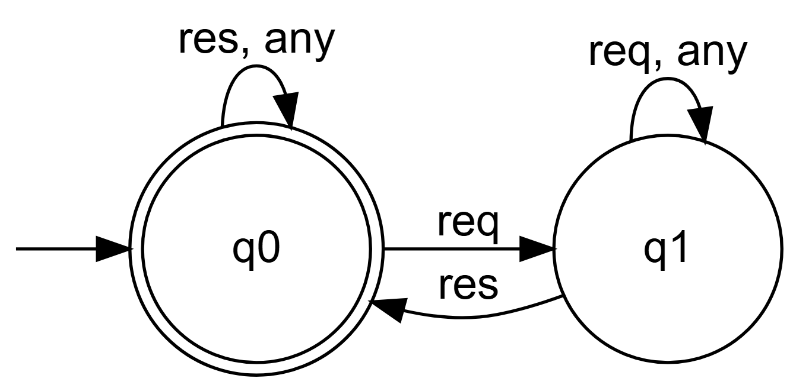

Example 2: Concatenation Operation FA and BA
Context: Construct a BA for $\left(ab+c\right)c^{*}{\left(ab^{*}\right)}^{ω}$ from an FA for $\left(ab+c\right)c^{*}$ and a BA for ${\left(ab^{*}\right)}^{ω}$.
Application:
- Let $A$ be the FA for $\left(ab+c\right)c^{*}$. It has an initial state $i_{A}$ and (at least) a final state $f_{A}$.
- Let $B$ be the BA for ${\left(ab^{*}\right)}^{ω}$. It has an initial state $i_{B}$ and accepting states $F_{B}$.
- Construction of the BA for concatenation:
  - States: Disjoint union of states of $A$ and $B$.
  - Initial state: $i_{A}$.
  - Accepting states: $F_{B}$ (only those of $B$).
  - Transitions: All transitions of $A$ and $B$ are kept.
  - Added transitions: For each transition in $A$ of the form $\left(p,α,f_{A}\right)$ where $f_{A}$ is a final state of $A$, add a new transition $\left(p,α,i_{B}\right)$ to the initial state of $B$.
- Justification: To be accepted, a word must first be accepted by the finite prefix recognized by $A$ (which leads to a final state $f_{A}$), then immediately start and satisfy the infinite suffix recognized by $B$. The added transition enables this “handover”.

Example 3: Model Checking by Synchronous Product
Context: Verify if the automaton $A$ (with $L\left(A\right)={\left(bc\right)}^{ω}$) satisfies $ϕ_{2}=▫\left(a⇒⋄c\right)$.
Application:
- Negation of the property: $¬ϕ_{2}=¬▫\left(a⇒⋄c\right)=⋄\left(a∧▫¬c\right)$.
- Construction of $B_{¬ϕ_{2}}$:
  - It seeks to capture a moment where $a$ is true and then $c$ is always false.
  - The shown automaton has states representing “has not yet seen $a∧▫¬c$” (initial), “has seen $a$ and now verifies $▫¬c$” (accepting).
  - It remains in the accepting state only when reading letters where $c$ is false.
- Synchronous Product $A×B_{¬ϕ_{2}}$:
  - We couple states of $A$ (e.g., $s_{1},s_{2},s_{3}$) with those of $B$.
  - Automaton $A$ only generates letters b and c. It never generates the letter a.
- Analysis: The premise $a$ of the formula $ϕ_{2}$ is never true in any word of $L\left(A\right)$. Therefore, the implication $a⇒⋄c$ is vacuously true at every position. The formula $ϕ_{2}$ is thus true on every word of $L\left(A\right)$.
- Verification by SCC: In the product, no execution can reach the accepting state of $B_{¬ϕ_{2}}$ because that requires reading an a. Hence, no accessible SCC contains an accepting state of $B_{¬ϕ_{2}}$. We conclude that $L\left(A\right)∩L\left(¬ϕ_{2}\right)=∅$, so $A⊨ϕ_{2}$.

Synthesis
This series of exercises covers the core of automata-based model checking. The key skills are:
- formal manipulation of ω-languages via expressions and Büchi automata
- translation between different notations (LTL, expressions, automata)
- use of automata operations to construct complex representations
- application of the central model checking algorithm via synchronous product and SCC search.
A deep understanding of LTL semantics and Büchi acceptance is fundamental for all these tasks.

