Quantum-Graph Allosteric Signal Propagation from Static Protein Structures:
A Hybrid Continuous-Time Quantum Walk, Hyperdimensional and Neuroevolutionary Framework
Robert McMenemy
Prepared for the Cleveland Clinic Global Quantum + AI Challenge 2026
Abstract
Allosteric drug discovery requires identifying sites whose perturbation can influence distant functional regions of a protein. Conventional approaches often rely on molecular dynamics or ensemble simulation, which can be computationally expensive and difficult to scale across targets. We present a static-structure framework that treats a protein as a weighted residue-contact graph and uses continuous-time quantum-walk (CTQW) dynamics as an interference-sensitive model of signal propagation. The normalized graph Laplacian defines both a quantum propagator and a matched classical diffusion analogue. We augment baseline transport with exact residue-local Hamiltonian interventions and collective pocket phase kicks, then aggregate residue evidence into spatially coherent candidate sites. A frozen mechanistic site-aware model provides the primary competition ranking. Separately, a 4096-dimensional hyperdimensional-computing representation and a compact neuroevolutionary ranker are calibrated on six proteins and fused with the frozen score by equal-weight reciprocal rank fusion; this learned layer is retained as auxiliary evidence rather than replacing the mechanistic model. Across six-protein leave-one-protein-out calibration, the hybrid achieved a median average-precision-to-prevalence ratio of 2.399 versus 1.650 for the frozen model. On challenge benchmarks excluded from fitting, the auxiliary hybrid improved KRAS G12C AP from 0.0909 to 0.1183 and BCR-ABL1 AP from 0.0618 to 0.0895. In a cryptographically sealed three-protein clean-room holdout, the median hybrid AP/prevalence ratio was 2.281 and it improved or matched the frozen model on two of three proteins, but the predeclared exact Top-5 success criterion failed (one of three targets). Accordingly, the frozen site-aware model remains primary. Coarse three-qubit Qiskit circuits showed high ideal-to-noisy rank stability, but full-resolution-to-coarse fidelity varied strongly by target, demonstrating that circuit noise robustness and biological representation fidelity are distinct properties. The framework therefore provides reproducible, interpretable allosteric hypotheses from static structures without claiming quantum computational advantage or atomistic dynamical equivalence.
Keywords: protein allostery; continuous-time quantum walk; residue interaction network; hyperdimensional computing; neuroevolution; quantum simulation; structure-based drug discovery

1. Introduction
Allostery is the regulation of protein function through coupling between spatially separated sites. A local perturbation - ligand binding, mutation, post-translational modification, or a change in interaction state - can reshape activity at a distant functional region. This long-range coupling is central to signalling and enzyme regulation and is particularly attractive for drug discovery because an allosteric pocket may be pharmacologically accessible even when the orthosteric or catalytic site is highly conserved, shallow, or otherwise difficult to target.
The computational difficulty is that a crystallographic or cryo-EM structure is a static observation, whereas allostery is inherently about communication and response. Elastic-network and graph-based models have shown that useful dynamical and communication information is encoded in native-state topology [2,4,5]. Sequence coevolution has likewise revealed sparse networks of residues that connect distant functional sites [3]. These results motivate a structure-first question: how much of allosteric signal propagation can be recovered from a single protein structure before resorting to long molecular-dynamics trajectories?
Our approach answers this question by combining a residue interaction graph with a continuous-time quantum walk (CTQW). CTQWs replace non-negative transition probabilities with complex amplitudes whose interference depends on graph topology [6]. We do not claim that a protein literally executes a quantum walk, nor do we claim a quantum speedup. Instead, the CTQW is used as a mathematically distinct transport probe whose interference structure can expose routes and regions that differ from matched classical diffusion. The resulting quantum observables are treated as topology-derived features of a static structure.
The framework then asks a more mechanistic question than simple centrality: if a residue or a candidate pocket is perturbed, how much does the seed-driven transport distribution change? We model residue interventions by local Hamiltonian shifts and pocket interventions by a collective phase-kick operator inserted midway through CTQW evolution. These perturbation observables are combined with topology, spatial coherence, multiscale pocket support, and robustness measures to produce a frozen site-aware ranking. A separate learned layer - deterministic hyperdimensional computing (HDC), a compact neuroevolutionary network, and reciprocal rank fusion (RRF) - is calibrated across independent proteins and used only as auxiliary evidence.
The design goal is not a single maximally tuned score. It is an auditable hierarchy of evidence: (i) a primary mechanistic ranking derived from a frozen quantum/topological architecture; (ii) an auxiliary learned ranking calibrated without challenge or holdout leakage; (iii) clean-room validation in which holdout labels are unavailable until predictions are cryptographically sealed; and (iv) a coarse-grained gate-based circuit demonstrating a plausible hardware path. Figure 1 summarizes the workflow.
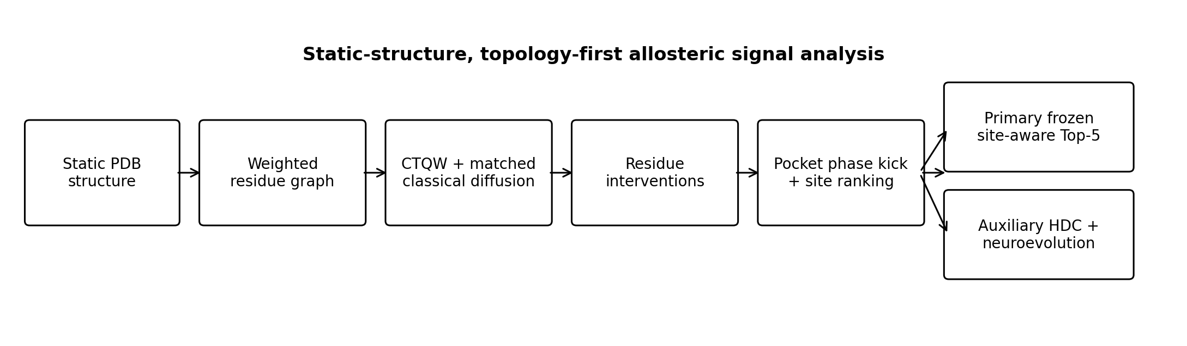
Figure 1. Overview of the static-structure quantum-graph allostery workflow. The frozen site-aware branch is the primary competition model; HDC and neuroevolution are calibrated separately and retained as auxiliary ranking evidence.

2. Background and related work
Protein network models provide a natural bridge between static structure and long-range communication. The Gaussian network model of Bahar, Atilgan and Erman represented close C-alpha contacts with a harmonic network and demonstrated that a simple topology-derived matrix can reproduce collective fluctuation patterns [2]. Chennubhotla and Bahar later framed allosteric communication as Markov propagation over biomolecular interaction networks [4]. More recently, Wang et al. developed Ohm, a structure-only network method for mapping allosteric communications without requiring molecular-dynamics trajectories [5]. These studies support the premise that native-state connectivity contains functionally useful information, while also providing an explicit classical baseline for our work.
The CTQW formalism introduced by Farhi and Gutmann provides a unitary counterpart to classical random walks [6]. On a graph, quantum amplitudes propagate under a Hermitian generator, and interference can redistribute transport in ways that do not reduce to a conventional Markov process. We exploit this difference as a representation of graph communication rather than as a claim about microscopic protein quantum mechanics.
HDC represents structured information using high-dimensional distributed vectors and simple algebraic operations [7]. Its robustness, deterministic construction and prototype-based classification are attractive in a small-data regime where only a limited number of proteins have trustworthy allosteric annotations. Neuroevolution offers a complementary gradient-free mechanism for fitting compact nonlinear rankers [8]. Finally, RRF combines heterogeneous rankings without requiring their raw scores to be calibrated to the same numerical scale [9]. These elements are used here only after the mechanistic branch is frozen.
The implementation uses the Protein Data Bank as the structural source [1] and Qiskit for the gate-based coarse-grained quantum circuit and Aer noise simulation [10].

3. Methods

3.1 Static residue-contact graph
Each input PDB structure is reduced to standard amino-acid residues with a resolved C-alpha atom. For residue i, the C-alpha coordinate x_i defines a graph node. A weighted undirected edge is added between residues i and j when their C-alpha separation d_ij is at most r_c = 8 A. The edge weight decays smoothly with distance:
A_ij = exp[-(d_ij / r_c)^2] for d_ij <= r_c, (1)
with additional sequence-continuity edges retained for nearby author-residue neighbours when necessary to preserve covalent continuity. Let D be the diagonal matrix of weighted degrees. The symmetric normalized graph Laplacian is
L = I - D^(-1/2) A D^(-1/2). (2)
This matrix is the common generator for both quantum and classical transport, ensuring that the two transport models are compared on exactly the same structural topology.

3.2 Seed definition and continuous-time quantum transport
A functional source or seed set S is defined independently of the eventual allosteric validation labels. Depending on the target, seeds are derived from an endogenous catalytic ligand, manually specified catalytic residues, or a nucleic-acid interface. The initial state is an equal-amplitude superposition over seed residues. With gamma = 1, CTQW evolution is
|psi(t)> = U(t)|psi_0>, U(t) = exp(-i gamma L t). (3)
The full residue-to-residue quantum connectivity matrix is computed as the time average of squared transition amplitudes over 12 points spanning t = 0.35 to 7.0:
C^Q_ij = (1/T) sum_t |U_ij(t)|^2. (4)
For each seed-driven trajectory we derive mean occupancy, peak occupancy, integrated occupancy, late-time occupancy, persistence, temporal entropy and quantum gain. The submitted notebook exports an explicit N x N quantum connectivity matrix for every challenge target.

3.3 Matched classical diffusion comparator
To isolate genuinely quantum-specific behaviour from generic graph connectivity, we use the same normalized Laplacian for a continuous-time classical diffusion kernel, K(t) = exp(-gamma L t). Rows are normalized to probability distributions before time averaging. Quantum gain and intervention excess are therefore defined relative to a same-topology classical process rather than to an unrelated baseline. This matched analogue is central to the interpretation: a high quantum-derived score is only interesting if it contains information not trivially explained by diffusion, degree or distance alone.

3.4 Residue-local intervention susceptibility
Baseline transport alone identifies where amplitude travels, but allostery is more naturally phrased as a response to perturbation. For each candidate residue r, we introduce a local projector shift to the graph Hamiltonian:
H_r(lambda) = L + lambda |r><r|. (5)
The seed-driven perturbed quantum distribution is compared with the unperturbed distribution using Jensen-Shannon divergence, with an analogous classical intervention computed for comparison. A lambda sweep of 0.10, 0.20, 0.35, 0.50 and 0.75 is used for the full challenge scans. Because small local perturbations are expected to produce an approximately quadratic divergence response, the implementation estimates a susceptibility coefficient from JS(lambda) proportional to chi lambda^2, while also measuring rank stability across lambda. Quantum-over-classical intervention excess is retained as a distinct feature.
The expensive intervention calculation is evaluated in exact block-diagonal batches. A direct numerical audit compared the batched implementation against the original residue-at-a-time solver across five intervention observables and found a maximum absolute difference of 4.56 x 10^-17 and maximum relative difference of 2.44 x 10^-12, far below the predeclared 10^-8 tolerance. The batching scheme is therefore an execution optimization rather than a scientific approximation.

3.5 Pocket discovery, multiscale coherence and collective phase kick
Allosteric drug discovery is a site-level problem, so residue evidence is aggregated spatially. Candidate centers are discovered from a combination of local pocket coherence and a reciprocal-rank core score, with non-maximum suppression enforcing 12 A center separation. Support is evaluated at radii 6, 8, 10 and 12 A, with 10 A retained as the canonical output scale. This multiscale construction reduces sensitivity to a single arbitrary pocket radius.
For each predicted pocket P, a collective phase kick is inserted halfway through CTQW evolution. Let Pi_P be the projector onto pocket residues. The site perturbation is
|psi_P(t)> = U(t/2) K_P(lambda) U(t/2)|psi_0>, K_P(lambda) = exp(-i lambda Pi_P). (6)
The notebook evaluates lambda in {0.15, 0.35, 0.65} across six times. The phase-kick response is quantified by the change in the final probability distribution and normalized by sqrt(|P|) to reduce trivial pocket-size effects. Site ranking then combines phase-kick density, collective transfer gain, collective quantum peak, topology and multiscale consistency using equal-weight RRF. The resulting site field contributes 90% of the primary residue score, with 10% retained for residue-level RRF tie-breaking. No validation labels enter this site construction after the architecture is frozen.

3.6 Hyperdimensional calibration layer
The auxiliary HDC layer maps each residue to a 4096-dimensional deterministic bipolar hypervector. Each feature receives a reproducible role vector generated from a SHA-256-derived seed, and each normalized feature value is discretized into one of 16 value bins with its own bipolar vector. Binding is element-wise multiplication and bundling is signed summation:
h_i = sign[ sum_f R_f (*) V_b(x_if) ]. (7)
Positive and negative prototypes are formed by bundling labelled residue hypervectors across calibration proteins. The HDC score is the difference between cosine similarity to the positive and negative prototypes. This gives a lightweight cross-protein representation that preserves the deterministic physics-derived feature semantics while avoiding a large parameterized model.

3.7 Neuroevolution and rank fusion
A compact nonlinear ranker with six hidden tanh units receives frozen physics-derived features. In the full run, population size is 36 and evolution proceeds for 28 generations with elitism, uniform crossover and Gaussian mutation. Fitness is macro-averaged across proteins rather than across residues so that large proteins do not dominate. For a protein with positive prevalence pi, the per-protein fitness contribution is
F = 0.70 [(AP - pi)/(1 - pi)] + 0.30 R_Top5. (8)
The final auxiliary score is an equal-weight reciprocal-rank fusion of three independently ranked components: the frozen V3.6 score, HDC score and neuroevolution score. With RRF constant k = 60,
S_RRF(i) = sum_m 1 / [k + rank_m(i)]. (9)
No learned post-hoc fusion weights are fitted. The role of the learned layer is explicitly auxiliary: it may support or challenge the mechanistic ranking, but it does not overwrite the primary site-aware output unless independent validation criteria are met.

3.8 Coarse graining and gate-based hardware path
For scalability and a concrete gate-based path, residues are clustered in C-alpha coordinate space using K-means at K in {8,16,32}. A size-normalized quotient adjacency is constructed and converted to the same normalized Laplacian form. Fidelity is evaluated without labels by comparing full-resolution seed transport aggregated onto the clusters against transport computed directly on the quotient graph, using Spearman correlation and Top-3 cluster Jaccard overlap.
At K = 8, the quotient Hamiltonian fits in three qubits. Qiskit Pauli decomposition and Suzuki-Trotter evolution implement the split-step U(t/2) K_P U(t/2) circuit. The hardware demonstration uses t = 3.0, phase lambda = 0.35, two Trotter repetitions and 4096 shots. Aer depolarizing noise uses 0.1% one-qubit and 1% two-qubit error probabilities. Crucially, circuit noise stability is reported separately from full-resolution-to-coarse fidelity.

3.9 Leakage controls and clean-room holdout
The experimental protocol separates model development, calibration, challenge evaluation and final holdout evaluation. Challenge labels and c-Myc are excluded from fitting. Six previously unsealed proteins form the calibration set. Leave-one-protein-out (LOPO) evaluation is performed across these six proteins before a final HDC/neuroevolution model is fit to all six.
For the three-protein Phase-3 holdout, the validation registry is removed from runtime state before scoring. Predictions, feature tables, candidate pockets and Top-5 lists are written and SHA-256 sealed under a fresh run nonce. Only after the pre-unseal target set and file hashes are verified are the holo structures and ligands introduced for evaluation. Predeclared criteria require median hybrid AP/prevalence > 1, exact Top-5 any-hit success on at least 50% of targets, and hybrid improvement or parity with the frozen model on at least 50% of targets. This protocol prevents Phase-3 labels from influencing calibration or ranking construction.

4. Experimental design

4.1 Challenge targets
The challenge set contains four structurally distinct targets. KRAS G12C and BCR-ABL1 have explicit ligand-defined allosteric validation structures. Cardiac myosin is retained as a structural challenge target, but the configured 5TBY to 6C1H pair is intentionally not assigned a ligand-contact label in the notebook; ADP is not substituted as a surrogate mavacamten label. c-Myc is treated as a prospective discovery target with no holo validation structure.
Target | Apo PDB | Validation / holo | Ligand label | Role
KRAS G12C | 4OBE | 6OIM | MOV | Validated challenge benchmark
BCR-ABL1 | 1OPL | 5MO4 | AY7 | Validated challenge benchmark
Cardiac myosin | 5TBY | 6C1H | None | Structural challenge target; no ligand-contact accuracy claim
c-Myc/Max | 1NKP | None | None | Prospective allosteric discovery

Table 1. Challenge target registry used by the submitted notebook.

4.2 Calibration and independent holdout panels
The six calibration proteins span phosphatase, protease, metabolic enzyme and kinase/regulatory mechanisms. The three Phase-3 proteins are held out from calibration and are scored before their validation ligands are revealed.
Panel | Target | Apo PDB | Holo PDB | Ligand
Calibration | PTP1B | 8U1E | 1T49 | 892
Calibration | Caspase-7 | 1GQF | 1SHJ | NXN
Calibration | Glucokinase | 1V4T | 1V4S | MRK
Calibration | SHP2 | 4DGP | 5EHR | 5OD
Calibration | MEK1 | 3EQD | 3E8N | VRA
Calibration | AKT1 | 7APJ | 3O96 | IQO
Clean-room holdout | EGFR T790M | 2JIT | 6P1L | 9LL
Clean-room holdout | IDH1 R132H | 3MAP | 6ADG | 9UO
Clean-room holdout | HIV-1 integrase | 1EX4 | 4E1N | TQX

Table 2. Calibration and clean-room validation panels. Holdout holo information is introduced only after pre-unseal predictions are sealed.

4.3 Metrics
Residue-level ranking is evaluated using average precision (AP), ROC AUC and Top-5 recall. Because positive allosteric residues are sparse and prevalence differs substantially between proteins, AP is normalized by the positive prevalence pi. AP/prevalence = 1 corresponds to the expected AP of a random ranking under the same prevalence, values above 1 indicate enrichment, and values below 1 indicate depletion. For Phase-3, we additionally report whether the global auxiliary Top-5 contains at least one labelled residue. These metrics are interpreted together rather than selecting a single favourable statistic.

5. Results

5.1 Leave-one-protein-out calibration
Across the six calibration proteins, equal-weight fusion improved distribution-level ranking quality relative to the frozen mechanistic model. The median AP/prevalence ratio increased from 1.650 for frozen V3.6 to 2.399 for the hybrid, while median ROC AUC increased from 0.663 to 0.709. HDC alone reached 1.885 median AP/prevalence. Exact Top-5 recall did not improve, however: both frozen and HDC/hybrid averaged 0.167, while neuroevolution averaged 0.133. This distinction foreshadows the holdout result: the learned layer improves broad ranking enrichment more consistently than it improves the extreme head of the ranking.
Model | Median AP/prevalence | Median ROC AUC | Mean Top-5 recall
Frozen V3.6 | 1.650 | 0.663 | 0.167
HDC | 1.885 | 0.664 | 0.167
Neuroevolution | 1.663 | 0.618 | 0.133
Hybrid RRF | 2.399 | 0.709 | 0.167

Table 3. Six-protein LOPO calibration summary.
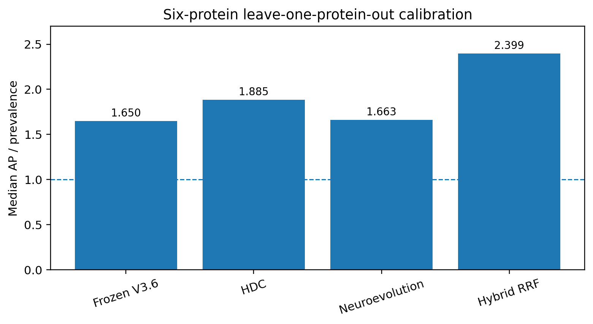
Figure 2. Median AP/prevalence across six-protein LOPO calibration. The dashed line marks random-ranking expectation (1.0).

5.2 Challenge benchmarks excluded from fitting
KRAS G12C and BCR-ABL1 were evaluated after calibration and were not used to fit HDC prototypes, neuroevolution parameters or fusion weights. On KRAS, the auxiliary hybrid improved AP from 0.0909 to 0.1183, ROC AUC from 0.3663 to 0.4550, and AP/prevalence from 0.776 to 1.009; global Top-5 recall increased from 0 to 0.20. On BCR-ABL1, AP improved from 0.0618 to 0.0895, ROC AUC from 0.5999 to 0.6533, and AP/prevalence from 1.180 to 1.708, although global Top-5 recall remained zero. These results support the learned layer as auxiliary ranking evidence but do not justify replacing the mechanistic Top-5 with the global hybrid Top-5.
Target | Model | AP | ROC AUC | AP/prevalence | Global Top-5 recall
KRAS G12C | Frozen V3.6 | 0.0909 | 0.3663 | 0.776 | 0.000
KRAS G12C | Hybrid | 0.1183 | 0.4550 | 1.009 | 0.200
BCR-ABL1 | Frozen V3.6 | 0.0618 | 0.5999 | 1.180 | 0.000
BCR-ABL1 | Hybrid | 0.0895 | 0.6533 | 1.708 | 0.000

Table 4. Challenge benchmark comparison. Challenge labels are excluded from model fitting.
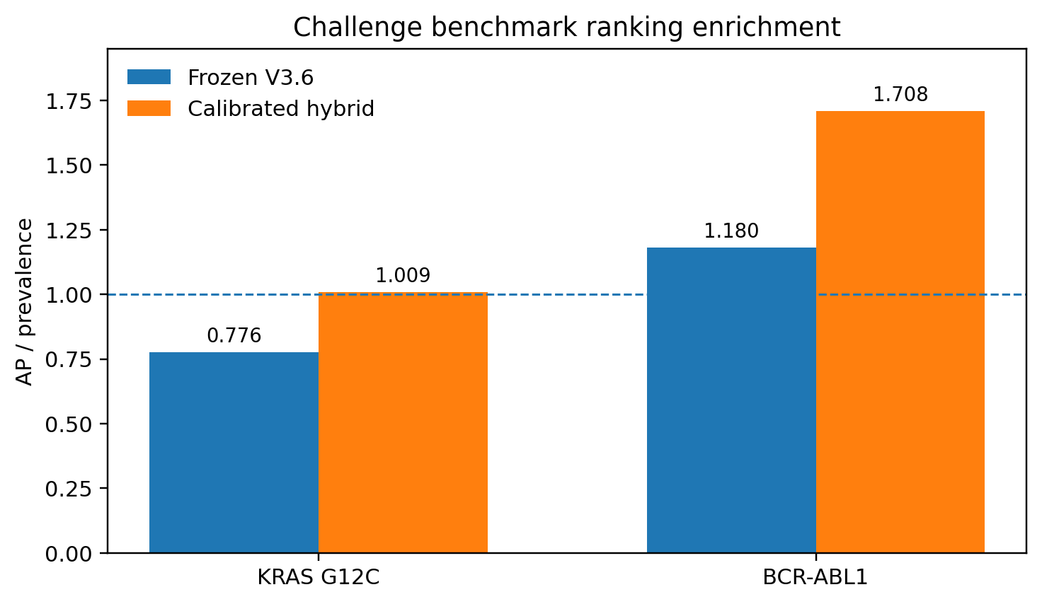
Figure 3. AP/prevalence on the two ligand-labelled challenge benchmarks. The calibrated hybrid improves ranking enrichment but remains auxiliary because exact Top-5 generalization is not independently established.

5.3 Independent clean-room Phase-3 holdout
The clean-room holdout produced mixed but informative transfer. EGFR hybrid AP/prevalence was 2.281 versus 2.189 for frozen V3.6; IDH1 was 4.669 versus 4.906; and HIV integrase remained below random expectation at 0.842 versus 0.803. The median hybrid AP/prevalence was therefore 2.281. The hybrid improved or matched the frozen score on two of three proteins, satisfying the predeclared majority-improvement criterion.
The stricter exact Top-5 criterion failed. Neither EGFR nor HIV integrase produced a labelled residue in the auxiliary global Top-5, while IDH1 produced one hit (A:121). The any-hit success fraction was 1/3 = 0.333, below the predeclared 0.50 threshold. This failure is not hidden or re-optimized away; it is the reason the calibrated layer is retained as auxiliary rather than promoted to the primary competition model.
Holdout | Frozen AP/prevalence | Hybrid AP/prevalence | Hybrid Top-5 hits | Interpretation
EGFR T790M | 2.189 | 2.281 | 0/5 | Distribution-level enrichment; no exact Top-5 hit
IDH1 R132H | 4.906 | 4.669 | 1/5 | Strong enrichment; one exact Top-5 hit
HIV-1 integrase | 0.803 | 0.842 | 0/5 | Failure case retained

Table 5. Cryptographically sealed Phase-3 holdout results.

5.4 Primary challenge predictions
The competition output is the frozen V3.6 site-aware Top-5, not the auxiliary global hybrid Top-5. Site-aware representatives are actual members of ranked pockets and include a diversity constraint limiting overconcentration within a single predicted pocket.
Target | Rank 1 | Rank 2 | Rank 3 | Rank 4 | Rank 5
KRAS G12C | A:24 ILE | A:23 LEU | A:25 GLN | A:155 ALA | A:148 THR
BCR-ABL1 | A:380 HIS | A:384 ALA | A:437 ILE | A:316 ASN | A:407 MET
Cardiac myosin | A:119 GLY | A:767 ALA | A:91 ALA | A:474 GLU | A:473 PHE
c-Myc | A:917 LEU | A:913 ARG | A:912 GLN | A:943 LEU | A:942 ILE

Table 6. Primary frozen site-aware Top-5 predictions submitted for the four challenge targets.
The notebook also exports the complete N x N quantum and classical matrices. Their sizes are 169 x 169 for KRAS, 451 x 451 for BCR-ABL1, 954 x 954 for cardiac myosin and 171 x 171 for c-Myc.

5.5 Coarse-graining fidelity and hardware-aligned noise simulation
Coarse-graining fidelity is strongly target dependent. At K = 8, full-resolution-to-coarse seed-transport Spearman is -0.500 for KRAS, 0.833 for BCR-ABL1, 0.548 for cardiac myosin and 0.286 for c-Myc. Increasing resolution substantially improves several targets: KRAS reaches 0.830 at K = 32, cardiac myosin reaches 0.868 at K = 16, and c-Myc reaches 0.812 at K = 16 and 0.938 at K = 32. BCR-ABL1 is already strong at K = 8 and reaches 0.898 at K = 32.
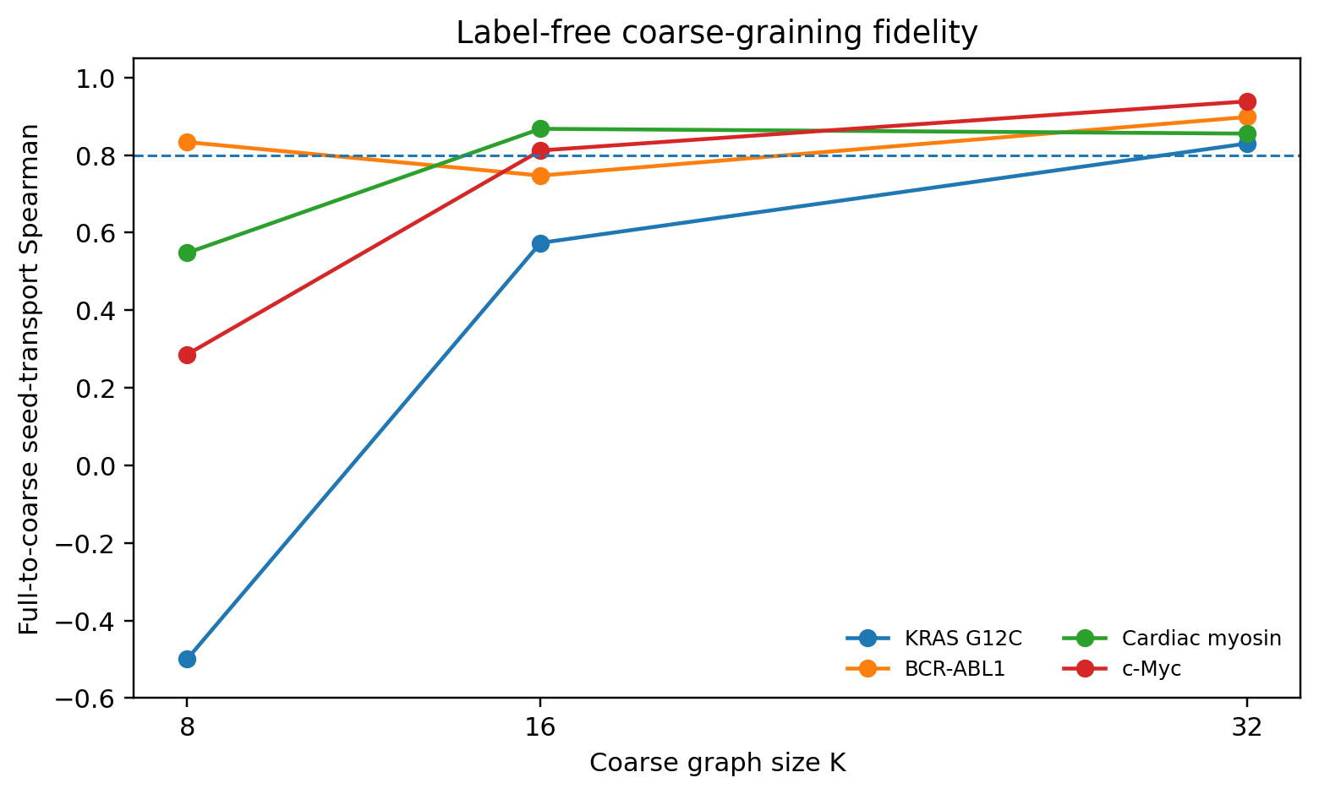
Figure 4. Label-free full-resolution-to-coarse seed-transport fidelity. K = 8 is a useful three-qubit hardware demonstration but is not an equally faithful biological surrogate for every target.
The K = 8 phase-kick circuits compile to three qubits. KRAS uses 29 Pauli terms and transpiled depth 696; BCR-ABL1 uses 25 Pauli terms and depth 638. Under the specified Aer depolarizing noise model, both retain ideal-to-noisy Spearman 0.976 and Top-3 Jaccard 1.0 in the final executed audit. Jensen-Shannon divergence between ideal and noisy sampled distributions is 0.0063 for KRAS and 0.0093 for BCR-ABL1.

Target | K | Qubits | Pauli terms | Depth | Full->K8 Spearman | Ideal/noisy Spearman | Top-3 Jaccard
KRAS G12C | 8 | 3 | 29 | 696 | -0.500 | 0.976 | 1.000
BCR-ABL1 | 8 | 3 | 25 | 638 | 0.833 | 0.976 | 1.000

Table 7. Hardware-aligned phase-kick circuit evidence. The last two columns quantify noise stability of the coarse circuit; Full->K8 Spearman quantifies representation fidelity and must be interpreted separately.

5.6 Chain-mapping sensitivity
Validation labels are generated by mapping ligand-contact residues from holo structures back to the scored apo structure. Symmetric multimers can make this mapping ambiguous. A post-hoc one-to-one bipartite chain assignment audit was therefore applied without recomputing predictions or refitting the model. Four of nine evaluated proteins were flagged as historical chain-collapse risks.
Target | Historical positives | One-to-one positives | Label Jaccard | Collapse-risk
PTP1B | 13 | 13 | 1.000 | No
Caspase-7 | 18 | 33 | 0.417 | Yes
Glucokinase | 20 | 20 | 1.000 | No
SHP2 | 19 | 19 | 1.000 | Yes
MEK1 | 23 | 23 | 1.000 | No
AKT1 | 21 | 21 | 1.000 | No
EGFR | 21 | 21 | 1.000 | Yes
IDH1 | 16 | 16 | 0.882 | Yes
HIV-1 integrase | 7 | 7 | 1.000 | No

Table 8. One-to-one chain-mapping sensitivity. Corrected labels are post-hoc diagnostics only.
Caspase-7 is the largest calibration-label sensitivity: positives change from 18 to 33 and the label-set Jaccard is 0.417. In Phase-3, IDH1 retains 16 positives but its label Jaccard is 0.882; under the one-to-one sensitivity labels, hybrid AP/prevalence falls from 4.669 to 2.909 and the single auxiliary Top-5 hit disappears. Because this remapping was developed after unsealing, it does not replace the cryptographically sealed historical Phase-3 record and is not used for retrospective model selection. Instead, it strengthens the decision to keep the learned layer auxiliary and identifies chain-aware label curation as a priority for future work.

6. Discussion
The central result is not that a quantum model uniformly outperforms classical protein models. Rather, the study demonstrates a reproducible way to turn static structure into a hierarchy of mechanistic and learned allosteric evidence. CTQW provides an interference-sensitive transport observable; local Hamiltonian interventions ask which residues most strongly reshape that transport; collective phase kicks extend the same idea to drug-like spatial sites; and matched classical diffusion exposes which effects are genuinely quantum-specific within the graph model.
The calibration results show that HDC and neuroevolution can improve broad cross-protein ranking enrichment, but the Phase-3 result also shows why that improvement should not automatically be converted into an exact pocket claim. Median enrichment was strong, yet the exact Top-5 criterion failed. In practical drug discovery, both views are useful: a globally enriched ranking can reduce the experimental search space, while an exact Top-5 claim demands a higher validation bar.
The primary/auxiliary split is therefore a methodological feature, not a concession. The frozen V3.6 branch preserves a traceable mechanistic interpretation and avoids benchmark-driven drift. The learned branch can surface additional cross-protein regularities without being allowed to erase a negative holdout result. This separation also makes the system easier to audit: every challenge prediction can be inspected in the context of raw quantum transport, classical transport, intervention susceptibility, pocket coherence and learned support.
The hardware study provides a second important separation. A coarse circuit may be internally robust to gate noise yet still be an inaccurate compression of the full residue graph. KRAS is the clearest example: its K = 8 ideal/noisy Spearman is high, but its full-resolution-to-K8 transport Spearman is negative. BCR-ABL1, by contrast, is both noise-stable and reasonably faithful at K = 8. This argues for a fidelity-first hardware scaling strategy in which K is chosen from label-free transport preservation rather than from qubit count alone.
Finally, the chain-mapping sensitivity demonstrates that benchmark construction can be as important as scoring architecture. Caspase-7 and IDH1 expose how homologous chains and asymmetric mapping choices can alter residue labels. Reporting this sensitivity prevents inflated confidence and provides a concrete route for the next model generation: rebuild calibration labels with one-to-one chain assignment, retrain as a new model, and evaluate on a fresh independent holdout rather than reusing Phase-3.

7. Limitations and claim boundaries
Several limitations are deliberately retained in the submission. First, the residue-level CTQW is evaluated classically; the quantum contribution is an alternative transport formalism and perturbation observable, not a demonstrated computational speedup. Second, a static contact graph cannot reproduce solvent, entropic, protonation, side-chain rearrangement or conformational-ensemble effects captured by atomistic simulations. Third, the learned calibration set contains only six proteins, so HDC and neuroevolution should be viewed as small-data auxiliary models rather than universal allostery predictors.
Fourth, the independent Phase-3 exact Top-5 criterion failed, and the post-hoc one-to-one mapping sensitivity removes the single IDH1 auxiliary Top-5 hit. We therefore do not claim reliable exact Top-5 generalization for the calibrated hybrid. Fifth, c-Myc is prospective: the reported residues are hypotheses, not experimentally validated allosteric sites. Sixth, the configured cardiac-myosin challenge pair does not provide a valid mavacamten ligand-contact label in this notebook, so no ligand-contact accuracy claim is made for that target. Seventh, hardware results are simulator-based noise experiments on coarse Hamiltonians, not execution on physical quantum hardware.

8. Reproducibility and submitted artifacts
The accompanying Colab notebook contains the full pipeline, checkpointed exact intervention scans, calibration, clean-room holdout, N x N matrix export, 3D visualization, coarse-graining, Qiskit circuit construction, noise simulation and execution attestation. The final executed scientific audit used one run identity across all required evidence stages and a persistent Google Drive checkpoint backend.
Key immutable identifiers are: frozen V3.6 architecture signature 4ac271ce2347959b441e90d1f834ce1c35f22333a09907ab1f60a609dfc83328; calibration signature c126b357c272012af58d1d5c3f4802961cafe33bbf883475be9bc93a6d1c216f; and clean-room Phase-3 freeze-manifest SHA-256 f93b4f6785cc9c50ed0329db1bb756911c720cbc0cac316c1641dbf3dcb508c0. These signatures allow the submitted evidence to be tied to a frozen architecture and calibration state.
The notebook exports both quantum and classical connectivity matrices, primary and auxiliary Top-5 tables, validation metrics, coarse-graining fidelity, hardware/noise evidence, chain-mapping sensitivity and execution manifests. All structures are identified by public PDB accession IDs in Tables 1 and 2.

9. Conclusion
We introduced a static-structure framework for protein allosteric signal propagation that combines continuous-time quantum walks, matched classical diffusion, exact residue-local interventions, collective pocket phase kicks, spatial site aggregation, hyperdimensional representations and neuroevolutionary calibration. The method produces explicit N x N connectivity matrices and interpretable residue/pocket rankings without molecular-dynamics trajectories.
The results support a nuanced conclusion. Quantum/topological observables provide a coherent mechanistic ranking; HDC and neuroevolution improve distribution-level cross-protein enrichment; but exact Top-5 transfer remains insufficiently reliable to promote the learned model to primary status. A clean-room holdout, exact numerical equivalence audit, hardware fidelity analysis and chain-mapping sensitivity all reinforce this conservative decision. The resulting submission is therefore best viewed as an auditable quantum-graph hypothesis generator for allosteric drug discovery, with a clear gate-based hardware path and explicitly declared limits rather than a claim of quantum advantage.

References
[1] H. M. Berman, J. Westbrook, Z. Feng, G. Gilliland, T. N. Bhat, H. Weissig, I. N. Shindyalov, and P. E. Bourne, "The Protein Data Bank," Nucleic Acids Research, vol. 28, no. 1, pp. 235-242, 2000. doi:10.1093/nar/28.1.235.
[2] I. Bahar, A. R. Atilgan, and B. Erman, "Direct evaluation of thermal fluctuations in proteins using a single-parameter harmonic potential," Folding & Design, vol. 2, no. 3, pp. 173-181, 1997. doi:10.1016/S1359-0278(97)00024-2.
[3] G. M. Suel, S. W. Lockless, M. A. Wall, and R. Ranganathan, "Evolutionarily conserved networks of residues mediate allosteric communication in proteins," Nature Structural Biology, vol. 10, pp. 59-69, 2003. doi:10.1038/nsb881.
[4] C. Chennubhotla and I. Bahar, "Markov propagation of allosteric effects in biomolecular systems: application to GroEL-GroES," Molecular Systems Biology, vol. 2, article 36, 2006. doi:10.1038/msb4100075.
[5] J. Wang, A. Jain, L. R. McDonald, C. Gambogi, A. L. Lee, and N. V. Dokholyan, "Mapping allosteric communications within individual proteins," Nature Communications, vol. 11, article 3862, 2020. doi:10.1038/s41467-020-17618-2.
[6] E. Farhi and S. Gutmann, "Quantum computation and decision trees," Physical Review A, vol. 58, p. 915, 1998. doi:10.1103/PhysRevA.58.915.
[7] P. Kanerva, "Hyperdimensional computing: An introduction to computing in distributed representation with high-dimensional random vectors," Cognitive Computation, vol. 1, no. 2, pp. 139-159, 2009. doi:10.1007/s12559-009-9009-8.
[8] F. P. Such, V. Madhavan, E. Conti, J. Lehman, K. O. Stanley, and J. Clune, "Deep Neuroevolution: Genetic Algorithms Are a Competitive Alternative for Training Deep Neural Networks for Reinforcement Learning," arXiv:1712.06567, 2017.
[9] G. V. Cormack, C. L. A. Clarke, and S. Buettcher, "Reciprocal rank fusion outperforms Condorcet and individual rank learning methods," in Proc. 32nd ACM SIGIR Conference, pp. 758-759, 2009. doi:10.1145/1571941.1572114.
[10] A. Javadi-Abhari et al., "Quantum computing with Qiskit," arXiv:2405.08810, 2024.
Submission note. This paper is intended to accompany the executable Colab notebook. Quantitative claims are tied to the fully executed V4.1.2 scientific audit; subsequent packaging branches do not alter the frozen primary scorer.

